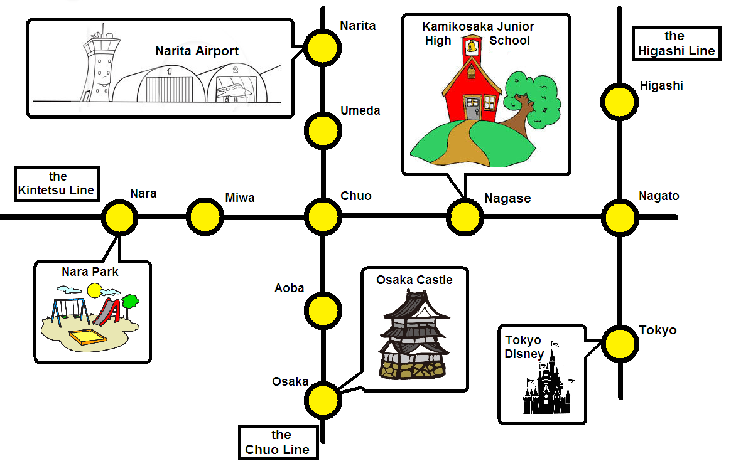

**Part 2**

　How can I get to Kamikosaka Junior High School?  
Take the ____________________ Line.  
Get off at __________________ station.

　How can I get to Osaka Castle?  
Take the ____________________ Line.  
Osaka is the __________________ stop.

　How can I get to Tokyo Disney?  
Take the ____________________ Line.  
Change to the Higashi Line at __________ Station.  
Get off at ______________ Station.

**Part 3**

1. How can I get to Aoba Station? *Take the Chuo Line. Aoba is the first stop.* _________________________
2. How can I get to Umeda? _________________

___________________________________

1. How can I get to Narita Airport? ____________

_______________________________________

**Part 1**

1. How can I get to Nagato Station?
2. Take the Kintetsu Line.
3. Take the Higashi Line.
4. Take the Chuo Line.
5. How can I get to Nara Park?
6. Take the Kintetsu Line. Get off at Miwa Station.
7. Take the Chuo Line. Get off at Nara Station.
8. Take the Kintetsu Line. Get off at Nara Station.
9. How can I get Osaka station?
10. Take the Chuo Line. Osaka is the first stop.
11. Take the Chuo Line. Osaka is the second stop.
12. Take the Chuo Line. Osaka is the third stop.
13. How can I get to Higashi station?
14. Take the Kintetsu Line. Change to the Higashi Line at Nagato Station.
15. Take the Higashi Line. Change to the Chuo Line at Nagato Station.
16. Take the Kintetsu Line. Change to the Higashi Line at Chuo Station.