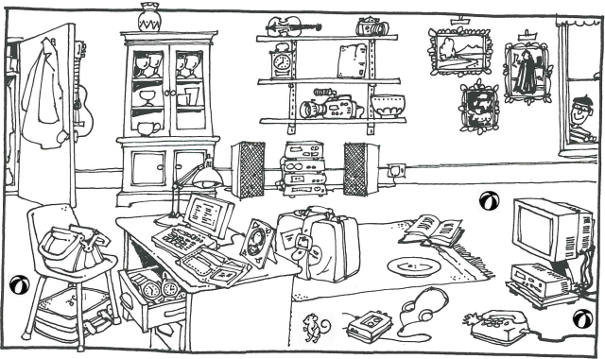

|  |  |  |
| --- | --- | --- |
| **Part 1:**   1. Is there a **dog** in the room? No, there is not. 2. Is there a **bookcase** in the room? ________________________________ 3. Is there a **clock** in the room? ________________________________ 4. Is there a **fridge** in the room? ________________________________ 5. Is there a **phone** in the room? ________________________________ 6. Is there a **vase** in the room? ________________________________ 7. Is there a **guitar** in the room? ________________________________ |  | **Part 2:**   1. pictures There are four pictures in the room. 2. watches _________________________________ 3. desks _________________________________ 4. cameras _________________________________ 5. instruments _________________________________ 6. balls _________________________________ 7. chairs _________________________________ |