|  |  |
| --- | --- |
| Lesson8-2 | **Listening Practice** |

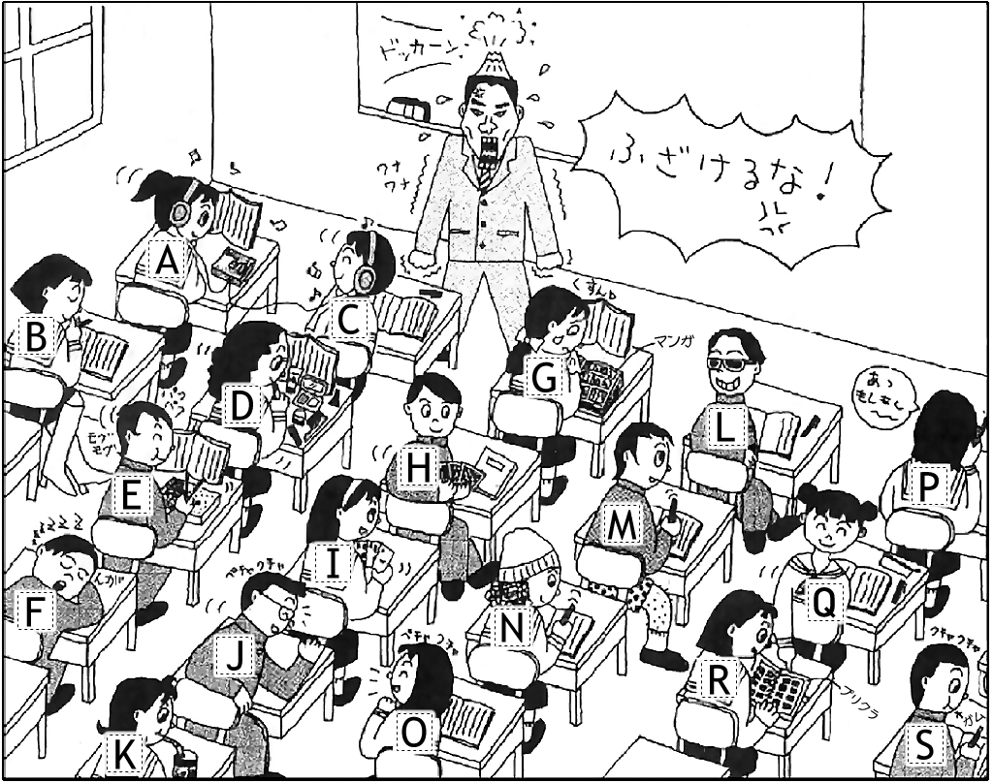**Memo**

1. Asami ( *B* ) 　*read*
2. Takumi & Marie ( ) _________________
3. Maki ( ) ____________________
4. Daichi ( ) ____________________
5. Takasa ( ) ____________________
6. Aya ( ) ____________________
7. Saho & Mizuki ( ) _________________
8. Kenta ( ) ____________________
9. Maya ( ) ____________________
10. Mai ( ) ____________________
11. Takeshi ( ) ____________________
12. Mayumi ( ) ____________________
13. Chisato ( ) ____________________

**Lesson 8-2: Listening Answers**

1. [B] A book is read by Asami.
2. [H / I] Cards are played by Takumi & Marie.
3. [G] Comic books are read by Maki.
4. [L] Sunglasses are worn by Daichi.
5. [D] Make-up is put on by Takasa.
6. [K] Coca-cola is drank by Aya.
7. [A / C] Music is listened to by Saho & Mizuki.
8. [E] Lunch is eaten by Kenta.
9. [P] A phone is used by Maya.
10. [O] A girl talking to a boy is Mai.
11. [F] A desk is slept on by Takeshi
12. [R] Purikura pictures are looked at by Mayumi.
13. [N] The hat is worn by Chisato.