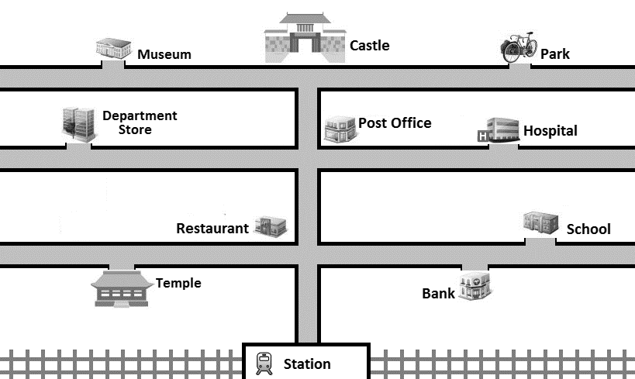

Excuse me. Could you tell me the way to ?

Well, go down this street and turn left / right at .

Turn left / right at …

Yes. You’ll see it on your left / right !