**Part 2: Listening**

Muggli : Ms. Inoue, I don’t feel 　 .

Iwakiri : What’s the 　　　　 　 ?

Muggli : I have a 　　 　 　　.

Iwakiri : That’s too 　 　 . Let’s go to the doctor.

Muggli : That’s very 　 　 of you.

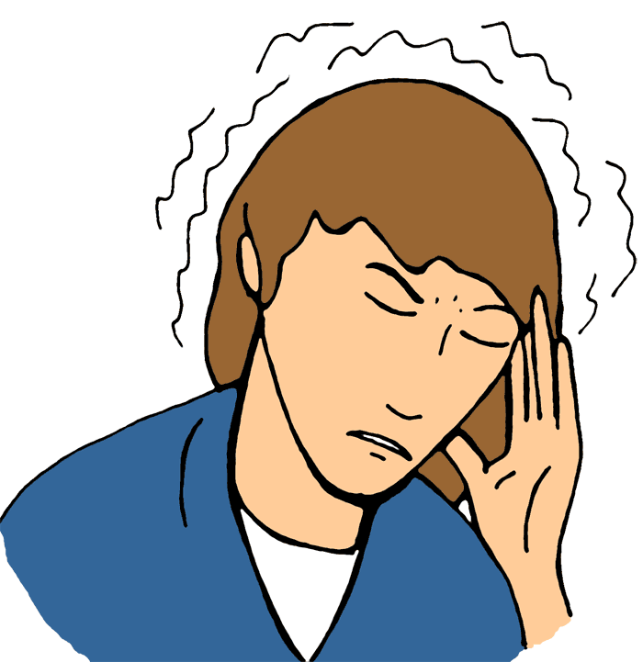

**Part 1: English Japanese**

|  |  |  |  |
| --- | --- | --- | --- |
|  | I have a stomachache. |  | 頭痛がします |
|  | I have a fever. |  | かぜをひきました |
|  | I have a cold. |  | 腹痛がします |
|  | I have a headache. |  | 気分が悪い |
|  | I have a nosebleed. |  | 鼻から出血してます |
|  | I hurt my arm. |  | 熱があります |
|  | I feel sick. |  | 腕を痛めました |

**Part 3: Writing Practice**

|  |  |  |
| --- | --- | --- |
| 1. **headache** | 1. **arm** | 1. **stomachache** |

1. What’s the matter ?  
   －I have a headache_________________.
2. _____________ the ________________?  
   －I hurt my _________________________.
3. ________________________________?  
   －__________________________________.

**Part 4: Speaking Practice**

: , I don’t feel well.

: What’s the matter?

: ①　 　 　 　.

: That’s too bad.

Let’s 　 　 .

: That’s very kind of you.

|  |  |
| --- | --- |
| 1. **Sentences** |  |
| I have a stomachache.  I have a cold.  I have a fever.  I feel sick. | I have a nosebleed.  I have a headache.  I hurt my arm. |