|  |  |  |  |  |  |  |  |
| --- | --- | --- | --- | --- | --- | --- | --- |
|  | 94 | 93 | 92 | 91 | 90 | 89 | 88 |
| 80 | 81 | 82 | 83 |  | 85 |  | 87 |
| 79 | 78 | 77 | 76 | 75 | 74 | 73 | 72 |
| 64 | 65 |  | 67 | 68 | 69 | 70 | 71 |
| 63 | 62 | 61 | 60 | 59 |  | 57 | 56 |
| 48 |  | 50 | 51 | 52 | 53 | 54 | 55 |
| 47 | 46 | 45 |  | 43 | 42 |  | 40 |
| 32 | 33 | 34 | 35 | 36 | 37 | 38 | 39 |
| 31 | 30 | 29 | 28 |  | 26 | 25 | 24 |
| 16 |  | 18 | 19 | 20 | 21 | 22 | 23 |
| 15 | 14 | 13 |  | 11 | 10 |  | 8 |
|  | 1 | 2 | 3 | 4 | 5 | 6 | 7 |

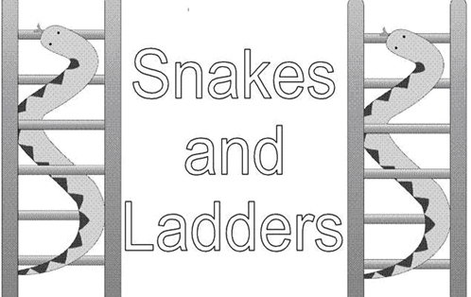

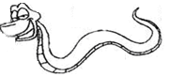



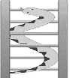

**Snakes and Ladders**