Database Modeling, API Contracts & UI Wireframes

QuickMenu QR – Dynamic Multi-Language Restaurant Menu & Ordering
Field | Detail
Project No. | #031
Course | Project 1 (Lab), Department of Software Engineering Technology
University | Punjab Tianjin University of Technology
Faculty Advisor | Dr. Zaigham Mushtaq
Prepared by | Muhammad Haroon
Version | 1.0 (Week 4 Submission)
Input documents | Week 2 SRS (IEEE 830) v1.0; Week 3 Architecture Document v1.0 (3-tier design, DFD Level 0 and 1)

1. Introduction

1.1 Purpose
Week 3 defined the system structure and the data stores (D1 to D5). This document turns that design into three concrete, build-ready artifacts:
- Database model: Entity-Relationship Diagram (ERD), data dictionary, indexing definitions, and PostgreSQL DDL.
- API contract: complete REST endpoint definitions, request and response formats, error handling, and the order state machine.
- UI wireframes: six primary application screens with annotated elements mapped to requirements.

1.2 How this document links to earlier work
Earlier artifact | Used here for
DFD Level 1 data stores D1 to D5 | Table groups in the ERD (D1 = restaurants, users; D2 = categories, items, variants, images; D3 = tables; D4 = orders; D5 = translations)
DFD Level 1 processes 1.0 to 6.0 | API endpoint groups
SRS functional requirements FR-01 to FR-35 | Endpoint and screen traceability
SRS non-functional requirements | Index choices (p95 ≤ 300 ms), security rules, idempotency

1.3 Contents
- Introduction
- Database Design (ERD, data dictionary, indexes, DDL)
- API Contract (REST)
- UI Wireframes
- Traceability
- Decisions, Risks, and Next Steps

2. Database Design

2.1 Design principles
Principle | How it is applied
Relational model | PostgreSQL 14+; orders, menus, and tables have strict relationships and need transactions
Multi-tenancy | Every business table carries restaurant_id (directly or through its parent). All queries filter by it, so one restaurant can never see another's data (NFR-S6)
Primary keys | UUIDs (gen_random_uuid()), so IDs are not guessable or sequential in URLs
Normalization | Third Normal Form (3NF). Tags and allergens are stored as text[] arrays on the item (a deliberate, documented simplification, see 2.9)
Controlled exceptions | order_items stores a snapshot of item name and unit price, so later menu changes never alter past orders (SRS 3.5)
Money | numeric(10,2), never floating point
Time | timestamptz (UTC); the app converts to local time (Pakistan Standard Time)
Integrity | Foreign keys, CHECK constraints, NOT NULL, and enums for fixed value sets
Deletion | ON DELETE CASCADE for owned children (items to variants), SET NULL for order history references

2.2 Entity-Relationship Diagram
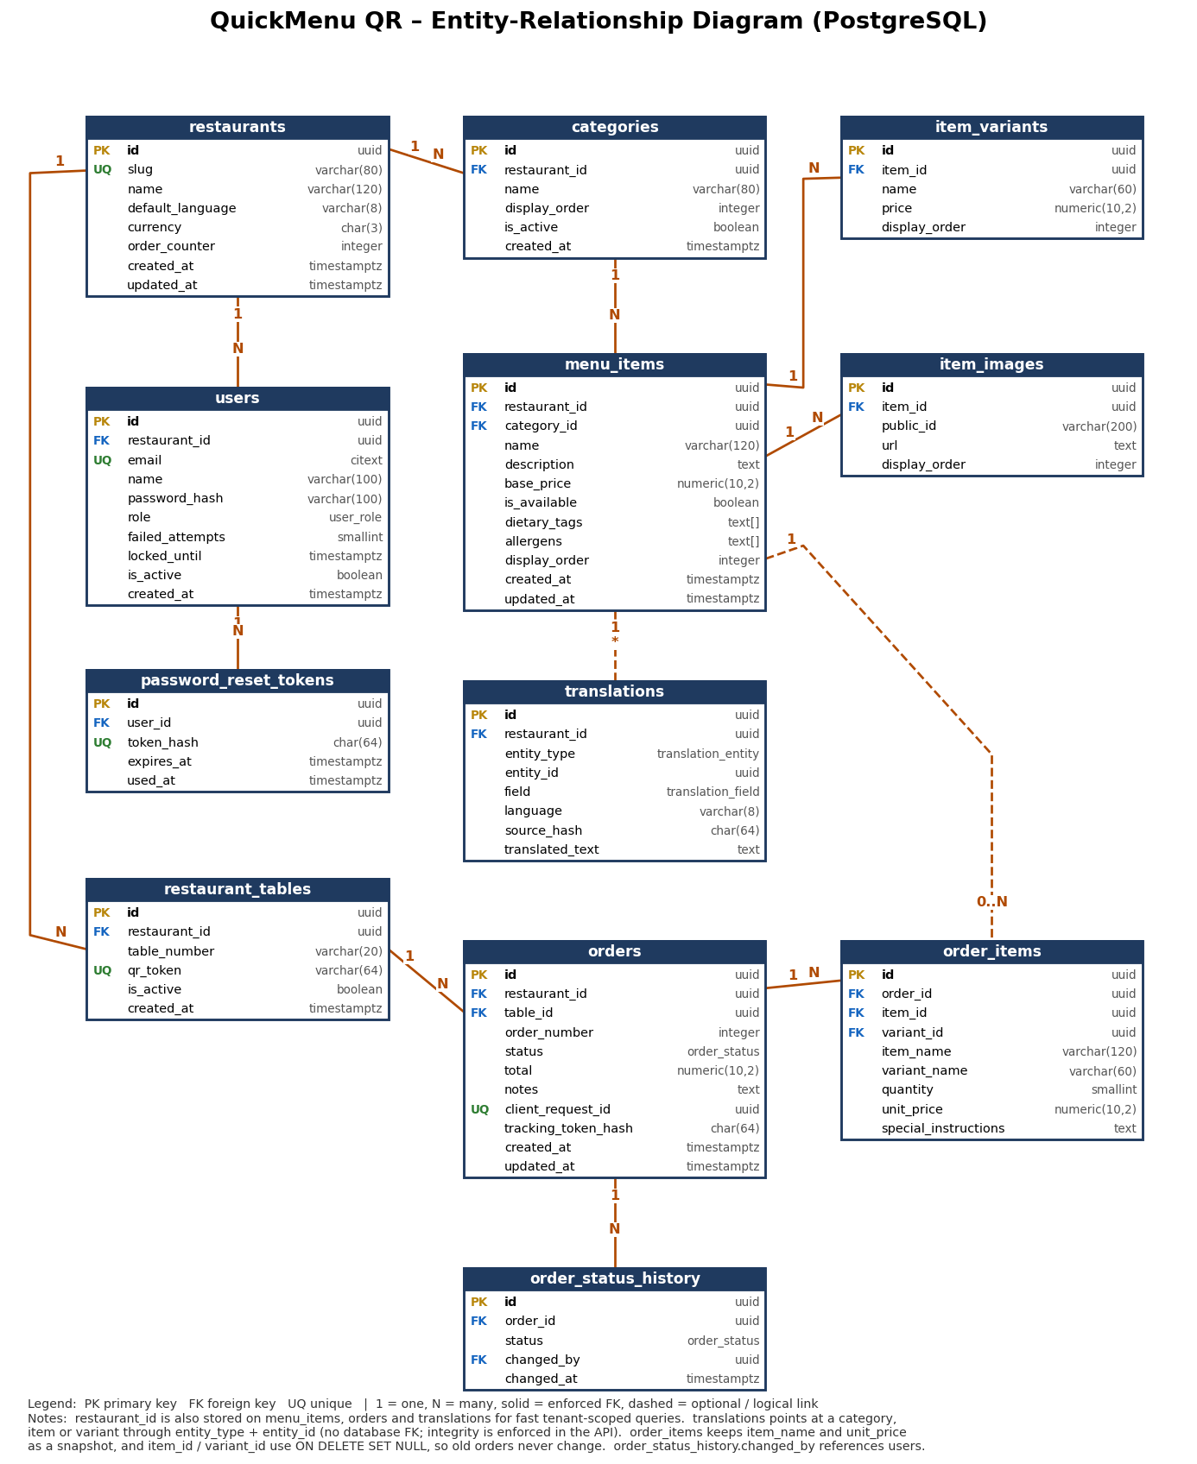
Figure 1: ERD (file: QuickMenuQR_ERD.png)

2.3 Entities and their purpose
Entity | DFD Store | Purpose
restaurants | D1 | One row per restaurant (tenant); holds default language, currency, and the order counter
users | D1 | Owner and kitchen accounts with role, lockout fields
password_reset_tokens | D1 | Single-use, expiring reset tokens (stored hashed)
categories | D2 | Menu sections such as Starters and Drinks
menu_items | D2 | Dishes with price, availability, dietary tags, allergens
item_variants | D2 | Sizes or options with their own price
item_images | D2 | Up to 3 Cloudinary photos per item
restaurant_tables | D3 | Tables, each with a unique QR token
orders | D4 | Customer orders with status, total, and tracking token
order_items | D4 | Line items of an order (with price snapshot)
order_status_history | D4 | Audit trail of every status change
translations | D5 | Cache of translated names and descriptions

2.4 Relationships and cardinality
Parent | Child | Cardinality | On Delete | Meaning
restaurants | users | 1 : N | CASCADE | A restaurant has one owner and several kitchen staff
users | password_reset_tokens | 1 : N | CASCADE | A user can request several reset tokens
restaurants | categories | 1 : N | CASCADE | Each restaurant has its own categories
categories | menu_items | 1 : N | RESTRICT | A category with items cannot be dropped silently (FR-13)
menu_items | item_variants | 1 : N | CASCADE | Variants belong to one item
menu_items | item_images | 1 : N | CASCADE | Up to 3 images per item (enforced by the API and a trigger)
restaurants | restaurant_tables | 1 : N | CASCADE | Tables belong to a restaurant
restaurant_tables | orders | 1 : N | RESTRICT | Orders reference the table they came from
restaurants | orders | 1 : N | CASCADE | Tenant ownership of orders
orders | order_items | 1 : N | CASCADE | Line items
menu_items | order_items | 1 : N (optional) | SET NULL | Item may be deleted later; the snapshot stays
item_variants | order_items | 1 : N (optional) | SET NULL | Same as above
orders | order_status_history | 1 : N | CASCADE | Audit trail
users | order_status_history | 1 : N (optional) | SET NULL | Who changed the status
menu_items / categories / item_variants | translations | 1 : N (logical) | App-managed | Polymorphic link by entity_type + entity_id

2.5 Data dictionary

restaurants
Column | Type | Constraints | Description
id | uuid | PK, default gen_random_uuid() | Restaurant (tenant) ID
name | varchar(120) | NOT NULL | Display name
slug | varchar(80) | NOT NULL, UNIQUE | URL-safe name
default_language | varchar(8) | NOT NULL, default 'en' | Language the owner writes the menu in
currency | char(3) | NOT NULL, default 'PKR' | ISO currency code
order_counter | integer | NOT NULL, default 0 | Last issued order number (incremented in a transaction)
created_at / updated_at | timestamptz | NOT NULL, default now() | Timestamps

users
Column | Type | Constraints | Description
id | uuid | PK | User ID
restaurant_id | uuid | FK to restaurants, NOT NULL | Tenant
email | citext | NOT NULL, UNIQUE | Login (case-insensitive)
name | varchar(100) | NOT NULL | Full name
password_hash | varchar(100) | NOT NULL | bcrypt hash, cost 10 or more (NFR-S2)
role | user_role | NOT NULL | owner or kitchen
failed_attempts | smallint | NOT NULL, default 0 | Consecutive failed logins
locked_until | timestamptz | NULL | Lockout end time (15 min after 5 failures, NFR-S4)
is_active | boolean | NOT NULL, default true | Disabled accounts cannot log in
created_at | timestamptz | NOT NULL | Creation time

password_reset_tokens
Column | Type | Constraints | Description
id | uuid | PK | Token record ID
user_id | uuid | FK to users, NOT NULL | Owner of the token
token_hash | char(64) | NOT NULL, UNIQUE | SHA-256 of the emailed token (raw token never stored)
expires_at | timestamptz | NOT NULL | Valid for 30 minutes
used_at | timestamptz | NULL | Set when consumed (single use)

categories
Column | Type | Constraints | Description
id | uuid | PK | Category ID
restaurant_id | uuid | FK, NOT NULL | Tenant
name | varchar(80) | NOT NULL, UNIQUE per restaurant | Category name
display_order | integer | NOT NULL, default 0 | Position on the menu
is_active | boolean | NOT NULL, default true | Hide without deleting
created_at | timestamptz | NOT NULL | Creation time

menu_items
Column | Type | Constraints | Description
id | uuid | PK | Item ID
restaurant_id | uuid | FK, NOT NULL | Tenant (stored here for fast filtering)
category_id | uuid | FK, NOT NULL | Parent category
name | varchar(120) | NOT NULL | Item name
description | text | NULL | Short description
base_price | numeric(10,2) | NOT NULL, CHECK ≥ 0 | Default price
is_available | boolean | NOT NULL, default true | In stock or out of stock (FR-11)
dietary_tags | text[] | NOT NULL, default {} | Allowed: vegetarian, vegan, halal, gluten_free
allergens | text[] | NOT NULL, default {} | Allowed: nuts, dairy, gluten, eggs, seafood, soy
display_order | integer | NOT NULL, default 0 | Position inside the category
created_at / updated_at | timestamptz | NOT NULL | Timestamps

item_variants
Column | Type | Constraints | Description
id | uuid | PK | Variant ID
item_id | uuid | FK, NOT NULL | Parent item
name | varchar(60) | NOT NULL | For example Small, Large
price | numeric(10,2) | NOT NULL, CHECK ≥ 0 | Full price of this variant
display_order | integer | NOT NULL, default 0 | Order shown

item_images
Column | Type | Constraints | Description
id | uuid | PK | Image record ID
item_id | uuid | FK, NOT NULL | Parent item
public_id | varchar(200) | NOT NULL | Cloudinary public ID (needed for deletion)
url | text | NOT NULL | Cloudinary delivery URL
display_order | integer | NOT NULL, default 0 | First image is the cover

restaurant_tables
Column | Type | Constraints | Description
id | uuid | PK | Table ID
restaurant_id | uuid | FK, NOT NULL | Tenant
table_number | varchar(20) | NOT NULL, UNIQUE per restaurant | Label such as "5" or "Terrace 2"
qr_token | varchar(64) | NOT NULL, UNIQUE | Random unguessable token inside the QR URL
is_active | boolean | NOT NULL, default true | Inactive tables reject new orders
created_at | timestamptz | NOT NULL | Creation time

orders
Column | Type | Constraints | Description
id | uuid | PK | Order ID
restaurant_id | uuid | FK, NOT NULL | Tenant
table_id | uuid | FK, NOT NULL | Source table
order_number | integer | NOT NULL, UNIQUE per restaurant | Short human number shown to customer and kitchen
status | order_status | NOT NULL, default new | See state machine in 3.5
total | numeric(10,2) | NOT NULL, CHECK ≥ 0 | Sum of line totals, calculated by the server
notes | text | NULL | Order-level note
client_request_id | uuid | NOT NULL, UNIQUE | Idempotency key from the client (NFR-R5)
tracking_token_hash | char(64) | NOT NULL | SHA-256 of the token that lets only this customer view the order
created_at / updated_at | timestamptz | NOT NULL | Timestamps

order_items
Column | Type | Constraints | Description
id | uuid | PK | Line ID
order_id | uuid | FK, NOT NULL | Parent order
item_id | uuid | FK, NULL | Original item (SET NULL if later deleted)
variant_id | uuid | FK, NULL | Original variant
item_name | varchar(120) | NOT NULL | Snapshot of name at order time
variant_name | varchar(60) | NULL | Snapshot of variant
quantity | smallint | NOT NULL, CHECK 1 to 50 | Quantity
unit_price | numeric(10,2) | NOT NULL | Snapshot of price at order time
special_instructions | text | NULL | Per-line note

order_status_history
Column | Type | Constraints | Description
id | uuid | PK | Record ID
order_id | uuid | FK, NOT NULL | Order
status | order_status | NOT NULL | New status
changed_by | uuid | FK users, NULL | Staff who changed it (null for system)
changed_at | timestamptz | NOT NULL | Time of change

translations
Column | Type | Constraints | Description
id | uuid | PK | Cache row ID
restaurant_id | uuid | FK, NOT NULL | Tenant
entity_type | translation_entity | NOT NULL | category, item, or variant
entity_id | uuid | NOT NULL | ID of that entity (logical link)
field | translation_field | NOT NULL | name or description
language | varchar(8) | NOT NULL | Target language code (for example ur, ar, zh)
source_hash | char(64) | NOT NULL | SHA-256 of the original text; if the text changes, the row is stale
translated_text | text | NOT NULL | Cached translation

2.6 Enumerations
Type | Values
user_role | owner, kitchen
order_status | new, preparing, ready, served, cancelled
translation_entity | category, item, variant
translation_field | name, description

2.7 Indexing definitions
Indexes are chosen from the actual queries the system runs, to meet the SRS targets (API p95 ≤ 300 ms, order to kitchen ≤ 2 s).
Index | Table | Definition | Type | Query or rule it supports
pk_* | all | Primary key on id | B-tree (automatic) | Lookup by ID
ux_restaurants_slug | restaurants | (slug) UNIQUE | B-tree | Unique restaurant URL
ux_users_email | users | (email) UNIQUE | B-tree | Login lookup and duplicate prevention (FR-01, FR-02)
ix_users_restaurant | users | (restaurant_id) | B-tree | Staff list per restaurant
ux_prt_token_hash | password_reset_tokens | (token_hash) UNIQUE | B-tree | Token verification (FR-04)
ix_prt_user | password_reset_tokens | (user_id) | B-tree | Invalidate old tokens
ux_categories_restaurant_name | categories | (restaurant_id, name) UNIQUE | B-tree | No duplicate names (UC-02)
ix_categories_order | categories | (restaurant_id, display_order) | B-tree | Ordered category list
ix_items_restaurant_category | menu_items | (restaurant_id, category_id, display_order) | B-tree (composite) | Main menu query for the customer page (FR-18)
ix_items_available | menu_items | (restaurant_id) WHERE is_available | B-tree, partial | Fast listing of in-stock items only
ix_items_dietary | menu_items | (dietary_tags) | GIN | Dietary filter using @> (FR-22)
ix_items_allergens | menu_items | (allergens) | GIN | Allergen filter using && (FR-22)
ix_items_name_trgm | menu_items | (name gin_trgm_ops) | GIN (pg_trgm) | Search by name, partial and typo tolerant (FR-19)
ix_variants_item | item_variants | (item_id, display_order) | B-tree | Load variants with an item
ix_images_item | item_images | (item_id, display_order) | B-tree | Load photos with an item
ux_tables_qr_token | restaurant_tables | (qr_token) UNIQUE | B-tree | Every customer scan resolves the table by token (FR-17)
ux_tables_restaurant_number | restaurant_tables | (restaurant_id, table_number) UNIQUE | B-tree | No duplicate table numbers (UC-05)
ux_orders_client_request | orders | (client_request_id) UNIQUE | B-tree | Duplicate-order prevention (NFR-R5)
ux_orders_restaurant_number | orders | (restaurant_id, order_number) UNIQUE | B-tree | Unique order number per restaurant
ix_orders_active | orders | (restaurant_id, created_at) WHERE status IN ('new','preparing','ready') | B-tree, partial | Kitchen screen query and kot:sync (FR-30, FR-34); stays tiny because finished orders are excluded
ix_orders_history | orders | (restaurant_id, created_at DESC) | B-tree | Owner order history by date (FR-35)
ix_orders_table | orders | (table_id, created_at DESC) | B-tree | Orders per table
ix_order_items_order | order_items | (order_id) | B-tree | Load lines of an order
ix_history_order | order_status_history | (order_id, changed_at) | B-tree | Status timeline
ux_translations_key | translations | (entity_type, entity_id, field, language) UNIQUE | B-tree | Cache lookup and upsert (FR-20, NFR-P4)
ix_translations_restaurant | translations | (restaurant_id) | B-tree | Purge a restaurant's cache
Index rules followed
- Every foreign key column that is queried has an index (PostgreSQL does not create these automatically).
- Composite indexes put the equality column (restaurant_id) first, then the sort column.
- Partial indexes are used where only a small subset of rows is hot (active orders, available items).
- No index is added "just in case"; write cost on orders is kept low because orders are inserted frequently.

2.8 Key query patterns
# | Query | SQL (simplified) | Index used
Q1 | Customer menu for a scanned table | SELECT t.id, t.restaurant_id FROM restaurant_tables t WHERE t.qr_token = $1 AND t.is_active; then SELECT c.name, i.* FROM categories c JOIN menu_items i ON i.category_id = c.id WHERE c.restaurant_id = $1 AND c.is_active ORDER BY c.display_order, i.display_order; | ux_tables_qr_token, ix_items_restaurant_category
Q2 | Filter vegetarian, exclude nuts | ... WHERE restaurant_id = $1 AND dietary_tags @> ARRAY['vegetarian'] AND NOT (allergens && ARRAY['nuts']); | ix_items_dietary for the include rule; the exclusion is applied on the already small restaurant-scoped result (a restaurant has far fewer than 500 items)
Q3 | Active orders for the kitchen | SELECT * FROM orders WHERE restaurant_id = $1 AND status IN ('new','preparing','ready') ORDER BY created_at; | ix_orders_active
Q4 | Place order (inside one transaction) | UPDATE restaurants SET order_counter = order_counter + 1 WHERE id = $1 RETURNING order_counter; then INSERT orders ... ON CONFLICT (client_request_id) DO NOTHING; then INSERT order_items ...; then INSERT order_status_history ...; | ux_orders_client_request
Q5 | Translation cache lookup | SELECT translated_text FROM translations WHERE entity_type = $1 AND entity_id = $2 AND field = $3 AND language = $4 AND source_hash = $5; | ux_translations_key

2.9 Business rules enforced in the database
Rule | Mechanism
Price never negative | CHECK (base_price >= 0), CHECK (price >= 0)
Quantity from 1 to 50 | CHECK (quantity BETWEEN 1 AND 50)
Valid tags and allergens only | CHECK (dietary_tags <@ ARRAY[...]) and CHECK (allergens <@ ARRAY[...])
At most 3 images per item | Trigger trg_limit_item_images raises an error on the 4th insert
No duplicate order on retry | UNIQUE (client_request_id) plus ON CONFLICT DO NOTHING
No two restaurants share a table token | UNIQUE (qr_token)
Past orders never change when the menu changes | Snapshot columns item_name, variant_name, unit_price
Every status change is logged | Application writes to order_status_history in the same transaction as the status update
Design note on arrays: storing tags and allergens as text[] keeps the item model simple and fast with GIN indexes. The trade-off is that the allowed values live in a CHECK constraint rather than a lookup table. If owners later need custom tags, they can be moved to tags and item_tags tables without changing the API.

2.10 PostgreSQL DDL
-- Extensions
CREATE EXTENSION IF NOT EXISTS pgcrypto; -- gen_random_uuid()
CREATE EXTENSION IF NOT EXISTS citext; -- case-insensitive email
CREATE EXTENSION IF NOT EXISTS pg_trgm; -- fuzzy name search
-- Enumerations
CREATE TYPE user_role AS ENUM ('owner', 'kitchen');
CREATE TYPE order_status AS ENUM ('new', 'preparing', 'ready', 'served', 'cancelled');
CREATE TYPE translation_entity AS ENUM ('category', 'item', 'variant');
CREATE TYPE translation_field AS ENUM ('name', 'description');
-- D1: restaurants and users
CREATE TABLE restaurants (
id UUID PRIMARY KEY DEFAULT gen_random_uuid(),
name VARCHAR(120) NOT NULL,
slug VARCHAR(80) NOT NULL UNIQUE,
default_language VARCHAR(8) NOT NULL DEFAULT 'en',
currency CHAR(3) NOT NULL DEFAULT 'PKR',
order_counter INTEGER NOT NULL DEFAULT 0,
created_at TIMESTAMPTZ NOT NULL DEFAULT now(),
updated_at TIMESTAMPTZ NOT NULL DEFAULT now()
);
CREATE TABLE users (
id UUID PRIMARY KEY DEFAULT gen_random_uuid(),
restaurant_id UUID NOT NULL REFERENCES restaurants(id) ON DELETE CASCADE,
email CITEXT NOT NULL UNIQUE,
name VARCHAR(100) NOT NULL,
password_hash VARCHAR(100) NOT NULL,
role user_role NOT NULL,
failed_attempts SMALLINT NOT NULL DEFAULT 0,
locked_until TIMESTAMPTZ,
is_active BOOLEAN NOT NULL DEFAULT TRUE,
created_at TIMESTAMPTZ NOT NULL DEFAULT now()
);
CREATE INDEX ix_users_restaurant ON users (restaurant_id);
CREATE TABLE password_reset_tokens (
id UUID PRIMARY KEY DEFAULT gen_random_uuid(),
user_id UUID NOT NULL REFERENCES users(id) ON DELETE CASCADE,
token_hash CHAR(64) NOT NULL UNIQUE,
expires_at TIMESTAMPTZ NOT NULL,
used_at TIMESTAMPTZ
);
CREATE INDEX ix_prt_user ON password_reset_tokens (user_id);
-- D2: menu
CREATE TABLE categories (
id UUID PRIMARY KEY DEFAULT gen_random_uuid(),
restaurant_id UUID NOT NULL REFERENCES restaurants(id) ON DELETE CASCADE,
name VARCHAR(80) NOT NULL,
display_order INTEGER NOT NULL DEFAULT 0,
is_active BOOLEAN NOT NULL DEFAULT TRUE,
created_at TIMESTAMPTZ NOT NULL DEFAULT now(),
CONSTRAINT ux_categories_restaurant_name UNIQUE (restaurant_id, name)
);
CREATE INDEX ix_categories_order ON categories (restaurant_id, display_order);
CREATE TABLE menu_items (
id UUID PRIMARY KEY DEFAULT gen_random_uuid(),
restaurant_id UUID NOT NULL REFERENCES restaurants(id) ON DELETE CASCADE,
category_id UUID NOT NULL REFERENCES categories(id) ON DELETE RESTRICT,
name VARCHAR(120) NOT NULL,
description TEXT,
base_price NUMERIC(10,2) NOT NULL CHECK (base_price >= 0),
is_available BOOLEAN NOT NULL DEFAULT TRUE,
dietary_tags TEXT[] NOT NULL DEFAULT '{}'
CHECK (dietary_tags <@ ARRAY['vegetarian','vegan','halal','gluten_free']),
allergens TEXT[] NOT NULL DEFAULT '{}'
CHECK (allergens <@ ARRAY['nuts','dairy','gluten','eggs','seafood','soy']),
display_order INTEGER NOT NULL DEFAULT 0,
created_at TIMESTAMPTZ NOT NULL DEFAULT now(),
updated_at TIMESTAMPTZ NOT NULL DEFAULT now()
);
CREATE INDEX ix_items_restaurant_category ON menu_items (restaurant_id, category_id, display_order);
CREATE INDEX ix_items_available ON menu_items (restaurant_id) WHERE is_available;
CREATE INDEX ix_items_dietary ON menu_items USING GIN (dietary_tags);
CREATE INDEX ix_items_allergens ON menu_items USING GIN (allergens);
CREATE INDEX ix_items_name_trgm ON menu_items USING GIN (name gin_trgm_ops);
CREATE TABLE item_variants (
id UUID PRIMARY KEY DEFAULT gen_random_uuid(),
item_id UUID NOT NULL REFERENCES menu_items(id) ON DELETE CASCADE,
name VARCHAR(60) NOT NULL,
price NUMERIC(10,2) NOT NULL CHECK (price >= 0),
display_order INTEGER NOT NULL DEFAULT 0
);
CREATE INDEX ix_variants_item ON item_variants (item_id, display_order);
CREATE TABLE item_images (
id UUID PRIMARY KEY DEFAULT gen_random_uuid(),
item_id UUID NOT NULL REFERENCES menu_items(id) ON DELETE CASCADE,
public_id VARCHAR(200) NOT NULL,
url TEXT NOT NULL,
display_order INTEGER NOT NULL DEFAULT 0
);
CREATE INDEX ix_images_item ON item_images (item_id, display_order);
-- D3: tables and QR
CREATE TABLE restaurant_tables (
id UUID PRIMARY KEY DEFAULT gen_random_uuid(),
restaurant_id UUID NOT NULL REFERENCES restaurants(id) ON DELETE CASCADE,
table_number VARCHAR(20) NOT NULL,
qr_token VARCHAR(64) NOT NULL UNIQUE,
is_active BOOLEAN NOT NULL DEFAULT TRUE,
created_at TIMESTAMPTZ NOT NULL DEFAULT now(),
CONSTRAINT ux_tables_restaurant_number UNIQUE (restaurant_id, table_number)
);
-- D4: orders
CREATE TABLE orders (
id UUID PRIMARY KEY DEFAULT gen_random_uuid(),
restaurant_id UUID NOT NULL REFERENCES restaurants(id) ON DELETE CASCADE,
table_id UUID NOT NULL REFERENCES restaurant_tables(id) ON DELETE RESTRICT,
order_number INTEGER NOT NULL,
status order_status NOT NULL DEFAULT 'new',
total NUMERIC(10,2) NOT NULL CHECK (total >= 0),
notes TEXT,
client_request_id UUID NOT NULL UNIQUE,
tracking_token_hash CHAR(64) NOT NULL,
created_at TIMESTAMPTZ NOT NULL DEFAULT now(),
updated_at TIMESTAMPTZ NOT NULL DEFAULT now(),
CONSTRAINT ux_orders_restaurant_number UNIQUE (restaurant_id, order_number)
);
CREATE INDEX ix_orders_active ON orders (restaurant_id, created_at)
WHERE status IN ('new', 'preparing', 'ready');
CREATE INDEX ix_orders_history ON orders (restaurant_id, created_at DESC);
CREATE INDEX ix_orders_table ON orders (table_id, created_at DESC);
CREATE TABLE order_items (
id UUID PRIMARY KEY DEFAULT gen_random_uuid(),
order_id UUID NOT NULL REFERENCES orders(id) ON DELETE CASCADE,
item_id UUID REFERENCES menu_items(id) ON DELETE SET NULL,
variant_id UUID REFERENCES item_variants(id) ON DELETE SET NULL,
item_name VARCHAR(120) NOT NULL,
variant_name VARCHAR(60),
quantity SMALLINT NOT NULL CHECK (quantity BETWEEN 1 AND 50),
unit_price NUMERIC(10,2) NOT NULL CHECK (unit_price >= 0),
special_instructions TEXT
);
CREATE INDEX ix_order_items_order ON order_items (order_id);
CREATE TABLE order_status_history (
id UUID PRIMARY KEY DEFAULT gen_random_uuid(),
order_id UUID NOT NULL REFERENCES orders(id) ON DELETE CASCADE,
status order_status NOT NULL,
changed_by UUID REFERENCES users(id) ON DELETE SET NULL,
changed_at TIMESTAMPTZ NOT NULL DEFAULT now()
);
CREATE INDEX ix_history_order ON order_status_history (order_id, changed_at);
-- D5: translation cache
CREATE TABLE translations (
id UUID PRIMARY KEY DEFAULT gen_random_uuid(),
restaurant_id UUID NOT NULL REFERENCES restaurants(id) ON DELETE CASCADE,
entity_type translation_entity NOT NULL,
entity_id UUID NOT NULL,
field translation_field NOT NULL,
language VARCHAR(8) NOT NULL,
source_hash CHAR(64) NOT NULL,
translated_text TEXT NOT NULL,
CONSTRAINT ux_translations_key UNIQUE (entity_type, entity_id, field, language)
);
CREATE INDEX ix_translations_restaurant ON translations (restaurant_id);
-- Rule: at most 3 images per item
CREATE FUNCTION limit_item_images() RETURNS trigger AS $$
BEGIN
IF (SELECT count(*) FROM item_images WHERE item_id = NEW.item_id) >= 3 THEN
RAISE EXCEPTION 'An item can have at most 3 images';
END IF;
RETURN NEW;
END;
$$ LANGUAGE plpgsql;
CREATE TRIGGER trg_limit_item_images
BEFORE INSERT ON item_images
FOR EACH ROW EXECUTE FUNCTION limit_item_images();

2.11 Data lifecycle and protection
- Backups: daily automated backups by the managed provider, with a restore test before the pilot (RPO ≤ 24 h, RTO ≤ 4 h).
- Migrations: schema changes are written as versioned migration files kept in Git and applied automatically in CI/CD; never edited by hand in production.
- Seed data: a demo restaurant with 4 categories, 12 items, and 7 tables for development and the advisor demo.
- Retention: orders are kept for reporting; translation cache rows may be purged at any time because they can be regenerated.
- Privacy: no customer personal data is stored (NFR-S7). Passwords and tokens are stored only as hashes.

3. API Contract (REST)

3.1 Style decision: REST over GraphQL
Factor | REST | GraphQL | Decision
Fit for this app | Clear resources (menu, tables, orders) | Better for deeply nested, varied client queries | Our screens need fixed, predictable data
Public menu caching | Easy HTTP and CDN caching of GET | Harder (single POST endpoint) | REST helps meet the ≤ 2.5 s load target
Rate limiting and security | Per endpoint, simple | Needs query-cost analysis | REST is simpler and safer for a small team
Learning and tooling | Express, OpenAPI, Postman | Extra server and schema layer | REST fits the timeline
Real-time | Handled by WebSockets either way | Subscriptions add complexity | Keep the Week 3 WebSocket design
Conclusion: the system uses a REST JSON API for requests and WebSockets for live events. GraphQL can be reconsidered later if more client types appear.

3.2 General conventions
Topic | Rule
Base URL | https://api.quickmenu.example/api/v1 (version in the path)
Format | JSON (Content-Type: application/json), UTF-8; field names in camelCase
Authentication | Authorization: Bearer <accessToken> (JWT, expires in 60 minutes). Refresh token in an HttpOnly, Secure cookie (7 days)
Public endpoints | Under /public/...; need no login; identified by the table's qrToken
Roles | owner (full access), kitchen (orders only)
Tenant isolation | restaurantId always comes from the token or QR token, never from the request body
IDs | UUID strings
Money | Numbers with 2 decimals plus a currency field
Dates | ISO 8601 UTC, for example 2026-10-16T09:32:00Z
Success envelope | { "data": ... }; lists add "meta": { "page", "pageSize", "total" }
Pagination | ?page=1&pageSize=20 (default 20, max 100)
Idempotency | POST /public/orders requires header Idempotency-Key: <uuid>; the same key returns the original order
Rate limits | 100 requests per minute per IP overall (NFR-S8); login 10 per minute; order creation 5 per minute per table and IP. Headers: X-RateLimit-Limit, X-RateLimit-Remaining; excess returns 429
Request tracing | Every response carries X-Request-Id
CORS | Only the production and staging front-end origins

3.3 Error format
{
"error": {
"code": "VALIDATION_ERROR",
"message": "One or more fields are invalid.",
"details": [
{ "field": "basePrice", "issue": "must be greater than or equal to 0" }
],
"requestId": "9f1c2e0a-5b8d-4e6f-a1c3-2d7b9e4f0a11"
}
}
HTTP | Code | When
400 | VALIDATION_ERROR | Missing or invalid fields
401 | UNAUTHENTICATED | Missing, invalid, or expired token
401 | INVALID_CREDENTIALS | Wrong email or password
403 | FORBIDDEN | Role not allowed
404 | NOT_FOUND | Resource missing or belongs to another restaurant
409 | CONFLICT | Duplicate name, email, or table number
409 | ITEM_UNAVAILABLE | Ordered item is out of stock (lists the items)
409 | INVALID_STATUS_TRANSITION | Status change not allowed
409 | CATEGORY_NOT_EMPTY | Deleting a category that still has items without force=true
413 | PAYLOAD_TOO_LARGE | Upload over the limit
422 | TABLE_INACTIVE | Table is disabled or the QR token is invalid
423 | ACCOUNT_LOCKED | Too many failed logins (15-minute lock)
429 | RATE_LIMITED | Rate limit exceeded
500 | INTERNAL_ERROR | Unexpected server error (no internal details leaked)
503 | TRANSLATION_UNAVAILABLE | Translation service down (menu still returns in the original language with a warning)

3.4 Endpoint catalogue
Auth column: P = public, A = any logged-in user, O = owner, K = kitchen or owner, T = tracking token.

3.4.1 Authentication and accounts (Process 1.0)
Method | Path | Auth | Purpose | Success | Req.
POST | /auth/register | P | Create restaurant and owner account | 201 | FR-01
POST | /auth/login | P | Log in, receive tokens | 200 | FR-02
POST | /auth/refresh | cookie | Get a new access token | 200 | FR-03, NFR-S3
POST | /auth/logout | A | End the session | 204 | FR-03
POST | /auth/forgot-password | P | Email a reset link | 202 | FR-04
POST | /auth/reset-password | P | Set a new password with the token | 204 | FR-04
GET | /me | A | Current user and restaurant | 200 | FR-05
GET | /staff | O | List kitchen accounts | 200 | FR-05
POST | /staff | O | Create a kitchen account | 201 | FR-05
PATCH | /staff/{id} | O | Update, deactivate, or reset password | 200 | FR-05
DELETE | /staff/{id} | O | Remove a kitchen account | 204 | FR-05
GET | /restaurant | A | Restaurant profile | 200 | FR-01
PATCH | /restaurant | O | Edit name, default language, currency | 200 | FR-01

3.4.2 Menu management (Process 2.0)
Method | Path | Auth | Purpose | Success | Req.
GET | /categories | O | List categories with item counts | 200 | FR-06
POST | /categories | O | Create a category | 201 | FR-06
PATCH | /categories/{id} | O | Rename or hide | 200 | FR-06
PUT | /categories/order | O | Save new display order | 200 | FR-06
DELETE | /categories/{id}?force=true | O | Delete (warns if it has items) | 204 | FR-06, FR-13
GET | /items?categoryId=&q=&page= | O | List items | 200 | FR-07
POST | /items | O | Create an item (with variants) | 201 | FR-07, FR-08, FR-10
GET | /items/{id} | O | Item detail | 200 | FR-07
PATCH | /items/{id} | O | Edit item, price, tags | 200 | FR-07, FR-12
PATCH | /items/{id}/availability | O | Mark in stock or out of stock | 200 | FR-11
DELETE | /items/{id} | O | Delete an item | 204 | FR-07
POST | /items/{id}/variants | O | Add a variant | 201 | FR-08
PATCH | /variants/{id} | O | Edit a variant | 200 | FR-08
DELETE | /variants/{id} | O | Delete a variant | 204 | FR-08
POST | /media/upload-signature | O | Get a signed Cloudinary upload signature | 200 | FR-09
POST | /items/{id}/images | O | Save an uploaded image reference (max 3) | 201 | FR-09
DELETE | /images/{id} | O | Delete an image (also from Cloudinary) | 204 | FR-09

3.4.3 Tables and QR codes (Process 3.0)
Method | Path | Auth | Purpose | Success | Req.
GET | /tables | O | List tables with QR links | 200 | FR-14
POST | /tables | O | Create a table and its QR token | 201 | FR-14, FR-15
PATCH | /tables/{id} | O | Rename, activate, deactivate | 200 | FR-14
DELETE | /tables/{id} | O | Delete (blocked if it has orders; deactivate instead) | 204 | FR-14
GET | /tables/{id}/qr?format=png|pdf | O | Download printable QR code | 200 (file) | FR-16

3.4.4 Customer endpoints (Processes 4.0 and 5.0)
Method | Path | Auth | Purpose | Success | Req.
GET | /public/menu/{qrToken}?lang=&dietary=&exclude=&q= | P | Menu for the scanned table with language, filters, search | 200 | FR-17 to FR-22
GET | /public/languages | P | Supported languages list | 200 | FR-20
POST | /public/orders | P + Idempotency-Key | Place an order | 201 | FR-23 to FR-28
GET | /public/orders/{id} | T (X-Tracking-Token) | Current status of own order | 200 | FR-29

3.4.5 Kitchen and order management (Process 6.0)
Method | Path | Auth | Purpose | Success | Req.
GET | /orders?status=&from=&to=&page= | K | Active orders or history | 200 | FR-30, FR-35
GET | /orders/{id} | K | Order detail with timeline | 200 | FR-31
PATCH | /orders/{id}/status | K | Change order status | 200 | FR-33

3.4.6 System
Method | Path | Auth | Purpose | Success
GET | /health | P | Health check for uptime monitoring | 200
Total: 43 endpoints (the table above lists each one once).

3.5 Detailed contracts for key endpoints

POST /auth/login
Request
{ "email": "owner@cafearoma.pk", "password": "S3cure!pass" }
Response 200
{
"data": {
"accessToken": "eyJhbGciOiJIUzI1NiIs...",
"expiresIn": 3600,
"user": {
"id": "7c1f0b9e-3a52-4c0e-9d11-5b0a2f6c8e01",
"name": "Bilal Ahmed",
"email": "owner@cafearoma.pk",
"role": "owner",
"restaurantId": "d2a4e7f0-91b3-4c58-8a6e-0f3b7c1d2e55"
}
}
}
Errors: 401 INVALID_CREDENTIALS, 423 ACCOUNT_LOCKED, 429 RATE_LIMITED.

POST /items
Request (owner)
{
"categoryId": "4b8e1c2d-7a90-4f31-b6c5-9d0e3a1f2b77",
"name": "Chicken Biryani",
"description": "Basmati rice, spiced chicken",
"basePrice": 450.00,
"dietaryTags": ["halal"],
"allergens": ["dairy"],
"variants": [
{ "name": "Small", "price": 450.00 },
{ "name": "Large", "price": 650.00 }
]
}
Response 201
{
"data": {
"id": "a91c7d3e-0b24-4e8f-93a6-1c5d7e9f0a12",
"categoryId": "4b8e1c2d-7a90-4f31-b6c5-9d0e3a1f2b77",
"name": "Chicken Biryani",
"description": "Basmati rice, spiced chicken",
"basePrice": 450.00,
"currency": "PKR",
"isAvailable": true,
"dietaryTags": ["halal"],
"allergens": ["dairy"],
"variants": [
{ "id": "e3f2...", "name": "Small", "price": 450.00 },
{ "id": "f4a3...", "name": "Large", "price": 650.00 }
],
"images": []
}
}
Validation: name 1 to 120 characters; basePrice 0 to 1,000,000; dietaryTags and allergens only from the allowed lists; at most 10 variants; unique variant names per item.

PATCH /items/{id}/availability
Request: { "isAvailable": false }
Response 200: { "data": { "id": "a91c...", "isAvailable": false } }
Side effect: customer menus update on the next load (cache lifetime of 5 seconds for the public menu), meeting the 2-second update goal for open pages through a menu:updated WebSocket event.

GET /public/menu/{qrToken}?lang=ur&dietary=vegetarian&exclude=nuts&q=pan
Response 200
{
"data": {
"restaurant": { "name": "Café Aroma", "currency": "PKR", "defaultLanguage": "en" },
"table": { "id": "b7d2...", "number": "5" },
"language": "ur",
"categories": [
{
"id": "4b8e...",
"name": "Starters",
"items": [
{
"id": "c8e3...",
"name": "Paneer Tikka",
"description": "Grilled cottage cheese",
"price": 480.00,
"variants": [],
"images": [{ "url": "https://res.cloudinary.com/.../w_400,q_auto/..." }],
"dietaryTags": ["vegetarian"],
"allergens": ["dairy"],
"isAvailable": true
}
]
}
]
},
"warnings": []
}
If translation fails: warnings: ["TRANSLATION_UNAVAILABLE"] and text is returned in the default language. Errors: 404 NOT_FOUND or 422 TABLE_INACTIVE for a bad QR token.

POST /public/orders
Headers: Idempotency-Key: 5d0f3b1e-8a44-4c7e-9b21-6a3c2e1d0f99 Request
{
"qrToken": "k3J9xQ2mV7pL0aZs",
"items": [
{ "itemId": "a91c...", "variantId": "f4a3...", "quantity": 2, "specialInstructions": "no onions" },
{ "itemId": "d5b1...", "variantId": null, "quantity": 1 }
],
"notes": "Please serve together"
}
Response 201
{
"data": {
"id": "0e7a9c14-2b36-4d58-a1f0-3c9e5b7d2a46",
"orderNumber": 42,
"status": "new",
"table": { "number": "5" },
"items": [
{ "name": "Chicken Biryani", "variant": "Large", "quantity": 2, "unitPrice": 650.00 },
{ "name": "Mint Lemonade", "variant": null, "quantity": 1, "unitPrice": 150.00 }
],
"total": 1450.00,
"currency": "PKR",
"trackingToken": "t_9f2b7e1c4a6d8035",
"createdAt": "2026-10-16T09:32:00Z"
}
}
Server rules: re-reads every price and availability from the database (client prices are ignored); calculates the total; writes the order, lines, history, and counter in one transaction; then emits order:new. Errors: 409 ITEM_UNAVAILABLE with details: [{ "itemId": "...", "name": "Daal Makhni" }], 422 TABLE_INACTIVE, 400 VALIDATION_ERROR (quantity outside 1 to 50, more than 30 lines, empty cart), 429 RATE_LIMITED. A repeated Idempotency-Key returns 200 with the original order and creates nothing new.

GET /public/orders/{id}
Header: X-Tracking-Token: t_9f2b7e1c4a6d8035
Response 200
{
"data": {
"id": "0e7a...",
"orderNumber": 42,
"status": "preparing",
"timeline": [
{ "status": "new", "at": "2026-10-16T09:32:00Z" },
{ "status": "preparing", "at": "2026-10-16T09:34:10Z" }
],
"items": [ ... ],
"total": 1450.00
}
}
A wrong or missing token returns 404 (never reveals that the order exists).

GET /orders?status=new,preparing,ready
Response 200 (kitchen, newest last)
{
"data": [
{
"id": "0e7a...",
"orderNumber": 42,
"table": { "number": "5" },
"status": "new",
"notes": "Please serve together",
"items": [
{ "name": "Chicken Biryani", "variant": "Large", "quantity": 2, "specialInstructions": "no onions" }
],
"createdAt": "2026-10-16T09:32:00Z"
}
],
"meta": { "page": 1, "pageSize": 20, "total": 5 }
}

PATCH /orders/{id}/status
Request: { "status": "preparing" }
Response 200: { "data": { "id": "0e7a...", "status": "preparing", "updatedAt": "2026-10-16T09:34:10Z" } }
Errors: 409 INVALID_STATUS_TRANSITION (see 3.6). Side effects: row added to order_status_history; event order:status emitted to the KOT room and the customer's order room.

POST /tables
Request: { "tableNumber": "8" }
Response 201
{
"data": {
"id": "f1a9...",
"tableNumber": "8",
"isActive": true,
"menuUrl": "https://menu.quickmenu.example/m/k3J9xQ2mV7pL0aZs",
"qrDownload": { "png": "/tables/f1a9.../qr?format=png", "pdf": "/tables/f1a9.../qr?format=pdf" }
}
}
The QR token is 16 or more random characters generated with a cryptographically secure generator.

3.6 Order status state machine
From | Allowed next status | Who
new | preparing, cancelled | kitchen, owner
preparing | ready, cancelled | kitchen, owner
ready | served, cancelled | kitchen, owner
served | none (final) | not applicable
cancelled | none (final) | not applicable
Any other change returns 409 INVALID_STATUS_TRANSITION.

3.7 WebSocket contract (from Week 3, finalized)
Item | Detail
URL | wss://api.quickmenu.example/ws
KOT connection | Connect with the staff JWT; the server joins the socket to room restaurant:{id}
Customer connection | Connect with orderId and trackingToken; joined to room order:{id}

Event | Direction | Payload
order:new | Server to KOT | Full order object (same shape as GET /orders)
order:status | Server to KOT and customer | { orderId, status, at }
order:update_status | KOT to server | { orderId, status } (validated with the same state machine)
kot:sync | Server to KOT on connect or reconnect | All active orders
menu:updated | Server to open customer menus | { itemId, isAvailable }

3.8 Security rules for the API
- Every owner and kitchen endpoint checks the JWT, the role, and that the resource belongs to the token's restaurant; a mismatch returns 404.
- All input is validated with a schema (type, length, range) before use; SQL always uses parameters.
- Passwords are hashed with bcrypt; reset tokens and tracking tokens are stored only as SHA-256 hashes.
- Public endpoints return only customer-safe fields (no internal IDs of staff, no cost data).
- Image uploads go straight to Cloudinary using a short-lived signature; the API only stores the returned reference.
- The API is documented as an OpenAPI 3 file kept in the repository so the front end and tests use the same contract.

4. UI Wireframes

4.1 Design principles
Principle | Application
Mobile-first for customers | Layout designed at 360 px wide; thumb-reachable actions at the bottom
No login for customers | The QR scan opens the menu directly (FR-17)
Few taps to order | Add, view cart, place order: 6 taps or fewer (NFR-U1)
Large touch targets | At least 44 × 44 px (NFR-U5)
Clear status | Out-of-stock items are visibly disabled; order progress is always visible
Owner simplicity | Two-panel menu builder with a side drawer for editing; one item added in about 2 minutes (NFR-U2)
Kitchen readability | Large text, color-coded columns, one-tap status buttons, audible alert
Accessibility | WCAG 2.1 AA contrast, text labels with icons, language selector on every customer screen

4.2 Screen inventory
# | Screen | User | Device | File
1 | Customer Menu | Customer | Phone | QuickMenuQR_Wireframe_1_CustomerMenu.png
2 | Cart & Place Order | Customer | Phone | QuickMenuQR_Wireframe_2_CartOrder.png
3 | Order Status | Customer | Phone | QuickMenuQR_Wireframe_3_OrderStatus.png
4 | Menu Builder | Owner | Desktop or laptop | QuickMenuQR_Wireframe_4_MenuBuilder.png
5 | Tables & QR Codes | Owner | Desktop or laptop | QuickMenuQR_Wireframe_5_TablesQR.png
6 | Kitchen Order Ticket Display | Kitchen staff | Tablet or wall monitor | QuickMenuQR_Wireframe_6_KitchenDisplay.png
Login, registration, and staff-management forms follow standard patterns and will be designed together with the final UI in the build phase.

4.3 Navigation flow
CUSTOMER (no login)
Scan QR -> [1 Customer Menu] --(+ Add)--> [1 Customer Menu with cart bar]
|
View cart
v
[2 Cart & Place Order]
|
Place Order
v
[3 Order Status] <-- live updates
|
Back to menu --> [1]
OWNER (login required)
Login -> [4 Menu Builder] <-> [5 Tables & QR Codes] (side navigation)
(Orders, Staff, Settings in the same navigation)
KITCHEN (login required)
Login -> [6 Kitchen Display]

4.4 Mobile Screens 1 to 3: Customer Menu, Cart, and Order Status
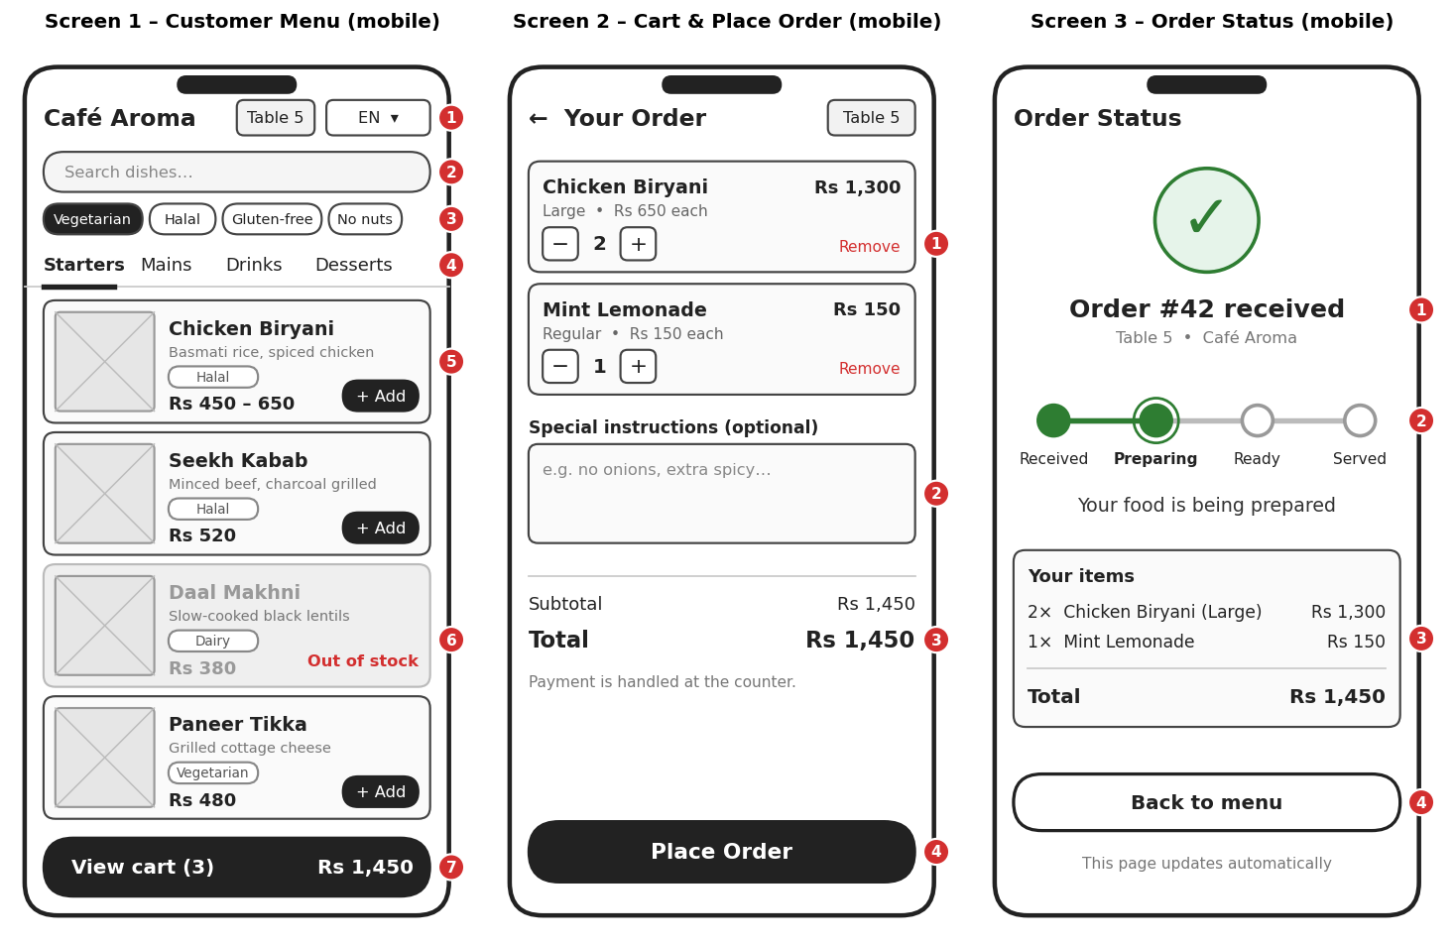
Figure 2: Customer wireframes (files: QuickMenuQR_Wireframe_1, 2, 3)

Screen 1: Customer Menu
# | Element | Behavior | Req.
1 | Language selector | Opens the language list; menu text switches and the choice is remembered for the session | FR-20, FR-21, UC-07
2 | Search box | Filters items by name as the customer types | FR-19
3 | Dietary and allergen chips | Tap to include or exclude; selected chip is filled dark | FR-22, UC-08
4 | Category tabs | Sticky tabs; tapping scrolls to the category | FR-18
5 | Item card | Photo, name, short description, dietary tag, price (range if variants), and the + Add button (variants are chosen in a small sheet) | FR-18, UC-06
6 | Out-of-stock card | Greyed out with a red "Out of stock" label; no Add button | FR-11, FR-27
7 | Sticky cart bar | Shows item count and total; opens the cart | FR-23, FR-25

Screen 2: Cart & Place Order
# | Element | Behavior | Req.
1 | Line items with quantity stepper | Change quantity with − and +, or remove an item | FR-24
2 | Special instructions | Optional free text for the kitchen | FR-24
3 | Totals | Subtotal and total calculated from current prices | FR-25
4 | Place Order button | Sends the order with an idempotency key; shows an inline message if an item became unavailable and asks the customer to confirm again | FR-26, FR-27, FR-28, UC-09

Screen 3: Order Status
# | Element | Behavior | Req.
1 | Confirmation and order number | Confirms the order was saved; the number matches what the kitchen sees | FR-28
2 | Progress tracker | Received, Preparing, Ready, Served; updates live over WebSocket | FR-29, UC-10
3 | Items summary | Read-only list and total | FR-28
4 | Back to menu | Returns to Screen 1 to order more | FR-17

4.5 Screen 4: Owner Menu Builder
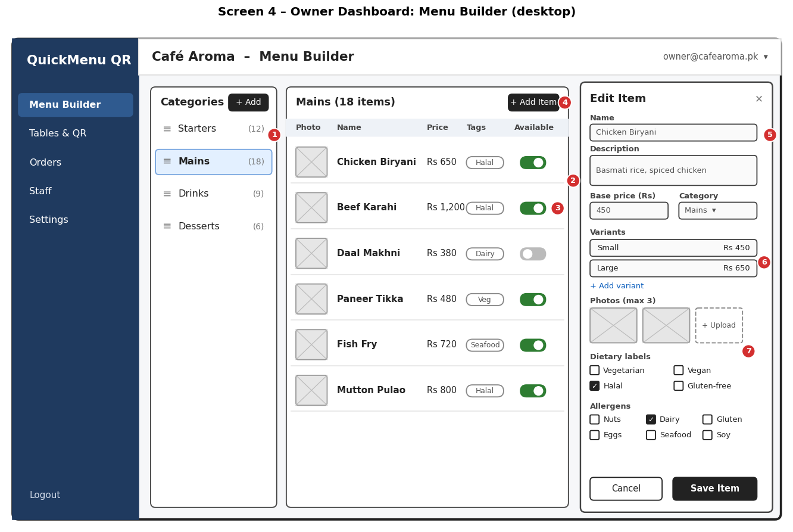
# | Element | Behavior | Req.
1 | Category list | Add, rename, hide, drag to reorder; counts per category; delete warns if items exist | FR-06, FR-13, UC-02
2 | Items table | Photo, name, price, tags, and availability for the selected category | FR-07, UC-03
3 | Availability toggle | One-click in stock or out of stock | FR-11, UC-04
4 | Add Item button | Opens the edit drawer with an empty form | FR-07
5 | Edit drawer | Name, description, price, category, dietary labels, allergens; Save validates and stores | FR-07, FR-10, FR-12
6 | Variants | Add or edit sizes and their prices | FR-08
7 | Photos | Up to 3 images uploaded directly to Cloudinary | FR-09

4.6 Screen 5: Tables & QR Codes
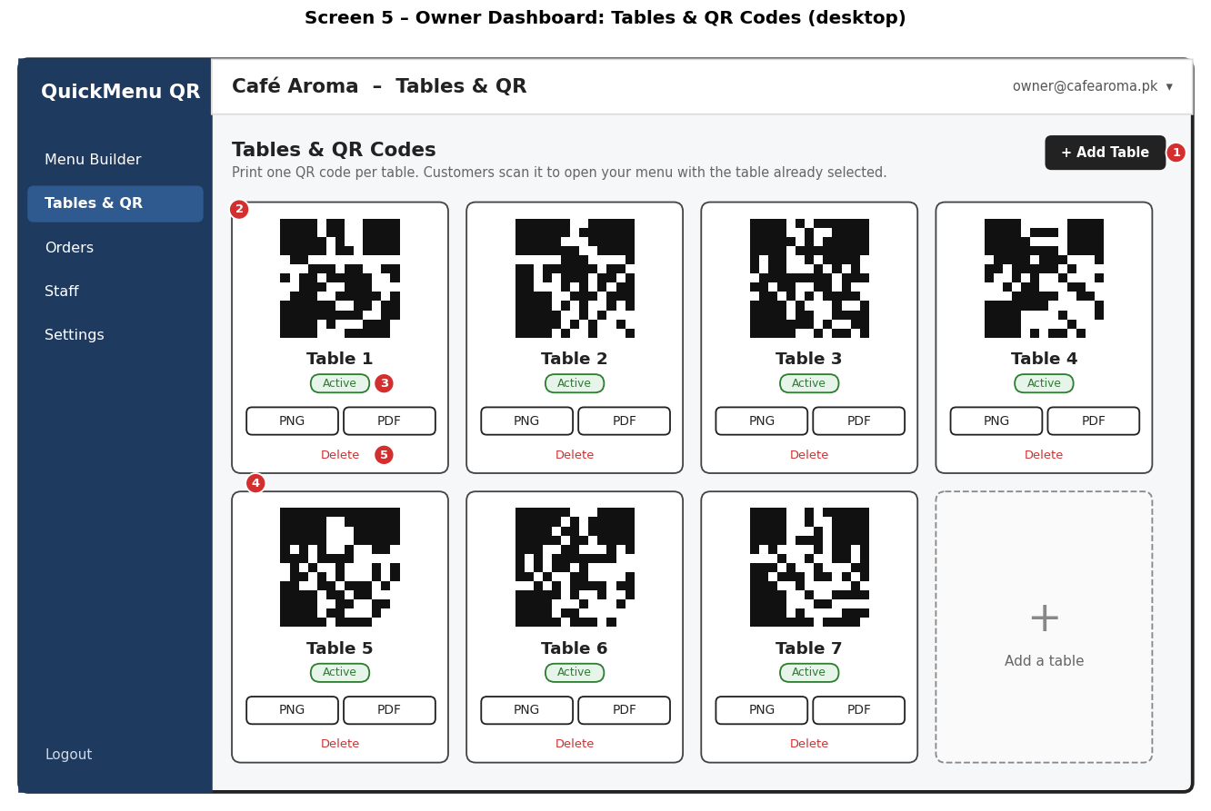
# | Element | Behavior | Req.
1 | Add Table | Creates a table and generates its unique QR token | FR-14, UC-05
2 | QR preview | The exact code to print | FR-15
3 | Active status | Inactive tables stop accepting orders | FR-14
4 | PNG and PDF download | Printable QR codes | FR-16
5 | Delete | Asks for confirmation; blocked if the table has orders (deactivate instead) | FR-14

4.7 Screen 6: Kitchen Order Ticket Display
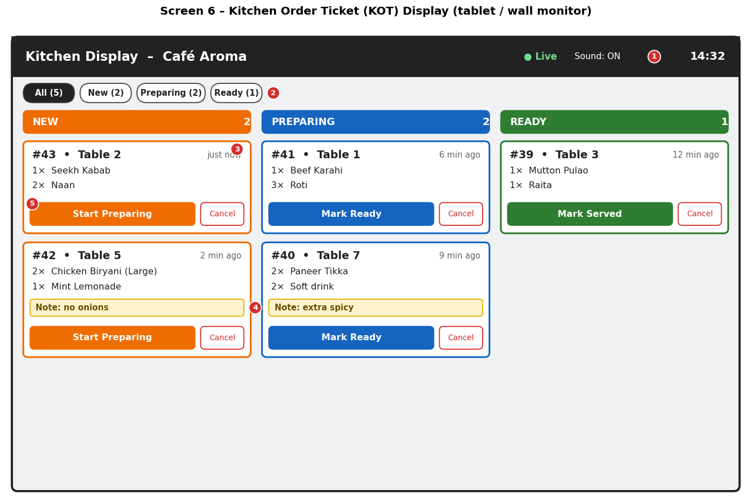
# | Element | Behavior | Req.
1 | Connection and sound indicator | "Live" shows the WebSocket is connected; turns red with a banner when offline and reconnects automatically | FR-32, FR-34, NFR-R3
2 | Status filter tabs | All, New, Preparing, Ready with counts | FR-30
3 | Order card | Order number, table, time since order, and items with quantities | FR-30, FR-31, UC-11
4 | Customer note highlight | Special instructions shown in a yellow box so they are not missed | FR-31
5 | Status action button | One tap moves the order to the next status; Cancel asks for confirmation | FR-33, UC-12

4.8 Responsive and accessibility notes
- Customer screens scale from 320 px to 1280 px wide (NFR-C3); on large screens the menu is centered in a 480 px column.
- The owner dashboard collapses its side navigation into a menu button below 900 px and the edit drawer becomes a full-screen page.
- The KOT screen uses a three-column layout on tablets and wall monitors, and a single scrolling column on narrow screens.
- Colors are never the only signal: status columns also carry text labels.
- Right-to-left support (Urdu, Arabic) mirrors the layout of the customer screens; this is verified during the language test in the build phase.

5. Traceability
Screen | Use cases | API endpoints | Tables read or written
1 Customer Menu | UC-06, UC-07, UC-08 | GET /public/menu/{qrToken}, GET /public/languages | restaurant_tables, categories, menu_items, item_variants, item_images, translations
2 Cart & Place Order | UC-09 | POST /public/orders | orders, order_items, order_status_history, restaurants (counter)
3 Order Status | UC-10 | GET /public/orders/{id}, WebSocket order:status | orders, order_status_history
4 Menu Builder | UC-01 to UC-04 | /categories, /items, /variants, /media/upload-signature, /items/{id}/images | categories, menu_items, item_variants, item_images
5 Tables & QR | UC-05 | /tables, /tables/{id}/qr | restaurant_tables
6 Kitchen Display | UC-11, UC-12 | GET /orders, PATCH /orders/{id}/status, WebSocket order:new, kot:sync | orders, order_items, order_status_history

SRS requirement group | Covered by
FR-01 to FR-05 (accounts) | /auth/*, /staff, /me; tables users, password_reset_tokens
FR-06 to FR-13 (menu) | /categories, /items, /variants, images; Screen 4
FR-14 to FR-16 (QR) | /tables; Screen 5
FR-17 to FR-22 (browse) | /public/menu; Screen 1
FR-23 to FR-29 (order) | /public/orders; Screens 2 and 3
FR-30 to FR-34 (kitchen) | /orders, WebSocket; Screen 6
FR-35 (history) | GET /orders?from=&to=; index ix_orders_history
NFR-P2, NFR-P3 | Indexes in 2.7, partial index for active orders
NFR-R4, NFR-R5 | Transactional order insert, client_request_id and Idempotency-Key
NFR-S2 to S8 | bcrypt, lockout columns, JWT expiry, hashed tokens, rate limits, tenant filtering

6. Decisions, Risks, and Next Steps

6.1 Decisions
# | Decision | Rationale
DD-1 | UUID primary keys | Not guessable, safe in URLs, no clashes across environments
DD-2 | restaurant_id on every business table | Simple, fast tenant isolation
DD-3 | Tags and allergens as text[] with GIN indexes | Fast filtering with a simple model; can be normalized later
DD-4 | Price and name snapshots in order_items | Past orders never change
DD-5 | Unique client_request_id plus Idempotency-Key | No duplicate orders on network retries
DD-6 | Partial index for active orders | Kitchen query stays fast as history grows
DD-7 | Tracking token per order | Customers can follow their own order without an account and cannot see others
DD-8 | REST plus WebSocket, not GraphQL | Simpler, cacheable, fits the screens
DD-9 | Translation cache keyed by source hash | Edited text is re-translated automatically

6.2 Risks
Risk | Impact | Mitigation
Schema changes after the build starts | Rework | Versioned migrations; schema reviewed with the advisor now
Wireframes differ from final visual design | Rework | Wireframes fix layout and behavior only; styling follows in the build phase
Array columns limit custom tags | Limited flexibility | Documented migration path to tags and item_tags tables
Translation of long menus is slow on first load | Slow first view | Cache by language; translate in the background after the owner saves the menu
Order counter contention on busy restaurants | Slower orders | Single-row increment inside the order transaction is fast at this scale; revisit with a sequence per restaurant if needed

6.3 Next steps (Week 5 onward)
- Set up the Git repository, Node.js and Next.js project skeletons, and the CI pipeline.
- Create the migration files from the DDL and a seed script.
- Implement authentication (register, login, refresh, lockout) and the first protected endpoints.
- Begin the owner dashboard: categories and items (Screen 4).
- Export the endpoint catalogue as an OpenAPI 3 file.
End of Document

