**PLANNED LEAVE PROCESS**

Employee decides to apply for a leave

Check leave balance and eligibility for leave on S drive or with HR

Check the Holiday Schedule to ensure your leave does not conflict with others in your team

Complete the leave form and e­ mail it to your Line Manager (copy HR) with the following notice time: (1) 2 weeks for 1-5 days holiday (2) 1 month for 6-10 days holiday (3) 2 month for more than 10 days

Line Manager responds to leave request within 3 working days

Line Manager submits to Partner/ Practice

Leader for request

to deny leave with reasons

**Partner/ Practice**

**Leader Approves**

Line Manager e­ mails employee with reasons for deniel

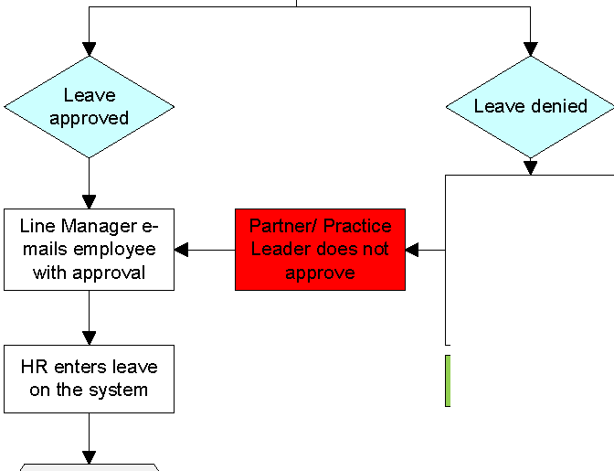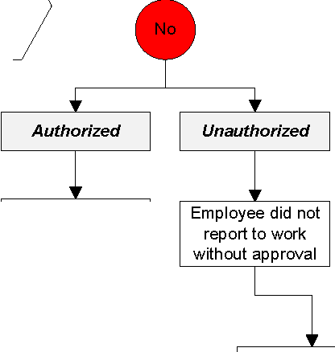

Prepare handover sheet



Employee preparations before going on leave

Set up auto-reply email and call diverts

Provide HR & Line Manager with contact details while on leave

Employee returns back from leave as scheduled

Employee receives back the handover sheet with the replacement's comments on the progress of work

Submit to

Line Manager

&

replacement

Employee sent an e-mail to the Line Manager and the Line Manager approved leave extension

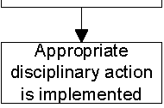

HR Investigates