|  |  |  |  |  |  |  |  |  |  |  |
| --- | --- | --- | --- | --- | --- | --- | --- | --- | --- | --- |
|  | | **COMSATS University Islamabad, Wah Campus**  **Terminal Examinations (Spring 2020)** | | | | | | | | |
|  | | | Department of: | | **Computer Science** | | | | |  |
|  | | |  | |  | | | | |  |
| Class/Program: | | | **BS(SE)-6A,6B7A,7B** | | Date: | **August 18, 2020 (09:00 AM)** | | | | |
| Subject: | **Software Engineering Economics** | | | | Instructor: | | **RIAZ AHMAD** | | | |
| Total Time Allowed: | | | | **3 hours** | Maximum Marks: | | | | **60** | |
| Student Name: | | | Muhammad Mughees khan | | Registration #: | | | SP17-BSE-021 | | |
|  | | |  | |  | | |  | | |

**Note: Try to attempt all questions on question paper. Only handwritten Answer Sheet will be accepted.**

**Instructions for Final Exam SP2020**

**Read First**

**Dear Students,**

**The following instruction MUST be followed in Online Final Exam SP2020, (PLEASE READ CAREFULLY).**

1. **Solve all questions on A4 Blank sheets in SAME ORDER as given in question paper (COMPUTER TYPED SOLUTION WILL NOT BE ACCEPTABLE).**
2. **Write down Serial No., Reg No. and Student Name clearly on every sheet’s top right: for example in short as 1. FA18-BBA-786 Student Name respectively.**
3. **Make single PDF file of your answer sheet and rename containing Serial No., Reg No. & Student Name for example as: 1. FA18-BBA-786 Student Name (Copy the highlighted text as file name and change accordingly).**
4. **Upload the file “1. FA18-BBA-786 Student Name.pdf” at Cu-Online (assignment section) within given time on your question paper.**
5. **Each and every question is self-explanatory, so please read all question carefully and give answers as required.**
6. **The actual time of paper will be 3 hours but I will give 5 hours (2 hours extra for uploading), so no excuse will be accepted about uploading, hence manage your time and resolve your issues before exam accordingly.**

**Question-1**: Marks 5

| Project | | | | | | |
| --- | --- | --- | --- | --- | --- | --- |
| Time: | 0 | 1 | 2 | 3 | 4 | 5 |
| Cash flow | -Rs.11,600 | Rs.3,410 | Rs.4,300 | Rs.1,640 | Rs.0 | Rs.1,120 |

a. Compute the payback statistic for Project if the appropriate cost of capital is 12% and the maximum allowable payback period is three years.

b. Should the project be accepted or rejected?

**ANSWER**

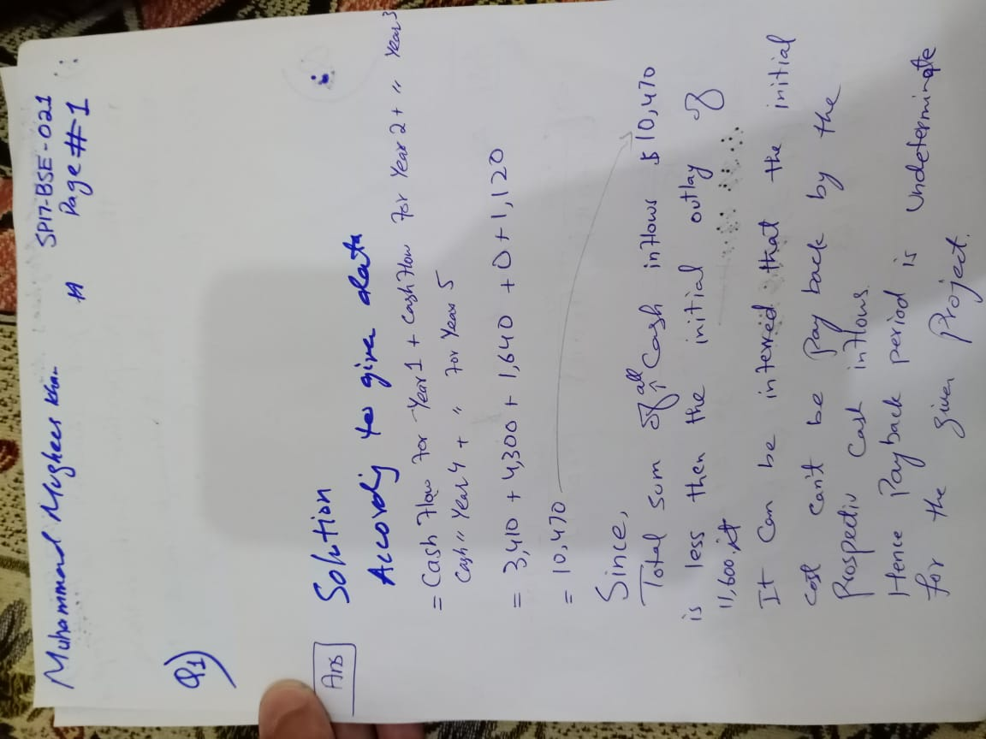

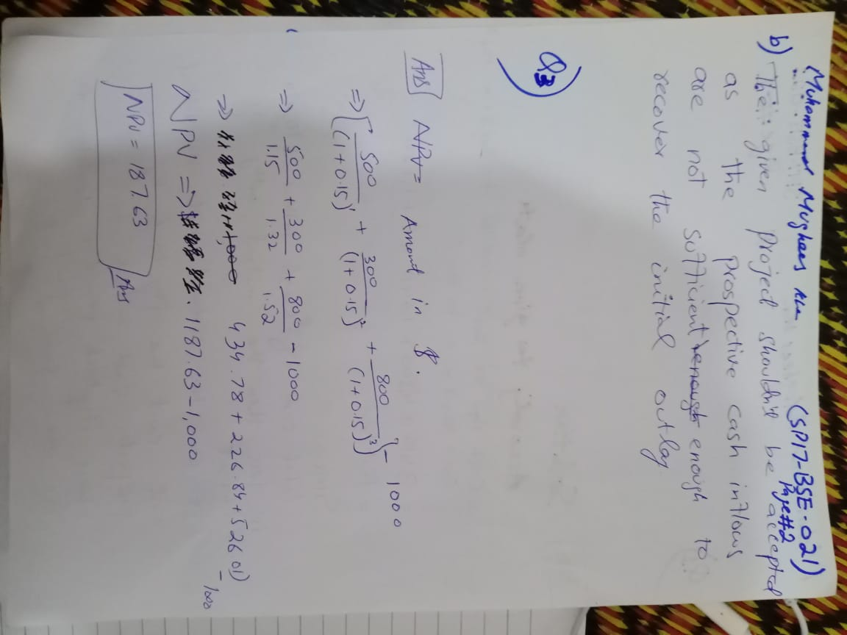

**Question-2**: Calculate Present Value (PV) and Future Value (FV) for given scenarios?

a) Mr. Afzal invests Rs.5,000 for five years with an interest rate of 15%. Marks 5

(b) Mr. Babar invests Rs.1,000 for five years with an interest rate of 10%. This time, it’s compounded annually. What will be the **future value**?

(c) Mr. Rashid promises you Rs.900 in 3 years, what is the **Present Value**?

(d) You are promised Rs.800 in 15 years’ time. What is its **Present Value** at an interest rate of 16%?

(e)  If you deposit Rs.4000 into an account paying 15% annual interest compounded quarterly, how much money will be in the account after 5 years?

(f) If you deposit Rs.6500 into an account paying 18% annual interest compounded monthly, how much money will be in the account after 15 years?

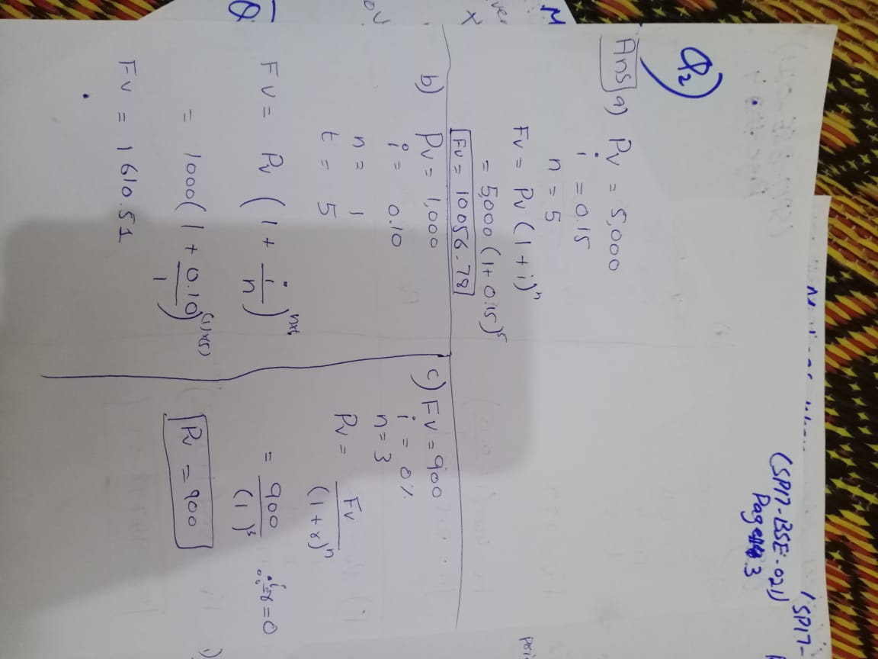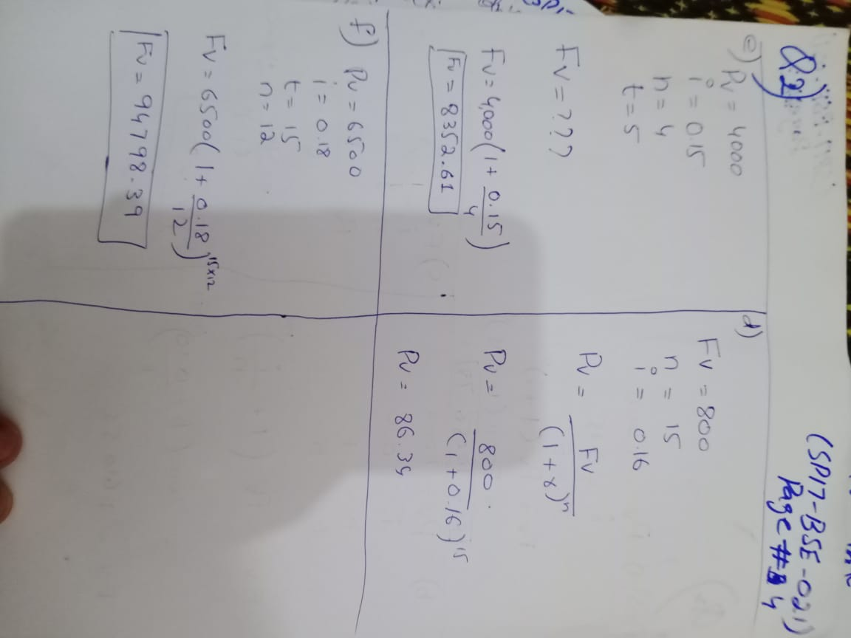

**Question-3**: A project that costs Rs.1,000 and will provide three cash flows of Rs.500, Rs.300, and Rs.800 over the next three years. Assume there is no salvage value at the end of the project and the required rate of return is 15%. The **NPV** of the project is calculated as follows: Marks 5



**Question-4**: you own a toy shop and want to figure out your break-even point in units. You know your fixed costs per month, variable costs, and sales per toy. Marks 5

To figure out how many toys you need to sell to break even (What is the break-even point in units?)

Date available Fixed Costs = Rs.4,500, Variable Costs = Rs.10, Sales Per Toy = Rs.20

**Question-5:**. What is the break-even point in sales? Marks 5

Available data: Fixed Costs = Rs.4,500, Variable Costs = Rs.10, Sales per toy = Rs.20

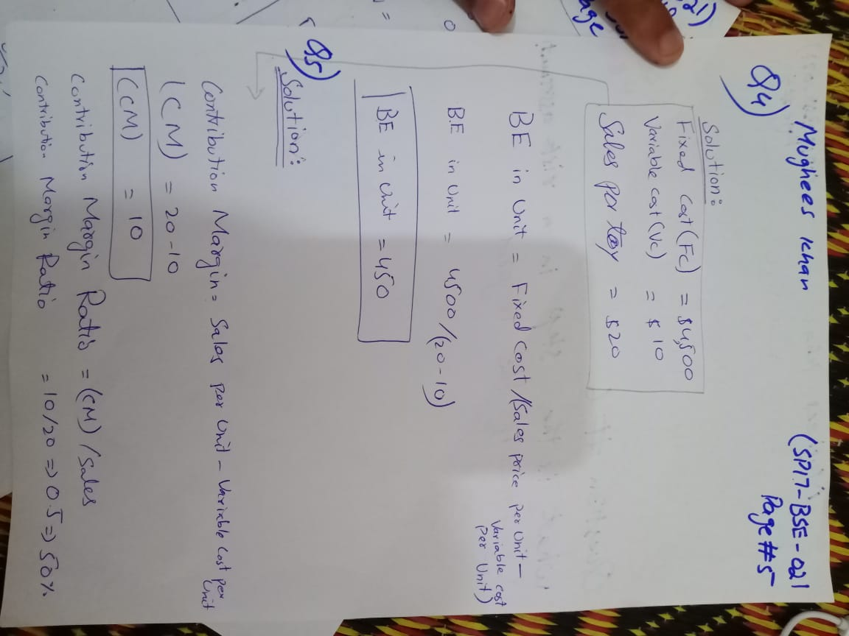

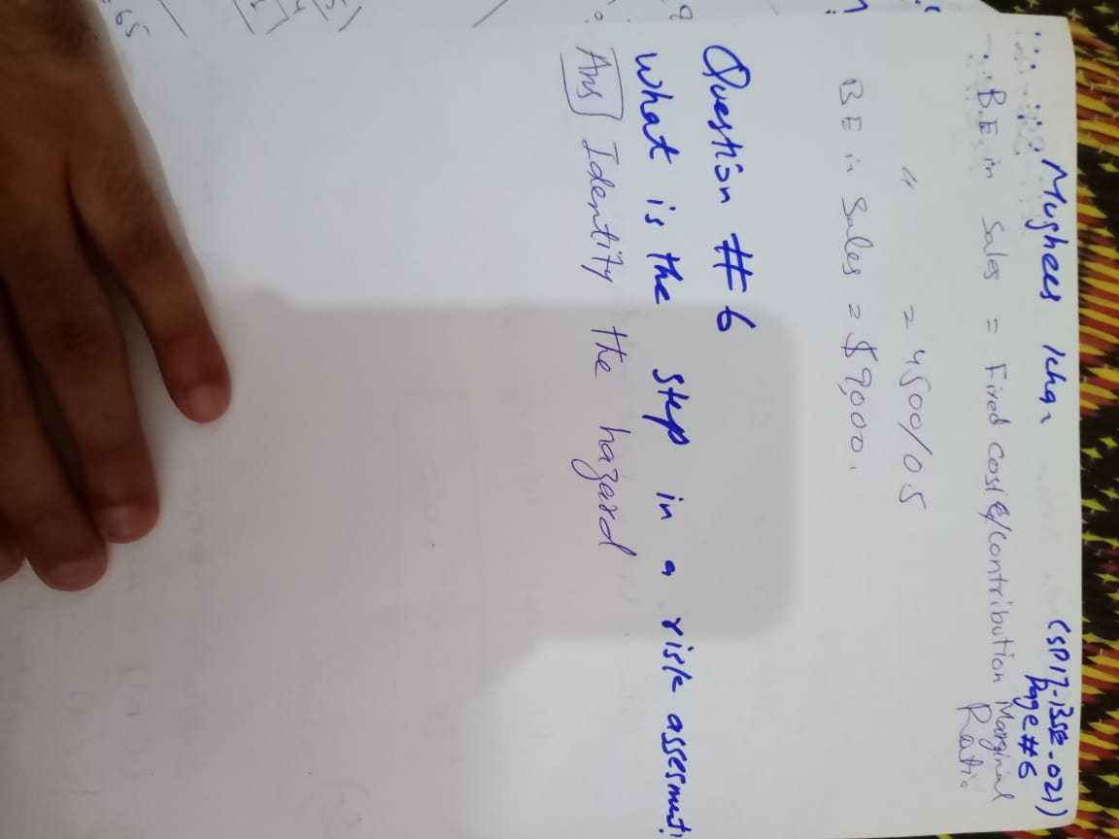

**Question-6:** Choose the right option? Marks 1

1. What is the first step in a risk assessment?

Record your finding

Evaluate the risk

Identify the hazards

Decide who may be harmed?



**Question-7:** Consider the following Network Diagram to solve this question Marks 10

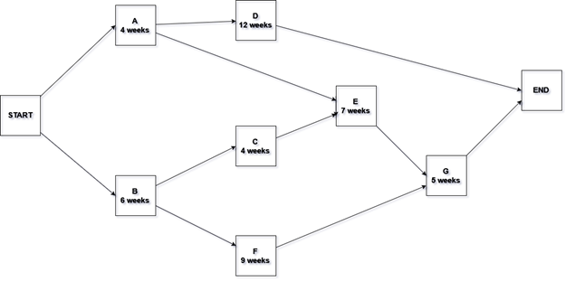1 : Calculate the total number of paths and their duration.

2 : Indicate the Critical Path

3 : Perform Forward Pass on Critical Path

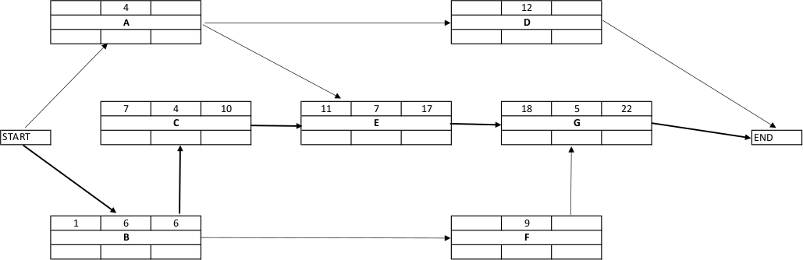

Note: Fill the above diagram

4 : Perform Backward Pass on Critical Path

5 : Calculate Total Float

6: Calculate Free Float

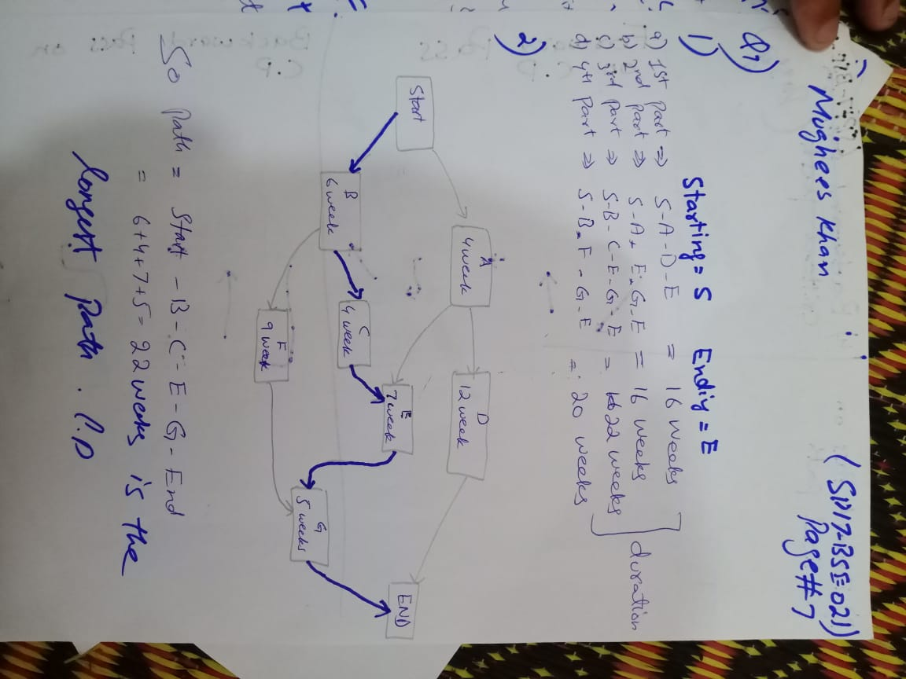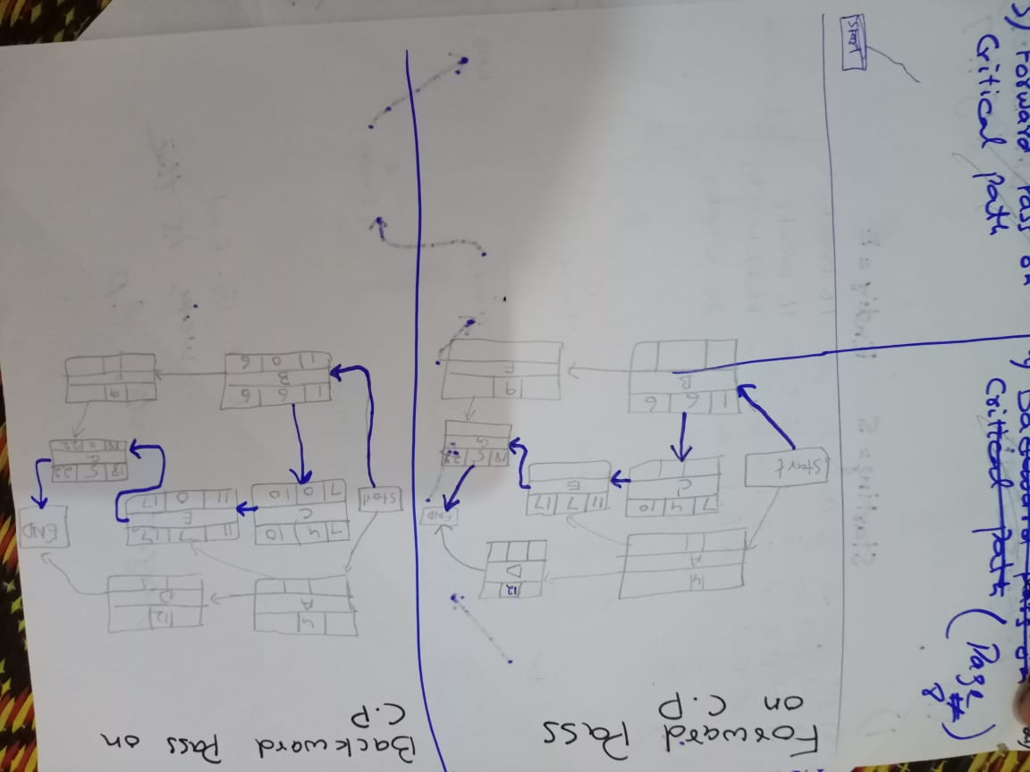

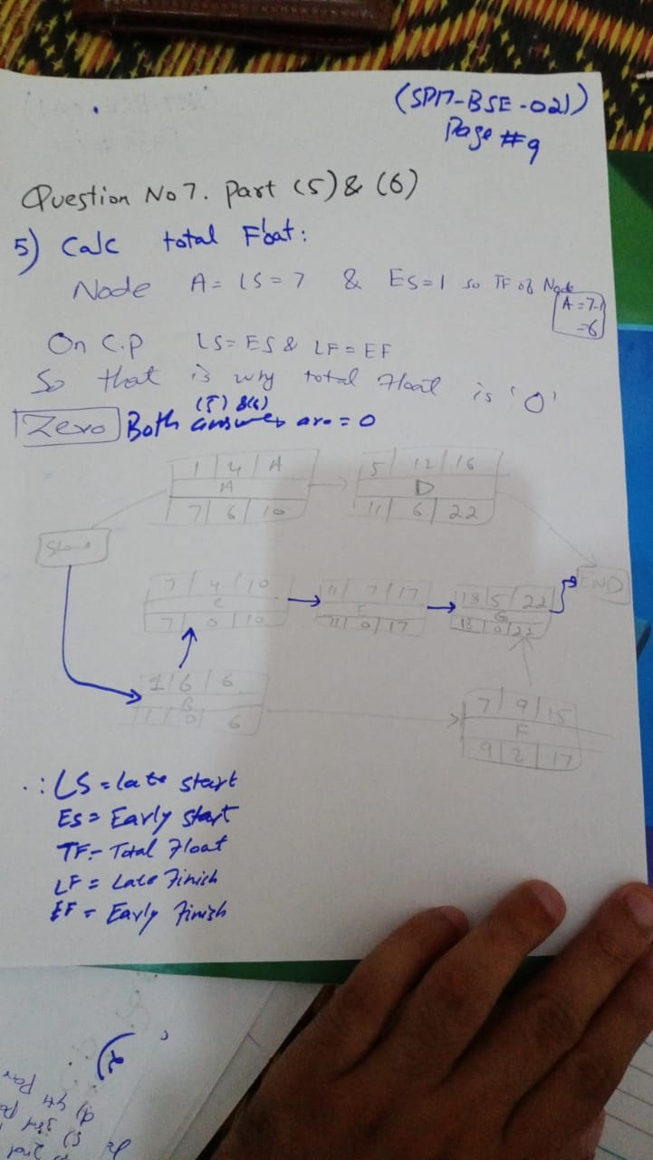

**Question-8:** Calculate mean and variance using figure (1) and what 47 indicate in figure (2) Marks 4

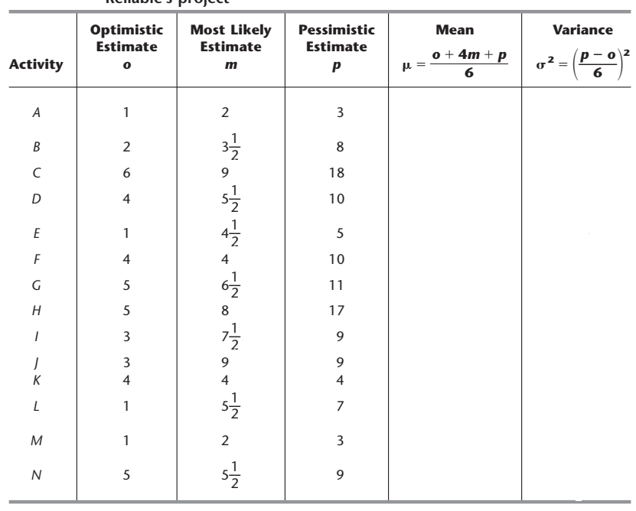

**Figure (1)**

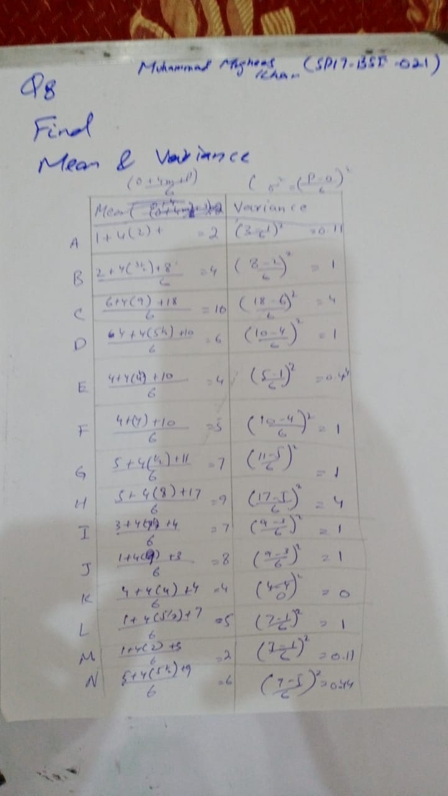

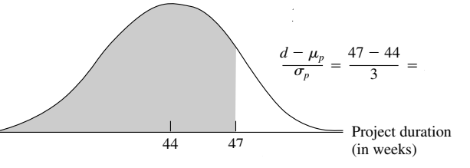

**Figure (2)**

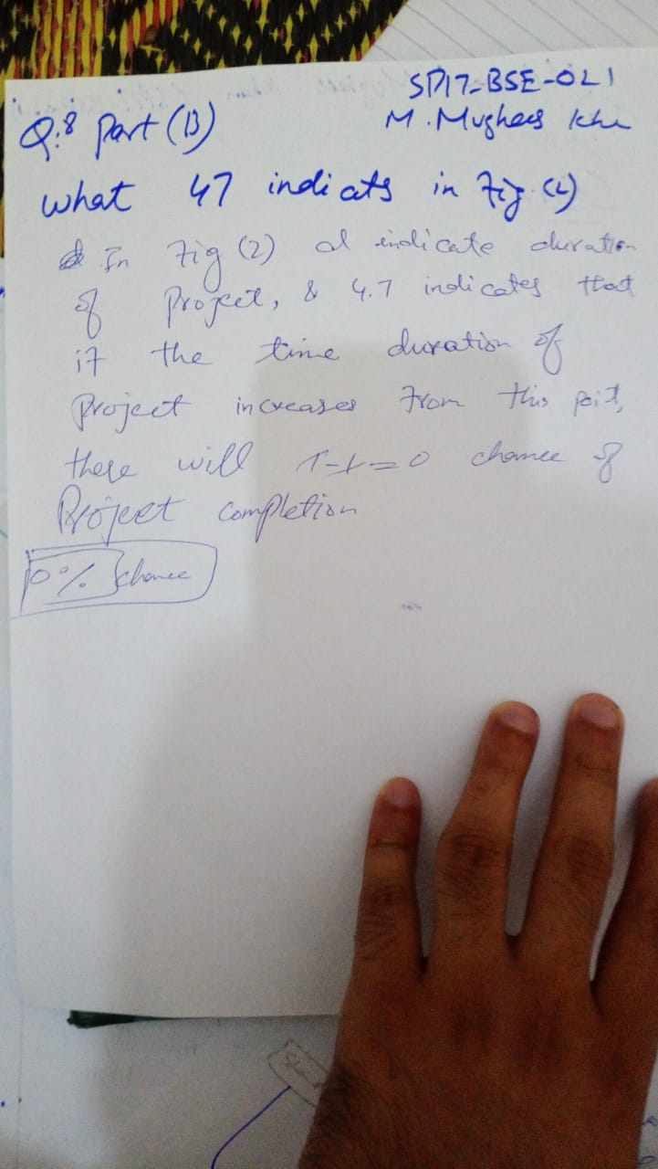

**Question 9-:** Summarize the CoBRA model? How it could be effective to assess the cost estimates of a software project? Write benefits of using for your organization? Marks 5

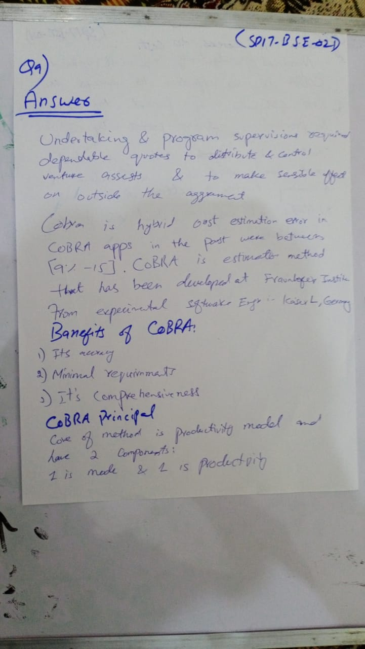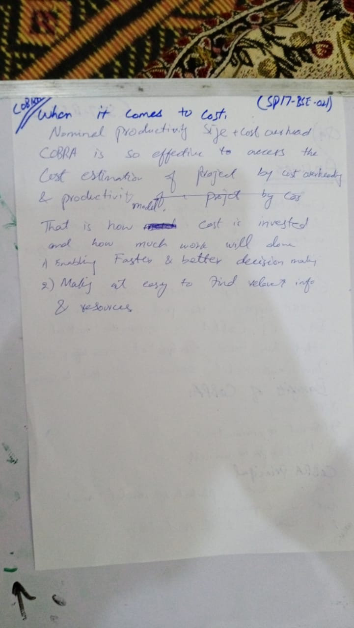

**Question-10:** What is Bayesian Calibration? In which circumstances this tool could be more effective to use? Provide at least two different scenarios? Marks 5

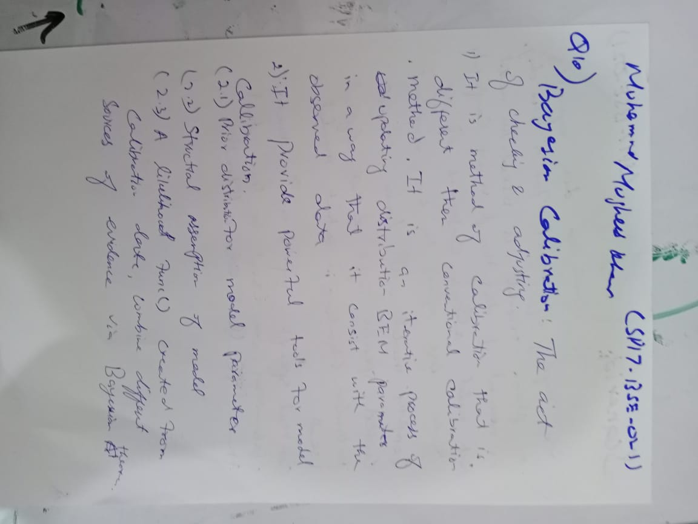

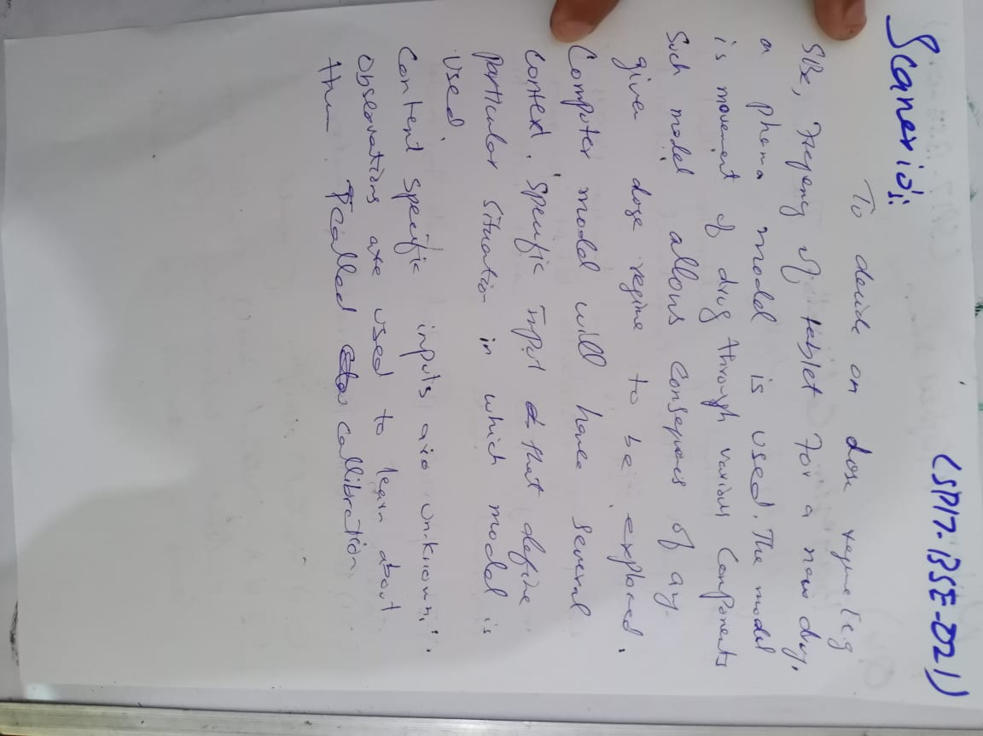

**Question-11:** Differentiate between model parameter and hyper model parameter give three examples for each to clear the concept? Marks 5

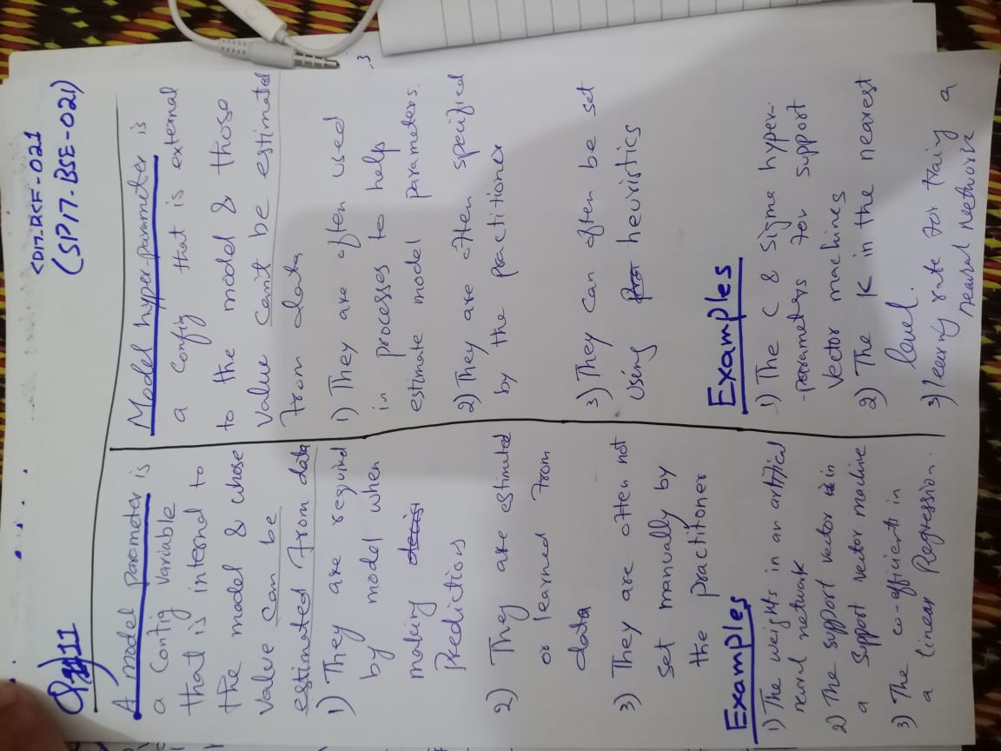

**Question-12:** Write the practical application of regression trees, and give a clear concept of gini coefficient, bootstrapping, random forest regression? these concepts overcome the drawbacks of which problem? Marks 5

