**Triangular Distribution**

In [probability theory](https://en.wikipedia.org/wiki/Probability_theory) and [statistics](https://en.wikipedia.org/wiki/Statistics), the triangular distribution is a continuous [probability distribution](https://en.wikipedia.org/wiki/Probability_distribution) with lower limit a, upper limit b and mode c (peak value), where a < b and a ≤ c ≤ b.

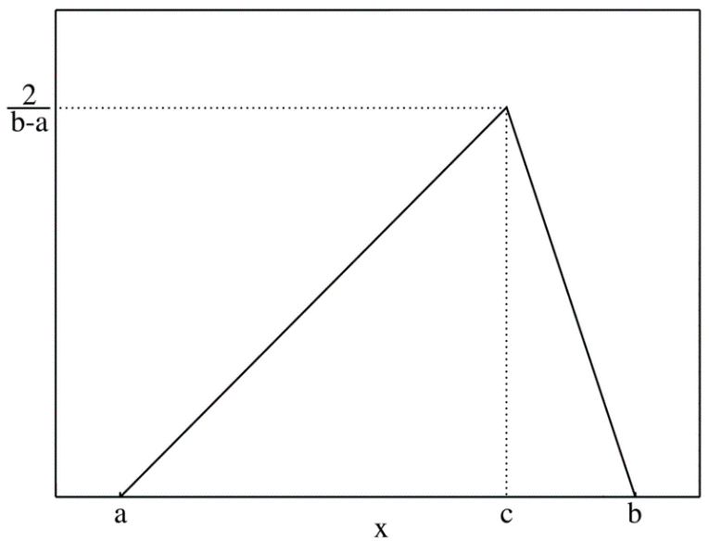

The triangular distribution, along with the [PERT distribution](https://en.wikipedia.org/wiki/PERT_distribution), is also widely used in [project management](https://en.wikipedia.org/wiki/Project_management) (as an input into [PERT](https://en.wikipedia.org/wiki/PERT) and hence [critical path method](https://en.wikipedia.org/wiki/Critical_path_method) (CPM)) to model events which take place within an interval defined by a minimum and maximum value. The symmetric triangular distribution on [a,b] is implemented in the [Wolfram Language](https://www.wolfram.com/language/) as [Triangular Distribution](https://reference.wolfram.com/language/ref/TriangularDistribution.html)[a, b], and the triangular distribution on [a,b] with mode c as [Triangular Distribution](https://reference.wolfram.com/language/ref/TriangularDistribution.html)[a, b, c].

The [mean](https://mathworld.wolfram.com/Mean.html) is

|  |
| --- |
| mu=1/3(a+b+c),  1=1/2( b-a) h  =1/2(9-1)h  1=4h  ¼=h |

m=y2-y1/x2-x1

A=1/2 (b*h)

F(x)= 2(x-a)/(b-a) (c-a)

F(X)=2(B-X)/(B-A)(B-C)

P(x<3)= 2(3-1)/(5-1)(4-1) =1/3

P(X>4.5)=2(5-4.5)/(5-1)(5-4)=1/4