**COMSATS University Islamabad, Wah Campus**

**Assignment 2**

Department of Computer Science

|  |  |
| --- | --- |
| Program/Class:__BSE-7___________________ | Date: ___02/7/2020___________________________ |
| Subject::**SOFTWARE DESIGN AND ARCHITECTURE** | Instructor: _Ms, SAMIA ISHTIAQ______________ |
| Submission date: ____06/7/2020____________ | Maximum Marks: ___20_______________________ |
| Student_Name:_M.Mughees khan____________ | Registration#: _SP17-BSE-021_________ |

Q1. Design the architecture of bank transaction batch processing software based on batch sequential architecture (other than discussed in book). Also explain your scenario along with diagram. (10)

**Answer:** We have used the batch sequential architecture; a transformation subsystem or module cannot start its process until the previous module completes its computation​.

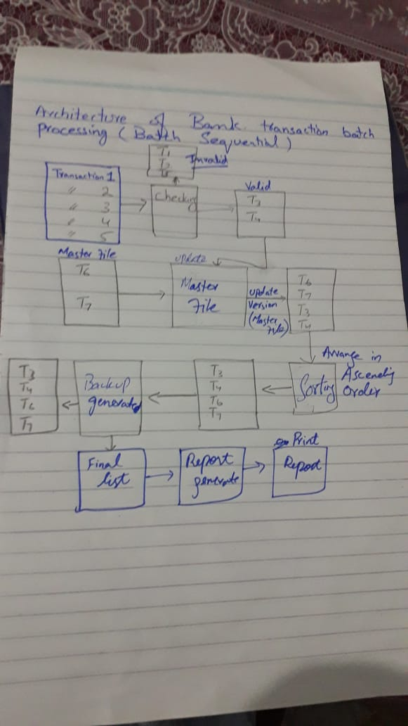

In the above diagram we have design Batch Sequential Architecture, by using that we have design architecture of Bank Transaction Batch Process. First we get Transaction as input into our architecture and on those transactions we have applied Check method which will check each transaction and identify them which of transaction is valid. The valid transactions will be input of next master file. On master file it will merge or update the file by combining the transactions which were in master file and which were valid transactions. After that all these transactions will get sort by Sorting algorithm and all transactions will get sort. In next step backup file will be created so if our batch failed we will able to restart by using backup file. In last final list will be generated and Report will be provided of that list.

Q2. Apply the data flow architecture style to the applicable domains in the university admission processing system which covers application checking and validation per university-wide and department wide requirements, finance requirements, additional information inquiry, decision notification, and other admission processing (10)

**Answer:** Below is Pipe and filter Architecture Diagram of University Admission Process.

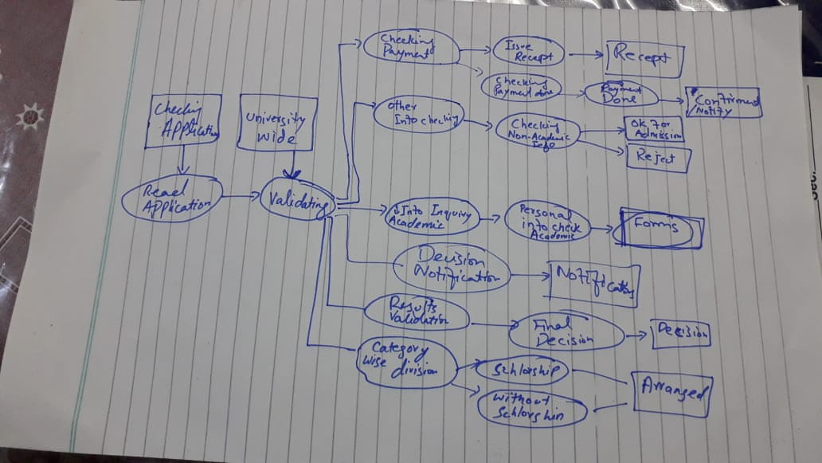

In diagram we have design architecture of Admission Process by using Data flow Pipe and filter. Here Application will be submitted and Validation rules will be applied on it by University wide, after passing through Validation process next it will perform different process. It will check Payment of the application of person, whether it has been paid or not and if not notification will be provided. Next all the information on application will be check, whether it is Academic or non-academic and provide 2 result like rejection or acceptance of the application. In info inquiry Personal information’s will be Check and provide result if it is entered correctly or not. More in that, Grades and result will be check so it is eligible or not and on that decision will be made and notify by Decision notification. In last Category wise division will be made on the bases of scholarship and without scholarship and arranged them accordingly.