

**COMSATS Institute of Information Technology,**

**Park Road, Chak Shahzad, Islamabad Pakistan**

**System Design Document**

**for**

**Biometric Authentication by Iris Recognition**

***By***

**Ehsan Aslam Fa11-bcs-050**

**Danish Ali Fa11-bcs-047**

**Anwar-ul-Haq Fa11-bcs-032**

**Abdul Muqtadir Maaz Fa11-bcs-009**

***Supervisor*Dr. Zafar Iqbal**

***Bachelor of Science in Computer Science (2011-2015)***

**The candidate confirms that the work submitted is their own and appropriate  
 credit has been given where reference has been made to the work of others**.



**COMSATS Institute of Information Technology,**

**Park Road, Chak Shahzad, Islamabad Pakistan**

**Biometric Authentication by Iris Scanning**

**A project presented to**

**COMSATS Institute of Information Technology, Islamabad**

**In partial fulfillment**

**of the requirement for the degree of**

***Bachelors of Science in Computer Science (2011-2015)***

**By**

**Ehsan Aslam Fa11-bcs-050**

**Danish Ali Fa11-bcs-047**

**Anwar-ul-Haq Fa11-bcs-032**

**Abdul Muqtadir Maaz Fa11-bcs-009**

**DECLARATION**

We hereby declare that this software, not all some part of this will be developed with the help of content present on the internet. Proper referencing will be done in case of copy paste. No portion of the work presented has been submitted of any other application e.g., to obtain any other degree or qualification of this or any other university or institute of learning.

Ehsan Aslam Danish Ali

--------------------------- ---------------------------

Anwar-ul-Haq Abdul Muqtadir Maaz

--------------------------- ---------------------------

**CERTIFICATE OF APPROVAL**

It is to certify that the final year project of BS (CS) “Biometric Authentication by Iris Recognition” was developed by “**Ehsan Aslam (Fa11-bcs-050), Danish Ali (Fa11-bcs-047), Anwar-ul-Haq (Fa11-bcs-032) and Abdul Muqtadir Maaz (Fa11-bcs-009)** ” under the supervision of “**Dr. Zafar Iqbal**” and co supervisor “**Mr. Umair Naru** ” and that in their opinion; it is fully adequate, in scope and quality for the degree of Bachelors of Science in Computer Sciences.

---------------------------------------

**Supervisor**

---------------------------------------

**External Examiner**

---------------------------------------

**Head of Department**

**(Department of Computer Science)**

**Executive Summary**

Today need of security is increasing day by day because of this, new authentication systems are required which are fast, reliable and inexpensive. There are many biometric authentication systems available in the market like finger print scanner, voice recognition, face detection and many more. All of them have some flaws e.g. in finger print first they are no 100% accurate it does not detect the pattern first time and people who are doing physical labor ,their fingers pattern erased due to extensive using of hands. In voice recognition it’s difficult to get success in authentication first time because of background noises or somebody can play the recorded voice and can steal your identity. In face detection you can show the picture of the owner to get access so this can also be breach able.

The most common solution to above problem now days are finger print scanner but there have been serious limitations in it explored recently so new biometric authentication system is need of the hour. There is new biometric system using the part of the eye called “Iris”. This is fairly new technology as compared to others. The accuracy of this system is virtually 100%.Iris is so unique It's estimated the chance of two iris (irises) being identical is 1 in 1072 i.e. virtually zero; where in fingerprints scenario, this is 1 in 64*109. It also convenient in use we could perform iris scanning without requiring a physical contact, and possibility of iris scanning by walk-in cameras, open fresh opportunities in this emerging concept. One of the disadvantages with iris recognition technology, being that it is a relatively new technology, is that the equipment is very expansive (it could cost almost as much as five times the cost of fingerprint scanning).

In short, the Iris Recognition system will facilitate users with comparatively more comfortable, very reliable, and time saving (Authentication result will be very quick) as compared to other biometric authentication system.

**Acknowledgements**

All praise is to Almighty Allah who bestowed upon us a minute portion of His boundless knowledge by virtue of which we were able to accomplish this challenging task.

We are greatly indebted to our project supervisor “**Dr. Zafar Iqbal**” and co supervisor “Mr. Umair Naru”. Without their personal supervision, advice and valuable guidance, completion of this project would have been doubtful. We are deeply indebted to them for their encouragement and continual help during this work. We also very thank full to our all teachers, without them we could not have achieve this milestone. Finally, we wish to thanks our parents for their support and encouragement throughout our studies.

Student Name 1 Student Name 2

--------------------------- ---------------------------

Student Name 3 Student Name 4

--------------------------- ---------------------------

**Abbreviations**

|  |  |
| --- | --- |
| **SRS** | Software Require Specification |
| **PC** | Personal Computer |
| SDD | Software Design Document |
| ERD | Entity Relation Diagram |
| Iris | The colored, muscular ring around the pupil of the eye |

**Table of Contents**

**Introduction 11**

1.1 Brief 11

1.2 Relevance to Course Modules 11

1.3 Porject Background 11

1.4 Literature Review 12

1.5 Methodology and Software Life Cycle 13

**Problem Definition** 16

2.1 Problem statment 16

2.1.2 Prooblem solution 16

2.2 Project Deliverables 16

2.3 Current System 16

**Requirement Analysis** 19

3.1 Use case Diagram 19

3.1 Use Cases Discriptions 20

3.2 Functional Requirments 24

3.3 Non – Functional Requirments 25

3.3.1 Usability 25

3.3.2 Reliability 25

3.3.3 Performance 25

3.3.4 Supportability 26

3.3.5 Design Constraints 26

3.3.6 Licensing Requirements 26

**The Design** 27

4.1 System Architecture 27

4.2 Entity Relationship diagram 28

4.3 UML Behavioral Diagrams 29

4.3.1 Activity Diagrams 29

4.4 UML Interaction Diagrams 31

4.4.1 Sequence Diagrams 31

4.5 Data Flow diagram 35

**References** 36

# Chapter 1: Introduction

Our project is a biometric identification and authentication system that will identify and authenticate the targeted entry by performing scanning of the iris muscle. A brief overview of this system is described in this section.

# Brief

The purpose of the project is to overcome the security concerns of the society by developing a fool proof human identification and authentication system. Iris muscle is a well-protected internal organ and contains unique and structurally distinct patterns, which allow us to perform biometric identification.Iris recognition systems are the most reliable biometric system since iris patterns are unique to each individual and do not change with time. In iris scanning there are above 200 patterns that’s why it’s more reliable as compared to the fingerprints scanning based identification systems. Similarly, physical touching is not required during iris scanning process, which eliminates the possibility of illness spreading from one person to the other, during the passive scale scanning like in public election etc. we hope that a reliable functional application will be the end product.

# Relevance to Course Modules

Our project will be based on a desktop application which will be developed using C#, which we have studied in Visual Programming course of our degree, Database for the project will be developed using the rules we have studied in the course of Database Management Systems, System diagrams are developed using the knowledge of software engineering studied in the courses of software engineering(I,II)and the design of our system will be based on the rules we have studied in the Human Compute Interaction course.

# Project Background

Due to the need of biometric authentication systems there is so much development going on in this field. Many new ideas are worked on. Most reliable biometric system of all is Iris recognition system its error is vertically zero. So this biometric authentication system will be based upon iris recognition using specialized camera. It will authenticate users without have physically contact with the device. Result will be very quick and it will easy to maintain.

# Literature Review

There are many biometric recognition systems. Finger print scanners are widely used as biometric authentication system. Iris recognition systems are fairly new idea but there are systems which are available in the market e.g.

Iris ID (formerly LG IRIS) was the first concern to license, produce and market a commercially viable iris recognition product - the LG Iris Access 2200. This revolutionary new system introduced in 1999 utilized conventional camera technology with advanced lens design and special optics to capture the intricate detail found in the iris. In 2001, the second generation LG Iris Access 3000 was introduced, providing a platform that incorporated more robust system security features, improved speed and enhanced user interface, while lowering both the cost per portal and overall cost of ownership. The main problem they are much expensive and are not as reliable as its need to be.

# Analysis from Literature Review (in the context of your project)

The notable advantage of iris biometric over other biometrics is that irises have enormous pattern

variability. According to John Daugman iris pattern conditional false reject probability is 109.6

That is one in 4 billion. A single iris scan can analyze more than 200 different points of the iris,

Such as furrows, corona, rings, freckles etc. Compared to other biometrics, such as voice and

Facial features that tend to change over time, iris biometric is stable and remains the same for a

Person’s lifetime. The use of contact lenses, glasses and even eye surgery cannot affect the iris

Characteristics.

# Methodology and Software Lifecycle for This Project

We will use Waterfall method for the development of this project. Following are the steps which will be followed by this method:

1. Requirements

2. Implementation

3. Testing

4. Integration, if there are multiple subsystems

5. Verification

6. Deployment

7. Maintenance

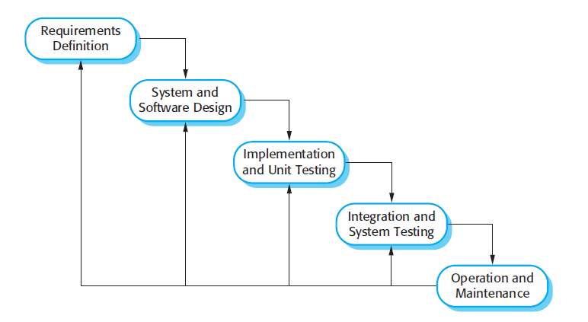

Figure 1 : Water Fall Process Model

**The Overall Working Hierarchy for every Module of the System**



Figure 2 : Working Hierarchy

* + 1. Rationale behind Selected Methodology

We use Water Fall process for the following reasons:

* All requirements are clearly defined
* Easy to use due to the rigidity of model
* Phases are processed and completed one at a time.
* Complexity

**Chapter 2: Problem Definition**

# Problem Statement

Fast emerging security situation is a serious concern for our society. Passwords can be guessed or hacked. In fingerprint scanning, only 60-70 points of reference are available so it’s not that reliable and manual labor normally deteriorates their physical composition, and therefore damages the causes of their identification. Scanned fingerprints can be exploited to fool the recognition system. Requirement of physical touching during fingerprints scanning is vulnerable toward health hazards. Similarly, the other identification methods such as recognition through speech do have many constraints and the fooling possibility is expected to be high. Therefore, a health secure and fool proof human identification system may be evaluated as a crying need of the time as per fast emerging security situation and to cater the health related issues.

## 2.1.2. Problem Solution

Iris muscle is a well-protected internal organ and contains unique and structurally distinct patterns, which allow us to perform biometric identification.Iris recognition systems are the most reliable biometric system since iris patterns are unique to each individual and do not change with time. In iris scanning there are above 200 patterns that’s why it’s more reliable as compared to the fingerprints scanning based identification systems. Similarly, physical touching is not required during iris scanning process, which eliminates the possibility of illness spreading from one person to the other, during the passive scale scanning like in public election etc.

# Deliverables and Development Requirements

The product functions are:

* **Acquire the image**

System shall be able to capture a high-resolution image of eye for iris recognition to include as many features as possible. The image shall be captured by iris scanner.

* **Extract the iris muscle part**

System shall identify the boundaries of iris and the pupil in captured picture and correctly extract region of interest from the captured image.

* **Encode the iris texture**

System shall be able to create a template containing only most discriminating features of the iris muscle. These features are reference points.

* **Store iris template**

System shall store the set of pixels covering the iris muscle (region of interest) that preserves the information essential for a comparison between two irises. System shall also store the related person’s data i.e. name, ID and photo to the system.

* **Perform matching between iris templates**

System should check all the stored images to perform authentication of captured iris templates by comparing with stored iris template

* **Add new template**

Admin can enter new user and system will extract iris and make new template of it and store in data base.

* **Delete/update data of an existing template**

Admin can delete the record of the person and can also update record of the person.

* **Create log file**

The system shall record date and time in entry log file whenever a user is authorized by the system

# Current System (if applicable to your project)

There are many System which are available in the market but most note able is InSide Lite IS software and IrisAccess7000 iris recognition solution.

(Reference http://irisid.com/irisaccessinaction/508)

**Figure 2.1: Sample picture**

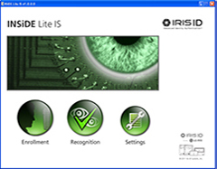 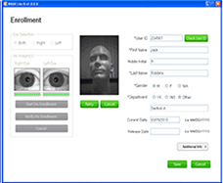

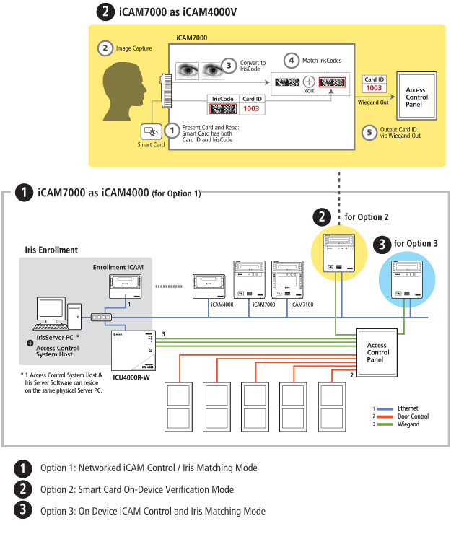

**Chapter 3: Requirement Analysis**

Requirement analysis for Biometric Authentication by Iris Scanning is explained in detail in this section.

# Use Cases



|  |  |  |
| --- | --- | --- |
| **Use Case ID:** | UC-001 | |
| **Use Case Name:** | Add New User | |
| **Actors:** | | Administrator |
| **Description:** | | In this use case the administrator will enter data of user and will scan iris muscle of the user and the user will be registered. |
| **Trigger:** | | New user has to be registered in the system  Admin log-in |
| **Preconditions:** | | 1. User has an ID card of the institution. 2. User is eligible to use iris identification and authentication system. |
| **Post conditions:** | | 1. User is registered. 2. Iris pattern is stored in database. |
| **Normal Flow:** | | 1. Admin logs-in the system 2. Admin enters ID of the user from ID-card of the institution 3. Admin enters name of the user 4. Admin enters gender of the user 5. Admin enters date of birth of the user 6. System scans the iris muscle of the user 7. System stores pattern in the database 8. Admin clicks ‘register’ button 9. System notifies administrator that the user is registered |
| **Alternative Flows:** | | None. |
| **Exceptions:** | | 2a. In step 2 of the normal flow, if the entered ID-number doesn’t exists   1. System prompts entered ID doesn’t exists 2. Admin enters correct ID 3. Use case resumes on step 3 of normal flow   2b. In step 2 of the normal flow, if the entered ID-number is already registered   1. System prompts entered ID is already registered 2. Admin enters another ID 3. Use case resumes on step 3 of normal flow   6a. In step 6 of normal flow, if a scanning error occurs like quality of iris image is not acceptable   1. System will prompt error message. 2. System will wait to scan iris again 3. Use case resumes on step 6 of normal flow |
| **Includes:** | | None |
| **Special Requirements:** | | Database to add data of the user |
| **Assumptions:** | | User has a ID-card of the institution |
| **Notes and Issues:** | | None |

|  |  |  |
| --- | --- | --- |
| **Use Case ID:** | UC-002 | |
| **Use Case Name:** | Delete User | |
| **Actors:** | | Administrator |
| **Description:** | | In this use case the administrator will delete the user by selecting preregistered user. The user will be deleted. |
| **Trigger:** | | Admin log-in  Admin selects user |
| **Preconditions:** | | 1. Admin is logged in the system 2. User is registered in the database. |
| **Post conditions:** | | 1. User’s data is deleted. 2. Iris pattern is deleted from database. |
| **Normal Flow:** | | 1. Admin selects user from user-list. 2. Admin clicks ‘delete’ button 3. System deletes data of user 4. System deletes pattern from database 5. System notifies administrator that the user is deleted |
| **Alternative Flows:** | | 1a. In step 1 of normal flow, admin can search for user by using user ID   1. Admin enter user ID and clicks search 2. Information if user with that user ID is displayed 3. Use case resumes on step 2 of normal flow |
| **Exceptions:** | | 1a. In step 1 of normal flow, if user doesn’t exists in the user list   1. Use case resumes on step 1 of normal flow   (User is either not registered or the admin is looking for wrong ID)  1ai. In step 1 of alternative flow, If the admin enters an ID that does not exists in system database   1. The system prompts ‘Wrong ID’ 2. Use case resumes on step 1 of alternative flow |
| **Includes:** | | None |
| **Special Requirements:** | | User should be already register to the system |
| **Assumptions:** | | User is registered in the system |
| **Notes and Issues:** | | None |

|  |  |  |
| --- | --- | --- |
| **Use Case ID:** | UC-003 | |
| **Use Case Name:** | Initialize Iris recognition | |
| **Actors:** | | User |
| **Description:** | | In this use case the system will capture image of iris of user and authorize user on bases of result after comparing it with data in database. |
| **Trigger:** | | User stands in front of the camera |
| **Preconditions:** | | 1. User is registered in the system 2. User is in the range of the iris camera |
| **Post conditions:** | | 1. User is authorized |
| **Normal Flow:** | | 1. User stands in front of the camera 2. Iris camera captures image of the user’s eye 3. The system calculates the outer and inner boundaries of iris 4. System isolates/extract the iris pattern 5. System encodes the Iris texture 6. System compares the pattern with patterns in the database 7. After successful comparison the user is authorized |
| **Alternative Flows:** | | None. |
| **Exceptions:** | | 2a. In step 2 of normal flow, if the quality of the captured image of the user’s eye is not sufficient for comparison   1. System prompts wait or error message 2. Iris camera image of the eye of user again 3. Use case resumes on step 3 of the normal flow   6a. In step 6 of the normal flow, if the comparison is not successful (iris pattern of user doesn’t match with any pattern stored in database)   1. System prompts no match found 2. User is not authorized |
| **Includes:** | | None |
| **Special Requirements:** | | Matching between iris muscle codes |
| **Assumptions:** | | System is working properly |
| **Notes and Issues:** | | None |

|  |  |  |
| --- | --- | --- |
| **Use Case ID:** | UC-004 | |
| **Use Case Name:** | View log files | |
| **Actors:** | | Administrator |
| **Description:** | | In this use case the admin will view the entry date and time of user through entry log files |
| **Trigger:** | | Admin logs in the system |
| **Preconditions:** | | 1. Log files are accessible to the admin |
| **Post conditions:** | | 1. Admin views entry log files |
| **Normal Flow:** | | 1. Admin logs in the system 2. Admin clicks on ‘View Log Files’ button 3. List of entry log files is displayed sorted with respect to date and time (i.e. most recent entry log will be at top) 4. Admin views the entry log files |
| **Alternative Flows:** | | 3a. In step 3 of normal flow, the admin is given options to either view that days log file or last months or admin can manually enter date, admin can also search log files of user by entering his/her ID   1. Admin clicks on the ‘Last Week’ button 2. Log files form last week are displayed 3. Use case resumes on step 4 of normal flow   3b. In step 3 of normal flow, if the admin enters ID of the user   1. Admin enters ID of a specific user in ‘Search ID’ textbox 2. Log files of that user are displayed, sorted with respect to date and time 3. Use case resumes on step 4 of normal flow   3c. In step 3 of the normal flow, if the user wants log files of a specific day   1. Admin enters date in ‘Enter Date’ textbox 2. Log files of that day will be displayed 3. Use case resumes on step 4 of normal flow |
| **Exceptions:** | | 3bi. In step 3b of alternative flow, if the admin enters wrong user ID   1. The system prompts ‘Wrong ID’ 2. Use case resumes on step 3 of normal flow |
| **Includes:** | | None |
| **Special Requirements:** | | Create log files ,view log files |
| **Assumptions:** | | Log files are available |
| **Notes and Issues:** | | None |

# Functional Requirements

Functional Requirement for the system are given below.

### Stimulus/Response Sequence

|  |  |
| --- | --- |
| Stimulus: | Admin requests to login to the system |
| Response | If the username and password are correct then the system shall authenticate the user |
| Stimulus: | Admin requests to register new user |
| Response | If the fields in the registration form are filled correctly system shall register new user |
| Stimulus: | Admin requests to view log files |
| Response | System shall show the log files |
| Stimulus: | Admin requests to delete a register user |
| Response | After confirmation from the admin system shall delete user |

### System Administrator Requirements

|  |  |
| --- | --- |
| **Requirement** | **Description** |
| Administrator. Login | The system administrator shall be able to log in to the system by using his/her username and password, to perform designed/allocated jobs. |
| Register. User | The administrator shall register new users to the system by capturing and saving images of his/her (users’) iris muscle and by filling the registration form. |
| View.LogFiles | Administrator shall be able to view entry log files |
| Delete.existing.user | System shall give permission to admin to delete already saved user from the system by deleting the iris muscle templates of related user |

### System Requirements

|  |  |
| --- | --- |
| **Requirement** | **Description** |
| Capture.Image | System shall be able to capture a high-resolution image of eye for iris recognition to include as many features as possible. |
| Extract.Iris | System shall identify the boundaries of iris and the pupil in captured picture and correctly extract region of interest from the captured image |
| Encode.Iris.Texture | System shall be able to create a template containing only most discriminating features of the iris muscle. These features are reference points. |
| Store.Iris.Template | System shall store the set of pixels covering the iris muscle (region of interest) that preserves the information essential for a comparison between two irises. System shall also store the related person’s data i.e. name, ID and photo to the system |
| Compare.Iris.Patterns | System should check all the stored images to perform authentication of captured iris templates by comparing with stored iris template |
| Authorize.Signal | A green light shall glow for indication if a person is authorized by the system else red light |
| Authorize.Sound | The system shall play the sound once at the highest volume setting with the authorization signal(accepted or rejected) |
| Create.LogFiles | The system shall record date and time in entry log file whenever a user is authorized by the system |
| Update.Database | To provide backup facility to the system, system shall update server side database after every hour |

# Non-Functional Requirements

Nonfunctional requirements for the system are described below.

## 3.3.1 Usability

### U_R1: The system shall provide an easy-to-use graphical interface so that the admin will not have to learn a new style of interaction

### U_R2: One session of training for the system administrator shall be sufficient to operate the system correctly with a chance of error less than 5% .Users does not need to learn anything they just need to be in front of camera and wait for results.

## Reliability

### REL_R1: The system shall be reliable and works accordingly having less percentage of error. (As compared to the conventional systems such as biometric identification by fingerprint analysis)

### REL_R2: Availability: The designed system will be available for 24 hours of a day

### REL_R3: The system is highly sensitive because of security reason so the maintenance will only be performed by the developers.

### REL_R4: System is expected to be highly reliable, since, probability that two iris muscles being identical is 1 in 1072 i.e. virtually zero.

## Performance

### PER_R1: Response time for identification and authentication process is expected to be in few seconds

### PER_R2: System shall scan one user at a time

### PER_R3: The database shall be dynamic

### PER_R4: If system crashes there is no manual operation control for it, and it has to be repaired to restore its function

### PER_R5: The system shall be resource efficient. Since, image process job is involved, therefore, a minimum 2 GHz dual core processor, and 1 Giga byte RAM shall be required

## Supportability

### SUP_R1: The coding standard of the system shall base on C sharp and object oriented programming.

### SUP_R2: System shall use class libraries of MatLab for image processing

### SUP_R3: The code must be self-explanatory, it must be illustrated with comments where needed.

## Design Constraints

### DC_R1: The system shall use MatLab for the development of application.

### DC_R2: The system shall use visual studio for the development of windows application.

## On-line User Documentation and Help System Requirements

There is no on-line user documentation or help available for this system.

## Purchased Components

The only purchased component for this system is: Iris scanner camera

# Chapter 4: Design and Architecture

This chapter will discuss the design and architecture of your system.

# System Architecture



**Description of the system:**

Organizes the system into layers with related functionality associated with each layer. A layer provides services to the layer above it so the lowest-level layers represent core services that are likely to be used throughout the system.

This architecture is suitable for project which includes security and database

# System Design

UML diagrams of the system are described below.

### Entity Relationship Diagram

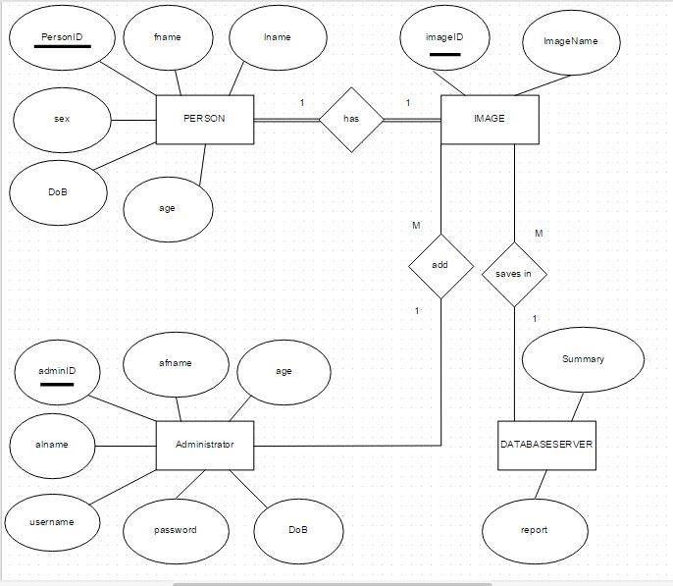

# Behavioral Diagram

* 1. **Activity Diagrams**

**User Registration**



**Activity Delete/Update User**



**4.4. Sequence Diagrams**

**User Registration**



**View log files**



**Delete user Sequence Diagram**



**Initialize Scanning Sequence Diagram**



**4.5 Data Flow Diagram**



**Reference**

<http://irisid.com/irisaccessinaction/508>

<http://findbiometrics.com/solutions/iris-scanners-recognition/>

<http://en.wikipedia.org/wiki/Iris_recognition>

www.fbi.gov/about-us/cjis/fingerprints...center.../**iris**-**recognition**.pdf