AI Travel Planner: Design Report

1. What it does
I built a trip planner with LangGraph and FastAPI. It researches a destination, drafts an itinerary and then waits for a person to review it.
You send a destination, dates, a budget range, a currency, interests, a traveller count and notes. A research agent gathers information and a planner agent turns it into a daily itinerary. The reviewer can approve the draft, reject it with feedback, or ask for changes to named days.
There are 2 agents, 4 tools, 45 offline tests and 4 opt-in live checks. A saved Lisbon session goes through all 3 review actions (section 7).

2. How it works
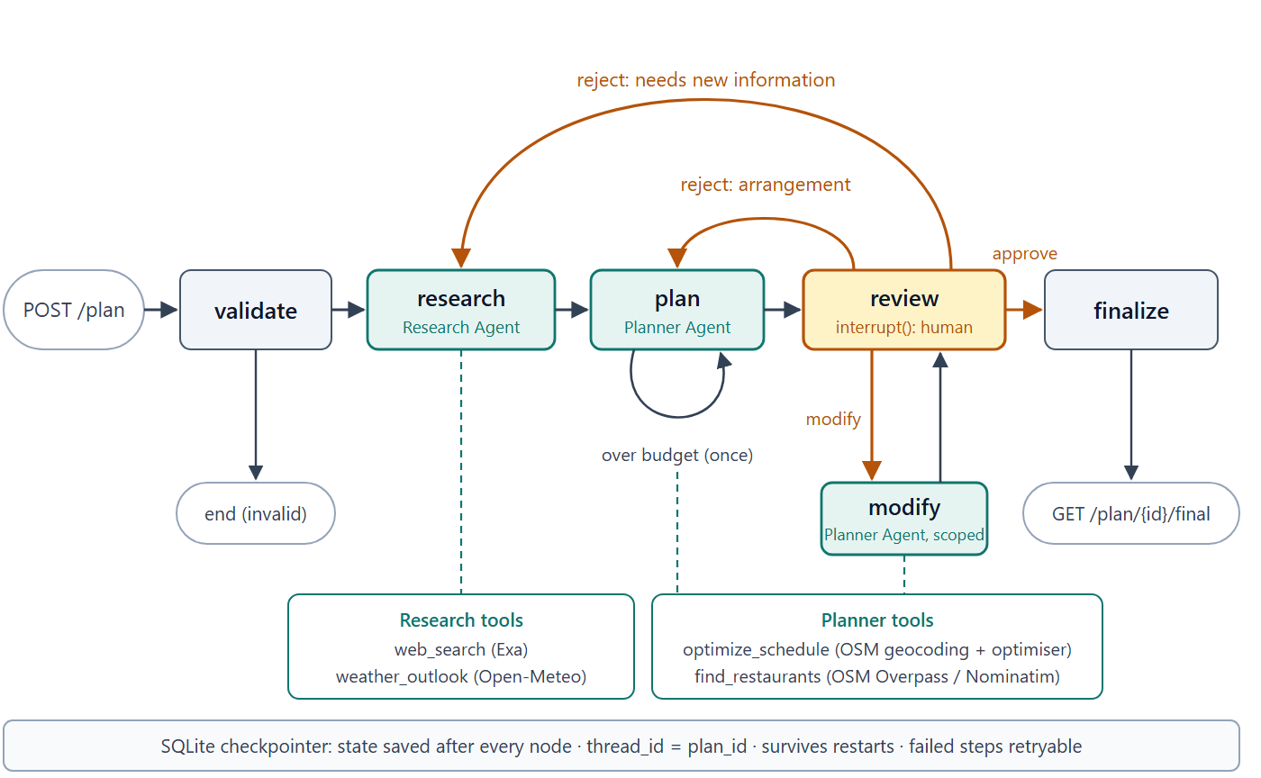
- POST /plan sends the request. The graph in app/graph.py validates it. A bad request stops with the status invalid.
- The research agent searches the web and checks the weather. It returns a ResearchReport.
- The planner agent returns an Itinerary (lodging, meals and timed visits).
- Python adds up the group cost and labels the draft under, within or over the budget. A draft over budget_max gets 1 automatic revision.
- The review node pauses the graph until a person approves, rejects or modifies the draft.
- On approval, finalize builds the final response, which you read at GET /plan/{id}/final.

3. The agents and tools
Both agents live in app/agents.py. They use LangChain's create_agent loop and return Pydantic objects. The research agent has the first two tools. The planner agent has the last two.
Tool | What it does | Data source
web_search | Returns 5 results with title, URL, date and highlights | Exa (API key needed)
weather_outlook | Forecast if the whole trip is within 16 days, otherwise the same dates a year earlier, labelled historical | Open-Meteo (no key)
optimize_schedule | Groups stops into days, orders them, returns timed visits and warnings | OpenStreetMap geocoding and a built-in optimiser (no key)
find_restaurants | Finds places in a radius, sorted by distance | OpenStreetMap Overpass, then Nominatim as a last fallback (no key)

The restaurant tool relaxes the cuisine filter if nothing matches, but never the vegetarian filter.

4. Human review
The review node stops at interrupt(), and POST /plan/{id}/review resumes it. The default limit is 5 reject or modify rounds, then the API accepts approval only.
Action | What happens
approve | finalize copies the draft unchanged into the itinerary field and adds the request, research, timestamps and review history. No extra model call.
reject | The reviewer gives feedback and can set revise to research or itinerary. Otherwise route_feedback() picks, and defaults to the planner if that call fails.
modify | The reviewer names the days to change. After the planner replies, keep_unchanged() restores every other day, the lodging and the top-level text.

A change without a day (for example the hotel) can update the lodging and the summary text. Every day stays exactly as it was.

5. Saving state and recovery
A checkpoint is a saved copy of the plan's state. The SQLite checkpointer writes one after every node, with thread_id set to the plan_id.
The runner uses durability="sync", so each checkpoint is written before the next step starts. A failed step resumes with POST /plan/{id}/retry. On startup the runner resumes stalled plans. Failed plans wait for a retry, and drafts awaiting review stay paused.
Status | Meaning
queued | Accepted, not started
validating, researching, planning, modifying, finalizing | A step is running
processing | Between checkpoint updates
awaiting_review | Paused for a person
completed | The graph finished
failed | A step raised an error
stalled | The run lost its active task
invalid | The request was rejected

6. API
Model runs can take minutes, so the API replies at once and a background runner does the work.
Method | Path | Purpose
POST | /plan | Submit a request and start the workflow
GET | /plan/{id} | Status, draft, research, reviews and progress events
POST | /plan/{id}/review | Approve, reject (with feedback) or modify (with changes)
GET | /plan/{id}/final | The approved plan
GET | /plan/{id}/events | Server-sent events, one per status change
POST | /plan/{id}/retry | Resume a failed or stalled run from its checkpoint

Codes: 202 accepted, 404 unknown plan, 409 wrong state or round limit reached, 422 bad input. Validation rejects past or reversed dates, trips over 14 days, reversed budget bounds, empty interests and unknown modification days. The currency must be 3 uppercase letters, with no ISO list check.

7. A real run: Lisbon
This is a saved session from 22 October 2026. The request was for Lisbon, 20-22 November, for 2 travellers with a group budget of 900-1600 EUR. Interests were food, history and viewpoints. One traveller was vegetarian.
Step | Result
Research | 6 Exa searches and 1 weather call gave 10 attractions and 9 sources
Draft 1 | Cost 897 EUR, below the 900 minimum, so marked under
Reject | I asked for less public transport, one area per day and a fado evening. The router sent it to research. Draft 2 cost 1417 EUR
Modify day 2 | I asked for a sunset viewpoint and a vegetarian dinner nearby. Draft 3 put Miradouro de Santa Luzia at 16:30 and cost 1221 EUR. Days 1 and 3 and the lodging matched draft 2
Approve | Revision 3 became the itinerary of the final response

Three things were not good:
- Drafts 2 and 3 came from gemini-3.5-flash-lite, because the free-tier quota ran out during the session. The output is weaker for it.
- Draft 2 scheduled fado on all 3 evenings when I had asked for one. Draft 3 kept the fado evenings on days 1 and 3.
- For the day 2 vegetarian dinner, the planner searched with cuisine vegetarian but without the vegetarian=True filter. It chose A Muralha Tasca Tipica. The saved record does not confirm a vegetarian menu.

8. Testing and what broke
On 26 October 2026, pytest -m "not live" passed all 45 offline tests. The graph and API tests use fake agents. The wiring test uses the real agent loop with a scripted model.
File | Tests | Covers
test_graph.py | 10 | Review routes, budget retry, saved state, retry
test_api.py | 13 | HTTP responses, round limit, SSE
test_tools.py | 19 | Scheduling, weather, restaurant fallbacks, Exa, budget maths
test_runner.py | 2 | Plan status while a step is active
test_agent_wiring.py | 1 | Real agents inside the graph
test_live.py | 4 (opt-in) | Open-Meteo, Nominatim, Overpass, Exa. Needs RUN_LIVE=1

The live run exposed four problems.
- Status race. An active plan could briefly read invalid between a node's writes and its checkpoint. The runner now checks its task registry first.
- Quota and overload. I saw Gemini 503 responses, a quota limit and Overpass 502 responses. I added model fallbacks and a restaurant retry, mirror and Nominatim sequence. A fallback can still give a worse draft.
- Runaway search. One research pass made 29 web searches. Each agent run is now capped at 8 web searches, 1 weather call, 2 scheduling calls and 10 restaurant searches.
- Checkpointer error. An AsyncPregelLoop attribute error came from checkpointer=False on the agents combined with synchronous durability. They now inherit the parent checkpointer.
I also tested recovery by hand: I stopped the server during research and retried a failed plan after a restart, and the finished research was reused. I have not repeated this for the current revision.

9. Design decisions
- Background runner. The client polls or keeps an SSE connection open. The runner's lock covers one process, so more workers would need a shared job system.
- SQLite for everything. Drafts and review history sit next to the graph state. Startup recovery scans the checkpoints, which costs more as history grows.
- Pydantic plus plain Python. Pydantic checks the shape of each response, and Python computes totals. Gemini still picks places and estimates prices, so a response can pass validation while ignoring a dietary need, as the Lisbon dinner shows.

10. What I would do next
- Build an evaluation set: a single fado evening, a verified vegetarian meal, narrow budgets and closed attractions. Run it against different prompts and Gemini models.
- Improve the tools: OSRM for road routes, parsing of opening_hours strings, and a currency tool with a dated exchange rate.
- Prepare for more than one process: a queue, a shared checkpointer such as Postgres, and database locks.
- Add idempotency keys, authentication, per-user quotas, logs with plan_id, and a retention period for the SQLite checkpoints.

11. Assumptions
- The budget covers the whole group (lodging, food, activities and local transport). It excludes travel to the destination, including flights.
- Costs are in the request currency, and Gemini currently converts local prices.
- TravelRequest accepts trips of 1-14 days that start today or later, for 1-20 travellers.
- Prices, opening hours and events come from searches and Gemini, so travellers should confirm them before booking.

