Technical Report
ALU HUB
Student Name: NIWENIZEYE BLAINE
Technology Used: Flutter, Dart, Firebase Authentication, Cloud Firestore, Riverpod
LESSON: MOBILE APPLICATION DEVELOPMENT
Institution: African Leadership University (ALU)

Executive Summary
ALU Hub is a Flutter and Firebase platform that connects ALU students with student-led startups. Students use the app to find practical opportunities, build experience, and track their applications. Startups use it to publish opportunities, review applicants, and manage application progress. An administrator verifies startup accounts before they are allowed to post opportunities.
The app is built with Flutter and Dart. Firebase Authentication lets users sign in with an email and a password. Cloud Firestore stores data such as user profiles, opportunities, applications, saved items, and notifications. Riverpod manages the app's state. This means screens update automatically when the Firestore data changes. Screens also show clear loading, success, and error messages.
The code is split into four parts: screens, models, providers, and repositories. This makes the code easier to read, test, and maintain.
The app has three roles: Student, Startup, and Admin. Students must use an official @alustudent.com email. Startup accounts must provide a valid account email and a founder ALU email. New startups begin with a Pending verification status. The Admin reviews each startup and can approve, reject, or return it to Pending. Only approved startups can create and manage opportunities. Firestore Security Rules enforce these permissions.
This project is more advanced than a simple CRUD (Create, Read, Update, Delete) app. It includes application tracking, saved items, status notifications, role-based dashboards, and real-time updates. This report explains the problem, goals, requirements, architecture (structure), database design, state management, security, workflows, testing, limits, future plans, and lessons learned.

Table of Contents
- Introduction
- Problem Definition and Project Objectives
- Functional and Non-Functional Requirements
- System Architecture
- Firebase Backend and Database Design
- State Management with Riverpod
- Core Application Workflows
- UI/UX Design Reasoning
- Security and Access Control
- Testing Strategy
- Scalability and Maintainability
- Challenges, Solutions and Lessons Learned
- Limitations and Future Improvements
- Conclusion, References, Appendices

1. Introduction
Internship experience is important. It helps students use what they learn in class, build professional habits, and show proof of their skills. But many organizations have few internship spots. They may also ask for experience that new students do not have yet. At the same time, student entrepreneurs and new ventures often have real work to do. But they may not have the money or contacts to hire through normal methods. ALU Hub is a campus platform that connects these two groups.
This project follows the course brief. The brief asked for a working Flutter mobile app with a Firebase backend, modern state management, login, organization profiles, opportunity posting, opportunity search, application submission, and live updates. The brief also asked for original work, a clean code structure, clear UI/UX reasoning, and the ability to explain technical choices in a short demo.

1.1 Project Scope
- Student onboarding, sign-up, and login.
- Public sign-up for two roles: Student and Startup. Admin accounts are created manually in Firebase.
- Student email validation using @alustudent.com, plus founder ALU email validation for startup accounts.
- Only Admin-approved startups can create, edit, activate, deactivate, and delete opportunities.
- Students can search, filter, and view opportunity details.
- Students can apply, and the app blocks duplicate applications.
- Students can track their applications. Startups can manage applicants.
- Saved bookmarks and status-change notifications stay after logout.
- Firebase saves data, Firestore sends live updates, and Riverpod manages state.

1.2 Intended Users
The platform serves three user groups. Students look for practical experience. Student-led startups publish opportunities and manage candidates. The Admin protects the platform by checking startup information and approving only startups that are recognized in the ALU community. Each role has its own navigation and permissions.

2. Problem Definition and Project Objectives

2.1 Problem Statement
Students need an easy way to find real opportunities that match their skills. Startups need a simple way to post their needs, get applications, and manage candidates. Right now, people often use informal methods, like messages in group chats. This makes opportunities hard to find, check, and manage.

2.2 Proposed Solution
ALU Hub brings opportunity discovery, application management, and startup verification into one app. Students can find and apply for opportunities. Verified startups can publish opportunities and manage applicants. The Admin reviews startup accounts. Firebase stores the data and manages authentication, while Riverpod keeps screens updated with the latest Firestore data.

2.3 Objectives
- Build a mobile app made for ALU students and student ventures, not a generic job board.
- Build secure sign-up, login, and session saving (so users stay logged in).
- Let startups manage the full life of an opportunity, from posting to closing it.
- Let students find, save, and apply for opportunities that fit them.
- Give real-time application tracking and notifications.
- Use a clean code structure that keeps UI, state, and data separate.
- Protect backend data with role-based Firestore Security Rules, ownership checks, and startup verification checks.

3. Functional and Non-Functional Requirements

3.1 Functional Requirements
ID | Requirement | Role | Status
FR-01 | Sign up and log in with email and password | Both | Done
FR-02 | Only allow alustudent.com emails for students | Student | Done
FR-03 | Create and edit role-based profiles | Both | Done
FR-04 | Create, update, turn on/off, and delete opportunities | Startup | Done
FR-05 | Browse, search, and filter active opportunities | Student | Done
FR-06 | Save and remove bookmarked opportunities | Student | Done
FR-07 | Submit an application with personal details and motivation | Student | Done
FR-08 | Block duplicate applications to the same opportunity | Student | Done
FR-09 | View applicants and change application status | Startup | Done
FR-10 | Track submitted applications and their status | Student | Done
FR-11 | Create and manage status-change notifications | Student | Done, needs final device test
FR-12 | Verify ALU-recognized startups through an Admin account | Admin | Done
FR-13 | Block pending or rejected startups from posting opportunities | Startup/Admin | Done

3.2 Non-Functional Requirements
Usability: The app should use clear labels, role-based navigation, validation messages, empty-state messages, and progress indicators.
Security: Users should only see and use data and actions allowed for their role and their own account.
Maintainability: Models, repositories, providers, and screens should stay separate. This reduces repeated code and makes changes easier.
Scalability: Firestore collections and parameterized providers should support more users and opportunities without a big redesign.
Reliability: Data should stay saved after logout or an app restart. Errors should show clear messages.
Responsiveness: The layout should work on common Android screen sizes and allow scrolling when needed.

4. System Architecture
The app uses a layered structure. Flutter's official guide recommends keeping the UI separate from the data layer. This makes apps easier to scale and maintain. In ALU Hub: screens show information, providers hold and share state, repositories talk to Firebase, and model classes define the shape of stored data.
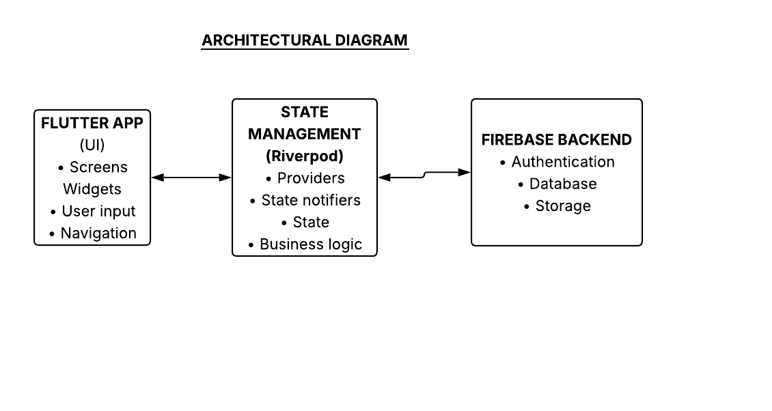
Figure 1. Layered architecture of ALU Hub.

4.1 Presentation Layer
This layer holds onboarding, registration, login, student screens, startup screens, and the Admin Dashboard. Widgets show data and send user actions to providers or repositories. Role-based navigation hides features that a user does not need. Students see opportunity discovery and application features. Startups see dashboard, opportunity, applicant, and profile features. Admin users see startup verification controls.

4.2 State Management Layer
Riverpod providers share data streams and repository instances. Screens use ref.watch() to react to changes, and ref.read() for one-time actions. AsyncValue shows loading, data, and error states. Riverpod keeps the app reactive without tightly linking the UI to the data layer.
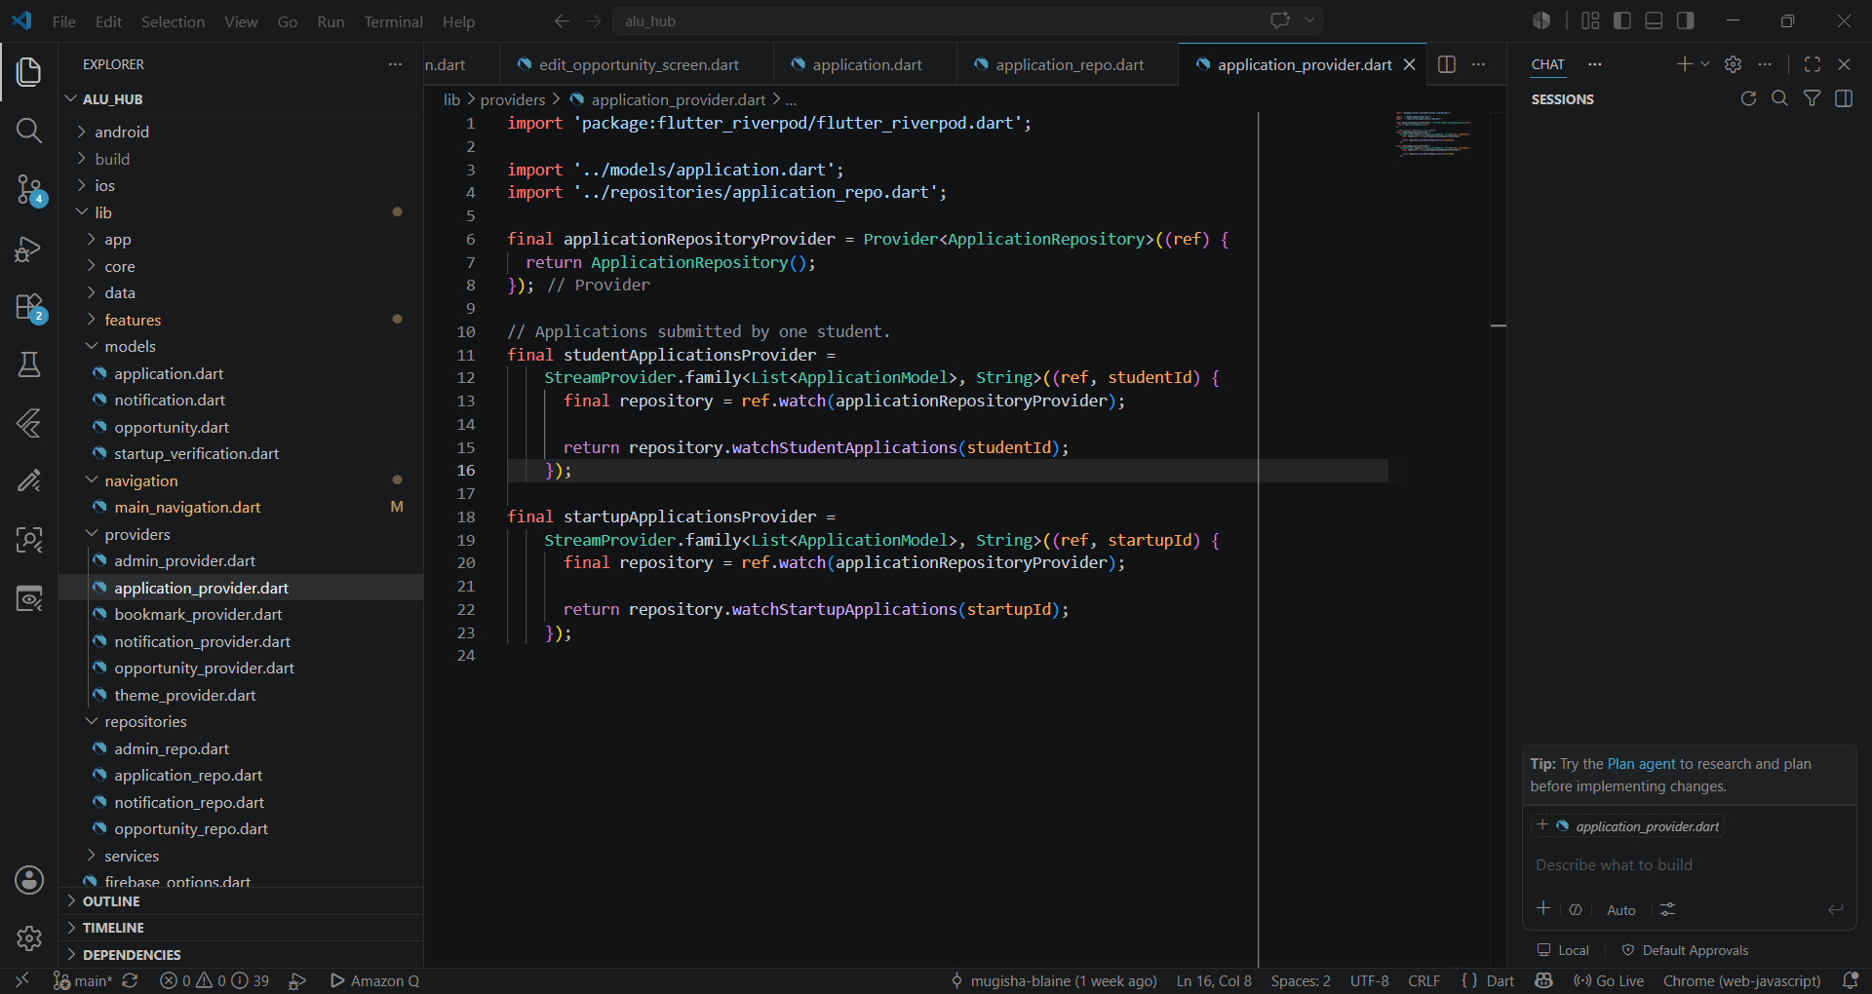

4.3 Data Access Layer
Repository classes keep Firebase code out of the widgets. OpportunityRepository manages opportunity documents. ApplicationRepository manages submissions and status updates. NotificationRepository manages notifications. BookmarkRepository manages each user's saved bookmarks. This structure keeps the code clean and easy to test.

4.4 Backend Layer
Firebase Authentication manages user identity and login sessions. Cloud Firestore stores the app's data and sends live updates when documents change. Firestore listeners give real-time updates. Errors, such as bad queries or permission problems, are handled through stream error states.

5. Firebase Backend and Database Design
Cloud Firestore was chosen because the app needs a flexible data structure, role-based queries, and real-time sync. Firebase also recommends protecting mobile apps with Authentication and Firestore Security Rules. The database uses top-level collections, plus a bookmark subcollection inside each user's profile.
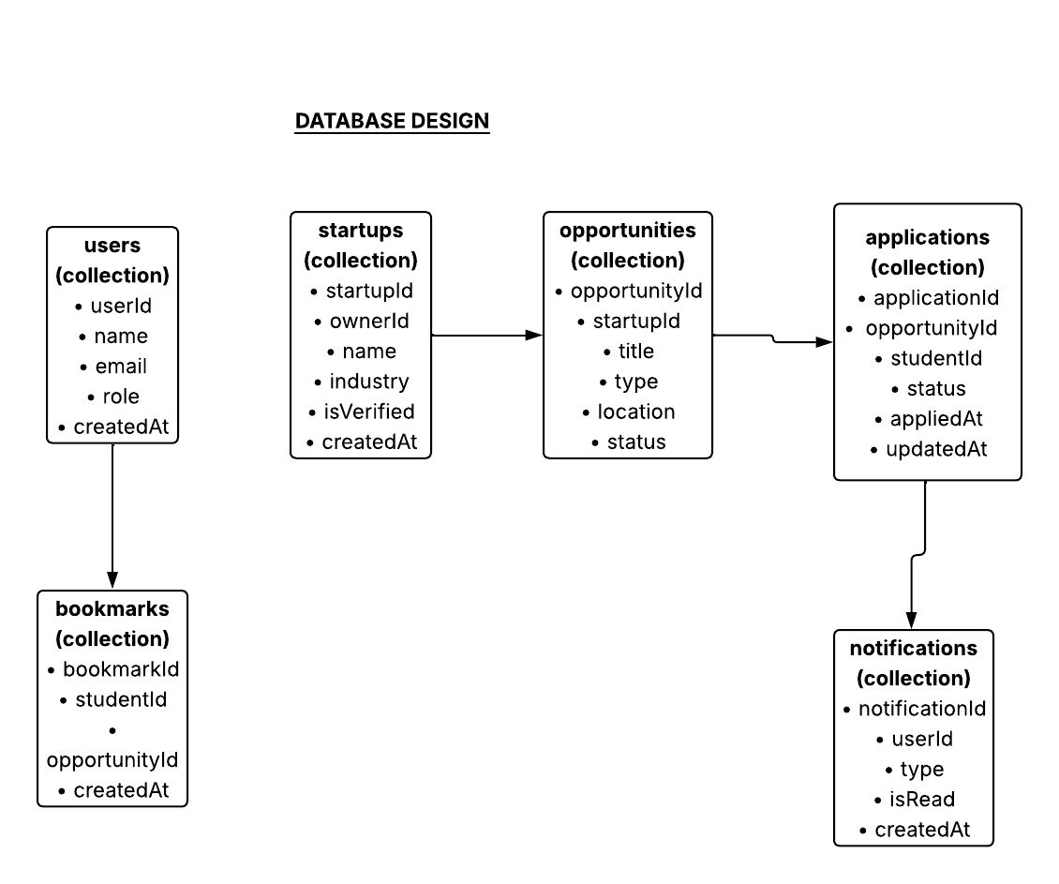
Figure 2. Firestore schema and main relationships.

5.1 users Collection
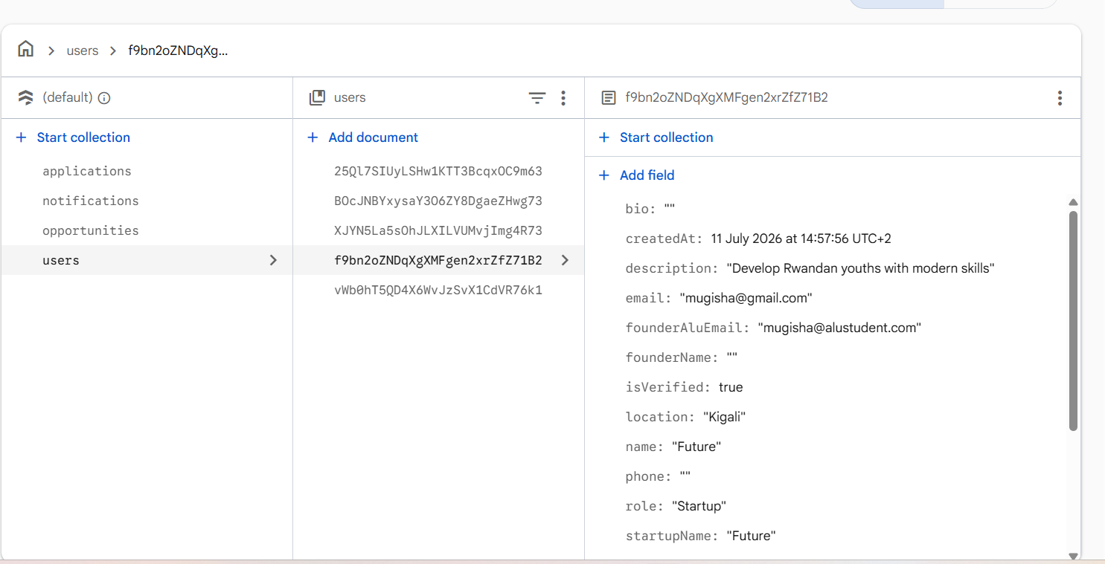
Each Firebase Authentication account has a matching profile document at users/{uid}. Common fields include uid, name, email, role, phone, bio, createdAt, and updatedAt. Startup profiles also store startupName, founderName, founderAluEmail, website, location, description, isVerified, verificationStatus, verificationMessage, verifiedBy, and verifiedAt. Admin profiles use role: Admin. Using the Authentication UID as the document ID makes ownership checks simple.

5.2 opportunities Collection
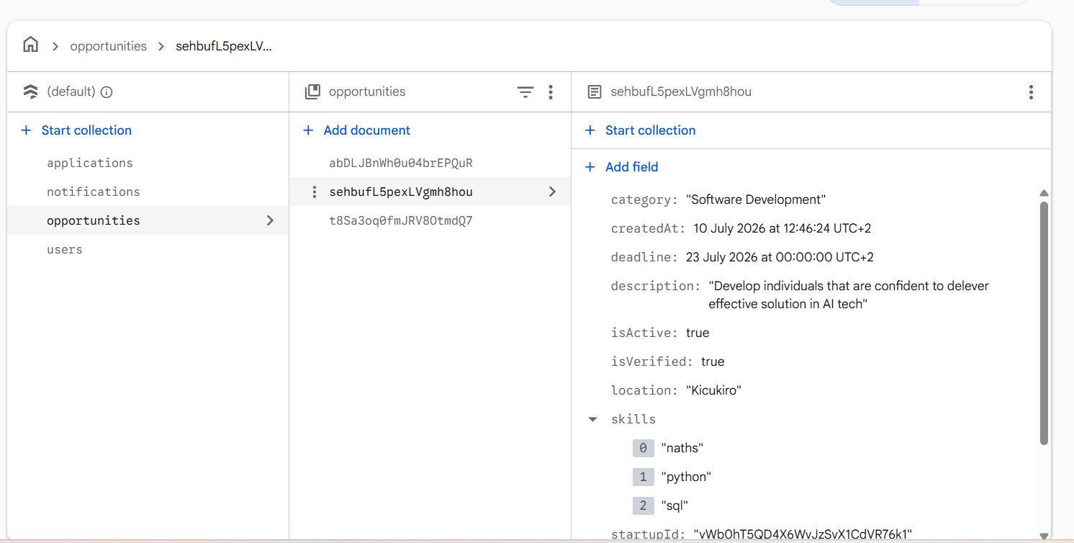
Each opportunity document stores the startup owner, title, category, description, needed skills, work type, deadline, active status, and timestamps. The startupId field links the opportunity to its owner. Students usually see only active opportunities. Startups see their own opportunities.

5.3 applications Collection
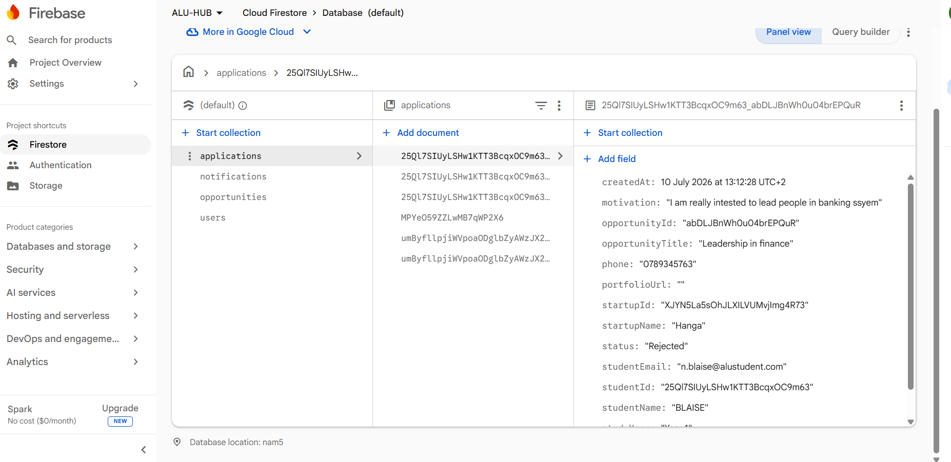
Applications are stored as separate documents because both students and startups need to query them. Each document stores opportunityId, opportunityTitle, startupId, startupName, studentId, student details, motivation, portfolio URL, status, and timestamps. New applications start as "Submitted." A verified startup can change the status to "Under Review," "Interview," "Accepted," or "Rejected."

5.4 bookmarks Subcollection
Bookmarks are stored at users/{uid}/bookmarks/{opportunityId}. Using the opportunity ID as the document ID stops duplicate bookmarks. It also makes saving or removing a bookmark simple.

5.5 notifications Collection
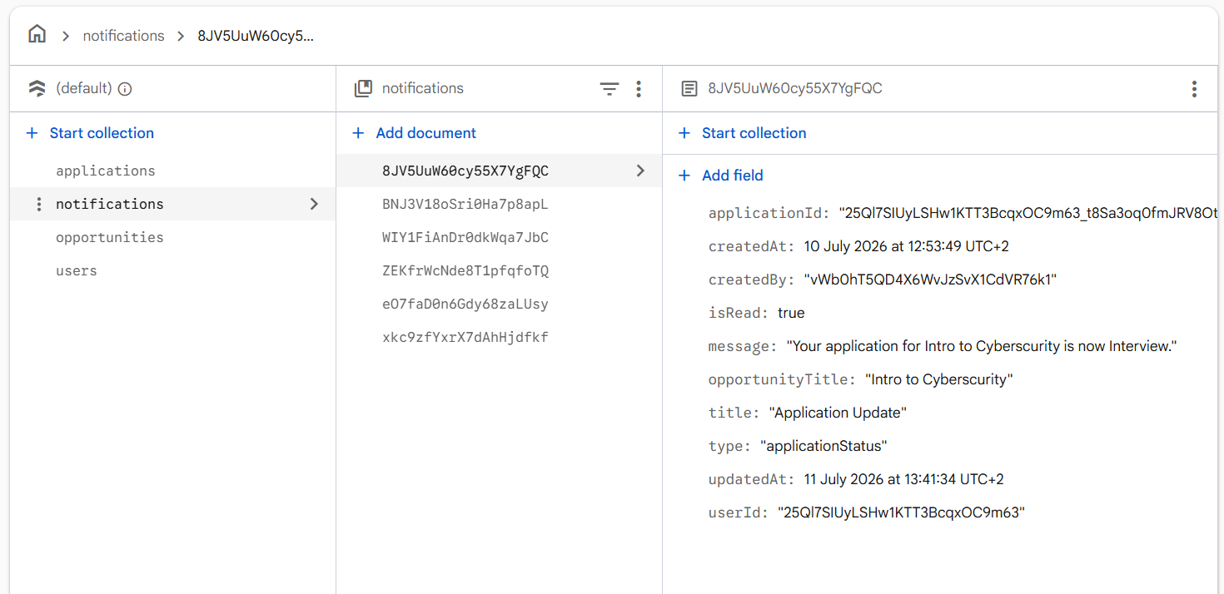
When a startup changes an application's status, the app creates a notification for the student. The notification has userId, applicationId, opportunityTitle, title, message, type, isRead, and createdAt. Students can read, mark as read, mark all as read, and delete their own notifications.

5.6 Example Data Flow
When a startup updates an application, the app also creates a notification. Firestore streams then update the student's My Applications screen and Notifications screen automatically. No manual refresh is needed.

6. State Management with Riverpod
Riverpod was chosen because it supports dependency injection, parameterized providers, async state, and reactive streams, without tightly linking screens to services. StreamProvider works well with Firebase. It gives the latest stream update and lets the UI handle loading and errors in a consistent way.

6.1 Provider Types Used
- Provider: Shares repository instances, such as notificationRepositoryProvider.
- StreamProvider: Listens to Firestore streams, such as activeOpportunitiesProvider.
- StreamProvider.family: Creates separate state for a specific value, such as studentApplicationsProvider(userId).
- AsyncValue: Shows loading, data, and error states in the UI.

6.2 Reactive Update Example
final applicationsAsync =
ref.watch(studentApplicationsProvider(user.uid));
return applicationsAsync.when(
loading: () => const CircularProgressIndicator(),
error: (error, _) => const Text('Unable to load applications'),
data: (applications) => ApplicationsList(applications: applications),
);
This pattern means the screen does not need to ask for data manually every time. When Firestore sends a new update, the provider updates itself, and the UI rebuilds with the newest data.

6.3 Benefits of This Structure
- Clear separation between the interface and backend logic.
- Data streams can be reused across many screens.
- Simpler loading and error handling.
- Separate state for different users or opportunities.
- Easier to test later, because repositories can be mocked (faked for testing).

7. Core Application Workflows

7.1 Onboarding, Registration and Authentication
AuthGate listens to Firebase Authentication and opens the correct interface after sign-in. A signed-out user sees onboarding and can open login or registration. Students must use an @alustudent.com email. A startup may use a valid organization email but must also provide a founder ALU email. Firebase Authentication creates the account, and Firestore stores the role-based profile. Startup accounts begin as Pending and cannot post until an Admin approves them.
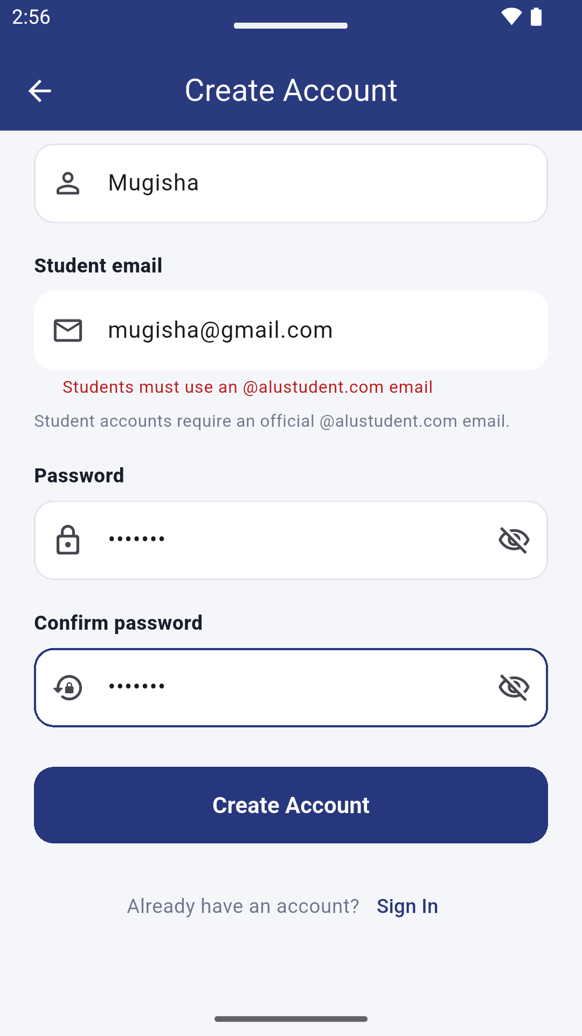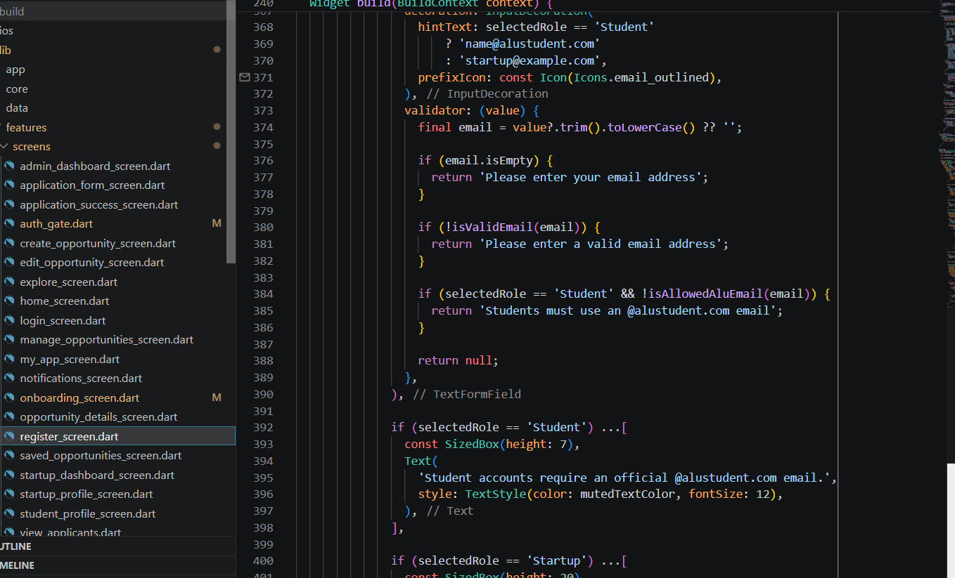
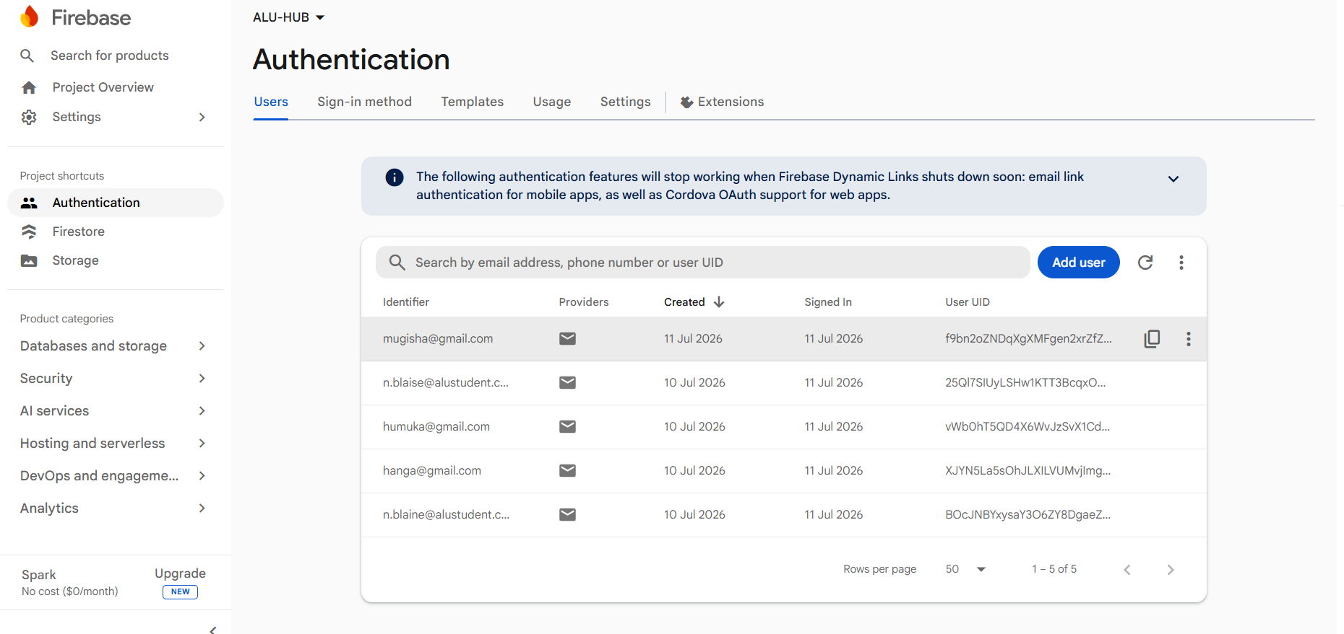
Figure placeholder: Authentication and Role-Based Routing.

7.2 Student Opportunity Discovery
Students can view active opportunities, search by text, open details, and save the ones they like. The Saved Opportunities screen combines bookmark data with opportunity data. It shows only the opportunities the student has saved.
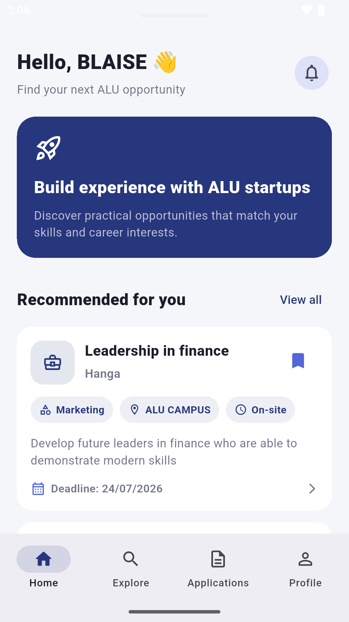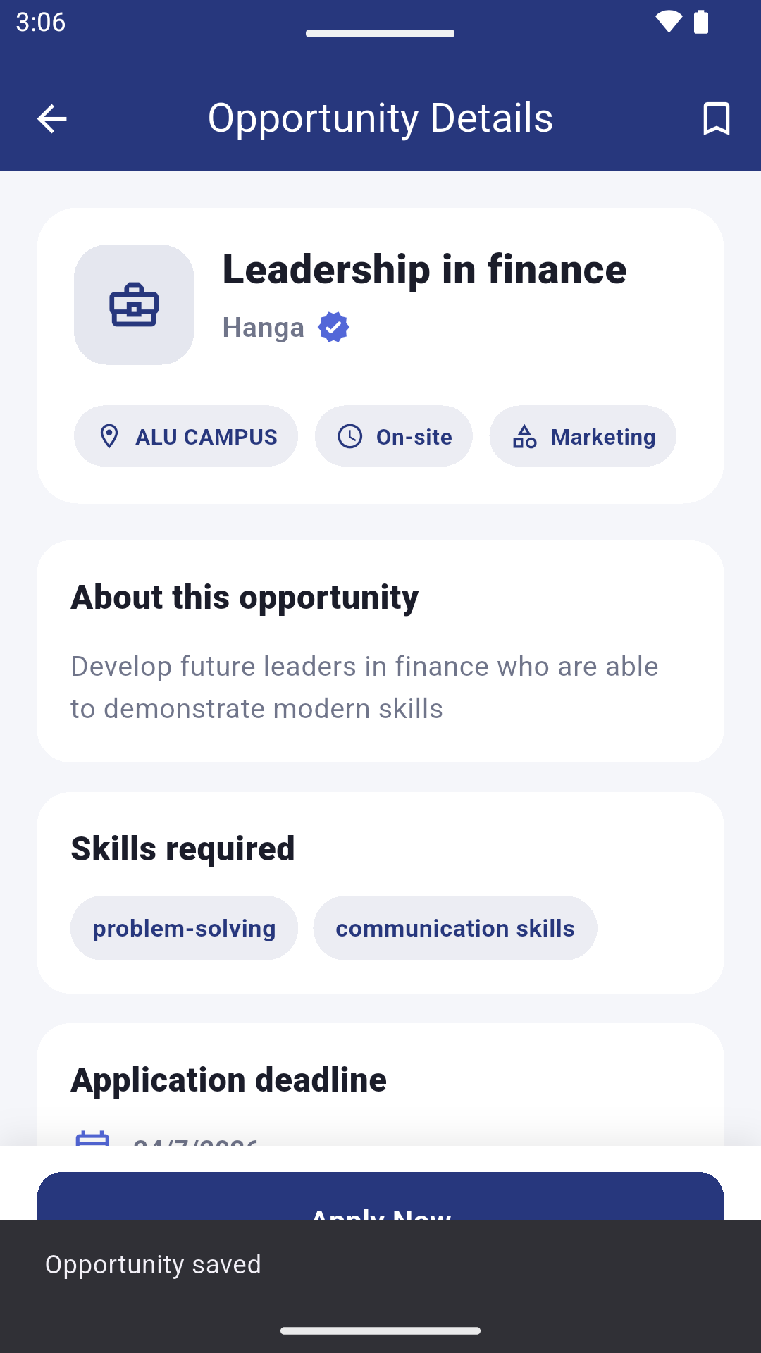

Figure placeholder: Student Opportunity Discovery.

7.3 Student Application Submission
The application form asks for study year, phone number, portfolio URL, and motivation. Before saving, the repository checks if the student already applied to the same opportunity. If it is a new application, the app saves both studentId and startupId, so both roles can search for it safely.
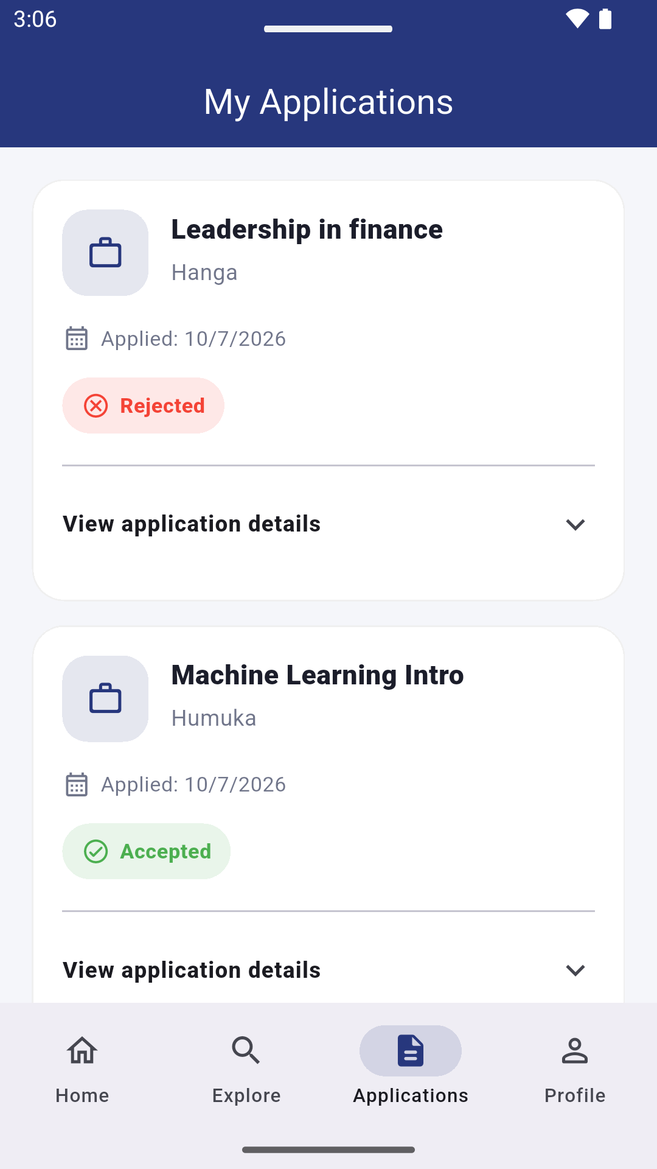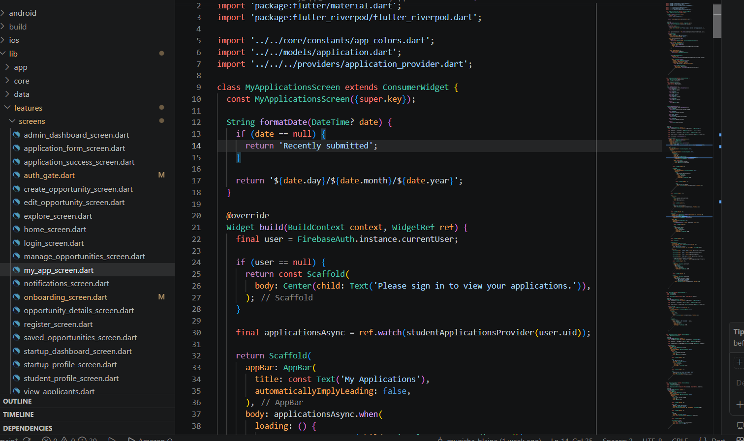
Figure placeholder: Student Application Submission.

7.4 Startup Opportunity Management
The startup dashboard shows opportunity and application activity. An approved startup can create, edit, activate, deactivate, and delete its opportunities. Pending or rejected startups cannot post. Ownership is checked using startupId, so one startup cannot manage another startup's opportunities.
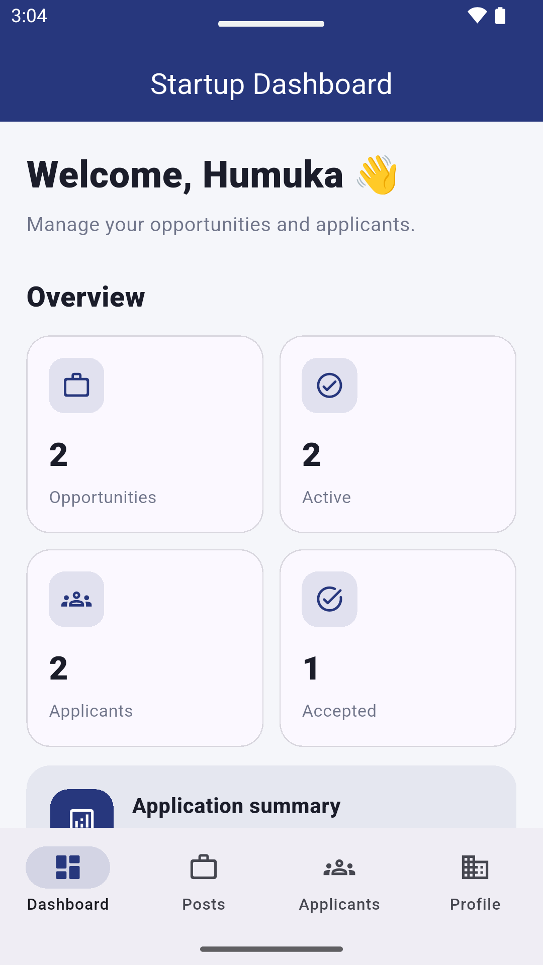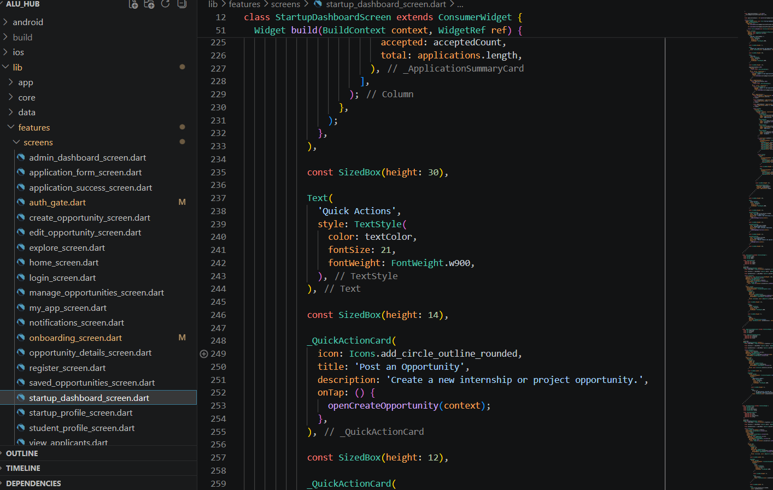
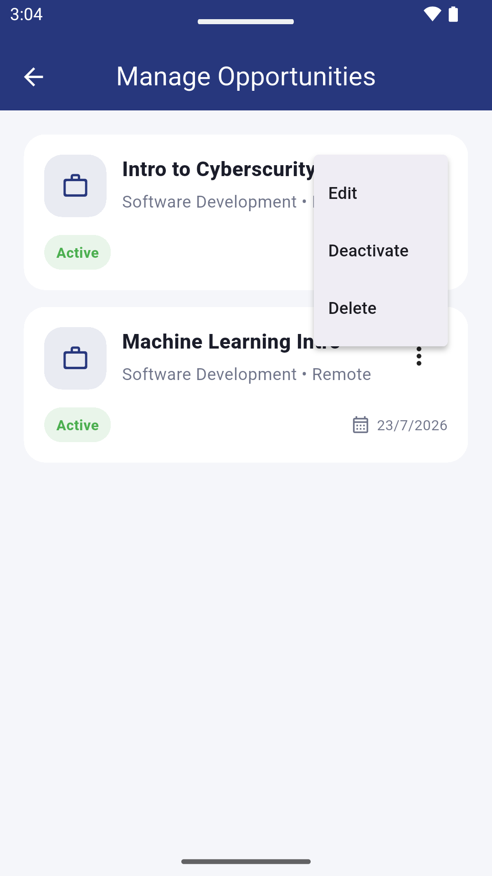

Figure placeholder: Startup Opportunity Management.

7.5 Applicant Review and Notifications
The View Applicants screen shows all applications sent to the signed-in startup. The startup changes the status using a dropdown menu. The repository updates the application and creates a notification for the student. The student then sees the new status in My Applications, along with a new notification.
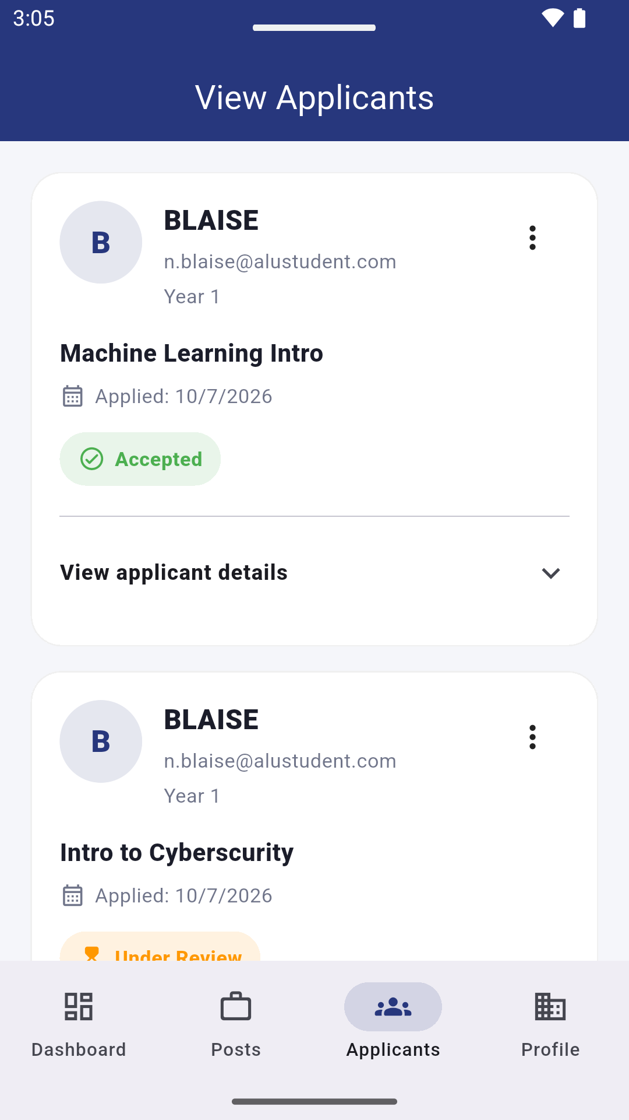
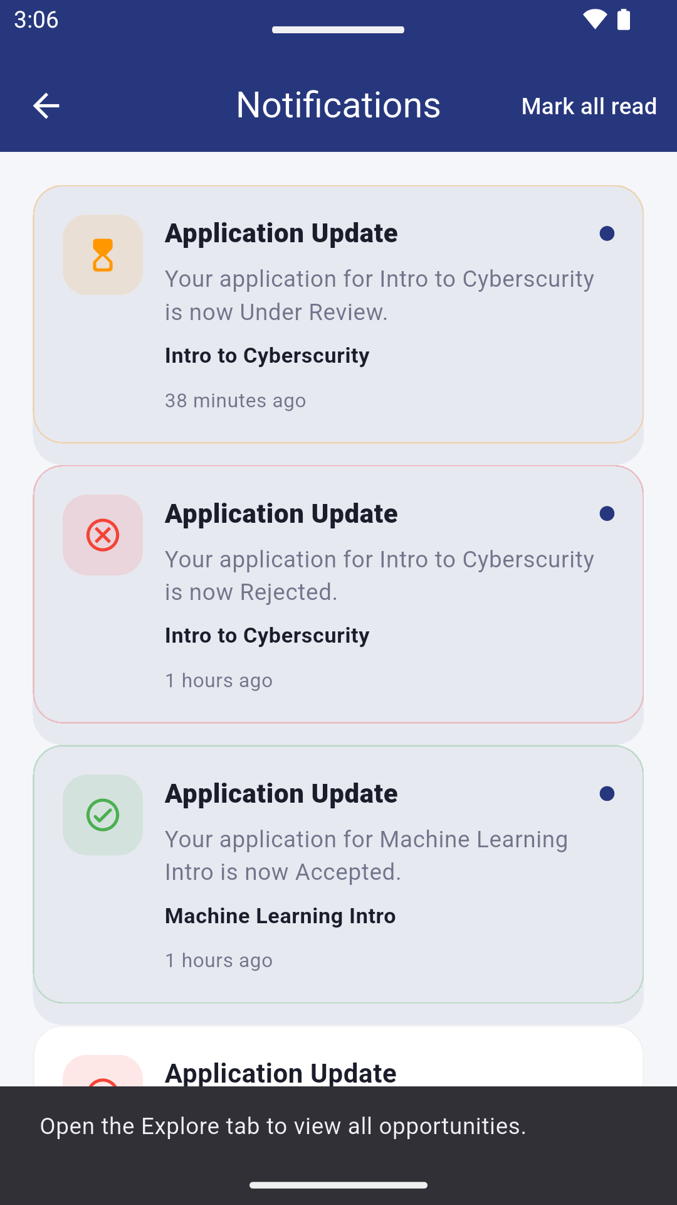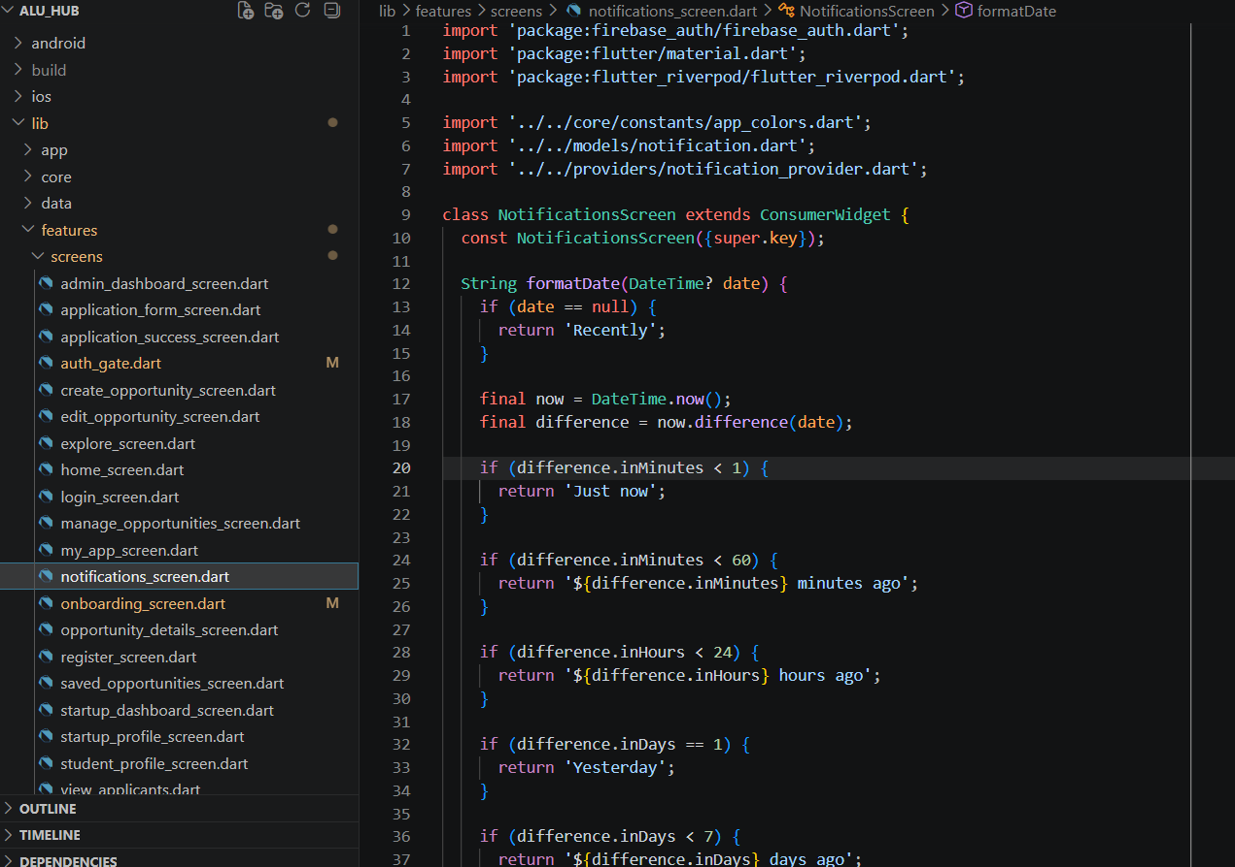
Figure placeholder: Applicant Review and Notification.

7.6 Admin Startup Verification
A startup registers with isVerified set to false and verificationStatus set to Pending. The Admin Dashboard reads startup profiles from the users collection. The Admin reviews the startup name, account email, founder ALU email, website, location, and description. The Admin can approve, reject with a reason, or move the startup back to Pending. Firestore Security Rules allow only the Admin to change verification fields. Only approved startups can create or manage opportunities.
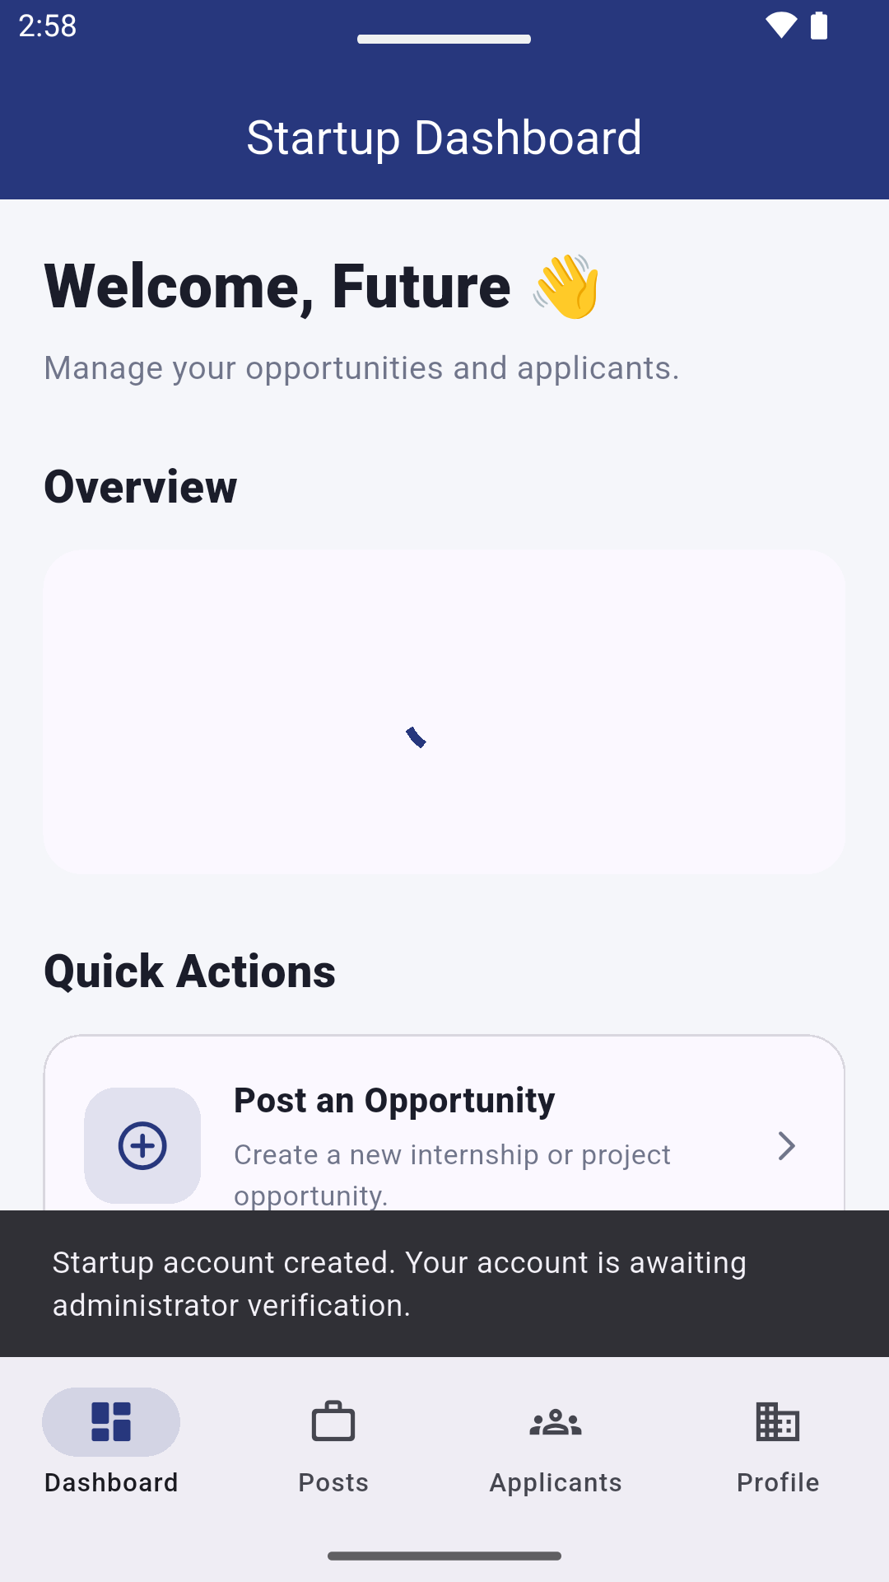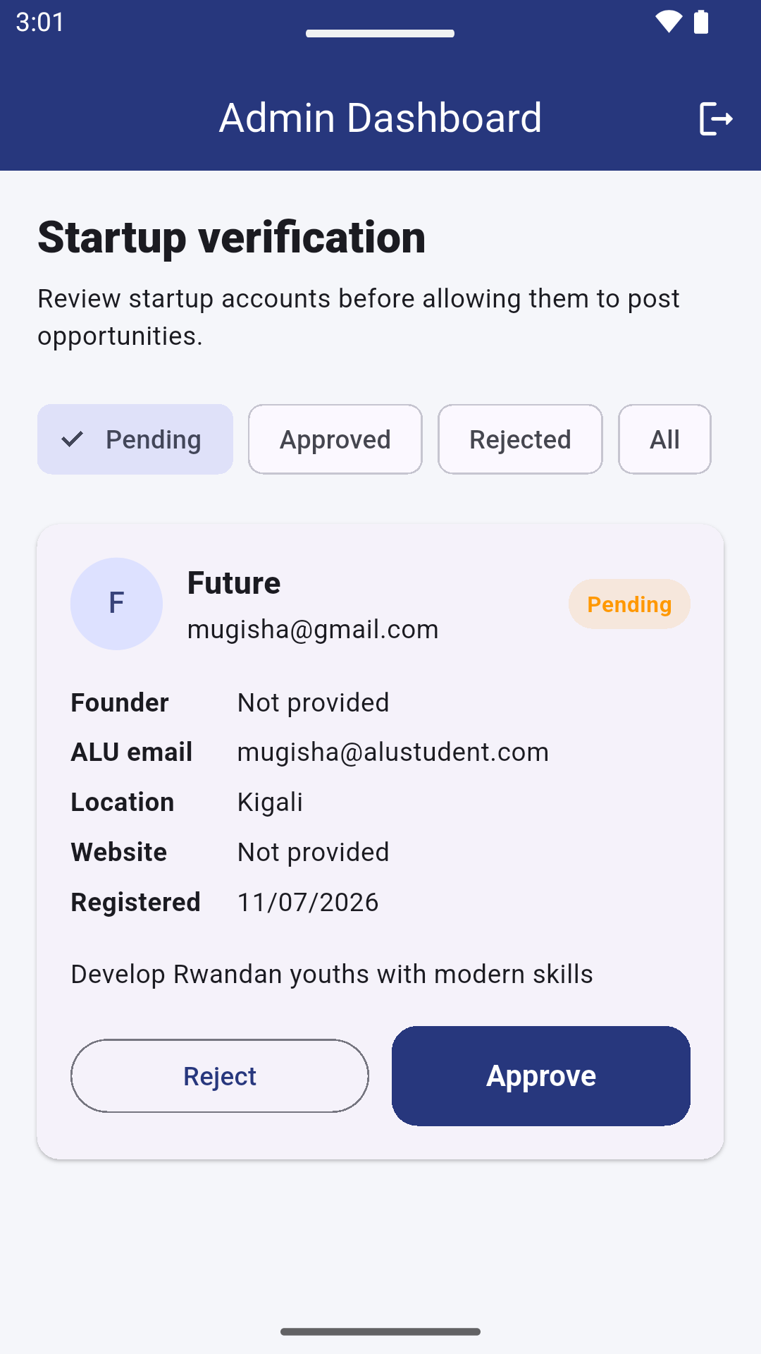

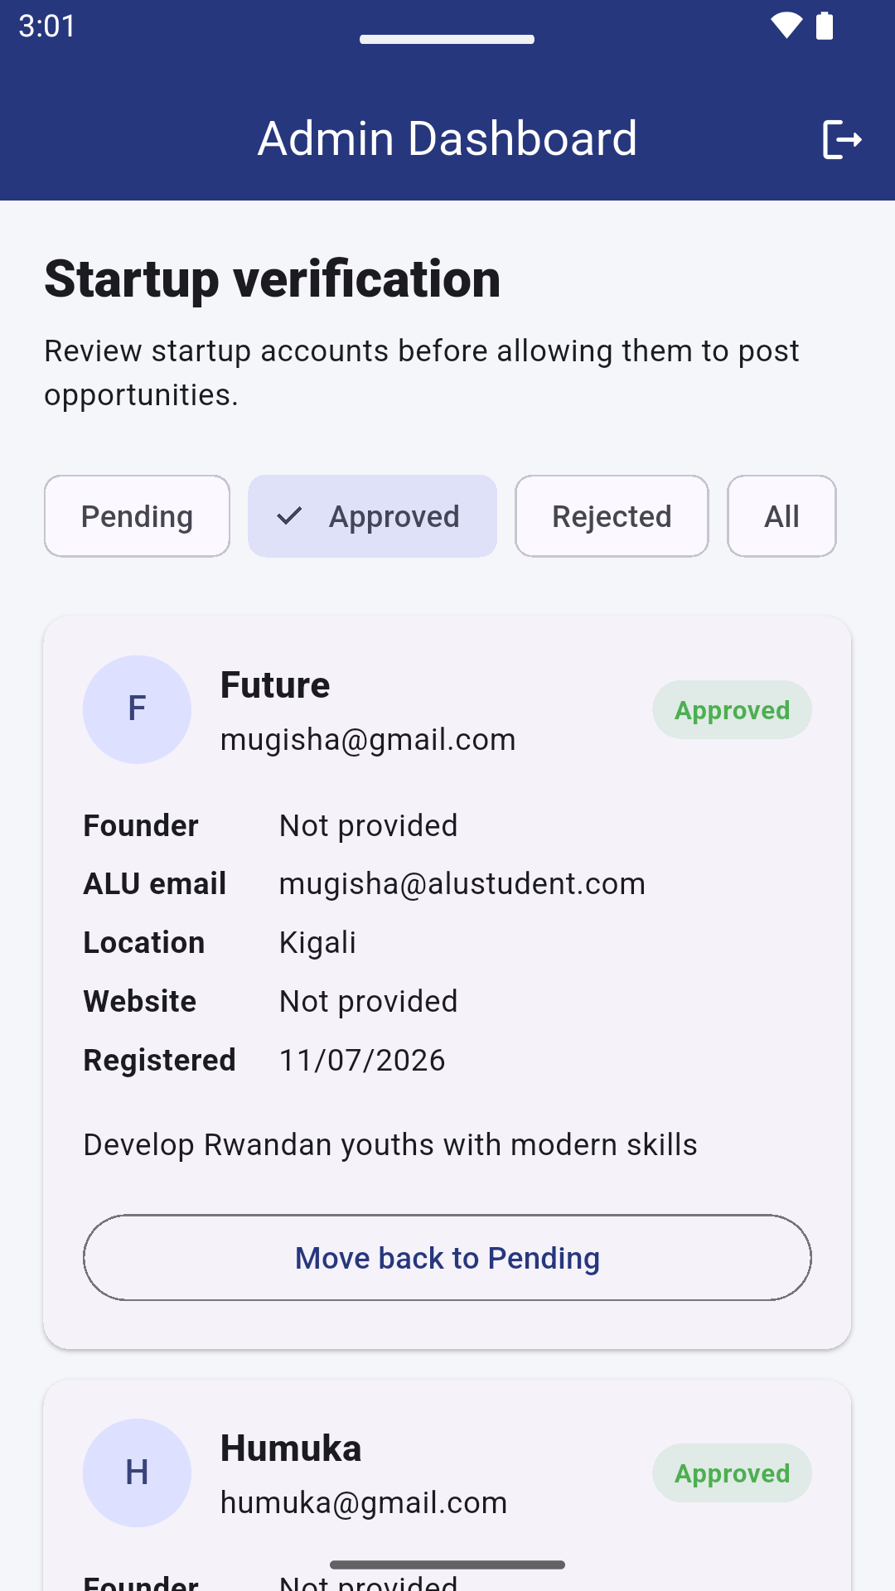
Figure placeholder: Admin Startup Verification.

8. UI/UX Design Reasoning

The interface was designed for clarity, not to show every feature to every user. Students and startups have different navigation, because their goals are different. This reduces confusion and makes the app easier to use.

8.1 Key Design Decisions
- Role-first experience: The chosen role controls navigation, labels, and available actions.
- One-screen registration: Role selection and sign-up are combined into one form, so there are fewer steps.
- Clear status labels: Application status uses simple text: Pending, Reviewing, Accepted, Rejected.
- Empty-state guidance: Screens show helpful messages when there are no opportunities, bookmarks, applications, applicants, or notifications.
- Progress feedback: Buttons turn off while submitting, and loading indicators appear while data loads.
- Mobile-first scrolling: Forms use SingleChildScrollView and SafeArea. This stops the keyboard from covering content on small screens.

8.2 Accessibility Considerations
- Clear text labels are used, not only icons.
- Validation messages tell users exactly what to fix.
- Touch targets use standard Material buttons and icon buttons.
- Text and controls support light and dark themes, where built.
- Important actions, like deleting something, should ask for confirmation before the final release.

9. Security and Access Control
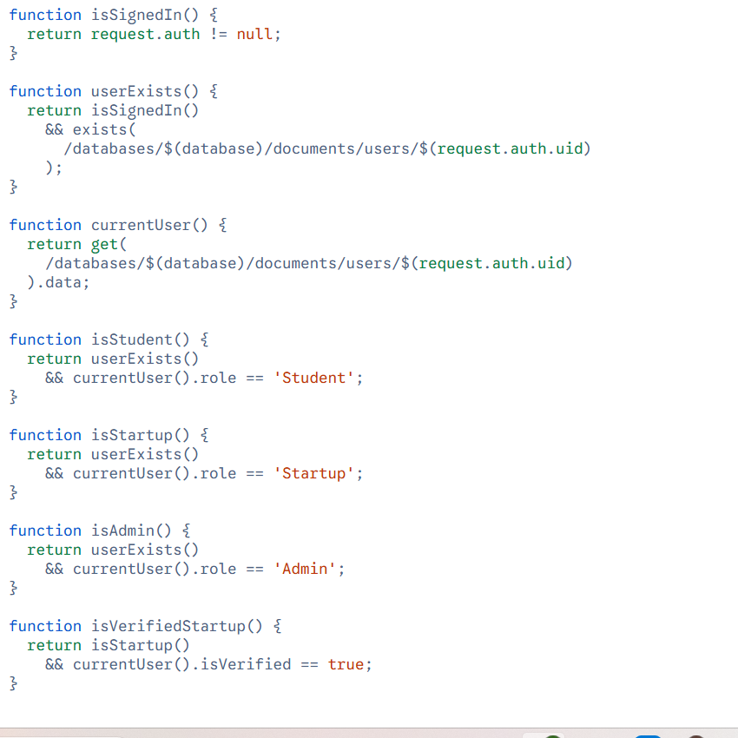
Security is enforced in both the app and in Firestore. UI checks improve the user experience, but Firestore Security Rules give the real protection, because a client app's code can be changed by anyone. The rules check login status, role, ownership, and which fields can be changed.

9.1 Authentication Controls
- Firebase Authentication identifies each signed-in user by their UID (unique ID).
- AuthGate restores the correct session and role-based navigation.
- Student profiles must use an @alustudent.com email. Startup accounts must provide a valid account email and a founder @alustudent.com email. These checks are applied in Flutter and Firestore rules.
- The profile email must match the authenticated email.

9.2 Firestore Authorization
Resource | Allowed operations | Protection
User profile | Own read/update; Admin reads startup profiles | UID, protected fields, and Admin-only verification updates
Opportunity | Signed-in read; verified startup create/update/delete | startupId ownership and isVerified check
Application | Student creates; student or matching startup reads; startup updates status | studentId/startupId ownership and limited fields
Bookmark | Owner read/create/delete | Path userId must match signed-in UID
Notification | Startup creates status notification; student reads/updates/deletes | Linked to application owner and notification userId
Startup verification | Admin approve/reject/pending | Admin role and limited verification fields

9.3 API Key Consideration
The Firebase client configuration may appear in the code repository. This is normal, because Firebase client API keys identify the project, not give full access. Even so, the key should still be restricted in Google Cloud. Firestore rules must stay secure, and service-account credentials should never be uploaded to the repository. If the key becomes public, it should be rotated (changed) or restricted before the final release.

10. Testing Strategy
Testing combines static analysis, manual workflow testing, and checking the Firebase Console. The final check should happen on an Android emulator or a real device, not only in Chrome.

10.1 Static and Build Checks

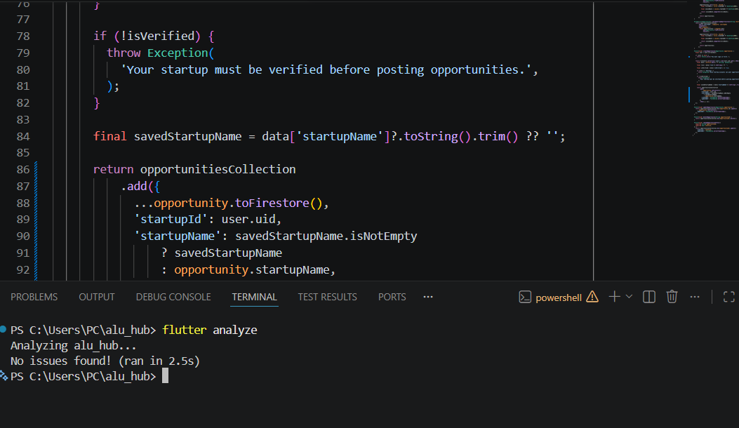
flutter analyze
flutter clean
flutter pub get
flutter run

10.2 Manual Functional Test Cases
ID | Test | Expected Result | Evidence
01 | Register Student with Gmail | App rejects sign-up and shows an ALU-email message | App screenshot
02 | Register Student with alustudent.com | Auth account and users document are created | App + Firebase Auth
03 | Register Startup | Startup profile is created with Pending verification status | App + users collection
04 | Create opportunity | Opportunity appears in startup dashboard and student discovery | App + opportunities collection
05 | Edit and deactivate opportunity | Updated values sync; inactive item is hidden from student discovery | App + Firestore
06 | Bookmark opportunity | Saved list updates and stays after restart | App + bookmark subcollection
07 | Submit application | Application saves once and appears for both roles | App + applications collection
08 | Submit duplicate application | Second submission is blocked | Validation message
09 | Change application status | Student's application status updates | Two user sessions
10 | Receive notification | Notification appears and can be read or deleted | App + notifications collection
11 | Unauthorized data access | Rules reject cross-user writes | Firebase rules test / manual attempt
12 | Logout and login again | Session ends; correct account can sign in again | App
13 | Approve startup as Admin | Status becomes Approved and isVerified becomes true | Admin app + users collection
14 | Reject or return startup to Pending | Startup cannot create an opportunity | Admin app + permission message
15 | Sign in with Admin account | Admin Dashboard opens and lists startup accounts | App screenshot

10.3 Error and Edge-Case Testing
- Empty form fields and wrong email formats.
- Passwords shorter than the minimum length, and mismatched confirmation.
- No internet connection or a failed Firebase request.
- Empty Firestore collections.
- Expired opportunity deadlines.
- A startup with no applicants.
- A student with no applications or notifications.
- Repeated button taps during submission.

10.4 Current Verification Status
The main Firebase-connected workflows, including Admin startup verification, are implemented. Before submission, complete an end-to-end Android test, capture the requested evidence, and replace every highlighted screenshot slot. A test should be marked as passed only after it has been observed on the final build.

11. Scalability and Maintainability

11.1 Current Strengths
- Repositories keep all backend logic in one place, instead of repeating Firebase calls in each screen.
- Model classes create a consistent link between Dart objects and Firestore documents.
- Riverpod family providers create separate state for each student, startup, or search value.
- Firestore streams give real-time updates without needing to refresh manually.
- Role and ownership fields make the app easier to secure as it grows.
- Feature-based folders help keep related screens easy to find.

11.2 Scaling Considerations
As more users join, Firestore indexes should be added for combined queries, such as startupId plus createdAt, or isActive plus deadline. Pagination (loading data in smaller pieces) should replace loading whole collections at once. Repeated fields, like opportunityTitle and startupName, help lists load fast, but they need a clear plan for updating when the source data changes. Notification creation could later move to Cloud Functions, so it does not depend on the client app. Image uploads would need Firebase Storage and file-size limits.

11.3 Maintainability Practices
- Use consistent names for screens, and remove old mock files.
- Keep role names in one central place, to avoid mistakes like "Student" vs. "student."
- Add unit tests for model conversion and repository checks.
- Write down Firestore fields and needed indexes in the README file.
- Use clear Git commit messages for each major change.

12. Challenges, Solutions and Lessons Learned
Challenge | Solution applied | Lesson learned
Mock data was still connected to some screens | Replaced old applicant, application, bookmark, and notification data with real Firestore providers, and removed unused navigation code | A screen can look finished while still not connected to the real backend
Role selection was a separate step from registration | Combined account type and sign-up into one form | Workflow design should remove extra screens and put validation where it is needed
Student email validation used an undefined selectedRole variable | Moved selectedRole into RegisterScreen's state, and validated it in the same screen | State variables must live where validators and callbacks can reach them
Managing role-based navigation and login persistence | Used AuthGate to listen to authStateChanges and read the Firestore profile | Login status and user role are related, but they are two separate things
Sending real-time notifications for application status | Updated the application and created a notification together, inside the repository logic | Actions that touch more than one feature should live in the data layer, not the UI
Protecting Firestore data | Built security rules based on role and ownership | Checks in the app are not real security; the backend rules must check every write
Allowing only valid ALU startups to post | Added an Admin account, Pending/Approved/Rejected status, founder ALU email, and Firestore verification rules | Important business rules must be enforced in both the interface and the backend

12.1 Lessons Learned
The biggest lesson was that a working app needs the UI flow, state management, backend schema, and security rules to all work together. A change like combining registration screens affects navigation, validation, account creation, and Firestore data, all at once. The project also showed that real-time behavior is easier to manage when streams are shared through providers.

13. Limitations and Future Improvements

13.1 Current Limitations
- Startup verification is manual. The Admin must review the founder ALU email and startup information before approval; the app does not yet connect to an official ALU startup registry.
- The app does not yet support direct messaging or interview scheduling.
- Opportunity recommendations use search and browsing, not skill matching.
- Notifications are created by client-side code, not a trusted server function.
- Automated unit, widget, and integration test coverage is limited.
- Portfolio uploads use URLs, not managed file storage.
- The Admin feature currently focuses on startup verification. It does not yet include user reports, content moderation, audit history, or advanced analytics.

13.2 Future Improvements
- Connect verification to an official ALU startup directory or approval process.
- Use Cloud Functions to create trusted notifications after application updates.
- Add Firebase Storage for profile pictures, CVs, and portfolio files.
- Add chat, interview scheduling, and calendar reminders.
- Add skill-based recommendations, and filters for location, work mode, and time commitment.
- Add analytics dashboards for application conversion and opportunity engagement.
- Add pagination, caching, and Firestore composite indexes for larger amounts of data.
- Add automated testing and Firebase Emulator Suite rule tests.
- Turn on Firebase App Check and verified-email enforcement before production release.

14. Conclusion
ALU Hub shows how Flutter, Firebase, and Riverpod can work together to solve a real problem in the ALU community. The app supports Student, Startup, and Admin roles, saved login sessions, startup verification, opportunity management, discovery, applications, bookmarks, status tracking, and notifications. Its layered structure keeps the interface, state, and data separate. Firestore Security Rules protect role-based access, ownership, and verification-controlled actions.
This project goes beyond a basic CRUD app because its workflows reflect the real relationship between students, student-led startups, and platform administrators.

References
[1] Flutter, “Guide to app architecture,” Flutter Documentation, 2026. [Online]. https://docs.flutter.dev/app-architecture/guide
[2] Google Firebase, “Authenticate with Firebase using password-based accounts on Flutter,” Firebase Documentation. [Online]. Available: https://firebase.google.com/docs/auth/flutter/password-auth
[3] Google Firebase, “Get started with Firebase Authentication on Flutter,” Firebase Documentation. [Online]. Available: https://firebase.google.com/docs/auth/flutter/start
[4] Google Firebase, “Get realtime updates with Cloud Firestore,” Firebase Documentation. [Online]. Available: https://firebase.google.com/docs/firestore/query-data/listen
[5] Google Firebase, “Get started with Cloud Firestore Security Rules,” Firebase Documentation. [Online]. Available: https://firebase.google.com/docs/firestore/security/get-started
[6] Riverpod, “Providers,” Riverpod Documentation. [Online]. Available: https://riverpod.dev/docs/concepts2/providers
[7] Riverpod, “StreamProvider,” Riverpod Documentation. [Online]. Available: https://docs-v2.riverpod.dev/docs/providers/stream_provider
[8] Riverpod, “Family,” Riverpod Documentation. [Online]. Available: https://riverpod.dev/docs/concepts2/family

