MIT91207 Machine Learning: Assignment 1
Mugisha Jean Claude
17 September 2026
Table of Contents

MIT91207 Machine Learning: Assignment 1
Programme: MSc Information Technology, Level 9, Trimester 4 Module: MIT91207 Machine Learning Lecturer: Dr Gustave Udahemuka Submission date: 17 September 2026

Note on reproducibility
Every number, table and figure in this report was produced by the scripts in code/ and can be regenerated in full. Nothing is quoted from memory or from a textbook.
Item | Detail
Python | 3.9.6, virtual environment mluok
Libraries | pandas 2.3.3, scikit-learn 1.6.1, statsmodels, scipy, matplotlib
Random seed | 42 throughout, so all results are reproducible
Q6 data | data/uscrime.txt, 47 states, 16 variables, no missing values
Q7 data | data/synthetic_ETA.csv, 1,500 journeys, 15 variables, no missing values
Other questions | Data generated under a stated process, since no dataset was supplied
To reproduce: pip install -r requirements.txt then bash run_all.sh. Console output for each question is preserved in output/*_console.txt.
Where a question supplies no dataset (Questions 2, 3, 4, 5 and 8), a sample frame is constructed that carries exactly the faults the question describes. The generating process is written out in the script, so the conclusions can be checked against a known ground truth. This is deliberate: it is the only way to show that a proposed treatment recovers the right answer, because with real data the right answer is unknown.

Question 1: Student early-warning system (12 marks)

1(a) Formulating the problem (5 marks)
The university has not asked for a prediction. It has asked for a way to decide which students an advisory team should contact next week. That distinction governs everything that follows, because the quantity being optimised is the quality of a ranking under a fixed capacity constraint, not the accuracy of a label.
The target variable. “Poor academic outcome” is not yet a variable. It has to be made one, and the choice is a policy decision rather than a technical one. Three defensible definitions are available, and they are not equivalent:
Definition | Type | What it supports
Final module mark | Continuous, 0 to 100 | How far below the line a student is likely to fall
Pass or fail at the 50% threshold | Binary | Whether to intervene at all
Progression outcome at end of year | Binary, longer horizon | Retention planning
The prediction horizon is part of the problem definition. A model that predicts the final mark using the final coursework score is useless, because by the time that score exists the outcome is already settled. The system must be specified as: given only the information observable at week t, predict the outcome at end of module. This makes the feature set a function of t and forces attendance, learning-management-system engagement and early assessment marks to be truncated at the prediction date. Section 2(d) of this report treats the same problem in a recommendation setting.
My recommendation is to treat it as both, with the regression as the primary model. The underlying quantity, the final mark, is continuous and the dichotomy at 50% is an administrative convention applied to it. Fitting the continuous outcome and then thresholding preserves information that a direct classifier discards. A student predicted at 49% and a student predicted at 18% are both classified “at risk”, but they require entirely different interventions, and the classifier cannot tell them apart. The regression output also supports a conversation the classifier cannot support, namely what mark the student needs on the remaining assessment to recover.
The classification framing is still required, for two reasons. The decision itself is binary, so a threshold has to exist somewhere. And a calibrated probability of failure is the correct input to a capacity-constrained triage rule, because it can be combined with the cost of a missed intervention to produce a defensible cut-off. The practical design is therefore a regression model on the mark, plus a calibrated classifier used for ranking, with the two reconciled at the point of decision.
What the university is really buying is a ranking. With, say, four advisors and 900 students, only the top forty or so cases will ever be contacted. A model with modest overall accuracy but a well-ordered top decile is more useful than an accurate model that mixes the top decile, and this is why the evaluation in 1(c) and in Question 5 is framed around ranking quality and subgroup behaviour rather than raw accuracy.

1(b) Two modelling approaches (5 marks)
Classification approach: penalised logistic regression, moving to gradient boosting if the data justifies it.
Logistic regression is the right starting point here, not a fallback. It produces a probability that is directly interpretable as a risk score, the coefficients can be shown to an academic board that will reasonably ask why a particular student was flagged, and with L2 penalisation it behaves stably when attendance and engagement measures are correlated, which they invariably are. Question 7 of this report demonstrates that penalisation mainly buys coefficient stability rather than accuracy, which is precisely what is wanted when the output has to be defended.
How the prediction supports the decision: the model returns P(fail) for every enrolled student each week. Advisors receive a ranked list with the probability attached, banded into three tiers. Above 0.70, contact this week. Between 0.40 and 0.70, monitor and contact if the trend worsens. Below 0.40, no action. The bands are set from the advisory capacity and the relative cost of the two errors, not from the default 0.50 cut-off, which corresponds to no particular institutional preference. Because the probability is calibrated, “seventy per cent” can be checked against the observed failure rate of students given that score, and the board can audit that claim.
Regression approach: gradient-boosted regression trees on the final mark.
The relationship between engagement and attainment is not linear. Attendance rising from 30% to 50% matters a great deal, and from 80% to 95% matters very little. A boosted tree model captures that saturation without anyone having to specify it, and it handles the interaction between prior grades and current engagement that a linear model would need to be told about explicitly. Ridge regression is the appropriate comparator, and on a first-year cohort with few features it will often match the boosted model, which is a result worth knowing before committing to the more complex option.
How the prediction supports the decision: the model returns a predicted mark with an interval. The actionable quantity is the predicted distance from the pass mark. A student predicted at 47 plus or minus 6 is a different case from one predicted at 25 plus or minus 6, even though both are below the line, and the intervals let an advisor distinguish a confident prediction from an uncertain one. The intervals matter more than the point estimate for a borderline student, because that is where the intervention decision is genuinely difficult.
Why run both. They fail differently. If the classifier flags a student the regression places at 62, that disagreement is itself a signal, usually that the student’s pattern is unusual relative to the training cohort. Routing disagreements to human review is a cheap and effective safeguard.

1(c) Two factors beyond predictive accuracy (2 marks)
Subgroup performance, and the asymmetry of the two errors. Aggregate accuracy is an average, and averages conceal exactly the failures that matter here. Question 5 of this report measures this directly on a comparable problem: an overall AUC of 0.731 was composed of subgroup AUCs ranging from 0.695 to 0.763, and subgroup recall ranged from 0.275 to 0.529. A 25 percentage point spread in recall means the system finds half the at-risk students in one group and a quarter in another, while reporting a single respectable headline number. In this university setting the groups that matter are likely to be part-time students, students entering through non-standard qualifications, and students whose engagement is off-campus and therefore under-recorded by the learning-management system. The two errors are also not symmetric. A false negative is a student who fails without ever being contacted. A false positive costs an advisor twenty minutes. Accuracy weights these equally, which is indefensible, so the model must be evaluated on recall within each subgroup at the operating threshold, and the threshold itself must be justified against that asymmetry.
The gap between prediction and action, and the feedback loop the system creates. The model finds association, not cause. Low learning-management-system engagement predicts failure, but it is largely a symptom. A student in financial difficulty, working night shifts, will show low engagement, and an intervention aimed at raising their click rate addresses the indicator rather than the cause. The features must therefore be interrogated for whether they are actionable at all before the system is allowed to drive interventions, a point developed at length in Question 6(d). There is also a loop that most deployments overlook: once interventions begin, a successful intervention makes the prediction wrong, so the model’s apparent accuracy degrades precisely when it is working. Without recording which students were contacted and treating that as a variable, the retraining cycle will progressively unlearn the signal that made the system useful. In addition, a student labelled “at risk” may be treated differently by staff and may internalise the label, so the prediction can contribute to the outcome it forecasts. Under Rwanda’s Law No. 058/2021 relating to the protection of personal data and privacy, profiling students in this way also carries transparency and lawful-basis obligations that need to be settled before deployment rather than after.

Question 2: Course-recommendation preprocessing (13 marks)

2(a) Preprocessing pipeline design (5 marks)
The four faults the question lists are not equally serious, and treating them as a uniform cleaning checklist is the main risk. Ordering matters, because several of the operations interact.
Order of operations, and why.
- Duplicates first. Deduplicating after computing statistics would mean the statistics were computed on inflated counts. Two kinds exist here and they need different treatment. Exact repeated rows are ingestion artefacts and can be dropped outright. Repeated learner-course pairs with different timestamps are not errors at all, they are re-enrolments, and dropping them blindly destroys real behaviour. In the sample frame this distinction removed 2 rows as re-enrolments while retaining the most recent record for each pair.
- Category harmonisation second, because grouped statistics computed later depend on the grouping key being correct. "Data Science", " data science", "DATA SCIENCE" and "Data Science" are one category recorded four ways. Left alone they become four one-hot columns, each with a quarter of the support, and the model sees four rare categories instead of one common one. In the sample frame, 9 distinct raw strings collapse to 3 genuine categories.
- Missing ratings third. The critical judgement is that a missing rating is not a missing number, it is an absent behaviour. Learners who abandon a course rarely rate it. Imputing the mean assigns an average opinion to people who were too indifferent to express one, which biases the recommender towards courses that are quietly disliked. The treatment is to impute a central value so the row remains usable, and to retain a binary rating_missing indicator so the model can learn what the absence itself means. Question 3 develops this argument with measured consequences.
- Scaling last, and fitted on training rows only. minutes_watched spans 30 to 1,450 while rating spans 2.5 to 5.0. Any method operating on distance, which includes k-nearest-neighbour recommenders, matrix factorisation with regularisation, and anything penalised, will be dominated by the wider variable purely because of its units.
Effect on the downstream model. Skipping harmonisation fragments the category signal and weakens any content-based component. Mean-imputing ratings without an indicator introduces a systematic bias towards recommending material that learners quietly abandoned. Fitting the scaler on all rows leaks the test distribution into training and produces an optimistic offline estimate that will not survive contact with live traffic. Deduplicating carelessly removes genuine repeat engagement, which is one of the strongest signals a recommender has.
On what not to do. Rows with missing ratings should not be dropped. In the sample frame that would discard 3 of 15 records, and the discarded rows are systematically the disengaged learners, which is to say the population the recommender most needs to model.

2(b) Implementation (5 marks)
The full script is code/q2_recommender_prep.py. The core operations:
# 1. two kinds of duplicate, treated differently
df = df.drop_duplicates() # ingestion artefacts
df = (df.sort_values("timestamp")
.drop_duplicates(subset=["learner_id", "course_title"], keep="last"))
# 2. category harmonisation: case, whitespace, separators
def norm(s):
s = s.strip().lower().replace("/", " ").replace("-", " ")
s = " ".join(s.split())
return {"data science": "Data Science", "ai ml": "AI/ML",
"databases": "Databases"}.get(s, s.title())
df["course_category"] = df.course_category.map(norm)
# 3. missing ratings: indicator retained, statistics from training rows only
cut = df.timestamp.quantile(0.7)
train_mask = df.timestamp <= cut
df["rating_missing"] = df.rating.isna().astype(int)
med_by_cat = df.loc[train_mask].groupby("course_category").rating.median()
df["rating_filled"] = (df.rating.fillna(df.course_category.map(med_by_cat))
.fillna(df.loc[train_mask].rating.median()))
# 4. scaling fitted on training rows, applied to all
sc = StandardScaler().fit(df.loc[train_mask, num])
df[[c + "_z" for c in num]] = sc.transform(df[num])
Measured result:
rows=15 exact duplicates=0 missing ratings=3 distinct category strings=9
raw category labels: [' data science', 'AI / ML', 'AI/ML', 'DATA SCIENCE',
'Data Science', 'Data Science', 'Databases', 'ai/ml', 'databases']
STEP 1 repeat learner-course rows removed (kept most recent): 2
STEP 2 9 raw strings -> 3 canonical: ['AI/ML', 'Data Science', 'Databases']
STEP 3 category medians from training rows: {'AI/ML': 4.5, 'Data Science': 4.0,
'Databases': 3.0}
STEP 5 StandardScaler fitted on training rows only
variable train mean train scale
rating_filled 3.83 0.71
minutes_watched 496.67 479.92
The scale disparity is worth stating numerically, since it is the reason step 5 exists: before scaling, minutes_watched has a standard deviation of 536.34 against 0.77 for rating, a ratio of roughly 700 to 1.

2(c) Two engineered features (2 marks)
engagement_ratio = learner’s minutes on a course divided by the median minutes for that course. Raw watch time confounds two different things, how engaged the learner is and how long the course happens to be. A 45-minute course watched in full and a 1,400-minute course abandoned after 45 minutes produce the same raw value and mean opposite things. Normalising by the course median separates them. For the recommendation problem this matters because the quantity of interest is whether this learner found this material worth their time relative to how other learners treated it, which is a completion signal that does not depend on a rating being given. In the sample frame the feature ranges from 0.375 to 4.0, cleanly separating skimming from deep engagement.
prior_completion_rate = the proportion of the learner’s earlier courses that they completed. Learners differ systematically in follow-through, and that disposition is one of the strongest available predictors of whether a recommendation will be acted on. Recommending an advanced twelve-week course to a learner who has abandoned four of five enrolments is a poor recommendation even if the topic matches perfectly. The implementation detail is the entire point: it uses shift() before expanding().mean(), so a record never contributes to its own feature value. Without the shift this is a textbook leak, since the current course’s completion status would be encoded in the feature used to predict it.

2(d) Preventing information from the future (1 mark)
Split on time, not at random, and fit every statistic on the past side only.
Concretely, four things are required. Records are ordered by timestamp and cut at a date, so training ends before validation begins. Every fitted quantity, meaning imputation medians, scaler means and scales, and category vocabularies, is learned on the training window and applied unchanged afterwards. Any per-learner aggregate is computed with an expanding window over strictly earlier records, which is what shift() enforces above. And features that could only be known after the fact, such as final course rating or total watch time, are excluded from any model that scores a learner mid-course.
The check is mechanical and is run by the script:
train window 2026-01-05 .. 2026-04-15 (n=9)
test window 2026-04-21 .. 2026-06-01 (n=4)
overlap: NONE
first-ever record for any learner carrying non-zero history: False (must be False)
The second assertion is the one that catches real bugs. Any learner’s first record must carry a prior-completion rate of zero, because at that moment they have no history. If it does not, an aggregate has been computed over the full series and the future has entered the training data. —

Question 3: Missing data in loan default prediction (13 marks)
The analysis uses a 3,000-record loan book generated under a known process, so that the true values behind the gaps are available for comparison. The missingness mechanisms are deliberately realistic: income is under-reported by informally employed applicants, and credit scores are absent for applicants with no borrowing history. Script: code/q3_missing_data.py.
missing %
income 506 16.9
years_employed 255 8.5
credit_score 492 16.4
employment_type 122 4.1

3(a) Critical evaluation of zero-filling (5 marks)
The proposal is wrong, and it is worth being precise about why, because “zero is a bad imputation” is not an argument. Zero is a legitimate value for some financial variables and a nonsensical one for others, and the distinction turns on what zero means on each variable’s own scale.
Zero is a real, meaningful value on some of these fields and not on others. A loan balance of zero means no outstanding debt. A missed-payment count of zero means a clean record. On those fields, zero-filling does not merely add noise, it writes a specific and usually favourable claim into the data. Applied to n_prev_loans, it converts “we do not know their borrowing history” into “they have never borrowed”, which is a materially different statement to a credit committee.
On other fields zero is outside the admissible range entirely. A credit score is defined on 300 to 850. Zero is not a low score, it is not a score. Placing 492 applicants at zero creates a cluster 300 points below the legal minimum, roughly 3.5 standard deviations outside the observed distribution, and any model will read that as overwhelming evidence of default risk. The measured consequence appears in 3(d).
It destroys the geometry the model depends on. In the generated book the applicants with missing income truly earn between 64,895 and 1,390,624, with a median of 302,620, slightly above the observed median of 296,520. These are not poor applicants. They are mostly self-employed and informally employed people who did not supply a payslip. Zero-filling moves them 1.50 standard deviations below the median of the observed distribution, inverting their true position.
It silently corrupts every derived variable. Debt-to-income is the single most important ratio in consumer lending, and loan_amount / income becomes a division by zero for all 506 affected applicants. Depending on the implementation this yields infinity, a NaN that propagates, or a silently clipped maximum. Any of the three makes those applicants look like the worst credits in the portfolio.
It confounds two populations that must stay separate. After zero-filling, an applicant with a genuinely low income and an applicant who declined to state their income are the same record. These are different credit risks and, under most regulatory regimes, attract different treatment. The information distinguishing them has been erased rather than modelled.
It is not random, so the damage is systematic rather than diffuse. The script tests this directly. Testing missingness against the outcome alone is insufficient and would have cleared two of the three fields:
Default rate by whether the field is missing:
income missing: 0.247 present: 0.251 Welch p = 8.66e-01 -> consistent with MCAR
years_employed missing: 0.204 present: 0.254 Welch p = 5.94e-02 -> consistent with MCAR
credit_score missing: 0.183 present: 0.263 Welch p = 4.45e-05 -> NOT MCAR
Missingness tested against an OBSERVED COVARIATE (employment_type):
income chi2 p = 4.83e-77 -> MAR, depends on employment_type
missing rate: {'informal': 0.417, 'salaried': 0.068, 'self_employed': 0.177}
Income is missing for 41.7% of informally employed applicants against 6.8% of salaried applicants. A target-only test returns p = 0.87 and would have declared it missing-completely-at-random. Because the missingness concentrates in one employment class, zero-filling imposes its damage almost entirely on informal-sector applicants, who in the Rwandan market are the majority of the addressable population. This is the mechanism by which a naive imputation choice becomes a systematic lending bias.

3(b) A defensible strategy (3 marks)
The strategy must distinguish variables by type and, more importantly, by why the value is absent. The two questions are separate and both have to be answered.
First, classify the mechanism. Missing-completely-at-random means the gap is unrelated to anything, and almost nothing in a loan book qualifies. Missing-at-random means the gap depends on other observed variables, which is what the chi-square result above establishes for income: it depends on employment type, which is recorded. Conditional imputation is valid here. Missing-not-at-random means the gap depends on the unobserved value itself, and credit score is the clear case. The cross-tabulation shows all 492 absent scores belong to applicants with no prior loans:
no prior loans False True
score missing
False 2415 93
True 0 492
This is not a gap to be filled. It is a structural fact about thin-file customers, and imputing any score onto that population fabricates a credit history that does not exist.
Second, apply a treatment matched to the type and the mechanism.
Variable class | Treatment | Reasoning
Skewed monetary (income, loan amount) | Median from training rows, plus missing indicator | Median resists the right skew that makes the mean misleading on income data
Continuous non-monetary (years employed) | Median or conditional median within employment type, plus indicator | MAR given employment type, so conditioning recovers more than a global statistic
Structural absence (credit score) | Explicit no_credit_file flag, value held separately from the score scale | The applicant has no score; a thin file is a distinct underwriting category
Categorical (employment type) | not_reported as its own level, never the mode | Non-response is itself informative; imputing the mode invents an employment status
Target | Never imputed | Rows without a known outcome are excluded from supervised training
Third, retain the indicator in every case. If non-response carries no information the model will assign the indicator a near-zero coefficient and nothing is lost. If it does carry information, and here it plainly does, that information is preserved instead of being averaged away. This is the cheapest insurance available in the whole pipeline.
Fourth, learn every statistic on training rows only, and persist it. A median computed over the full dataset leaks the test distribution; a median recomputed at scoring time makes today’s decision depend on who else applied today, which is indefensible to an applicant and to a regulator.
Listwise deletion should be rejected explicitly. The measurement in 3(d) shows it retains only 62% of training rows and shifts the observed default rate from 0.250 to 0.276, because the discarded records are not a random sample.

3(c) A pipeline-ready function (3 marks)
Implemented as a scikit-learn transformer so it composes inside a Pipeline and inherits the fit/transform separation that prevents leakage by construction. Full source in code/q3_missing_data.py.
class MissingValueHandler(BaseEstimator, TransformerMixin):
"""Type-aware missing-value handler.
Assumptions, stated explicitly:
1. Numeric fields are MAR given the observed data, so a median computed on the
training rows is an acceptable central estimate. The median is used rather than
the mean because every monetary field here is right-skewed.
2. Missingness itself may be informative, so an indicator column is retained for
every field that is imputed. If the indicator carries no signal the model can
ignore it; if it does, the information is not thrown away.
3. Structurally absent values (no credit file) are a distinct category, not a low
value, and are flagged separately rather than imputed onto the score scale.
4. All statistics are learned in fit() on training rows only and re-applied
unchanged in transform(), so no test or production record influences them.
"""
def __init__(self, numeric, categorical, structural=(), indicator=True):
self.numeric, self.categorical = list(numeric), list(categorical)
self.structural, self.indicator = list(structural), indicator
def fit(self, X, y=None):
self.medians_ = X[self.numeric].median()
self.modes_ = {c: (X[c].mode().iloc[0] if X[c].notna().any() else "unknown")
for c in self.categorical}
self.columns_ = list(X.columns)
return self
def transform(self, X):
X = X.copy()
for c in self.numeric + self.categorical:
if self.indicator and X[c].isna().any() or c in self.structural:
X[f"{c}__missing"] = X[c].isna().astype(int)
for c in self.structural:
X[c] = X[c].fillna(self.medians_.get(c, 0))
for c in self.numeric:
X[c] = X[c].fillna(self.medians_[c])
for c in self.categorical:
X[c] = X[c].fillna("not_reported")
return X
Assumptions and their limits. The median is a point estimate, so single imputation of this kind understates uncertainty: the model treats an imputed income as being known as precisely as a reported one. Multiple imputation addresses that and should be preferred where the downstream use requires calibrated intervals rather than a ranking. The transformer also assumes the missingness mechanism is stable between training and production, which is an assumption that has to be monitored rather than believed, since a change in application-form design can alter it overnight.

3(d) Consequences for the model and for applicants (2 marks)
Three treatments, identical splits, identical model, so the only difference is the handling of gaps:
Treatment | Test AUC | Brier score | Note
Zero-fill, as proposed by management | 0.6659 | 0.1772
Type-aware median with indicators | 0.7575 | 0.1586
Complete-case deletion | 0.7524 | 0.1611 | Retains 1,397 of 2,250 rows; default rate shifts 0.250 to 0.276
Model performance. Zero-filling costs 9.2 points of AUC, from 0.758 to 0.666. On a discrimination scale where 0.5 is a coin toss, that is roughly a third of all the signal the model had. The Brier score, which measures the accuracy of the probabilities rather than the ranking, worsens by 12%, so the predicted probabilities are not merely ordered worse, they are numerically wrong. Complete-case deletion very nearly matches the proper treatment on these metrics but does so having discarded 38% of the training data, and its retained sample has a default rate 2.6 percentage points above the true one. That bias does not appear in the AUC and would surface later as a miscalibrated portfolio.
Decisions about individual applicants. This is where the abstract metric becomes a person. Of 750 test applicants, 228 have at least one missing field.
mean predicted default probability, those applicants:
zero-fill 0.2883
type-aware 0.2373
largest single shift: 0.3342 in predicted probability
at a 20% decline threshold, 75 applicants (32.9% of those with gaps) receive a
different decision purely from the imputation choice
at a 30% decline threshold, 31 applicants (13.6%) receive a different decision
One applicant’s assessed probability of default moves by 33 percentage points depending on a preprocessing default that nobody would think to document. At a 20% decline threshold, a third of applicants with any data gap are decided differently. None of these people changed. Their circumstances did not change. A line of code changed.
Because the gaps concentrate in informally employed applicants, as established in 3(a), those reversals are not spread evenly across the applicant pool. They fall on a specific economic class, which converts a technical shortcut into a fair-lending exposure. That is the argument to put to the management team: the proposal is not a simplification that costs a little accuracy, it is an undocumented change in credit policy.

Question 4: Feature engineering for subscription renewal (12 marks)
Measured on 4,000 generated customer records with a known outcome process, so that the cost of each encoding choice can be quantified rather than asserted. Script: code/q4_encoding.py.

4(a) Pipeline design (3 marks)
The variables divide into three groups, and the division is by measurement level rather than by storage type. This is the judgement the question is testing, because subscription_type and region are both stored as strings and must be treated differently.
Group | Variables | Transformation | Justification
Numeric, skewed | monthly_spend | Log, then standardise | Log-normal by construction; a linear model fitted on the raw scale is dominated by the upper tail
Numeric, roughly symmetric | age, n_prev_transactions, account_duration_days | Standardise | Puts all coefficients on a comparable scale and makes any penalty act evenly
Ordinal | subscription_type (basic, standard, premium) | Ordinal encoding with the order stated explicitly | A genuine ranking exists, and one coefficient captures it
Nominal | region, payment_method, customer_status | One-hot | No ordering exists, so none may be imposed
On scaling. Standardisation rather than min-max, because min-max is defined by the observed minimum and maximum and is therefore hostage to a single outlier; a customer with an unusually long account compresses everyone else into a narrow band. Standardisation also matters for any penalised model, since a penalty applied to coefficients on different scales penalises variables unequally for reasons that have nothing to do with their importance.
An empirical note that qualifies the usual advice: in this dataset, omitting scaling cost almost nothing in discrimination, 0.7302 against 0.7310 AUC. What it did cost was convergence. The unscaled model exhausted 2,000 L-BFGS iterations without converging on every cross-validation fold. Scaling here is a numerical-conditioning requirement rather than an accuracy requirement, and that is the honest statement of its value.
Ordering. Fit every transformation on training data only, and compose the whole sequence inside a single ColumnTransformer so that the same objects can be persisted and reused at scoring time. Section 4(d) shows what the alternative costs.

4(b) Consequences of each encoding choice (4 marks)
Measured by five-fold stratified cross-validated AUC, varying only the encoding:
Strategy | Model | CV AUC | Width
One-hot nominal, ordinal tier | Logistic regression | 0.7310 | 14
Ordinal codes forced onto nominal | Logistic regression | 0.6424 | 8
One-hot everything, tier order discarded | Logistic regression | 0.7305 | 15
Correct encoding, no scaling | Logistic regression | 0.7302 | 14
Ordinal codes forced onto nominal | Random forest | 0.6908 | 8
One-hot nominal | Random forest | 0.7069 | 17
One-hot encoding. Appropriate whenever the categories have no order, which covers region, payment_method and customer_status. It imposes no false relationship, and each category gets its own coefficient. The costs are real but manageable at this cardinality: the design matrix widens from 8 to 14 columns, and with a high-cardinality field such as a customer identifier or a postcode it would widen without limit while each resulting column carried almost no data. It is the wrong choice when cardinality is high relative to sample size, where target encoding with out-of-fold statistics or a grouped “other” category is preferable. Notably, one-hot encoding the ordinal tier cost only 0.0005 AUC. Discarding a genuine ordering is nearly free when the variable has three levels, because the model simply spends two coefficients where one would have done. That is the mild error.
Ordinal encoding. Correct for subscription_type, where basic, standard and premium form a real progression, provided the order is stated explicitly rather than left to alphabetical accident. Applied to nominal variables it is the severe error, costing 0.0886 AUC, which is 12% of the model’s discrimination. The reason is visible in the generating process:
region alphabetical code true effect on renewal
Kigali 0 0.9
Northern 1 -0.3
Southern 2 -0.5
Eastern 3 0.2
Western 4 -0.4
correlation between the integer code and the real effect: -0.572
Encoding these regions as 0 to 4 asserts that Kigali is less than Northern is less than Southern, and that the gap between each pair is identical. Neither claim is true. The model fits one coefficient to a sequence carrying no meaning, and the sign of the correlation between code and effect is arbitrary, being an artefact of the alphabet.
Inappropriate numerical encoding, and why the model matters. The same mistake under a random forest costs 0.0161 AUC rather than 0.0886. A tree splits on thresholds and can isolate any individual integer code through repeated splits, so it recovers most of the structure a linear model cannot. This is the part usually stated too simply. Encoding is not right or wrong in isolation, it is right or wrong relative to the model that consumes it. Ordinal codes on nominal variables are close to fatal for linear and distance-based methods and merely inefficient for tree ensembles. Even so, the forest still pays for it, so the defensible default is to encode correctly rather than to rely on the model to compensate.

4(c) Implementation (3 marks)
pre = ColumnTransformer([
("num", Pipeline([("impute", SimpleImputer(strategy="median")),
("scale", StandardScaler())]), num),
("ord", Pipeline([("impute", SimpleImputer(strategy="most_frequent")),
("encode", OrdinalEncoder(categories=[tiers],
handle_unknown="use_encoded_value",
unknown_value=-1))]), ordinal),
("nom", Pipeline([("impute", SimpleImputer(strategy="constant",
fill_value="not_reported")),
("encode", OneHotEncoder(handle_unknown="ignore"))]), nominal),
])
full = Pipeline([("pre", pre),
("model", LogisticRegression(max_iter=2000, random_state=42))]).fit(X, y)
Two details carry the weight. categories=[tiers] states the ordering explicitly, so it cannot be reassigned alphabetically when a future dataset happens to sort differently. handle_unknown is set on both encoders, so an unrecognised category at scoring time produces a defined value instead of an exception in production.

4(d) Consistency at deployment (2 marks)
Persist the fitted pipeline and load it at scoring time. Never rebuild it. The transformation is not code, it is code plus the parameters learned from training data: the medians, the means and scales, and the category vocabularies. Re-deriving those from whatever data happens to be present at scoring time silently changes the transformation.
saved artefact reproduces training-time output exactly: True
training feature width frozen at 17 columns
refitting the transformer on a later batch instead of loading it shifts the same
five customers by up to 0.0924 in predicted probability
Refitting rather than loading moved identical customers by up to 9.2 percentage points of predicted renewal probability. Nothing about those customers changed. This is train/serve skew, and it is silent, since both pipelines run without error and produce plausible numbers.
A specific trap worth naming, because it is a default that looks safe. Combining drop="first" with handle_unknown="ignore" is a common pairing and the two options are incompatible:
reference level 'Eastern' -> [[0, 0, 0, 0]]
unseen level 'Musanze' -> [[0, 0, 0, 0]]
The dropped reference category and a genuinely unrecognised category produce an identical all-zero vector. A customer from a region the model has never seen is therefore scored as though they were from the reference region, silently and with no error raised. The remedy is to keep all levels when unknown categories are possible in production, or to add an explicit unknown category during training so the two cases stay distinguishable. This also surfaced during Question 7’s small-sample experiments, where subsamples that happened to contain no highway journeys folded that category into the reference level.
Beyond the artefact. Pin library versions, since encoder behaviour changes between releases. Validate the schema of each incoming batch against the training schema and fail loudly on a mismatch rather than coercing. Monitor the input distributions, because a pipeline that is applied perfectly consistently to data that has drifted is still producing the wrong answer, just reproducibly. —

Question 5: Hospital readmission prediction (13 marks)
Measured on 3,558 admissions belonging to 1,200 patients, of whom 78% have more than one admission. That structure is the crux of the question. Scripts: code/q5_readmission.py and code/q5b_leakage_scaling.py.

5(a) End-to-end workflow (4 marks)
1. Define the label before touching the data. “Readmitted within a specified period” is under-specified, and the specification changes the problem. Thirty days is the usual clinical and reimbursement standard. Planned readmissions, for instance a scheduled second stage of a procedure, must be excluded, or the model will learn to predict the surgical calendar rather than clinical deterioration. Transfers between facilities must not count as discharge followed by readmission. This step is placed first because every later decision depends on it, and relabelling after modelling invalidates the work.
2. Fix the prediction point. The model must run at discharge, so only information available at discharge may be used. Any post-discharge field, such as a follow-up appointment attendance flag, is unusable no matter how predictive it looks. This is the single most common source of a model that performs superbly offline and fails in deployment.
3. Acquire and link, at the patient level. Admissions are linked to a stable patient identifier before anything else, because that identifier is what makes the partitioning in 5(b) possible. Without it, group-aware splitting cannot be done and the evaluation cannot be trusted.
4. Prepare. Diagnoses and procedures are high-cardinality codes and should be grouped into clinically coherent categories rather than one-hot encoded raw. Length of stay is right-skewed and log-transformed. Missing clinical values follow the type-aware strategy of Question 3, with the specific caution that in clinical data an absent test result usually means the clinician saw no reason to order it, which is information about the patient’s presentation and must be preserved as an indicator.
5. Partition, grouped by patient. Detailed in 5(b) and implemented in 5(d).
6. Train a baseline first. Penalised logistic regression, because it is calibrated, auditable, and gives a floor that any more complex model must clear. Gradient boosting follows. A clinical model that cannot be explained to the clinicians expected to act on it will not be used, so interpretability is a functional requirement rather than a nicety.
7. Evaluate on the ranking, not on accuracy. With a 34% readmission rate, a model predicting “never readmitted” scores 66% accuracy and is worthless. Discrimination and calibration are the relevant properties, together with the subgroup analysis in 5(c).
8. Set the threshold from capacity. If the transitional-care team can follow up twenty patients a week, the threshold is the one that yields twenty flags a week. In the measured run the top quartile of predicted risk was flagged, giving recall 0.438 at precision 0.590, meaning roughly six of every ten flagged patients were genuinely readmitted.
9. Deploy behind the persisted pipeline of Question 4(d), with input-schema validation and a shadow period in which predictions are recorded but not acted upon, so that live performance can be compared with the offline estimate before anyone relies on it.
10. Monitor and schedule retraining. Clinical practice, coding standards and case mix all drift. Monitoring covers input distributions, calibration and subgroup performance, not just aggregate discrimination. As in Question 1(c), acting on predictions changes the outcomes being predicted, so the intervention flag must be recorded as a variable or retraining will progressively erase the signal.

5(b) Partitioning strategy (3 marks)
The strategy: split by patient, not by admission, and hold the test set back for a single final evaluation. Because 78% of patients contribute more than one admission, a partition drawn over rows places the same individual on both sides of the split. The model can then recognise the patient rather than the clinical pattern, and the test score measures memorisation as well as skill.
Measured on a single split:
Split | Test AUC | Patients on both sides
Random over admissions | 0.7455 | 581
Grouped by patient | 0.7299 | 0
Temporal, first 75% of days | 0.7579 | 561
The careless split reports 0.0156 AUC more than the grouped one. A single split is a noisy instrument, and that difference alone does not establish anything, which is why the comparison was repeated across twelve seeds while sweeping the number of admissions recorded per patient:
Admissions per patient | Random AUC | Grouped AUC | Inflation | 95% CI | p
1 | 0.7159 | 0.7319 | −0.0160 | [−0.0474, +0.0153] | 0.338
2 | 0.7469 | 0.7515 | −0.0046 | [−0.0137, +0.0045] | 0.345
4 | 0.7476 | 0.7353 | +0.0123 | [+0.0015, +0.0232] | 0.048
8 | 0.7636 | 0.7574 | +0.0063 | [−0.0005, +0.0131] | 0.099
16 | 0.7745 | 0.7666 | +0.0079 | [+0.0017, +0.0140] | 0.030
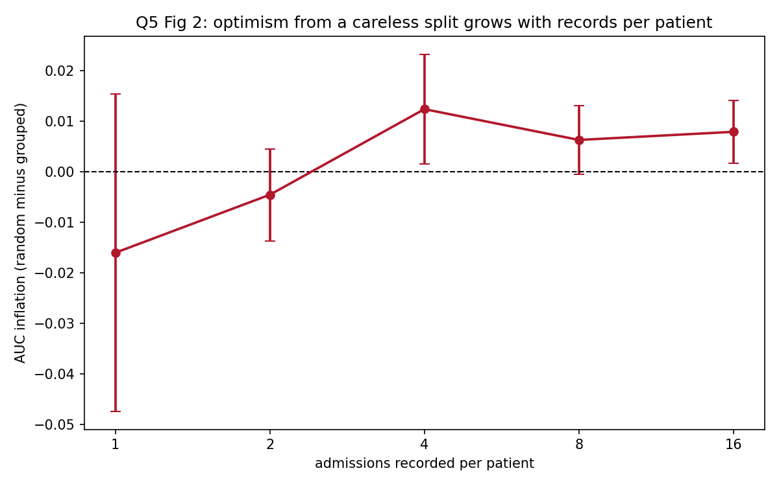
Leakage scaling with records per patient
The honest reading: with one admission per patient the two procedures are identical by construction and the difference is noise, as expected. Once patients repeat, the optimism becomes positive and statistically detectable, but in this setting it is modest, on the order of 0.006 to 0.012 AUC. It is not the dramatic collapse the textbook version of this warning implies.
That modest size is itself the useful finding, and it has a mechanism. Optimism from group leakage scales with how much of the outcome is patient-specific and with how many records each patient contributes. Here the patient effect is observable through a recorded chronic risk score, so a model trained on other patients recovers most of it legitimately, and little is left to memorise. In a setting where the patient effect is large and not captured by any recorded feature, the same mistake can inflate the estimate by far more. The practical conclusion is unchanged: group by patient regardless, because grouping costs nothing and the optimism it prevents is unbounded in the worst case.
Why careless partitioning flatters a model, in general terms. Three mechanisms, only the first of which is specific to this dataset. Group leakage, where records from one entity span the split, so the model is tested on entities it has already seen. Temporal leakage, where training data postdates test data, so the model is given knowledge of a period it is supposedly forecasting. And preprocessing leakage, where scalers, imputers or feature-selection steps are fitted on the full dataset, so the test distribution informs the transformation. The third is the most common in practice and the least visible, since the code looks correct.
A further caution specific to this dataset: the cross-validated comparison gave StratifiedKFold 0.7267 and StratifiedGroupKFold 0.7289, with the grouped estimate marginally higher. Had only that comparison been run, the conclusion would have been that grouping does not matter. Single comparisons at this effect size are not informative, and the repeated experiment is what settles it.

5(c) Uneven performance across patient groups (3 marks)
The situation is normal rather than exceptional, and the aggregate number is what concealed it. An overall AUC of 0.7314 decomposes as:
Subgroup | n | Base rate | AUC | Recall | Precision | Flag rate
insurance = mutuelle | 430 | 0.344 | 0.749 | 0.439 | 0.644 | 0.235
insurance = none | 98 | 0.347 | 0.701 | 0.529 | 0.529 | 0.347
insurance = private | 135 | 0.311 | 0.695 | 0.357 | 0.484 | 0.230
sex = F | 347 | 0.354 | 0.763 | 0.455 | 0.675 | 0.239
sex = M | 316 | 0.320 | 0.699 | 0.416 | 0.506 | 0.263
age 18-45 | 152 | 0.263 | 0.721 | 0.275 | 0.524 | 0.138
age 46-65 | 300 | 0.347 | 0.736 | 0.433 | 0.616 | 0.243
age 66+ | 211 | 0.379 | 0.717 | 0.525 | 0.583 | 0.341
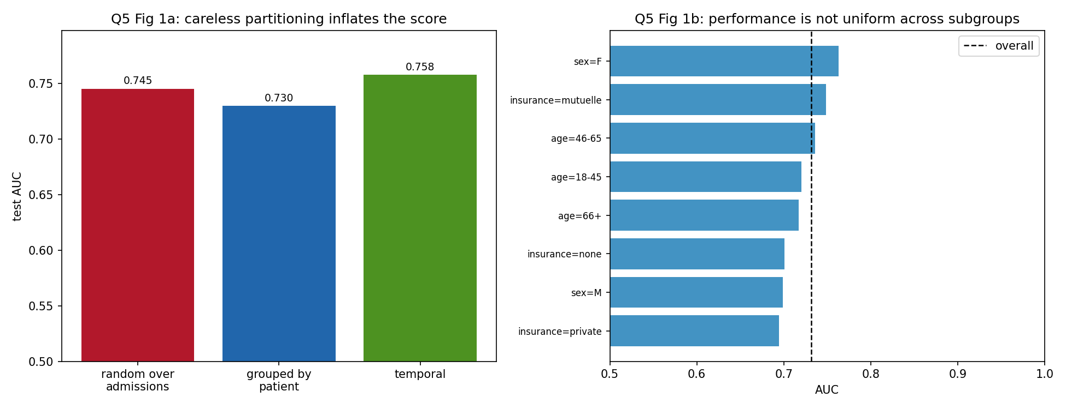
Split comparison and subgroup performance
The widest AUC gap is 0.068 and the widest recall gap is 0.254. The recall gap is the one with clinical consequences: the system identifies 52.9% of at-risk uninsured patients and 27.5% of at-risk patients aged 18 to 45. Both groups are being served by the same headline number.
Diagnosis before remedy. Three causes are worth separating, because they call for different responses. Sample size, since the uninsured group has 98 test records and its subgroup estimates carry wide intervals that should be reported with confidence bounds rather than as point values. Genuinely different relationships, which is the case here by construction, since the uninsured group’s readmission risk was generated with an additional term, so one global model is fitting a compromise that suits neither group. And differential measurement, where a group with less complete records supplies the model with less to work with, which is the most likely explanation for the private-insurance group being modelled worst despite not being the smallest.
What should be added before deployment.
Report subgroup metrics as standard, with confidence intervals, and treat the minimum across subgroups as the headline figure rather than the average. Add calibration by subgroup, since a model can rank well within a group while being systematically over- or under-confident about it, and a miscalibrated risk score sends the wrong absolute number to a clinician. Measure equal-opportunity difference, meaning the spread in true-positive rate at the operating threshold, which is the 0.254 recall gap above and is the fairness criterion that matches the harm at stake, namely a readmission that was preventable and was not prevented. Consider group-specific thresholds so that each group is flagged at a rate proportionate to its risk, noting that this is a policy decision with legal implications and not a modelling decision to be taken quietly. Evaluate against a clinical baseline such as the LACE index, because a model that underperforms existing practice in a subgroup should not be deployed for that subgroup. And run a prospective silent period before the model influences any care decision.
Underlying all of it: the question of whether the model is good enough cannot be answered in aggregate, because no patient experiences the aggregate. A patient is treated by the subgroup-specific behaviour of the system.

5(d) Partition implementation (3 marks)
from sklearn.model_selection import GroupShuffleSplit
# 1. hold out 20% of PATIENTS as the test set, touched once at the very end
rest, test = next(GroupShuffleSplit(n_splits=1, test_size=0.20, random_state=42)
.split(X, y, groups=patient_id))
# 2. split the remainder into train and validation, again by patient
# 0.25 of the remaining 80% gives a 60/20/20 overall partition
tr, val = next(GroupShuffleSplit(n_splits=1, test_size=0.25, random_state=42)
.split(X.iloc[rest], y.iloc[rest], groups=patient_id.iloc[rest]))
train_idx, val_idx = rest[tr], rest[val]
# 3. verify, do not assume
for a, b in [("train","validation"), ("train","test"), ("validation","test")]:
assert len(set(patient_id.iloc[parts[a]]) & set(patient_id.iloc[parts[b]])) == 0
Result:
subset admissions patients share readmit rate
train 2195 720 61.7% 0.350
validation 700 240 19.7% 0.314
test 663 240 18.6% 0.338
patient overlap between subsets: train/validation=0, train/test=0, validation/test=0
The shares are approximate rather than exact because patients contribute different numbers of admissions, and the split is over patients. That is the correct behaviour and the alternative would defeat the purpose. The assertion at step 3 is not decoration: it is the only thing standing between a correct split and a silent bug, and it costs one line. For model selection rather than a single split, StratifiedGroupKFold provides the same protection while preserving the class balance in each fold.

Question 6: US Crime dataset (13 marks)
47 states, 15 predictors, no missing values, with Crime measured as offences per 100,000 population. The ratio of 3.1 observations per predictor governs the entire analysis and is stated first because it disqualifies several otherwise reasonable approaches. Script: code/q6_crime.py.

6(a) Feature-selection strategy (3 marks)
Step 1: begin from the constraint, not from the data. With n = 47 and p = 15, ordinary least squares fitted on all predictors has 31 residual degrees of freedom. The measured consequence is severe: cross-validated R² for the full model is 0.098, against an in-sample fit that appears far better. The model is memorising states. Any strategy that does not reduce dimensionality is not viable here, and this is a property of the dataset rather than a preference.
Step 2: remove redundancy on structural grounds, before looking at the target. Po1 and Po2 are police expenditure in 1960 and 1959 and correlate at r = 0.994. They are one variable recorded twice. Dropping one is a decision about the data’s construction, not a data-driven selection, so it does not consume any of the statistical budget and does not risk selection bias.
Step 3: apply the three selection families and compare them honestly under cross-validation. Filter methods rank by univariate association and are fast but blind to interaction, which matters here because Section 6(b) shows two variables whose importance only appears once others are held constant. Wrapper methods such as recursive feature elimination search subsets against model performance and capture interaction, at the cost of being prone to overfitting the selection itself at this sample size. Embedded methods such as Lasso select during fitting and are the most efficient use of a small sample.
Step 4: transform where the variable’s own scale calls for it. Pop has skew 1.98 and NW 1.47, both right-skewed, so a log transformation is appropriate. Prob is a probability and a logit transformation is natural. So is already binary. The target itself has skew 1.125, which argues for modelling log(Crime) if the residuals show heteroscedasticity.
Step 5: consider combining rather than discarding. Wealth and Ineq correlate at −0.884 and both describe the same economic structure. A composite index, or principal components, retains the information that dropping one would discard.
Measured comparison, five-fold cross-validation repeated ten times:
Strategy | k | CV RMSE | CV R²
All 15 predictors | 15 | 296.84 | 0.098
Filter, abs(r) with Crime ≥ 0.30 | 6 | 317.39 | −0.052
Drop redundant (Po2, U1, Wealth) | 12 | 280.95 | 0.196
Embedded, LassoCV (α = 11.39) | 11 | 250.04 | 0.327
Wrapper, RFE with CV | 4 | 255.32 | 0.334
Two findings deserve emphasis. The filter method performs worse than using everything, with a negative R² meaning it predicts less well than the sample mean. Selecting on univariate correlation discarded variables whose contribution is conditional, which is exactly the failure mode Section 6(b) demonstrates. And the wrapper method reaches the best R² using only four predictors, Ed, Po1, Po2, Ineq, though its selection of both Po1 and Po2 shows that recursive elimination does not by itself resolve collinearity and still needs the structural judgement from step 2.
Recommended strategy: drop Po2 structurally, log-transform Pop and NW, then use Lasso with cross-validated penalty for selection, and report the result alongside a domain-chosen model rather than in place of it. Selection should be nested inside the cross-validation loop, otherwise the reported performance is optimistic for the same reason discussed in Question 5(b).

6(b) Exploratory analysis and correlation matrix (6 marks)
corr = df.corr()
fig, ax = plt.subplots(figsize=(10, 8.5))
im = ax.imshow(corr, cmap="RdBu_r", vmin=-1, vmax=1)
for i in range(len(corr)):
for j in range(len(corr)):
ax.text(j, i, f"{corr.iloc[i,j]:.2f}", ha="center", va="center", fontsize=6.5)
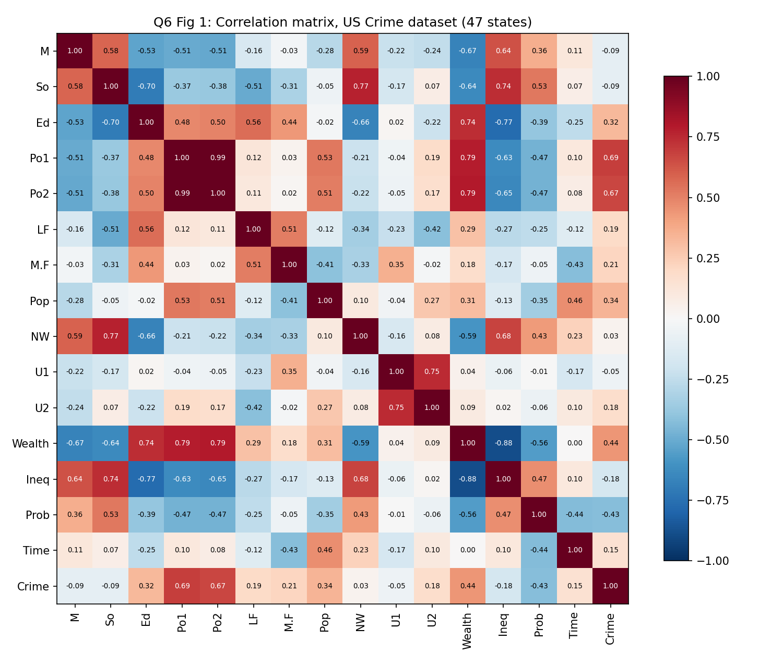
Correlation matrix
Association with the target.
Variable | Meaning | r with Crime | p
Po1 | Police spending 1960 | +0.688 | <0.001
Po2 | Police spending 1959 | +0.667 | <0.001
Wealth | Median assets | +0.441 | 0.002
Prob | Probability of imprisonment | −0.427 | 0.003
Pop | Population | +0.338 | 0.020
Ed | Mean schooling | +0.323 | 0.027
M.F | Males per 100 females | +0.214 | 0.149
Ineq | Income inequality | −0.179 | 0.229
NW | Non-white population | +0.033 | 0.828
Six of fifteen predictors reach conventional significance. Note that with fifteen simultaneous tests at α = 0.05, roughly one false positive is expected by chance alone, so the marginal results around p = 0.02 to 0.03 should not be over-read.
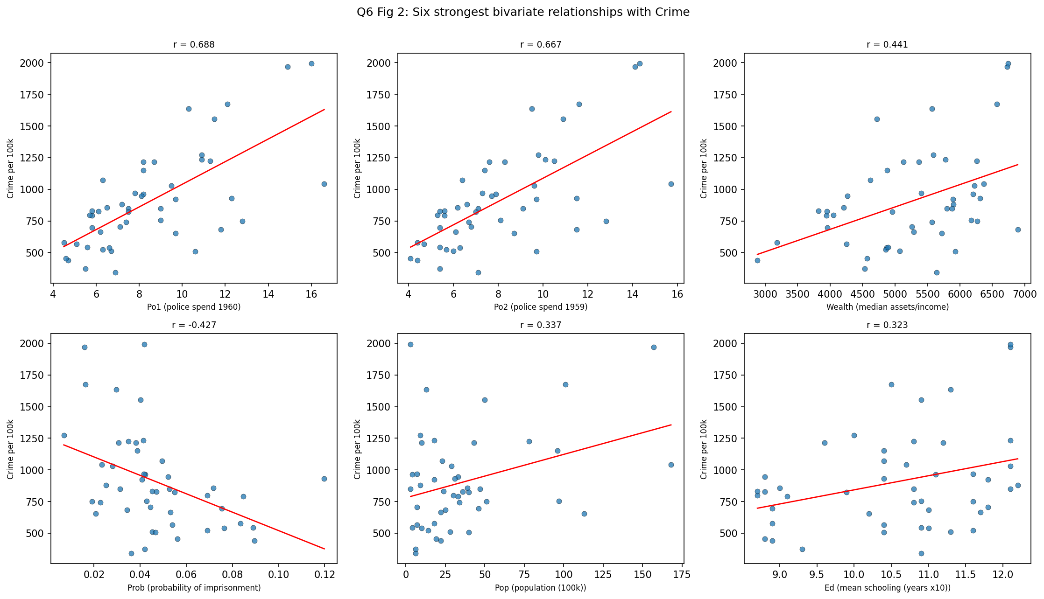
Bivariate relationships
Relationships that look useful. Police expenditure is the strongest single correlate. The probability of imprisonment is the strongest negative one, consistent with a deterrence reading. Wealth and education both associate positively with crime, which is counter-intuitive until one notices they also correlate with urbanisation and with reporting quality.
Why correlation alone is not sufficient evidence for selecting features. Four distinct reasons, each measured on this dataset rather than asserted.
First, reverse causation. Po1 has the strongest correlation with Crime in the dataset. The natural reading, that police spending causes crime, is absurd. The plausible mechanism runs the other way: states experiencing high crime allocate more money to policing. A correlation coefficient is symmetric and contains no information about direction. It cannot distinguish “police cause crime” from “crime causes police”, and nothing in the matrix resolves it.
Second, confounding. Both Wealth and Ed associate positively with crime, which inverts the usual expectation. Both also correlate with urbanisation, and urban areas have more reported property crime and better reporting infrastructure. The bivariate correlation absorbs the confounder’s effect and attributes it to the variable being examined.
Third, and most damaging for feature selection, suppression. A variable can appear irrelevant on its own and become strongly significant once others are held constant:
Ineq simple r=-0.179 (p=0.229) controlled beta= 281.65 (p=0.0010)
M simple r=-0.089 (p=0.550) controlled beta= 129.99 (p=0.0164)
U2 simple r= 0.177 (p=0.233) controlled beta= 14.35 (p=0.7350)
Income inequality has a negative, non-significant simple correlation with crime. After controlling for police spending and wealth, its coefficient is positive, large and highly significant (p = 0.001). Both the sign and the significance reverse. A filter that screened at abs(r) ≥ 0.30 would have discarded Ineq and M before modelling began, and this is precisely why that strategy produced a negative cross-validated R² in 6(a). The converse also appears: U2 looks mildly promising alone and is clearly irrelevant once conditioned.
Fourth, correlation measures only monotone linear association. A U-shaped relationship returns r near zero. Pearson correlation also responds strongly to outliers, and with 47 points a single unusual state can move a coefficient materially.
The effect works in the other direction too. Po1’s simple correlation of 0.688 rises to a partial correlation of 0.773 once Ineq, Ed and Prob are held constant, and its standardised coefficient increases from 263.10 to 340.72. The bivariate figure understated it.

6(c) The problem caused by correlated predictors (2 marks)
The problem is variance inflation, which destabilises coefficients and makes them uninterpretable, while leaving overall predictive accuracy largely intact. This last clause matters: the model still predicts, so the failure is invisible unless the coefficients are examined.
predictor VIF severity
Po2 113.56 severe
Po1 104.66 severe
Wealth 10.53 severe
Ineq 8.64 moderate
U1 6.06 moderate
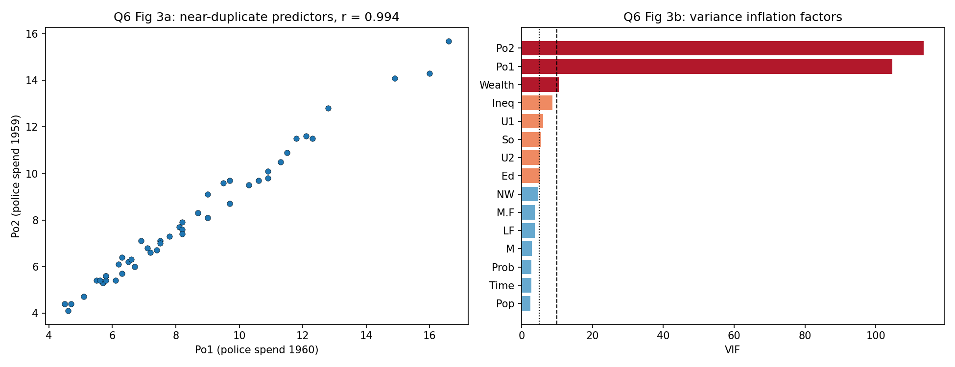
Collinearity
A VIF of 113 means the variance of that coefficient is 113 times what it would be under orthogonal predictors, so its standard error is inflated roughly elevenfold. The consequence is visible in the fitted model:
Predictor | OLS coefficient | Ridge coefficient
Po1 | +566.87 | +124.47
Po2 | −302.69 | +104.60
Ineq | +278.94 | +94.64
Ed | +208.43 | +74.16
Po1 and Po2 correlate at 0.994 and measure the same thing one year apart. Ordinary least squares assigns them coefficients of opposite sign, +566.87 and −302.69. Read literally, the model claims police spending in 1960 raises crime sharply while spending in 1959 lowers it. That is not a finding, it is the arithmetic of a near-singular design matrix, which can only identify their sum and distributes it arbitrarily between them. A small change in the sample would redistribute it differently. The same instability was measured directly in Question 7, where the collinear predictors flipped sign in 26% to 41% of bootstrap refits.
Strategies, in order of preference for this dataset.
Remove one of the pair on structural grounds. Po1 and Po2 are the same measurement in consecutive years, so retaining Po1 loses nothing. This is the first move because it requires no statistical machinery and is defensible to a non-technical audience.
Apply ridge regression, which keeps all predictors and shrinks the variance at the cost of a little bias. Measured here at α = 10.91, ridge reduces Po1 from 566.87 to 124.47 and corrects Po2 from −302.69 to +104.60, so the two now agree, as they must. Cross-validated RMSE is 282.04 against 296.84 for full OLS, so stability was gained without losing accuracy. One caution on reading the shrinkage table: for So, whose OLS coefficient is −1.80 and therefore near zero, the percentage change is arithmetically extreme and meaningless.
Combine into components. Five principal components capture 80% of the variance and eight capture 95%, with principal-component regression on eight components reaching CV RMSE 272.95, which is better than full OLS. The cost is interpretability, since a component mixing wealth, education and inequality has no policy meaning, and this dataset exists to inform policy.

6(d) Recommendations to government (2 marks)
What the analysis supports. Three variables are consistently retained across independent selection methods and are worth treating as planning indicators: police expenditure (Po1), income inequality (Ineq) and education (Ed). Recursive feature elimination selected these plus Po2 and reached the best cross-validated fit of any subset tested. They can be used to identify which areas are likely to record higher crime, and therefore where to position resources.
What the analysis does not support, stated plainly. Every relationship reported here is an association measured across 47 states at one point in time. None of it is causal evidence, and three specific cautions follow.
Do not read the police coefficient as a policy lever. Police expenditure is the strongest correlate of crime and the association is positive. Acting on it directly would imply cutting police budgets to reduce crime, which inverts the likely direction of causation. Resources follow crime. This variable is useful as an indicator of where crime already is and is unusable as an instrument for reducing it.
Do not read the null results as evidence of no effect. Unemployment shows no significant simple correlation, yet Ineq demonstrates that a variable can be invisible alone and important once conditioned. Absence of correlation at n = 47 is weak evidence of absence.
Do not extrapolate. These are 47 US states from a single historical period. The relationships are not transportable to Rwandan districts, where the reporting infrastructure, the age structure and the economic base all differ. Applying these coefficients elsewhere would be an error of a different order from the statistical ones above.
The distinction, stated for the record. Statistical association means two quantities move together in this sample and offers no guarantee that changing one changes the other. Causal interpretation requires either an experiment or a design that credibly rules out confounding and reverse causation, and this dataset supports neither. The practical consequence is that the selected variables are legitimate for targeting resources and illegitimate for justifying interventions.
What would be needed to move from association to causation. Panel data tracking the same states over time, so that within-state changes can be examined and time-invariant state characteristics differenced out. A natural experiment or policy discontinuity, such as a funding formula that allocates policing by an arbitrary population threshold. A pre-registered analysis plan, given that fifteen predictors offer ample scope for selecting a congenial result. And an explicit causal diagram stating which variables are assumed to be confounders and which are on the causal path, since conditioning on a mediator introduces bias rather than removing it. —

Question 7: YEGO ETA prediction (14 marks)
1,500 journeys, 13 candidate predictors, no missing values and no duplicate rows. Target eta_minutes has mean 38.13 and standard deviation 13.54. Scripts: code/q7_regression.py and code/q7b_complexity.py.

7(a) Experimental procedure (3 marks)
Data preparation. Drop observation_id, which identifies records and carries no information about journeys. One-hot encode road_type with arterial as the reference level. Standardise every numeric predictor, which is not optional here: ridge and lasso penalise the sum of squared or absolute coefficients, so on unstandardised data a variable measured in small units attracts a large coefficient and is penalised more heavily for reasons of measurement scale alone. Standardising also makes the coefficients directly comparable, each expressing minutes of ETA per one standard deviation of the predictor.
Splitting. Hold out 20% (300 journeys) as a test set that is touched exactly once, at the end. Within the remaining 1,200, use ten-fold cross-validation for all model selection. The penalty parameter is chosen on cross-validation folds only. Using the test set to choose α would make the reported test error an optimistic estimate of a quantity that no longer means anything.
Training. OLS has no hyperparameter. Ridge and lasso are searched over 61 values of α on a logarithmic grid from 10⁻³ to 10³, wide enough that the chosen value is interior rather than at a boundary. Every transformation sits inside a Pipeline so the scaler is refitted within each cross-validation fold, preventing the preprocessing leakage described in Question 5(b).
Evaluation. RMSE as the primary measure, since it is in minutes and penalises the large errors that damage a ride-hailing arrival promise most. MAE alongside it, being less sensitive to a handful of extreme journeys. R² for the share of variance explained. Beyond these, and central to the argument in 7(c): the number of retained predictors, the stability of coefficients under resampling, and the gap between training and test error.
A step most comparisons omit. Because the three models are expected to perform similarly on a sample this size, the procedure includes a bootstrap analysis of coefficient stability and a sweep of training-set size. Without these, the comparison reduces to three nearly identical numbers and no basis for choosing between them.

7(b) Implementation and comparison (6 marks)
pre = ColumnTransformer([
("num", StandardScaler(), num_cols),
("cat", OneHotEncoder(drop="first", handle_unknown="ignore"), cat_cols)])
cv = KFold(n_splits=10, shuffle=True, random_state=42)
alphas = np.logspace(-3, 3, 61)
for name, est, grid in [("Linear Regression (OLS)", LinearRegression(), None),
("Ridge Regression", Ridge(), {"model__alpha": alphas}),
("Lasso Regression", Lasso(max_iter=50000), {"model__alpha": alphas})]:
pipe = Pipeline([("pre", pre), ("model", est)])
best = (GridSearchCV(pipe, grid, scoring="neg_root_mean_squared_error", cv=cv)
.fit(X_tr, y_tr).best_estimator_) if grid else pipe.fit(X_tr, y_tr)
Multicollinearity, as advertised in the data description.
predictor VIF Strongest predictor-predictor correlations
journey_distance_km 10.86 journey_distance_km <-> distance_proxy 0.928
traffic_index 7.38 traffic_proxy <-> traffic_index 0.897
distance_proxy 7.22 previous_journey <-> journey_distance 0.835
previous_journey_time_min 5.25 traffic_index <-> average_speed 0.770
traffic_proxy 5.20
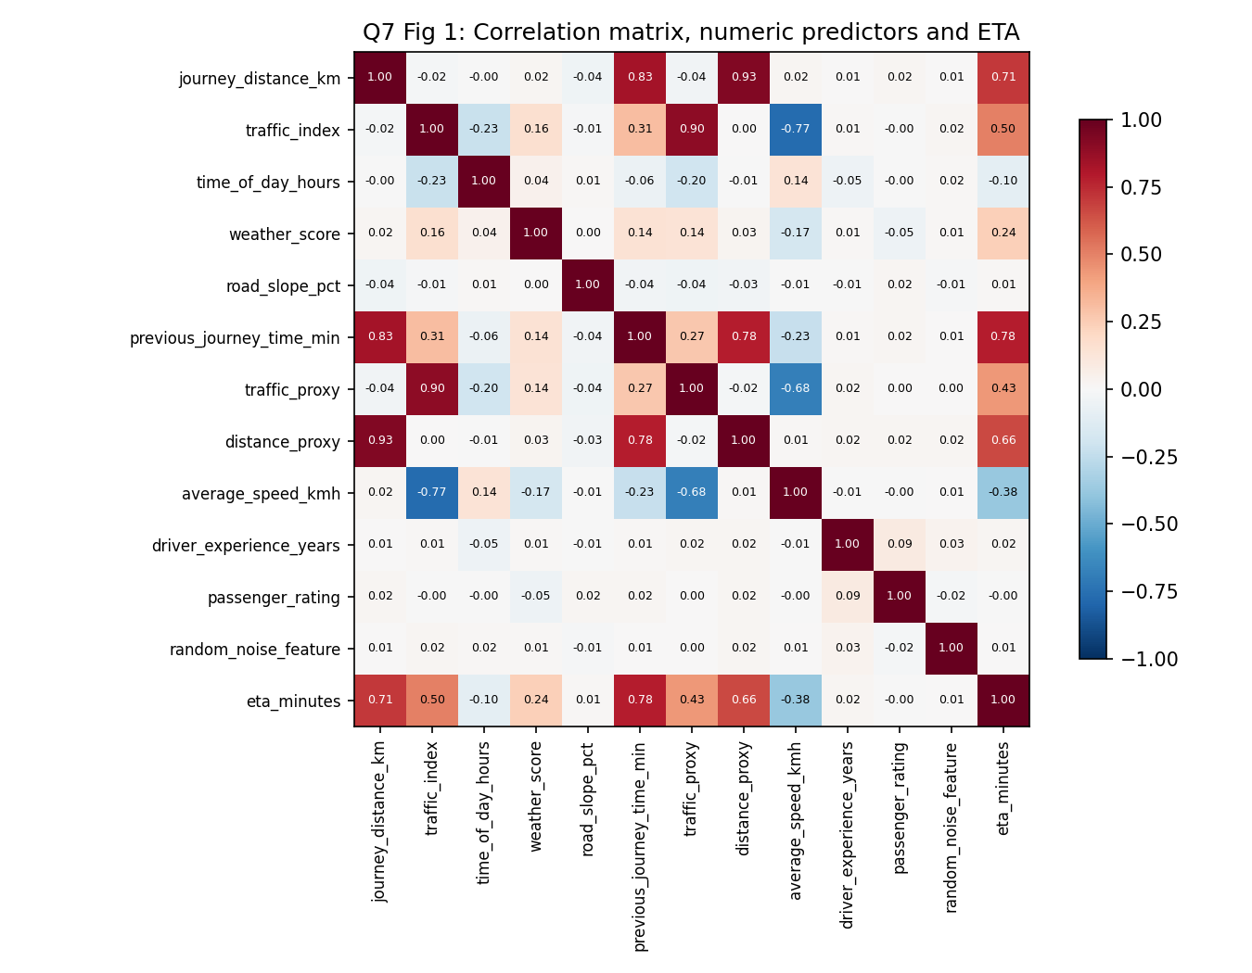
Correlation matrix
Results.
Model | α | CV RMSE | Train RMSE | Test RMSE | Test MAE | Train R² | Test R²
Linear Regression (OLS) | – | 5.7119 | 5.6518 | 6.2366 | 4.3801 | 0.8223 | 0.7999
Ridge Regression | 1.000 | 5.7117 | 5.6519 | 6.2353 | 4.3775 | 0.8223 | 0.8000
Lasso Regression | 0.004 | 5.7117 | 5.6519 | 6.2355 | 4.3781 | 0.8223 | 0.8000
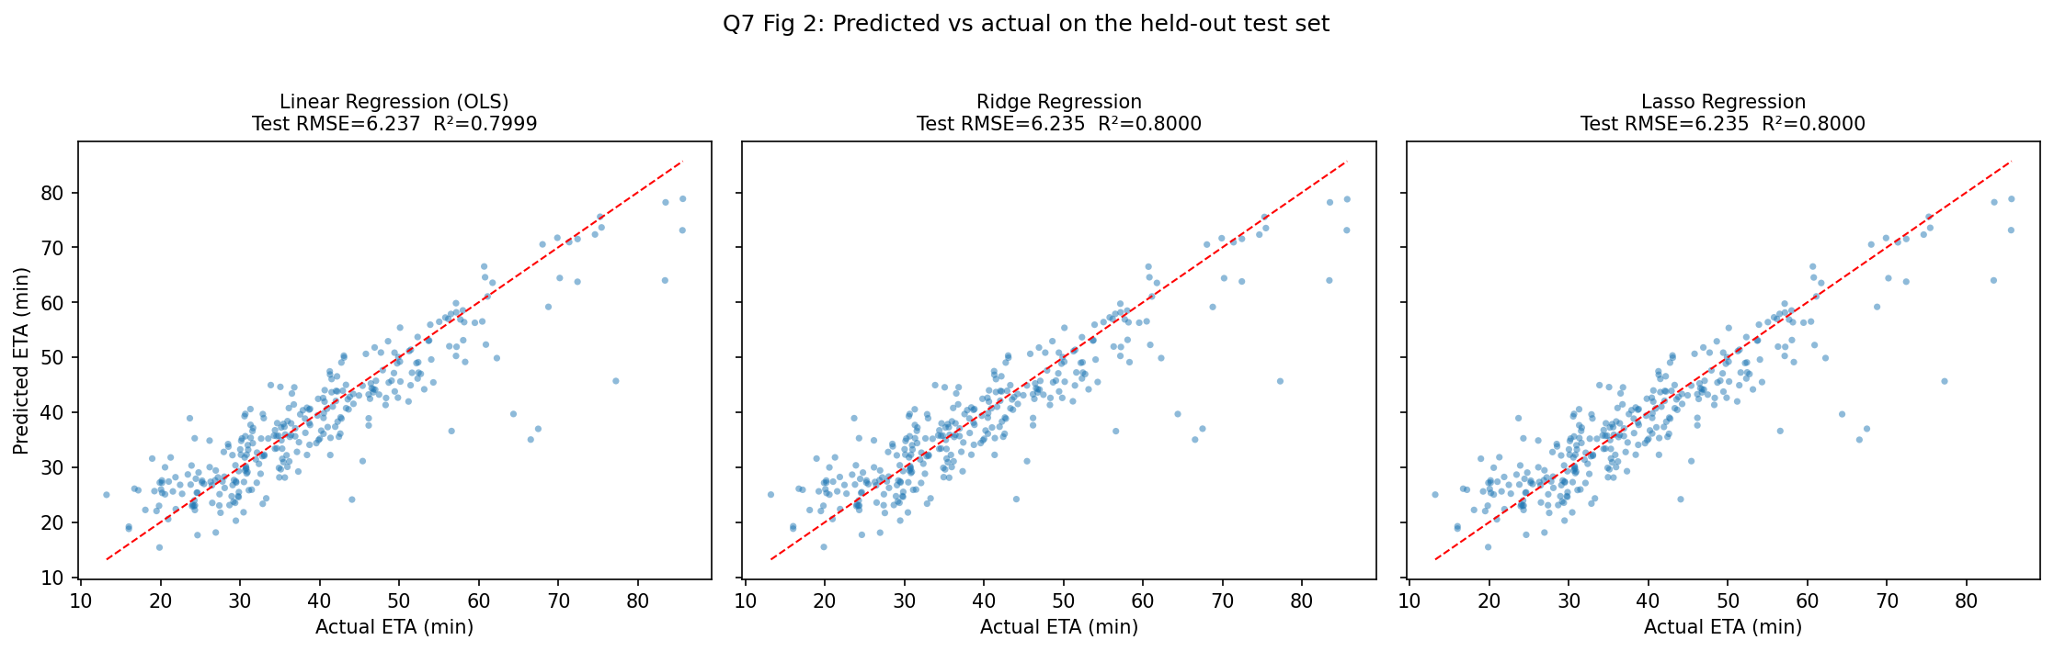
Predicted versus actual
The three models are indistinguishable. Test RMSE spans 6.2353 to 6.2366, a range of 0.0013 minutes, which is eight hundredths of a second. Reporting Ridge as “the winner” on that margin would be meaningless. The gap between training RMSE (5.65) and test RMSE (6.24) is about 10%, which is modest and consistent across all three, so none is materially overfitting.
Standardised coefficients, in minutes per one standard deviation.
Predictor | OLS | Ridge | Lasso
journey_distance_km | 9.537 | 9.442 | 9.484
traffic_index | 6.811 | 6.757 | 6.756
road_type_highway | −4.112 | −4.071 | −4.066
road_type_express | −3.034 | −3.011 | −3.007
weather_score | 1.829 | 1.825 | 1.825
road_type_local | 1.476 | 1.488 | 1.478
distance_proxy | −0.932 | −0.873 | −0.880
previous_journey_time_min | 0.907 | 0.946 | 0.911
road_slope_pct | 0.758 | 0.758 | 0.755
average_speed_kmh | 0.313 | 0.301 | 0.295
traffic_proxy | −0.229 | −0.201 | −0.190
random_noise_feature | −0.139 | −0.138 | −0.134
time_of_day_hours | 0.079 | 0.076 | 0.072
passenger_rating | −0.022 | −0.022 | −0.018
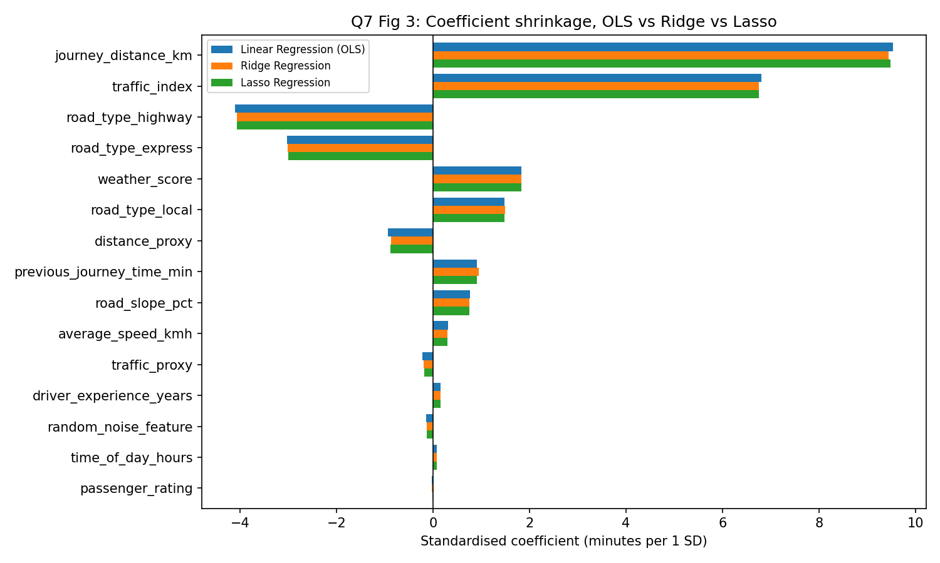
Coefficient shrinkage across the three models
Three coefficients have signs that contradict their own simple correlations with the target. distance_proxy correlates +0.662 with ETA and receives a negative coefficient. traffic_proxy correlates +0.431 and receives a negative coefficient. average_speed_kmh correlates −0.380 and receives a positive one. These are the sign reversals predicted by collinearity in Question 6(c), appearing here in a second dataset.
Lasso eliminated nothing at the cross-validation optimum. The selected α of 0.004 is so small that all 15 coefficients remain non-zero, including random_noise_feature, which the data description states has no relationship with ETA. At n = 1,200 with 15 predictors, cross-validation finds it cannot improve prediction by shrinking, so it does not.
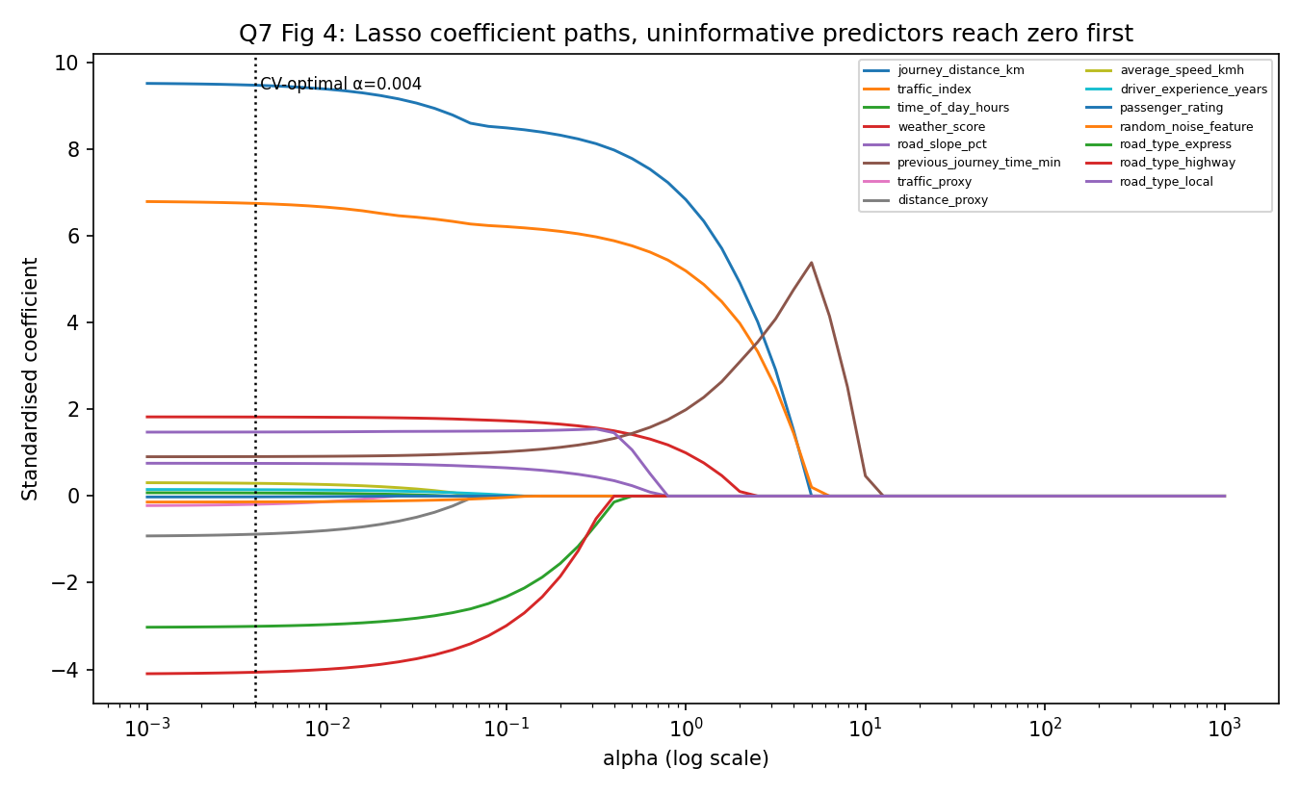
Lasso paths
The coefficient paths show why the exercise still worked as designed: passenger_rating, time_of_day_hours, random_noise_feature and driver_experience_years are the first to reach zero as α rises. Regularisation does order the predictors correctly by usefulness. It simply is not asked to discard any of them at the penalty that minimises prediction error.
The one-standard-error rule, which is where regularisation earns its place. Selecting the largest α whose cross-validated error is within one standard error of the minimum:
best alpha = 0.0039 CV RMSE = 5.7117 (SE 0.1536)
1-SE threshold = 5.8653
largest alpha within = 0.2868 CV RMSE = 5.8563
Model | α | Predictors kept | Test RMSE | Test R²
OLS, all predictors | – | 15 | 6.2366 | 0.7999
Lasso, CV-optimal | 0.0039 | 15 | 6.2355 | 0.8000
Lasso, 1-SE rule | 0.2868 | 8 | 6.3680 | 0.7914
The 1-SE model retains journey_distance_km (8.184), traffic_index (6.015), weather_score (1.594), the three road-type indicators, previous_journey_time_min (1.213) and road_slope_pct (0.468). It discards exactly the seven predictors that should be discarded: random_noise_feature, passenger_rating, driver_experience_years, time_of_day_hours, both redundant proxies, and average_speed_kmh. Nearly half the predictors removed costs 0.13 minutes of RMSE, which is eight seconds.
Coefficient stability, 300 bootstrap refits at n = 200.
Predictor | OLS sd | Ridge sd | Reduction | OLS sign flips
journey_distance_km | 1.645 | 0.864 | 47.5% | 0.0%
traffic_index | 1.209 | 0.758 | 37.3% | 0.0%
distance_proxy | 1.180 | 0.768 | 35.0% | 26.3%
traffic_proxy | 0.989 | 0.701 | 29.1% | 41.3%
previous_journey_time_min | 0.950 | 0.702 | 26.1% | 17.7%
average_speed_kmh | 0.620 | 0.540 | 12.9% | 27.7%
passenger_rating | 0.448 | 0.416 | 7.1% | 44.0%
random_noise_feature | 0.427 | 0.403 | 5.8% | 39.0%
Ridge reduces coefficient variance by 26% to 47% on exactly the collinear predictors and by only 3% to 7% on the independent ones, which is the behaviour the penalty is designed to produce. traffic_proxy changes sign in 41.3% of refits under OLS: its estimated direction of effect is close to a coin toss. A model whose coefficients are quoted to a product team must not behave that way.
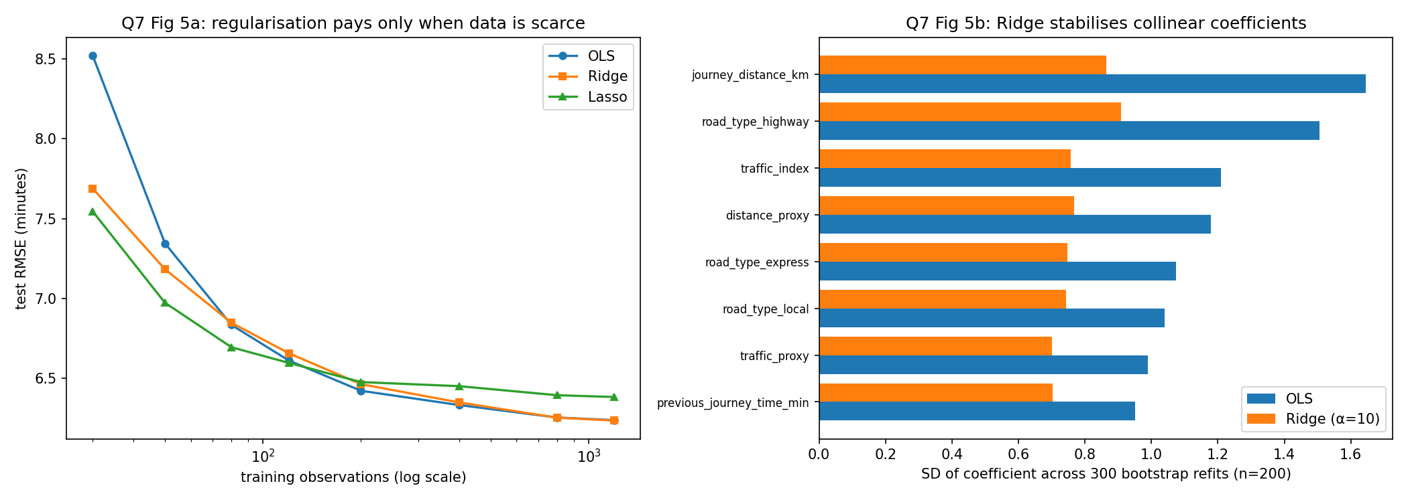
Complexity and stability
Where regularisation actually matters, by training-set size.
n_train | OLS | Ridge | Lasso | OLS − Ridge
30 | 8.520 | 7.688 | 7.544 | +0.832
50 | 7.344 | 7.182 | 6.972 | +0.162
80 | 6.833 | 6.847 | 6.693 | −0.014
200 | 6.421 | 6.462 | 6.475 | −0.042
1200 | 6.237 | 6.234 | 6.381 | +0.003
This explains the tie. At 30 training journeys OLS is 0.83 minutes worse than ridge, an 11% degradation. The advantage disappears by roughly 80 observations and is absent thereafter. With 1,200 journeys and 15 predictors, OLS is already well-conditioned enough that shrinkage has nothing left to correct.

7(c) Which model to deploy (2 marks)
Recommendation: lasso at the one-standard-error penalty, giving an eight-predictor model. If all fields must be retained for other reasons, ridge rather than OLS.
Choosing on test RMSE alone is not possible, since the three differ by 0.0013 minutes. Four other considerations decide it.
Predictors are an operating cost, not a free parameter. Each retained feature is a field that must be collected, validated, stored and monitored in production. The 1-SE model needs eight inputs instead of fifteen. The 0.13-minute accuracy cost, against a typical journey of 38 minutes, is an error of one third of one per cent, and no passenger distinguishes a 38.0-minute estimate from a 38.1-minute one. Halving the feature pipeline for that is a straightforward trade.
Two of the discarded predictors were redundant by construction. traffic_proxy and distance_proxy exist to duplicate traffic_index and journey_distance_km at r = 0.897 and r = 0.928. Removing them eliminates the multicollinearity rather than merely damping it, which is the preference established in Question 6(c).
One discarded predictor should never have been a candidate. average_speed_kmh is described as the estimated average speed during the journey. A journey’s average speed is not knowable at the moment the ETA is quoted, which is before the journey starts. Whatever its statistical contribution, it is unavailable at prediction time, and including it would produce a model that validates well offline and cannot be served. The 1-SE model removes it on statistical grounds; it should have been removed on design grounds. This is the Question 5(a) discipline of fixing the prediction point applied to a specific field.
Stability is a deployment property. The bootstrap analysis shows OLS coefficients on the collinear predictors flipping sign in up to 41% of resamples. A model retrained weekly on fresh journey data would present a different and sometimes contradictory account of what drives ETA each week. Ridge reduces that variance by up to 47%, and the 1-SE lasso removes the unstable predictors altogether.
The honest qualification. Ridge is the better answer if YEGO expects to retrain on small city-level or corridor-level subsets, where the learning curve shows OLS losing 0.83 minutes at n = 30. The recommendation is conditional on the operating regime, and with 1,500 journeys per model the 1-SE lasso wins on simplicity at negligible cost.

7(d) Reducing overfitting risk (3 marks)
1. Nest model selection inside cross-validation, and keep a test set that is used once. The α values here were chosen on ten-fold cross-validation within the training set alone, and the 300-journey test set was scored a single time. Where selection and evaluation share data, the reported error is a selection artefact. For a fully unbiased estimate of the whole procedure, including the choice of α, nested cross-validation is required: an inner loop selecting α and an outer loop estimating error. The gap between training and test RMSE here, 5.65 against 6.24, is the quantity to watch, and a widening gap on retraining is the first symptom of overfitting.
2. Prefer the simpler model when the difference is within noise, using the 1-SE rule. This is the measure with the largest effect in this study. Cross-validated error has a standard error of 0.1536, and the difference between the best and the eight-predictor model is 0.1446, which is inside it. The two models are statistically indistinguishable, and one uses seven fewer inputs. Selecting the minimum of a cross-validation curve systematically chooses a model slightly too complex, because the minimum of a noisy curve sits below the true minimum.
3. Validate the way the model will be used, not the way the data is stored. Random splitting assumes journeys are exchangeable. They are not. Journeys cluster by driver, by corridor and by time of day, and a random split places journeys from the same driver on the same corridor in both training and test, which is the group leakage quantified in Question 5(b). A production estimate requires splitting by time, training on earlier weeks and testing on later ones, and by driver or corridor. The reported R² of 0.80 should be regarded as an upper bound until that is done.
4. Audit features for availability at prediction time. As noted in 7(c), average_speed_kmh cannot be known before the journey. A feature that is unavailable at serving time produces a validated model that cannot be deployed, and it is not detectable by any amount of cross-validation, because the leak is in the data’s definition rather than in the split.
5. Monitor after deployment. Kigali traffic in six months is not Kigali traffic today. Track the distribution of each input and the realised prediction error against the offline estimate, and retrain on a schedule rather than waiting for complaints.

Question 8: Product-launch survey analysis (12 marks)
600 unique responses after cleaning, with stated willingness to purchase at 36.3%. Script: code/q8_survey_eda.py.

8(a) Exploratory strategy (3 marks)
The brief is explicit that management wants evidence for a decision rather than a summary of responses. That shapes the analysis: every step should reduce uncertainty about whether to launch, at what price, and to whom.
Establish what the sample can and cannot support, first. With 600 responses, the 95% margin of error on a single proportion is ±3.8 percentage points. Any difference smaller than that is not a finding. Stating this before analysis prevents the familiar pattern of reporting a 2-point gap between subgroups as though it were real.
Data quality, before any interpretation. Twelve duplicate submissions were present and removed. satisfaction_current is missing for 4.3% of respondents and expected_price_band for 3.0%. Non-response is checked for informativeness rather than assumed neutral: willingness among those who skipped the satisfaction question is 0.308 against 0.366 for those who answered, a gap in the direction one would expect from disengagement, though the subgroup of 26 is too small to conclude from.
Distributions before relationships. Each variable’s measurement level determines what may be done with it. expected_price_band is ordinal and its ordering must be preserved, as in Question 4. occupation and preferred_feature are nominal. satisfaction_current is a five-point scale, so medians and rank tests are safer than means, although both are reported.
Relationships selected by decision relevance. Only three or four comparisons actually bear on the launch: does prior experience with similar products predict willingness, does willingness vary with expected price, does dissatisfaction with the current solution predict willingness, and do feature preferences differ by segment. Each is paired with an appropriate statistical test, so that a visible pattern is separated from a real one.
Segments last, because segmentation is only meaningful once the drivers are known.

8(b) Visualisations (4 marks)
Each chart is chosen from the measurement levels of the two variables involved, and each carries the test statistic that justifies reading it.
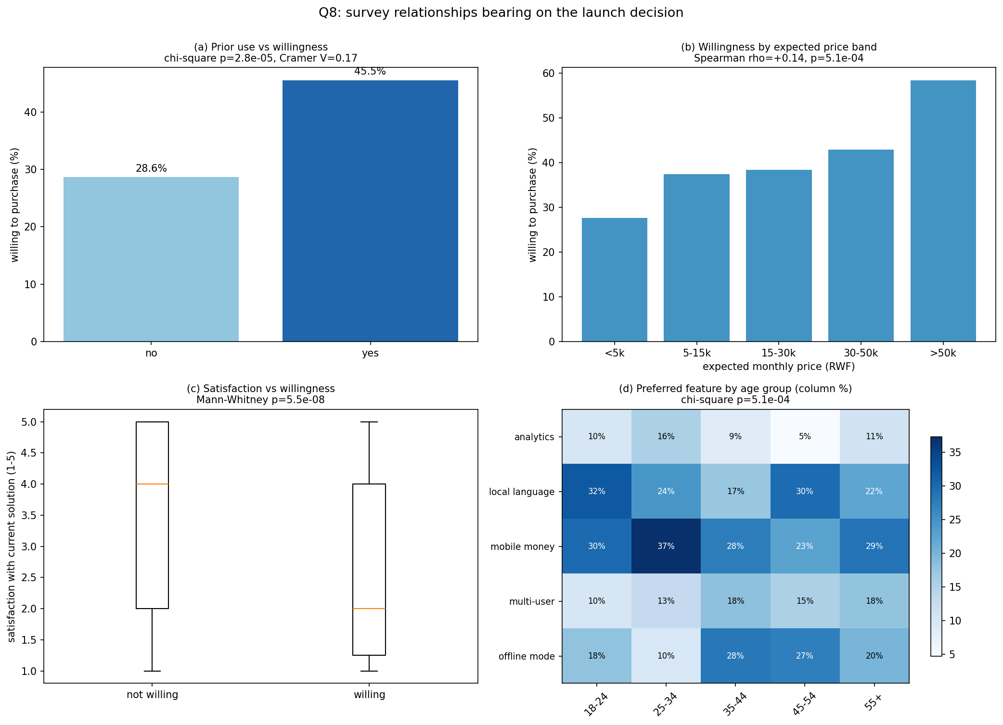
Survey relationships
(a) Prior use against willingness. Nominal by binary, so a grouped bar of proportions. A pie chart would be wrong, since the comparison is between two rates rather than parts of a whole.
willingness: prior users 45.5% vs non-users 28.6%
chi-square p = 2.82e-05, Cramer V = 0.171
(b) Expected price band against willingness. Ordinal by binary, so an ordered bar with a trend test. The category order carries meaning and must not be sorted by frequency.
n willing %
<5k 177 27.7
5-15k 187 37.4
15-30k 112 38.4
30-50k 70 42.9
>50k 36 58.3
Spearman rho = +0.144 (p = 5.10e-04)
(c) Current satisfaction against willingness. Ordinal by binary, so a box plot. It shows the median, the spread and the overlap, where a bar of means would hide all three.
median satisfaction, willing = 2.0 vs not willing = 4.0 (Mann-Whitney p = 5.45e-08)
mean satisfaction, willing = 2.68 vs not willing = 3.35
(d) Preferred feature by age group. Nominal by nominal, so a heatmap of column percentages. Column rather than row percentages, because the question is what each age group wants, not how each feature’s supporters are distributed.
age_group 18-24 25-34 35-44 45-54 55+
local language 32.1 24.4 17.4 29.8 22.2
mobile money 30.0 37.3 27.5 22.6 28.9
offline mode 17.9 9.8 28.3 27.4 20.0
chi-square p = 5.13e-04, Cramer V = 0.131

8(c) Insights bearing on the launch (3 marks)
Insight 1: the addressable market is the dissatisfied, not the unfamiliar. Willingness among prior users of similar products is 45.5% against 28.6% among non-users, a 16.9-point gap at p < 0.001. Dissatisfaction points the same way, with median satisfaction of 2 among willing buyers against 4 among unwilling ones (p < 0.001). The two together describe a specific buyer: someone who has used a competing product and found it wanting. The implication for the launch is that positioning should be comparative and migration-focused, addressing people who already understand the category, rather than educational messaging aimed at first-time users. It also identifies the competitor’s dissatisfied base as the primary acquisition channel.
Insight 2: price is not the binding constraint, and the pricing assumption is probably wrong. Willingness rises with the price band the respondent already expects to pay, from 27.7% in the under-5,000 band to 58.3% above 50,000, with Spearman ρ = +0.144 at p < 0.001. The usual reading of a price question, that a lower price widens the market, is contradicted here. Respondents anchored to low prices are the least likely to buy at any price, which is consistent with them placing little value on the category. The implication is that a low-price launch would attract the least willing segment while surrendering margin on the most willing one. The caution attached to this is that the highest band contains only 36 respondents, so the 58.3% figure carries a wide interval and the direction of the trend is better supported than its magnitude.
Supporting finding on the feature roadmap. Preferences differ significantly by age (p < 0.001), but Cramér’s V of 0.131 indicates a weak association. Mobile money is the top or joint-top preference in every age group, ranging from 22.6% to 37.3%. The practical conclusion is that mobile money is a universal requirement rather than a segment feature, while offline mode shows a genuine split, at 9.8% among 25 to 34 year olds and 28.3% among 35 to 44 year olds, and is a candidate for later differentiation rather than for the first release.
Segment concentration.
Segment | n | Willing | Share of sample | Share of all willing
Experienced, higher budget | 100 | 54.0% | 16.7% | 24.8%
Experienced, lower budget | 175 | 40.6% | 29.2% | 32.6%
New, higher budget | 126 | 32.5% | 21.0% | 18.8%
New, lower budget | 199 | 26.1% | 33.2% | 23.9%
Experienced buyers with a higher budget are 16.7% of respondents and 24.8% of everyone willing to buy. The two experienced segments together are 45.8% of the sample and 57.4% of willing buyers. A launch targeting them addresses well over half the demand with under half the outreach.

8(d) Limitation and further evidence (2 marks)
The limitation: stated willingness to purchase is not purchase. Every finding here rests on what 600 people said they would do about a product that does not exist and that they have not seen priced. Three distinct biases operate, and they do not cancel. Hypothetical bias, where survey willingness routinely overstates purchase by a large factor, so the 36.3% headline is an upper bound rather than a forecast. Acquiescence and social-desirability effects, where respondents give the answer the questioner appears to want. And selection, since the analysis can say nothing about who declined to take the survey, and non-respondents are plausibly the least interested. There is a further structural point: because the sample is dominated by people already familiar with the category, and familiarity is the strongest predictor of willingness, the survey may be measuring the enthusiasm of an existing market rather than the size of a new one.
Additional evidence to obtain before committing the budget. In rough order of cost:
A discrete-choice or conjoint exercise, in which respondents choose between specified bundles at specified prices rather than reporting an abstract willingness. This produces price-elasticity estimates that the current ordinal price question cannot, and the ordering effect found in 8(c) needs exactly that test before it is trusted as a pricing rule.
A pre-launch commitment test: a landing page with real pricing, measuring sign-ups or pre-orders. A small financial or registration commitment separates intent from politeness far more reliably than any survey instrument, and it can be run in days.
A limited pilot in one segment, preferably the experienced higher-budget group, measuring actual conversion, activation and retention. Retention is the number that determines whether the product is viable, and no survey can supply it.
Market sizing from independent data, since 600 respondents can establish the proportion willing but not the absolute size of the addressable market.
Competitive and channel analysis, because the finding that the buyer is a dissatisfied competitor customer makes the competitor’s switching costs and response the decisive commercial variable, and the survey says nothing about either.
Recommendation to management: treat the survey as having identified who to sell to and what to build first, and as having established nothing reliable about how many will buy or at what price. Fund the commitment test and the pilot before the full launch.

Appendix: Repository contents
Path | Contents
data/synthetic_ETA.csv | Question 7 dataset, 1,500 journeys
data/uscrime.txt | Question 6 dataset, 47 states
code/q2_recommender_prep.py | Q2 preprocessing pipeline and leakage checks
code/q3_missing_data.py | Q3 missingness diagnostics, MissingValueHandler, comparison
code/q4_encoding.py | Q4 encoding experiments and deployment artefact
code/q5_readmission.py | Q5 workflow, partitioning, subgroup analysis
code/q5b_leakage_scaling.py | Q5 repeated-seed leakage measurement
code/q6_crime.py | Q6 EDA, correlation, VIF, feature selection
code/q7_regression.py | Q7 OLS, Ridge, Lasso comparison
code/q7b_complexity.py | Q7 1-SE rule, bootstrap stability, learning curve
code/q8_survey_eda.py | Q8 survey EDA and significance tests
figures/ | 11 generated figures
output/ | Console logs and result tables for every question
run_all.sh | Regenerates every result from scratch
All results in this report were produced by these scripts at seed 42 and can be reproduced by running bash run_all.sh.

