Development Report
By Ryan Rupahketi, Roy Rodriguez, Joshua White, Jeffrey Kotz
Contents
Project Title 1
Project Description 1
Problem Solved 1
Engineering Planned Approach 1
Software Functionality Developed 2
Risk Management (Complete) 2
Schedule (Complete) 2
Configuration Management (Include Metrics) 2
Completion State (Definition of Done, Licensing) 3
Team Members and Responsibilities 3

Project Title
- Monetally

Project Description
- Monetally is a financial tracking application.
  - Users can input incomes/expenses (e.g. salaries and bills) and see when they occur.
  - Users can set aside a percentage of income for some purpose, whether it be savings, retirement, or otherwise.
  - Users can be notified of upcoming transactions through the notification page.

Problem Solved
- With expensive apps that manage your finances for you it is very easy to be financially illiterate. Monetally job to help teach users how to manage their finances on their own and learn.

Engineering Planned Approach
- Monetally was developed using a scrum methodology
- Our initial plan for each sprint was 2 weeks, one week for developing and one week for testing.
- We followed this scrum development and testing cycle for every week except Scrum 2 where we were 2 days behind.
- Also due the extra time we got from planning to present on the 11/15/2025 to 12/1/2025 our final scrum was extended to 3 weeks where we finalized key features that took a bit longer than expected. Added a MISC feature and finished our documentation and presentation for 12/1/2025.
- For scrum 3 development and testing schedule had one week of development followed by a week of testing for one requirement. Then we did it again for the next requirement. For the final non mvp feature we did testing and development in one week. We finalized documentation throughout the scrum time period.
- We had planned mandatory team meetings every week on Sunday via discord since the start of the project to see where the overall project is at
- We had meetings after class to catch up and see what each person was doing and constantly communicated on a discord server throughout the week.
- We used pair programming throughout the development so no one would get lost or get out of their scope.

Software Functionality Developed
Primary Language: Javascript, HTML, CSS
Functions:
- Log in / Log out / Account creation.
- Receive user information, income, expenses.
- Provide a graphic summary of the user's financial information.
- Notify the user of upcoming expenses and other important notifications.
- Encrypt user data on download.

Risk Management
- Unsatisfactory Tool Performance
  - All tools were satisfactory (with one exception).
- Team Members Being Unavailable
  - The project saw enough progress that whenever developers weren’t available, it wasn’t an issue. When it was, we ended up usually working in teams of 2, so the second person would perform work for the first.
- Scope Creep
  - The project was simple enough to get an MVP within a few weeks.
- Privacy/Regulations
  - Data is stored as locally as possible. We do not connect to external bank accounts.

Schedule
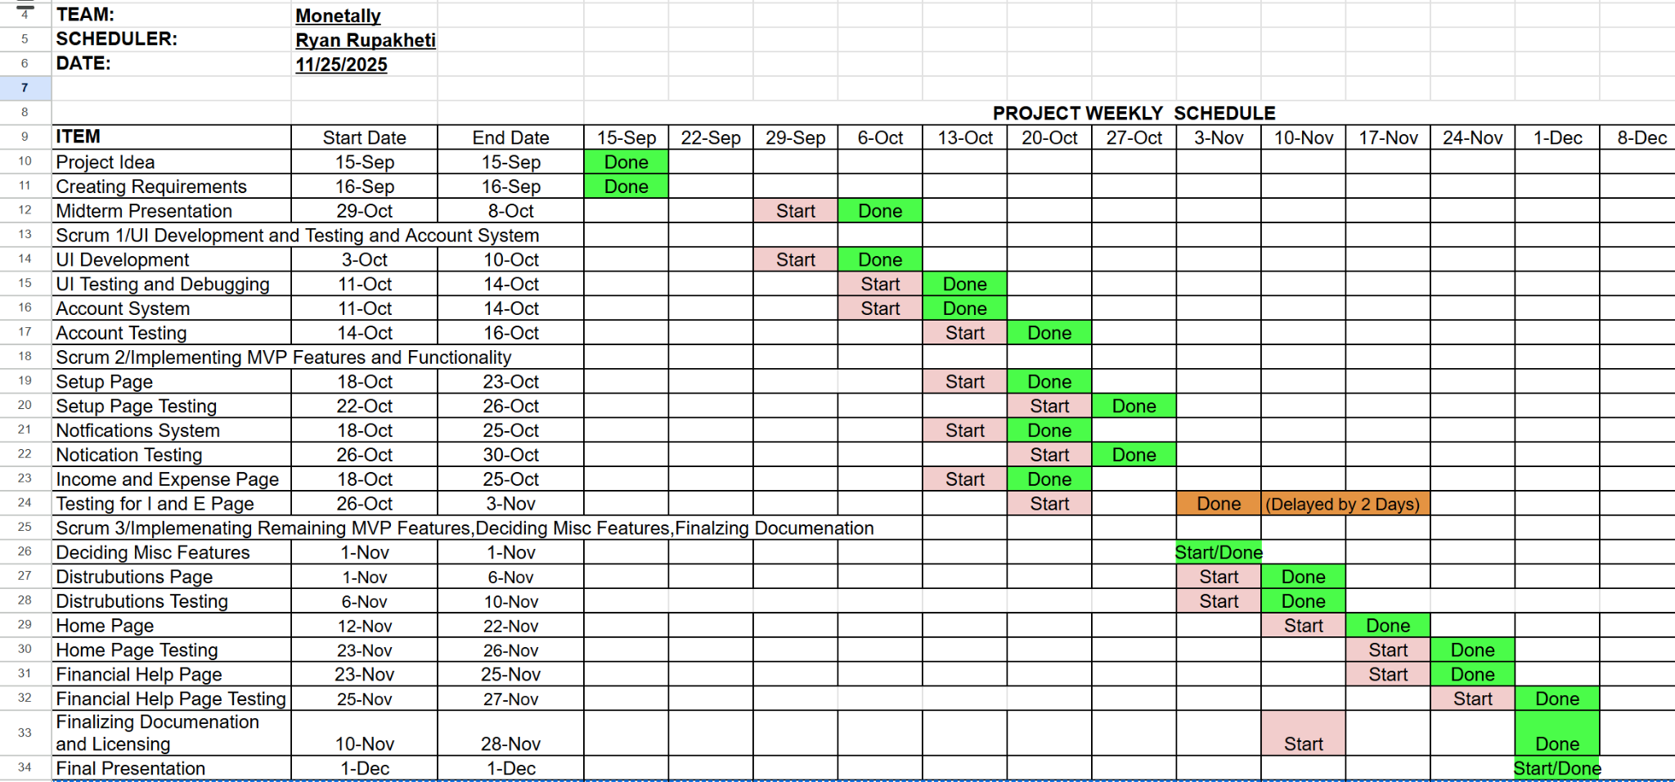

Configuration Management
Configuration Management
- Default CSS files universal to every webpage were always used.
- The same JS file for account handling was loaded on every page.
- A default webpage was copy-pasted for creating new pages.
- The website had to have its root folder name changed to account for GitHub Pages.

Final Configuration Metrics
- https://mugiwara-joshuawhite.github.io/
- Around 5506 Lines of Code
- 26.9 MB
- Web pages on average load in less than 5 seconds
- Has no paid APIs, free to run
- File names: kebab-case

Completion State
- Publicly accessible website published using GitHub Pages.
- Receives expense and income information to display visual summary.
- Notifies user of upcoming expenses, and allows user to create own expenses.
- Allows users to locally store their data encrypted in a file.
- Provides various useful resources to help users manage their finances.

Licensing:
Our software is licensed under the zlib license, a permissive and open source license.

Team Members and Responsibilities
Jeffrey Kotz: Developer / Product Owner
Joshua White: Developer / UI Designer
Roy Rodriguez: Developer / Tester
Ryan Rupakheti: Developer / Scrum Master

