26/May/2023 Fri

TOGAF简介（一）

TOGAF(The Open Group Architecture Framework) 是企业级IT架构框架，提供规划、设计、开发和维运等标准流程。产生于九十年代美国并于九五年发布首版，最新版为发布于二二年的第十版。

TOGAF框架主体有五大内容。

- 架构开发方法 （Architecture Development Method 缩写为ADM）
- ADM导念和技巧（ADM Guidelines and Techniques）
- 架构内容框架 （Architecture Content Framework）
- 架构演化和工具 (Enterprise Continuum and Tools）
- 架构能力框架 （Architecture Capability Framework）

（一） 架构开发方法 （Architecture Development Method 缩写为ADM)
主图为此，共十个阶段组成。

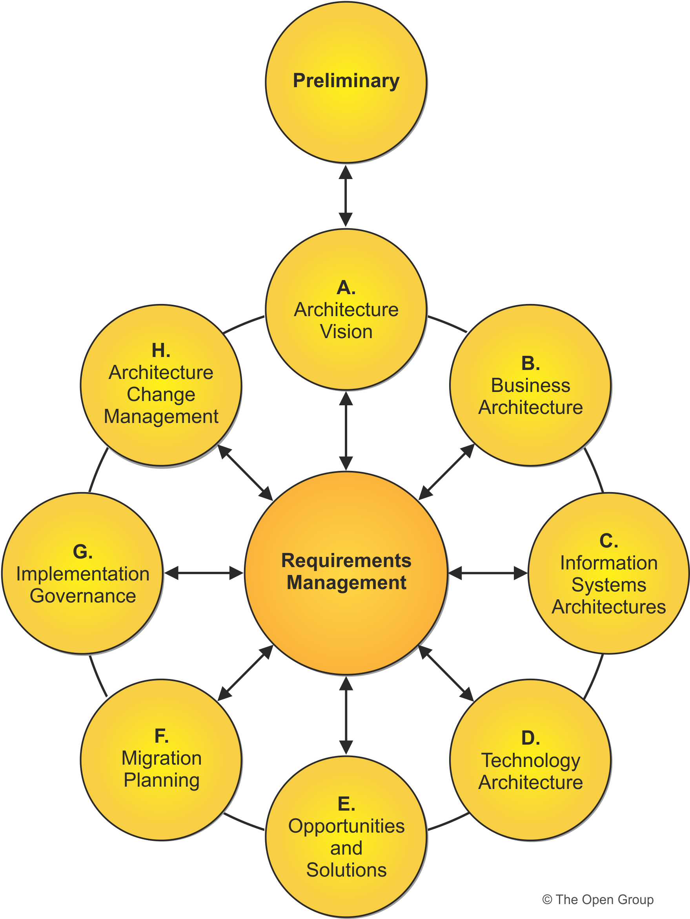

- 孕育期（Preliminary Phase）阶段
- Phase A: 架构愿境 （ Architecture Vision）
- Phase B: 业务层面架构 （Business Architecture ）
- Phase C: 系统层面架构 （Information Systems Architectures），又再分两部份: 数据架构 ， 和应用架构
- Phase D: 技术层面架构 （Technology Architecture）
- Phase E: 实现和解决（Opportunities & Solutions ）
- Phase F: 升级转场计划 （Migration Planning）
- Phase G: 开发监管（Implementation Governance ）
- Phase H: 架构变更管理（Architecture Change Management）
- 架构需求管理（ADM Architecture Requirements Management ）阶段

十个阶段各自独立内循环，又可组合循环。
- 孕育期和架构愿境阶段（A）之间
- 业务层面架构（B）至升级转场计划（F）阶段之间
- 实现和解决（E）和升级转场计划（F）阶段之间
- 开发监管（G）和架构变更管理（H）阶段之间
- 架构变更管理（H）和孕育期
- 架构需求管理阶段又起到核心桥梁作用，连接各个阶段的及时诉求。

下期再续。

（二）ADM Guidelines and Techniques – ADM导念和技术
约提供十四种技术
- Applying Iteration to the ADM
- Applying the ADM Across the Architecture Landscape
- Architecture Principles
- Stakeholder Management
- Architecture Patterns
- Gap Analysis
- Migration Planning Techniques
- Interoperability Requirements
- Business Transformation Readiness Assessment
- Risk Management
- Capability-Based Planning

（三）Architecture Content Framework – 架构内容框架
主图为此，共九个阶段组成。

（四）Enterprise Continuum and Tools – 企业架构连续进化体和工具
主图为此，共九个阶段组成。

（五）Architecture Capability Framework – 架构能力框架
主图为此，共九个阶段组成。

1/Jun/2023 Thu

- Share how do you go about identifying a specific domains (e.g. API Standards, Streaming Technology, Data) and create the business capabilities, technology and roadmap for enterprise wide adoption | Define the EA product  ADM  Principle  workpackage, Implementation factor assessment and deduction matrix, Consolidated Gaps, Solution and dependencies Matrix, Transition arch,  Biz capability assessment,  a. Clear the enterprise scope, oragnization, EA princlple and enviroment (regularity, authority, industry) trend and change  b. Run Business scenario and Capability-Based Planning with stakeholder  c. Review existing Architecture repository (architecture requirement respository, architecture landscape, SIB)  d. Follow Business architecture, Information (data and application) architeture, Technology architecture to define baseline, target, gap and implment component with business capabilities, and technology.  e. Implement with Oppotunity/Solution and Migration planning phases to create the ‘EA proudct’ roadmap (may phases with transition), to support business continous.  f. To minmize and reduce risk, do the proof of concept.
[chatgpt]
Identifying specific domains and creating the business capabilities, technology, and roadmap for enterprise-wide adoption involves a systematic approach. Here are the steps you can follow:
- Define the Scope: Clearly define the scope of the initiative. Identify the specific domains you want to focus on, such as API standards, streaming technology, or data. Understand the business objectives and goals associated with each domain.
- Conduct Research and Analysis: Gather information about the selected domains. Research industry trends, best practices, and emerging technologies. Identify the key players and standards relevant to each domain. Analyze how these domains can benefit your organization and align with your overall business strategy.
- Engage Stakeholders: Involve stakeholders from different business units and departments. Seek input from business leaders, technology experts, and end-users who are impacted by these domains. Conduct workshops, interviews, or surveys to gather their perspectives, pain points, and requirements.
- Assess Current State: Evaluate your organization's current capabilities and technology landscape related to the chosen domains. Identify strengths, weaknesses, and gaps. Assess the maturity level of existing processes, technologies, and resources.
- Define Business Capabilities: Based on the identified gaps and stakeholder input, define the desired business capabilities for each domain. Business capabilities are high-level descriptions of what the organization needs to be able to do to achieve its goals. For example, in the case of API standards, a business capability might be "API governance and management."
- Develop Technology Strategy: Define the technology strategy for each domain. Identify the tools, platforms, and infrastructure required to support the desired capabilities. Consider factors such as scalability, security, interoperability, and integration with existing systems. Explore emerging technologies and industry standards that can drive innovation and efficiency.
- Create Roadmap: Develop a roadmap that outlines the sequence and timeline for adopting the identified capabilities and technologies. Prioritize initiatives based on business value, urgency, and dependencies. Break down the roadmap into manageable phases or projects, considering the resources, budget, and organizational capacity.
- Communicate and Socialize: Share the proposed capabilities, technology strategy, and roadmap with key stakeholders and decision-makers. Clearly communicate the benefits, risks, and anticipated outcomes of adopting these domains. Address concerns and gather feedback to refine the plan.
- Pilot and Validate: Before implementing enterprise-wide, consider conducting pilot projects or proofs of concept. Test the selected technologies, processes, and capabilities in a controlled environment. Gather feedback, measure success criteria, and refine the approach based on lessons learned.
- Execute and Monitor: Once validated, execute the roadmap in a phased manner. Monitor progress, measure key performance indicators (KPIs), and adjust the plan as necessary. Continuously engage with stakeholders, evaluate the impact, and make necessary adjustments to ensure successful adoption.
Remember, this is a high-level overview of the process. Each step may require further iterations, collaboration, and refinement to align with your organization's specific context and goals.

- Describe how you help to develop and enforce enterprise standards / design patterns for consistency, and yet allow for innovation to take place in organization. | Develop the EA product  Arch contract, Repository (landscape, SIB, governance log,  Compliance assessment review  phase G, H, Req mgmt  32.2.15 Implementation governace model  32.2.18 Requirement impact assessment  Ch44 depensation,  a. Provide architecure definitaion document and architecuture requirement specification, for solution and operation to align and follow  b. Review architecture-compliant solutions and approve architect contract  c. Conduct architecure compliance assessments reguarly  d. By as EA change request, combine with Agile/Scrum metholgoth, to provide EA support, review and assessment on the inovation, exception, strategic, emergencey etc. changes,
- Developing and enforcing enterprise standards and design patterns while fostering innovation within an organization requires a balanced approach. Here's how I can help:
- Establish a Standards Governance Framework: Together, we can develop a governance framework to define and enforce enterprise standards and design patterns. This framework will outline the processes, roles, and responsibilities for creating, reviewing, and approving standards. It will also provide guidelines for incorporating innovative ideas within the defined boundaries.
- Define Core Standards and Design Patterns: We can identify a set of core standards and design patterns that provide a consistent foundation for the organization. These may include architectural principles, coding conventions, data modeling guidelines, security standards, or user interface design patterns. These standards should align with industry best practices and support the organization's goals.
- Encourage Collaboration and Feedback: To foster innovation, it's important to create channels for collaboration and feedback. We can facilitate discussions, workshops, and forums where teams can share ideas and propose new approaches. Encourage teams to provide feedback on existing standards and suggest improvements.
- Establish an Innovation Review Process: Implement a process for reviewing innovative ideas and technologies. This process should allow teams to present their proposals, assess their impact on existing standards, and evaluate their potential benefits. Encourage teams to demonstrate how their innovations align with the organization's strategic objectives.
- Pilot Projects and Proof of Concepts: Encourage teams to conduct pilot projects or proofs of concept to validate new ideas. This allows for experimentation in a controlled environment while assessing the feasibility and potential impact of innovative approaches. Encourage documentation and sharing of lessons learned from these initiatives.
- Regularly Update and Evolve Standards: Standards and design patterns should not be set in stone. As technology evolves and new ideas emerge, it's crucial to review and update the standards regularly. We can collaborate with teams to assess the effectiveness of existing standards and design patterns, identify areas for improvement, and incorporate new technologies or approaches.
- Training and Knowledge Sharing: Provide training and resources to ensure teams understand and can effectively implement the established standards and design patterns. Conduct workshops, webinars, or documentation sessions to educate teams on the rationale behind the standards and how to apply them. Encourage knowledge sharing across teams to foster cross-pollination of ideas.
- Monitor and Enforce Compliance: Establish mechanisms to monitor and enforce compliance with the established standards and design patterns. This may involve regular code reviews, automated tools for static code analysis, or periodic assessments of project adherence to standards. Encourage accountability and address non-compliance through constructive feedback and coaching.
- Celebrate and Showcase Innovations: Recognize and celebrate successful innovative projects and initiatives within the organization. Highlight how these innovations have positively impacted the business and aligned with the overall goals. Share success stories to inspire other teams and promote a culture of innovation.
By following these strategies, we can strike a balance between enforcing consistency through enterprise standards and design patterns while fostering an environment that encourages and supports innovation within the organization.

- Describe some of the governance framework, process for managing technology standards and re-use within the organization. | Operate/Manufacture the EA product  ADM?  measure, service quality, contract  12 skill?  Building block, ABB/SBB  Content frame work  1. The artchitecture content framework, to provide artifact, building block and deliverable  2. The Enterprise Continuum, to provide enterprise achitecture re-use stragegy, block, partitioning and repository  3. The architecure capability framework, to establish the architecture capabilbility, ARB/ SRB, compliance, contract, governance, maturity and skills frame.  4.
A governance framework and process for managing technology standards and re-use within an organization help ensure consistency, efficiency, and effective use of technology resources. Here are some components of such a framework:
- Governance Structure: Establish a governance structure that defines the roles, responsibilities, and decision-making processes related to technology standards and re-use. This may include a Technology Standards Committee or a similar governing body responsible for setting policies, reviewing proposals, and making decisions.
- Standardization Process: Define a clear process for proposing, evaluating, and approving technology standards. This process should outline the steps involved, from initial proposal submission to final approval. It may include criteria for evaluating proposed standards, such as alignment with business objectives, interoperability, scalability, security, and cost-effectiveness.
- Standardization Lifecycle: Establish a lifecycle for technology standards that includes creation, review, maintenance, and retirement phases. Regularly assess and update existing standards to keep them relevant and in line with emerging technologies and industry trends. Define criteria for retiring outdated or redundant standards.
- Documentation and Communication: Maintain a centralized repository or knowledge base for documenting approved technology standards. This repository should provide comprehensive documentation, including the rationale behind each standard, implementation guidelines, and best practices. Ensure the repository is easily accessible and regularly updated. Communicate new or updated standards to relevant stakeholders effectively.
- Re-use Framework: Implement a framework for managing technology re-use within the organization. This framework should facilitate the identification, evaluation, and sharing of reusable technology assets, such as code libraries, components, frameworks, or templates. Encourage teams to contribute and utilize reusable assets to promote efficiency and consistency.
- Evaluation and Approval Process: Define a process for evaluating and approving technology assets for re-use. This process may involve assessing factors such as quality, reliability, maintainability, compatibility, and licensing considerations. Establish criteria for determining when re-use is appropriate and beneficial.
- Knowledge Sharing and Collaboration: Foster a culture of knowledge sharing and collaboration to encourage teams to contribute and leverage technology assets. Provide platforms or tools for teams to share their experiences, success stories, and lessons learned related to technology re-use. Facilitate cross-team collaboration and learning opportunities.
- Compliance and Enforcement: Establish mechanisms for monitoring compliance with technology standards and re-use policies. Conduct regular audits or assessments to ensure adherence to approved standards and identify areas for improvement. Address non-compliance through appropriate measures, such as corrective actions, training, or coaching.
- Metrics and Performance Measurement: Define metrics and performance indicators to assess the effectiveness and impact of technology standards and re-use initiatives. Measure factors such as the number of re-used components, cost savings, reduced development time, improved system interoperability, or increased efficiency. Regularly review and analyze these metrics to refine the governance framework and drive continuous improvement.
- Continuous Improvement: Foster a feedback loop to continuously improve the governance framework and processes. Encourage stakeholders to provide input, suggestions, and lessons learned to enhance the effectiveness of technology standards and re-use management. Regularly evaluate the governance framework itself and make adjustments as needed.
By implementing a robust governance framework and process for managing technology standards and re-use, organizations can promote consistency, efficiency, collaboration, and innovation while effectively leveraging technology resources across the enterprise.

- Describe the measurement of success for enterprise architecture and how you go about measuring and showcasing the impact and measurement of success. | Review & improve the EA product  Biz value accessment  measure, service quality, contract  a. The measuremnt include capability, contract compliance, quality, performance and capacity.  b. The methology can be various,  There are multiplicity of measurement models available. One of them recommended is as Architecture Capability  Maturity Model (ACMM). It is scored in 6 levels (None, Initial, Under development, Defined, Managed and Measured) on 9 architecture elements (architecture process,  development, business linkage, senior management involvement, operating unit participation, communication, security, governance, IT investment and acquisition strategy).
Measuring the success of enterprise architecture (EA) involves assessing the impact of architectural initiatives on the organization's goals, operational efficiency, and overall value creation. Here's how you can measure and showcase the impact and success of EA:
- Define Key Performance Indicators (KPIs): Identify KPIs that align with the organization's strategic objectives and the goals of the EA program. These KPIs should reflect the desired outcomes of EA initiatives. Examples include improved agility, cost savings, reduced time-to-market, increased system interoperability, enhanced data quality, or customer satisfaction. Define measurable targets for each KPI.
- Data Collection and Analysis: Establish mechanisms to collect relevant data for measuring the identified KPIs. This may involve automated monitoring systems, surveys, interviews, or analysis of project metrics and performance indicators. Regularly collect and analyze the data to assess progress and identify trends or areas requiring improvement.
- Impact Analysis: Conduct impact analysis to evaluate the direct and indirect effects of EA initiatives on the organization. Assess how EA has influenced business processes, technology investments, risk management, decision-making, or resource allocation. Quantify the value created by EA, such as cost savings achieved through rationalized systems or improved operational efficiency due to standardized processes.
- Stakeholder Feedback: Gather feedback from stakeholders across the organization to understand their perceptions and experiences related to EA. Surveys, interviews, or focus groups can provide valuable insights into how EA has positively influenced their work. Capture both quantitative data (e.g., satisfaction scores) and qualitative feedback (e.g., success stories or anecdotes).
- Case Studies and Success Stories: Develop case studies and success stories that highlight the tangible benefits and achievements resulting from EA initiatives. Showcase specific projects or initiatives where EA principles, frameworks, or guidelines have been effectively applied to drive positive outcomes. Use real-world examples to illustrate the value brought by EA in terms of improved processes, cost savings, innovation, or competitive advantage.
- Benchmarking: Compare your organization's EA maturity and performance against industry best practices or relevant benchmarks. This can help identify areas for improvement and highlight where the organization stands in relation to peers or competitors. Benchmarking can be done through surveys, industry research, or participation in EA-related forums or conferences.
- Regular Reporting: Prepare regular reports or dashboards that present the measured results and progress of EA initiatives. These reports should clearly communicate the impact of EA in quantitative and qualitative terms. Visualize the data in a compelling and easily understandable format, highlighting the achievements, trends, and areas of improvement.
- Executive Communication: Engage with executives and key stakeholders to effectively communicate the impact of EA. Present the measured results, success stories, and progress updates in executive meetings, town halls, or strategy sessions. Demonstrate how EA has contributed to the organization's strategic goals, improved decision-making, mitigated risks, or enhanced customer satisfaction.
- Continuous Improvement: Use the insights gained from the measurement of success to drive continuous improvement in EA initiatives. Incorporate feedback, learn from challenges, and refine the EA approach accordingly. Regularly revisit and update the defined KPIs, ensuring they remain relevant and aligned with organizational priorities.
By implementing a robust measurement framework and effectively showcasing the impact of EA, organizations can gain visibility into the value delivered by their architectural initiatives, gain stakeholder buy-in, and continuously improve their EA practice.

