EXPERIMENT 1A
Name:- Mugunthan k
Reg. No. :- 192412236
Program Code:
clc;
clear;
close all;
%% WR-90 Rectangular Waveguide Parameters
a = 22.86e-3; % Width in meters
b = 10.16e-3; % Height in meters
L = 100e-3; % Length in meters
f = 10e9; % Operating frequency = 10 GHz
c = 3e8; % Speed of light (m/s)
mu0 = 4*pi*1e-7; % Permeability of free space
eps0 = 8.854e-12; % Permittivity of free space
%% Theoretical Cutoff Frequency for TE10 Mode
fc = c/(2*a);
fprintf('THEORETICAL RESULTS\n');
fprintf('Cutoff frequency fc = %.4f GHz\n', fc/1e9);
%% Propagation Constant
if f > fc
beta = (2*pi*f/c)*sqrt(1-(fc/f)^2);
fprintf('Propagation constant beta = %.4f rad/m\n', beta);
else
beta = 0;
fprintf('Wave does not propagate at this frequency.\n');
end

%% Waveguide Coordinates
Nx = 100;
Nz = 100;
x = linspace(0,a,Nx);
z = linspace(0,L,Nz);
[X,Z] = meshgrid(x,z);
%% TE10 Electric Field Distribution
% Dominant electric field component is Ey
Ey = sin(pi*X/a).*exp(-1j*beta*Z);
figure;
surf(X*1000,Z*1000,abs(Ey));
shading interp;
colorbar;
xlabel('Width x (mm)');
ylabel('Length z (mm)');
zlabel('|Ey| (V/m, normalized)');
title('TE10 Mode - Electric Field Distribution');
view(45,30);
%% TE10 Magnetic Field Distribution
% Hx component for TE10 mode
omega = 2*pi*f;
Hx = -(beta/(omega*mu0))*Ey;
figure;
surf(X*1000,Z*1000,abs(Hx));
shading interp;
colorbar;
xlabel('Width x (mm)');
ylabel('Length z (mm)');
zlabel('|Hx| (A/m, normalized)');

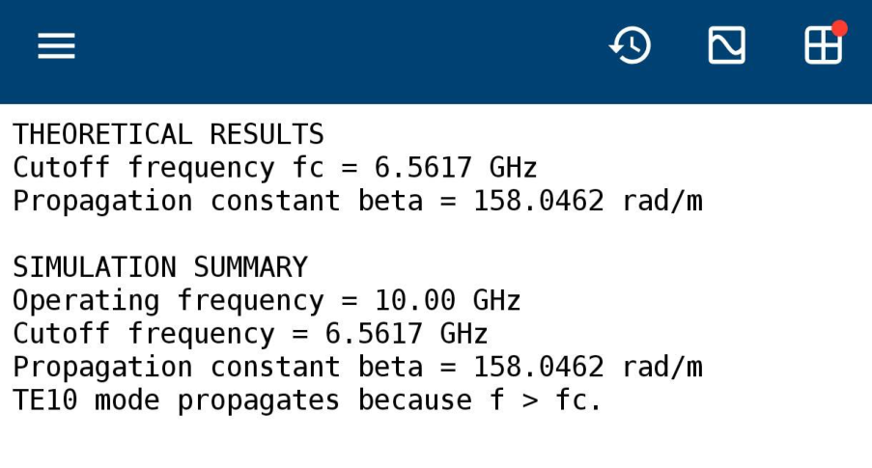

title('TE10 Mode - Magnetic Field Distribution');
view(45,30);
%% Electric Field Cross-Section
figure;
plot(x*1000, sin(pi*x/a),'LineWidth',2);
grid on;
xlabel('Width x (mm)');
ylabel('Normalized Electric Field');
title('TE10 Electric Field Across Waveguide Width');
%% Summary
fprintf('\nSIMULATION SUMMARY\n');
fprintf('Operating frequency = %.2f GHz\n',f/1e9);
fprintf('Cutoff frequency = %.4f GHz\n',fc/1e9);
fprintf('Propagation constant beta = %.4f rad/m\n',beta);
fprintf('TE10 mode propagates because f > fc.\n');
OUTPUT

