Toast
http://pareshnmayani.wordpress.com/category/android/toast-notification/
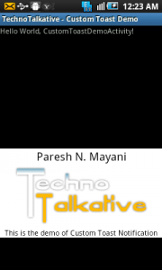
cust_toast_layout.xml
01 <?xml version="1.0" encoding="utf-8"?>
02 <RelativeLayout
03 xmlns:android="http://schemas.android.com/apk/res/android"
04 android:layout_width="match_parent"
05 android:layout_height="match_parent"
06 android:id="@+id/relativeLayout1"
07 android:background="@android:color/white">
08
09 <TextView
10 android:textAppearance="?android:attr/textAppearanceLarge"
11 android:id="@+id/textView1" android:layout_height="wrap_content"
12 android:layout_width="fill_parent" android:text="Paresh N. Mayani"
14 android:gravity="center" android:textColor="@android:color/black">
16 </TextView>
18 <ImageView
19 android:layout_height="wrap_content" android:layout_width="fill_parent"
21 android:src="@drawable/new_logo" android:layout_below="@+id/textView1"
23 android:layout_margin="5dip" android:id="@+id/imageView1">
25 </ImageView>
27 <TextView
28 android:id="@+id/textView2" android:layout_height="wrap_content"
30 android:layout_width="fill_parent"
31 android:text="This is the demo of Custom Toast Notification"
32 android:gravity="center" android:layout_below="@+id/imageView1"
34 android:textColor="@android:color/black">
35 </TextView>
37 </RelativeLayout>

CustomToastDemoActivity.java
1 LayoutInflater inflater = getLayoutInflater();
2 View view = inflater.inflate(R.layout.cust_toast_layout,
3 (ViewGroup) findViewById(R.id.relativeLayout1));
4
5 Toast toast = new Toast(this);
6 toast.setView(view);
7 toast.show();

