//http://www.droiddraw.org/widgetguide.html

A Visual Guide to Android GUI Widgets
To make your life as a Java Android cell phone programmer/ui designer easier.
For rapid development of your user interfaces try DroidDraw

AnalogClock
 | <AnalogClock id="@+id/clock1"  android:layout_width="wrap_content"  android:layout_height="wrap_content"/>
Button
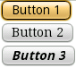 | <Button id ="@+id/button1" android:text="Label"  android:layout_width="fill_parent" android:layout_height="fill_parent"/>  <Button id ="@+id/button2" android:text="Label"  android:layout_width="fill_parent"  android:layout_height="fill_parent" android:typeface="serif"/>  <Button id ="@+id/button3" android:text="Label"  android:textStyle="bold_italic"/>
CheckBox
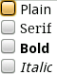 | <CheckBox id="@+id/plain_cb" android:text="Plain"/>  <CheckBox id="@+id/serif_cb" android:text="Serif"  android:typeface="serif"/>  <CheckBox id="@+id/bold_cb" android:text="Bold"  android:textStyle="bold"/>  <CheckBox id ="@+id/italic_cb"  android:text="Italic" android:textStyle="italic"/>
DatePicker
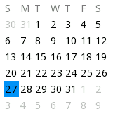 | <DatePicker android:layout_width="wrap_content"  android:layout_height="wrap_content" >  ...  // Required Java init code:  DatePicker dp = (DatePicker)this.findViewById(R.id.widget27);  // for example init to 1/27/2008, no callback  dp.init(2008, 0, 27, Calendar.SUNDAY, null);  ...
DigitalClock
 | <DigitalClock id="@+id/digitalclock""/>
EditText
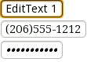 | <EditText id ="@+id/edittext1" android:text="EditText 1"/>  <EditText id ="@+id/button2" android:text="(206)555-1212"  android:typeface="serif" android:phoneNumber="true"/>  <EditText id ="@+id/password" android:text="SuperSecret"  android:textStyle="bold_italic" android:password="true"/>
Gallery
 | <Gallery id="@+id/gallery" android:layout_width="wrap_content"  android:layout_height="wrap_content"/>
ImageButton
 | <ImageButton id="@+id/imagebutton"  android:src="@drawable/brush""/>
ImageView
 | <ImageView id="@+id/imagebutton" android:src="@drawable/brush"/>
ProgressBar
 | <ProgressBar id="@+id/progress"/>
RadioButton
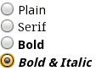 | <RadioGroup id="@+id/widget1"  xmlns:android="http://schemas.android.com/apk/res/android"  android:orientation="vertical">  <RadioButton id="@+id/widget2" android:text="Plain"  android:checked="false" android:layout_gravity="left"  android:layout_weight="0" ></RadioButton>  <RadioButton id="@+id/widget3" android:text="Serif"  android:checked="true" android:layout_gravity="left"  android:layout_weight="0" android:typeface="serif" >  </RadioButton>  <RadioButton id="@+id/widget25" android:text="Bold"  android:checked="false" android:layout_weight="0"  android:layout_gravity="left" android:textStyle="bold">  </RadioButton>  <RadioButton id="@+id/widget24" android:text="Bold & Italic"  android:checked="false" android:layout_weight="0"  android:layout_gravity="left" android:textStyle="bold_italic">  </RadioButton>  </RadioGroup>
Spinner
 | <Spinner id="@+id/widget1" android:drawSelectorOnTop="false"/>
TextView
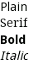 | <TextView id="@+id/plain" android:text="Plain" />  <TextView id="@+id/serif" android:text="Serif" android:typeface="serif"/>  <TextView id="@+id/bold" android:text="Bold"  android:textStyle="bold"/>  <TextView id ="@+id/italic" android:text="Italic" android:textStyle="italic"/>
TimePicker
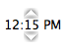 | <TimePicker id="@+id/widget3"/>
GirdView
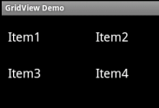 | <GridView android:id="@+id/grid" android:numColumns="2"/>  final String [] items=new String[]{"Item1","Item2","Item3","Item4"};  ArrayAdapter ad=new ArrayAdapter(this,android.R.layout.simple_list_item_1,items);  GridView grid=(GridView)findViewById(R.id.grid);  grid.setAdapter(ad);
ListView
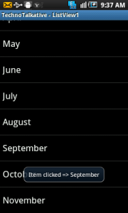 | <ListView android:layout_height="wrap_content"  android:id="@+id/listView1" android:layout_width="match_parent">  </ListView>  ListView lview;  private final static String month[] = {"January", "February", "March", "April", "May", "June", "July", "August", "September", "October", "November", "December"};  lview = (ListView) findViewById(R.id.listView1);  lview.setAdapter(new ArrayAdapter(this, android.R.layout.simple_list_item_1,month));  lview.setOnItemClickListener(this);

