http://www.learn-android.com/2010/01/05/android-layout-tutorial/6/

TableLayout
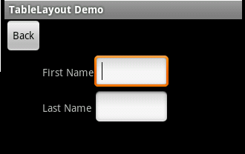

<TableLayout
android:layout_width="fill_parent"
android:layout_height="fill_parent"
xmlns:android="http://schemas.android.com/apk/res/android">
<TableRow>
<Button android:id="@+id/backbutton"
android:text="Back"
android:layout_width="wrap_content"
android:layout_height="wrap_content" />
</TableRow>
<TableRow>
<TextView android:text="First Name"
android:layout_width="wrap_content"
android:layout_height="wrap_content"
android:layout_column="1" />
<EditText android:width="100px"
android:layout_width="wrap_content"
android:layout_height="wrap_content" />
</TableRow>
<TableRow>
<TextView android:text="Last Name"
android:layout_width="wrap_content"
android:layout_height="wrap_content"
android:layout_column="1" />
<EditText android:width="100px"
android:layout_width="wrap_content"
android:layout_height="wrap_content" />
</TableRow>
</TableLayout>

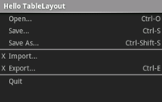
<?xml version="1.0" encoding="utf-8"?>
<TableLayout xmlns:android="http://schemas.android.com/apk/res/android" android:layout_width="fill_parent" android:layout_height="fill_parent" android:stretchColumns="1">
<TableRow>
<TextView android:layout_column="1" android:text="Open..." android:padding="3dip" />
<TextView android:text="Ctrl-O" android:gravity="right" android:padding="3dip" />
</TableRow>
<TableRow>
<TextView android:layout_column="1" android:text="Save..." android:padding="3dip" />
<TextView android:text="Ctrl-S" android:gravity="right" android:padding="3dip" />
</TableRow>
<TableRow>
<TextView android:layout_column="1" android:text="Save As..." android:padding="3dip" />
<TextView android:text="Ctrl-Shift-S" android:gravity="right" android:padding="3dip" />
</TableRow>

<View android:layout_height="2dip" android:background="#FF909090" />
<TableRow>
<TextView android:text="X" android:padding="3dip" />
<TextView android:text="Import..." android:padding="3dip" />
</TableRow>
<TableRow>
<TextView android:text="X" android:padding="3dip" />
<TextView android:text="Export..." android:padding="3dip" />
<TextView android:text="Ctrl-E" android:gravity="right" android:padding="3dip" />
</TableRow>

<View android:layout_height="2dip" android:background="#FF909090" />
<TableRow>
<TextView android:layout_column="1" android:text="Quit" android:padding="3dip" />
</TableRow>
</TableLayout>

Appending rows dynamically
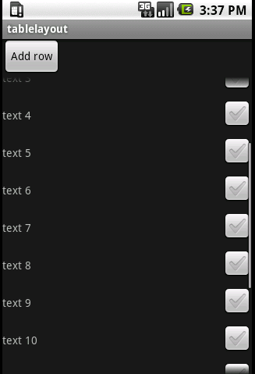

- XML
<Button android:id="@+id/Button01" android:layout_width="wrap_content" android:layout_height="wrap_content" android:text="Add row"></Button>
<ScrollView android:id="@+id/ScrollView01" android:layout_width="wrap_content" android:layout_height="wrap_content">
<TableLayout android:id="@+id/TableLayout01" android:layout_width="fill_parent" android:layout_height="wrap_content" android:stretchColumns="0">
<TableRow android:id="@+id/TableRow01" android:layout_width="wrap_content" android:layout_height="wrap_content">
<TextView android:id="@+id/TextView01" android:layout_width="fill_parent" android:layout_height="wrap_content" android:text="textfield 1-1"></TextView>
<CheckBox android:id="@+id/CheckBox01" android:layout_width="wrap_content" android:layout_height="wrap_content"></CheckBox>
</TableRow>
</TableLayout>
</ScrollView>

- Java code
- package huuah.tablelayout;

- import android.app.Activity;
- import android.os.Bundle;
- import android.widget.TableLayout;
- import android.widget.TextView;
- import android.view.View;

- import android.view.View.OnClickListener;
- import android.widget.Button;
- import android.widget.CheckBox;
- import android.widget.TableRow;
- import android.widget.TableRow.LayoutParams;

- public class tablelayout extends Activity implements OnClickListener {
- /** Called when the activity is first created. */

- //initialize a button and a counter
- Button btn;
- int counter = 0;

- @Override
- public void onCreate(Bundle savedInstanceState) {
- super.onCreate(savedInstanceState);

- // setup the layout
- setContentView(R.layout.main);

- // add a click-listener on the button
- btn = (Button) findViewById(R.id.Button01);
- btn.setOnClickListener(this);

- }

- // run when the button is clicked
- public void onClick(View view) {

- // get a reference for the TableLayout
- TableLayout table = (TableLayout) findViewById(R.id.TableLayout01);

- // create a new TableRow
- TableRow row = new TableRow(this);

- // count the counter up by one
- counter++;

- // create a new TextView
- TextView t = new TextView(this);
- // set the text to "text xx"
- t.setText("text " + counter);

- // create a CheckBox
- CheckBox c = new CheckBox(this);

- // add the TextView and the CheckBox to the new TableRow
- row.addView(t);
- row.addView(c);

- // add the TableRow to the TableLayout
- table.addView(row,new TableLayout.LayoutParams(LayoutParams.WRAP_CONTENT, LayoutParams.WRAP_CONTENT));

- }
- }

