http://www.androidhive.info/2011/09/how-to-create-android-menus/

How to Create Android Menus
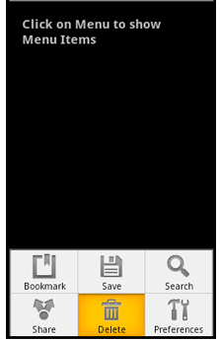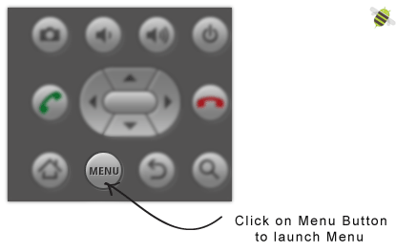

In this tutorial we are creating a simple menu with 6 menu items. On clicking on single menu item a simple Toast message will be shown.
- Create a new project File ⇒ New ⇒ Android Project and give activity name as AndroidMenusActivity.
2. Now create an XML file under res/layout folder and name it as menu.xml.
3. Open menu.xml file and type following code. In the following code we are creating a single menu with 6 menu items. Each menu item has an icon and title for display the label under menu icon. Also we have id for each menu item to identify uniquely.

» menu.xml
<?xml version="1.0" encoding="utf-8"?>
<menu xmlns:android="http://schemas.android.com/apk/res/android">
<!-- Single menu item
Set id, icon and Title for each menu item
-->
<item android:id="@+id/menu_bookmark" android:icon="@drawable/icon_bookmark"
android:title="Bookmark" />
<item android:id="@+id/menu_save" android:icon="@drawable/icon_save"
android:title="Save" />

<item android:id="@+id/menu_search" android:icon="@drawable/icon_search"
android:title="Search" />
<item android:id="@+id/menu_share" android:icon="@drawable/icon_share"
android:title="Share" />
<item android:id="@+id/menu_delete" android:icon="@drawable/icon_delete"
android:title="Delete" />
<item android:id="@+id/menu_preferences" android:icon="@drawable/icon_preferences"
android:title="Preferences" />
</menu>
4. Now open your main Activity class file (AndroidMenusActivity.java) and type following code. In the following code each menu item is identified by its ID in switch case statement.
» AndroidMenusActivity.java
package com.androidhive.androidmenus;

import android.app.Activity;
import android.os.Bundle;
import android.view.Menu;
import android.view.MenuInflater;
import android.view.MenuItem;
import android.widget.Toast;

public class AndroidMenusActivity extends Activity {
@Override
public void onCreate(Bundle savedInstanceState) {
super.onCreate(savedInstanceState);
setContentView(R.layout.main);
}

// Initiating Menu XML file (menu.xml)
@Override
public boolean onCreateOptionsMenu(Menu menu)
{
MenuInflater menuInflater = getMenuInflater();
menuInflater.inflate(R.layout.menu, menu);
return true;
}

/**
* Event Handling for Individual menu item selected
* Identify single menu item by it's id
* */
@Override
public boolean onOptionsItemSelected(MenuItem item)
{

switch (item.getItemId())
{
case R.id.menu_bookmark:
// Single menu item is selected do something
// Ex: launching new activity/screen or show alert message
Toast.makeText(AndroidMenusActivity.this, "Bookmark is Selected", Toast.LENGTH_SHORT).show();
return true;

case R.id.menu_save:
Toast.makeText(AndroidMenusActivity.this, "Save is Selected", Toast.LENGTH_SHORT).show();
return true;

case R.id.menu_search:
Toast.makeText(AndroidMenusActivity.this, "Search is Selected", Toast.LENGTH_SHORT).show();
return true;

case R.id.menu_share:
Toast.makeText(AndroidMenusActivity.this, "Share is Selected", Toast.LENGTH_SHORT).show();
return true;

case R.id.menu_delete:
Toast.makeText(AndroidMenusActivity.this, "Delete is Selected", Toast.LENGTH_SHORT).show();
return true;

case R.id.menu_preferences:
Toast.makeText(AndroidMenusActivity.this, "Preferences is Selected", Toast.LENGTH_SHORT).show();
return true;

default:
return super.onOptionsItemSelected(item);
}
}

}
5. Finally run your project by right clicking on your project folder ⇒ Run As ⇒ 1 Android Application to test your application. On Android Emulator click on Menu Button to launch menu.

