http://www.learn-android.com/2010/01/05/android-layout-tutorial/4/

LinearLayout
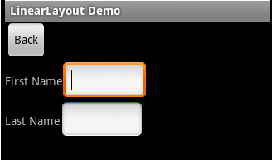

<LinearLayout xmlns:android="http://schemas.android.com/apk/res/android"
android:orientation="vertical"
android:layout_width="fill_parent"
android:layout_height="fill_parent">
<Button
android:id="@+id/backbutton"
android:text="Back"
android:layout_width="wrap_content"
android:layout_height="wrap_content" />
<LinearLayout
android:orientation="horizontal"
android:layout_width="fill_parent"
android:layout_height="wrap_content">
<TextView
android:text="First Name"
android:layout_width="wrap_content"
android:layout_height="wrap_content" />
<EditText
android:width="100px"
android:layout_width="wrap_content"
android:layout_height="wrap_content" />
</LinearLayout>
<LinearLayout
android:orientation="horizontal"
android:layout_width="fill_parent"
android:layout_height="wrap_content">
<TextView
android:text="Last Name"
android:layout_width="wrap_content"
android:layout_height="wrap_content" />
<EditText
android:width="100px"
android:layout_width="wrap_content"
android:layout_height="wrap_content" />
</LinearLayout>
</LinearLayout>

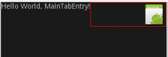

<?xml version="1.0" encoding="utf-8"?>
02 <LinearLayout xmlns:android="http://schemas.android.com/apk/res/android"
03 android:orientation="vertical"
04 android:layout_width="fill_parent"
05 android:layout_height="fill_parent" >
06 <LinearLayout
07 android:orientation="horizontal"
08 android:layout_width="fill_parent"
09 android:layout_height="wrap_content" >
10 <TextView
11 android:layout_width="wrap_content"
12 android:layout_height="wrap_content"
13 android:layout_gravity="left"
14 android:text="@string/hello" />
15 <!-- New Layout -->
16 <LinearLayout
17 android:orientation="horizontal"
18 android:layout_width="fill_parent"
19 android:layout_height="wrap_content"
20 android:gravity="right" >
21 <ImageView
22 android:layout_width="wrap_content"
23 android:layout_height="wrap_content"
24 android:src="@drawable/icon" />
25 </LinearLayout>
26 </LinearLayout>
27 </LinearLayout>

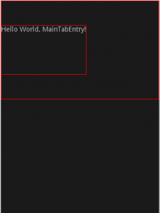

<?xml version="1.0" encoding="utf-8"?>
02 <!-- layout_gravity example -->
03 <LinearLayout xmlns:android="http://schemas.android.com/apk/res/android"
04 android:orientation="vertical"
05 android:layout_width="fill_parent"
06 android:layout_height="fill_parent" >
07 <LinearLayout
08 android:orientation="horizontal"
09 android:layout_width="fill_parent"
10 android:layout_height="200px" >
11 <TextView
12 android:layout_width="wrap_content"
13 android:layout_height="100px"
14 android:layout_gravity="center"
15 android:text="@string/hello" />
16 </LinearLayout>
17 </LinearLayout>

