**CAMPUS AUTOMATIC ENTRANCE & EXIT TRACKING SYSTEM**

**by**

**ALEXIS MUGWANEZA**

Thesis Submitted in Partial Fulfilment of the Requirements for the Master’s degree in theInternet system

**Supervisor** : **Dr. HABIMANA Olivier**

Kigali Independent University ULK

**October 2021**

## **DECLARATION**

I, Alexis MUGWANEZA, hereby declare that this research study entitled “**CAMPUS AUTOMATIC ENTRANCE & EXIT TRACKING SYSTEM**” submitted in partial fulfilment of the requirement for the award of the Degree of Master of Internet Systems**.** I declare that the work reported in this study is my original work and has not been presented to any other Institution. No part of this research should be reproduced without the authors’ consent or that of Kigali Independent University

**Students Name**: **ALEXIS MUGWANEZA**

**Date and signature -------------------------------------------------**

## **CERTIFICATE**

# This is to certify that the study entitled “**CAMPUS AUTOMATIC ENTRANCE & EXIT TRACKING SYSTEM**” submitted by ALEXIS MUGWANEZA, Roll number:201910975 to the Kigali Independent University in partial fulfilment of the requirement for the award of Master’s Degree in Internet System.

**Supervisor  
Dr. HABIMANA Olivier**Date: …...... /............../…………Signature ………………………

## **DEDICATION**

I dedicate this work to my beloved relatives, my father, my brother Emmanuel and my sister Odette, among others, for the continued moral and financial support, sincere guidance, and encouragement they have rendered to me throughout my education.

**May the Almighty God reward them abundantly.**

## **LIST OF FIGURES**

**Figure 1.1** Gantt chart 7

**Figure 2.1** System workflow 13

**Figure 3.1** Waterfall model 17

**Figure 3.2** System architecture 19

**Figure 3.3**  Context Diagram 22

**Figure 3.4** Data Flow Diagram 23

**Figure 3.5** Entity Relationship Diagram 25

**Figure 3.6** Physical Data Model 26

**Figure 4.1** Home page 32

**Figure 4.2** Admin login page 32

**Figure 4.3** Administrator dashboard 33

**Figure 4.4** Administrator dashboard – membership section 33

**Figure 4.5** Administrator dashboard – guest application section 34

**Figure 4.6** Administrator dashboard – student finance status section 34

**Figure 4.7** Administrator dashboard – checked-in and out attendance 35

**Figure 4.8** System welcome page 35

**Figure 4.9** Scanned output 36

**Figure 4.9** Scanned output 36

## **ACKNOWLEDGEMENT**

I am grateful to Almighty God for His endless care, abundant blessings, and provision of good health throughout undertaking my studies. I would like to express sincere thanks to my supervisor, **Dr. HABIMANA Oliver**, for his professionalism and continuous suggestions that inspired and encouraged me to work hard throughout the process of this study. Finally, I thank my family for being there for me every step of the way. It has always made everything so easy, reachable, and possible that I never felt lonely or struggled. Thank you for your love, support, understanding and for reminding us not to overturn.

# **TABLE OF CONTENTS**

DECLARATION i

CERTIFICATE ii

DEDICATION iii

LIST OF FIGURES iv

ACKNOWLEDGEMENT v

LIST OF TABLES ix

LIST OF ABBREVIATIONS x

ABSTRACT xi

CHAPTER 1: INTRODUCTION TO THE STUDY 1

**1.1 Background of the study ……………………………………………………………..1**

1.2 Problem statement 1

1.3 Research objectives 2

**1.3.1 General Objective** 2

**1.3.2 Specific objectives** 2

1.4 Research question 3

1.5 Hypothesis 3

1.6 Scope of the study 3

1.7 Significance of the study 3

**1.7.1 Personal interest** 3

**1.7.2 Society interest** 4

**1.7.3 Institutional interest** 4

1.8 Methodology 4

**1.8.1 Data collection** 4

**1.8.2 Software Development Process Model** 6

1.9 Dissemination of research findings 6

1.10 Structure of the thesis 7

1.11 Duration of the project 7

CHAPTER 2: LITERATURE REVIEW 8

2.1 Introduction 8

2.2 Conceptual and Theoretical Perspectives 8

**2.2.1 Database concepts** 8

2.3 Related case studies 11

**2.3.1 Factors of a good Electronic Security System** 11

**2.3.2. Critical review of existing related systems** 12

2.4 Workflow of the system 13

CHAPTER 3: SYSTEM ANALYSIS AND DESIGN 15

3.1 Introduction to the study 15

3.2 System analysis 15

3.3 Analysis of the new system 15

**3.3.1 Introduction** 15

**3.3.2 Weakness observed in the current system** 16

3.4 Research methodology 16

**3.4.1 Introduction** 16

**3.4.3 Data collection** 16

3.5 Data processing 17

**3.5.1 Waterfall Model** 17

3.6 System Architecture 19

3.7 System requirements 20

**3.7.1 Functional Requirements of Campus Automated Entrance and Exit Tracking System** 20

**3.7.2 Non functional requirements** 20

**3.7.3 User requirement of the proposed system** 21

3.8 Systems Design 22

**3.8.1 Context (Level 0) Diagram** 22

**3.8.2 Data Flow Diagram Level 1** 23

**3.8.3 Entity relationship diagram** 23

3.8.3.1 Entity relationship diagram 25

**3.8.4 Physical Data Model (PDM)** 25

**3.8.5 Data dictionary** 27

CHAPTER 4: SYSTEM IMPLEMENTATION 30

4.1 Introduction 30

4.2 Tools and languages that are used in the software development 30

**4.2.1 Python** 30

**4.2.2 PostgreSQL** 30

**4.2.4 LDAP** 31

4.3. System implementation 31

**4.3.1. Screenshots of a running system** 32

CHAPTER 5: SUMMARY, CONCLUSIONS, AND RECOMMENDATIONS 37

5.1. Summary 37

5.2. Conclusion 37

5.3. Recommendation 38

## **LIST OF TABLES**

**Table 3.1** Personal information 27

**Table 3.2** Accounts 27

**Table 3.3** Attendace report 28

**Table 3.4** Departments 28

**Table 3.5** Finance 28

**Table 3.6** Guest application 29

**Table 3.7** Roles 29

**Table 3.8** User documents 29

## **LIST OF ABBREVIATIONS**

CAETS : Campus Automated Exit and Entrance Tracking System

CSS: Cascading Style Sheet

DFD: Data Flow Diagram

ERD: Entity Relational Diagram

FK: Foreign Key

GB: Giga Bite

GHZ: Gigahertz

GUI: Graphic User Interface

HDD: Hard Disk

HTML: Hypertext Markup Language

HTTP: Hypertext Transfer Protocol

IT: Information Technology

MIS: Management Information System

PDM: Physical Data Model

PK: Primary Key

QR: Quick Response

RAM: Random Access Memory

RDBMS: Relational Database Management System

SQL: Structure Query Language

## **ABSTRACT**

The study’s objectives are to identify challenges that Campus face in visitor’s management, improve performance and efficiency in handling entrance and exit traffic management, and develop a collaborative management system. After realizing that previously there was no system to track campus’ visitors according to the respective departments they needed to attend, the campus management ended up with a lack of important and exact information of the campus' daily visitors, monthly, etc, as well they were not aware of what is interesting each and every campus attendee with their respective departments; in another hand, the campus attendees are students, some of them used to attend classes for a long time without school fees payment which leads the campus to unplanned losses. The methodology used includes primary and secondary data collection, interviews, and observation. In addition, several technologies were also used to develop the system, such as Bootstrap used as front end language, python used as back end language, and the use of multiple database management systems like PostgreSQL, OpeenLadap, and Mongo DB. Furthermore, the research design and implementation of the prototype of Campus Automated Exit and Entrance Tracking System allow the system admin to generate a tracking report about campus checked-in and checked-out effectively. This research contributes to the development and implementation of a Campus Automated Entrance and Exit Tracking System which improves management and security of campus visitors by collecting information via a membership card, allowing for easier interaction with humans.During the production phase of the Campus Automated Exit and Entrance Tracking System, this system will be integrated with the campus MIS and NIDA for fetching essential personal information such as names, departments, membership ID, NID, students roll number, payment status and so on. The system provides an effective way for administrators to view the dashboard, a graphical user interface because the system also has an android component that allows them to integrate the system into their smartphones. The Campus Automated Exit and Entrance Tracking System dynamically updates the time and dates based on when an individual visitor enters or exits the campus, therefore it affects the visitor status in the system.

# **CHAPTER 1: INTRODUCTION TO THE STUDY**

## **Background of the study**

Information and communication technologies (ICT) is becoming increasingly important in business and in human life. It has provided functions and tools that almost all individuals and businesses around the world rely on. With the advent of new technologies, so has access to data and the use of Management Information Systems. This has enabled business functions to operate autonomously.

Rwanda's ICT sector has grown rapidly, resulting in an improvement in the lifestyle of its citizens. Information technology and computer technology have been introduced to help people work more effectively. This is true not only in large institutions, but also in small institutions such as universities. Many tasks in universities make use of ICT to speed up service delivery. We can discuss topics such as online applications, online payments, e-learning, and so on.

As a result, security systems have evolved into a fundamental and effective tool for monitoring campus security and information. This is why we made an effort to complete a project that will contribute to the design of a system that will manage the majority of the activities or tasks taking place on the ULK-Kigali campus. The system generates a report on campus visitors' history as well as financial information status for students. Furthermore, this system includes features such as student finance account management, which controls the balance of school fees, staff information about attendance and exit time, and guest booking information.

## **1.2 Problem statement**

Today, with the rise of technology, a significant portion of daily activities take place over technology. Since people's tracking system is important to ensure their wellbeing, security, and freedom wherever they are. Therefore, it is important to develop an application that can track their activities and their time accordingly in their institutions. Normally, campuses face daily in and out traffic activities through their gates depending on the campus variant workers, students, and visitors. Some workers are part-time, others are full-time. Students study in different sessions. Therefore, managing when they are present or absent becomes a big issue sometimes. Also, tracking the case of theft, Covid-19, and restriction of the entrance is almost impossible.

It takes more effort and physical space to keep track of paper documents, find information, and keep details secure. With manual or partially automated systems, information often must be written down and copied or entered more than once. Another impact of manual systems is on Customer service. Customer queries can be difficult to respond to as information is stored in different places and may even require that you find the right person before responding.  This is no good if they are out to lunch or only work part-time.

The Campus Automatic Entrance & Exit Tracking System is a software application designed to manage the majority of the activities and processes that grant entrance permission to the campus for the security, management, and safety of campus visitors. Based on my case study, we determined that it is preferable to create a web application system and a mobile application for the Campus Automatic Entrance & Exit Tracking System to address issues that arise when using the current manual system.

## **1.3 Research objectives**

### **1.3.1 General Objective**

The main objective of this research project is to develop a web application system and its mobile application version for the management of campus entrance and exit movement to ensure the security of campus attendees and materials.

### **1.3.2 Specific objectives**

To achieve the mission or main objective of this project, several objectives were identified

1. To provide Campus Automatic Entrance & Exit Tracking System access to the gatekeepers and administrators
2. To define the process by which the system can track all campus visitors and manage their information.
3. To develop a system for automating the Campus Entrance & Exit movements.
4. To improve precision and efficiency in handling the management of campus visitors by keeping scanned information of each and everyone who attends the campus.

## **1.4 Research question**

1. What are the issues encountered when the manual system for campus visitor tracking is used?
2. In which process visitors coming in and out of the campus are identified and tracked daily?
3. How can we develop automated system for Campus Entrance & Exit movements ?
4. On which efficiency level the system can handle the campus visitors ?

## **1.5 Hypothesis**

* The Automated Campus Entrance & Exit Tracking System application allows for the tracking of covid-19 new infection cases.
* The project assists the campus finance team in identifying students who used to attend classes for a long time without paying school fees.
* The system identifies the student payment status from the gate.
* The project reduces card fraud where scammers can pirate the normal cards in order to gain access to the campus entrances.

## **1.6 Scope of the study**

This project deals with a web application and mobile application for Campus Automatic Entrance & Exit Tracking System, it will cover all aspects in the development of Campus Automatic Entrance & Exit Tracking System either hardware or software, the project will take scope of ULK, Kigali campus and it will take three months to be completed.

## **1.7 Significance of the study**

The main significance of this project resides in the promotion of the use of software that can replace the traditional way used to manage and control campus visitors, to ensure the campus’s security and visitors information reliability by using technological aspects. The significance is classified into personal interest, society interest, and institutional interest:

### **1.7.1 Personal interest**

1. To improve my knowledge in the field of software development.
2. Implementing the current application will stimulate the development of intellectual knowledge acquired in the research field to solve real-life timeliness problems.

### **1.7.2 Society interest**

1. The main interest of this project resides in supporting the use of software that can facilitate campus security and management.
2. The system will facilitate the management of the campus visitors, including their staff and students, without spending much time on inaccurate details of how visitors come to or leave the campus.
3. This system will help ULK achieve its goal of managing, availing staff, students, and guest’s information timely, and using information and communication technology (ICT) as the key tool in the transformation of the country and improving the daily operation.

### **1.7.3 Institutional interest**

The researcher will provide appropriate recommendations to the universities by suggesting proper ways to improve the Campus Automatic Entrance & Exit Tracking System by using advanced technology to use and manage their visitors effectively.

## **1.8 Methodology**

This section discusses the methodology that has been used in gathering the data. Here, the researcher aimed to identify the objectives to be carried out and the techniques and tools used to present and analyze data to get proper and maximum information related to the subject under study.

The methodology is broad [principles](http://www.businessdictionary.com/definition/principles.html) or [rules](http://www.businessdictionary.com/definition/rule.html) from which specific [methods](http://www.businessdictionary.com/definition/method.html) or [procedures](http://www.businessdictionary.com/definition/procedure.html) may be derived to interpret or solve different [problems](http://www.businessdictionary.com/definition/problem.html) within the [scope](http://www.businessdictionary.com/definition/scope.html) of a particular [discipline](http://www.businessdictionary.com/definition/discipline.html). Unlike an [algorithm](http://www.businessdictionary.com/definition/algorithm.html), a methodology is not a [formula](http://www.businessdictionary.com/definition/formula.html) but a set of [practices](http://www.businessdictionary.com/definition/practice.html) (Vasumathi & Rani, 2001).

Research methodology is a collective term for the structured process of conducting research (Gounder, 2012). Different approaches are used in the software development process, such as waterfall, prototyping, spiral, etc. The methodology for the software development process model used in this project is the waterfall model.

### **1.8.1 Data collection**

Data collection is the process of gathering and [measuring](http://en.wikipedia.org/wiki/Measuring) information on variables of interest. The goal for all data collection is to capture quality evidence that then translates to rich data analysis and allows the building of a convincing and credible answer to questions that have been posed. For our project we used it to collect our data in order to achieve our objective we are going to explain it in the following way.

1. **Interview**

In the broad sense, interviewing is the process whereby individuals (usually two) exchange information. The individuals may be concerned with a job opening, a promotion, a special assignment, a product sale, information for intelligence purposes, a proposed merger, or other questions. The information exchanged need not be limited to facts (Trull, 1964).

 Interviewee try to answer the questions that we discuss about such as:

* How are the campus attendees managed in current system?
* How is a membership card used in the campus?
* How is the report generated?
* Which level of using computer in different department?
* How smart phone is daily used to solve the campus problem?
  + - * + **Types of Interviews**

**Structured or formal interview:** the researcher works through a questionnaire or Interview schedule as part of a social survey. Like the postal questionnaire, all respondents exposed to the same set of questions. Positivists like this type of interview because they produce large amounts of information very cheaply and quickly compared with the unstructured interview and observation.

An interviewer can explain the questionnaire, thus reducing the possibility of non-response and ask for clarification of vague responses. An interviewer can observe the social context in which answers are given, e.g., the facial expression, tone of voice, body language, status, etc., of the respondent.

**The unstructured interview:** Interpreters argue that research should focus on the respondent’s view of the world with unstructured interviews (sometimes known as ‘guided conversations’). This method involves the interviewer informally asking open-ended questions about a topic and allowing the respondent to respond freely and in depth.

They are flexible because the conversation is not constrained by fixed questions. This may generate more valid information (especially if the respondent can see their input is valued) and Allows for probing of deeper meanings

1. **Observation**

Observation is a systematic data collection approach. Researchers use all of their senses to examine people in natural settings or naturally occurring situations. Observation of a field setting involves prolonged engagement in a setting or social situation.

According to my observation in this organization, the campus entrances and exits are done manually, where the gatekeeper records attendees in the logbook manually. Thus, they aren’t computerized for the campus movement.

### **1.8.2 Software Development Process Model**

The development models are the various processes or methodologies selected for the development of the project depending on the project’s aims and goals. Many development life cycle models have been developed in order to achieve different required objectives. The models specify the various stages of the process and the order in which they are carried out.

A lot of different approaches are being used in the software development process, such as waterfall, prototyping, spiral, and rapid application development (RAD), and so on (ind, Karambir, 2015).

## **1.9 Dissemination of research findings**

During the dissemination process, the following steps will be followed:

1st step: Design two digital card where the first one is hardware card contains key information of staff and student that are already in the campus Management Information System, the second card will be an electronic one that is given to the guests where it will grant him/her the access after the guest has filled his information from respective app or website. For the quest, the electronic temporary QR card given will be scanned by the Gate keepers’ mobile app, or they search him or her from the app and approve his entrance or exit.

2nd step: Design a hybrid mobile application that can be used in android and iOS mobile phones. This mobile app will be used to scan cards of campus attendees.

3rd step, which is the last one, is to design the web application that will be used for remote tracking of every single piece of information that has been recorded in the database from the campus gate and reporting according to the various information that is in the system

## **1.10 Structure of the thesis**

This work is divided into five chapters. The first chapter is related to the general introduction of this project. It contains the statement of the problem, research objectives, questions, hypothesis, the scope of the project, significance of the study, methodology, dissemination of research findings, structure of the thesis, and Duration of the project. The second chapter deals with the theoretical concepts. The third chapter deals with research design and methodology. The fourth chapter provides the analysis, development, and implementation of the system. The fifth chapter includes the conclusion and recommendations.

## **1.11 Duration of the project**

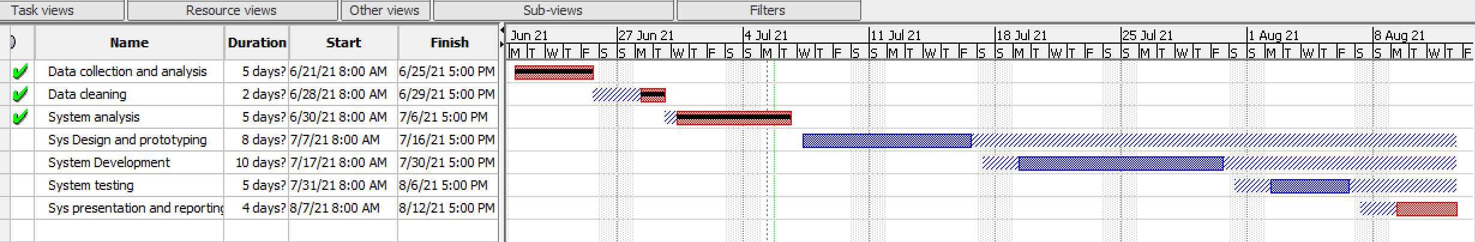

Figure 1.1 Gantt chart

*Gantt chart, the project took three months as shown in the figure (Own design, 2021b).*

# **CHAPTER 2: LITERATURE REVIEW**

## **2.1 Introduction**

This chapter gives an overview of the system or concepts used in our study topic “Campus Automatic Entrance and Exit Tracking System” for the better reading and understanding of this document . It provides a detailed definition and description of key terms as well as related literature to the study topic in order to arrive at conceptual interpretation.

## **2.2 Conceptual and Theoretical Perspectives**

### **2.2.1 Database concepts**

1. **Data**

The data is typically organized to model aspects of reality in a way that supports processes requiring information. They are values stored in a database, and they need to be processed before they can be turned into something useful(Technology, 2015).

1. **Data versus information**

Data is raw, unorganized facts that need to be processed. It can be something simple and seemingly random and useless until it is organized. When data is processed, organized, structured, or presented in a given context to make it useful, it is called data.

1. **Database**

A database is a collection of information that is organized so that it can easily be accessed, managed, and updated. In one view, databases can be classified according to types of content. By Edgar Frank "Ted" Codd an English computer scientist who invented the relational model for database management, the theoretical basis for relational databases and relational database management systems(Technology, 2015).

1. **Database management system (DBMS)**

A database-management system (DBMS) is a collection of interconnected data and a set of programs that allow you to access that data. This is a database because it is a collection of related data with an implicit meaning. The database is a collection of data that contains information relevant to an enterprise. A DBMS's primary goal is to provide a convenient and efficient method of storing and retrieving database information. Data refers to known facts that can be recorded and have implicit meaning (Technology, 2015).

1. **Attributes**

An attribute is a named property or characteristic of an entity that describes the entity with which they are associated.

1. **Relationship**

A relationship is a situation that exists between two relational database tables. A relationship specifies the entities involved and the roles played by each in that association. Relationship types are represented on the ER diagram by a series of lines.

1. **Tables**

A table is a two-dimensional display of data values corresponding to an entity. The columns of a table represent the characteristics of the entity, and the rows represent instances of the entity.

1. **Field**

The location in a database record reserve for a particular type of data; for example, in the library catalog, author, title; subject headings would all be stored in specific fields.

1. **Primary Key**

The PRIMARY KEY constraint uniquely identifies each record in a database table.

Primary keys must contain UNIQUE values. A primary key column cannot contain NULL values. Most tables should have a primary key, and each table can have only ONE primary key.

1. **Foreign keys**

In the context of relational databases, a foreign key is a field (or collection of fields) in one table that uniquely identifies a row of another table. In simpler words, the foreign key is defined in a second table, but it refers to the primary key in the first table.

1. **Hierarchical versus Relational Database**

Several types of database management systems are categorized generally by how they logically store and retrieve data. The two most common types in use today are relational and hierarchical. Each type has its advantages and disadvantages, and in many organizations, both types are used. Whether you choose a relational or hierarchical database management system depends largely on how you intend to use the data being stored.

* **Relational Database**

A relational database is a collection of data items organized as a set of formally described tables. Data can be accessed or reassembled in many different ways without reorganizing the database tables.

In a relational database, data is stored in a table made up of rows and columns. A separate table is created for logically related data, and a relational database may consist of hundreds or thousands of tables (Das, 2005).

In addition to being relatively easy to create and access, a relational database has the important advantage of being easy to extend. After the original database creation, a new data category can be added without modifying all existing applications.

A relational database is a set of tables containing data fitted into predefined categories. Each table (which is sometimes called a relation) contains one or more data categories in columns. Each row contains a unique instance of data for the categories defined by the columns.

When creating a relational database, you can define the domain of possible values in a data column and further constraints that may apply to that data value.

* **Hierarchical Databases**

The data is arranged logically in a top-down format. In a hierarchical database, data is grouped in records, subdivided into a series of segments. In a hierarchical database, the structure of the database is designed to reflect logical dependencies-certain data is dependent on the existence of certain other data. In a hierarchical database, the data relationships are defined. The rules for queries are highly structured. These fixed relationships give IMS extremely fast access to data compared to a relational database. Speeds of access and query flexibility are factors to consider when selecting a DBMS (Tsichritzis & Lochovsky, 1976) .

## **2.3 Related case studies**

Due to technological advancements, the traditional method of tracking campus movement has become inefficient in terms of time and situation. Electronic cards are now the preferred and easiest way to gain access to the campus. 'The internet has fundamentally changed people's mindsets of time advantage, information access, and service,' it can be said. As a result, it has provided a completely new way to create value for clients and build relationships with them.'

In recent years, the global security system sector has expanded. According to the data, the global commercial security system market is expected to grow from USD 223.9 billion in 2021 to USD 223.9 billion in 2025, at an estimated Compound Annual Growth Rate (CAGR) of 8.9 percent during the forecast period.

Key factors contributing to the growth of the commercial security system market include the rising number of terrorist attacks and organized crimes worldwide, the growing construction industry, and the rising adoption of IoT-based security systems powered by cloud computing platforms (Harkins, 2016).

### **2.3.1 Factors of a good Electronic Security System**

Electronic Security System supports the interaction between different parties participating in an action that has a reason to make them meet in a certain area physically or virtually on the network and the management of the data involved in the process. (Philosophy, 2020)

A good e-security system should present the following factors to the respective users for better usability:

1. Reliability: The system should include measures of performance that are consistent and free of error.
2. Authenticity: The system must be authentic, which are security measures in place to secure system data.
3. Easy scanning, identifying, and differentiating persons.
4. Simple navigation from the home page to information and order links for specific data.
5. Availability: the system should be available each time it is needed to be used.

Another important factor in designing an e-security system is that the interactive cycle between a user and an application is not complete until the application responds to a command requested by the user. According to Norman (), "feedback-sending back to the user information about what action has been done, what result has been accomplished--is a well-known concept in the science of control and information theory.

 Imagine trying to talk to someone when you cannot even hear your voice, or trying to draw a picture with a pencil that leaves no mark: there would be no feedback".

### **2.3.2. Critical review of existing related systems**

Actually we have seen and visited different security systems now we critically analyze our choice ,let’s refer to RFID where a user presents the Radio-frequency identification (RFID) device to a connected reader, such as USB, embedded, or PC Express reader, and RapidIdentity identifies the user's information but this way is expese because the cards that are used and other devices mentainance are too expensive, it requires some time and enough training in order to be able for mentainance. In our case the way that is being on the campus gates is manual recording by a pen and paper which is a shame in this centery of tech to stay behind that way to the extent a campus can not own .

About the current system "Campus Automatic Entrance and Exit Tracking System" will manage the majority of the activities or tasks are taken automatically without losing a lot of money and time because android phones and the cards are tools to read visitors information, thus the membership cards that are simple documents without a chip as on RFID but a Qr code.

## **2.4 Workflow of the system**

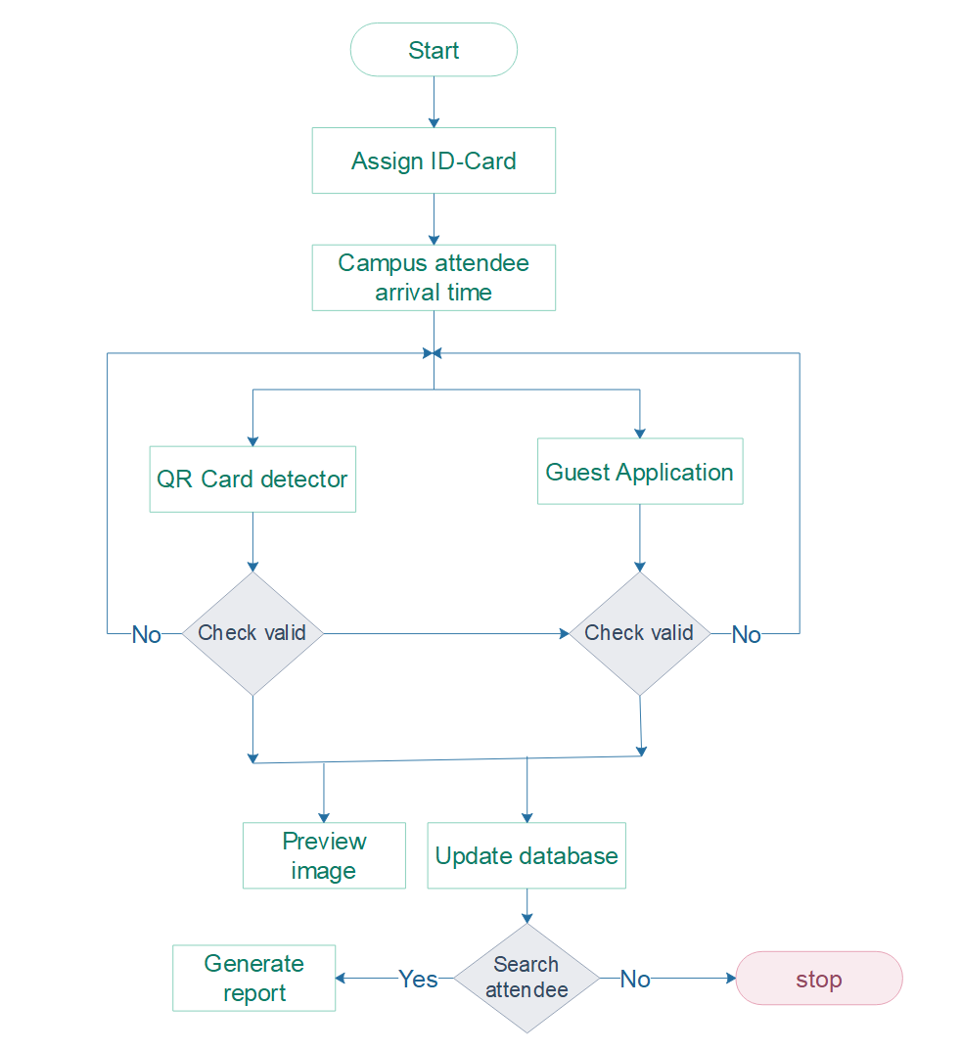

Figure 2.1 System workflow

*The workflow of the Campus Automated Entrance and Exit Tracking System describes how the system works. When a system administrator logs in, the following main actions are initiated: generating a member's ID card or taking attendance by reading the QR code on the card. The QR reader reads the tag information that is stored in QR, then it retrieves the information of the campus attendee and updates a database (Own design, 2021g).*

**2.6 Summary**

This chapter describes a review of the literature on the system's design and functionality. The system's design is very user-friendly, and it adheres to modern web and mobile app standards.

The system is designed with the needs of a business in mind. The system is simple to use for both visitors and campus staff. The system operates in accordance with campus requirements and is also safe to use. The system is extremely adaptable, and adding new features and modules is a breeze.

Receptionists or gatekeepers can easily view the status of campus visitors and manage their entrance and exit. The administrator control panel provides options for managing the overall system via a graphical user interface (GUI), and they do not need to edit any code files.

Changing the system settings and the look of the pages is also very simple and does not necessitate any special skills. As a result, the system is very simple for both visitors and staff.

# **CHAPTER 3: SYSTEM ANALYSIS AND DESIGN**

## **3.1 Introduction to the study**

This chapter goes over the specifics of the software engineering methodology that was used. It makes an attempt to identify the source of data as well as the methods and techniques used to collect data that will be analyzed and interpreted in order to develop such an application. It also includes an examination of the current information system, particularly the Campus Automatic Entrance and Exit Tracking System.

## **3.2 System analysis**

Systems analysis is a problem-solving technique that decomposes a system into component pieces to study how well those parts work and interact to accomplish their purpose.

This Systems analysis collects factual data, understands the processes involved, identifies problems, and recommends feasible suggestions for improving the system functioning. This involves studying the business processes, gathering operational data, understand the information flow, finding out bottlenecks, and evolving solutions for overcoming the weaknesses of the system so as to achieve the organizational goals. System Analysis also includes subdividing a complex process involving the entire system, identification of data store, and manual processes.

## **3.3 Analysis of the new system**

### **3.3.1 Introduction**

A developed web application system and mobile application for Campus Automatic Entrance & Exit Tracking System in the view of solving problems that arise when using the current manual system of Campus Entrance & Exit Tracking System.

 In an automated campus Entrance & Exit Tracking System project helps to solve the problem of tracking the covid-19 infection cases also the project helps the campus finance team to identify students who used to infiltrate in the campus and attend classes for a long time without paying school fees where the system identifies the student payment status from the gate.

This project reduces the fraud of cards where scammers can pirate the normal cards to get access to the campus gate,  the project ease the work of gatekeepers where they it save time they used to spend while recording and checking the campus visitors, all campus movements data are stored and well-kept in centered databases for reporting, all staff and students attendances that were not known the system provide it on the real-time.

### **3.3.2 Weakness observed in the current system**

Depending on the campus variant workers, students, and visitors, where some workers are part-time others are full-time. Students study in different sessions, therefore, to manage when they are present or absent, becomes a big problem sometimes, also tracking the case of theft, Covid-19 and restriction of the entrance is almost impossible with the current system which is fully manual.

## **3.4 Research methodology**

### **3.4.1 Introduction**

Methodology is broad [principles](http://www.businessdictionary.com/definition/principles.html) or [rules](http://www.businessdictionary.com/definition/rule.html) from which specific [methods](http://www.businessdictionary.com/definition/method.html) or [procedures](http://www.businessdictionary.com/definition/procedure.html) may be derived to interpret or solve different [problems](http://www.businessdictionary.com/definition/problem.html) within the [scope](http://www.businessdictionary.com/definition/scope.html) of a particular [discipline](http://www.businessdictionary.com/definition/discipline.html). Unlike an [algorithm](http://www.businessdictionary.com/definition/algorithm.html), a methodology is not a [formula](http://www.businessdictionary.com/definition/formula.html) but a set of [practices](http://www.businessdictionary.com/definition/practice.html).

Research methods refer to a number of ways of arriving at the knowledge regarding that research. Different approaches are used in the software development process, such as waterfall, prototyping, spiral, etc. The methodology for the software development process model that will be used in this project is the waterfall model.

**3.4.2 Research Design**

System design is the first phase of the system development life cycle in which you and the user develop a concrete understanding of how the system will operate. Systems design defines the architecture, components, modules, interfaces, and data for a system to satisfy specified requirements.

### **3.4.3 Data collection**

Data collection is the process of gathering and [measuring](http://en.wikipedia.org/wiki/Measuring) information on variables of interest. The goal for all data collection is to capture quality evidence that translates to rich data analysis and allows the building of a convincing and credible answer to questions posed. For our project, we used it to collect our data to achieve our objective. We are going to explain it in the following way.

## **3.5 Data processing**

This is the process of cleaning and organizing data for display and analysis purposes. We should also see the programming tools and languages ​​used to process data in the coding process.

There are many development life cycle models that have been developed in order to achieve different required objectives. The models specify the various stages of the process and the order in which they are carried out.

A lot of different approaches are being used in software development process, such as waterfall, prototyping, spiral, and rapid application development (RAD) and so on.

### **3.5.1 Waterfall Model**

The Waterfall Model was first Process Model to be introduced. It is also referred to as a linear-sequential life cycle model.  It is very simple to understand and use.  In a waterfall model, each phase must be completed fully before the next phase can begin. In this model the testing starts only after the development is complete. In waterfall model phases do not overlap.

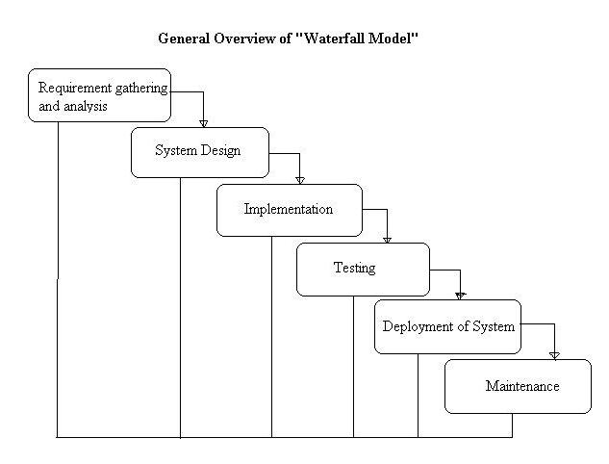

Figure 3.1 Waterfall model

*The waterfall model is a sequential software development model in which development is seen as flowing steadily downwards (like a waterfall) through the phases of requirements analysis, design, implementation, testing (validation), integration, and maintenance (ind, Karambir, 2015).*

* **Phases of waterfall model**

1. **Requirements Definition**

This is the crucial phase where the developer sits as a team and plans everything required to accomplish a task or the needed tools to finish the project. The problem, the desired service objectives (goals), and the constraints are also identified by specificities.

1. **Design phase**

This phase looks at how the software will be built and how the system will operate, emphasizing hardware, software, network infrastructure, and user interface. Here we have two types of design to be considered:

Logical Design: logical design, which includes the design of forms and reports, the design of the interface, and the database design.

Physical Design: physical design which is concerned with designing the physical database, the programs and processes and the distributed systems.

1. **Implementation and unit testing phase**

After receiving the system design documents, the work is shared into various modules, and the real coding is commenced. The system is developed into small coding units. These units are later integrated into the subsequent phase. Every unit is tested for its functionality.

1. **The integration system and testing phase**

The modules that are divided into units are integrated into a complete system and tested for proper coordination among modules and system behaves as per the specifications. Once the testing is completed, the software product is delivered to the customer.

1. **Operations and Maintenance phase**

It is a never ending phase. Once the system is running in production environment, problems come up. The issues that are related to the system are solved only after deployment of the system. The problems arise from time to time and need to be solved; hence this phase is referred as maintenance.

* **Advantages of the Waterfall Model**
* This model is simple and easy to understand and use.
* It is easy to manage due to the rigidity of the model
* Eeach phase has specific deliverables and a review process.
* In this model phases are processed and completed one at a time. Phases do not overlap.
* Waterfall model works well for smaller projects where requirements are very well understood.
* **Disadvantages of the Waterfall Model**
* Once an application is in the [testing](http://istqbexamcertification.com/what-is-a-software-testing/) stage, it is very difficult to go back and change something that was not well-thought out in the concept stage.
* No working software is produced until late during the life cycle.
* High amounts of risk and uncertainty.
* Not a good model for complex and object-oriented projects.
* Poor model for long and ongoing projects

## **3.6 System Architecture**

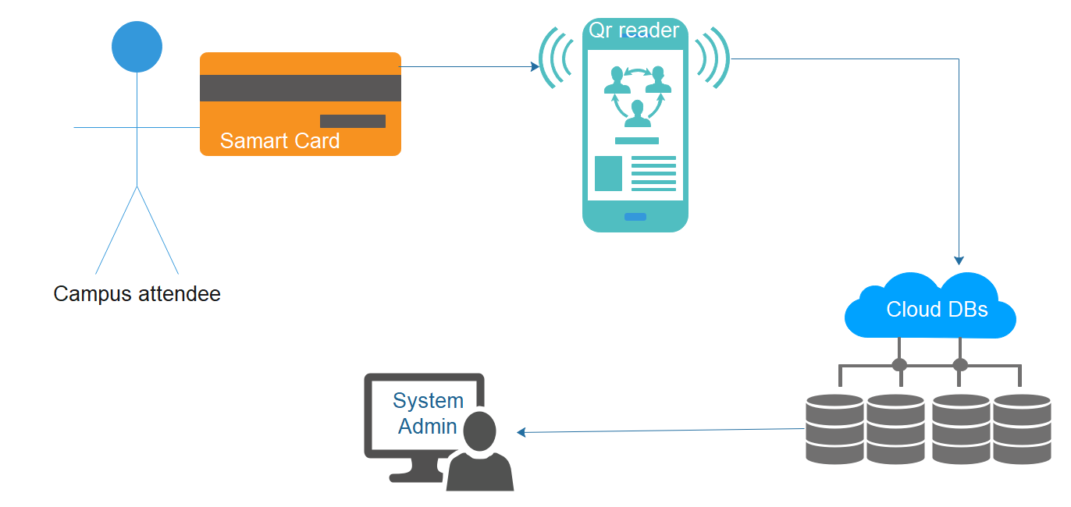

Figure 3.2 System architecture

*The following system architecture demonstrates how a QR reader prevents a campus attendee (staff, student) from giving his/her ID-card to a colleague who attends the campus by scanning the ID-card or reader, and his/her information is automatically stored in the database without other users' information ( Own design, 2021a).*

*QR stands for "****Quick Response****.", QR codes are competent for storing parcels of information. But no matter how much they contain, when filtered, the QR code ought to permit the user to get to data immediately.*

## **3.7 System requirements**

System requirements are a structured document setting out detailed descriptions of the system services (Field, 1996).

### **3.7.1 Functional Requirements of Campus Automated Entrance and Exit Tracking System**

In Software engineering and systems engineering, a functional requirement defines a function of a system or its component. A function is described as a set of inputs, the behavior, and outputs. As defined in requirements engineering, functional requirements specify particular results of a system.

* System must be able to add/modify customer.
* Gate-keeper must be able to view each visitor’s personal details and photo
* System must be able to accept application from the guest who plan to visit the campus
* Administrator must be able to view history of everyone who entered in the campus every day.
* System must alert the campus for the new comers.
* The system should generate different attendance reports accordingly.
* Administrator should be able to register and validate new students and staff.
* Campus Gate-keeper should be able to view and manage student’s payments status.
* System must store information related to the attendance and the campus visit for each person.
* The system must guarantee secure access to the stored data, managing the permissions according to the user profile.
* The system must support easy addition of functionalities and enhancements

### **3.7.2 Non functional requirements**

1. The system shall be accessible from anywhere in the world.
2. The system shall be made available 99% yearly.
3. System shall automatically make backups after every day. This can be tuned according to campus needs.
4. System connectivity with internet shall be ensured through backup line.
5. The safety of the system information shall be insured by means of firewall.
6. The CAETS is going to be used in education institutions only, so the project in not open-source and the source code cannot be published.

### **3.7.3 User requirement of the proposed system**

Whenever individual visits the campus, he/she will be required to present the card for information scan or register from the system I case he/she is a guest. Only system administrator and gatekeepers can login for campus attendees information management, therefore in this part, specific functions are described as below:

Login and logout

Register

Card scan

Handle guest’s application

View movement report

Update account information.

#### **3.7.4 Requirement specification**

##### **3.7.4.1 Hardware specifications**

* Computer: HP, Del, Mac, etc.
* Mobile phone: Android, iOS
* Processor: >= Intel core i3
* RAM: At least 4GB
* Mobile phone USB Cable

##### **3.7.4.2 Software specifications**

*Client-side specifications:*

Operating system: Windows 10 and above, android phone with android version 8 or above, ios12 or above

*Server-side specifications:*

Back-End Tool: Open lap 2.8 for Windows, postgresql-10.17-2-windows-x64, mongodb-windows-x86_64-4.4.6-signed

## **3.8 Systems Design**

### **3.8.1 Context (Level 0) Diagram**

The context diagram shows the system under consideration as a single high-level process, and then shows the relationship between the system and other external entities (systems, organizational groups, external data storage, etc.). Another name for the context graph is the context level data flow graph or level 0 data flow graph.

System context diagram represents all external entities that can interact with the system. a diagram represents the system at the center, without the details of its internal structure, surrounded by all its interactive systems, environments, and activities.

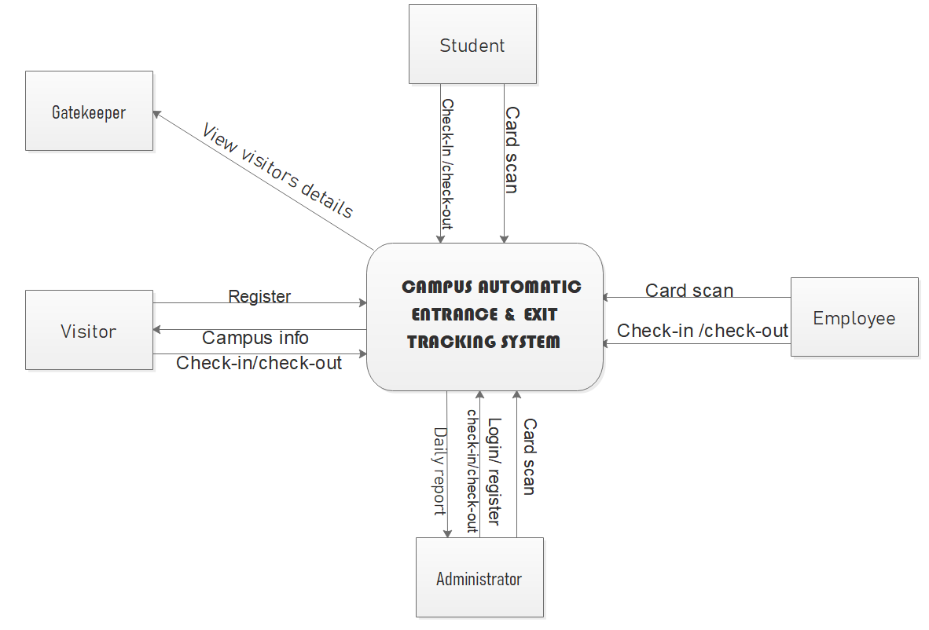

Figure 3.3 Context Diagram

*Context Diagram of Campus Automatic Entrance and Exit Tracking System (Own design, 2021b).*

### **3.8.2 Data Flow Diagram Level 1**

Data Flow Diagrams show the flow of data from external entities into the system, and from one process to another within the system. There are four symbols for drawing a DFD:

1. Rectangles representing external entities, which are sources or destinations of data.

2. Ellipses representing processes, which take data as input, validate and process it and output it.

3. Arrows representing the data flows, which can either, be electronic data or physical items.

4. Open-ended rectangles or a Disk symbol representing data stores, including electronic stores such as databases or XML files and physical stores such as filing cabinets or stacks of paper

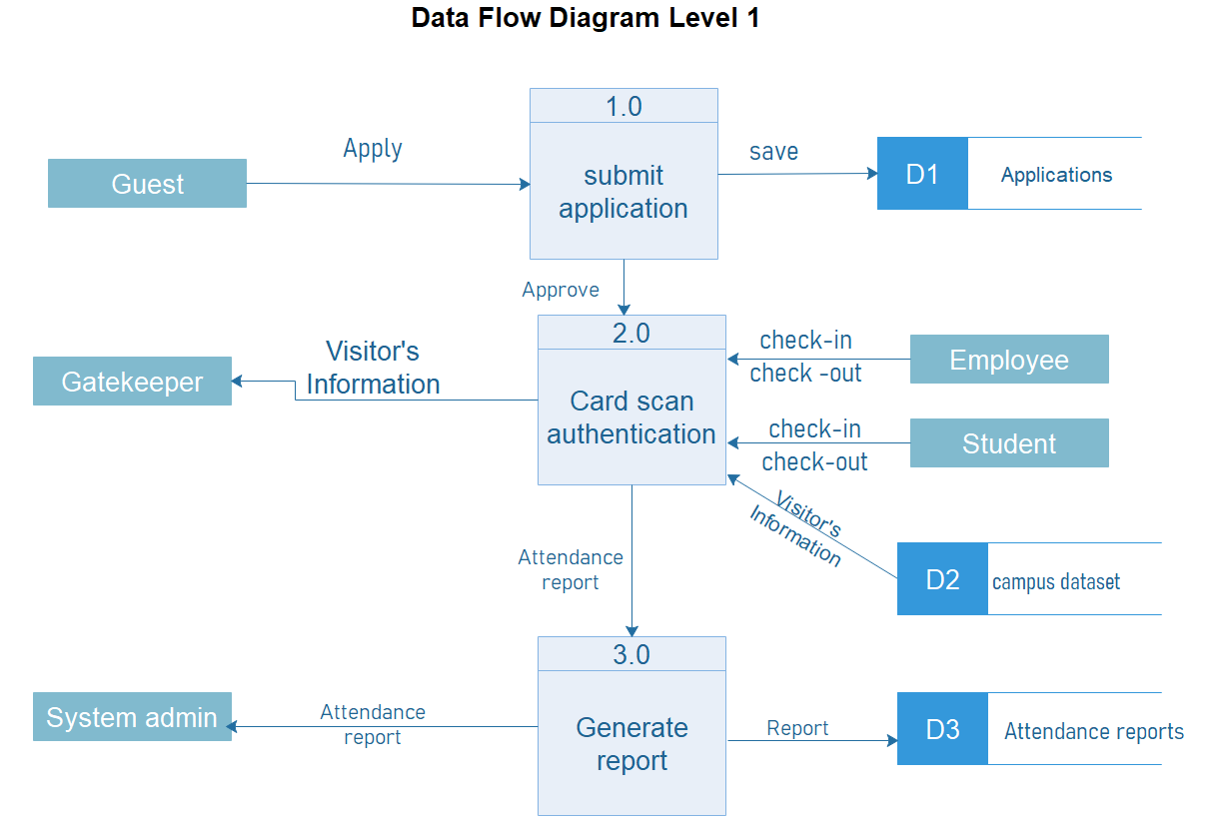

Figure 3.4 Data Flow Diagram

*Data Flow Diagram Level 1 of Campus Automatic Entrance and Exit Tracking System (Own design, 2021c).*

### **3.8.3 Entity relationship diagram**

An entity relationship diagram (ERD) shows the relationships of entity sets stored in a database. An entity in this context is a component of data. In other words, ER diagrams illustrate the logical structure of databases. At first glance an entity relationship diagram looks very much like a [flowchart](https://www.smartdraw.com/flowchart/). It is the specialized symbols, and the meanings of those symbols, that make it unique.

An ER diagram is a means of visualizing how the information a system produces is related. There are five main components of an ERD:

* Entities, which are represented by rectangles. An entity is an object or concept about which you want to store information.

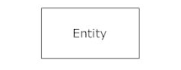

* Actions, which are represented by diamond shapes, show how two entities share information in the database

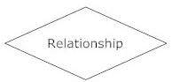

* Attributes, which are represented by ovals. A key attribute is the unique, distinguishing characteristic of the entity.

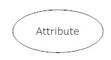

* Connecting lines, solid lines that connect attributes to show the relationships of entities in the diagram.
* Cardinality specifies how many instances of an entity relate to one instance of another entity. Ordinality is also closely linked to cardinality.

## **3.8.3.1 Entity relationship diagram**

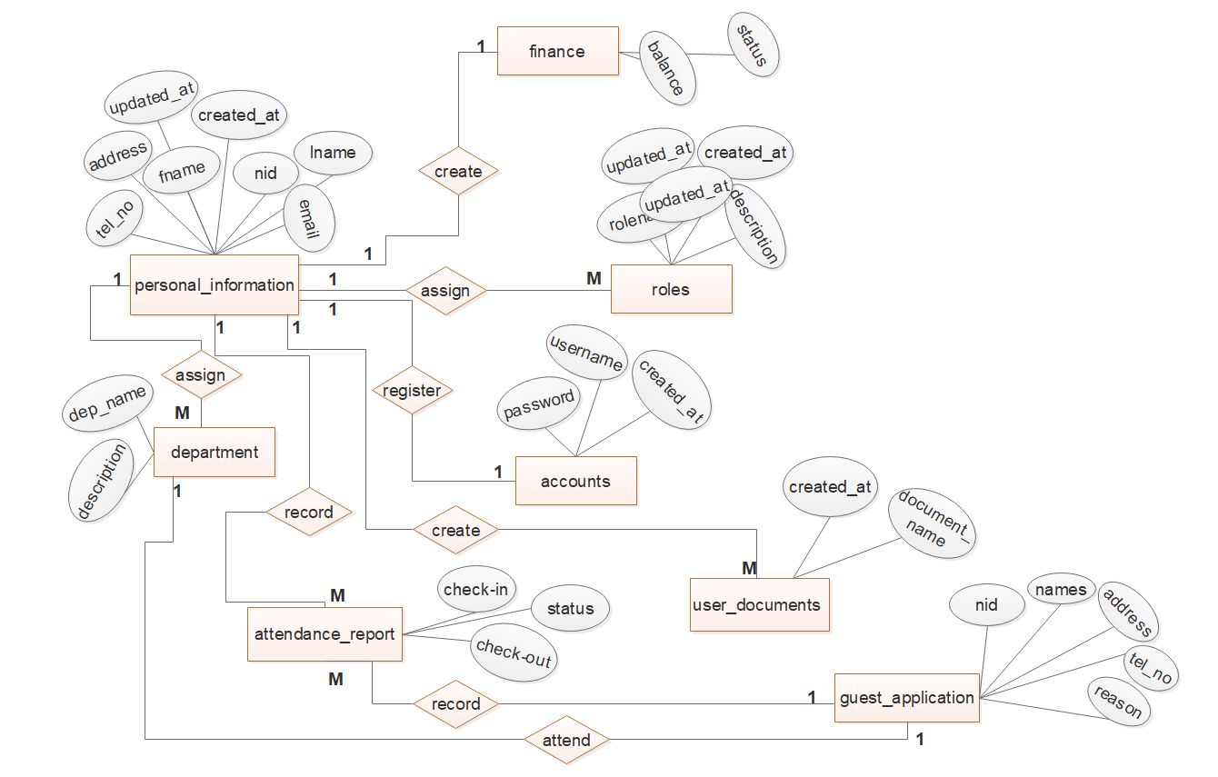

**Figure 3.5** Entity Relationship Diagram

*Entity Relationship Diagram of Campus Automatic Entrance and Exit Tracking System (Own design, 2021d).*

### **3.8.4 Physical Data Model (PDM)**

Physical data model represents how the model will be built in the database. A physical database model shows all table structures, including column name, column data type, column constraints, primary key, foreign key, and relationships between tables. Features of a physical data model include:

* Specification all tables and columns.
* Foreign keys are used to identify relationships between tables.
* Denormalization may occur based on user requirements.
* Physical considerations may cause the physical data model to be quite different from the logical data model.
* Physical data model will be different for different RDBMS. For example, data type for a column may be different between MySQL,Postgresql, MongoDb and OpenLdap.

The steps for physical data model design are as follows:

1. Convert entities into tables.
2. Convert relationships into foreign keys.
3. Convert attributes into columns.
4. Modify the physical data model based on physical constraints / requirements

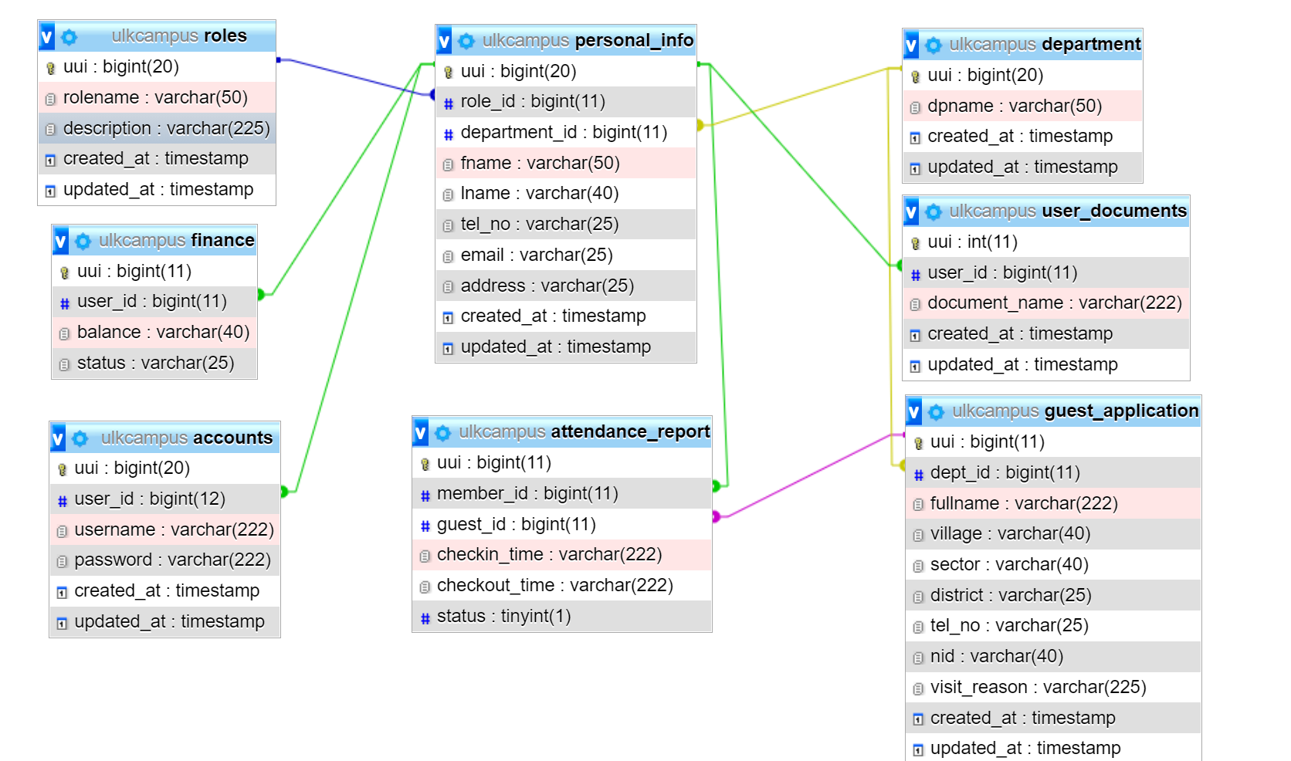**Figure 3.6** Physical Data Model

*Physical Data Model of Campus Automatic Entrance and Exit Tracking System (*Own design, 2021c*).*

### **3.8.5 Data dictionary**

A data dictionary is a file or a set of files that contains a database's metadata. The data dictionary contains records about other objects in the database, such as data ownership, data relationships to other objects, and other data. The data dictionary is a crucial component of any relational database.

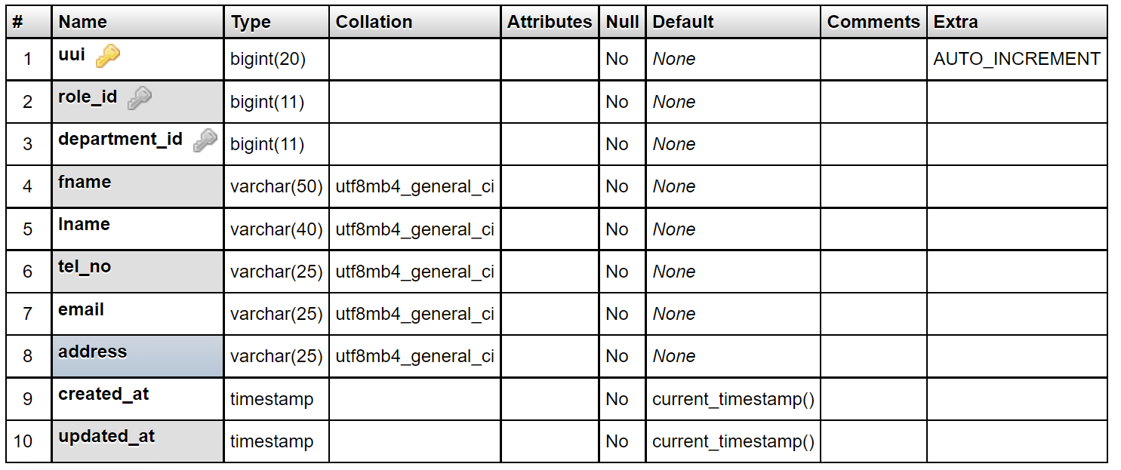

Table 3.1 Personal information

*Personal information is stored in this table for each campus member.*

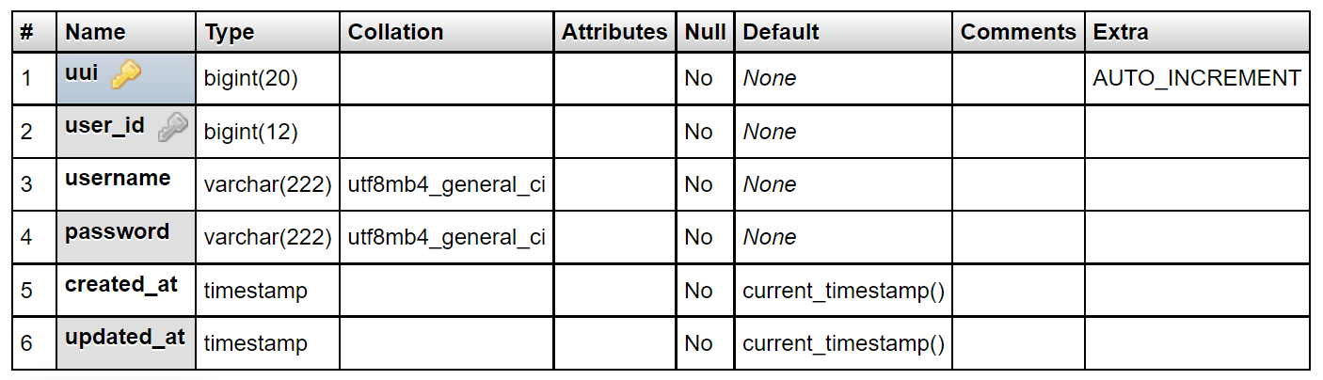

Table 3.2 Accounts

*This table contains login information for accounts.*

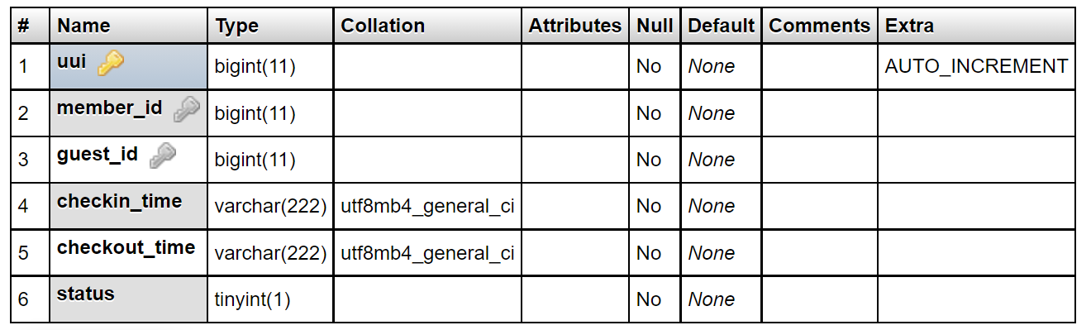 **Table 3.3** Attendace report

*Attendance report, this table is the one that keeps attendance of each and everyone who exits or who enters in the campus*

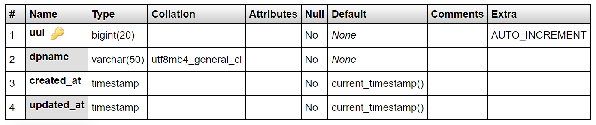

**Table 3.4** Departments

*The department table is used to register all campus departments.*

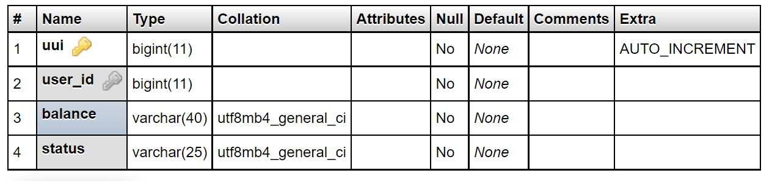**Table 3.5** Finance

*The finance table is used to keep track of each student's financial information.*

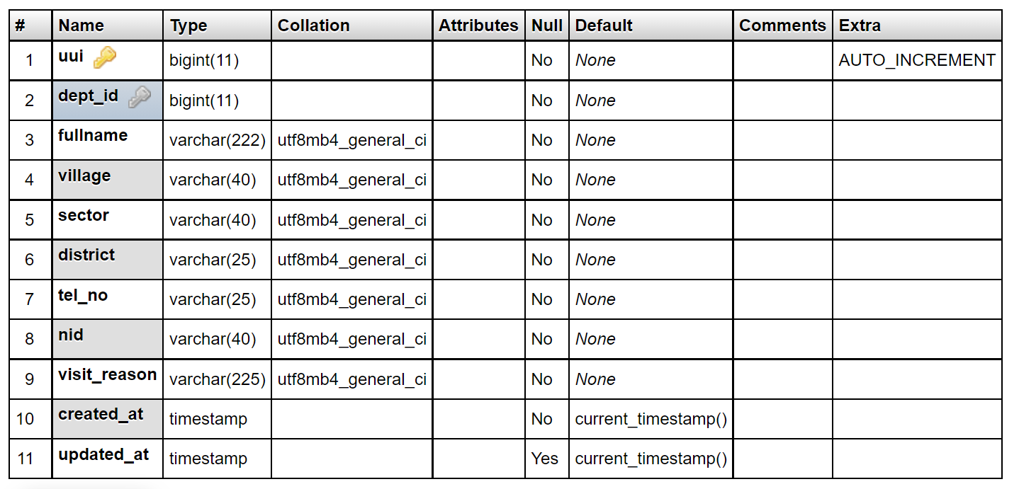

Table 3.6 Guest application

*The guest application table accepts reservations for guests who need to visit the campus*

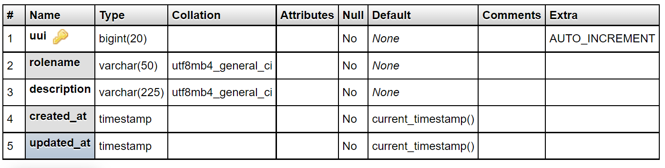**Table 3.7** Roles

*The roles table stores* *the roles of registered users.*

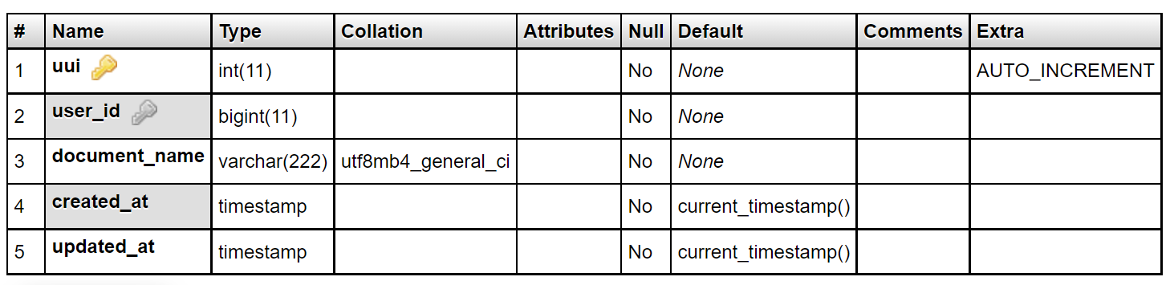**Table 3.8** User documents

*The User documents table stores documents of system’s users*

# **CHAPTER 4: SYSTEM IMPLEMENTATION**

## **4.1 Introduction**

In this chapter, we will deeply present the tools and technologies used for implementing this “Campus Automatic Entrance and Exit Tracking System”. In this chapter, I will demonstrate the output of the new system, how it works, and how it will solve different problems.

## **4.2 Tools and languages that are used in the software development**

* Computer operating system: Windows 10
* Web browser Google Chrome, Opera
* IDE: JetBrains PyCharm 3.4.1, Android studio
* Web server: WSGI server (Web Server Gateway Interface)
* Front languages end: HTML, CSS, JavaScript
* Server-side languages: Python
* Database: PostgreSQL, MongoDb, OpenLdap
* Database GUI tools: pgadmin4-4.20-x86, Ldap Apache directory studio,

### **4.2.1 Python**

Python is a high-level interpreted general programming language. Its design philosophy emphasizes the readability of the code through the use of meaningful indentations. Its language constructs and object-oriented approach aim to help programmers write clear and logical code for projects small and large (Mark, 2015).

### **4.2.2 PostgreSQL**

PostgreSQL is a high-level endeavor class, and open-source social data set framework. PostgreSQL upholds both SQL (relational) and JSON (non- relational) questioning.

PostgreSQL is an exceptionally steady database-backed sponsored by over 20 years of advancement by the open-source community.

PostgreSQL is an essential information base for some web applications, just as portable and investigation applications (Documentation, 2019).

**4.2.3 MongoDB**

MongoDB is a document-oriented database that stores information in JSON-like records with a dynamic outline. It implies you can store your records without agonizing over the information design like the number of fields or sorts of fields to store esteems. MongoDB records are like JSON objects.

This kind of data set fundamentally breaks the typical practice of information stockpiling design of the social data set. It gives the arrangement to the engineers to store information in the data set according to the real necessity of their program. This sort of office we can't accomplish by utilizing the customary RDBMS data set (Seguin, 2009).

### **4.2.4 LDAP**

Lightweight Directory Access Protocol (LDAP for short) is one of the main authentication protocols for directory services. LDAP has historically been used as an information database, mainly storing the following information: users. About the attributes of these users, Group membership privileges.

## **4.3. System implementation**

System implementation is an important phase in the software development life cycle. Web mobile-based Campus Automated Entrance and Exit Tracking System is implemented on Windows operating systems, Android phones, and iOs. In the system implementation stage, the newly developed system is delivered to the users, organization after proper and adequate testing. System implementation encompasses series of stages, and each of these stages is essential to the successful implementation of any system.

Implementation: The implementation stage is carried out in the following aspects:

1. Defining how the information system should be built (i.e., physical system design),
2. Ensuring that the information system is operational and used,
3. Ensuring that the information system meets the quality standard (i.e., quality assurance).

### **4.3.1. Screenshots of a running system**

The following interface is a home page where any user can view it without authentication. The system’s administrator can login through that and help the guests apply for the campus visit. When the system admin logs in, all privileges are granted; otherwise, access is denied.

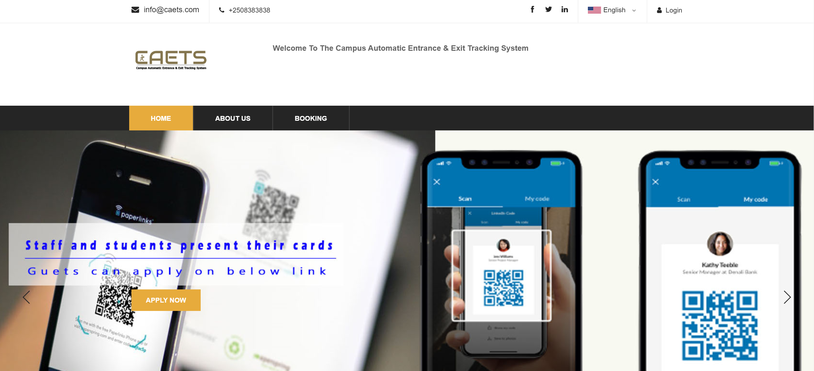

Figure 4.1 Home page

*Home page of Campus Automatic Entrance & Exit Tracking System* (Screenshot from the system, 2021h*).*

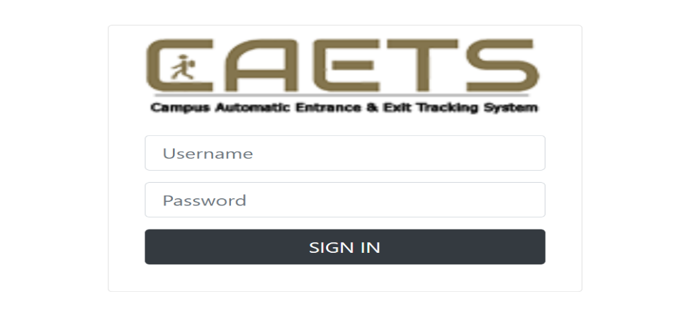

Figure 4.2 Admin login page

*Admin login page, through this page, the system administrator can log in and starts all operations (*Screenshot from the system, 2021a*).*

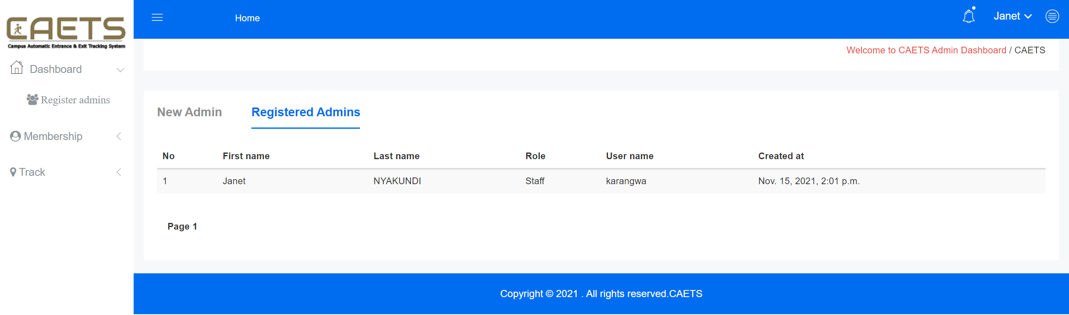

**Figure 4.3** Administrator dashboard

*Administrator dashboard where an admin can register or modify other registered administrators ( Screenshot from the system, 2021d).*

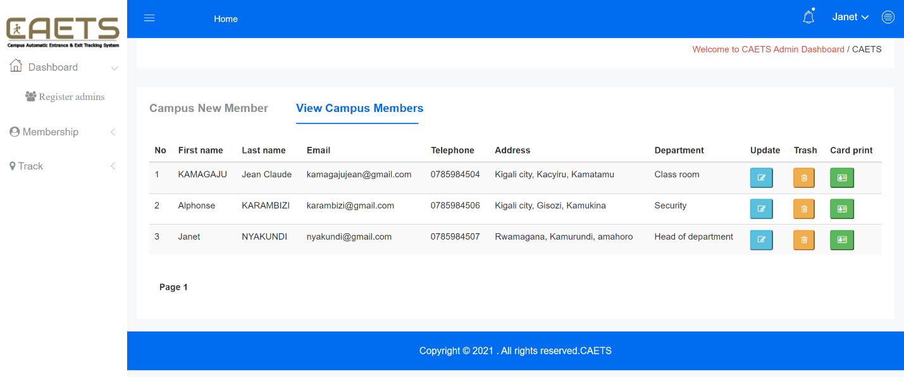

Figure 4.4 Administrator dashboard – membership section

*Administrator dashboard – membership section, Registered members detailed information in admin dashboard* (Screenshot from the system, 2021e*).*

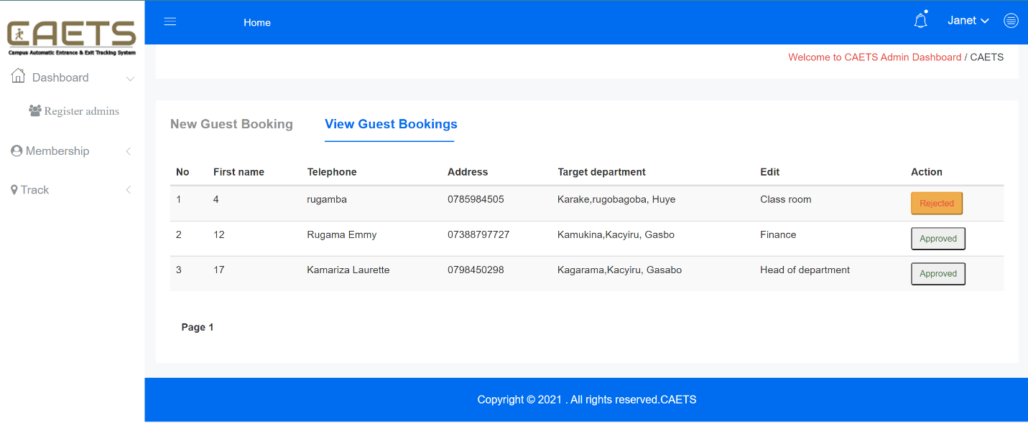

Figure 4.5 Administrator dashboard – guest application section

*Administrator dashboard – guest application section, the folowing page helps guests apply for campus access and show administrator or gatekeeper registered ones, and they can approve during entrance or reject accordingly* *(* Screenshot from the system, 2021g).

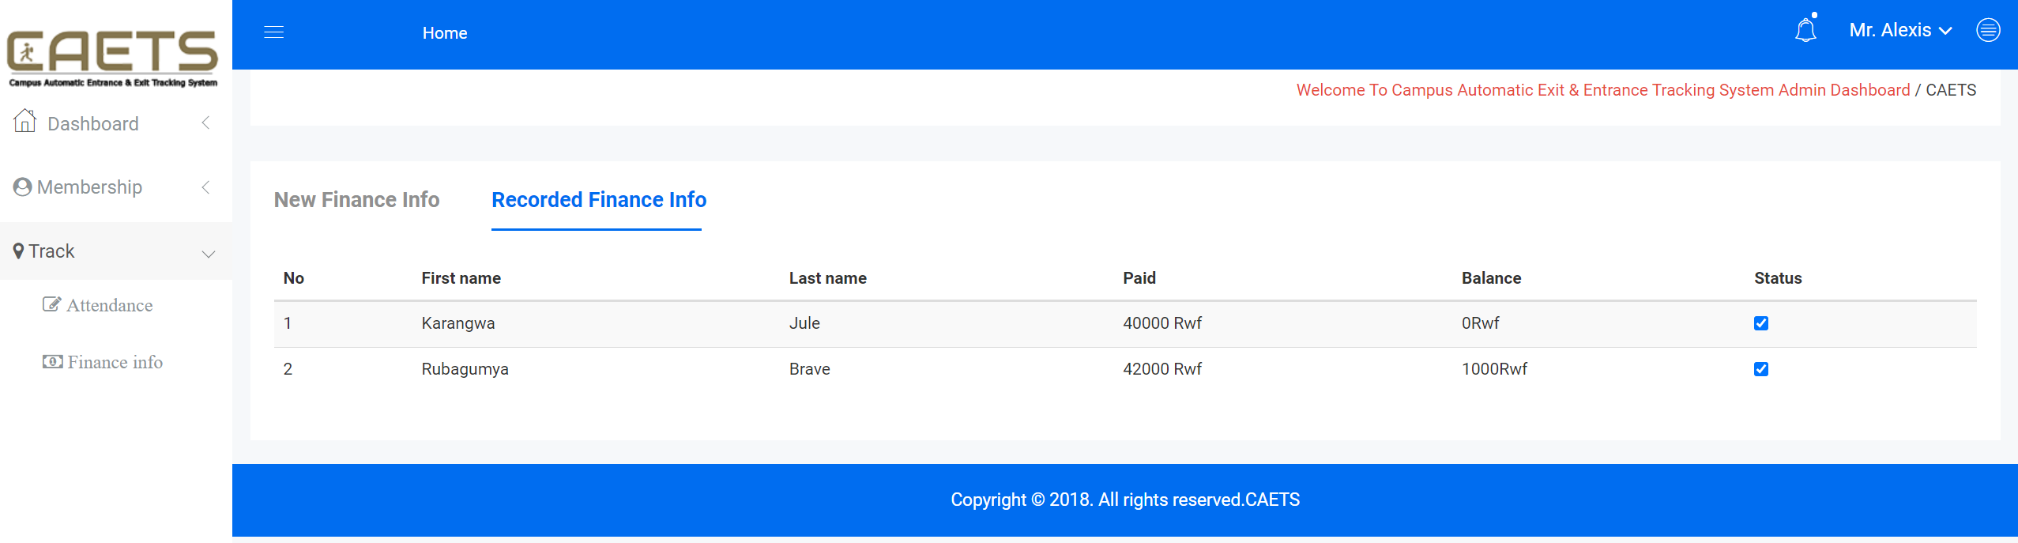

Figure 4.6 Administrator dashboard – student finance status section

*Administrator dashboard – student finance status section, this section helps the admin to view each student financial status (* Screenshot from the system, 2021f).

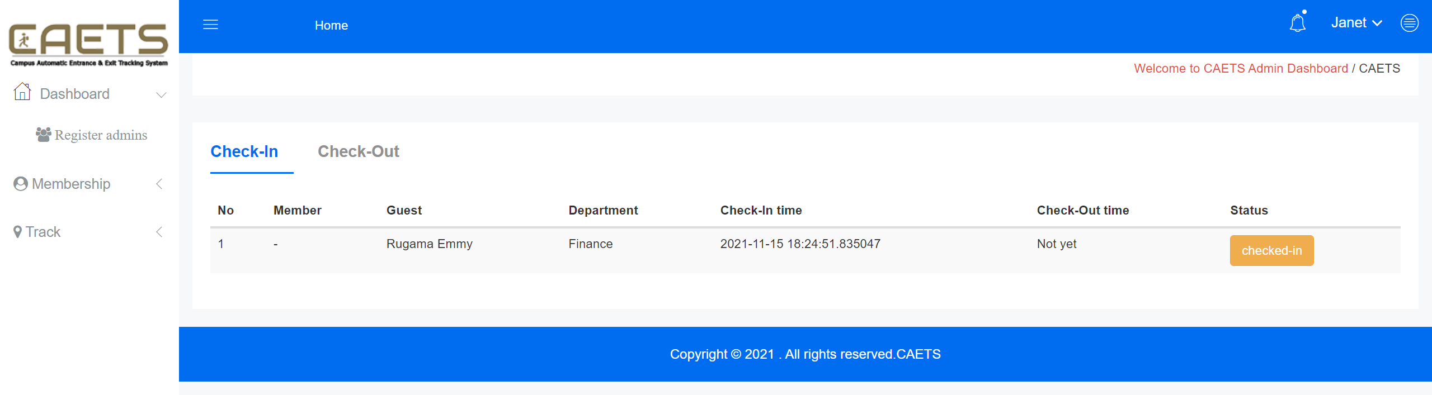

Figure 4.7 Administrator dashboard – checked-in and out attendance

*Administrator dashboard – check-in and out activities,screenshots demonstrated the status of all persons who checked in and out activities that day also the time of activity (*Screenshot from the system, 2021h*).*

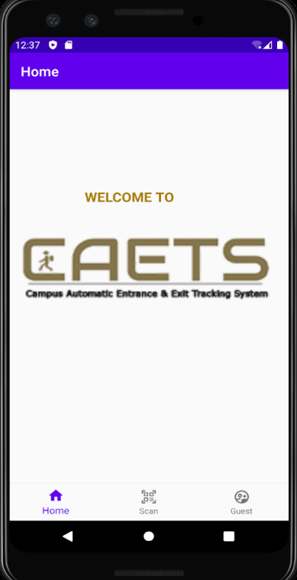

Figure 4.8 System welcome page

*Mobile app – Home page (*Screenshot from the system, 2021c*).*

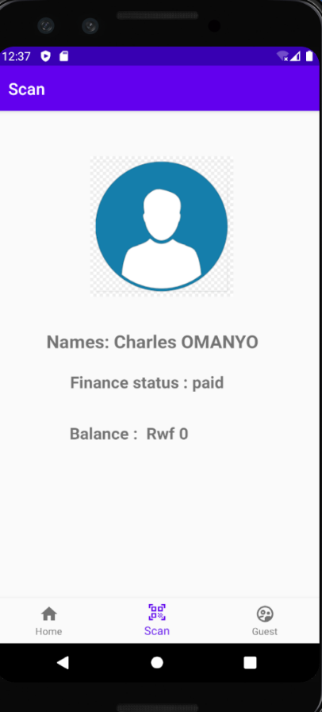

Figure 4.9 Scanned output

*Mobile app – Scanned card results page (*Screenshot from the system, 2021b*).*

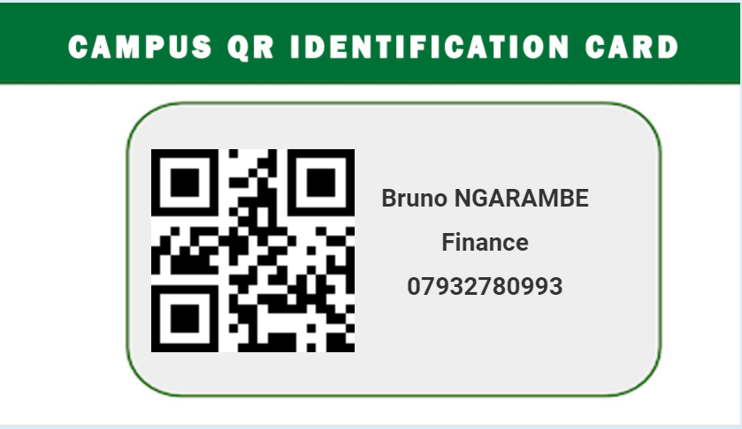

Figure 4.10 Campus QR membership card

*Mobile app – A card generated by the system for distinguished campus members (*Screenshot from the system, 2021j*).*

# **CHAPTER 5: SUMMARY, CONCLUSIONS, AND RECOMMENDATIONS**

## **5.1. Summary**

This work presents a pleasant automated tracking system for Campus Entrance and Entrance management where staff , students and guets are recorded automatically to the entrance and exit gates throught the developed system and the information from scanned information is kept in databases for further reports. This work aims to help ULK campus for maximizing visitor’s traffic management in the respective campus departments, improve daily security work performance and efficiency in finance control, and security in general.

## **5.2. Conclusion**

This research aimed to develop and implement a campus automated entrance and exit tracking system to increase sovereignty and control of the campus’s assets and finance. The research revealed that the objectives of this project were achieved through the development of this system. Implementing this system will put campuses on a good level since is a technological-based system for a user-friendly tracking system.

Since the project focuses on a small area, the equipment used is not costly according to the materials used is software applications for keeping data and produce the report. The system will help the users key in data in the database automatically without a lot of effort. Then, the system will generate data based on the function it is asked for, such as checked-outs report and detect checked-ins. The system is user-friendly, and it is useful for all levels of users.

## **5.3. Recommendation**

1. Campus should have a centralized database of its members' information so that an automated system can retrieve the information they require.
2. Campus should make use of automated tools that deal with cutting-edge technology. I can discuss mobile phones that run the latest versions of the Android and iOS operating systems and have a high processing capacity.
3. Integrate Tracking system with National Identification for visitor’s IDs correct information
4. Campus should adopt technology of designing electronic cards that are readable by QR readers

# **REFERENCES**

das, D. (2005). *Relational Data Base Management System (R.D.B.M.S)*. 1–206.

Documentation, S. O. (2019). Learning Postgresql. *Creative Commons*.

Field, M. D. (1996). System Requirements Engineering Process. *Incose International Symposium*, *6*(1), 442–446. Https://Doi.Org/10.1002/J.2334-5837.1996.Tb02037.X

Gounder, S. (2012). Chapter 3 - Research Methodology And Research Questions. *Research Methodology And Research Method*, *March 2012*, 84–193.

Harkins, M. W. (2016). Managing Risk And Information Security. In *Managing Risk And Information Security*. Https://Doi.Org/10.1007/978-1-4842-1455-8

Ind, Karambir, S. T. (2015). A Simulation Model For The Spiral Software Development Life Cycle. *International Journal Of Innovative Research In Computer And Communication Engineering*, *03*(05), 3823–3830. Https://Doi.Org/10.15680/Ijircce.2015.0305013

Mark, L. (2015). Learning Python. In *Icarus* (Vol. 78, Issue 1).

Philosophy, L. (2020). *Digitalcommons @ University Of Nebraska - Lincoln Practice Of Security Systems In University Libraries Of Assam : A Study*.

Seguin, K. (2009). Mongodb Book. *Openmymind.Net*.

Technology, M. R. C. Of E. &. (2015). Database Management System (Dbms). *The Dictionary Of Genomics, Transcriptomics And Proteomics*, 1–1. Https://Doi.Org/10.1002/9783527678679.Dg05141

Trull, S. G. (1964). Strategies Of Effective Interviewing. *Harvard Business Review*, *42*(1), 89–95.

Tsichritzis, D. C., & Lochovsky, F. H. (1976). Hierarchical Data-Base Management: A Survey. *Acm Computing Surveys (Csur)*, *8*(1), 105–123. Https://Doi.Org/10.1145/356662.356667

Vasumathi, V. J., & Rani, V. (2001). Methodologies Of Translation. *Iosr Journal Of Humanities And Social Science*, 1–4. Http://Www.iosrjournals.org/iosr-jhss/papers/Conf.TS/Volume-2/1. 01-04.pdf

## 

# **APPENDICES**

**Sample Code used**

* 1. **Routes collection in urls.py**

from django.urls import path

from admin_app.views import AddUser,AddMember,AddGuest,AddDepartment, ViewAttendance,ViewFinanceInfo,Login,AddRole,Logout,FindMemberById,UpdateMemberById, DeleteMemberById, Test, ApproveGuestById, RejectGuestById

urlpatterns =[

path('welcome/user', AddUser,name='admin'),

path('admin/login', Login, name='login'),

path('logout', Logout, name='logout'),

…..

]

* 1. **Login and Logout method in Django Python views**

…..

# Create your views here.

**def Login (request):** #Admin Login

if request.session.get('admin_session'):

return redirect("admin")

else:

logout(request) # clear sessions that may be existing previously

if request.method == 'POST':

username = request.POST.get('username')

Iputpassword = request.POST.get('password')

if users.objects.filter(username=username).exists(): #when username is valid

user = users.objects.get(username=username)

hashedpass = user.password

userId = user.id

firstname = user.user.fname

if check_password(Iputpassword, hashedpass) : #when username is valid and pasword is correct

request.session['admin_session'] = userId

request.session['user'] = firstname

return redirect("admin")

else:

messages.error(request, 'Sorry invalid username or password !')

return render(request, 'admin_dashboard/login.html')

else:

messages.error(request, 'Sorry unknown username !')

return render(request, 'admin_dashboard/login.html')

else:

return render(request, 'admin_dashboard/login.html')

**def Logout(request):**

logout(request)

return render(request, 'admin_dashboard/login.html')

….

* 1. **Encoding data in QR using Jquery in Django Python**

……

$('#qrcodeholder').qrcode({

text :$mid ,

render : "canvas", // 'canvas' or 'table'. Default value is 'canvas'

background : "#ffffff",

foreground : "#000000",

width : 115,

height: 115

});

$('#idcardmodal').modal('show'); // show print modal });

……

* 1. **React native script for reading QR card**

$('#qrcodeholder').qrcode({

text :$mid ,

render : "canvas", // 'canvas' or 'table'. Default value is 'canvas'

background : "#ffffff",

foreground : "#000000",

width : 115,

height: 115

});

$('#idcardmodal').modal('show'); // show print modal

**});**