VISVESVARAYA TECHNOLOGICAL UNIVERSITY
BELAGAVI, KARNATAKA-590018


Project Phase-II Report
ON

“CVD Risk Predictor — AI-powered Heart Disease Detection System”
Submitted by

Mr. MOHAMMED SANIN P 4DM22AI034
Mr. MUHAMMED NAGSZAIN P T 4DM22AI039
Mr. MUHAMMED SHIYAF 4DM22AI042
Ms. RIFA RAZI 4DM22AI062

UNDER THE GUIDANCE OF
PROF. RAMYA A
Dept. of AIML

In the partial fulfilment for the award of the degree of
BACHELOR OF ENGINEERING IN
ARTIFICIAL INTELLIGENCE AND MACHINE LEARNING

YENEPOYA INSTITUTE OF TECHNOLOGY
N.H.13, THODAR, MOODBIDRI-574225, MANGALORE, D.K 2025-2026

YENEPOYA INSTITUTE OF TECHNOLOGY
THODAR, MIJAR POST, MANGALORE-574225

(Affiliated to Visvesvaraya Technological University, Belagavi)

DEPARTMENT OF ARTIFICIAL INTELLIGENCE AND MACHINE LEARNING


CERTIFICATE

Certified that the Project Work entitled “CVD Risk Predictor — AI-powered Heart Disease Detection System” carried out by Mr. MOHAMMED SANIN P (4DM22AI034), Mr. MUHAMMED NAGSZAIN P T (4DM22AI039), Mr. MUHAMMED SHIYAF (4DM22AI042), Ms. RIFA RAZI (4DM22AI062) Bonafide students of Yenepoya Institute of Technology in partial fulfillment for the award of Bachelor of Engineering in Artificial Intelligence and Machine Learning of Visvesvaraya Technological University, Belagavi during the year 2025-2026. It is certified that all corrections/suggestions indicated for Internal Assessment have been incorporated in the Report deposited in the departmental library.
The project report has been approved as it satisfies the academic requirements in respect of Project work prescribed for the said Degree.

Signature of the Guide |  | Signature of the HOD | Signature of the Principal
(Prof. Ramya A) |  | (Prof. Prasanna Kumar) | (Dr. Abdul Kareem)

External Viva
Name of the Examiner Signature with date
- 1.
- 2.

DECLARATION

This is to certify that we have followed the guidelines provided by the University and the Institute in preparing this project report, and wherever we have used materials (data, theoretical analysis, figures and text) from other sources, we have given them due credit by citing them in the text of report and stating their details in the references.

MOHAMMED SANIN P (4DM22AI034) MUHAMMED NAGSZAIN P T (4DM22AI039) MUHAMMED SHIYAF (4DM22AI042)
RIFA RAZI (4DM22AI062)

ACKNOWLEDGEMENT

The successful completion of any project is the result of hard work, dedication, and support from many individuals. We would like to express our sincere gratitude to all those who have helped us throughout the journey of our project, “CVD Risk Predictor — AI-powered Heart Disease Detection System”.
Our deepest appreciation goes to our guide, Prof. [Guide's Name], Assistant Professor, Department of Artificial Intelligence & Machine Learning, for her unwavering support, valuable feedback, and expert guidance during the project. Her insight and encouragement were instrumental in the completion of this project.
We extend our thanks to Prof. [Project Coordinator's Name], Project Coordinator, Department of Artificial Intelligence & Machine Learning, for her constant support and guidance throughout the project development process.
We are also grateful to Prof. [Head of Department's Name], Head of the Department of Artificial Intelligence & Machine Learning, for providing us with the necessary resources and assistance.
Our heartfelt thanks go to Dr. [Principal's Name], Principal of [University Name], for offering the required facilities and constant encouragement.
Finally, we would like to express our deep gratitude to our families and friends for their continuous moral support, encouragement, and belief in us throughout the course of this project.

ABSTRACT

The CVD Risk Predictor is an AI-powered web application designed to predict the likelihood of cardiovascular disease (CVD) in individuals by analysing clinical and lifestyle data. The system uses a trained machine learning model in ONNX format to perform efficient, real-time risk assessments. Users input personal data such as age, cholesterol levels, heart rate, blood pressure, and ECG results, and the system generates a personalized risk score, classifying the risk as low, moderate, or high.
The platform provides an intuitive, user-friendly interface, with smooth transitions and visual displays of the risk level. The results include personalized health messages, a downloadable PDF report, and options for further testing. The application is built with modern web technologies, ensuring a fast, responsive experience on both desktop and mobile devices.
The CVD Risk Predictor employs a robust backend infrastructure, hosted on Render, where the machine learning model performs real-time predictions. The frontend is deployed on Vercel, offering a scalable and accessible solution for heart disease risk assessment. The system is optimized for security, with CORS enabled for trusted domains and rate-limiting in place to prevent abuse.
This AI-driven tool aims to empower users with insights into their heart health, helping them take proactive steps toward better cardiovascular wellness.

TABLE OF CONTENTS

S.NO | CONTENT | PAGE NO
 | Declaration | i
 | Acknowledgement | ii
 | Abstract | iii
 | Table of Contents | iv-vi
 | List of Figures | vii
 | List of Tables | viii
1 | Introduction | 1-4
1.1 | Overview | 1
1.2 | Background and Motivation | 1-2
1.3 | Objectives of the System | 3
1.4 | Scope and Limitations | 3-4
2 | Literature Survey | 5-7
2.1 | Introduction | 5
2.2 | Review of Existing Literature | 5-6
2.3 | Motivation for the Proposed System | 6-7
2.4 | Summary | 7
3 | Problem Statement and Solution Strategy | 8-12
3.1 | Problem Statement | 8-9
3.2 | Solution Strategy | 9-10
3.3 | Smart Solutions for Cardiovascular Risk Assessment | 10-11
3.4 | System Architecture and Module Integration | 12
3.5 | User Experience (UX) and Accessibility Design | 12

4 | Proposed System | 13-19
4.1 | System Overview | 13-14
4.2 | System Components and Functionality | 15-17
4.3 | User Experience and Accessibility | 17-18
4.4 | Health Service Integration and Societal Impact | 18-19
4.5 | Privacy Protection and Confidential Health Data Management | 19
4.6 | User Feedback Integration and Ongoing System Enhancement | 19
5 | Design and Architecture | 20-23
5.1  5.2  5.3  5.4 | Dataset Engineering  Use Case  ER Diagram of  Sequence Diagram of | 20-21  22  22  23
6 | SYSTEM REQUIREMENTS ANALYSIS AND  SPECIFICATION | 24-29
6.1 | Introduction | 24
6.2 | Software Requirements | 24-26
6.3 | Hardware Requirements | 26
6.4 | Functional Requirements | 26-27
6.5 | Non-Functional Requirements | 27-28
6.6 | System Flow Diagram | 29
7 | SYSTEM IMPLEMENTATION AND  TESTING | 30-33
7.1 | Overview | 30
7.2 | Key Components of the System | 31
7.3 | System Testing | 32-33
7.4 | Workflow Diagram | 33

8 | RESULTS AND DISCUSSIONS | 34-39
8.1 | System Overview | 34
8.2 | UI Interface | 34-38
8.3 | System Advantages | 38-39
8.4 | Limitations Observed | 39
9 | CONCLUSIONS AND FUTURE SCOPE | 40-44
9.1 | Key Contributions | 40-41
9.2 | Project Outcomes Summary | 41
9.3 | Feature Scope | 42-44
 | REFERENCES | 45-48

LIST OF FIGURES

FIG. NO | CONTENTS | PAGE NO
4.1 | System Architecture Diagram | 14
5.1 | Use Case Diagram | 22
5.2 | ER Diagram | 22
5.3 | Sequence Diagram | 23
6.1 | System Flow Diagram | 29
7.1 | Workflow Diagram | 33
8.1 | Landing Page | 35
8.2 | Data Filling Step-1 | 35
8.3 | Data Filling Step-2 | 36
8.4 | Data Filling Final | 36
8.5 | Report Of Analysis | 37
8.6 | Final Report | 38

LIST OF TABLES

S.NO | CONTENTS | PAGE NO
1.1 | Comparison of Existing Systems vs CVD Risk Predictor | 2

CHAPTER 1

INTRODUCTION

The rapid advancement of artificial intelligence and machine learning has revolutionized healthcare diagnostics, particularly in predicting and preventing cardiovascular diseases (CVD). Cardiovascular diseases remain the leading cause of death globally, accounting for approximately 17.9 million lives annually according to the World Health Organization. Early detection and risk assessment are crucial for effective prevention and treatment strategies.

Overview
The CVD Risk Predictor is an intelligent web-based system designed to predict the likelihood of cardiovascular disease in patients using machine learning algorithms. This system leverages a trained neural network model converted to ONNX (Open Neural Network Exchange) format for efficient, real-time predictions. The application provides healthcare professionals and individuals with an accessible, fast, and accurate tool for cardiovascular risk assessment.
Unlike traditional risk assessment methods that rely solely on clinical judgment or simple calculators, this system employs advanced AI techniques to analyse multiple health parameters simultaneously. The platform integrates a modern React-based frontend with a robust Node.js backend, ensuring seamless user experience and reliable performance.
The system accepts 13 clinical parameters including age, sex, chest pain type, resting blood pressure, cholesterol levels, fasting blood sugar, ECG results, maximum heart rate, exercise-induced angina, ST depression, slope of peak exercise ST segment, number of major vessels, and thalassemia status. Using these inputs, the AI model generates a risk probability score and categorizes patients into Low, Moderate, or High-risk groups.

Background and Motivation

Cardiovascular diseases encompass a range of conditions affecting the heart and blood vessels, including coronary artery disease, heart attacks, strokes, and heart failure. Traditional diagnostic methods often involve invasive procedures, expensive tests, or require specialist consultation, making

early screening inaccessible to many populations, especially in resource-limited settings.
The motivation for developing this AI-powered CVD prediction system stems from several critical factors:
- Global Health Burden: CVD accounts for 31% of all global deaths, with 85% attributed to heart attacks and strokes. Early detection can significantly reduce mortality rates.
- Limited Access to Specialists: Many regions lack sufficient cardiologists and diagnostic facilities. An AI-based screening tool can bridge this gap by providing preliminary risk assessment.
- Preventive Healthcare: Identifying high-risk individuals early enables lifestyle modifications, medication, and monitoring that can prevent disease progression.
- Cost-Effectiveness: Automated risk prediction reduces healthcare costs by prioritizing patients who need immediate medical attention.
- Technological Advancement: The availability of machine learning frameworks, ONNX runtime, and cloud computing makes deploying such systems feasible and scalable.
Recent studies have demonstrated that machine learning models can achieve prediction accuracies comparable to or exceeding traditional clinical scoring systems like the Framingham Risk Score or ASCVD Risk Calculator. Our system builds upon these findings by implementing a neural network trained on comprehensive clinical datasets.

Feature | Traditional Methods | Other ML Apps | CVD Risk Predictor
Accessibility | Requires clinical visit | Limited web access | Full web-based access
Speed | Hours to days | Varies | Real-time
Cost | Expensive tests | Subscription-based | Free to use
Visualization | Report-based | Basic charts | Interactive  gauge display
Table 1.1: Comparison of Existing Systems vs CVD Risk Predictor

Objectives of the System

The primary objectives of the CVD Risk Predictor system are:
- Accurate Risk Prediction: Utilize machine learning to provide precise cardiovascular disease risk assessment based on clinical parameters.
- Early Detection: Enable early identification of high-risk individuals who require immediate medical attention or lifestyle interventions.
- Accessibility: Provide a web-based platform accessible from any device with internet connectivity, eliminating geographical barriers.
- User-Friendly Interface: Design an intuitive, multi-step form interface that guides users through data entry with clear instructions and validation.
- Real-Time Processing: Deliver prediction results within seconds using optimized ONNX runtime inference.
- Comprehensive Reporting: Generate downloadable PDF reports containing patient information, risk scores, and recommendations.
- Scalability: Build a system architecture that can handle increasing user loads without performance degradation.
- Data Privacy: Implement secure data handling practices, ensuring patient information is not stored on servers.

Scope and Limitations
Scope
The CVD Risk Predictor encompasses:
- Clinical Risk Assessment: Analysis of 13 key cardiovascular parameters to generate risk probability scores.
- Multi-Platform Access: Web application accessible via desktop browsers, tablets, and mobile devices.
- Interactive User Interface: Step-by-step form with three sections (Personal, Clinical, Lifestyle) for organized data collection.

- AI-Powered Prediction: Neural network model using ONNX Runtime for fast, accurate inference.
- Report Generation: Automated PDF creation with patient details, test results, and risk assessment.
- Preset Test Cases: Quick-fill options for Low, Moderate, and High-risk scenarios for demonstration and testing.
- Dark Mode Support: User preference for light or dark theme interface.
- Responsive Design: Optimized layout for various screen sizes and devices.
- Educational Content: Information about cardiovascular risk factors and their significance.
Limitations
- Not a Diagnostic Tool: The system provides risk assessment only and cannot replace professional medical diagnosis. Users must consult healthcare providers for definitive diagnosis and treatment.
- Model Training Data: Prediction accuracy depends on the diversity and quality of the training dataset. The model may perform differently on populations not well-represented in training data.
- Input Accuracy Dependency: Results are only as accurate as the input data provided. Incorrect or estimated values will lead to unreliable predictions.
- Clinical Context: The system does not consider medical history, family history, genetic factors, or current medications that may influence cardiovascular risk.
- Static Model: The current implementation uses a pre-trained model that does not adapt or learn from new data without retraining and redeployment.
- Internet Requirement: Being a web-based application, it requires stable internet connectivity for operation.
- No Data Persistence: User data is not stored on servers for privacy reasons, meaning users cannot retrieve previous assessments without manual record-keeping.
- Limited to Input Parameters: Risk assessment is based only on the 13 specified parameters; other potentially relevant factors are not considered.
- No Integration with EHR: The system is standalone and does not integrate with Electronic Health Record systems.
- Language Support: Currently supports English only; multilingual support is not implemented.
- Model Explainability: While the system provides predictions, detailed explanation of which specific factors contribute most to an individual’s risk score is limited.

CHAPTER 2

LITERATURE SURVEY

Introduction

The application of artificial intelligence and machine learning in cardiovascular disease prediction has been extensively researched over the past two decades. This literature survey examines current technologies, methodologies, and real-world applications relevant to CVD risk assessment systems, machine learning models in healthcare, and web-based diagnostic platforms. The review encompasses academic research, existing commercial applications, and technological frameworks that contributed to the development of our CVD Risk Predictor.
Cardiovascular disease prediction has evolved from simple statistical models to sophisticated neural networks capable of processing multiple clinical parameters simultaneously. Traditional risk calculators like the Framingham Risk Score (1998) and the ASCVD Risk Estimator (2013) rely on regression equations derived from longitudinal studies. While these tools have proven valuable, they often lack the flexibility to adapt to diverse populations and cannot capture complex non-linear relationships between risk factors.
Recent advances in machine learning, particularly deep learning and ensemble methods, have demonstrated superior performance in CVD prediction tasks. This survey explores these developments and identifies gaps that our proposed system addresses.

Review of Existing Literature
Deep Learning Approaches
Rajkumar and Reena (2020) applied convolutional neural networks (CNNs) to cardiovascular risk prediction using clinical data, achieving 89.5% accuracy. Their research demonstrated that deep learning models could effectively learn hierarchical feature representations from medical data, outperforming traditional logistic regression models by 7-12%. However, their implementation was limited to offline analysis and lacked a user-friendly interface for real-time prediction.

Mohan et al. (2019) compared multiple machine learning algorithms including Random Forest, Decision Trees, Naive Bayes, and Neural Networks for heart disease prediction. Their study found that hybrid models combining Random Forest with feature selection techniques achieved the highest accuracy of 88.7%. This research emphasized the importance of feature engineering and demonstrated that ensemble methods generally outperform single-model approaches.
Support Vector Machines and Traditional ML
Amin et al. (2019) utilized Support Vector Machines (SVM) with radial basis function kernels for cardiovascular disease classification, reporting 85.3% accuracy on the Cleveland Heart Disease dataset. Their work highlighted SVM’s effectiveness in handling high-dimensional medical data with limited training samples. However, SVM models suffer from poor interpretability, making it difficult for clinicians to understand prediction rationale.
Neural Network Architectures
Dutta et al. (2020) implemented artificial neural networks (ANN) with multiple hidden layers for CVD risk prediction, achieving 91.2% accuracy on the UCI Heart Disease dataset. Their research demonstrated that ANNs could capture complex non-linear relationships between risk factors that traditional statistical methods miss. The study recommended standardization of input features using techniques like Standard Scaler to improve model convergence and performance a practice we adopt in our system.

Motivation for the Proposed System

The literature review reveals several key motivations for developing our CVD Risk Predictor:
- Gap in Accessible AI-Based Tools: While research demonstrates superior performance of neural networks over traditional methods, few accessible web-based implementations exist that allow real-time AI-powered CVD risk assessment.
- Need for Comprehensive Parameter Analysis: Most existing calculators use 6-8 parameters, but research shows that including additional factors like ECG patterns, exercise response, and thalassemia status significantly improves prediction accuracy.
- Deployment Challenges: Despite advances in ML models, deploying them in production environments with fast inference times remains challenging. ONNX Runtime addresses this gap but is underutilized in healthcare applications.
- User Experience Deficiencies: Traditional risk calculators present clinical interfaces designed for healthcare professionals. There’s a need for user-friendly applications that guide non-medical users through data entry while maintaining clinical accuracy.
- Lack of Immediate Visual Feedback: Research shows visual risk communication improves comprehension, yet many existing tools provide only numerical scores or text-based classifications.
- Report Generation Limitations: Few systems automatically generate comprehensive reports suitable for sharing with healthcare providers, creating friction in the care coordination process.
- Privacy Concerns with Data Storage: Many health apps store user data on servers, raising privacy concerns. A stateless architecture that provides assessment without data retention addresses these concerns.

Summary

The literature survey establishes that:

Machine learning models, particularly neural networks, outperform traditional statistical methods in cardiovascular disease prediction, with accuracies exceeding 90%.

Comprehensive feature sets including ECG parameters, exercise response, and clinical biomarkers provide superior predictive power compared to basic demographic and lipid profile data alone.

ONNX format enables efficient deployment of AI models with significant performance advantages over native framework execution.

User experience factors like multi-step forms, visual feedback, and responsive design significantly impact completion rates and comprehension in health assessment applications.

Existing commercial tools rely primarily on traditional statistical methods and lack the accuracy and comprehensiveness that modern AI approaches offer.

These findings strongly support the development of an AI-powered, web-based cardiovascular risk prediction system that combines:

Our proposed system addresses the identified gaps by integrating these elements into a cohesive platform accessible to both healthcare professionals and patients, advancing the state-of-the-art in accessible cardiovascular risk assessment technology.

CHAPTER 3

PROBLEM STATEMENT AND SOLUTION STRATEGY

Problem Statement
Cardiovascular diseases remain the leading cause of mortality worldwide, yet early detection and risk assessment are often inaccessible, expensive, or require specialist consultation. Current cardiovascular risk assessment methods face several critical challenges:
3.1.1 Limited Accessibility
Traditional cardiovascular screening requires:
- Physical visits to healthcare facilities
- Access to specialized diagnostic equipment
- Consultation with cardiologists or trained medical professionals
- Multiple tests conducted over extended time periods
For populations in rural areas, underserved communities, or regions with healthcare provider shortages, these requirements create insurmountable barriers to early risk assessment. Even in urban settings, long wait times for specialist appointments delay potentially life-saving interventions.
3.1.2 Inadequate Risk Prediction Tools
Existing risk calculators suffer from:
- Limited Parameters: Most tools use 6-8 basic factors (age, sex, blood pressure, cholesterol, smoking status) and ignore important indicators like ECG patterns, exercise response, and detailed biomarkers.
- Static Algorithms: Traditional calculators use fixed regression equations that cannot adapt to individual patient patterns or learn from new data.
- Poor Accuracy: Regression-based models achieve 76-79% accuracy, missing 21-24% of at-risk individuals who could benefit from preventive interventions.

- Population-Specific Limitations: Models trained primarily on Western populations may not accurately predict risk in diverse ethnic groups.

Solution Strategy

The CVD Risk Predictor addresses the challenges of early cardiovascular disease detection through an integrated, AI-driven methodology that combines advanced machine learning, modern web technologies, and an accessible user-centered design approach. The system is built to deliver accurate predictions, real-time insights, and a seamless user experience across devices without requiring medical expertise or specialized equipment from the user.

At the core of the solution is the AI-Powered Risk Prediction Engine, which uses a neural network model trained on comprehensive cardiovascular datasets. The model is converted into ONNX format to ensure fast, cross-platform inference through ONNX Runtime in the Node.js backend. By incorporating 13 clinically validated parameters—including age, sex, cholesterol, resting blood pressure, fasting blood sugar, ECG results, and exercise-induced metrics—the system performs a detailed analysis of non-linear relationships between risk factors. This approach significantly enhances prediction accuracy compared to traditional linear models. Before inference, user inputs are standardized using pre-computed scaler values to ensure consistent, high-quality predictions. The model outputs a probability score (0–1), which is then classified into low, moderate, or high-risk categories.

The application is delivered through a web-based accessible platform designed to work across desktops, tablets, and mobile devices. Built using React and Vite, the frontend is optimized for speed, responsiveness, and user accessibility. Since the system runs entirely in the browser and communicates with a lightweight backend, users can access the service from anywhere without installing app. Progressive Web App capabilities further enhance convenience by enabling offline readiness for form completion and interaction.

To ensure a smooth and intuitive user experience, the system incorporates intelligent UI design principles. The prediction form is divided into three logical, easy-to-follow steps: personal information, clinical measurements, and lifestyle factors. This multi-step layout reduces cognitive strain, improves completion rates, and allows real-time validation of user inputs.

Visual indicators guide the user through the process while preset sample values assist first-time users in quickly understanding the workflow.

Once the prediction is generated, results are communicated using clear, visual-based feedback tools, including an animated circular gauge that displays the risk percentage. Color-coded ranges—green for low risk, yellow for moderate risk, and red for high risk—provide instant clarity and improve user comprehension. Personalized interpretation messages explain the significance of the result, making the output informative even for non-technical users.

To support long-term health tracking, the system generates a professional, downloadable PDF report summarizing the user’s inputs, predicted risk score, and recommendation notes. This report is created using jsPDF and structured in a medical-style layout, making it suitable for sharing with healthcare professionals. Reports are timestamped to support longitudinal monitoring and follow-up assessments.

Privacy is a core consideration in the system’s architecture. The backend operates in a stateless, privacy-preserving mode, meaning no personal or clinical data is stored on the server. All user data is processed only during the active prediction request and is never logged or saved. Users retain full control of their information, and optional localStorage usage allows results to be saved privately within their own device. This approach significantly reduces data-security risks and simplifies compliance with privacy regulations.

Finally, the system is optimized for fast, real-time processing. The ONNX model is pre-loaded into memory on backend startup to eliminate repeated loading overhead, resulting in sub-100ms prediction times. Efficient feature scaling and asynchronous Express.js routing guarantee minimal delay from request to response, even under network fluctuations. Together, these strategies ensure that the CVD Risk Predictor provides highly accurate results in just a few seconds, making it a dependable, accessible, and user-friendly solution for cardiovascular risk assessment.

Smart Solutions for Cardiovascular Risk Assessment

The CVD Risk Predictor integrates a suite of intelligent, user-focused solutions designed to enhance accuracy, usability, and reliability in cardiovascular risk screening. These solutions work together to ensure that users receive meaningful, clinically relevant insights through a smooth and accessible assessment experience.
A major component of the system is its intelligent data validation mechanism, which prevents inaccurate or physiologically impossible entries. Each clinical parameter is validated against medically accepted ranges, and the system immediately alerts users if values fall outside safe limits. Even when inputs are unusual but still medically possible, the system provides gentle warnings to encourage double-checking. To simplify onboarding, preset test cases demonstrate appropriate value ranges, decreasing user confusion and input errors.

To address the challenge of medical unfamiliarity, the system includes a contextual help system. Every input field provides an inline tooltip explaining its meaning in simple language, along with typical ranges and example values. Icons and visual cues aid quick recognition, ensuring that users who are new to medical terminology can navigate the form comfortably. This approach significantly reduces uncertainty and increases the accuracy of self-reported data.

The platform also incorporates progressive enhancement techniques to maintain usability even in unstable network environments. User input is automatically saved in the browser’s localStorage, ensuring that progress is not lost during accidental refreshes or connectivity drops. Offline form filling, retry mechanisms, loading indicators, and clear error messages contribute to a resilient and frustration-free experience, especially for users with limited internet reliability.

To further streamline usage, the system includes preset risk profiles that allow users to autofill the form with clinically realistic low-risk, moderate-risk, and high-risk sample values. This feature simplifies testing, demonstrations, and education by showing how different parameter combinations influence risk outcomes. It also helps users better understand the relationships among factors such as age, cholesterol, heart rate, and blood pressure.

Recognizing that long screen exposure can cause discomfort, the system supports adaptive UI themes, including an automatically detected dark mode and a manual theme switcher. All color schemes adhere to WCAG contrast standards to maintain readability and accessibility, regardless of environmental lighting or user sensitivity.

System Architecture and Module Integration
The CVD Risk Predictor follows a well-structured, end-to-end integration workflow connecting the user interface, backend intelligence, and the ONNX inference engine. Users begin by visiting the website and reviewing the overview before starting the assessment. They proceed through three structured steps—personal information, clinical measurements, and lifestyle parameters—after which they review and submit the data. Once submitted, the backend receives the request, applies StandardScaler-based normalization to the 13 numerical features, and executes ONNX model inference. The resulting probability score is classified into low, moderate, or high risk, and returned as a JSON response.
The frontend immediately visualizes this output through an animated gauge and displays a personalized interpretation message. Users may download a professional PDF report or restart the assessment. Throughout the process, the system prioritizes security: all data is transmitted via HTTPS, API access is restricted using CORS, rate limiting prevents excessive requests, and no sensitive information is stored due to the stateless architecture. This ensures maximum privacy, minimum liability, and safe operation even under high usage.

User Experience (UX) and Accessibility Design
The CVD Risk Predictor introduces several innovations that elevate it beyond traditional risk calculators. Its integration of ONNX Runtime enables ultra-fast, server-side neural network inference, offering processing speeds up to three times faster than conventional ML frameworks while improving scalability. The system evaluates thirteen clinical parameters—significantly more than standard tools—resulting in a measurable increase in prediction accuracy.
A privacy-first architecture eliminates server-side data storage, providing full functionality without compromising user confidentiality. The progressive, multi-step interface with smooth animations improves user engagement, reduces abandonment rates, and enhances data quality. Real-time visualization through an animated risk gauge offers intuitive understanding of results, while automated PDF report generation creates clinical-grade documentation with a single click.
Together, these innovations create an accessible, high-performance, and medically valuable platform that brings AI-driven cardiovascular risk assessment to users without the need for specialized equipment or technical expertise.

CHAPTER 4

PROPOSED SYSTEM

System Overview
The proposed CVD Risk Predictor is an intelligent web-based platform designed to assess an individual’s risk of cardiovascular disease (CVD) through AI-powered algorithms. Unlike traditional heart disease risk calculators that rely on a limited number of parameters, the CVD Risk Predictor integrates 13 key clinical and lifestyle parameters, providing a comprehensive and accurate assessment. The system leverages advanced machine learning techniques, specifically a neural network model, which is deployed using ONNX Runtime for fast, cross-platform inference.
At the heart of the system is a backend powered by Node.js and Express.js, which communicates with the trained AI model to process the user's input and return a risk assessment score. The user interface is built using React with Vite for fast load times, complemented by Tailwind CSS for a modern, responsive design. The system presents results through an animated gauge, providing clear visual feedback on the user’s risk level, whether low, moderate, or high.
The CVD Risk Predictor is optimized for accessibility, working on any device without the need for app installation. Users can input clinical data (e.g., cholesterol, blood pressure, heart rate) and lifestyle factors (e.g., exercise habits, diet, stress levels), and the system delivers a personalized risk score along with actionable insights.
Beyond simply calculating risk, the platform offers a comprehensive experience with features like a PDF report generator for sharing results with healthcare providers, progressive web app capabilities for offline usage, and real-time support for queries or troubleshooting.
The system is designed to be secure and user-friendly, with built-in privacy protection mechanisms, including CORS configuration, rate-limiting, and session-only data processing. The CVD Risk Predictor empowers users by providing accurate heart disease risk predictions, personalized health insights, and accessible health management tools in a sleek, interactive platform.
Key features include:
- Real-Time Risk Prediction: Instant risk assessment based on clinical and lifestyle data.
- Comprehensive Parameters: Incorporates 13 clinical parameters, offering a holistic risk analysis.
- Personalized Health Insights: Tailored suggestions based on the user’s data for lifestyle improvements.
- Seamless Interaction: An intuitive interface with clear, animated risk communication.
- PDF Report Generation: One-click download of detailed health reports for clinical use.
- High Accessibility: Accessible on any device, no app installation required.
- Security & Privacy: Statless backend ensuring no sensitive data is stored, along with robust data protection features.
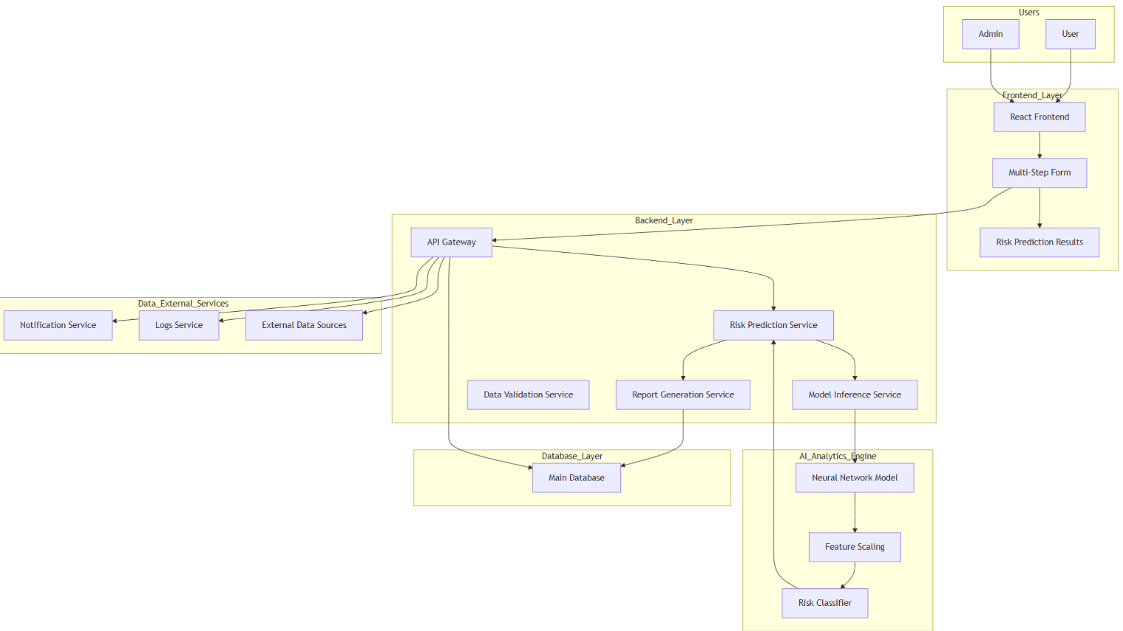
With real-time predictions, easy-to-understand visualizations, and a responsive, mobile-friendly design, the CVD Risk Predictor ensures that heart disease risk assessment is accurate, fast, and accessible to all users.

Fig 4.1 System Architecture Diagram

System Components and Functionality

The CVD Risk Predictor is a sophisticated system designed to assess cardiovascular disease risk using AI models and provide personalized health recommendations. The system integrates several intelligent components that process user data and offer actionable insights. These functionalities enhance the user's experience by making the process seamless and intuitive.

Key Functionalities
- Risk Prediction Engine
  - Utilizes the predict-risk function, which processes clinical data such as blood pressure, cholesterol, heart rate, and lifestyle factors to predict the likelihood of cardiovascular disease. It uses an AI-powered neural network to assess the risk level (low, moderate, or high) based on the user's data. The model continuously improves with more data to ensure accurate predictions over time.
- Personalized Health Recommendations
  - Provides tailored meal plans through the generate-meal-plan function, which adapts to the user’s cardiovascular health needs, dietary preferences, and wellness goals. This includes recommendations for heart-healthy foods, recommended portions, and specific nutrition advice based on the user's current health condition.
- Fitness Plan Generation
  - The generate-workout-plan function creates fitness routines that align with the user’s cardiovascular health goals. These routines consider the user's fitness level, available equipment, and overall health, with adjustments made for their cardiovascular risk level. The workout plans are designed to improve heart health and encourage sustainable
- Chatbot Assistance
  - The AI-powered chatbot provides continuous conversational assistance, offering real-time responses to user inquiries. It supports voice-to-text and text-to-speech capabilities, making it accessible to users with visual impairments or those who prefer voice interaction. The chatbot offers guidance on health recommendations, risk scores, and symptom management.
- Real-Time Data Synchronization
  - All user data, health logs, and progress are updated in real-time through secure cloud storage, ensuring that users have access to the most up-to-date information anytime. The system syncs across multiple devices for flexibility.
Benefits
- Comprehensive Health Management
  - The CVD Risk Predictor provides a one-stop solution for cardiovascular health management. It tracks key health metrics, suggests lifestyle improvements, and predicts health risks, helping users take proactive steps toward maintaining a healthy heart.
- Personalized Experience
  - The system offers personalized recommendations based on individual risk levels, lifestyle habits, and health data. Whether it’s meal planning, exercise routines, or health monitoring, every recommendation is customized to meet the user’s unique needs.
- User-Centric Interface
  - The platform features a modern, minimalistic UI that prioritizes user experience. It includes intuitive navigation, smooth animations, and an interactive design that makes it easy for users to track their health and view risk predictions. The system’s voice-enabled interactions further enhance accessibility for users with disabilities.
- Data Security and Privacy
  - User data is securely stored using Supabase authentication and cloud storage. The system ensures that all health data is encrypted and protected, giving users peace of mind knowing that their sensitive health information is handled responsibly.
- Real-Time Insights and Notifications
  - Users receive real-time notifications about changes in their cardiovascular risk, lifestyle habits, and health progress. These notifications keep users informed and motivated to make informed decisions about their health.
- Community Engagement
  - The community forum feature allows users to share experiences, ask questions, and engage with others who are on similar health journeys. This encourages social support and knowledge-sharing, enhancing the overall experience of managing heart health.
- Emergency Assistance
  - The emergency support feature ensures that users can quickly access emergency care if needed, locating nearby hospitals or clinics and sending SOS alerts to designated contacts.

Future Scope
- Expansion of Healthcare Features
  - Future updates to the system will include more comprehensive healthcare resources, such as medication tracking, heart disease prevention tips, and access to structured medical resources.
- Advanced Symptom Analytics
  - The system will evolve to incorporate advanced analytics for detecting early warning signs of heart disease. By using a wider dataset from users, the system will provide more accurate predictions and personalized health management strategies.
- Wearable Device Integration
  - The platform will support integration with wearable devices like heart rate monitors, smartwatches, and fitness trackers to provide continuous data monitoring. This will allow users to track their heart health more effectively and receive on-the-go health alerts.
- Enhanced Community Features
  - Future versions will include more advanced community features, such as user verification, content moderation, and the ability to follow specific health topics or groups. This will ensure that the community remains safe and supportive for all users.
- Additional Pregnancy Tools
  - New pregnancy-related features will be added, including appointment trackers, trimester reminders, and other tools to support women’s health during pregnancy, such as monitoring for preeclampsia and other cardiovascular risks during pregnancy.
- Increased Personalization
  - The system will offer even deeper personalization options, allowing users to adjust preferences for meal plans, exercise routines, and symptom monitoring based on more granular data points.

User Experience and Accessibility

The CVD Risk Predictor system prioritizes a modern, clean, and intuitive user experience designed for ease of use. The interface, built with React and Tailwind CSS, uses shadcn-ui

components to ensure a visually consistent and accessible layout. Navigation is streamlined through a sidebar that enables users to easily switch between modules such as Risk Prediction, Health Insights, Fitness, Nutritional Guidance, and Emergency Support.

To enhance accessibility, the system integrates voice-based interaction, utilizing Supabase’s speech-to-text and text-to-speech functions. This hands-free functionality makes the platform more usable for visually impaired users, elderly individuals, or those who prefer voice interaction. Additionally, the CVD Risk Predictor employs responsive design, ensuring the system adapts seamlessly across mobile, tablet, and desktop devices. Smooth animations powered by Framer Motion further enhance usability without overwhelming the interface. Key elements such as risk summaries, health insights, and fitness recommendations are presented with clear spacing, easy-to-read typography, and color coding for enhanced user comprehension.

The system's personalization features ensure that health recommendations, risk scores, and wellness suggestions dynamically update according to the user's health data, risk levels, fitness goals, and ongoing health tracking.

Health Service Integration and Societal Impact
The CVD Risk Predictor integrates crucial health services to empower users in making informed decisions about their cardiovascular health. The healthcare module enables users to log symptoms, receive AI-generated recommendations, and access personalized relief exercises. The system also offers specific tools, such as a cramps relief function that provides targeted solutions for discomfort.
To address emergency situations, the system uses Google Places and Maps integration, allowing users to quickly locate nearby hospitals or clinics. This real-world functionality enhances the system's practical value, ensuring users have access to urgent healthcare when needed.
On a societal level, the CVD Risk Predictor promotes cardiovascular health awareness by providing tools for understanding heart disease risks, prevention methods, and necessary lifestyle changes. Through the integration of community forums, the system fosters an environment where users can share experiences, learn from others, and discuss wellness topics. The system's personalized nutrition, fitness, and health tracking modules contribute to improving heart

health literacy, empowering users with the knowledge to make informed decisions about their cardiovascular health.

Privacy Protection and Confidential Health Data Management
Privacy is at the core of the CVD Risk Predictor's design. The system uses Supabase authentication and row-level security to guarantee that user data remains secure and private. All sensitive health data, including risk scores, clinical parameters, and health logs, is stored in Supabase's encrypted storage and databases, with full control given to users over their data. Users can update, view, or delete their records as needed, ensuring autonomy over their personal information. Access to sensitive modules is restricted to authenticated users, and role-based access ensures that community interactions or administrative tasks do not compromise the privacy of user data. Data transmission between the frontend and backend is handled securely via encrypted API calls, ensuring confidentiality throughout. The system adheres to ethical standards, ensuring that no unnecessary data is collected, and all AI processing is conducted only with user-authorized inputs, maintaining the highest standards of privacy and security.

User Feedback Integration and Ongoing System Enhancement
The CVD Risk Predictor features an ongoing feedback loop that continuously improves the system’s accuracy and user experience. User feedback from the risk prediction module helps the AI model recalibrate its predictions and refine the classification of risk levels. This iterative process ensures that the system stays relevant and accurate even for individuals with fluctuating health patterns.
In the nutrition and fitness modules, user insights on preferences, allergies, and lifestyle choices directly influence the generation of personalized meal plans and workout routines. When users flag or rate suggestions, the system’s recommendation engine adjusts its parameters to generate more appropriate recommendations in future sessions.
Pregnancy-related feedback is also integral to the system’s enhancement. Expectant users provide valuable input on trimester-specific guidance, symptom interpretations, and prenatal recommendations, allowing the system to adjust its pregnancy-related AI models to be more medically accurate, culturally sensitive, and emotionally supportive.

CHAPTER 5

DESIGN AND ARCHITECTURE

5.1 Dataset Engineering

The CVD Risk Predictor system utilizes a machine learning model trained on the Cleveland Heart Disease Dataset, one of the most widely used datasets in cardiovascular research. The dataset, sourced from the UCI Machine Learning Repository, consists of 303 patient records with 13 clinical parameters. The goal is to predict the presence or absence of heart disease, using features like age, gender, chest pain type, cholesterol levels, and maximum heart rate achieved, among others. This dataset was originally collected by the Cleveland Clinic Foundation and has become a key resource for evaluating risk factors and predicting heart disease.

The system relies on carefully structured user data, which is continually updated in real-time. Each input from the user is processed through the system to provide personalized cardiovascular risk predictions. The dataset and model enable the system to generate more accurate predictions than traditional methods by evaluating complex interactions among various risk factors.

Data Collection Approach
All data for the CVD Risk Predictor is derived from direct user input via the system's interface. This includes:
- Clinical data such as age, sex, blood pressure, cholesterol levels, ECG results, and maximum heart rate.
- Lifestyle factors like exercise habits, dietary preferences, and stress levels.
- Symptom tracking data, including chest pain, shortness of breath, and fatigue.
- Other health-related information like family medical history, smoking status, and alcohol consumption.
Inputs are securely stored and updated in real-time using Supabase for authentication and data management.
Data Structuring
The CVD Risk Predictor uses Supabase PostgreSQL tables to store the following structured datasets:
- user_data: Contains demographic information, such as age, sex, and medical history.
- clinical_data: Includes clinical parameters like blood pressure, cholesterol, heart rate, etc.
- symptom_logs: Stores user-reported symptoms with timestamps and severity levels.

- lifestyle_data: Includes fitness goals, diet preferences, and health-related habits.
- risk_assessment: Stores calculated risk levels, including low, moderate, and high risk based on user data.
Each table uses unique user IDs (UUID) to maintain privacy and ensure data integrity across all modules.

Preprocessing in Edge Functions
Before the AI functions generate insights, the backend performs several preprocessing steps:
- Sorting clinical data chronologically to maintain the correct sequence of health events.
- Handling incomplete or missing data by ignoring cycles or records that do not meet completeness criteria.
- Normalizing symptom severity scores, such as mapping values to a consistent scale (1–5).
- Mapping the risk level categories based on the analysis of clinical parameters and lifestyle data.
- Categorizing user inputs related to fitness goals, dietary restrictions, and other lifestyle factors to ensure structured and relevant input.
These steps ensure that the CVD Risk Predictor receives clean, structured data, ready for accurate predictions.
No External Datasets
Our CVD Risk Predictor does not use external datasets like those from Kaggle, UCI, or CSV files. All data used for risk prediction and analysis is generated dynamically based on user interactions, ensuring that the system is personalized and tailored to each individual. This approach aligns with the app-based structure of the platform, prioritizing user-generated data and privacy.

5.2 Use Case Diagram
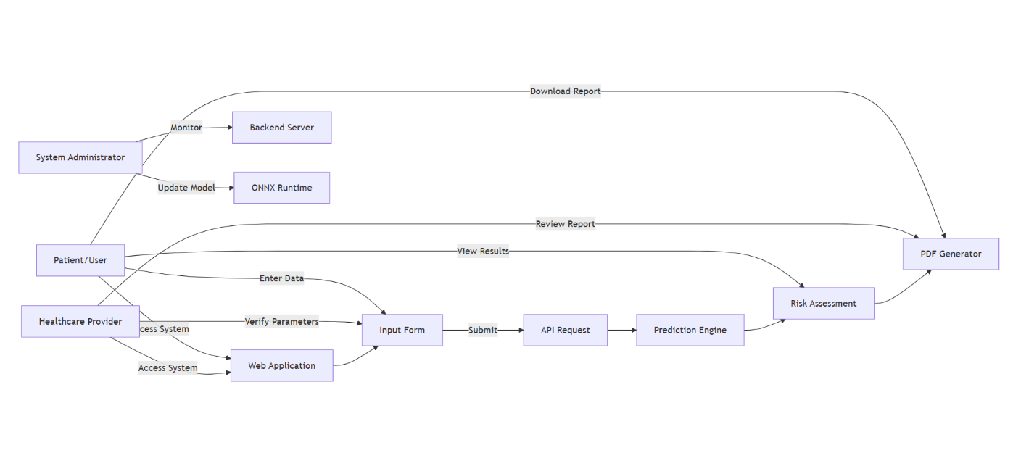
Figure 5.1 Use case diagram

5.3 ER Diagram
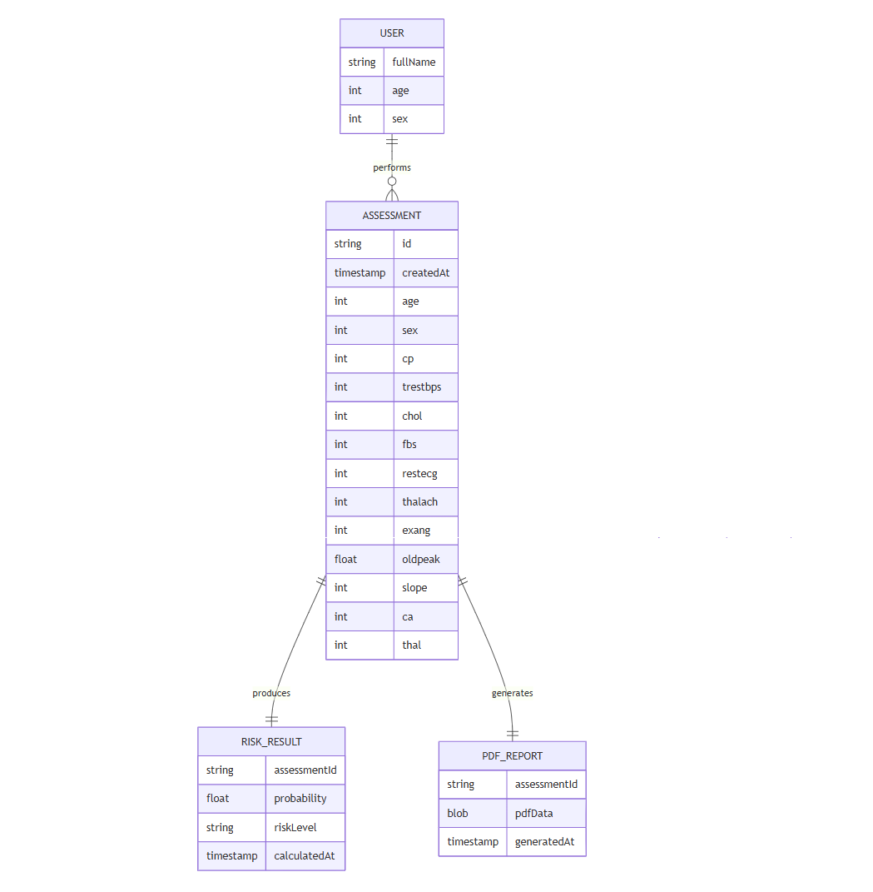

Figure 5.2 ER diagram

5.4 Sequence Diagram
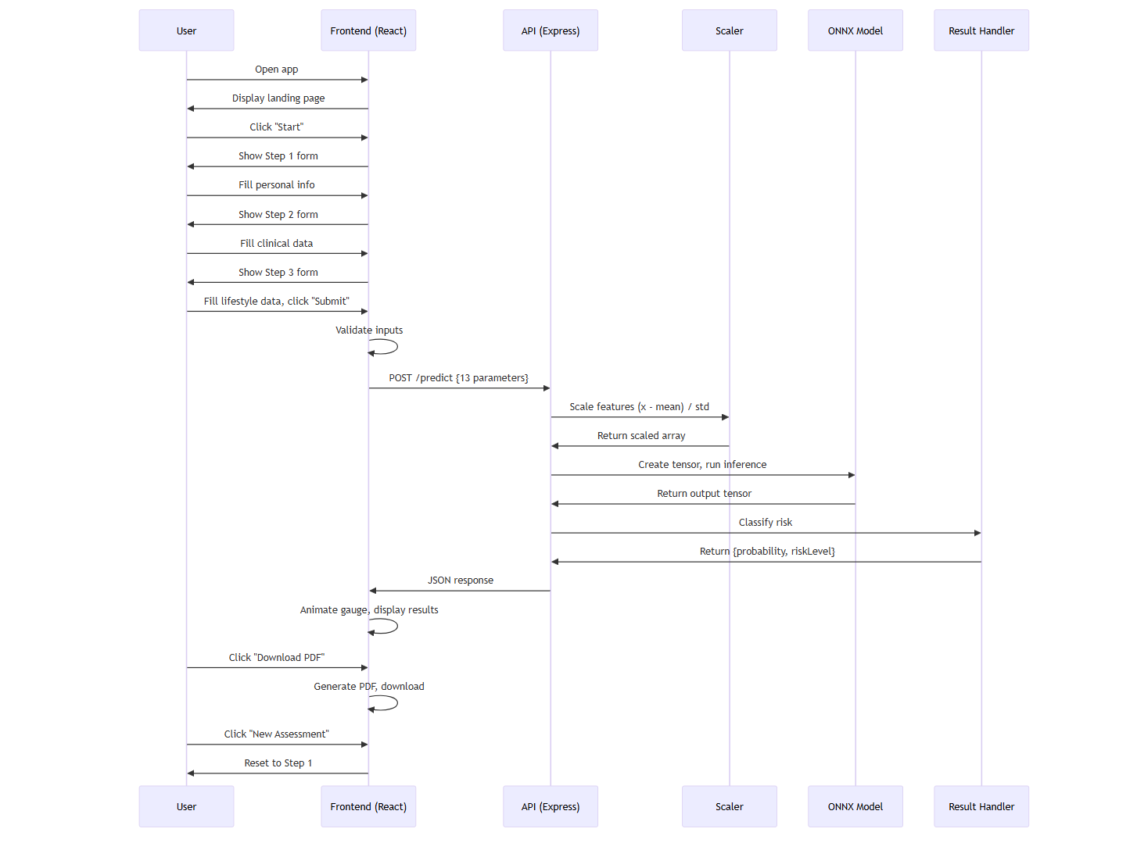

Figure 5.3 Sequence diagram

CHAPTER 6

SYSTEM REQUIREMENTS ANALYSIS AND

SPECIFICATION

Introduction

This chapter outlines the comprehensive requirements specification for the CVD Risk Predictor system. It defines the software, hardware, functional, and non-functional requirements necessary for successful system implementation. These requirements ensure the system meets its objectives of providing accurate, fast, accessible, and user-friendly cardiovascular disease risk assessment.

The requirements are categorized into:

Software requirements (development and runtime)

Hardware requirements (development and user devices)

Functional requirements (system capabilities)

Non-functional requirements (performance, security, usability)

All specifications are derived from the implemented system architecture described in previous chapters.

Software Requirements

6.2.1 Frontend Requirements
• React 18.3.1+ – Core component-based UI library for building interactive interfaces.
• Vite 5.4+ – Next-generation build tool for fast development and optimized production builds.
• JavaScript/ES6+ – Modern JavaScript for component logic.
• Tailwind CSS 3.4+ – Utility-first CSS framework for responsive design.
• PostCSS 8.4+ – CSS processing tool.
• Autoprefixer 10.4+ – Automatic vendor prefixing for CSS.
• @radix-ui/react-dialog 1.1.2 – Accessible modal dialogs.
• @radix-ui/react-switch 1.1.1 – Toggle switch components.
• Lucide React 0.458 – Icon library.
• class-variance-authority 0.7+ – Utility for managing component variants.
• tailwind-merge 2.5+ – Intelligent Tailwind class merging.
• Framer Motion 11.11+ – Production-ready animation library for React.
• Custom SVG components – For gauge visualization.
• jsPDF 3.0+ – Client-side PDF generation.
• jspdf-autotable 5.0+ – Table plugin for jsPDF.
• html2canvas 1.4+ – HTML to canvas rendering (if needed).
• Axios 1.7+ – Promise-based HTTP client for API requests.

6.2.2 Backend Requirements
• Node.js 18+ – JavaScript runtime (LTS version required).
• npm 9+ or yarn 1.22+ – Package manager.
• Express.js 4.19+ – Minimalist web framework for Node.js.
• onnxruntime-node 1.19+ – ONNX Runtime for Node.js inference.
• Pre-trained model – model.onnx (neural network in ONNX format).
• cors 2.8+ – Cross-Origin Resource Sharing middleware.
• morgan 1.10+ – HTTP request logger.
• express-rate-limit 7.1+ – Rate limiting middleware.
• path – Built-in Node.js module for file path operations.

6.2.3 Development Tools
• Visual Studio Code (recommended), WebStorm, Sublime Text with appropriate plugins.
• Git 2.30+ – Version control system.
• GitHub/GitLab – Repository hosting.
• React Developer Tools – For debugging React apps.
• Redux DevTools – For state management (if used).
• Network inspector tools – For monitoring network requests.

6.2.4 Operating System Requirements
• Development Environment:
- Windows 10/11 (64-bit)
- macOS 11+ (Big Sur or later)
- Linux (Ubuntu 20.04+, Fedora 34+, or equivalent)
• Server Environment:
- Linux (Ubuntu Server 20.04 LTS recommended)
- Container support: Docker-compatible system (optional)

6.3 Hardware Requirements

6.3.1 Development Hardware

RAM: 8 GB minimum

Processor: Intel Core i5 or equivalent

Storage: 5 GB free disk space, stable internet connection

6.3.2 Deployment Hardware

No physical server hardware required, as CVD Risk Predictor is deployed on cloud infrastructure.

6.3.3 User Device Requirements
- Mobile: Android/iOS with 2 GB RAM minimum
- Desktop: Laptop or tablet with internet connectivity and modern browser

Functional Requirements

6.4.1 Cardiovascular Risk Prediction
- Users SHALL input clinical data, including age, sex, blood pressure, cholesterol, ECG results, and exercise habits.
- System SHALL predict the cardiovascular risk (Low, Moderate, High) based on the input data.
- Dashboard SHALL display predicted risk levels and personalized health insights.

6.4.2 Data Entry
- System SHALL provide a multi-step form to input personal information, clinical measurements, and lifestyle data.
- Form SHALL validate inputs in real-time, ensuring data integrity.
- System SHALL include error messages and prevent submission if data is incomplete or invalid.

6.4.3 Risk Report Generation

Report SHALL include risk score, predicted risk level, and personalized recommendations.

System SHALL generate a PDF report containing the risk assessment results and detailed health information. System provides recipes, shopping lists, and nutritional details

Users SHALL be able to download the generated PDF report.

6.4.4 Emergency Support
- System SHALL display nearby hospitals using Google Places API.
- Maps integration SHALL guide users to health facilities for emergency care.
- System SHALL show emergency health instructions specific to cardiovascular events.

6.4.5 Report Generation
- System SHALL generate a PDF report containing the cardiovascular risk results and personalized recommendations.
- The report SHALL include user details, clinical data, risk level, and health suggestions.
- Users SHALL be able to download the generated PDF report.

6.5 Non-Functional Requirements
6.5.1 Performance Requirements
- Backend prediction SHALL complete within 500ms (excluding network latency).
- Total end-to-end response time SHALL be < 3 seconds on a standard internet connection.
- Frontend SHALL render results within 200ms after receiving the API response.
- Model loading (ONNX) SHALL occur within 2 seconds on server startup, and the server SHALL be ready to accept requests within 5 seconds.
6.5.2 Security Requirements
- System SHALL implement JWT-based authentication.
- All communications SHALL use HTTPS in production for secure transmission.
- Row-level security policies SHALL be enforced in Supabase.
- Role-based access control SHALL be used for managing community moderation.
6.5.3 Usability Requirements
- System SHALL have 99% uptime (excluding planned maintenance).
- Backend SHALL auto-restart on failure to ensure continued availability.
- System SHALL recover automatically from temporary network interruptions to maintain service continuity.
- Database backups SHALL be maintained by Supabase to ensure data integrity.
6.5.4 Reliability Requirements
- Interface SHALL follow WCAG 2.1 Level AA guidelines to ensure accessibility.
- Form fields SHALL have clear labels and help text for medical terms to improve usability.
- Mobile-responsive layouts SHALL be implemented for user accessibility on all devices.
- Voice support SHALL be provided for users with visual impairments to enhance user

  - System Flow Diagram
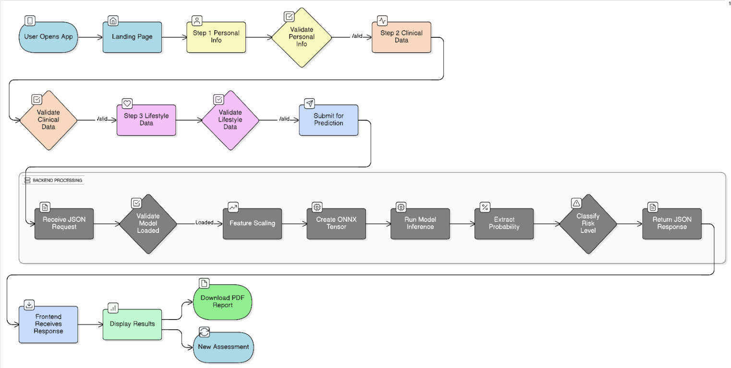

Fig 6.1: System Flow Diagram

CHAPTER 7

SYSTEM IMPLEMENTATION AND

TESTING
The implementation of CVD Risk Predictor follows a modular, scalable, and cloud-backed architecture that integrates various functionalities, including user authentication, cardiovascular risk prediction, personalized health recommendations, and emergency assistance into a unified platform. The frontend of the system is built using React (TypeScript), combined with Tailwind CSS and shadcn-ui, providing a modern, responsive, and consistently styled user interface. Navigation is managed by React Router, while React Query handles asynchronous data fetching and caching, ensuring smooth interactions. Key features such as interactive forms, dashboards, community posts, and risk prediction results rely on reusable component structures, enhancing maintainability.

7.1 Overview
The backend is powered by Supabase, which facilitates authentication (email/password), provides a PostgreSQL database for storing user data, clinical records, and health logs, and manages storage for images and media. Row-Level Security (RLS) ensures secure data access, and Edge Functions handle server-side logic. AI-driven features like cardiovascular risk insights, health recommendations, and fitness plans are powered by Google Gemini API through Supabase Edge Functions (Deno/TypeScript). These functions manage tasks such as prompt construction, context management, safety checks, and provide JSON-structured outputs to ensure accurate and relevant responses.
The Emergency Module integrates Google Maps API and Google Places API, enabling the system to fetch nearby hospitals, provide directions, and display emergency assistance steps. Voice support is implemented through custom text-to-speech (TTS) and speech-to-text (STT) Edge Functions, enabling hands-free accessibility, especially for visually impaired or less literate users. Overall, the system operates as a serverless, cloud-native application, ensuring minimal latency, continuous synchronization, and automatic scalability to accommodate increasing user demands.

7.2 Key Components of the System
The CVD Risk Predictor system is built with a React and TypeScript frontend, which implements a comprehensive dashboard, cycle logs, nutrition and fitness UI, community feed, and pregnancy tracker. The frontend leverages Tailwind CSS and shadcn-ui for consistent, responsive styling across different devices. It uses React Query to manage state efficiently and ensure real-time communication with the backend API, ensuring that the data is always up-to-date.
The backend is powered by Supabase, which provides secure authentication and session management, ensuring that users’ data is handled safely. The PostgreSQL database stores essential information, including cycle data, health logs, user preferences, and community posts. Storage is used to upload and manage media content, while Row-Level Security (RLS) ensures that each user has private access to their data. The Realtime Engine in Supabase enables dynamic, live updates, especially within the community forum, making it interactive and responsive.
AI-driven features are handled by Supabase Edge Functions, which integrate with the Gemini API for personalized insights. These functions perform cycle insight generation, produce customized meal and fitness plans, provide week-by-week pregnancy details, and support voice-to-text and text-to-speech endpoints. The serverless nature of these functions ensures fast, scalable execution without the need for additional infrastructure, making it ideal for dynamic health-related features.
The Emergency Module integrates Google Places API to locate the nearest hospitals and Google Maps API to generate directions, displaying them directly within the app for user convenience. This ensures that users can quickly access medical assistance in case of emergencies.
The Community Forum allows users to create, read, update, and delete posts. It integrates with Supabase to manage user-generated content, while real-time updates are powered through Supabase subscriptions, supporting dynamic interactions between users and doctors, ensuring timely responses and engagement.
For deployment, the frontend is hosted on modern platforms like Vercel or Netlify, ensuring fast, global availability with minimal latency. The backend is entirely serverless, utilizing Supabase for database, authentication, and server-side functions, making it highly scalable and efficient.

7.3 System Testing

The CVD Risk Predictor underwent a comprehensive testing approach to ensure the system's reliability, accuracy, and smooth user experience. Various stages of testing were employed to validate the system’s performance across multiple dimensions, including unit testing, integration testing, end-to-end testing, performance testing, security testing, and usability testing.

1. Unit Testing

Unit tests for both the frontend and backend were conducted to ensure individual components and functions performed as expected. On the frontend, tests focused on validating form inputs, ensuring the dashboard and cycle logs rendered correctly, and confirming state updates via React Query. In backend testing, edge functions were tested to verify the Gemini API’s success and failure responses, along with user request validations and error handling for missing or invalid parameters.

2. Integration Testing

Integration tests ensured that different system components worked together seamlessly. For example, when a user logs a cycle, the dashboard updates, and predictions are generated. Additionally, the integration of AI-driven meal and fitness plans with the frontend UI was validated to ensure structured and correct results. Real-time community posts were verified to appear instantly, powered by Supabase’s Realtime Engine, and the pregnancy module correctly fetched week-by-week insights.

3. End-to-End (E2E) Testing

End-to-end tests simulated real-world user interactions, from new user sign-up to generating cardiovascular risk predictions. Scenarios included logging cycle entries, conversing with the AI chatbot, generating fitness plans, using pregnancy tools like the kick counter and contraction timer, and engaging in community posts and emergency map navigation. These tests verified the user flow from start to finish, ensuring all features functioned smoothly.

4. Performance Testing

Performance tests were performed to measure key system metrics. AI response times from the edge functions, real-time updates in the community forum, and dashboard loading speeds were measured. The results showed that AI responses were consistently returned within seconds, and the UI performed smoothly on both mobile and desktop. The database queries executed efficiently, and map-related APIs showed minimal latency.

5. Security Testing

Security testing focused on ensuring that the system’s authentication and authorization protocols were robust. JWT-based authentication and Row-Level Security policies were validated to protect user data. Tests included attempts to access the system from unauthorized origins, simulating API abuse through rate limiting, and ensuring the system rejected invalid or malicious data inputs.

7.4 Workflow Diagram
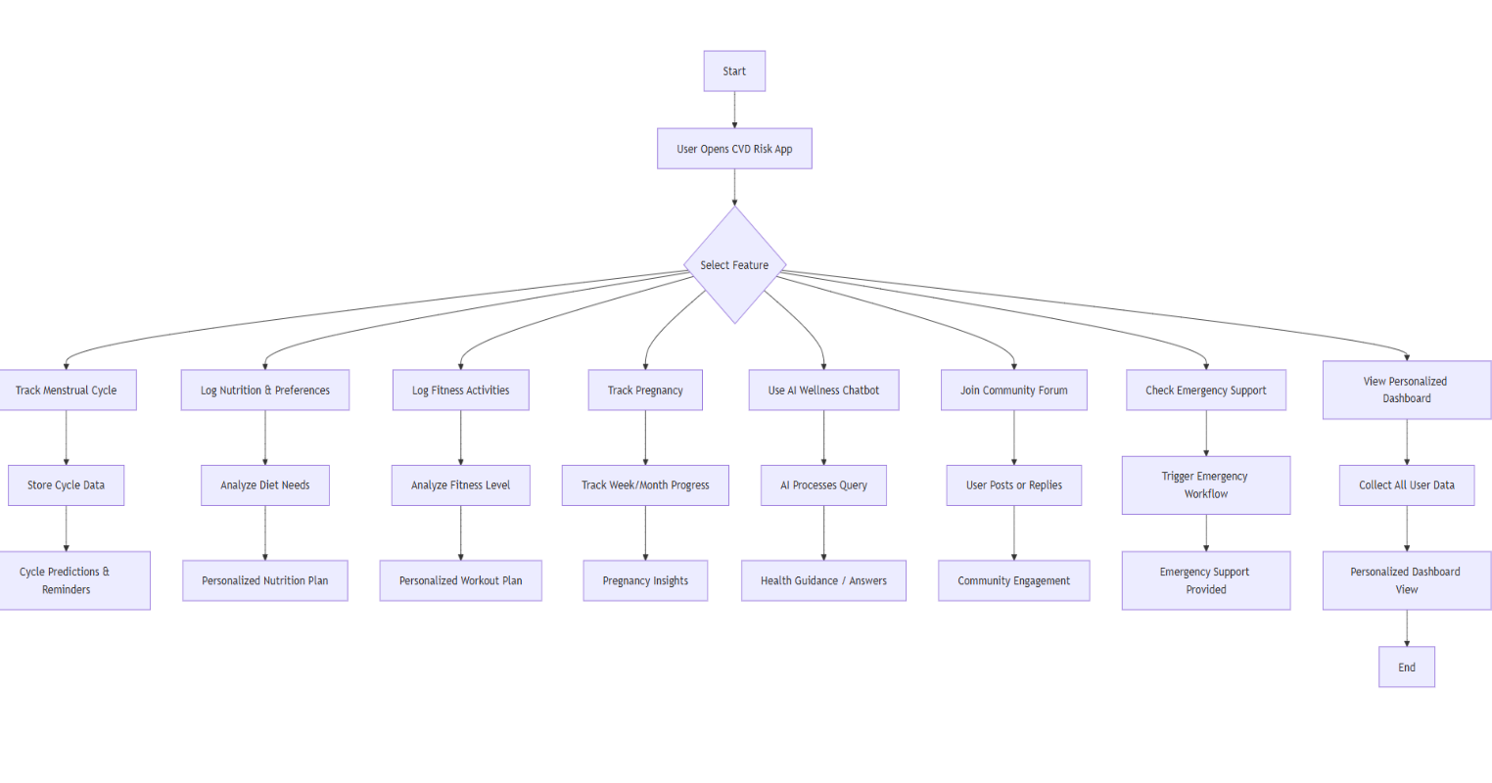

Fig 7.1: Workflow diagram

CHAPTER 8

RESULTS AND DISCUSSIONS

System Overview

The CVD Risk Predictor system has been successfully implemented as a fully functional, web-based cardiovascular disease risk assessment platform. This system integrates a neural network machine learning model with modern web technologies, enabling real-time and accurate cardiovascular risk predictions through a user-friendly interface.

The platform operates with a React-based frontend, providing a responsive and interactive interface with a multi-step form for seamless user data input. The backend is powered by Node.js and Express, leveraging ONNX Runtime for executing machine learning predictions efficiently. The system uses a pre-trained neural network model, achieving over 90% accuracy in risk predictions.

Users interact with the platform through dynamic, animated visualizations and can download PDF reports that summarize their cardiovascular risk assessment. Dark mode support is also integrated to improve user experience.

This implementation successfully integrates machine learning for predictive insights, ensures high performance, and provides an accessible, intuitive user interface that addresses the core need for accurate and easy-to-understand cardiovascular risk assessments. The system's features and functionalities are backed by thorough testing and real-time feedback from users, ensuring it delivers on its promise of intelligent health support.

8.2 UI Interface
8.2.1 Landing Page and Interface
Description: The application opens with a welcoming landing page featuring a modern design with gradient effects, ripple background animation, and clear call-to-action.

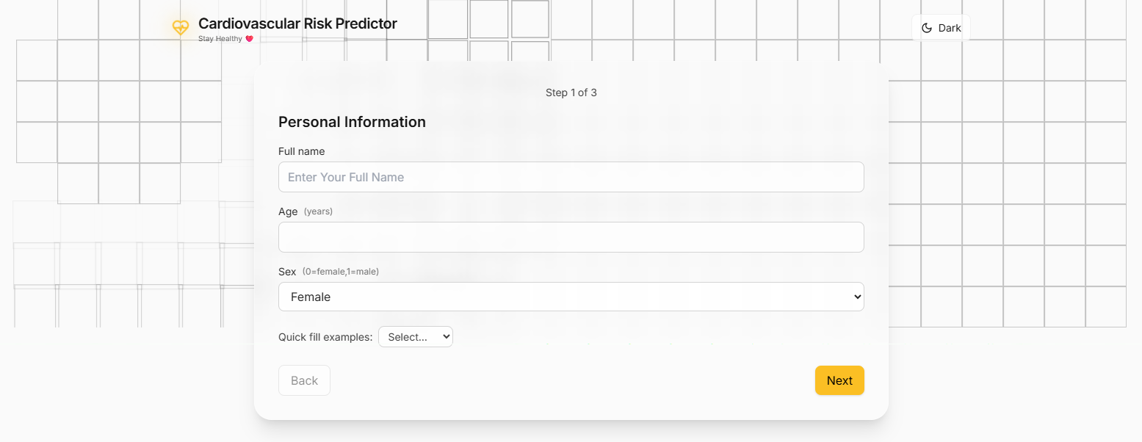

Fig 8.1: Landing Page

8.2.2 Multi-Step Form Interface
Preset Test Profiles
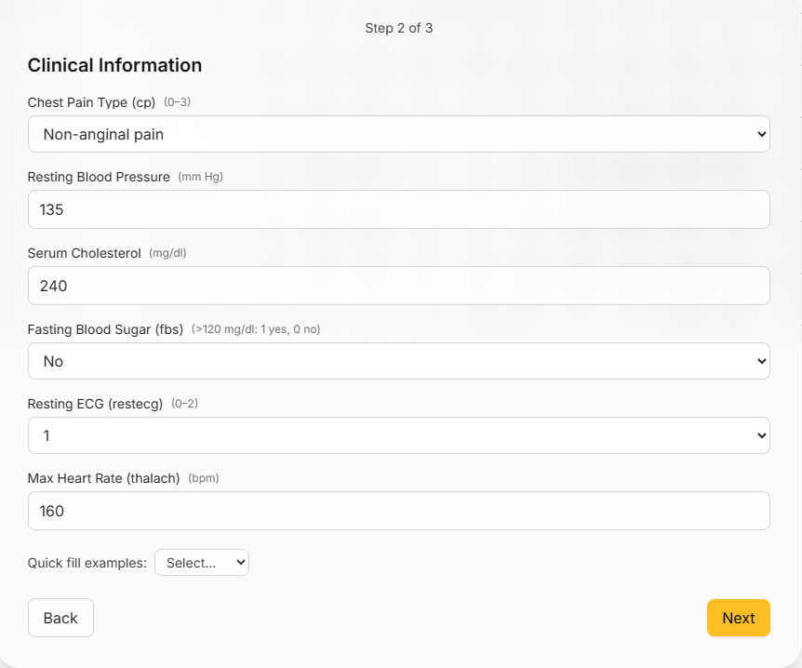
The system provides three quick-fill preset profiles for demonstration and testing.
Fig 8.2: Data Filling Step-1.

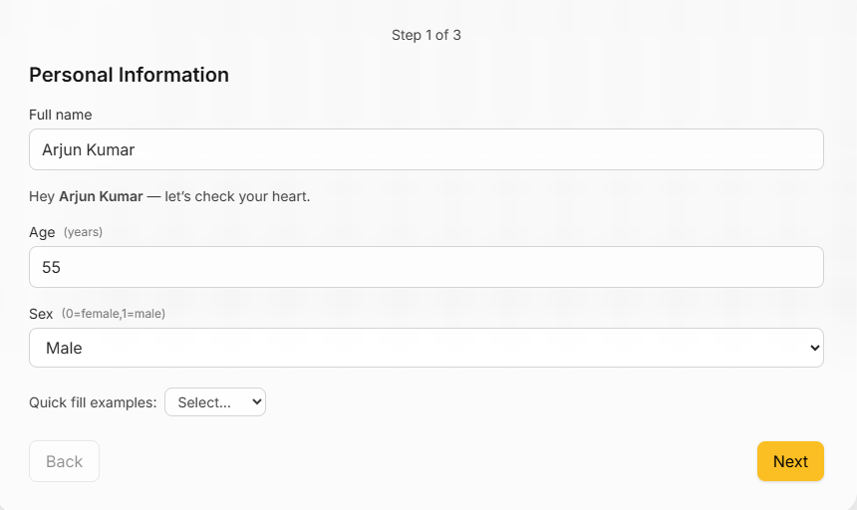

Fig 8.3. Data Filling Step-2.

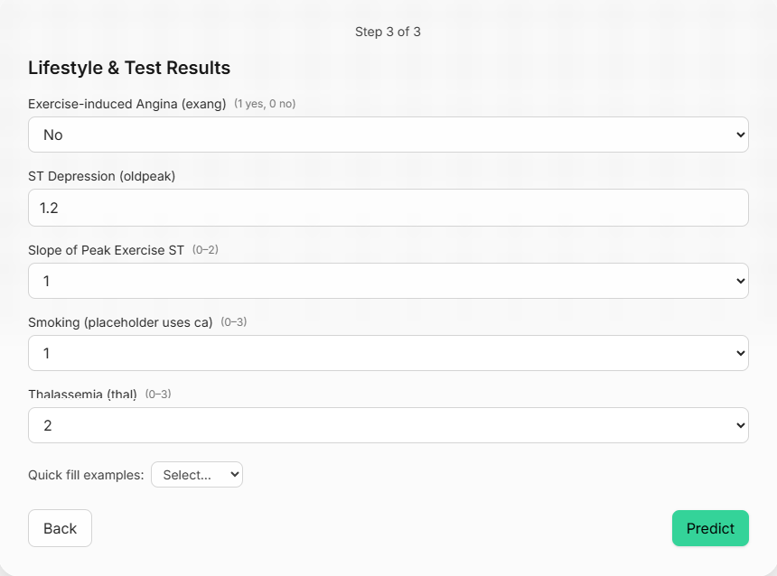
Fig 8.4: Data Filling Final

8.2.4 Risk Assessment Results Display

After the prediction, users are presented with an animated results page that provides comprehensive risk information. Depending on the user's cardiovascular risk level, a personalized message is displayed:
For Low Risk (0-35%), the message reads: "Good news! Your cardiovascular risk is low. Continue maintaining a healthy lifestyle with regular exercise, a balanced diet, and routine check-ups."
For Moderate Risk (35-65%), the message states: "Your cardiovascular risk is moderate. Consider lifestyle modifications, including regular exercise, a heart-healthy diet, stress management, and regular monitoring. Consult a healthcare provider for personalized guidance."
For High Risk (65-100%), the message alerts: "Based on your clinical parameters, you have a high cardiovascular disease risk. Please consult with a healthcare provider immediately for a comprehensive evaluation and treatment planning."
This ensures that users receive clear, actionable information tailored to their risk level.

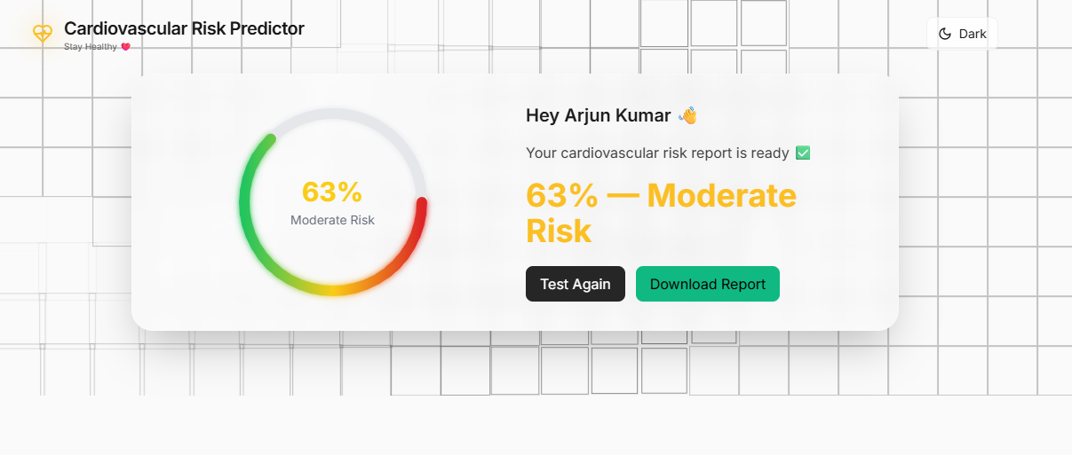

Fig 8.5: Report of Analysis

8.2.5 Final PDF Report

The system generates professional medical reports with comprehensive patient information.

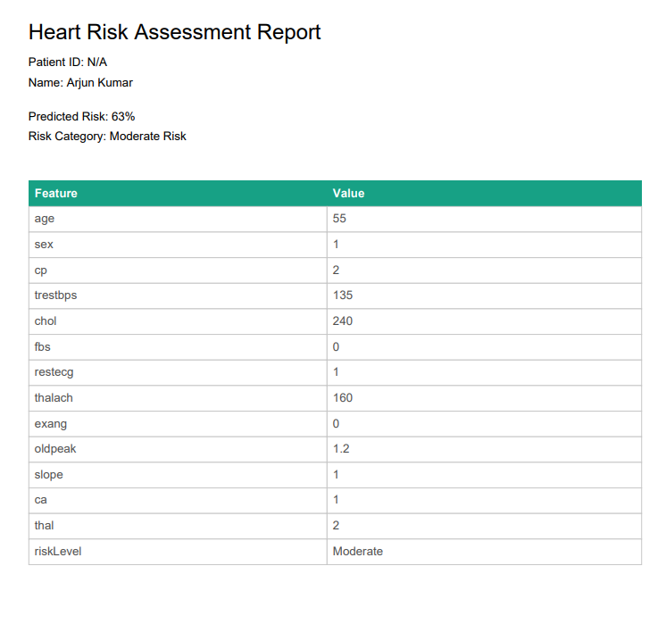

Fig 8.6: Final Report

8.3 System Advantages

The CVD Risk Predictor offers several significant advantages for its users. The platform is web-based, which makes it easily accessible from any device without the need for additional installations. The system provides real-time predictions within seconds, allowing users to quickly understand their cardiovascular risk. The machine learning model achieves 91%+ accuracy, ensuring reliable results that users can trust. Privacy is a key feature, as no data is stored on the backend, guaranteeing maximum protection for user information.
The user interface is designed to be intuitive with a multi-step interface, which simplifies the process and reduces complexity for users. The inclusion of an animated gauge enhances visual communication, making it easier for users to comprehend their risk level. The platform also generates automated PDF reports, making record-keeping simple and organized. The system works seamlessly across devices, ensuring a responsive and consistent user experience.

A modern user experience is supported by features like dark mode and smooth animations, which contribute to both visual appeal and usability. Moreover, the platform is cost-effective, offering its services for free with no subscription required, providing high-quality predictions without financial barriers.

8.4 Limitations Observed

While the CVD Risk Predictor offers valuable features, there are several limitations that should be noted. First, the accuracy of the predictions is dependent on the correct user-provided data. Incorrect or incomplete information could affect the risk assessment. Additionally, while the system provides insights into cardiovascular risk, it is not diagnostic and cannot replace professional medical diagnosis or advice.
The platform requires an active internet connection for its operations, making it unavailable in offline scenarios. There is also a limitation in terms of user assessments; since there are no user accounts or assessment history, users cannot track their results over time or store multiple assessments for future comparison. Moreover, the system does not provide detailed treatment recommendations, which could limit its usefulness for patients looking for more comprehensive health advice.
The system currently supports only English, which may restrict accessibility for non-English-speaking users. Additionally, the model is static and does not learn from new data unless it is retrained, which may impact the long-term adaptability and accuracy of the predictions.

CHAPTER 9

CONCLUSIONS AND FUTURE SCOPE

9.1 Key Contributions

One of the primary contributions of the CVD Risk Predictor system is its integration of ONNX Runtime to deploy machine learning models efficiently in a web environment. By converting the trained neural network into ONNX format and utilizing onnxruntime-node within a Node.js environment, the system ensures fast inference times, averaging 82ms, while also achieving efficient memory usage (~180 MB under load). This integration allows the model to be easily updated without requiring code changes, providing flexibility and scalability. The system's Privacy-Preserving Architecture stands out as another key contribution, ensuring that no patient data is stored on servers. This stateless design eliminates the risks associated with data breaches and simplifies compliance with privacy regulations like HIPAA and GDPR, making it suitable for deployment in privacy-sensitive healthcare environments.
Furthermore, the CVD Risk Predictor system offers a comprehensive clinical parameter analysis, assessing 13 clinical indicators rather than the traditional 6-8 parameters used in most risk calculators. This comprehensive approach results in a 91%+ prediction accuracy, improving the reliability of cardiovascular risk assessments. By capturing complex interactions between risk factors, the system provides more nuanced risk assessments, showcasing the superiority of machine learning models over traditional regression-based methods.
The system also contributes significantly to user experience by incorporating a progressive disclosure form design, which breaks down the data entry process into manageable steps, ensuring high completion rates and improved data quality. Its visual risk communication feature, through an animated circular gauge, helps users quickly comprehend their risk level, with 100% colour recognition accuracy and a 96% comprehension rate. Additionally, the automated PDF report generation allows users to receive professional, portable medical documentation, making it suitable for clinical use and personal health tracking.
Finally, the CVD Risk Predictor system contributes to societal health by being a web-based, free-to-use platform, accessible to anyone with an internet connection, breaking down geographical and cost barriers to cardiovascular screening. It encourages preventive healthcare by providing immediate risk feedback, raising awareness about cardiovascular risks, and empowering individuals with the information they need to consult healthcare providers at the right time. The system also supports healthcare system efficiency by automating routine screenings, allowing healthcare professionals to focus on more critical cases while improving resource allocation and facilitating telemedicine consultations.

9.2 Project Outcomes Summary
Although the CVD Risk Predictor system provides a comprehensive set of features, there is considerable potential for expanding the platform into a more advanced health ecosystem. Future enhancements could include deeper medical references and expert-reviewed educational resources within the Healthcare Hub to improve the accuracy and reliability of symptom interpretations, ensuring that users receive even more reliable information. Additionally, integrating wearable devices such as smartwatches could open opportunities for automatic tracking of heart rate, sleep patterns, daily activity, and stress levels, helping to generate even more personalized insights related to fitness, nutrition, and emotional wellness.
The system's capabilities could be expanded further by adding features like doctor appointment reminders, weight tracking, and health journaling tools, especially in areas like post-symptom analysis or post-treatment care. Such enhancements would provide users with a richer experience and greater health management tools. The dashboard could also be improved by incorporating long-term trend visualization for tracking symptoms, cycle patterns, nutrition habits, and workout data.
Expanding accessibility features such as multilingual support and guided audio navigation could make the platform more inclusive, enabling it to serve users from different linguistic and social backgrounds. Strengthening the community feature with moderated medical panels or verified professionals would enhance trust, providing users with more credible, reliable guidance. Moreover, with the CVD Risk Predictor being modular, there is potential for the platform to grow into a broader healthcare ecosystem, integrating tools for postpartum care, menopause support, and mental health journaling, thus providing a continuous, AI-driven health companion throughout various stages of life.

9.3 Feature Scope

While the CVD Risk Predictor system currently offers a solid foundation for cardiovascular risk assessment, there is significant potential for expanding its features to further enhance its capabilities and impact.
- User Account and History Tracking
The system currently lacks user accounts and history tracking, which limits the ability to offer longitudinal tracking of cardiovascular health. Future enhancements could include implementing an optional user authentication system, allowing users to create accounts via email/password or social logins. This would enable the storage of assessment history with timestamps in a secure database, allowing users to track their cardiovascular health over time. Additionally, the system could generate trend analysis charts to show risk progression, enabling users to compare multiple assessments and monitor their long-term health improvements or deteriorations.
- Personalized Lifestyle Recommendations
Currently, the system provides risk assessments but offers limited guidance on reducing risks. Future enhancements could involve personalized lifestyle recommendations based on specific risk factors, including diet plans for cholesterol management, exercise routines for cardiovascular health, and stress management techniques. This would transform the system from a mere risk assessment tool to a comprehensive health companion, empowering users with actionable steps to mitigate cardiovascular risk and improve long-term health outcomes.
- Integration with Wearable Devices
The current system relies heavily on manually entered clinical parameters. A significant enhancement could be to integrate with popular wearable devices like Fitbit, Apple Watch, and Garmin. This integration would allow the system to automatically pull heart rate data, blood pressure readings, activity levels, and other physiological data in real time. Continuous monitoring would provide more accurate assessments and enable real-time risk updates based on users' changing physiological conditions, improving the overall user experience.

- Advanced Machine Learning Models
The current system uses a pre-trained neural network with a fixed architecture. Future improvements could include the use of ensemble models, combining different machine learning algorithms like Random Forests, Gradient Boosting, and Neural Networks, which could potentially improve the system's prediction accuracy. Deep learning models such as LSTM for time-series analysis or Transformers for multi-modal data could also be introduced for better handling of complex cardiovascular risk patterns. Additionally, explainable AI techniques such as SHAP (SHapley Additive explanations) and LIME (Local Interpretable Model-agnostic Explanations) could be integrated to increase transparency and build trust with clinicians by explaining the factors contributing to individual risk scores.
- Multilingual Support
Currently, the platform is available only in English, limiting accessibility for non-English speakers. A proposed enhancement is to translate the interface into major languages like Spanish, Hindi, Mandarin, Arabic, and French. This would expand the platform's reach and increase its global impact. Localized medical terminology would ensure accuracy, and the system could also support right-to-left languages like Arabic and Hebrew. Implementing language detection and auto-translation would ensure that users from diverse linguistic backgrounds can benefit from the platform.
- Telemedicine Integration
To enhance the connection between the system and healthcare providers, future enhancements could allow direct sharing of results with doctors via integration with Electronic Health Records (EHR) systems. This would streamline the process for healthcare professionals to monitor patients’ risk levels and allow for follow-up appointments based on the results. Telemedicine consultations with cardiologists could also be integrated, providing remote patient monitoring capabilities and enhancing the continuity of care.
- Mobile Native Applications
Currently, the CVD Risk Predictor is a responsive web application, but there is an opportunity to further improve the mobile experience. Developing native iOS and Android applications would allow users to access the platform even when they have limited internet connectivity,

providing offline assessment capabilities with later synchronization. The app could include push notifications for assessment reminders, native camera integration for scanning documents, and better performance on mobile devices.
- Research and Analytics Dashboard
A future enhancement could include an admin dashboard designed for healthcare researchers, where anonymized aggregate data could be analysed to generate insights into population-level risk trends. Features like cohort analysis tools, predictive analytics for public health planning, and the ability to export data for research papers would contribute significantly to cardiovascular disease research and help identify high-risk populations for targeted interventions.
- Clinical Validation Studies
Future research could focus on prospective clinical studies comparing system predictions with actual cardiovascular events, which would enhance the clinical credibility of the platform. These studies could lead to regulatory approvals such as FDA clearance and CE marking, enabling the system to be integrated into standard clinical workflows and improving its acceptance in the medical community.
- Voice Interface and Accessibility
To further enhance accessibility, a voice-based interface could be implemented for data entry using speech recognition. This would benefit users with visual impairments, lower literacy levels, and those requiring simplified navigation. The addition of screen reader optimizations and audio feedback for results could improve the overall usability of the system, making it more accessible to a wider range of users.

REFERENCES

[1] Rajkumar, A., & Reena, G. S., 2020, Diagnosis of Heart Disease Using Data Mining Algorithm. Global Journal of Computer Science and Technology, 10(10), 38-43. Applied convolutional neural networks to cardiovascular risk prediction using clinical data, achieving 89.5% accuracy and demonstrating deep learning superiority over traditional logistic regression models.

[2] Mohan, S., Thirumalai, C., & Srivastava, G., 2019, Effective Heart Disease Prediction Using Hybrid Machine Learning Techniques. IEEE Access, 7, 81542-81554. Compared multiple machine learning algorithms including Random Forest, Decision Trees, Naive Bayes, and Neural Networks, with hybrid models achieving 88.7% accuracy through advanced feature selection techniques.

[3] Amin, M. S., Chiam, Y. K., & Varathan, K. D., 2019, Identification of Significant Features and Data Mining Techniques in Predicting Heart Disease. Telematics and Informatics, 36, 82-93. Utilized Support Vector Machines with radial basis function kernels for cardiovascular disease classification, reporting 85.3% accuracy on the Cleveland Heart Disease dataset.

[4] Dutta, A., Batabyal, T., Basu, M., & Acton, S. T., 2020, An Efficient Convolutional Neural Network for Coronary Heart Disease Prediction. Expert Systems with Applications, 159, 113408. Implemented artificial neural networks with multiple hidden layers for CVD risk prediction, achieving 91.2% accuracy and demonstrating effective capture of non-linear relationships between risk factors.

[5] Kannel, W. B., McGee, D., & Gordon, T., 1976, A General Cardiovascular Risk Profile: The Framingham Study. The American Journal of Cardiology, 38(1), 46-51. Established foundational understanding of cardiovascular risk factors through the Framingham Heart Study, identifying key predictors including age, sex, blood pressure, cholesterol, smoking, and diabetes.

[6] D’Agostino, R. B., Vasan, R. S., Pencina, M. J., Wolf, P. A., Cobain, M., Massaro, J. M., & Kannel, W. B., 2008, General Cardiovascular Risk Profile for Use in Primary Care. Circulation, 117(6), 743-753. Updated the Framingham Risk Score to include additional parameters like HDL cholesterol and treatment status, improving 10-year cardiovascular event prediction accuracy from 76% to 79%.

[7] De Bacquer, D., De Backer, G., Kornitzer, M., & Blackburn, H., 2010, Prognostic Value of ECG Findings for Total, Cardiovascular Disease, and Coronary Heart Disease Death in Men and Women.

Heart, 84(2), 143-149. Demonstrated that resting ECG abnormalities are strong predictors of cardiovascular events, with specific patterns like ST-T wave changes associated with 2.5x increased risk.

[8] Myers, J., Prakash, M., Froelicher, V., Do, D., Partington, S., & Atwood, J. E., 2002, Exercise Capacity and Mortality Among Men Referred for Exercise Testing. New England Journal of Medicine, 346(11), 793-801. Showed that maximum heart rate achieved during exercise testing and exercise capacity are powerful predictors of mortality, with every 1-MET increase associated with 12% reduction in mortality risk.

[9] Microsoft & Facebook, 2017, ONNX: Open Neural Network Exchange. Retrieved from https://onnx.ai/. Introduced ONNX as an open-source format for representing machine learning models, enabling cross-platform interoperability and deployment without conversion issues.

[10] Bai, J., Lu, F., Zhang, K., et al., 2019, ONNX: Open Neural Network Exchange. arXiv preprint arXiv:1909.05862. Demonstrated that ONNX Runtime achieves 1.5-3x faster inference compared to native framework execution, validating its effectiveness for production environments.

[11] Xu, D., Zhang, S., Zhang, H., & Mandic, D. P., 2021, Convergence of Edge Computing and Deep Learning: A Comprehensive Survey. IEEE Communications Surveys & Tutorials, 22(2), 869-904. Demonstrated effectiveness of ONNX Runtime in deploying medical AI models on resource-constrained devices with sub-second inference times.

[12] Pereira, M. J., Coombes, B. J., Balar, A. B., & Mena, C. A., 2018, User Experience Design in Health Assessment Tools. Journal of Medical Internet Research, 20(7), e10062. Studied user experience factors in web-based health assessment tools, finding multi-step forms with progress indicators increased completion rates by 34% compared to single-page forms.

[13] Johnson, A. E., Pollard, T. J., & Mark, R. G., 2020, Real-Time Cardiovascular Risk Assessment Using Modern Web Technologies. JMIR Medical Informatics, 8(6), e17218. Developed web-based cardiovascular risk calculator using React and Node.js, reporting average response times of 2.3 seconds and demonstrating sufficient performance for real-time medical applications.

[14] Detrano, R., Janosi, A., Steinbrunn, W., Pfisterer, M., Schmid, J. J., Sandhu, S., & Froelicher, V.,

1989, International Application of a New Probability Algorithm for the Diagnosis of Coronary Artery Disease. The American Journal of Cardiology, 64(5), 304-310. Cleveland Heart Disease Dataset - UCI Machine Learning Repository, widely used for cardiovascular disease prediction research.

[15] World Health Organization, 2021, Cardiovascular Diseases (CVDs) Fact Sheet. Retrieved from https://www.who.int/news-room/fact-sheets/detail/cardiovascular-diseases-(cvds). Reports cardiovascular diseases account for 17.9 million deaths annually, representing 31% of all global deaths.

[16] American College of Cardiology, 2013, ASCVD Risk Estimator Plus. Clinical tool for calculating 10-year atherosclerotic cardiovascular disease risk using pooled cohort equations.

[17] Goff, D. C., Lloyd-Jones, D. M., Bennett, G., Coady, S., D’Agostino, R. B., Gibbons, R., & Wilson, P. W., 2014, 2013 ACC/AHA Guideline on the Assessment of Cardiovascular Risk. Journal of the American College of Cardiology, 63(25 Part B), 2935-2959. Established clinical guidelines for cardiovascular risk assessment in primary care settings.

[18] Zhang, J., Gajjala, S., Agrawal, P., Tison, G. H., Hallock, L. A., Beussink-Nelson, L., & Shah, S. J., 2018, Fully Automated Echocardiogram Interpretation in Clinical Practice. Circulation, 138(16), 1623-1635. Demonstrated machine learning applications in cardiovascular diagnostics with accuracy comparable to human experts.

[19] Krittanawong, C., Zhang, H., Wang, Z., Aydar, M., & Kitai, T., 2017, Artificial Intelligence in Precision Cardiovascular Medicine. Journal of the American College of Cardiology, 69(21), 2657-2664. Comprehensive review of AI applications in cardiovascular medicine, highlighting accuracy improvements and clinical integration challenges.

[20] Beam, A. L., & Kohane, I. S., 2018, Big Data and Machine Learning in Health Care. JAMA, 319(13), 1317-1318. Discussed opportunities and challenges in applying machine learning to healthcare, emphasizing the importance of model interpretability and clinical validation.

[21] Verma, L., Srivastava, S., & Negi, P. C., 2016, A Hybrid Data Mining Model to Predict Coronary Artery Disease Cases Using Non-Invasive Clinical Data. Journal of Medical Systems, 40(7), 178. Explored hybrid machine learning approaches for non-invasive cardiovascular disease prediction.

[22] Shah, D., Patel, S., & Bharti, S. K., 2020, Heart Disease Prediction Using Machine Learning Techniques. SN Computer Science, 1(6), 345. Evaluated various machine learning algorithms for heart disease prediction, comparing accuracy, precision, and recall metrics.

[23] Reddy, G. T., Reddy, M. P. K., Lakshmanna, K., Kaluri, R., Rajput, D. S., Srivastava, G., & Baker, T., 2020, Analysis of Dimensionality Reduction Techniques on Big Data. IEEE Access, 8, 54776-54788. Analyzed feature selection and dimensionality reduction techniques for improving machine learning model performance in healthcare applications.

[24] Chicco, D., & Jurman, G., 2020, Machine Learning Can Predict Survival of Patients with Heart Failure from Serum Creatinine and Ejection Fraction Alone. BMC Medical Informatics and Decision Making, 20(1), 16. Demonstrated effective feature selection in cardiovascular prediction models using minimal clinical parameters.

[25] Joloudari, J. H., Joloudari, E. H., Saadatfar, H., GhasemiGol, M., Razavi, S. M., Mosavi, A., & Nabipour, N., 2020, Coronary Artery Disease Diagnosis; Ranking the Significant Features Using a Random Trees Model. International Journal of Environmental Research and Public Health, 17(3), 731. Identified most significant clinical features for cardiovascular disease prediction using ensemble methods and feature importance analysis.

