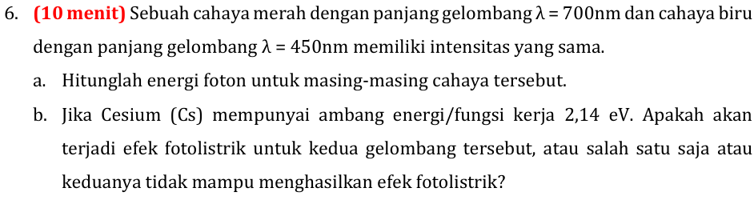
Diketahui:
$$λ_{m}=700nm=700×{10}^{-9}m$$
$$λ_{b}=450nm=450×{10}^{-9}m$$
a)
$$E=\frac{hc}{λ};h=6,626×{10}^{-34};c=3×{10}^{8}\frac{m}{s}$$
$$E_{m}=6,626×{10}^{-34}.\frac{3×{10}^{8}}{700×{10}^{-9}}=2,84×{10}^{-19}J$$
$$E_{b}=6,626×{10}^{-34}.\frac{3×{10}^{8}}{450×{10}^{-9}}=4,42×{10}^{-19}J$$
b)
$$W=2,14 eV=2,14 . 1,6×{10}^{-19}=3,424×{10}^{-19}J$$
$$E>W \left(syarat\right)$$
Jadi, cahaya biru mengalami efek fotolistrik, sedangkan Cahaya merah tidak.

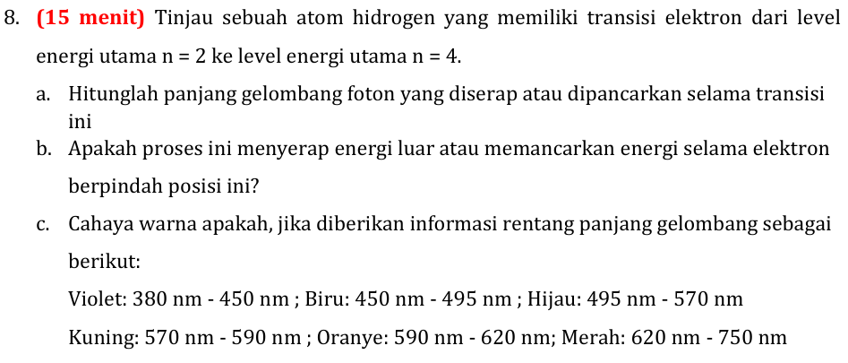
Diketahui:
Energi 2 ke 4
Ditanya:
- $λ=?$
$$E_{f}=\frac{hc}{λ};h=6,26×{10}^{-34};c=3×{10}^{8}$$
$$n1=2;n2=4$$
$$E=-\frac{13,6}{n^{2}}eV=\frac{-13,6 . 1,6×{10}^{-19}}{n^{2}}J=\frac{-2,176×{10}^{-18}}{n^{2}}J$$

Mencari lambda:

$$E_{f}=E_{n2}-E_{n1}$$

$$\frac{hc}{λ}=\frac{-2,176×{10}^{-18}}{4^{2}}-(\frac{-2,176×{10}^{-18}}{2^{2}})$$
$$\frac{6,26×{10}^{-34}. 3×{10}^{8}}{λ}=\frac{-2,176×{10}^{-18}}{16}-\left(\frac{-2,176×{10}^{-18}}{4}\right)$$
$$λ=487,2 nm$$
- Menyerap
- Berwarna biru.

