

Egypt University of Informatics

Computer and Information Systems

Data Analysis Course

The Analysis of the Performance of Data Analysis Students

Submitted by: Mohamed Taher Alrefaie

29/3/2023

# Introduction

Ever wondered what sets high-achieving university students apart? Passion might be the key. In this report, we explore how passion influences academic performance among university students. By understanding this connection, we can unlock ways to enhance student success, uncovering the power of passion in education!

# Research Question

# How does passion relate to academic performance among university students?

# Hypothesis

We hypothesize that there is a positive correlation between passion and academic performance among university students.

# Population of Interest:

The population of interest for this research includes university students from diverse majors, academic backgrounds, and institutions.

# Sampling Method:

# The sampling method used for this research is convenience sampling, where participants were selected based on their availability and willingness to participate in an online survey.

Note: Stratified sampling would be a lot better but due to some limitations we couldn’t reach more students from different majors and universities.

# Bias Identification:

-In designing this survey, we have taken steps to identify and minimize potential sources of bias. One potential bias could be response bias, where participants may provide answers that they think are more socially acceptable or desirable rather than their true opinions. To mitigate this bias, we ensured that survey questions were clear and unbiased, we didn’t record emails and the name question was optional, and we encouraged honest and thoughtful responses.

-Due to limitations of reaching many students, most students in this research were computer science students which could lead to some bias because passion might have a bigger effect on some majors more than others

-Again, due to limitations of collecting large sample and reaching many students, most students are from EUI, and we know that this might lead to a bias because the required grades for different majors are close to each other and relatively lower than public universities. In other words, most students in EUI, like private universities students, chose the major they want. In other public universities, many students couldn’t be in the faculty they want maybe because financial limitations.

# Survey Questions:

What is your name? (optional)

What is your age?

What is your major?

What is your level?

Did you want to pursue that major?

If your answer was no, why did you choose it?

What is your CGPA?

How much do you engage in activities related to your major outside of your coursework?

Do you consider pursuing a master’s degree?

Do you believe your chosen major aligns with your interests and career goals?

Online survey link: <https://docs.google.com/forms/d/e/1FAIpQLSfRjE2dfHkTyhGUce5GzhQFXFQg2D3JAl4B_gDnm5WAS8YIXg/viewform?usp=sf_link>

Number of samples collected: 36

# Analysis:

# Mean, median, mode calculations:

# Mean CGPA: 2.77

# Median CGPA: 2.58

# Mode CGPA: 2.5

# Mean Passion Score: 4.89

# Median Passion Score: 6.0

# Mode Passion Score: 6

# Data visualization:

This is a scatterplot between CGPA and Passion Score, Pearson correlation equals 0.08 which is very weak positive, this shows that there is nearly no correlation between passion and academic performance.

This is a box plot for passion score, and CGPA.

It shows the median for both, upper and lower limits, first and third quartiles.

It also shows that there are no outliers for both quantitative variables.

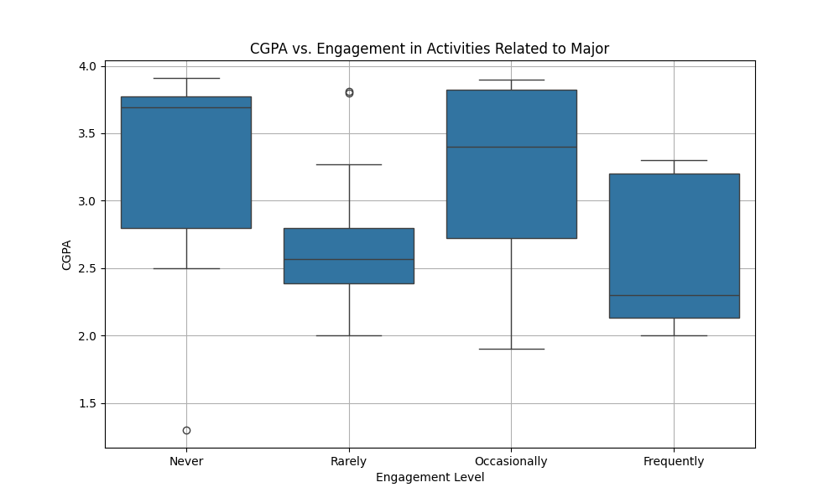

This represents the box plots for CGPAs among the categorical variables of the engagement level in activities related to the major.

It doesn’t show any correlation between engagement level and CGPA.

These are 4 pie charts for the different responses of the survey questions, it shows that most respondents chose majors that they wanted to pursue, if they didn’t, then they joined mostly because of the trendiness or popularity. More than half are considering pursuing a master’s degree in their major, and the majority sees that their major aligns with their goals.

These are 4 scatterplots for the 4 majors, each representing two quantitative variables, the passion score and the CGPA.

There is a weak positive correlation for computer science students, very weak for business and engineering (nearly no correlation), and surprisingly a moderate negative correlation for arts.

This suggests that for CS students’ passion affects academic performance positively, but for arts passion affects performance negatively and this is a strange behaviour. And for business and engineering no clear correlation (neglectable).

# Conclusion

As it should be, passion affects the academic performance of computer science students.

But unexpectedly, business and engineering students there is no clear correlation, but maybe because the small sample size for those majors.

On the other hand, for Arts students, a passion for the subject may not always directly translate to academic success. The arts often require a different set of skills, such as creativity and expression, which may not be as closely tied to traditional academic measures like GPA. Additionally, the subjective nature of arts evaluation could lead to discrepancies in grading, impacting the correlation between passion and performance.

Further research could explore these factors in more detail to better understand the relationship between passion and academic performance for Arts students.

# Any potential issues

-Small sample size due to limitations of reaching more students

-Most students are CS students and from EUI university as I mentioned in bias identification

-One mistake I should avoid in upcoming projects is that most questions where Yes/No questions and this wasn’t the best idea I should have set scales of Strongly Agree, Agree, Neutral, Disagree, Strongly Disagree because that would have helped me to calculate the passion score more accurately.