**THE MINISTRY FOR DEVELOPMENT OF INFORMATION TECHNOLOGIES AND COMMUNICATIONS OF THE REPUBLIC OF UZBEKISTAN**

**TASHKENT UNIVERSITY OF INFORMATION TECHNOLOGIES NAMED AFTER MUHAMMAD AL-KHWARIZMI**

**FACULTY OF “PROFESSIONAL EDUCATION IN THE FIELD OF INFORMATION COMMUNICATION TECHNOLOGIES”**

**DEPARTMENT OF “INFORMATION LIBRARY SYSTEMS”**

**AUTOMATED LIBRARY SYSTEM**

**Course Work**

**Theme: Open software packages for library process automation  
in CDL**

**Group: 694-17**

**Student: Pulatova Muhabbat**

**Checked by: Rakhmatullayev M.**

**Tashkent 2021**

**CONTENTS**

|  |  |
| --- | --- |
| **INTRODUCTION**…….…………………………………………………….... | 3 |
| **1.** The proposed solution and method of open software packages for library process of automation in CDL…………………………………………………. | 6 |
| **2.** Models of open software packages for library process of automation in CDL…………………………………………………………………………... | 7 |
| **3.** Algorithms for solving the creation of online courses for teaching librarians in CDL……………………………………………………………… |  |
| **4.** Functional, Technical, and Organizational structures of the web application for the creation of online courses for teaching librarians in CDL……………… |  |
| **CONCLUSION**…….……………………………………………………....... |  |
| **REFERENCES**…….……………………………………………………........ |  |

**INTRODUCTION**

**Relevance of the topic.** There is a great need for open-source software in Uzbekistan today, especially in the library sector. This is due to the important task of reducing the cost of the electronic library and the creation of an electronic catalog and full-text database in the national library system. To carry out such tasks, libraries invest heavily in software development by foreign experts. Open-source software can be a great help in avoiding wasting money.

**References to government decisions**:

**1.** Law of the Republic of Uzbekistan "On information and library activities"[1];

**2.** Resolution of the President of the Republic of Uzbekistan dated June 7, 2019 No PP-4354 "On further improving the provision of information and library services to the population of the Republic of Uzbekistan";

**3.** The concept of development of the information and library sector in the Republic of Uzbekistan in 2019-2024;

**4**. Of the President of the Republic of Uzbekistan dated February 23, 2011, No. PP-1487 "On measures for the further qualitative development of information-library and information-resource services based on information and communication technologies for 2011 - 2015.“

**5.** Uz DSt 3304: 2018 System of standards for information, librarianship, and publishing. Machine-readable communicative UZMARC Database format for machine-readable data arrays

**Global trends, a review of the literature:**

1. In her article “Usability testing for an open-source integrated library system”, Asma Khatun explains the task-based usability of Koha OPAC and empirically examines the usability of other open-source ILSs, which might result in improved user performance and satisfaction with these systems. [2]
2. Lyn H. Dennison and Alana Faye Lewis reviews on their work named after “Small and Open Source: Decisions and Implementation of an Open Source Integrated Library System in a Small Private College” the success of open source ILS implementation in public libraries and analyze Koha. [3]
3. In the article “How to choose a free and opensource integrated library system” Tristan Mu ̈ller highlights from which, of the batch of dozens of open source ILSs, librarians and decision-makers can choose without worrying about how perennial or sustainable each open or free project is, as well as understanding which ILS provides them with the functionalities to meet the needs of their institutions.[4]
4. Linda analyzes library systems in her article "Survey of open source integrated library systems" and gets the following results:
   * 1. Users of open source ILS are modestly more satisfied than users of proprietary ILSs. However, according to this survey, the Koha ILS in its present form lags furthest behind proprietary ILSs in installation smoothness. Also, the two major open source ILSs, Koha and Evergreen, compare unfavorably with proprietary ILSs in documentation completeness.[5]
5. “A comparison between select open-source and proprietary integrated library systems “ was the article written by Joseph Pruett and Namjoo Choi. Which was reviewed major functions that libraries need in an integrated library system are available for opensource software. [6]
6. In the article “A checklist for evaluating opensource digital library software” which attempts to develop a comprehensive checklist for assessing DLs (digital libraries)[7]
7. K.T. Anuradha, R. Sivakaminathan, and P. Arun Kumar review search engine inside ILS in their “Open-source tools for enhancing full-text searching of OPACs. Use of Koha, Greenstone and Fedora”[8]
8. Data structures and algorithms were introduced by Sammie Bae in his “JavaScript Data Structures and algorithms”. [9]
9. Adam D. Scott guide through building an API that can power the user interfaces of a web application, a native mobile application, and a desktop application in his book named after “JavaScript Everywhere”.[10]
10. Benjamin, William J. explain the way of creating the electronic library in “How to built digital library” [11]

**Purpose of the researches.** Improve digital library services throw connecting library entries.

**Research objectives:**

* Study of open source software with foreign experience;
* Study of the demand for software in information and library institutions in Uzbekistan;
* Analysis of the strengths and weaknesses of existing systems;
* Study the standards introduced in Uzbekistan and abroad and create software accordingly.

1. **The proposed solution and method of open software packages for library process of automation in CDL**

The relevance of the application of information and communication technology in library activities such as acquisition, cataloging, circulation, serials management, etc is no longer debatable as libraries globally have realized the need to move from their isolated past into integrated systems and networked operations. It is important to know which of the open-source software is compatible with IRC (Information Resource Center) and how to implement them in these libraries.

One of the solutions to the problem is the use of automated library systems, which are provided on a global scale, and their installation in each IRC, and the creation of a local area network between them. It will cost a lot of money to create a separate local area network for IRCs, in addition to this, it will be questionable whether the chosen system will meet the standards of Uzbekistan.

Another solution to this problem is to develop open-source software for automated libraries that meet the standards of our country and are easy to use for users and to create an integrated electronic catalog by combining IRCs via the Internet.

Library automation and the use of open-source software are relevant for achieving optimal library effectiveness at a minimal cost. This process benefits both the library staff and the users as it reduces the level of job stress on the staff and enhances remote and timely provision of up-to-date information to the users. To achieve a successful automation of the library services with the open-source software, it is recommended that all key factors such as; consideration of user requirements, presence of the infrastructure (hardware, software, network), support from software developers, availability of user group for the software, and competent staff must be prioritized for the project. So, the second solution is more effective. Combining electronic catalogs available in our country to prevent duplication between them in such method.

1. **Models of open software packages for library process of automation in CDL**

**Classification schemes:**

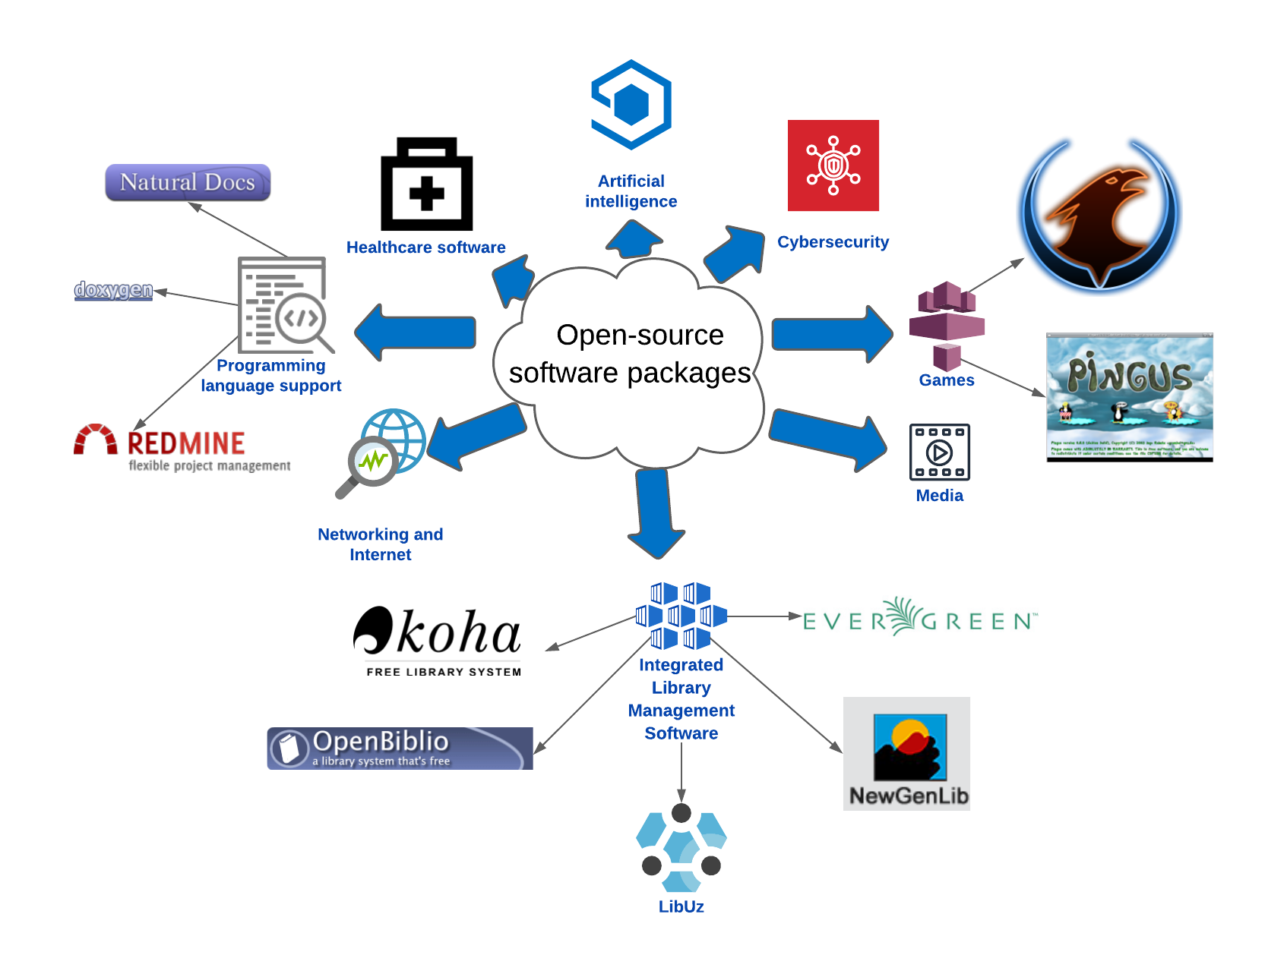

There are many types of open-source software packages. For instance

**Metadata:**

There are two main fields in LibUz :

Authority Fields with the following metadata:

* Username;
* Password;
* Organization.

Dublin Core Fields with the following metadata:

* Title: The name given to the resource. Typically, a Title will be a name by which the resource is formally known;
* Subject and Keywords: The topic of the content of the resource. Typically, a Subject will be expressed as keywords or key phrases, or classification codes that describe the topic of the resource. Recommended best practice is to select a value from a controlled vocabulary or formal classification scheme;
* Description: An account of the content of the resource. Description may include but is not limited to: an abstract, table of contents, reference to a graphical representation of content or a free-text account of the content;
* Resource Type: The nature or genre of the content of the resource. Type includes terms describing general categories, functions, genres, or aggregation levels for content. Recommended best practice is to select a value from a controlled vocabulary (for example, the [DCMIType vocabulary](https://www.dublincore.org/documents/dcmi-type-vocabulary/) ). To describe the physical or digital manifestation of the resource, use the FORMAT element;
* Source: A Reference to a resource from which the present resource is derived. The present resource may be derived from the Source resource in whole or part. Recommended best practice is to reference the resource utilizing a string or number conforming to a formal identification system;
* Relation: A reference to a related resource. Recommended best practice is to reference the resource using a string or number conforming to a formal identification system;
* Coverage: The extent or scope of the content of the resource. Coverage will typically include spatial location (a place name or geographic coordinates), temporal period (a period label, date, or date range), or jurisdiction (such as a named administrative entity). Recommended best practice is to select a value from a controlled vocabulary (for example, the Thesaurus of Geographic Names [Getty Thesaurus of Geographic Names, [http://www. getty.edu/research/tools/vocabulary/tgn/](http://www.getty.edu/research/tools/vocabulary/tgn/)]). Where appropriate, named places or periods should be used in preference to numeric identifiers such as sets of co-ordinates or date ranges;
* Creator: An entity primarily responsible for making the content of the resource. Examples of a Creator include a person, an organization, or a service. Typically the name of the Creator should be used to indicate the entity;
* Publisher: The entity responsible for making the resource available. Examples of a Publisher include a person, an organization, or a service. Typically, the name of a Publisher should be used to indicate the entity;
* Contributor: An entity responsible for making contributions to the content of the resource. Examples of a Contributor include a person, an organization, or a service. Typically, the name of a Contributor should be used to indicate the entity;
* Rights Management: Information about rights held in and over the resource. Typically a Rights element will contain a rights management statement for the resource or reference a service providing such information. Rights information often encompasses Intellectual Property Rights (IPR), Copyright, and various Property Rights. If the rights element is absent, no assumptions can be made about the status of these and other rights with respect to the resource;
* Date: A date associated with an event in the life cycle of the resource. Typically, the Date will be associated with the creation or availability of the resource. Recommended best practice for encoding the date value is defined in a profile of ISO 8601 [Date and Time Formats, W3C Note, [http://www.w3.org/TR/NOTE- datetime](http://www.w3.org/TR/NOTE-datetime)] and follows the YYYY-MM-DD format;
* Format: The physical or digital manifestation of the resource. Typically, Format may include the media-type or dimensions of the resource. Examples of dimensions include size and duration. Format may be used to determine the software, hardware, or other equipment needed to display or operate the resource;
* Resource Identifier: An unambiguous reference to the resource within a given context. Recommended best practice is to identify the resource utilizing a string or number conforming to a formal identification system. Examples of formal identification systems include the Uniform Resource Identifier (URI) (including the Uniform Resource Locator (URL), the Digital Object Identifier (DOI) and the International Standard Book Number (ISBN);
* Language: A language of the intellectual content of the resource. Recommended best practice for the values of the Language element is defined by RFC 3066 [RFC 3066, [http://www.ietf.org/rfc/ rfc3066.txt](http://www.ietf.org/rfc/rfc3066.txt)] which, in conjunction with ISO 639 [ISO 639, [http://www.oasis- open.org/cover/iso639a.html](http://www.oasis-open.org/cover/iso639a.html)]), defines two- and three-letter primary language tags with optional subtags. Examples include "en" or "eng" for English, "akk" for Akkadian, and "en-GB" for English used in the United Kingdom;
* Audience: A class of entity for whom the resource is intended or useful. A class of entity may be determined by the creator or the publisher or by a third party;
* Provenance: A statement of any changes in ownership and custody of the resource since its creation that are significant for its authenticity, integrity, and interpretation. The statement may include a description of any changes successive custodians made to the resource;
* Rights Holder: A person or organization owning or managing rights over the resource. Recommended best practice is to use the URI or name of the Rights Holder to indicate the entity;
* Instructional Method: A process, used to engender knowledge, attitudes, and skills, that the resource is designed to support. Instructional Methods will typically include ways of presenting instructional materials or conducting instructional activities, patterns of learner-to-learner and learner-to-instructor interactions, and mechanisms by which group and individual levels of learning are measured. Instructional methods include all aspects of the instruction and learning processes from planning and implementation through evaluation and feedback;
* Accrual Method: The method by which items are added to a collection. Recommended best practice is to use a value from a controlled vocabulary;
* Accrual Periodicity: The frequency with which items are added to a collection. Recommended best practice is to use a value from a controlled vocabulary;
* Accrual Policy: The policy governing the addition of items to a collection. Recommended best practice is to use a value from a controlled vocabulary.

**Database structure:**

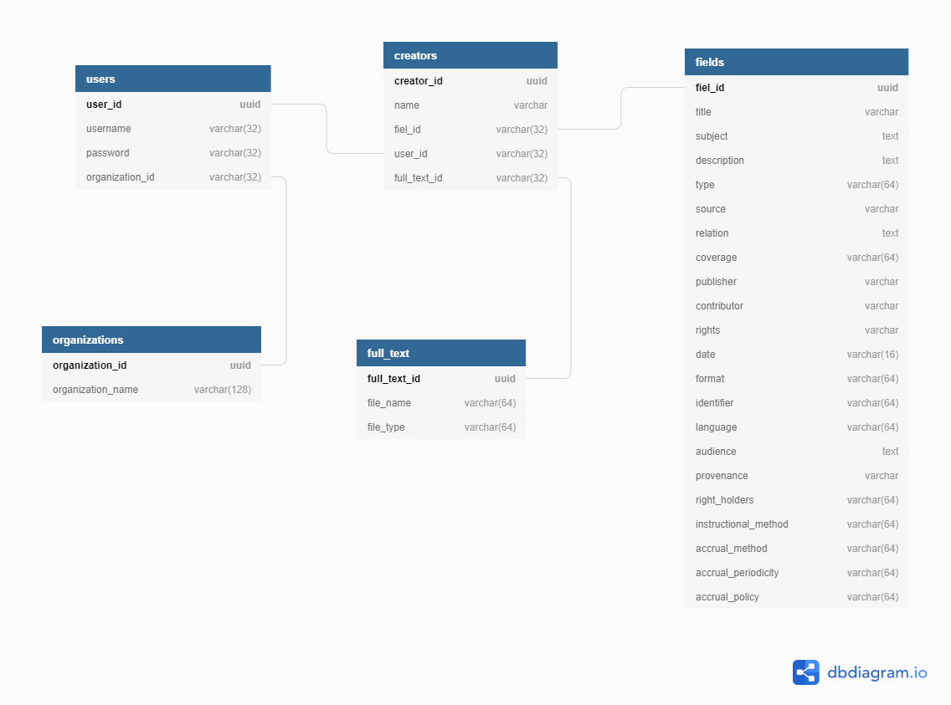

**Algorithm for solving**:

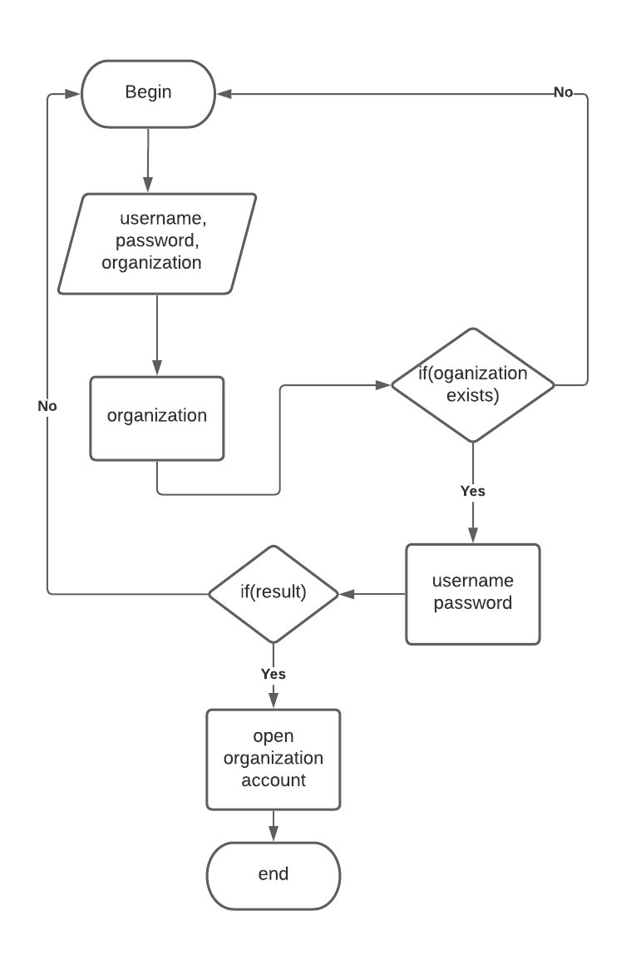

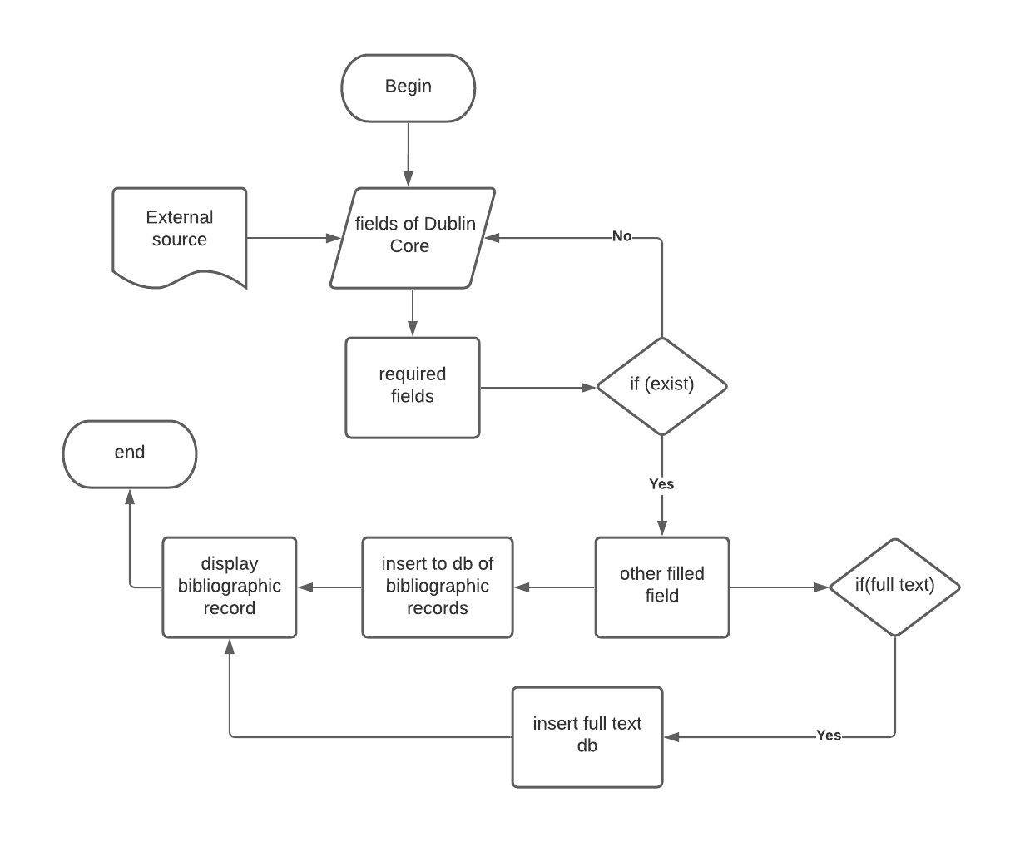

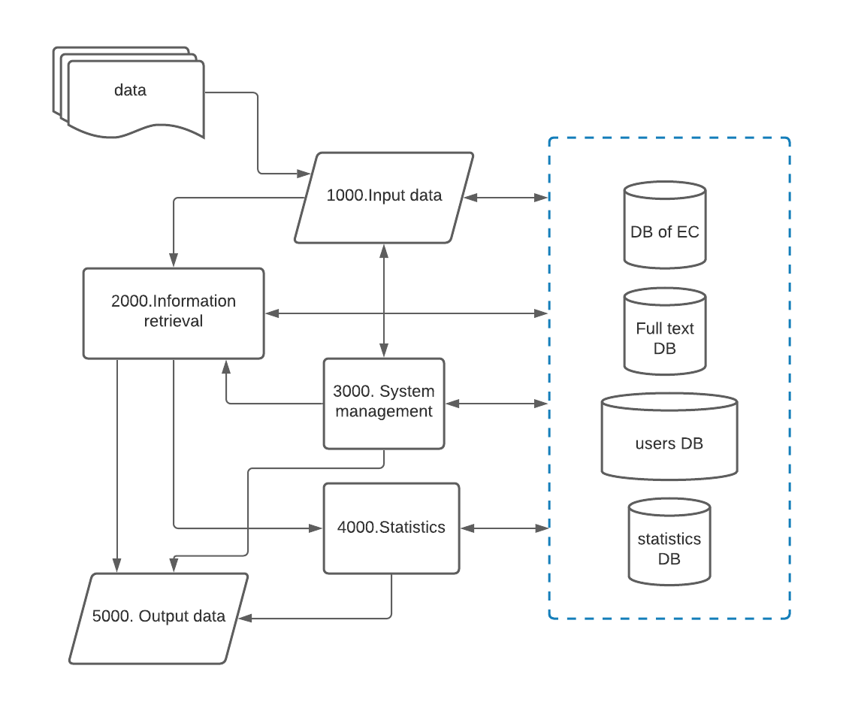

|  |  |  |  |  |
| --- | --- | --- | --- | --- |
| Task Code | CodeName of the task | The task assignment | Input information | Output information |
|  |  |  |  |  |
|  |  |  |  |  |
|  |  |  |  |  |
|  |  |  |  |  |
|  |  |  |  |  |

