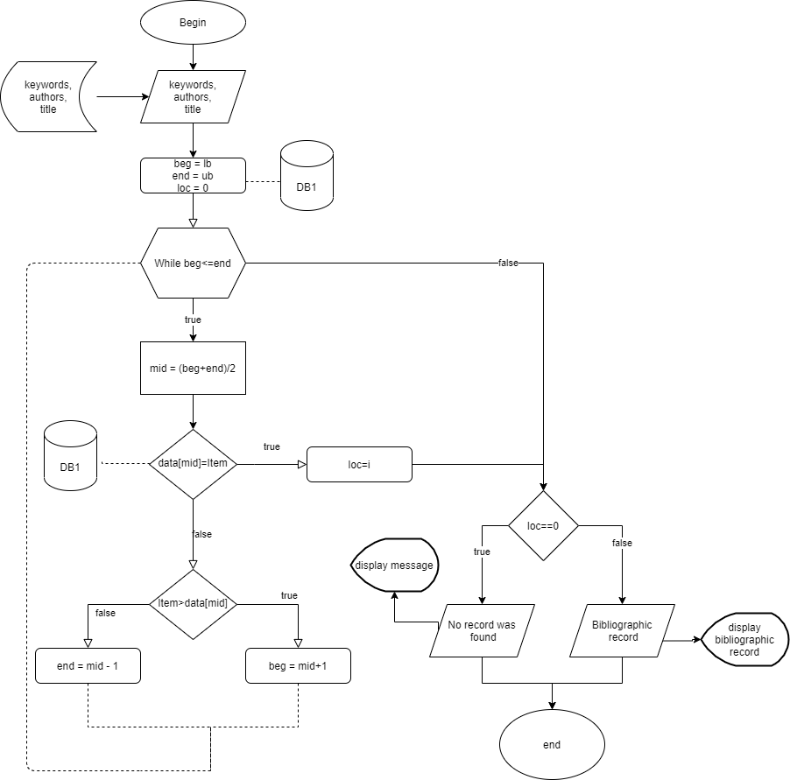

**Figure** Algorithm of information retriaval

Information retrieval algorithm

* Initially set beg = 1 and end = size of the array, then find the middle of an array using mid= (beg+end)/2.
* Compare array[mid] with the item to be searched, if they are equal the search is successful and the process is stopped.
* When the value of item >  array[mid] then proceed to search in the upper half using beg = mid + 1. Otherwise, when the value of item < array [mid] then proceeds to search in the lower half using end = mid - 1.
* The same steps are repeated in the respective half until the element is found or beg <= end.

Description of algorithm's marks:

* Data[]- Array of an element which came from database,
* lb- lower bound,
* ub - upper bound,
* beg -beginning position,
* end - end position,
* mid - middle position,
* item - element to be search,
* loc - location

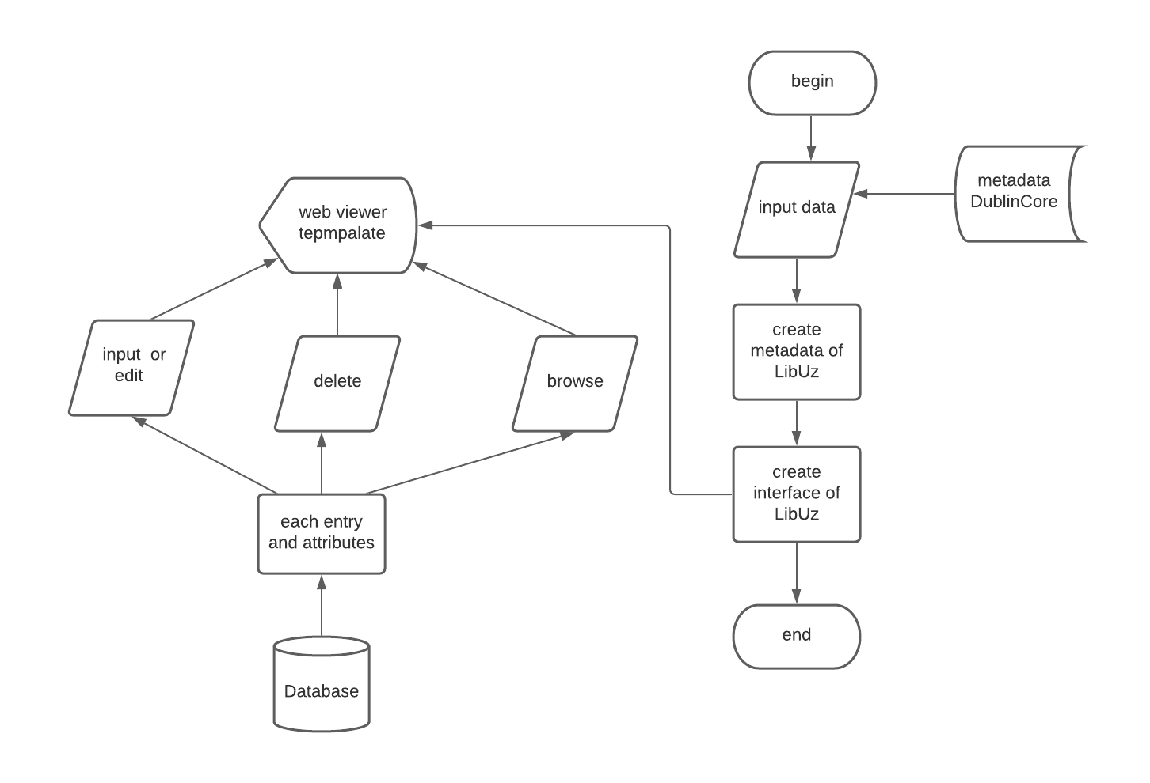

**Figure** Algorithm of creating LibUz

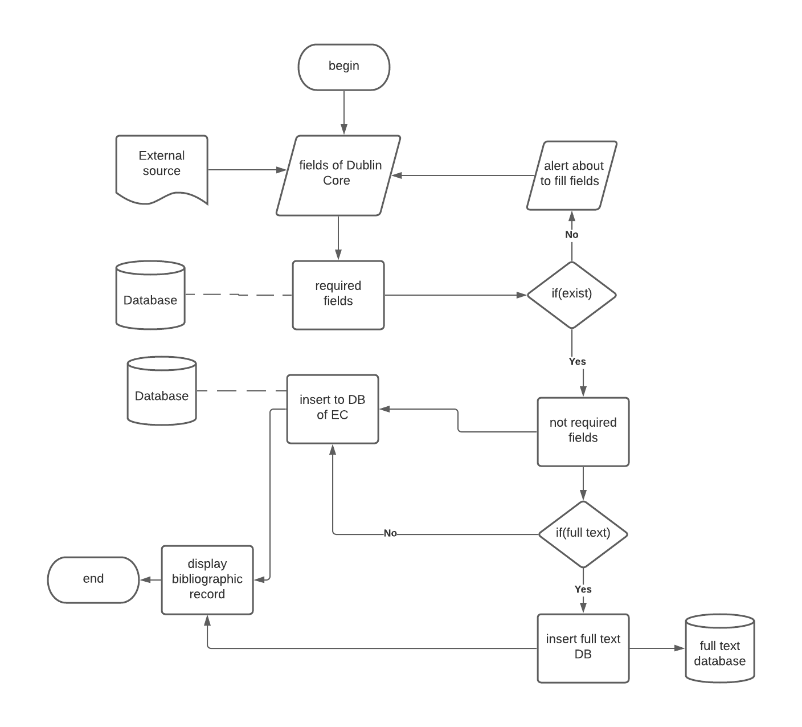

**Figure** Algorithm of entering bibliographic records

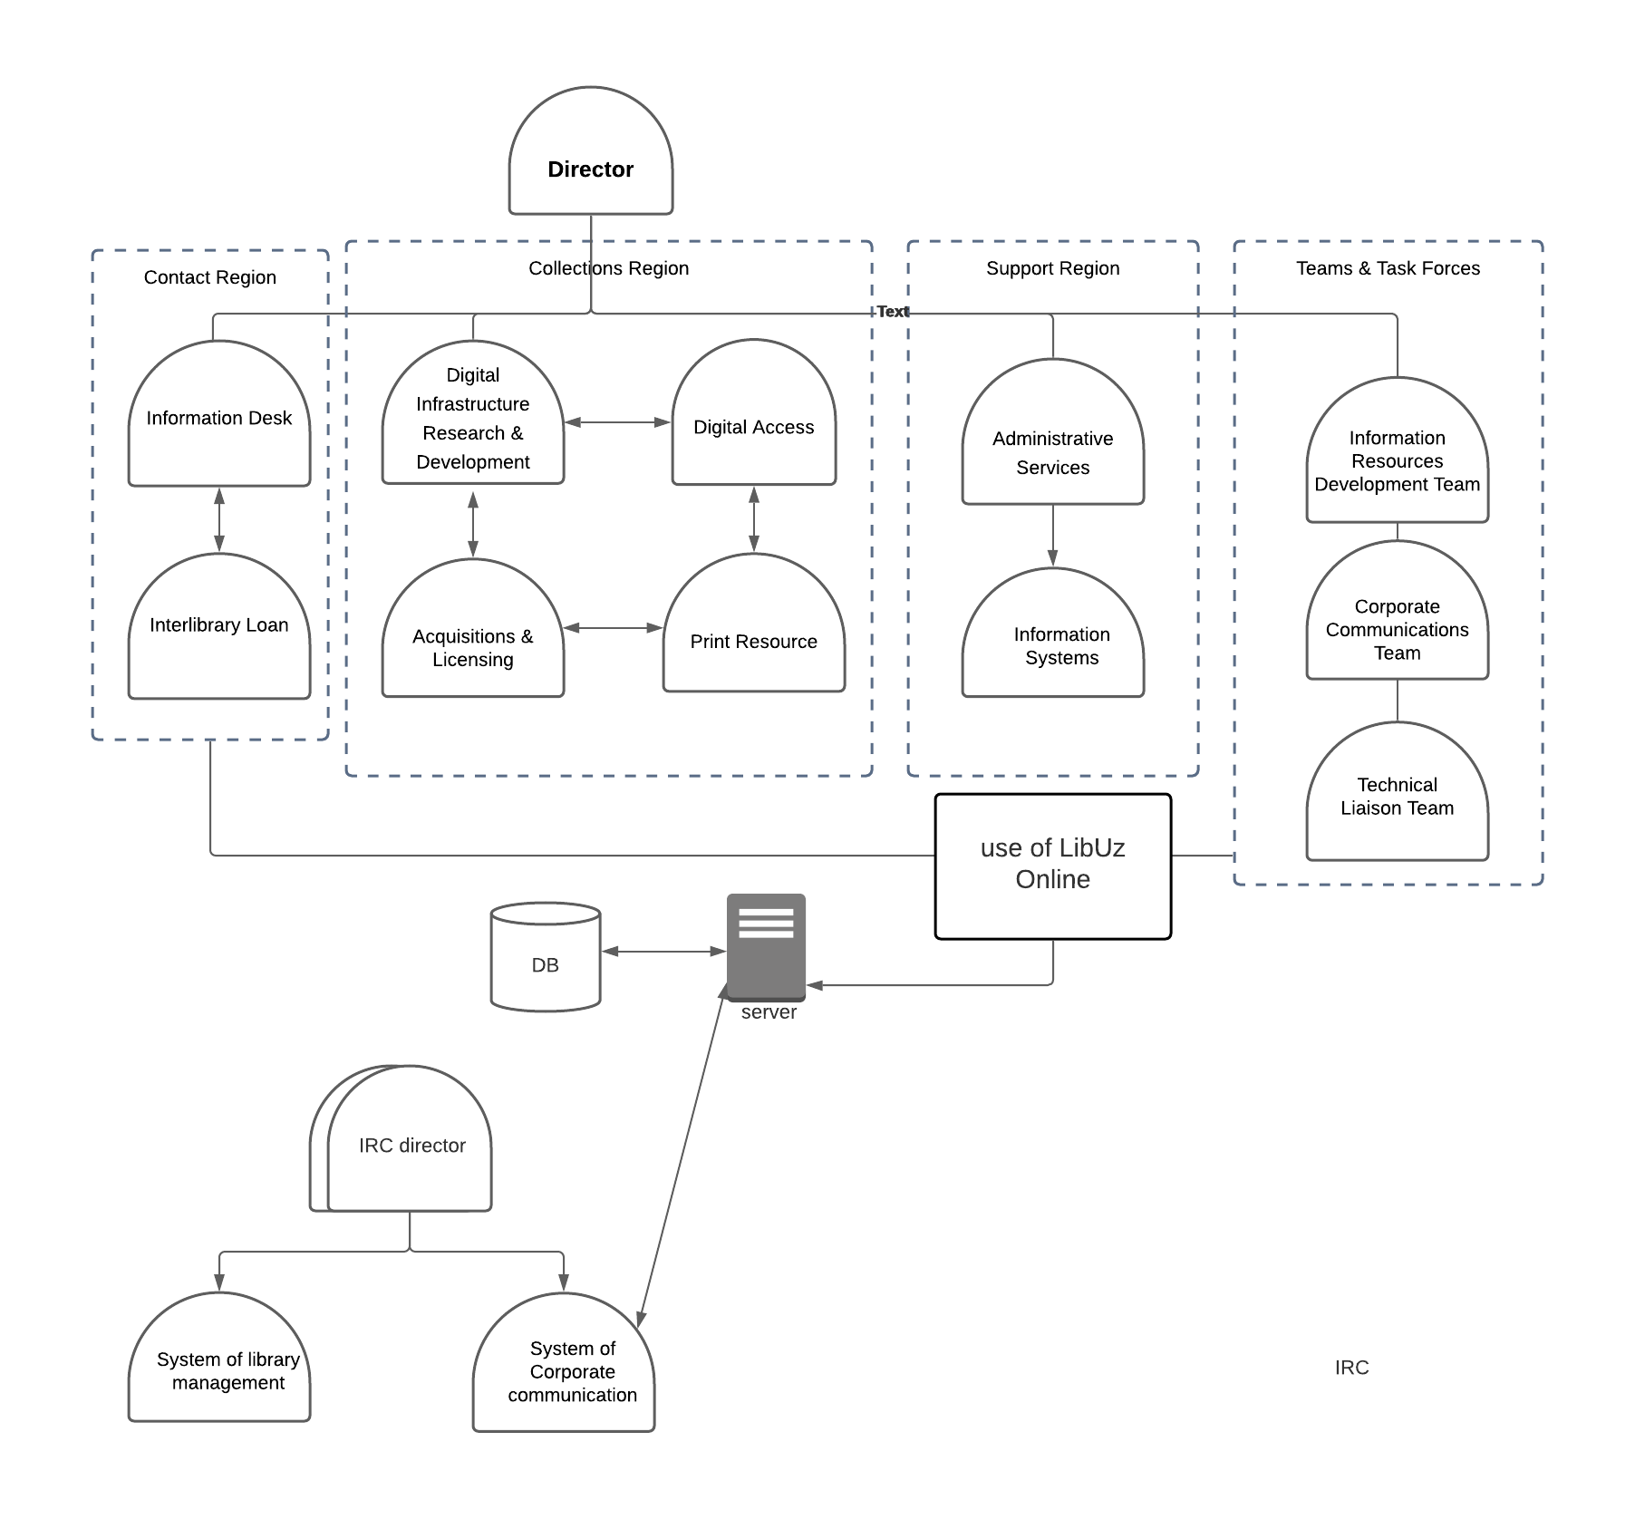

**Figure** Organizational structure