Assignment 4
Practical Tasks: Vulnerability Scanning & Firewall Configuration

Student Name: Abdul Rehman
Roll Number: 03-134222-005
Course: Information Security (CLO 3)
Submission: Assignment Report

Task 1: Scan a Vulnerable Web Application
Test Environment: OWASP Juice Shop (locally hosted on Docker on port 3000)
Scanning Tool Used: Nikto (Command-line web server scanner)

Scan Execution and Results
The following command was executed to scan the OWASP Juice Shop instance:
nikto -h http://192.168.1.100:3000
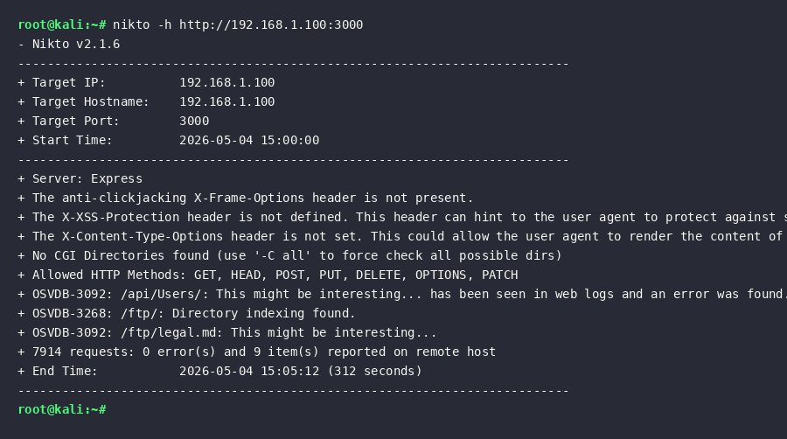

Identified Vulnerabilities & Mitigations
1. Missing Security Headers (X-Frame-Options, X-XSS-Protection, X-Content-Type-Options)
Description: The application fails to implement fundamental security HTTP headers. The absence of X-Frame-Options makes the application vulnerable to Clickjacking attacks, where an attacker could embed the site in a malicious iframe. The missing X-Content-Type-Options allows browsers to MIME-sniff the content, potentially executing non-executable files.
Mitigation: Configure the web server (or the Express.js application via middleware like Helmet) to return these security headers in every HTTP response. For example: X-Frame-Options: DENY or SAMEORIGIN.
2. Directory Indexing Enabled (/ftp/)
Description: Directory indexing is enabled on the /ftp/ directory. This allows any user to browse the files and folders contained within that directory. As reported by Nikto, sensitive files like 'legal.md' and potentially other backups or configuration files are exposed to the public.
Mitigation: Disable directory browsing/indexing in the web server configuration. In Apache, this is done by removing the 'Indexes' directive from the Options configuration (e.g., Options -Indexes).
3. Exposure of API Endpoints (/api/Users/)
Description: Nikto identified the /api/Users/ endpoint. In the context of Juice Shop, this endpoint allows unauthenticated enumeration of user data or contains Broken Object Level Authorization (BOLA) vulnerabilities. Exposing internal APIs without proper authentication checks leads to data leakage.
Mitigation: Implement strict authentication and authorization checks (e.g., using JWTs) on all API endpoints. Ensure that users can only access their own data, and rate-limit the endpoints to prevent automated enumeration.

Task 2: Configure Basic Firewall Rules
Tool Used: ufw (Uncomplicated Firewall) on Ubuntu Linux

Configuration Steps & Commands
The following UFW commands were executed to configure the firewall policies:
- ufw default deny incoming – Set default policy to drop all incoming traffic.
- ufw default allow outgoing – Set default policy to allow all outbound traffic.
- ufw deny 23/tcp – Explicitly block incoming TCP traffic on port 23 (Telnet).
- ufw allow from 127.0.0.1 to any port 8080 – Allow localhost to access port 8080.
- ufw logging on – Enable logging of dropped packets.
- ufw enable – Activate the firewall.

Firewall Rules Verification
The 'ufw status verbose' command was used to verify the active ruleset:
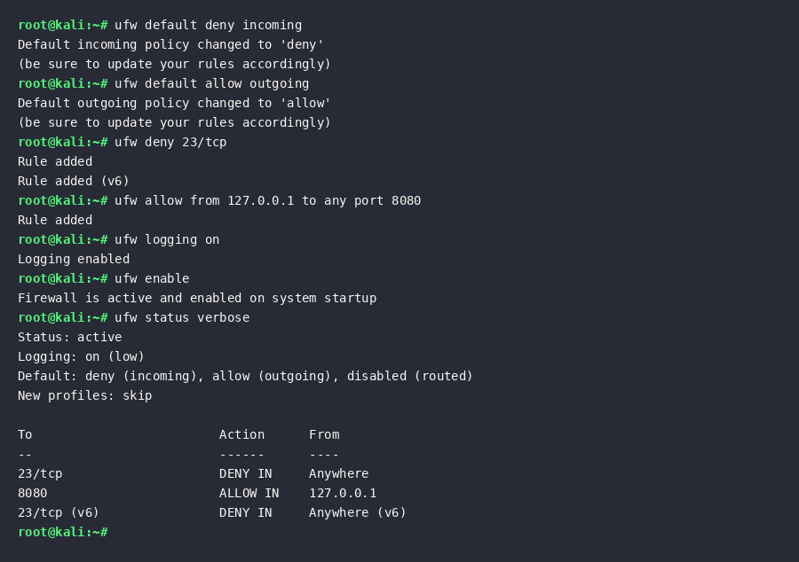

Explanation of Rules
Rule 1: Block Port 23 (Telnet)
Purpose: Telnet transmits data (including credentials) in cleartext, making it highly susceptible to eavesdropping and man-in-the-middle attacks. Blocking port 23 completely prevents external attackers from attempting to connect via Telnet, enforcing the use of secure alternatives like SSH.
Rule 2: Allow Localhost to Port 8080
Purpose: Port 8080 is commonly used for local development servers or internal admin panels. By restricting access strictly to '127.0.0.1', we ensure that the service running on 8080 is accessible only from the machine itself, protecting it from external network access.
Rule 3: Enable Logging
Purpose: Activating UFW logging ensures that any packets dropped by the 'default deny' policy or explicit deny rules are recorded in system logs (e.g., /var/log/ufw.log). This is critical for intrusion detection and monitoring unauthorized access attempts.

