 | Air University, Islamabad

Software Requirement Specification & Software Design Specification Document
(SRS & SDS DOCUMENT)

For
Muhaffiz: Offline-First Safety for Women and Children
Version 1.0
By
Muhammad Shamoil 232025
Ali Raza 232047

Supervisor
Kanwal Batool

Bachelor of Science in Software Engineering (2023-2027)
Revision History

Name | Date | Reason for Changes | Version

Application Evaluation and Review History

Comments by Committee | Action Taken

Approval
Role | Name | Signature | Date
Supervisor | Kanwal Batool
FYP Head | Dr. Farhad

Table of Contents
Chapter 1: Introduction 1
1.1 Purpose 1
1.2 Scope 2
1.3 Modules 3
1.4 Definitions, Acronyms and Abbreviations 5
1.5 Document Overview 7
1.6 Chapter Summary 8
Chapter 2: Overall Description and Requirements Elicitation 9
2.1 Product Perspective 9
2.2 User Classes and Characteristics 11
2.3 Operating Environment 11
2.4 Design and Implementation Constraints, Assumptions and Dependencies 13
2.5 Requirement Identifying Techniques 15
2.6 Chapter Summary 18
Chapter 3: Software Requirements Specification 19
3.1 Functional Requirement Catalogue 19
3.2 Functional Requirement Specification 21
3.2.1 MOD-01 SOS Alert System 22
3.2.2 MOD-02 Automatic Danger Detection Engine 24
3.2.3 MOD-03 Voice Activation and Safe-Phrase Engine 27
3.2.4 MOD-04 Family Circle Management 29
3.2.5 MOD-05 Location Sharing and Privacy Controls 30
3.2.6 MOD-06 Decoy Mode 32
3.2.7 MOD-07 Danger Heatmap 33
3.2.8 MOD-08 Near Help 35
3.2.9 MOD-09 Content Library Management 37
3.2.10 MOD-10 Semantic Search Engine 38
3.2.11 MOD-11 Emergency Services Directory 40
3.2.12 MOD-12 Tiered Delivery System 41
3.2.13 MOD-13 Offline Data Caching 42
3.2.14 MOD-14 Authentication and Account Management 43
3.2.15 MOD-15 Consent and Privacy Controls 45
3.2.16 MOD-16 Admin Dashboard 46
3.2.17 MOD-17 Missing-Child Report 48
3.2.18 MOD-18 Evidence Recording on SOS 50
3.2.19 MOD-19 Escalation to Authorities 52
3.2.20 MOD-20 Safe-Location Navigation 55
3.2.21 MOD-21 App Disguise 56
3.2.22 Use case Specification 57
3.3 Business Rules 63
3.4 Non-Functional Requirements 66
3.5 External Interface Requirements 69
3.5.1 User Interface Requirements 69
3.5.2 Software Interfaces 70
3.5.3 Hardware Interfaces 71
3.5.4 Communications Interfaces 72
3.6 Chapter Summary 73
Chapter 4: System Design 74
4.1 Design Methodology and Software Process Model 74
4.2 Architectural Design 75
4.3 Design Models 79
4.3.1 Class diagrams 80
4.3.2 System-sequence and detailed-sequence diagrams 88
4.3.3 Activity diagrams 102
4.3.4 State diagrams 112
4.3.5 Component diagram and event-response table 121
4.4 Data Design 123
4.5 Human Interface Design 130
4.6 Security, Error Handling and Logging Design 138
4.7 Risk Analysis and Sprint Plan 140
4.8 Chapter Summary 142
Chapter 5: Implementation and Deployment 143
5.1 Algorithms 143
5.2 External APIs/SDKs 147
5.3 REST API Specification 148
5.4 Implemented User Interface 149
5.5 Deployment 158
5.6 Chapter Summary 159
Chapter 6: Testing, Evaluation and Conclusion 160
6.1 Unit Testing 160
6.2 Functional Testing 162
6.3 Business Rules Testing 164
6.4 Integration Testing 165
6.5 Non-Functional Testing 166
6.6 Test Summary and Defect Log 169
6.7 Requirements Traceability Matrix 169
6.8 Conclusion, Limitations and Future Enhancements 177
6.9 Chapter Summary 179
References 180
Appendix A: Use Case List 181
Appendix B: Detailed Use Case Specifications 183
Appendix C: TBD List 194
Appendix D: Sample Test Data 195
Document Status 197

List of Figures
Figure 1: Context diagram of Muhaffiz 10
Figure 2: Use-case diagram: emergency alerting 58
Figure 3: Use-case diagram: family network and disguise 58
Figure 4: Use-case diagram: community, library and directory 59
Figure 5: Use-case diagram: account, consent and administration 59
Figure 6: Architecture of Muhaffiz (box-and-line view) 76
Figure 7: Deployment view of Muhaffiz 78
Figure 8: Class diagram: SOS core and delivery 81
Figure 9: Class diagram: evidence and escalation 82
Figure 10: Class diagram: distress detection 83
Figure 11: Class diagram: voice activation, consent and decoy 84
Figure 12: Class diagram: family network 85
Figure 13: Class diagram: community 86
Figure 14: Class diagram: library, search and directory 87
Figure 15: Class diagram: identity, disguise and administration 88
Figure 16: System-sequence diagram: manual SOS (UC-01) 89
Figure 17: Detailed sequence: SOS dispatch 90
Figure 18: Detailed sequence: automatic distress detection (UC-02) 91
Figure 19: Detailed sequence: voice-triggered SOS (UC-03) 92
Figure 20: Detailed sequence: stop sharing by safe phrase (UC-09) 93
Figure 21: Detailed sequence: escalation to authorities (UC-25) 94
Figure 22: Detailed sequence: offline queue and retry 95
Figure 23: Detailed sequence: circle invitation (UC-07) 96
Figure 24: Detailed sequence: nearby help (UC-15) 97
Figure 25: Detailed sequence: missing-child report (UC-23) 98
Figure 26: Detailed sequence: semantic library search (UC-17) 99
Figure 27: Detailed sequence: helper verification (UC-14) 100
Figure 28: Detailed sequence: incident report and heatmap (UC-12, UC-13) 101
Figure 29: Detailed sequence: sign-in (UC-19) 102
Figure 30: Activity diagram: SOS pipeline, trigger and dispatch 103
Figure 31: Activity diagram: SOS pipeline, response and escalation 104
Figure 32: Activity diagram: tiered delivery and retry 105
Figure 33: Activity diagram: phrase handling in context 106
Figure 34: Activity diagram: semantic search with fallback 107
Figure 35: Activity diagram with swimlanes: onboarding and consent 108
Figure 36: Activity diagram with swimlanes: missing-child report 109
Figure 37: Activity diagram with swimlanes: incident report and heatmap 110
Figure 38: Activity diagram with swimlanes: helper verification 111
Figure 39: Activity diagram with swimlanes: nearby help 112
Figure 40: State diagram: SOS event, trigger and dispatch 113
Figure 41: State diagram: SOS event, response and escalation 114
Figure 42: State diagram: confirmation countdown 115
Figure 43: State diagram: circle member and sharing 116
Figure 44: State diagram: circle invitation 117
Figure 45: State diagram: missing-child report 118
Figure 46: State diagram: Verified Helper application 119
Figure 47: State diagram: connectivity tier 120
Figure 48: State diagram: evidence recording 121
Figure 49: Component diagram 122
Figure 50: Entity-relationship diagram: server data, accounts and circles 126
Figure 51: Entity-relationship diagram: server data, community 127
Figure 52: Entity-relationship diagram: device data, SOS records 128
Figure 53: Entity-relationship diagram: device data, bundled content and settings 129
Figure 54: Navigation flow of the application 131
Figure 55: Key screens: Home and countdown 132
Figure 56: Key screens: SOS active and family map 133
Figure 57: Key screens: danger map and library search 134
Figure 58: Key screens: decoy and stop sharing 135
Figure 59: Key screens: trustees and settings 136
Figure 60: Mobile application: privacy summary and consent 150
Figure 61: Mobile application: sign-in and phrase enrolment 151
Figure 62: Mobile application: incident report and nearby help 152
Figure 63: Mobile application: helper registration and missing-child report 153
Figure 64: Mobile application: evidence and directory 154
Figure 65: Mobile application: safe-location guidance and escalation warning 155
Figure 66: Mobile application: escalation settings and app disguise 156
Figure 67: Admin website: overview 157
Figure 68: Admin website: moderation queue 157

List of Tables
Table 1: Scope of the Muhaffiz project 2
Table 2: Modules of Muhaffiz 3
Table 3: Definitions, acronyms and abbreviations 5
Table 4: User classes and external actors 11
Table 5: Operating environment 12
Table 6: Assumptions and dependencies 14
Table 7: Survey: current practice and barriers (n = 73) 15
Table 8: Survey: respondents likely or very likely to use each feature (n = 73) 16
Table 9: Module priorities 17
Table 10: Requirement identification techniques 18
Table 11: Functional requirement catalogue 19
Table 12: Specification of FR-01.01: Manual SOS Trigger 22
Table 13: Specification of FR-01.02: Multi-Channel Dispatch 22
Table 14: Specification of FR-01.03: Loud Alarm 23
Table 15: Specification of FR-01.04: Silent Mode 23
Table 16: Specification of FR-01.05: Trustee Management 24
Table 17: Specification of FR-01.06: SOS Event Log 24
Table 18: Specification of FR-02.01: Ambient Monitoring Service 24
Table 19: Specification of FR-02.02: Distress Sound Classification 25
Table 20: Specification of FR-02.03: Motion-Signal Fusion 25
Table 21: Specification of FR-02.04: Confirmation Countdown 26
Table 22: Specification of FR-02.05: On-Device Processing Guarantee 26
Table 23: Specification of FR-03.01: Safe-Phrase Enrolment 27
Table 24: Specification of FR-03.02: Duress-Phrase Enrolment 27
Table 25: Specification of FR-03.03: Offline Keyword Spotting 28
Table 26: Specification of FR-03.04: Voice-Triggered SOS 28
Table 27: Specification of FR-03.05: Shared Duress-Confirmation Hook 28
Table 28: Specification of FR-04.01: Circle Creation and Bilateral Invitation 29
Table 29: Specification of FR-04.02: Circle Membership List 29
Table 30: Specification of FR-04.03: Leave a Circle 30
Table 31: Specification of FR-05.01: Movement-Based Location Updates 30
Table 32: Specification of FR-05.02: Stop Sharing by Safe Phrase and Toggle 30
Table 33: Specification of FR-05.03: Private Opt-Out Confirmation 31
Table 34: Specification of FR-05.04: Last-Known Location Display 31
Table 35: Specification of FR-05.05: Real-Time Sharing Status 32
Table 36: Specification of FR-06.01: Disguised Interface 32
Table 37: Specification of FR-06.02: Hidden Re-entry Gesture 33
Table 38: Specification of FR-06.03: Background Pass-Through 33
Table 39: Specification of FR-07.01: Incident Report Form 33
Table 40: Specification of FR-07.02: Geohash Grid Aggregation 34
Table 41: Specification of FR-07.03: Recency Weighting 34
Table 42: Specification of FR-07.04: Heatmap Overlay 34
Table 43: Specification of FR-07.05: Rate Limits and Abuse Checks 35
Table 44: Specification of FR-08.01: Verified-Helper Registration 35
Table 45: Specification of FR-08.02: Help Request Broadcast 36
Table 46: Specification of FR-08.03: Accept or Decline Screen 36
Table 47: Specification of FR-08.04: Offline State 37
Table 48: Specification of FR-09.01: Curated Content 37
Table 49: Specification of FR-09.02: Offline Bundling 37
Table 50: Specification of FR-09.03: Browsing, Filters and Bookmarks 38
Table 51: Specification of FR-10.01: Precomputed Content Embeddings 38
Table 52: Specification of FR-10.02: On-Device Query Embedding 38
Table 53: Specification of FR-10.03: Cosine-Similarity Ranking 39
Table 54: Specification of FR-10.04: Keyword-Search Fallback 39
Table 55: Specification of FR-10.05: Ranked Result Cards 40
Table 56: Specification of FR-11.01: Localized Directory 40
Table 57: Specification of FR-11.02: One-Tap Call 40
Table 58: Specification of FR-11.03: Nearest Facilities First 41
Table 59: Specification of FR-12.01: Connectivity Tier Detection 41
Table 60: Specification of FR-12.02: SMS Delivery at Tier 1 41
Table 61: Specification of FR-12.03: Queue and Retry 42
Table 62: Specification of FR-13.01: Last-Known Location Cache 42
Table 63: Specification of FR-13.02: On-Device Database 43
Table 64: Specification of FR-14.01: Phone-Number Sign-Up and Login 43
Table 65: Specification of FR-14.02: Session Handling 43
Table 66: Specification of FR-14.03: Profile and Settings 44
Table 67: Specification of FR-14.04: Account Recovery 44
Table 68: Specification of FR-15.01: Onboarding Consent 45
Table 69: Specification of FR-15.02: Permission and Feature Toggles 45
Table 70: Specification of FR-15.03: Privacy Summary 46
Table 71: Specification of FR-16.01: User Overview 46
Table 72: Specification of FR-16.02: Moderation Queue 46
Table 73: Specification of FR-16.03: Helper Review Queue 47
Table 74: Specification of FR-16.04: Health Monitoring 47
Table 75: Specification of FR-16.05: Administrator Authentication 48
Table 76: Specification of FR-17.01: Missing-Child Report Form 48
Table 77: Specification of FR-17.02: Alert to Contacts and Nearby Helpers 48
Table 78: Specification of FR-17.03: Report Status Handling 49
Table 79: Specification of FR-17.04: Hand-Off to Official Channels 49
Table 80: Specification of FR-17.05: Moderation and Abuse Prevention 50
Table 81: Specification of FR-17.06: Child-Data Privacy 50
Table 82: Specification of FR-18.01: Automatic Recording on SOS 50
Table 83: Specification of FR-18.02: Encrypted On-Device Storage 51
Table 84: Specification of FR-18.03: Evidence List 51
Table 85: Specification of FR-18.04: Evidence Controls 51
Table 86: Specification of FR-18.05: Consent Disclosure 52
Table 87: Specification of FR-19.01: Response Tracking 52
Table 88: Specification of FR-19.02: No-Response Timer 53
Table 89: Specification of FR-19.03: Warning Countdown 53
Table 90: Specification of FR-19.04: Authority Channel Settings 53
Table 91: Specification of FR-19.05: Escalation Message 54
Table 92: Specification of FR-19.06: Escalation Log 54
Table 93: Specification of FR-20.01: Nearest Safe Location 55
Table 94: Specification of FR-20.02: One-Tap Directions Online 55
Table 95: Specification of FR-20.03: Offline Guidance 55
Table 96: Specification of FR-21.01: Disguise Options 56
Table 97: Specification of FR-21.02: Apply and Restore 56
Table 98: Specification of FR-21.03: Unchanged Functions 56
Table 99: Use case list 59
Table 100: Use case specification UC-01: Trigger Manual SOS 60
Table 101: Use case specification UC-02: Handle Automatic Distress Alert 60
Table 102: Use case specification UC-03: Trigger SOS by Voice Phrase 61
Table 103: Use case specification UC-09: Stop Sharing by Safe Phrase 62
Table 104: Use case specification UC-25: Escalate to Authorities 62
Table 105: Use case specification UC-23: File Missing-Child Report 63
Table 106: Business rules 64
Table 107: Non-functional requirements: Reliability 67
Table 108: Non-functional requirements: Performance 67
Table 109: Non-functional requirements: Security 68
Table 110: Non-functional requirements: Privacy 68
Table 111: Non-functional requirements: Usability 68
Table 112: Non-functional requirements: Maintainability, Portability and Other Qualities 69
Table 113: Summary of external interfaces 72
Table 114: Decomposition of the system into packages 76
Table 115: Architecture decision records 78
Table 116: Event-response table 122
Table 117: Data dictionary 124
Table 118: Indexes and constraints 129
Table 119: Screens of the application and the admin website 137
Table 120: Security, error handling and logging design 139
Table 121: Risk analysis 140
Table 122: Milestone plan 141
Table 123: Algorithm parameters and default values 143
Table 124: Algorithm: sound-level gate (A1) 144
Table 125: Algorithm: distress decision with fusion (A2) 144
Table 126: Algorithm: trigger arbitration and SOS pipeline (A3) 144
Table 127: Algorithm: tiered dispatch and queue retry (A4) 145
Table 128: Algorithm: phrase handling in context (A5) 145
Table 129: Algorithm: movement-based location publication (A6) 146
Table 130: Algorithm: heatmap cell score (A7) 146
Table 131: Algorithm: semantic search with keyword fallback (A8) 146
Table 132: Algorithm: escalation timer (A9) 147
Table 133: Algorithm: nearest safe location (A10) 147
Table 134: External APIs and SDKs 147
Table 135: Project backend interfaces 149
Table 136: Deployment environments 158
Table 137: Unit test cases 160
Table 138: Functional test cases 162
Table 139: Business rule test cases 164
Table 140: Integration test cases 166
Table 141: Non-functional test cases 167
Table 142: Test summary 169
Table 143: Defect log 169
Table 144: Requirements traceability matrix 170
Table 145: Use case list with descriptions 181
Table 146: Use case specification UC-04: Manage Trustees 183
Table 147: Use case specification UC-05: View SOS Event Log 183
Table 148: Use case specification UC-06: Enrol Safe and Duress Phrases 184
Table 149: Use case specification UC-07: Create Circle and Invite Member 184
Table 150: Use case specification UC-08: Share Location and View Members 185
Table 151: Use case specification UC-10: Leave Family Circle 185
Table 152: Use case specification UC-11: Use Decoy Mode 186
Table 153: Use case specification UC-12: Submit Incident Report 186
Table 154: Use case specification UC-13: View Danger Heatmap 187
Table 155: Use case specification UC-14: Register as Verified Helper 187
Table 156: Use case specification UC-15: Request and Respond to Nearby Help 187
Table 157: Use case specification UC-16: Browse Library 188
Table 158: Use case specification UC-17: Search Library 188
Table 159: Use case specification UC-18: Call Emergency Service 189
Table 160: Use case specification UC-19: Sign Up and Log In 189
Table 161: Use case specification UC-20: Manage Consent and Privacy Settings 190
Table 162: Use case specification UC-21: Moderate Reports and Review Helpers 190
Table 163: Use case specification UC-22: Monitor System Health 191
Table 164: Use case specification UC-24: Manage Evidence Recordings 191
Table 165: Use case specification UC-26: Navigate to Nearest Safe Location 192
Table 166: Use case specification UC-27: Change App Disguise 192
Table 167: Use case specification UC-28: Recover Account 193
Table 168: Use case specification UC-29: Acknowledge SOS Alert 193
Table 169: Items to be determined 194
Table 170: Sample trustees 195
Table 171: Sample SOS message 195
Table 172: Sample incident reports 195
Table 173: Sample library queries 195
Table 174: Sample audio test set (labelled clips) 195
Table 175: Sample directory entries 195

Introduction
Chapter Overview. This chapter introduces the Muhaffiz software product and the people who will read and use this document. It states the purpose of the document and its readers (Section 1.1), the scope and boundaries of the project (Section 1.2), the twenty-one modules of the system (Section 1.3), the terminology used throughout (Section 1.4) and the organization of the remaining chapters and appendices (Section 1.5).

Purpose
This document is the combined Software Requirements Specification (SRS) and Software Design Specification (SDS), version 1.0, for Muhaffiz: Offline-First Safety for Women and Children. Muhaffiz (from the Urdu word for "guardian") is an Android application, supported by a cloud backend and a separate web-based administration site, that helps a person call for help, be detected as being in distress, share their location with family under privacy safeguards, and reach safety information and emergency contacts, including when no data connection is available.
The document defines what the system shall do (the requirements) and how it will be structured to do it (the design). Every requirement has a unique identifier that is kept unchanged in the design, implementation and test documentation, so that each statement can be traced from its source to its verification. The document is written to be read by the following groups.
- Supervisor and evaluation committee: to judge whether the scope is complete, coherent and achievable within a Final Year Project.
- Developers: to implement the system without having to guess intended behaviour.
- Testers: to derive test cases from the requirements, business rules and acceptance criteria.
- Project managers: to plan milestones, assign work and manage risk.
- Users and stakeholders: to confirm that the user-visible behaviour matches their needs and privacy expectations.
- Documentation writers: to prepare user and administrator guidance consistent with the specified behaviour.

Scope
Muhaffiz is an Android application for women and children, with a supporting cloud backend and an administration website. It is designed around three principles: an emergency alert must be able to leave the phone without a data connection; sensitive signals, namely microphone audio and voice phrases, are processed only on the phone; and every action that someone might be forced to perform is protected against coercion. The application provides a manual, automatic and voice-triggered SOS; family location sharing with consent rules that the tracked person controls; a community danger map; verified nearby helpers; an offline safety library with on-device semantic search; a directory of emergency services; evidence recording and escalation after an SOS; and a missing-child report. Table 1 states what is committed for this project, what is excluded, and the expected benefits, so that committed work can be distinguished from possible future work.
Table 1: Scope of the Muhaffiz project
Scope Category | Description
In Scope | • An Android application, built with Flutter, that implements the twenty-one modules MOD-01 to MOD-21 listed in Section 1.3.  • A Firebase backend for authentication, data synchronisation, push messaging and storage, and server-side functions for channels that cannot run on the phone.  • A separate administration website on its own domain (muhaffiz.me) that implements MOD-16.  • On-device machine-learning components that use existing pre-trained models: distress-sound classification, keyword spotting and sentence embedding.  • SOS delivery by WhatsApp, in-app push, email and SMS, with SMS usable without a data connection.  • Verification of the system as described in Chapter 6.
Out of Scope | • Versions of the user application for iOS, desktop or the web.  • Training any machine-learning model from scratch, and any GPU infrastructure.  • Uploading, storing or transmitting raw audio from the detection and voice engines, and any video recording.  • Direct system-to-system integration with police, emergency-service dispatch or government missing-child systems. Muhaffiz hands off by SMS, call or share to numbers and channels that are configured.  • Any guarantee that an authority receives, accepts or acts on a message.  • User-interface languages other than English.  • Wearable devices and dedicated panic-button hardware.  • Payments, advertising and any other monetisation.  • The content of the promotional website (muhaffiz.live).
Benefits | • For users: an alert path that does not depend on a data connection (SMS still needs cellular coverage); hands-free and discreet ways to trigger help; microphone audio kept on the phone; control over who can see their location and a private way to stop sharing; safety information and emergency contacts available offline; audio evidence kept on the phone for later use.  • For communities: a shared picture of areas reported as unsafe and a way to reach verified people nearby.  • For the project: a demonstration of on-device machine learning, offline-first delivery and privacy-by-design combined in one system, with behaviour that can be measured and tested.

Where demonstration data or simulated users are needed to evaluate a module, for example for the heatmap or Near Help, they shall be identified as simulated in Chapter 6 and shall not be presented as real usage.

Modules
The functionality of Muhaffiz is divided into twenty-one modules. Each module has a persistent identifier of the form MOD-nn, which is used in the requirement catalogue, the design models and the test cases. Table 2 lists the modules with their primary actors; the actors are described in Section 2.2.
Table 2: Modules of Muhaffiz
Module ID | Module Name | Description | Primary Actor or User
MOD-01 | SOS Alert System | Manual SOS trigger on the home screen and as a lock-screen quick action; simultaneous dispatch of live location and a preset message by WhatsApp, in-app push, email and SMS; loud alarm and silent mode; trustee management; SOS event log. | Primary User; Trustee (recipient)
MOD-02 | Automatic Danger Detection Engine | Low-power background monitoring that stays dormant until a sudden loud sound; on-device classification of distress sounds; fusion with motion sensors; 20-second countdown before the SOS fires, cancelled by the swipe, the spoken safe phrase or the typed safe phrase as the user chooses. No audio leaves the phone. | Primary User
MOD-03 | Voice Activation and Safe-Phrase Engine | Fully offline keyword spotting. A safe phrase fires a loud SOS and a different duress phrase fires a silent SOS; the same engine confirms the family-sharing opt-out and supports Decoy Mode. | Primary User
MOD-04 | Family Circle Management | Creation of a family circle; invitations that both people must accept; member list with each person's sharing status and last update time; leaving a circle, which is separate from pausing sharing. | Primary User; Family Circle Member
MOD-05 | Location Sharing and Privacy Controls | Location updates on significant movement; opt-out by spoken safe phrase without anyone's approval; private confirmation shown only to the person who opted out; timestamped last-known location marked as not live; real-time sharing status. | Family Circle Member
MOD-06 | Decoy Mode | A neutral, unrelated-looking screen replaces the app when the user is forced to unlock the phone; a hidden gesture returns to the real app; SOS, voice triggers and location updates continue underneath. | Primary User
MOD-07 | Danger Heatmap | Incident report form (category, auto-filled editable location, optional note); geohash grid; recency weighting; Google Maps overlay from green to red; zone details without identifying reporters; rate limits and abuse checks. | Primary User; Administrator (moderation)
MOD-08 | Near Help | Verified-helper registration with an identity check; help requests broadcast to verified users within a set radius; accept or decline screen; clear "unavailable, no connection" state when offline. | Primary User; Verified Helper
MOD-09 | Content Library Management | Curated articles, videos and links on prevention and post-trauma care, grouped by category, bundled with the app for offline use; browsing with category filters and bookmarks. | Primary User
MOD-10 | Semantic Search Engine | On-device search of the library by meaning: pre-computed content embeddings, query embedding on the phone, cosine-similarity ranking, keyword-search fallback and ranked result cards. | Primary User
MOD-11 | Emergency Services Directory | Localized directory of hospitals, police stations, helplines and emergency numbers (including Rescue 1122 and women's helplines) with one-tap calling and nearest-first ordering when location is available. | Primary User
MOD-12 | Tiered Delivery System | Detection of connectivity as Tier 1 (no connection), Tier 2 (any connection) or Tier 3 (good connection); SMS delivery that works at Tier 1; automatic queue and retry of alerts created offline. | Primary User (system service)
MOD-13 | Offline Data Caching | Last-known-location cache used when no fresh GPS fix is available at SOS time; on-device database for library content, map tiles for frequent areas and pending outbound alerts. | Primary User (system service)
MOD-14 | Authentication and Account Management | Phone-number sign-up and login; secure session handling with automatic re-authentication; profile and settings (name, emergency message template, linked trustees); account recovery for lost devices. | Primary User
MOD-15 | Consent and Privacy Controls | Onboarding consent explaining what the detection and voice engines listen for; separate toggles for microphone detection, location sharing and voice activation; in-app privacy summary. | Primary User
MOD-16 | Admin Dashboard | Separate website for administrators: user overview, moderation queue for flagged heatmap reports, review queue for approving or revoking Near Help helpers, and monitoring of delivery success and backend errors. | Administrator
MOD-17 | Missing-Child Report | Report form (name, age, photo, description, last-seen place and time, guardian contact); alert to the guardian's trusted contacts and nearby verified users; active, found and expired status handling; hand-off to official channels; moderation and child-data privacy. | Primary User (Guardian); Administrator
MOD-18 | Evidence Recording on SOS | Audio recording that starts automatically when an SOS fires; encrypted storage on the device only; evidence list with time, location and trigger; user controls to stop, delete, export and auto-delete. | Primary User
MOD-19 | Escalation to Authorities | Tracking of trustee and helper acknowledgements; 3-minute no-response timer; 30-second warning countdown with cancel; escalation message to configured authority numbers (SMS, call or share); escalation log. | Primary User; Authority Contact (recipient)
MOD-20 | Safe-Location Navigation | One-tap directions from the current position to the nearest safe location, designed to work from data stored on the device when there is no connection. | Primary User
MOD-21 | App Disguise | Option to change the app's launcher icon and name to a neutral appearance so that it does not reveal itself as a safety application. | Primary User

Definitions, Acronyms and Abbreviations
Table 3 defines the domain-specific terms, acronyms and abbreviations used in this document. The entries are in alphabetical order.
Table 3: Definitions, acronyms and abbreviations
Term or Acronym | Definition
Accelerometer | A phone sensor that measures acceleration. It is combined with the gyroscope to recognise a sudden drop or struggle movement.
Acknowledgement | A confirmation by a trustee or a helper that they have seen an alert; it stops the no-response timer.
Administrator | A member of the Muhaffiz team authorised to use the web-based Admin Dashboard (MOD-16).
ADR | Architecture decision record: a short record of a design decision, the alternatives and the reasons.
AES-256-GCM | An authenticated encryption method with a 256-bit key, used for evidence recordings.
Alert Page | A web page, served by Firebase Hosting and linked in an SOS message, where a trustee can see the alert and acknowledge it.
Android | The mobile operating system on which the Muhaffiz application runs.
Android Keystore | The Android facility that holds cryptographic keys so that they cannot be read by other applications.
API | Application Programming Interface: a defined way for one software component to request services from another.
Authority Contact | A phone number of an official emergency service, for example Police 15 or Rescue 1122, configured to receive escalation messages (MOD-19).
Bilateral Opt-in | The rule that sharing between two people starts only after both have explicitly accepted.
CI/CD | Continuous integration and continuous delivery: automatic building, testing and deployment of the software.
Cloud Functions | Server-side functions of Firebase that run in response to requests, events or schedules.
Cosine Similarity | A measure of how alike two vectors are, based on the angle between them. It is used to rank search results against a query.
Decoy Mode | A mode in which the application shows a neutral, unrelated-looking screen instead of its real interface while safety functions continue in the background (MOD-06).
Duress | A situation in which a person is forced or threatened into acting against their will.
Duress Phrase | A spoken phrase, chosen by the user and different from the safe phrase, that fires a silent SOS.
Embedding | A numeric vector that represents the meaning of a piece of text, produced by a language model.
Evidence Recording | Audio recorded on the device after an SOS fires and stored there in encrypted form (MOD-18).
FCM | Firebase Cloud Messaging: the Google service that delivers push notifications to Android devices.
Firebase | The Google backend platform used for authentication, database, messaging, storage and hosting.
Firestore | Cloud Firestore: the Firebase document database, which supports real-time listeners and a local offline cache.
Flutter | The Google user-interface toolkit, programmed in Dart, used to build the Android application.
Foreground Service | An Android service that runs with a visible notification so that the operating system does not stop it. Muhaffiz uses one for monitoring.
FR | Functional Requirement.
Fusion Rule | The rule that combines the audio distress score with the motion result to decide whether to start the confirmation countdown.
FYP | Final Year Project.
Geohash | A short string that identifies a rectangular geographic cell. It is used to group nearby points into fixed-size cells.
GPS | Global Positioning System: satellite-based positioning used to obtain the phone's location.
Gyroscope | A phone sensor that measures rotation.
Heatmap | A map overlay that colours each area from green to red according to the recency-weighted density of incident reports (MOD-07).
HTTPS and TLS | The secure web protocol and the encryption protocol (Transport Layer Security) that protects data in transit.
Incident Report | A user-submitted record of an unsafe event, with a location, a category and an optional note.
Keyword Spotting | Recognition of specific words or phrases in audio without transcribing general speech.
Last-Known Location | The most recent location a person shared before they stopped sharing. It is shown with a timestamp and is marked as not live.
Moderation Queue | The list of flagged reports and applications that an administrator reviews.
Near Help | The module that sends a help request to Verified Helpers within a set radius (MOD-08).
NFR | Non-Functional Requirement.
Offline-first | A design approach in which critical functions work without a data connection and remote synchronisation happens when a connection returns.
On-device Processing | Computation carried out on the user's phone, with no audio or analysis result sent to a server.
OTP (One-Time Code) | A single-use code sent by SMS to verify a phone number.
Outbound Queue | The on-device list of messages that could not yet be delivered and are retried.
Platform Channel | The Flutter mechanism by which Dart code calls native Android (Kotlin) code.
Primary User | A registered person who uses Muhaffiz for their own safety or, as a guardian, for the safety of a child.
Rescue 1122 | An emergency rescue helpline operating in Pakistan.
Safe Location | A place from the application's bundled directory, such as a police station or hospital, to which a user can be directed in an emergency (MOD-20).
Safe Phrase | A spoken phrase, chosen by the user, that fires a loud SOS and confirms an opt-out from family location sharing.
SDS | Software Design Specification.
SMS | Short Message Service: text messaging over the cellular network, which does not need a data connection.
SOS | An emergency alert sent from the application to the user's trustees and, where applicable, to other recipients.
SQLite | A small relational database that runs inside the application.
SRS | Software Requirements Specification.
TensorFlow Lite (TFLite) | A lightweight runtime for running machine-learning models on mobile devices.
Tier 1, Tier 2, Tier 3 | The three connectivity levels used by delivery: Tier 1 is no data connection, Tier 2 is any data connection, Tier 3 is a good data connection (MOD-12).
Trustee | A contact chosen by a Primary User to receive SOS alerts. A trustee may or may not have the application installed.
UI | User interface.
Unilateral Opt-out | The rule that a person can stop sharing their location at any time without anyone's approval.
Verified Helper | A registered user who has passed an identity check and agreed to respond to Near Help requests.
WhatsApp | A messaging application used by Muhaffiz as one SOS dispatch channel.
WorkManager | The Android component that runs persistent background work, such as retrying the outbound queue.
YAMNet | A pre-trained audio-event classification model that runs with TensorFlow Lite.

Document Overview
The remainder of this document is organized as follows.
- Chapter 2: Overall Description and Requirements Elicitation places Muhaffiz in context, identifies the user classes, the operating environment, the constraints, assumptions and dependencies, and explains how the requirements were identified, prioritized and validated.
- Chapter 3: Software Requirements Specification gives the functional requirement catalogue and the specification of each functional requirement, the use cases, the business rules, the non-functional requirements and the external interface requirements.
- Chapter 4: System Design presents the design methodology, the architecture, the design models, the data design, the human interface design, the security, error-handling and logging design, and the risk analysis and milestone plan.
- Chapter 5: Implementation and Deployment describes the core algorithms, the external APIs and SDKs, the interfaces of the backend, the user interface and the deployment arrangement.
- Chapter 6: Testing, Evaluation and Conclusion defines the test cases at each level, the traceability matrix, and the conclusion with limitations and future enhancements.
- References lists the sources cited in IEEE style.
- Appendix A lists all use cases, Appendix B gives the detailed specifications of the use cases not given in Chapter 3, Appendix C lists items still to be determined, and Appendix D gives sample test data. The glossary is in Section 1.4 and is not repeated.
Identifiers follow a fixed scheme: modules MOD-nn, functional requirements FR-nn.nn (the first number is the module), use cases UC-nn, business rules BR-nn, non-functional requirements NFR-xxx-nn, constraints CON-n, assumptions AS-n, dependencies DEP-n, and risks RSK-nn. Modules MOD-01 to MOD-16 keep the order of modules 7.1 to 7.16 of the approved project scope document; MOD-17 to MOD-21 were added after that document was written and are approved parts of the system.

Chapter Summary
This chapter introduced Muhaffiz as an offline-first, on-device and coercion-aware safety application for women and children, defined the committed and excluded scope, listed the twenty-one modules, and fixed the terminology and identifier scheme. Chapter 2 now describes the context in which the system operates and how its requirements were identified.

Overall Description and Requirements Elicitation
Chapter Overview. This chapter places Muhaffiz in its context and explains where its requirements come from. Section 2.1 describes the origin of the product and its relationship to existing systems, Section 2.2 identifies the user classes, Section 2.3 states the operating environment, Section 2.4 lists the constraints, assumptions and dependencies, and Section 2.5 explains how requirements were identified, prioritized and validated.

Product Perspective
Muhaffiz is a new, self-contained product. It does not replace or extend an earlier system. It was conceived to address a safety gap that is large and well documented: worldwide, about one in three women experience physical or sexual violence in their lifetime [1]. A person in danger needs to raise an alarm quickly, discreetly and in places where a data connection cannot be relied on, and a person who is being monitored by someone else needs a way to stop that monitoring safely.
People currently combine general-purpose tools to do this. In the survey described in Section 2.5, the most common tool was WhatsApp live location (61% of the 73 respondents), followed by the phone's built-in emergency SOS (19%); 29% used nothing, and only 3% had ever used a dedicated safety application. The most common reason for not using a safety application was that it needs internet (71%). Muhaffiz does not compete with the national emergency helplines. It complements them: it can alert a person's own contacts first, and it hands a message to a helpline number when the contacts do not respond.
The product consists of three parts. The Android application contains the on-device layer, which works without any network: sound-based distress detection, offline voice activation, SOS triggering, SMS dispatch, the offline library and its search, the local cache and the evidence recorder. The Firebase backend is the cloud coordination layer: authentication, family-circle synchronisation, the heatmap and Near Help data, push messaging, storage, and server-side functions for channels that cannot run on the phone, such as email. The admin website at muhaffiz.me lets administrators moderate reports and review helpers. Figure 1 shows the system as one unit and its interfaces with people and external services.
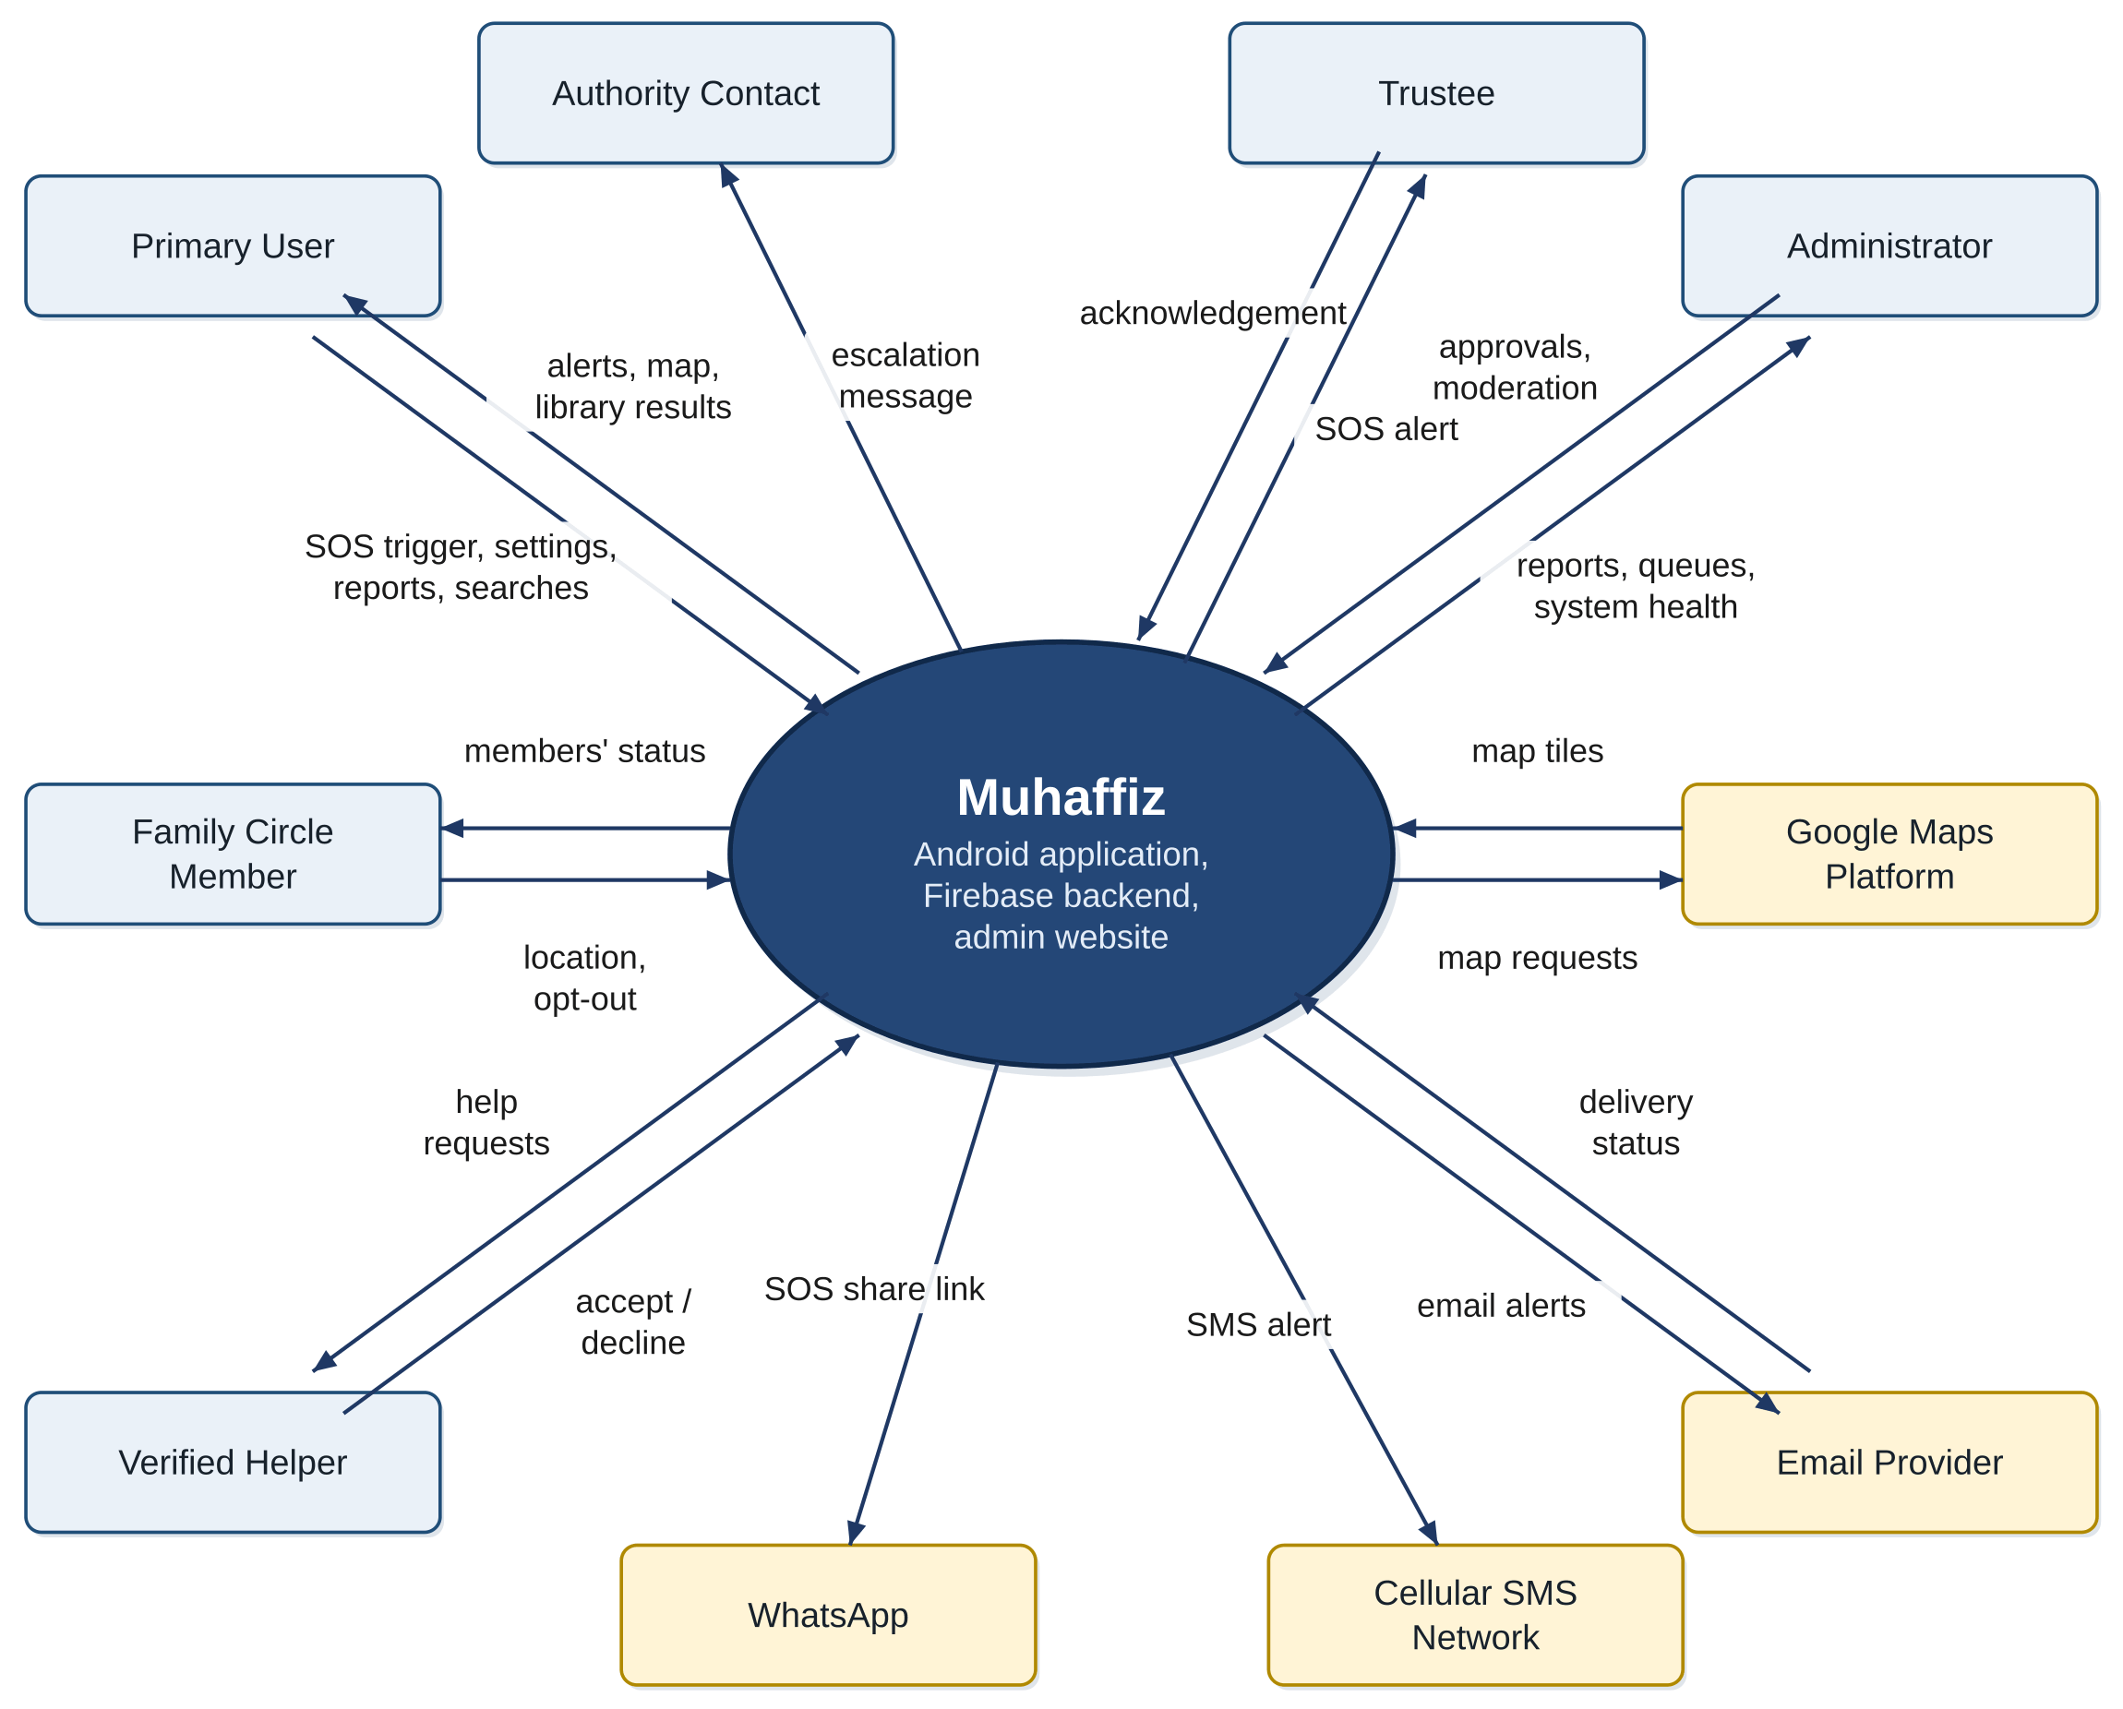
Figure 1: Context diagram of Muhaffiz
The external entities and their interfaces are as follows.
- Primary User: operates the application; sends SOS commands, settings, incident reports and searches, and receives alerts, map data and library results.
- Family Circle Member: shares location with, and views the sharing status of, other members of a circle.
- Verified Helper: receives nearby help requests and replies with accept or decline.
- Trustee: receives the SOS alert and may acknowledge it.
- Authority Contact: receives the escalation message when nobody has responded.
- Administrator: moderates reports, approves or revokes helpers, and monitors system health through the admin website.
- Google Maps Platform: supplies the map and tiles used by the heatmap, the family map and navigation.
- Email provider: carries the email copy of an SOS and returns delivery status.
- WhatsApp: receives the SOS share request on the user's phone.
- Cellular SMS network: carries SMS alerts, which need no data connection.

User Classes and Characteristics
Table 4 lists every user class and external actor. Access level and frequency of use are given in the description.
Table 4: User classes and external actors
User Class or Actor | Description | Expected Skills | Main Responsibilities or Interactions
Primary User | A registered person who uses Muhaffiz for personal safety. Authenticated by phone number. Full access to the user modules. Daily background use, with occasional active use. | Basic smartphone use. No technical or security knowledge. | Configures trustees, phrases and privacy toggles; triggers or cancels SOS; reports incidents; uses the library, directory and navigation.
Guardian | A Primary User who acts for a child. Same access as a Primary User, with additional access to the missing-child report. | Basic smartphone use. | Files and updates a missing-child report; manages the child-related contacts.
Family Circle Member | A Primary User who has joined a family circle. Access is limited to the circle they belong to. Continuous use while sharing. | Basic smartphone use. | Accepts invitations; shares location; stops sharing by safe phrase; views other members' status.
Trustee | A contact chosen by a Primary User to receive SOS alerts. May have no account and no app, in which case alerts arrive by SMS, WhatsApp or email. Rare use, at the time of an alert. | Reading a message and following a map link. | Receives alerts; may acknowledge an alert.
Verified Helper | A Primary User who has passed an identity check and agreed to respond to nearby requests. Occasional use. | Basic smartphone use. | Registers for verification; accepts or declines requests.
Administrator | A member of the project team with access to the admin website. Daily or weekly use. Authenticated separately from the application. | Web browser use; understanding of moderation rules. | Reviews flagged reports and missing-child reports; approves or revokes helpers; monitors delivery success and errors.
Authority Contact (external) | An emergency service number configured for escalation. Not a user of Muhaffiz. | Not applicable. | Receives the escalation message sent as SMS, call or share.

Operating Environment
Table 5 gives the hardware, software, network and hosting environment in which Muhaffiz operates.
Table 5: Operating environment
Environment Item | Specification or Version | Purpose
Client operating system | Android 8.0 (API level 26) or later | Foreground services, notification channels and runtime permissions used by the safety engines.
Client framework | Flutter (stable channel) with Dart; Android platform channels written in Kotlin | Single code base for the user interface, with platform channels for SMS, foreground services and launcher-icon switching.
Client hardware | Smartphone with microphone, accelerometer, gyroscope, GPS receiver, speaker, vibration motor and SIM card; Google Play services | Sensing, alarm, vibration countdown, SMS delivery, push messaging and maps.
Network | Cellular network (SMS, voice, data) and Wi-Fi | SOS must be deliverable by SMS without a data connection; other channels need data.
Backend platform | Google Firebase: Authentication, Cloud Firestore, Cloud Messaging, Cloud Storage, Cloud Functions, Hosting | Identity, synchronisation, push, file storage, server-side functions and web hosting.
Admin website | Flutter web build served by Firebase Hosting on the muhaffiz.me domain; current versions of Chrome, Edge, Firefox and Safari on desktop | Administrator access to moderation, helper review and monitoring.
Maps | Google Maps SDK for Android | Heatmap overlay, family map and navigation display.
Offline map data | Open map data (OpenStreetMap-derived) downloaded for up to three user-selected areas and stored on the device | Map display for frequent areas and safe-location guidance with no connection.
On-device intelligence | TensorFlow Lite runtime; pre-trained models for sound classification, keyword spotting and sentence embedding, bundled with the application | Distress detection, voice activation and semantic search without a network.
On-device storage | SQLite database; encrypted files protected by a key held in the Android Keystore | Offline library, cache, outbound queue and evidence recordings.
Geography and language | Pakistan; English user interface | Target users and emergency numbers.

- OE-1: The application shall operate correctly on Android 8.0 (API level 26) and later on phones that provide the sensors and radios listed in Table 5.
- OE-2: The SOS dispatch by SMS shall operate with no data connection when cellular coverage is present.
- OE-3: The voice-activation, distress-detection, library, search, directory and evidence functions shall operate with no network connection.
- OE-4: The admin website shall operate correctly on the current versions of Chrome, Edge, Firefox and Safari on desktop computers.

Design and Implementation Constraints, Assumptions and Dependencies
The following constraints restrict the design and implementation. Each is followed by its rationale.
- CON-1: The user application shall run on Android only. Rationale: Android permits the foreground services, background audio and SMS capability that the safety engines need; iOS restricts them.
- CON-2: The user application shall be built with Flutter and Dart, using Android platform channels where a native capability is required. Rationale: one code base is practical for a two-person team.
- CON-3: The backend shall use Firebase services. Rationale: they provide phone authentication, real-time synchronisation, push messaging and offline caching as one managed platform.
- CON-4: Machine-learning components shall use existing pre-trained models; no model shall be trained from scratch. Rationale: the project has no labelled incident data or GPU infrastructure.
- CON-5: Audio processed by the distress-detection and voice engines shall not be stored or transmitted off the device. Rationale: privacy and the consent given by the user.
- CON-6: Evidence recordings shall be stored only on the device, in encrypted form. Rationale: recordings are sensitive and are meant for the user to present later.
- CON-7: The voice-activation engine shall be open source or otherwise usable with no network access, account or access key. Rationale: voice activation must work fully offline.
- CON-8: Third-party services and components shall be used within their free tiers or free licences. Rationale: the project has no budget for paid services.
- CON-9: Microphone, location, SMS, notification and recording features shall run only after the user has granted the corresponding Android permission and has given consent in the application. Rationale: Android permission rules and the privacy principles of the product.
- CON-10: The user interface shall be in English. Rationale: approved project scope.
- CON-11: The admin website shall be served from its own domain, muhaffiz.me, and shall be separate from the user application. Rationale: administrative functions must not be reachable from the user application.
- CON-12: The system shall be completed within the final year project schedule by a team of two. Rationale: academic schedule and team size.
Table 6 states the assumptions, which are believed true but not guaranteed, and the external dependencies on which the project relies.
Table 6: Assumptions and dependencies
ID | Type | Statement | Rationale or Source | Impact if Invalid
AS-1 | Assumption | Users' phones have a microphone, motion sensors, GPS, a vibration motor and a SIM card. | Typical of current Android smartphones. | Detection, countdown or SMS delivery is unavailable on the affected phone.
AS-2 | Assumption | Cellular coverage is available when an SOS is sent. | SMS needs the cellular network, not data. | The alert stays in the outbound queue until coverage returns.
AS-3 | Assumption | Users grant the required permissions and exclude the application from battery optimisation. | Android may stop background services otherwise. | Background detection and voice activation stop silently.
AS-4 | Assumption | A pre-trained sound classifier distinguishes distress sounds from other loud sounds well enough for a confirm-or-cancel design. | The 20-second cancel step limits the cost of an error. | False alarms or missed detections increase; manual SOS remains available.
AS-5 | Assumption | The keyword-spotting engine recognises the phrases users choose, including with local accents. | Phrases are user-chosen and short. | Voice triggers are unreliable; manual SOS remains available.
AS-6 | Assumption | Emergency numbers such as Police 15 and Rescue 1122 accept calls and text messages from the public. | Published public numbers. | Escalation messages are delivered but may not be acted on.
AS-7 | Assumption | At least one of a trustee's channels (SMS, WhatsApp, email, push) is reachable at alert time. | Trustees are chosen by the user. | The alert is not seen; escalation to authorities applies.
AS-8 | Assumption | Incident reports and helper registrations are submitted in good faith, and abuse is caught by rate limits and moderation. | Crowd-sourced data needs moderation. | The heatmap or helper list becomes unreliable.
AS-9 | Assumption | Library content is curated by the project team from reputable sources. | Curated, bundled content. | Library guidance is inaccurate.
DEP-1 | Dependency | Availability of Firebase services (Authentication, Firestore, Cloud Messaging, Storage, Functions, Hosting). | Chosen backend platform. | Synchronised features and push are unavailable; on-device and SMS functions continue.
DEP-2 | Dependency | Google Maps Platform and Google Play services on the phone. | Map display and push delivery. | Maps and push are unavailable; SMS and call functions continue.
DEP-3 | Dependency | WhatsApp installed on the user's phone for share-based dispatch. | WhatsApp is one dispatch channel. | The WhatsApp channel is skipped; other channels continue.
DEP-4 | Dependency | An email delivery service reachable from Cloud Functions. | Email is a dispatch channel. | The email channel fails; other channels continue.
DEP-5 | Dependency | Pre-trained models and their licences: sound classifier, keyword spotter and sentence embedder. | CON-4 and CON-7. | The affected on-device function cannot be delivered.
DEP-6 | Dependency | The cellular operators and the emergency services that receive escalation messages. | External recipients. | Escalation depends on their acceptance and response.
DEP-7 | Dependency | An open map-data source that permits offline storage. | Offline maps need data that may be stored on the device. | Offline map display is unavailable; online maps and distance guidance continue.

Requirement Identifying Techniques
Elicitation. Requirements were identified from five sources: analysis of the approved project scope document and the feature document; a review of existing safety applications and emergency helplines to see which features already exist; a questionnaire survey; semi-structured interviews; and use-case analysis by the project team. The survey received 73 responses, and the percentages quoted in this document are percentages of these 73 respondents. Survey figures state interest, not adoption.
Table 7: Survey: current practice and barriers (n = 73)
Finding | Result
Worry about the safety of a woman or child "often" or "almost every time" | 87%
Has used a dedicated safety application | 3%
Has used WhatsApp live location | 61%
Has used the phone's built-in emergency SOS | 19%
Has used nothing | 29%
Barrier: the application needs internet | 71%
Barriers: privacy, too slow or complicated, lack of trust, do not know a good one (each) | 39%
Barrier: battery use | 19%
Barrier: someone could force me to share my location | 13%
Would use an application like this (for self, for a family member, or both) | 87%
Would install it for a woman or child in the family | 58%

Table 8: Survey: respondents likely or very likely to use each feature (n = 73)
Feature described in the survey | Likely or very likely | Related module
Decoy screen that hides the application when forced to unlock the phone | 87% | MOD-06
Map of areas reported as unsafe | 84% | MOD-07
One-tap list of nearby hospitals and helplines | 84% | MOD-11
SOS sent to authorities | 81% | MOD-19
Audio recording kept on the device as evidence while an SOS is active | 77% | MOD-18
Missing-child report to verified users | 77% | MOD-17
One-tap direction to the nearest safe area | 77% | MOD-20
SOS button that sends live location, by SMS when there is no internet | 74% | MOD-01, MOD-12
Family location map where everyone must agree and anyone can stop privately | 68% | MOD-04, MOD-05
Safety tips searchable in your own words, even offline | 68% | MOD-09, MOD-10
Secret phrase to call for help without touching the phone | 58% | MOD-03
Alerting verified application users nearby | 58% | MOD-08
Phone senses screaming or distress and sends an alert unless cancelled within 20 seconds | 55% | MOD-02

The interviews were held with a high-school student, a working woman, a medical (MBBS) student and a male university student. Table 7 and Table 8 and the interviews led to the following requirements decisions.
- Internet dependence was the most common barrier (71%). This supports the offline-first design of MOD-12 and MOD-13 and the requirement that voice, detection, library and search work with no network.
- The decoy screen was the most favoured feature (87%) and was named by a medical student as one of the most valuable. This supports MOD-06 and MOD-21.
- Audio evidence was accepted by interviewees as a trade-off for proof in front of authorities, while the high-school student considered video a privacy breach. This supports audio-only recording in MOD-18 and the exclusion of video recording.
- 13% of the survey respondents named the risk of being forced to share their location as a barrier. This supports the consent rules of MOD-04 and MOD-05.
- An interviewee said that trust in how applications handle personal data is a concern. This supports on-device processing, the consent flow of MOD-15 and the child-data rules of MOD-17.
- A male university student asked for directions to the nearest safe location that work offline. This, with the survey item, is the source of MOD-20.
- One survey respondent suggested disguising the application by changing its icon and name. This is the source of MOD-21.
- Automatic detection received the lowest stated interest (55%), and only 6% chose it as the single most important feature. It is therefore designed as an assistance that always asks for confirmation (the 20-second cancel step), with manual SOS as the primary path.
Stakeholders. The stakeholders are the Primary Users and Guardians for whom the system is built, the family circle members and trustees who receive its information, the verified helpers and administrators who operate its community functions, the emergency services that receive escalation messages, the supervisor, who guides and approves the work, the evaluation committee, and the two developers. Their interests are reflected in the user classes of Section 2.2.
Prioritization. Requirements are prioritized High, Medium or Low. A module is High when it is on the critical path of getting an alert out or protects the user from coercion, so that without it the purpose of the product fails. A module is Medium when it adds significant value but the core alert still works without it. A module is Low when it is an enhancement. The ranking considered the survey interest in Table 8, the dependencies between modules, and the technical risk. A requirement inherits the priority of its module in Table 9 unless Section 3.1 states otherwise.
Table 9: Module priorities
Priority | Modules | Basis
High | MOD-01, MOD-02, MOD-03, MOD-04, MOD-05, MOD-06, MOD-12, MOD-13, MOD-14, MOD-15 | Core alert path, offline delivery, identity and consent, and the duress-protection features that distinguish the product.
Medium | MOD-07, MOD-08, MOD-09, MOD-10, MOD-11, MOD-16, MOD-17, MOD-18, MOD-19 | Community, information and follow-through features; the admin dashboard is needed to moderate MOD-07, MOD-08 and MOD-17.
Low | MOD-20, MOD-21 | Enhancements that depend on other modules (the directory and the settings).

Validation. Requirements are written to be unique, clear, feasible, testable and traceable [2]. Each functional requirement carries acceptance criteria that are verified by the test cases of Chapter 6, and each requirement is traced to its source, design element and test in the traceability matrix. The specification is reviewed by the supervisor and the evaluation committee, and the screen designs of Section 4.5 are used to confirm user-interface flows. Table 10 summarizes the techniques.
Table 10: Requirement identification techniques
Technique | Stakeholders or Source | Purpose | Evidence or Output
Document analysis | Approved project scope document; feature document | Define modules and sub-modules | Modules MOD-01 to MOD-21 (Section 1.3)
Review of existing systems | Publicly available safety applications and national helplines | Identify what exists and the gaps | Product perspective (Section 2.1)
Questionnaire survey | Survey respondents (73 responses) | Measure current practice, barriers and interest by feature | Table 7 and Table 8
Semi-structured interviews | High-school student, working woman, MBBS student, male university student | Explore reactions, privacy concerns and missing features | Requirements decisions listed above; MOD-20 and MOD-21
Use cases | Project team and supervisor | Describe actor and system interaction | Chapter 3 and Appendices A and B
Event-response tables | Project team | Specify background behaviour of detection, delivery and escalation | Section 4.3
Storyboarding and prototyping | Project team; users | Confirm screen flows | Screen designs, Section 4.5
Prioritization (High, Medium, Low) | Project team and supervisor | Order the work | Table 9

Chapter Summary
This chapter described Muhaffiz as a new product made of an Android application, a Firebase backend and an admin website, and showed its interfaces in a context diagram. It identified seven user classes, fixed the operating environment, listed twelve constraints, nine assumptions and seven dependencies, and explained how requirements were elicited from documents, a survey and interviews, prioritized and validated. Chapter 3 now specifies the requirements in detail.

Software Requirements Specification
Chapter Overview. This chapter specifies what Muhaffiz shall do. Section 3.1 lists the functional requirements, Section 3.2 specifies each of them and gives the use cases, Section 3.3 states the business rules, Section 3.4 gives the non-functional requirements and Section 3.5 specifies the external interfaces. Every requirement has a unique identifier, is written with "shall", and has acceptance criteria that can be tested.

Functional Requirement Catalogue
The functional requirements are organized by module. The identifier FR-mm.nn names module mm and the requirement nn within it; the requirements of MOD-01 to MOD-19 follow the numbering of the sub-modules 7.1.1 to 7.19.6 of the feature document, so that each can be traced to it. There are 87 functional requirements. A requirement has the priority of its module in Section 2.5 unless Table 11 states otherwise.
Table 11: Functional requirement catalogue
FR ID | Feature or Module | Requirement Title | Priority | Dependencies
FR-01.01 | MOD-01 | Manual SOS Trigger | High | FR-01.02, FR-14.01
FR-01.02 | MOD-01 | Multi-Channel Dispatch | High | FR-01.05, FR-12.01, FR-13.01
FR-01.03 | MOD-01 | Loud Alarm | High | FR-01.01
FR-01.04 | MOD-01 | Silent Mode | High | FR-01.02, FR-03.04
FR-01.05 | MOD-01 | Trustee Management | High | FR-14.03
FR-01.06 | MOD-01 | SOS Event Log | Medium | FR-01.02, FR-12.03
FR-02.01 | MOD-02 | Ambient Monitoring Service | High | FR-15.02
FR-02.02 | MOD-02 | Distress Sound Classification | High | FR-02.01
FR-02.03 | MOD-02 | Motion-Signal Fusion | High | FR-02.02
FR-02.04 | MOD-02 | Confirmation Countdown | High | FR-02.03, FR-01.02, FR-03.05
FR-02.05 | MOD-02 | On-Device Processing Guarantee | High | FR-02.01, FR-02.02, FR-02.03
FR-03.01 | MOD-03 | Safe-Phrase Enrolment | High | FR-15.02
FR-03.02 | MOD-03 | Duress-Phrase Enrolment | High | FR-03.01
FR-03.03 | MOD-03 | Offline Keyword Spotting | High | FR-03.01, FR-03.02, FR-15.02
FR-03.04 | MOD-03 | Voice-Triggered SOS | High | FR-03.03, FR-02.04
FR-03.05 | MOD-03 | Shared Duress-Confirmation Hook | High | FR-03.03, FR-02.04, FR-05.02, FR-06.01
FR-04.01 | MOD-04 | Circle Creation and Bilateral Invitation | High | FR-14.01
FR-04.02 | MOD-04 | Circle Membership List | High | FR-05.05
FR-04.03 | MOD-04 | Leave a Circle | High | FR-04.01
FR-05.01 | MOD-05 | Movement-Based Location Updates | High | FR-04.01, FR-15.02
FR-05.02 | MOD-05 | Stop Sharing by Safe Phrase and Toggle | High | FR-03.05, FR-05.01
FR-05.03 | MOD-05 | Private Opt-Out Confirmation | High | FR-05.02
FR-05.04 | MOD-05 | Last-Known Location Display | High | FR-05.01
FR-05.05 | MOD-05 | Real-Time Sharing Status | High | FR-04.02
FR-06.01 | MOD-06 | Disguised Interface | High | FR-03.05
FR-06.02 | MOD-06 | Hidden Re-entry Gesture | High | FR-06.01
FR-06.03 | MOD-06 | Background Pass-Through | High | FR-06.01, FR-03.03
FR-07.01 | MOD-07 | Incident Report Form | Medium | FR-14.01, FR-07.05
FR-07.02 | MOD-07 | Geohash Grid Aggregation | Medium | FR-07.01
FR-07.03 | MOD-07 | Recency Weighting | Medium | FR-07.02
FR-07.04 | MOD-07 | Heatmap Overlay | Medium | FR-07.03
FR-07.05 | MOD-07 | Rate Limits and Abuse Checks | Medium | FR-16.02
FR-08.01 | MOD-08 | Verified-Helper Registration | Medium | FR-14.01, FR-16.03
FR-08.02 | MOD-08 | Help Request Broadcast | Medium | FR-08.01, FR-12.01
FR-08.03 | MOD-08 | Accept or Decline Screen | Medium | FR-08.02, FR-19.01
FR-08.04 | MOD-08 | Offline State | Medium | FR-12.03
FR-09.01 | MOD-09 | Curated Content | Medium | -
FR-09.02 | MOD-09 | Offline Bundling | Medium | FR-13.02
FR-09.03 | MOD-09 | Browsing, Filters and Bookmarks | Medium | FR-09.01
FR-10.01 | MOD-10 | Precomputed Content Embeddings | Medium | FR-09.02
FR-10.02 | MOD-10 | On-Device Query Embedding | Medium | FR-10.01
FR-10.03 | MOD-10 | Cosine-Similarity Ranking | Medium | FR-10.02
FR-10.04 | MOD-10 | Keyword-Search Fallback | Medium | FR-09.01
FR-10.05 | MOD-10 | Ranked Result Cards | Medium | FR-10.03, FR-09.03
FR-11.01 | MOD-11 | Localized Directory | Medium | FR-13.02
FR-11.02 | MOD-11 | One-Tap Call | Medium | FR-11.01
FR-11.03 | MOD-11 | Nearest Facilities First | Medium | FR-11.01, FR-13.01
FR-12.01 | MOD-12 | Connectivity Tier Detection | High | -
FR-12.02 | MOD-12 | SMS Delivery at Tier 1 | High | FR-01.02
FR-12.03 | MOD-12 | Queue and Retry | High | FR-13.02, FR-01.06
FR-13.01 | MOD-13 | Last-Known Location Cache | High | -
FR-13.02 | MOD-13 | On-Device Database | High | -
FR-14.01 | MOD-14 | Phone-Number Sign-Up and Login | High | DEP-1
FR-14.02 | MOD-14 | Session Handling | High | FR-14.01
FR-14.03 | MOD-14 | Profile and Settings | High | FR-01.05
FR-14.04 | MOD-14 | Account Recovery | High | FR-14.01
FR-15.01 | MOD-15 | Onboarding Consent | High | -
FR-15.02 | MOD-15 | Permission and Feature Toggles | High | FR-15.01
FR-15.03 | MOD-15 | Privacy Summary | High | -
FR-16.01 | MOD-16 | User Overview | Medium | FR-16.05
FR-16.02 | MOD-16 | Moderation Queue | Medium | FR-07.05, FR-17.05, FR-16.05
FR-16.03 | MOD-16 | Helper Review Queue | Medium | FR-08.01, FR-16.05
FR-16.04 | MOD-16 | Health Monitoring | Medium | FR-01.06, FR-16.05
FR-16.05 | MOD-16 | Administrator Authentication | Medium | DEP-1
FR-17.01 | MOD-17 | Missing-Child Report Form | Medium | FR-14.01
FR-17.02 | MOD-17 | Alert to Contacts and Nearby Helpers | Medium | FR-17.01, FR-08.01, FR-12.01
FR-17.03 | MOD-17 | Report Status Handling | Medium | FR-17.01
FR-17.04 | MOD-17 | Hand-Off to Official Channels | Medium | FR-17.01
FR-17.05 | MOD-17 | Moderation and Abuse Prevention | Medium | FR-16.02
FR-17.06 | MOD-17 | Child-Data Privacy | Medium | FR-17.03
FR-18.01 | MOD-18 | Automatic Recording on SOS | Medium | FR-01.01, FR-15.01
FR-18.02 | MOD-18 | Encrypted On-Device Storage | Medium | FR-18.01
FR-18.03 | MOD-18 | Evidence List | Medium | FR-18.02, FR-01.06
FR-18.04 | MOD-18 | Evidence Controls | Medium | FR-18.03
FR-18.05 | MOD-18 | Consent Disclosure | Medium | FR-15.01
FR-19.01 | MOD-19 | Response Tracking | Medium | FR-01.02, FR-08.03, UC-29
FR-19.02 | MOD-19 | No-Response Timer | Medium | FR-19.01
FR-19.03 | MOD-19 | Warning Countdown | Medium | FR-19.02
FR-19.04 | MOD-19 | Authority Channel Settings | Medium | FR-14.03
FR-19.05 | MOD-19 | Escalation Message | Medium | FR-19.03, FR-18.01
FR-19.06 | MOD-19 | Escalation Log | Medium | FR-19.05
FR-20.01 | MOD-20 | Nearest Safe Location | Low | FR-11.01, FR-13.01
FR-20.02 | MOD-20 | One-Tap Directions Online | Low | FR-20.01
FR-20.03 | MOD-20 | Offline Guidance | Low | FR-20.01, FR-13.02
FR-21.01 | MOD-21 | Disguise Options | Low | -
FR-21.02 | MOD-21 | Apply and Restore | Low | FR-21.01
FR-21.03 | MOD-21 | Unchanged Functions | Low | FR-21.01, FR-01.04

Functional Requirement Specification
Each functional requirement is specified in a table with the attributes required by the template. The requirement is stated from the user perspective, where a user acts, and from the system perspective, as the response of the system to a trigger. Valid input, invalid input and error conditions are covered by the system perspective and the acceptance criteria. The acceptance criteria are the conditions that the test cases of Chapter 6 verify.

MOD-01 SOS Alert System
Table 12: Specification of FR-01.01: Manual SOS Trigger
Attribute | Required Information
Identifier | FR-01.01
Title | Manual SOS Trigger
Requirement | User perspective: The Primary User shall be able to start an SOS by pressing and holding the SOS control on the home screen for 1 second, or by tapping the SOS action on the lock screen.  System perspective: When the hold completes or the lock-screen action is tapped, the system shall start the SOS dispatch pipeline immediately, without a confirmation countdown, and record the trigger method as "manual". If the control is released before 1 second, no SOS shall start.
Source | Feature Document 7.1.1; survey (SOS button 74%)
Rationale | The control must be usable with one hand under stress; the 1-second hold prevents accidental starts from the home screen.
Business Rule | BR-01, BR-02
Dependencies | FR-01.02, FR-14.01
Priority | High
Acceptance Criteria | • Holding the control for 1 second starts the dispatch pipeline within 1 second.  • Releasing at 0.5 seconds starts nothing.  • The lock-screen action starts an SOS while the phone is locked.  • The event log records the trigger method "manual".

Table 13: Specification of FR-01.02: Multi-Channel Dispatch
Attribute | Required Information
Identifier | FR-01.02
Title | Multi-Channel Dispatch
Requirement | System perspective: When an SOS starts, the system shall send the user's location and the preset message to every trustee on each channel that the trustee has enabled: SMS sent by the device, push notification through FCM, email through a backend function, and a prefilled WhatsApp message. SMS, push and email shall be started in parallel without waiting for one another. The WhatsApp message shall be prepared through the WhatsApp share link and requires the user's confirmation to send; it shall not be used when the SOS is silent. If a channel fails, the remaining channels shall continue and the failure shall be logged.
Source | Feature Document 7.1.2; survey (SOS button 74%)
Rationale | Several channels raise the chance that a trustee sees the alert; automatic channels cannot depend on user interaction.
Business Rule | BR-04, BR-05, BR-06, BR-32
Dependencies | FR-01.05, FR-12.01, FR-13.01
Priority | High
Acceptance Criteria | • With two trustees on different channels, each receives the alert on its enabled channels.  • The message contains coordinates, a map link, the time, the user's name and the preset text.  • Disabling the network does not prevent SMS dispatch.  • Failure of one channel does not stop the others.  • No WhatsApp message is prepared in silent mode.

Table 14: Specification of FR-01.03: Loud Alarm
Attribute | Required Information
Identifier | FR-01.03
Title | Loud Alarm
Requirement | User perspective: The Primary User shall be able to stop the alarm with a single control on the SOS screen.  System perspective: When an SOS starts in loud mode, the system shall play a siren through the alarm audio stream at maximum volume until the user stops it. The alarm shall not be played in silent mode.
Source | Feature Document 7.1.3; survey (SOS button 74%)
Rationale | A loud sound attracts the attention of people nearby.
Business Rule | BR-03
Dependencies | FR-01.01
Priority | High
Acceptance Criteria | • The siren starts within 1 second of the SOS start in loud mode.  • The alarm stream is at its maximum volume while the siren plays.  • The stop control ends the siren.  • No siren is played in silent mode.

Table 15: Specification of FR-01.04: Silent Mode
Attribute | Required Information
Identifier | FR-01.04
Title | Silent Mode
Requirement | User perspective: The Primary User shall be able to choose silent as the default SOS mode in the settings.  System perspective: When an SOS is started in silent mode, by the setting or by the duress phrase, the system shall play no sound, shall not vibrate, shall show no SOS indication on the screen and shall use neutral wording in any system notification, while dispatch continues in the background.
Source | Feature Document 7.1.4; survey (SOS button 74%)
Rationale | A user who is hiding must not reveal that an alert is being sent.
Business Rule | BR-03
Dependencies | FR-01.02, FR-03.04
Priority | High
Acceptance Criteria | • No sound or vibration occurs during a silent SOS.  • The screen shows no SOS text or alert colour.  • The status bar notification text does not mention SOS or safety.  • The event log shows dispatch on the enabled channels.

Table 16: Specification of FR-01.05: Trustee Management
Attribute | Required Information
Identifier | FR-01.05
Title | Trustee Management
Requirement | User perspective: The Primary User shall be able to add, edit and remove trustees, and to choose for each trustee the channels (SMS, push, email, WhatsApp) on which alerts are sent.  System perspective: When a trustee is saved, the system shall validate that the name is not empty and that the phone number is a valid mobile number, and shall store the channel preferences. If no channel is selected the system shall use SMS. The system shall require at least one trustee before the user completes onboarding and shall allow up to 10 trustees. Removing a trustee shall exclude that trustee from later alerts.
Source | Feature Document 7.1.5; survey (SOS button 74%)
Rationale | Alerts must reach people the user has chosen, over channels that suit each of them.
Business Rule | BR-04
Dependencies | FR-14.03
Priority | High
Acceptance Criteria | • An invalid phone number is rejected with an explanatory message.  • A saved trustee appears in the list with its channels.  • A removed trustee receives no later alert.  • Onboarding cannot finish without one trustee.

Table 17: Specification of FR-01.06: SOS Event Log
Attribute | Required Information
Identifier | FR-01.06
Title | SOS Event Log
Requirement | User perspective: The Primary User shall be able to view a list of past SOS events.  System perspective: For every SOS the system shall record the time, the location, the trigger method (manual, automatic or voice) and, for each trustee and channel, the delivery status, and shall update the status as it changes. The log shall be kept on the device.
Source | Feature Document 7.1.6; survey (SOS button 74%)
Rationale | The user needs to know whether and how an alert was delivered.
Business Rule | BR-05
Dependencies | FR-01.02, FR-12.03
Priority | Medium
Acceptance Criteria | • Each SOS creates one log entry with time, location and trigger method.  • Delivery status per channel changes from queued to sent or failed as events occur.  • The log remains after the application is closed.

MOD-02 Automatic Danger Detection Engine
Table 18: Specification of FR-02.01: Ambient Monitoring Service
Attribute | Required Information
Identifier | FR-02.01
Title | Ambient Monitoring Service
Requirement | System perspective: While microphone detection is enabled, the system shall run a low-power foreground service that measures the sound level of short audio frames in memory and discards each frame immediately. The service shall not classify audio until the level rises suddenly above the threshold relative to the recent ambient level. The service shall show a persistent notification, and shall restart after the device restarts.
Source | Feature Document 7.2.1; survey (55%); scope document
Rationale | Classification is expensive, so it must run only when something loud happens.
Business Rule | BR-07, BR-08, BR-09
Dependencies | FR-15.02
Priority | High
Acceptance Criteria | • In a quiet room no classification is started.  • A sudden loud sound starts one classification.  • No audio frame is written to storage.  • After a restart the service resumes without opening the application.

Table 19: Specification of FR-02.02: Distress Sound Classification
Attribute | Required Information
Identifier | FR-02.02
Title | Distress Sound Classification
Requirement | System perspective: When the monitoring service reports a sudden loud sound, the system shall run the on-device sound classifier on the buffered burst and shall produce a distress score for sounds such as screaming and shouting. The system shall not transcribe speech and shall discard the buffer after classification.
Source | Feature Document 7.2.2; survey (55%); scope document
Rationale | Recognising a distress sound is a smaller problem than understanding speech and keeps the content of conversations private.
Business Rule | BR-07, BR-08
Dependencies | FR-02.01
Priority | High
Acceptance Criteria | • A labelled distress clip yields a score above the distress threshold.  • A labelled non-distress loud clip yields a score below it.  • No transcript is produced and no audio is stored.

Table 20: Specification of FR-02.03: Motion-Signal Fusion
Attribute | Required Information
Identifier | FR-02.03
Title | Motion-Signal Fusion
Requirement | System perspective: For the same time window, the system shall read the accelerometer and gyroscope, shall detect a sudden drop or struggle movement, and shall combine this with the audio score under the fusion rule of Section 5.1. The system shall start the confirmation countdown only when the fusion rule is satisfied.
Source | Feature Document 7.2.3; survey (55%); scope document
Rationale | Using two independent signals reduces false alarms from loud but harmless sounds.
Business Rule | BR-02
Dependencies | FR-02.02
Priority | High
Acceptance Criteria | • A distress sound with no motion anomaly does not start the countdown unless the audio score is above the high-confidence threshold.  • A distress sound with a motion anomaly starts the countdown.  • Motion data are not stored.

Table 21: Specification of FR-02.04: Confirmation Countdown
Attribute | Required Information
Identifier | FR-02.04
Title | Confirmation Countdown
Requirement | User perspective: The Primary User shall be able to cancel a pending automatic, voice or duress alert during a 20-second countdown, by the cancel method that the user chose in the settings.  System perspective: When the fusion rule is satisfied, or a safe phrase or the duress phrase is detected, the system shall start a countdown of 20 seconds. In a loud countdown the system shall vibrate with a mild pattern, make no sound and present a cancel control. In a silent countdown (the duress phrase, or silent mode) the system shall not vibrate, shall make no sound and shall show no indication of the countdown. In the settings the user shall be able to enable any of three cancel methods, and at least one shall always be enabled (the default is the swipe): swiping the cancel control away (in a silent countdown, a swipe gesture on the decoy screen that has no on-screen hint), speaking the safe phrase, or typing the safe phrase. If the user cancels, nothing shall be sent. If the 20 seconds pass without a cancel, the system shall start the SOS (FR-01.02) with the trigger method of the countdown.
Source | Feature Document 7.2.4; survey (55%); scope document
Rationale | An automated decision must not send an irreversible alert without a chance to stop it, and the cancel method must suit the situation of the user.
Business Rule | BR-01, BR-02, BR-03
Dependencies | FR-02.03, FR-01.02, FR-03.05
Priority | High
Acceptance Criteria | • The vibration of a loud countdown lasts 20 seconds and no sound is played.  • A silent countdown has no vibration, sound or on-screen indication.  • Each enabled cancel method (swipe, spoken safe phrase, typed safe phrase) stops the countdown and sends nothing.  • A cancel method that is not enabled does not stop the countdown, and the last enabled method cannot be disabled.  • Without a cancel the SOS starts after 20 seconds with the trigger method of the countdown.

Table 22: Specification of FR-02.05: On-Device Processing Guarantee
Attribute | Required Information
Identifier | FR-02.05
Title | On-Device Processing Guarantee
Requirement | System perspective: The system shall confine the audio buffers, classifier output and sensor windows of this module to the device: the module shall make no network request and shall write no audio or sensor data to persistent storage.
Source | Feature Document 7.2.5; survey (55%); scope document
Rationale | Users consent to listening only because nothing leaves the phone.
Business Rule | BR-07, BR-08
Dependencies | FR-02.01, FR-02.02, FR-02.03
Priority | High
Acceptance Criteria | • A network capture during detection shows no traffic from the module.  • Inspection of device storage after a detection shows no audio or sensor files.

MOD-03 Voice Activation and Safe-Phrase Engine
Table 23: Specification of FR-03.01: Safe-Phrase Enrolment
Attribute | Required Information
Identifier | FR-03.01
Title | Safe-Phrase Enrolment
Requirement | User perspective: The Primary User shall be able to enter a safe phrase and confirm it by speaking it three times.  System perspective: When the user submits a phrase of two to five words, the system shall check that it is not empty and differs from the duress phrase, shall collect three spoken samples to set the detection sensitivity, and shall store the phrase and its sensitivity on the device. If a sample is not recognised, the system shall ask the user to repeat it.
Source | Feature Document 7.3.1; survey (secret phrase 58%)
Rationale | The user chooses a phrase that is memorable and that others cannot guess.
Business Rule | BR-07, BR-09
Dependencies | FR-15.02
Priority | High
Acceptance Criteria | • A phrase with one word or more than five words is rejected.  • A phrase equal to the duress phrase is rejected.  • After three recognised samples the phrase is saved.

Table 24: Specification of FR-03.02: Duress-Phrase Enrolment
Attribute | Required Information
Identifier | FR-03.02
Title | Duress-Phrase Enrolment
Requirement | User perspective: The Primary User shall be able to enter a second phrase, different from the safe phrase, that starts a silent SOS.  System perspective: When the user submits the duress phrase, the system shall apply the same checks and sampling as FR-03.01 and shall additionally check that the phrase is not a substring of, and does not contain, the safe phrase.
Source | Feature Document 7.3.2; survey (secret phrase 58%)
Rationale | A second phrase lets the user call for help silently while appearing to comply.
Business Rule | BR-03, BR-07
Dependencies | FR-03.01
Priority | High
Acceptance Criteria | • A duress phrase that contains the safe phrase is rejected.  • After three recognised samples the phrase is saved.

Table 25: Specification of FR-03.03: Offline Keyword Spotting
Attribute | Required Information
Identifier | FR-03.03
Title | Offline Keyword Spotting
Requirement | System perspective: While voice activation is enabled, the system shall run an on-device keyword-spotting engine that listens for the enrolled phrases, needs no network, no account and no access key, performs no general speech transcription and stores no audio.
Source | Feature Document 7.3.3; survey (secret phrase 58%)
Rationale | Voice activation must work where there is no connection.
Business Rule | BR-07, BR-08, BR-09
Dependencies | FR-03.01, FR-03.02, FR-15.02
Priority | High
Acceptance Criteria | • With the network disabled, a spoken safe phrase is detected.  • Other speech does not produce a detection.  • No audio is written to storage.

Table 26: Specification of FR-03.04: Voice-Triggered SOS
Attribute | Required Information
Identifier | FR-03.04
Title | Voice-Triggered SOS
Requirement | System perspective: When the safe phrase is detected outside a confirmation context, the system shall start the confirmation countdown of FR-02.04 and then an SOS in the user's default mode with trigger "voice". When the duress phrase is detected, the system shall start the same 20-second countdown in its silent form and then a silent SOS with trigger "voice".
Source | Feature Document 7.3.4; survey (secret phrase 58%)
Rationale | Voice triggers reuse the same pipeline as automatic detection, so every trigger behaves in the same way.
Business Rule | BR-01, BR-02, BR-03
Dependencies | FR-03.03, FR-02.04
Priority | High
Acceptance Criteria | • The safe phrase starts the countdown and then a loud or silent SOS according to the default mode.  • The duress phrase starts a silent countdown and then always results in a silent SOS.  • Cancelling during the countdown, by an enabled method, sends nothing.

Table 27: Specification of FR-03.05: Shared Duress-Confirmation Hook
Attribute | Required Information
Identifier | FR-03.05
Title | Shared Duress-Confirmation Hook
Requirement | System perspective: The system shall expose phrase detections as events to other modules. When the stop-sharing screen of FR-05.02 is open, the safe phrase shall be delivered to that module as a confirmation and shall not start an SOS. When a countdown is running and speaking the safe phrase is an enabled cancel method (FR-02.04), the safe phrase shall be delivered to the countdown as a cancel and shall not start an SOS. When the duress phrase is detected the system shall inform Decoy Mode (FR-06.01).
Source | Feature Document 7.3.5; survey (secret phrase 58%)
Rationale | One engine for all duress-sensitive actions keeps their behaviour consistent.
Business Rule | BR-01, BR-02, BR-11, BR-28
Dependencies | FR-03.03, FR-02.04, FR-05.02, FR-06.01
Priority | High
Acceptance Criteria | • The safe phrase spoken on the stop-sharing screen unlocks the sharing toggle and starts no SOS.  • The safe phrase spoken during a countdown cancels it when the spoken cancel method is enabled.  • The same phrase spoken elsewhere starts the voice SOS countdown.  • The duress phrase causes the decoy screen to appear.

MOD-04 Family Circle Management
Table 28: Specification of FR-04.01: Circle Creation and Bilateral Invitation
Attribute | Required Information
Identifier | FR-04.01
Title | Circle Creation and Bilateral Invitation
Requirement | User perspective: The Primary User shall be able to create a family circle and invite a person by phone number, and the invited person shall be able to accept or decline.  System perspective: When a circle is created or an invitation is sent, the system shall store the invitation as pending and shall start no sharing. Sharing between the two people shall begin only after the invited person accepts and the inviter's own sharing is enabled. A pending invitation shall expire after 7 days.
Source | Feature Document 7.4.1; survey (family map 68%); scope document
Rationale | Both people must agree before anyone can see anyone's location.
Business Rule | BR-10
Dependencies | FR-14.01
Priority | High
Acceptance Criteria | • No location is shared while the invitation is pending.  • Sharing begins after the invitee accepts.  • A declined or expired invitation leaves no sharing.

Table 29: Specification of FR-04.02: Circle Membership List
Attribute | Required Information
Identifier | FR-04.02
Title | Circle Membership List
Requirement | User perspective: The Primary User shall be able to view all members of a circle.  System perspective: The system shall show each member's name, current sharing status (sharing or stopped) and the time of the last location update, and shall update the list in real time.
Source | Feature Document 7.4.2; survey (family map 68%); scope document
Rationale | Members must always be able to see who is in the circle and who is sharing.
Business Rule | BR-13
Dependencies | FR-05.05
Priority | High
Acceptance Criteria | • Each member appears with a status and a last-update time.  • A status change on one device appears on the others within the target of NFR-PER-04.

Table 30: Specification of FR-04.03: Leave a Circle
Attribute | Required Information
Identifier | FR-04.03
Title | Leave a Circle
Requirement | User perspective: The Primary User shall be able to leave a circle completely.  System perspective: When the user confirms, the system shall remove the user from the circle, stop publishing their location and delete their stored location from the circle. Leaving shall be separate from stopping sharing. The system shall not send a notification about the departure.
Source | Feature Document 7.4.3; survey (family map 68%); scope document
Rationale | A person must be able to end their membership without anyone's approval.
Business Rule | BR-14
Dependencies | FR-04.01
Priority | High
Acceptance Criteria | • After leaving, the user no longer appears in the other members' list.  • The stored location of the user is deleted.  • No push notification about leaving is sent.

MOD-05 Location Sharing and Privacy Controls
Table 31: Specification of FR-05.01: Movement-Based Location Updates
Attribute | Required Information
Identifier | FR-05.01
Title | Movement-Based Location Updates
Requirement | System perspective: While a member's sharing is enabled, the system shall publish the member's location when the device has moved more than the movement threshold since the last published location, and shall not run continuous GPS polling.
Source | Feature Document 7.5.1; survey (13% forced-sharing barrier); scope document
Rationale | Updating on significant movement saves battery.
Business Rule | BR-13
Dependencies | FR-04.01, FR-15.02
Priority | High
Acceptance Criteria | • A stationary device publishes no new location.  • A move beyond the threshold publishes a location.  • The published document holds a time stamp.

Table 32: Specification of FR-05.02: Stop Sharing by Safe Phrase and Toggle
Attribute | Required Information
Identifier | FR-05.02
Title | Stop Sharing by Safe Phrase and Toggle
Requirement | User perspective: The Primary User shall be able to stop sharing their location by speaking the safe phrase on the stop-sharing screen and then switching the sharing toggle off.  System perspective: When the stop-sharing screen is open, the system shall keep its sharing toggle locked and shall listen for the safe phrase. When the safe phrase is recognised, the system shall unlock the toggle. When the user switches the toggle off, the system shall disable the user's sharing immediately, shall require no approval from any other person and shall notify no other member. If the phrase is not recognised within 15 seconds, the screen shall close and sharing shall continue.
Source | Feature Document 7.5.2; survey (13% forced-sharing barrier); scope document
Rationale | Stopping must be quick and must not depend on anyone else, and the spoken phrase prevents another person from switching sharing off by chance or by force.
Business Rule | BR-11
Dependencies | FR-03.05, FR-05.01
Priority | High
Acceptance Criteria | • The toggle stays locked until the safe phrase is recognised.  • Switching the toggle off after the phrase stops publication of location at once.  • No message is sent to other members.  • An unrecognised phrase leaves sharing on.

Table 33: Specification of FR-05.03: Private Opt-Out Confirmation
Attribute | Required Information
Identifier | FR-05.03
Title | Private Opt-Out Confirmation
Requirement | System perspective: After sharing stops, the system shall show a confirmation only on the device of the member who stopped it. The system shall create no message, notification or visible event for other members.
Source | Feature Document 7.5.3; survey (13% forced-sharing barrier); scope document
Rationale | A visible "opted out" message could provoke confrontation.
Business Rule | BR-11
Dependencies | FR-05.02
Priority | High
Acceptance Criteria | • The confirmation appears only on the stopping member's device.  • Other members' devices show no event when sharing stops.

Table 34: Specification of FR-05.04: Last-Known Location Display
Attribute | Required Information
Identifier | FR-05.04
Title | Last-Known Location Display
Requirement | User perspective: A Family Circle Member shall be able to see where another member last shared their location.  System perspective: After a member stops sharing, the system shall show to the other members only the last published location with its time stamp, labelled "Not live", and shall publish no further updates.
Source | Feature Document 7.5.4; survey (13% forced-sharing barrier); scope document
Rationale | A stale location with a clear time stamp cannot be mistaken for live tracking.
Business Rule | BR-12
Dependencies | FR-05.01
Priority | High
Acceptance Criteria | • The marker is labelled "Not live" with the time of the last update.  • The marker does not move after sharing stops.

Table 35: Specification of FR-05.05: Real-Time Sharing Status
Attribute | Required Information
Identifier | FR-05.05
Title | Real-Time Sharing Status
Requirement | User perspective: A Family Circle Member shall be able to see at all times whether they and the other members are sharing.  System perspective: The system shall propagate each sharing change to the circle through real-time listeners, shall show a persistent indicator on the member's own device while their location is being shared, and shall provide no mode that shares location without that indicator. Only the member shall be able to resume their own sharing.
Source | Feature Document 7.5.5; survey (13% forced-sharing barrier); scope document
Rationale | Hidden or silent tracking must be impossible.
Business Rule | BR-13
Dependencies | FR-04.02
Priority | High
Acceptance Criteria | • The indicator is present on the sharing member's device whenever location is published.  • No other member can switch another member's sharing on.  • A change is visible on the other devices within the target of NFR-PER-04.

MOD-06 Decoy Mode
Table 36: Specification of FR-06.01: Disguised Interface
Attribute | Required Information
Identifier | FR-06.01
Title | Disguised Interface
Requirement | User perspective: The Primary User shall be able to turn on Decoy Mode in the settings.  System perspective: When Decoy Mode is on, and when a silent SOS is started by the duress phrase, the system shall show a neutral calculator screen in place of the real interface whenever the application is opened. The decoy screen shall contain no reference to safety.
Source | Feature Document 7.6.1; survey (decoy 87%); interview (MBBS student)
Rationale | If someone forces the user to unlock the phone, the application must not reveal its purpose.
Business Rule | BR-28
Dependencies | FR-03.05
Priority | High
Acceptance Criteria | • With Decoy Mode on, opening the application shows the calculator.  • The calculator performs basic arithmetic.  • A duress-phrase SOS switches the application to the decoy screen.

Table 37: Specification of FR-06.02: Hidden Re-entry Gesture
Attribute | Required Information
Identifier | FR-06.02
Title | Hidden Re-entry Gesture
Requirement | User perspective: The Primary User shall be able to return to the real application by a hidden gesture.  System perspective: When the user presses and holds the equals key of the decoy calculator for 2 seconds, the system shall show the real interface. No other action shall reveal it.
Source | Feature Document 7.6.2; survey (decoy 87%); interview (MBBS student)
Rationale | The genuine user must be able to get back without an obvious control.
Business Rule | BR-28
Dependencies | FR-06.01
Priority | High
Acceptance Criteria | • A 2-second hold on the equals key opens the real application.  • A short press on the equals key only calculates.

Table 38: Specification of FR-06.03: Background Pass-Through
Attribute | Required Information
Identifier | FR-06.03
Title | Background Pass-Through
Requirement | System perspective: While the decoy screen is shown, the system shall continue SOS triggers, voice detection, location updates and evidence recording without any visible sign.
Source | Feature Document 7.6.3; survey (decoy 87%); interview (MBBS student)
Rationale | Protection must not stop because the interface is disguised.
Business Rule | BR-28
Dependencies | FR-06.01, FR-03.03
Priority | High
Acceptance Criteria | • The duress phrase starts a silent SOS while the decoy screen is shown.  • Location updates continue under the decoy screen.

MOD-07 Danger Heatmap
Table 39: Specification of FR-07.01: Incident Report Form
Attribute | Required Information
Identifier | FR-07.01
Title | Incident Report Form
Requirement | User perspective: The Primary User shall be able to report an unsafe incident by choosing a category (harassment, theft or felt unsafe), confirming or editing the location and optionally adding a note of up to 280 characters.  System perspective: When the user submits a report, the system shall validate the category and the location, fill the location from the current position by default, store the report with a time stamp and the geohash of its location, and show a confirmation. If validation fails, the system shall report the problem and keep the entered data.
Source | Feature Document 7.7.1; survey (unsafe-areas map 84%)
Rationale | Crowd-sourced reports are the data of the heatmap.
Business Rule | BR-15, BR-17
Dependencies | FR-14.01, FR-07.05
Priority | Medium
Acceptance Criteria | • A report without a category is rejected.  • The location is filled automatically and can be moved on the map.  • A valid report is stored with a time stamp and geohash.  • A note longer than 280 characters is rejected.

Table 40: Specification of FR-07.02: Geohash Grid Aggregation
Attribute | Required Information
Identifier | FR-07.02
Title | Geohash Grid Aggregation
Requirement | System perspective: The system shall assign every report to the geohash cell of precision 7 that contains its location and shall keep, for each cell, the number of reports per category and the weighted score.
Source | Feature Document 7.7.2; survey (unsafe-areas map 84%)
Rationale | Fixed cells hide exact positions and make density comparable.
Business Rule | BR-17
Dependencies | FR-07.01
Priority | Medium
Acceptance Criteria | • Two reports in the same cell increase that cell's count by two.  • Reports in different cells are counted separately.

Table 41: Specification of FR-07.03: Recency Weighting
Attribute | Required Information
Identifier | FR-07.03
Title | Recency Weighting
Requirement | System perspective: The system shall weight each report by 0.5 raised to the power of its age divided by 90 days, and shall compute the cell score as the sum of the weights.
Source | Feature Document 7.7.3; survey (unsafe-areas map 84%)
Rationale | The map should show current risk and not permanently mark an area.
Business Rule | BR-16
Dependencies | FR-07.02
Priority | Medium
Acceptance Criteria | • A report that is 90 days old counts half of a new report.  • A report that is 180 days old counts one quarter.

Table 42: Specification of FR-07.04: Heatmap Overlay
Attribute | Required Information
Identifier | FR-07.04
Title | Heatmap Overlay
Requirement | User perspective: The Primary User shall be able to view a map in which each cell is coloured from green to red by its score, and to tap a cell to see the report categories and counts.  System perspective: The system shall draw the cells on the map, scale the colour by the score, and on a tap show the category counts without any information that identifies a reporter. When there is no data connection the system shall show the last downloaded data with the time of the download.
Source | Feature Document 7.7.4; survey (unsafe-areas map 84%)
Rationale | The overlay turns reports into a view of the safer and less safe areas.
Business Rule | BR-16, BR-17
Dependencies | FR-07.03
Priority | Medium
Acceptance Criteria | • Cells with a higher score are drawn in a redder colour.  • The tap panel shows category counts and no reporter information.  • Offline, the map shows the last downloaded data with its time.

Table 43: Specification of FR-07.05: Rate Limits and Abuse Checks
Attribute | Required Information
Identifier | FR-07.05
Title | Rate Limits and Abuse Checks
Requirement | System perspective: The system shall reject a sixth report from the same user within 24 hours, shall reject a report by the same user within 100 m and one hour of a previous report, and shall place a report in the moderation queue when more than 10 reports reach one cell within one hour.
Source | Feature Document 7.7.5; survey (unsafe-areas map 84%)
Rationale | Rate limits stop spam and malicious flagging of an area.
Business Rule | BR-15
Dependencies | FR-16.02
Priority | Medium
Acceptance Criteria | • The sixth report in 24 hours is rejected with a message.  • A near-duplicate report is rejected.  • A burst of reports in one cell appears in the moderation queue.

MOD-08 Near Help
Table 44: Specification of FR-08.01: Verified-Helper Registration
Attribute | Required Information
Identifier | FR-08.01
Title | Verified-Helper Registration
Requirement | User perspective: The Primary User shall be able to apply to become a Verified Helper by submitting their name, phone number and a photo of an identity document.  System perspective: When the user submits the verification request with the required documents, the system shall store it with the status "pending", shall store the uploaded documents so that only administrators can read them, and shall make the user a Verified Helper only after an administrator has reviewed the documents manually and approved the request. The system shall perform no automated verification of any document. After the decision the system shall delete the identity image.
Source | Feature Document 7.8.1; survey (58%)
Rationale | A helper network is an attack surface if anyone can join it.
Business Rule | BR-18
Dependencies | FR-14.01, FR-16.03
Priority | Medium
Acceptance Criteria | • A new application has the status "pending".  • The user receives help requests only after approval.  • No document is checked automatically; only the administrator's decision changes the status.  • The identity image is not readable by other users and is deleted after the decision.

Table 45: Specification of FR-08.02: Help Request Broadcast
Attribute | Required Information
Identifier | FR-08.02
Title | Help Request Broadcast
Requirement | User perspective: The Primary User shall be able to request nearby help.  System perspective: When a help request is made, manually or as part of an SOS when the user has enabled it, the system shall send a push notification to every Verified Helper within the set radius (default 1 km). The notification shall show the approximate distance and age of the request and shall not show the exact location.
Source | Feature Document 7.8.2; survey (58%)
Rationale | Nearby people can reach a person faster than distant trustees.
Business Rule | BR-19, BR-32
Dependencies | FR-08.01, FR-12.01
Priority | Medium
Acceptance Criteria | • Helpers inside the radius receive a notification and helpers outside do not.  • The notification shows distance and age and not the exact location.

Table 46: Specification of FR-08.03: Accept or Decline Screen
Attribute | Required Information
Identifier | FR-08.03
Title | Accept or Decline Screen
Requirement | User perspective: A Verified Helper shall be able to accept or decline a help request.  System perspective: When a helper accepts, the system shall show the requester's exact location to that helper, notify the requester and record an acknowledgement. When a helper declines, the system shall record nothing visible to the requester.
Source | Feature Document 7.8.3; survey (58%)
Rationale | Responders choose whether to respond.
Business Rule | BR-19
Dependencies | FR-08.02, FR-19.01
Priority | Medium
Acceptance Criteria | • After acceptance the helper sees the exact location and the requester is notified.  • A decline creates no message for the requester.

Table 47: Specification of FR-08.04: Offline State
Attribute | Required Information
Identifier | FR-08.04
Title | Offline State
Requirement | System perspective: When there is no data connection, the system shall show "unavailable, no connection" on the Near Help screens and shall not drop a pending request silently. A request made while offline shall be queued with its creation time and sent when a connection returns, and the SOS shall continue by SMS to the trustees.
Source | Feature Document 7.8.4; survey (58%)
Rationale | Near Help cannot work without a connection, and the user must know that.
Business Rule | BR-05
Dependencies | FR-12.03
Priority | Medium
Acceptance Criteria | • Offline, the Near Help screen shows the unavailable message.  • A queued request is sent when the connection returns and shows its age to helpers.  • SMS dispatch to trustees is unaffected.

MOD-09 Content Library Management
Table 48: Specification of FR-09.01: Curated Content
Attribute | Required Information
Identifier | FR-09.01
Title | Curated Content
Requirement | System perspective: The system shall provide articles, videos and links on prevention and post-incident care, each with a title, category and summary, in the categories Prevention, Emergency Response, After-Incident Care and Emotional Support.
Source | Feature Document 7.9.1; scope document; survey (68%)
Rationale | Reliable guidance supports prevention and recovery.
Business Rule | BR-20
Dependencies | -
Priority | Medium
Acceptance Criteria | • Every item has a title, category and summary.  • Items are grouped into the four categories.

Table 49: Specification of FR-09.02: Offline Bundling
Attribute | Required Information
Identifier | FR-09.02
Title | Offline Bundling
Requirement | System perspective: The system shall store the article text, titles, summaries and metadata in the application package so that they can be read with no connection. Videos and external links shall be listed offline and shall open when a connection exists.
Source | Feature Document 7.9.2; scope document; survey (68%)
Rationale | Users may need guidance where there is no connection.
Business Rule | BR-20
Dependencies | FR-13.02
Priority | Medium
Acceptance Criteria | • With the network disabled all articles open.  • A video or link entry shows a notice that a connection is needed.

Table 50: Specification of FR-09.03: Browsing, Filters and Bookmarks
Attribute | Required Information
Identifier | FR-09.03
Title | Browsing, Filters and Bookmarks
Requirement | User perspective: The Primary User shall be able to browse the library, filter by category and bookmark items.  System perspective: The system shall list items by category, apply the chosen filter, store bookmarks on the device and show them in a bookmarks list.
Source | Feature Document 7.9.3; scope document; survey (68%)
Rationale | Users need to find and return to useful content.
Business Rule | BR-20
Dependencies | FR-09.01
Priority | Medium
Acceptance Criteria | • The filter shows only items of the chosen category.  • A bookmarked item appears in the bookmarks list after the application restarts.

MOD-10 Semantic Search Engine
Table 51: Specification of FR-10.01: Precomputed Content Embeddings
Attribute | Required Information
Identifier | FR-10.01
Title | Precomputed Content Embeddings
Requirement | System perspective: The system shall include, for every library item, an embedding computed before release with the same model that is used for queries, and shall load these embeddings from the application package.
Source | Feature Document 7.10.1; scope document; survey (68%)
Rationale | Precomputing avoids heavy work on the phone.
Business Rule | BR-20
Dependencies | FR-09.02
Priority | Medium
Acceptance Criteria | • The package contains one embedding for each library item.  • The embedding dimension matches the query model.

Table 52: Specification of FR-10.02: On-Device Query Embedding
Attribute | Required Information
Identifier | FR-10.02
Title | On-Device Query Embedding
Requirement | User perspective: The Primary User shall be able to search the library by typing a question or description in their own words.  System perspective: When the user submits a query, the system shall convert it into an embedding on the device with a compact sentence-embedding model and shall make no network request.
Source | Feature Document 7.10.2; scope document; survey (68%)
Rationale | Query text can be sensitive and must not leave the phone.
Business Rule | BR-20
Dependencies | FR-10.01
Priority | Medium
Acceptance Criteria | • The query embedding is computed with the network disabled.  • No network request is made during search.

Table 53: Specification of FR-10.03: Cosine-Similarity Ranking
Attribute | Required Information
Identifier | FR-10.03
Title | Cosine-Similarity Ranking
Requirement | System perspective: The system shall compute the cosine similarity between the query embedding and every content embedding and shall rank the items from the highest similarity to the lowest.
Source | Feature Document 7.10.3; scope document; survey (68%)
Rationale | Ranking by meaning finds relevant content even when the words differ.
Business Rule | BR-20
Dependencies | FR-10.02
Priority | Medium
Acceptance Criteria | • An item whose meaning matches the query ranks above an unrelated item.  • The ranking is repeatable for the same query.

Table 54: Specification of FR-10.04: Keyword-Search Fallback
Attribute | Required Information
Identifier | FR-10.04
Title | Keyword-Search Fallback
Requirement | System perspective: When the embedding model cannot be loaded, or when the highest similarity is below 0.30, the system shall run a keyword search over titles, summaries and text and shall show those results with a notice.
Source | Feature Document 7.10.4; scope document; survey (68%)
Rationale | Search must still work when the model fails or the query has no close meaning match.
Business Rule | BR-20
Dependencies | FR-09.01
Priority | Medium
Acceptance Criteria | • With the model file missing, a keyword search returns matching items.  • A query with a top similarity below 0.30 returns keyword results.

Table 55: Specification of FR-10.05: Ranked Result Cards
Attribute | Required Information
Identifier | FR-10.05
Title | Ranked Result Cards
Requirement | User perspective: The Primary User shall be able to open or bookmark a search result.  System perspective: The system shall show each result as a card with the title, category, summary and a relevance indicator derived from the similarity, and shall provide open and bookmark actions.
Source | Feature Document 7.10.5; scope document; survey (68%)
Rationale | Users should see how relevant each result is.
Business Rule | BR-20
Dependencies | FR-10.03, FR-09.03
Priority | Medium
Acceptance Criteria | • Each card shows a relevance indicator.  • Open shows the item and bookmark adds it to the bookmarks list.

MOD-11 Emergency Services Directory
Table 56: Specification of FR-11.01: Localized Directory
Attribute | Required Information
Identifier | FR-11.01
Title | Localized Directory
Requirement | System perspective: The system shall provide, in the application package, a directory of hospitals, police stations, helplines and emergency numbers for Pakistan, including Rescue 1122 and women's helplines, each with a name, category, phone number and, for hospitals and police stations, coordinates.
Source | Feature Document 7.11.1; survey (84%)
Rationale | Users need local emergency contacts at hand.
Business Rule | BR-21
Dependencies | FR-13.02
Priority | Medium
Acceptance Criteria | • The directory contains Rescue 1122 and at least one women's helpline.  • Hospital and police entries contain coordinates.

Table 57: Specification of FR-11.02: One-Tap Call
Attribute | Required Information
Identifier | FR-11.02
Title | One-Tap Call
Requirement | User perspective: The Primary User shall be able to call any directory entry with one tap.  System perspective: When the user taps the call control of an entry, the system shall place the call to its number, or open the dialer with the number filled in if the call permission has not been granted.
Source | Feature Document 7.11.2; survey (84%)
Rationale | In an emergency time matters.
Business Rule | BR-21
Dependencies | FR-11.01
Priority | Medium
Acceptance Criteria | • One tap places the call when permission is granted.  • Without permission the dialer opens with the number filled in.

Table 58: Specification of FR-11.03: Nearest Facilities First
Attribute | Required Information
Identifier | FR-11.03
Title | Nearest Facilities First
Requirement | System perspective: When a location is available, the system shall order hospitals and police stations by distance from the user; otherwise it shall order entries by category and name.
Source | Feature Document 7.11.3; survey (84%)
Rationale | The nearest help is the most useful.
Business Rule | BR-21
Dependencies | FR-11.01, FR-13.01
Priority | Medium
Acceptance Criteria | • With location, the nearest hospital is first.  • Without location, entries are ordered by category and name.

MOD-12 Tiered Delivery System
Table 59: Specification of FR-12.01: Connectivity Tier Detection
Attribute | Required Information
Identifier | FR-12.01
Title | Connectivity Tier Detection
Requirement | System perspective: The system shall classify the device connectivity as Tier 1 (no data connection), Tier 2 (any data connection) or Tier 3 (good data connection) and shall update the tier when connectivity changes. The tier shall be shown in the status strip of the home screen.
Source | Feature Document 7.12.1; survey (internet barrier 71%)
Rationale | Delivery must adapt to what the network can do.
Business Rule | BR-05
Dependencies | -
Priority | High
Acceptance Criteria | • With data disabled the tier is 1.  • With a reachable backend over a slow link the tier is 2.  • With a fast link the tier is 3.

Table 60: Specification of FR-12.02: SMS Delivery at Tier 1
Attribute | Required Information
Identifier | FR-12.02
Title | SMS Delivery at Tier 1
Requirement | System perspective: At Tier 1 the system shall send the SOS by SMS to every trustee through the device's SMS capability and shall not depend on any data connection. The SMS shall contain the user's name, the preset text, the coordinates and the time.
Source | Feature Document 7.12.2; survey (internet barrier 71%)
Rationale | SMS is the only channel that works with no data.
Business Rule | BR-05, BR-06
Dependencies | FR-01.02
Priority | High
Acceptance Criteria | • With mobile data and Wi-Fi off, an SOS sends SMS to every trustee.  • The SMS contains name, text, coordinates and time.

Table 61: Specification of FR-12.03: Queue and Retry
Attribute | Required Information
Identifier | FR-12.03
Title | Queue and Retry
Requirement | System perspective: When a channel cannot be delivered, the system shall store the message in the on-device outbound queue and shall retry automatically when the connection returns, until it is delivered, and shall update the SOS event log. The queue shall survive closing the application and restarting the device.
Source | Feature Document 7.12.3; survey (internet barrier 71%)
Rationale | Nothing created offline should be lost.
Business Rule | BR-05
Dependencies | FR-13.02, FR-01.06
Priority | High
Acceptance Criteria | • A message queued offline is sent after the connection returns.  • Queued messages remain after the device restarts.  • The event log shows the status change.

MOD-13 Offline Data Caching
Table 62: Specification of FR-13.01: Last-Known Location Cache
Attribute | Required Information
Identifier | FR-13.01
Title | Last-Known Location Cache
Requirement | System perspective: The system shall keep the most recent location fix with its time on the device. When an SOS starts and a fresh fix is not obtained within 10 seconds, the system shall use the cached location and shall state its age in the message.
Source | Feature Document 7.13.1; survey (internet barrier 71%)
Rationale | An alert with an older location is better than an alert without one.
Business Rule | BR-06
Dependencies | -
Priority | High
Acceptance Criteria | • With GPS unavailable, the SOS uses the cached location.  • The message states how old the location is.

Table 63: Specification of FR-13.02: On-Device Database
Attribute | Required Information
Identifier | FR-13.02
Title | On-Device Database
Requirement | System perspective: The system shall store the library content, the directory, the outbound queue, the SOS event log and the map data for up to three user-selected frequent areas in an on-device database and files. The map data shall be downloaded while online from an open map-data source that permits offline storage.
Source | Feature Document 7.13.2; survey (internet barrier 71%)
Rationale | Offline operation needs local data.
Business Rule | BR-05, BR-20
Dependencies | -
Priority | High
Acceptance Criteria | • With the network disabled the library, directory and SOS log can be read.  • A frequent area downloaded online can be shown offline.

MOD-14 Authentication and Account Management
Table 64: Specification of FR-14.01: Phone-Number Sign-Up and Login
Attribute | Required Information
Identifier | FR-14.01
Title | Phone-Number Sign-Up and Login
Requirement | User perspective: The Primary User shall be able to sign up and log in with their mobile phone number.  System perspective: When the user enters a valid number, the system shall send a one-time code through Firebase Authentication and, when the correct code is entered, shall sign the user in and create the account if it does not exist. A wrong code shall be rejected, and the number shall be locked for sending codes for 10 minutes after five wrong attempts.
Source | Feature Document 7.14.1; scope document
Rationale | Phone numbers are the usual identity for users in Pakistan.
Business Rule | BR-22
Dependencies | DEP-1
Priority | High
Acceptance Criteria | • A correct code signs in the user.  • A wrong code is rejected with a message.  • Five wrong attempts lock further attempts for 10 minutes.

Table 65: Specification of FR-14.02: Session Handling
Attribute | Required Information
Identifier | FR-14.02
Title | Session Handling
Requirement | System perspective: The system shall keep the user signed in, renew the session token automatically, and require a new login if the token is revoked. The SOS, detection, voice, library, directory and evidence functions shall not require a valid session to operate offline.
Source | Feature Document 7.14.2; scope document
Rationale | Safety functions must not fail because a session expired.
Business Rule | BR-22
Dependencies | FR-14.01
Priority | High
Acceptance Criteria | • The user stays signed in after restarting the application.  • A revoked token leads to the login screen.  • An SOS can be started offline with an expired token.

Table 66: Specification of FR-14.03: Profile and Settings
Attribute | Required Information
Identifier | FR-14.03
Title | Profile and Settings
Requirement | User perspective: The Primary User shall be able to edit their name, the emergency message template, the linked trustees and the default SOS mode.  System perspective: The system shall validate and save these settings, and shall use the template as the preset text of every SOS. A template shall not be empty and shall not exceed 160 characters.
Source | Feature Document 7.14.3; scope document
Rationale | The alert text must be personal and short enough for one SMS.
Business Rule | BR-22
Dependencies | FR-01.05
Priority | High
Acceptance Criteria | • An empty template is rejected.  • The saved template appears in the next SOS message.

Table 67: Specification of FR-14.04: Account Recovery
Attribute | Required Information
Identifier | FR-14.04
Title | Account Recovery
Requirement | User perspective: The Primary User shall be able to recover the account on a new device after losing the old one.  System perspective: When the user logs in on a new device with the same phone number and the correct code, the system shall restore the account data held on the server, shall end the sessions on all other devices and shall report that evidence recordings, which exist only on the old device, cannot be restored.
Source | Feature Document 7.14.4; scope document
Rationale | A lost phone should not mean a lost account.
Business Rule | BR-22, BR-23
Dependencies | FR-14.01
Priority | High
Acceptance Criteria | • The new device shows the profile, trustees and circles.  • The old device is signed out.  • The user is told that evidence recordings are not restored.

MOD-15 Consent and Privacy Controls
Table 68: Specification of FR-15.01: Onboarding Consent
Attribute | Required Information
Identifier | FR-15.01
Title | Onboarding Consent
Requirement | User perspective: The Primary User shall be able to read, and accept or decline, a plain-language statement of what the detection and voice engines listen for.  System perspective: During onboarding the system shall explain that the microphone is used to detect distress sounds and the enrolled phrases, that this processing stays on the device, that no audio is stored by these engines, that location is shared only as the user chooses, and that evidence recording begins only after an SOS starts. The system shall enable no microphone function until the user accepts.
Source | Feature Document 7.15.1; interviews (trust in data handling)
Rationale | Listening needs informed consent.
Business Rule | BR-09
Dependencies | -
Priority | High
Acceptance Criteria | • The consent text covers detection, voice, location and evidence recording.  • Declining leaves the microphone functions off.  • The acceptance and its time are stored.

Table 69: Specification of FR-15.02: Permission and Feature Toggles
Attribute | Required Information
Identifier | FR-15.02
Title | Permission and Feature Toggles
Requirement | User perspective: The Primary User shall be able to turn microphone detection and voice activation on or off separately at any time, and to turn location sharing on at any time and off through the stop-sharing screen.  System perspective: When a toggle changes, the system shall apply it immediately, shall stop the related service when the toggle is turned off and shall ask for the required Android permission when it is turned on.
Source | Feature Document 7.15.2; interviews (trust in data handling)
Rationale | Users must stay in control of each sensor.
Business Rule | BR-09
Dependencies | FR-15.01
Priority | High
Acceptance Criteria | • Turning microphone detection off stops the monitoring service.  • Switching the sharing toggle off on the stop-sharing screen (FR-05.02) stops location publication.  • Each toggle works independently of the others.

Table 70: Specification of FR-15.03: Privacy Summary
Attribute | Required Information
Identifier | FR-15.03
Title | Privacy Summary
Requirement | User perspective: The Primary User shall be able to view a summary of what the application stores, what stays on the device and what reaches the backend.  System perspective: The system shall present a summary screen that lists, in plain language, the data held on the server (profile, trustees, circles, shared locations, reports and helper status), the data that stays on the device (audio buffers, evidence recordings, library, models and event log) and the data sent to external channels during an SOS.
Source | Feature Document 7.15.3; interviews (trust in data handling)
Rationale | Transparency builds trust.
Business Rule | BR-07, BR-32
Dependencies | -
Priority | High
Acceptance Criteria | • The summary names the three categories of data.  • The summary matches the behaviour of the application.

MOD-16 Admin Dashboard
Table 71: Specification of FR-16.01: User Overview
Attribute | Required Information
Identifier | FR-16.01
Title | User Overview
Requirement | User perspective: The Administrator shall be able to view the number of registrations over time and the verification status of helpers.  System perspective: The system shall show registration counts by day, counts of helper applications by status and a user list with masked phone numbers. It shall show no message content, location or evidence.
Source | Feature Document 7.16.1; scope document
Rationale | Administrators need an overview without access to private content.
Business Rule | BR-31
Dependencies | FR-16.05
Priority | Medium
Acceptance Criteria | • Phone numbers are masked.  • No location or evidence data appears.

Table 72: Specification of FR-16.02: Moderation Queue
Attribute | Required Information
Identifier | FR-16.02
Title | Moderation Queue
Requirement | User perspective: The Administrator shall be able to review flagged heatmap reports and missing-child reports and approve, remove or suspend the author.  System perspective: The system shall list flagged reports with their content, let the administrator decide, apply the decision and record the administrator, time and decision.
Source | Feature Document 7.16.2; scope document
Rationale | Crowd-sourced content needs human moderation.
Business Rule | BR-15, BR-27, BR-31
Dependencies | FR-07.05, FR-17.05, FR-16.05
Priority | Medium
Acceptance Criteria | • A flagged report appears in the queue.  • A removed report no longer counts in the heatmap.  • The decision is logged with administrator and time.

Table 73: Specification of FR-16.03: Helper Review Queue
Attribute | Required Information
Identifier | FR-16.03
Title | Helper Review Queue
Requirement | User perspective: The Administrator shall be able to approve, reject or revoke a Verified Helper.  System perspective: The system shall show each pending application with the identity image, apply the decision, notify the applicant, delete the identity image and record the decision.
Source | Feature Document 7.16.3; scope document
Rationale | Only checked people should receive help requests.
Business Rule | BR-18, BR-31
Dependencies | FR-08.01, FR-16.05
Priority | Medium
Acceptance Criteria | • An approved helper starts receiving requests.  • A revoked helper stops receiving requests.  • The identity image is deleted after the decision.

Table 74: Specification of FR-16.04: Health Monitoring
Attribute | Required Information
Identifier | FR-16.04
Title | Health Monitoring
Requirement | User perspective: The Administrator shall be able to view delivery success by channel and backend errors.  System perspective: The system shall aggregate delivery outcomes per channel and shall list backend function errors with time and function name, without user identities.
Source | Feature Document 7.16.4; scope document
Rationale | Reliability of delivery is a core objective and must be observable.
Business Rule | BR-31
Dependencies | FR-01.06, FR-16.05
Priority | Medium
Acceptance Criteria | • Delivery success is shown per channel for a chosen period.  • Backend errors are listed with time and function name.

Table 75: Specification of FR-16.05: Administrator Authentication
Attribute | Required Information
Identifier | FR-16.05
Title | Administrator Authentication
Requirement | System perspective: The system shall allow access to the admin website only to accounts that have the administrator role, shall sign in with email and password through Firebase Authentication, and shall deny every other account.
Source | Added during specification: needed to protect FR-16.01 to FR-16.04
Rationale | Administrative functions must be separated from ordinary users.
Business Rule | BR-31
Dependencies | DEP-1
Priority | Medium
Acceptance Criteria | • An ordinary user account cannot open any admin page.  • An administrator account can.

MOD-17 Missing-Child Report
Table 76: Specification of FR-17.01: Missing-Child Report Form
Attribute | Required Information
Identifier | FR-17.01
Title | Missing-Child Report Form
Requirement | User perspective: The Guardian shall be able to report a missing child by entering the child's name and age, a photo, a description, the last-seen place and time, and the guardian's contact number.  System perspective: When the guardian submits the form, the system shall validate that all required fields are present, that the age is between 0 and 17, that the photo is a JPEG or PNG of at most 5 MB and that the guardian has confirmed being the child's guardian, and shall create the report with the status "active".
Source | Feature Document 7.17.1; survey (77%)
Rationale | A complete report helps others recognise the child.
Business Rule | BR-25, BR-26, BR-27
Dependencies | FR-14.01
Priority | Medium
Acceptance Criteria | • A report with a missing field is rejected.  • A photo larger than 5 MB is rejected.  • A valid report has the status "active".

Table 77: Specification of FR-17.02: Alert to Contacts and Nearby Helpers
Attribute | Required Information
Identifier | FR-17.02
Title | Alert to Contacts and Nearby Helpers
Requirement | System perspective: When a report becomes active, the system shall send it to the guardian's trustees and by push notification to Verified Helpers within 5 km of the last-seen place. The notification shall show the description, the last-seen place and time and the guardian's contact number.
Source | Feature Document 7.17.2; survey (77%)
Rationale | Quick local attention is most useful in the first hours.
Business Rule | BR-26, BR-32
Dependencies | FR-17.01, FR-08.01, FR-12.01
Priority | Medium
Acceptance Criteria | • Trustees and helpers within 5 km are notified.  • Helpers beyond 5 km are not.

Table 78: Specification of FR-17.03: Report Status Handling
Attribute | Required Information
Identifier | FR-17.03
Title | Report Status Handling
Requirement | User perspective: The Guardian shall be able to mark a report as found, or renew it.  System perspective: The system shall set the status to "found" when the guardian marks it, and to "expired" 72 hours after it was created or renewed unless the guardian renews it. When a report is found or expired the system shall stop alerts and shall delete the photo.
Source | Feature Document 7.17.3; survey (77%)
Rationale | Reports must not stay active after the child is found.
Business Rule | BR-25, BR-26
Dependencies | FR-17.01
Priority | Medium
Acceptance Criteria | • "Found" stops alerts and deletes the photo.  • After 72 hours without renewal the status is "expired".

Table 79: Specification of FR-17.04: Hand-Off to Official Channels
Attribute | Required Information
Identifier | FR-17.04
Title | Hand-Off to Official Channels
Requirement | User perspective: The Guardian shall be able to call an official missing-child helpline or share the report text.  System perspective: The system shall provide a call control for the configured helpline number (default 1099) and a share control that opens the Android share sheet with the report text. The system shall make no direct connection to any official system.
Source | Feature Document 7.17.4; survey (77%)
Rationale | Official channels exist and have authority that the application does not.
Business Rule | BR-27
Dependencies | FR-17.01
Priority | Medium
Acceptance Criteria | • The call control dials the configured number.  • The share control opens the share sheet with the report text.

Table 80: Specification of FR-17.05: Moderation and Abuse Prevention
Attribute | Required Information
Identifier | FR-17.05
Title | Moderation and Abuse Prevention
Requirement | System perspective: The system shall publish a report and send its alerts immediately, before any review, shall then place every report in the moderation queue for review, shall limit a user to 3 reports in 24 hours, and, when an administrator removes a report as false, shall remove it from all lists, shall stop its further alerts and may suspend the author.
Source | Feature Document 7.17.5; survey (77%)
Rationale | Immediate alerts matter, and false reports must be handled.
Business Rule | BR-27, BR-31
Dependencies | FR-16.02
Priority | Medium
Acceptance Criteria | • Every report appears in the moderation queue.  • A fourth report in 24 hours is rejected.  • The alerts are sent before the report is reviewed.  • A removed report disappears from all lists and sends no further alerts.

Table 81: Specification of FR-17.06: Child-Data Privacy
Attribute | Required Information
Identifier | FR-17.06
Title | Child-Data Privacy
Requirement | System perspective: The system shall show the child's photo only to the guardian, the alerted trustees and the notified helpers while the report is active, shall store the photo so that no other user can read it, and shall delete it when the report is found or expired.
Source | Feature Document 7.17.6; survey (77%)
Rationale | Children's images need the strongest protection.
Business Rule | BR-26
Dependencies | FR-17.03
Priority | Medium
Acceptance Criteria | • A user who is not alerted cannot read the photo.  • The photo is deleted when the report is found or expired.

MOD-18 Evidence Recording on SOS
Table 82: Specification of FR-18.01: Automatic Recording on SOS
Attribute | Required Information
Identifier | FR-18.01
Title | Automatic Recording on SOS
Requirement | System perspective: When an SOS starts by any trigger, the system shall start recording audio from the microphone within 1 second. If the microphone permission is missing or the microphone is in use, the SOS shall continue without recording and the event log shall note it.
Source | Feature Document 7.18.1; survey (77%); interviews
Rationale | Audio can later support the user's account.
Business Rule | BR-23
Dependencies | FR-01.01, FR-15.01
Priority | Medium
Acceptance Criteria | • Recording starts after a manual, an automatic and a voice SOS.  • A missing permission does not stop the SOS.

Table 83: Specification of FR-18.02: Encrypted On-Device Storage
Attribute | Required Information
Identifier | FR-18.02
Title | Encrypted On-Device Storage
Requirement | System perspective: The system shall encrypt each recording with AES-256-GCM using a key held in the Android Keystore, store it in the private storage of the application, exclude it from backups and never upload it.
Source | Feature Document 7.18.2; survey (77%); interviews
Rationale | Recordings are sensitive and must remain with the user.
Business Rule | BR-23
Dependencies | FR-18.01
Priority | Medium
Acceptance Criteria | • The stored file is unreadable without the key.  • No recording is sent over the network.  • Another application cannot read the file.

Table 84: Specification of FR-18.03: Evidence List
Attribute | Required Information
Identifier | FR-18.03
Title | Evidence List
Requirement | User perspective: The Primary User shall be able to see a list of recordings.  System perspective: The system shall list each recording with its time, location, trigger method and duration, linked to the SOS event.
Source | Feature Document 7.18.3; survey (77%); interviews
Rationale | The user needs to find the right recording later.
Business Rule | BR-23
Dependencies | FR-18.02, FR-01.06
Priority | Medium
Acceptance Criteria | • Each recording shows time, location, trigger and duration.

Table 85: Specification of FR-18.04: Evidence Controls
Attribute | Required Information
Identifier | FR-18.04
Title | Evidence Controls
Requirement | User perspective: The Primary User shall be able to stop a recording, delete a recording, export a recording and choose the retention period.  System perspective: The system shall stop recording on request, delete a recording on confirmation, export a decrypted copy through the share sheet only when the user asks, and delete recordings automatically after the retention period (7, 30 or 90 days; default 30).
Source | Feature Document 7.18.4; survey (77%); interviews
Rationale | The user stays in control of the evidence.
Business Rule | BR-23
Dependencies | FR-18.03
Priority | Medium
Acceptance Criteria | • Stop ends the recording and keeps the file.  • Delete removes the file.  • A recording older than the retention period is deleted.

Table 86: Specification of FR-18.05: Consent Disclosure
Attribute | Required Information
Identifier | FR-18.05
Title | Consent Disclosure
Requirement | System perspective: The consent text of FR-15.01 shall state that recording begins only after an SOS starts, that it is stored only on the device and how to delete it.
Source | Feature Document 7.18.5; survey (77%); interviews
Rationale | Recording is a sensitive action and requires disclosure.
Business Rule | BR-09, BR-23
Dependencies | FR-15.01
Priority | Medium
Acceptance Criteria | • The onboarding consent contains the recording disclosure.

MOD-19 Escalation to Authorities
Table 87: Specification of FR-19.01: Response Tracking
Attribute | Required Information
Identifier | FR-19.01
Title | Response Tracking
Requirement | System perspective: After an SOS is dispatched, the system shall record an acknowledgement when a trustee confirms through the application or through the acknowledgement link in the message, or when a Verified Helper accepts a request, and shall show it on the SOS screen.
Source | Feature Document 7.19.1; survey (81%)
Rationale | Escalation depends on knowing whether anyone responded.
Business Rule | BR-24
Dependencies | FR-01.02, FR-08.03, UC-29
Priority | Medium
Acceptance Criteria | • A trustee confirmation is shown on the SOS screen.  • A helper acceptance is shown on the SOS screen.

Table 88: Specification of FR-19.02: No-Response Timer
Attribute | Required Information
Identifier | FR-19.02
Title | No-Response Timer
Requirement | System perspective: When an SOS is dispatched, the system shall start a 3-minute timer on the device that stops when the first acknowledgement is recorded. If the device is offline, the timer shall still run.
Source | Feature Document 7.19.2; survey (81%)
Rationale | The wait must be long enough for people to react and short enough to help.
Business Rule | BR-24
Dependencies | FR-19.01
Priority | Medium
Acceptance Criteria | • The timer stops at the first acknowledgement.  • Offline, the timer expires after 3 minutes.

Table 89: Specification of FR-19.03: Warning Countdown
Attribute | Required Information
Identifier | FR-19.03
Title | Warning Countdown
Requirement | User perspective: The Primary User shall be able to cancel the escalation during a warning countdown.  System perspective: When the timer expires without an acknowledgement, the system shall start a 30-second warning with a one-tap cancel (vibration only in silent mode) and shall escalate if it is not cancelled.
Source | Feature Document 7.19.3; survey (81%)
Rationale | A warning limits false escalations.
Business Rule | BR-24
Dependencies | FR-19.02
Priority | Medium
Acceptance Criteria | • A cancel stops the escalation.  • Without a cancel the escalation starts after 30 seconds.

Table 90: Specification of FR-19.04: Authority Channel Settings
Attribute | Required Information
Identifier | FR-19.04
Title | Authority Channel Settings
Requirement | User perspective: The Primary User shall be able to choose which authority numbers receive the escalation and by which channel.  System perspective: The system shall provide a settings screen with the numbers (default Police 15 and Rescue 1122) and, for each number, the channel (SMS, call or share), and shall use SMS by default.
Source | Feature Document 7.19.4; survey (81%)
Rationale | The user must control which authorities are contacted and how.
Business Rule | BR-24
Dependencies | FR-14.03
Priority | Medium
Acceptance Criteria | • The default numbers are Police 15 and Rescue 1122.  • Changing the channel changes how the message is sent.

Table 91: Specification of FR-19.05: Escalation Message
Attribute | Required Information
Identifier | FR-19.05
Title | Escalation Message
Requirement | System perspective: The system shall compose the escalation message with the user's name and callback number, the location (with its age if cached), the time, the trigger type and whether an evidence recording exists, and shall not include audio.
Source | Feature Document 7.19.5; survey (81%)
Rationale | Authorities need the facts to act.
Business Rule | BR-24, BR-32
Dependencies | FR-19.03, FR-18.01
Priority | Medium
Acceptance Criteria | • The message contains name, number, location, time, trigger type and evidence status.  • The message contains no audio.

Table 92: Specification of FR-19.06: Escalation Log
Attribute | Required Information
Identifier | FR-19.06
Title | Escalation Log
Requirement | User perspective: The Primary User shall be able to view the escalation log.  System perspective: The system shall record each escalation with the time, recipient, channel and delivery status.
Source | Feature Document 7.19.6; survey (81%)
Rationale | The user should know what was sent.
Business Rule | BR-24
Dependencies | FR-19.05
Priority | Medium
Acceptance Criteria | • Each escalation appears in the log with time, recipient, channel and status.

MOD-20 Safe-Location Navigation
Table 93: Specification of FR-20.01: Nearest Safe Location
Attribute | Required Information
Identifier | FR-20.01
Title | Nearest Safe Location
Requirement | System perspective: When the user asks for the nearest safe location, the system shall compute it from the hospital and police-station entries of the bundled directory by straight-line distance from the current or last-known location. If no location exists, the system shall ask the user to enable location.
Source | Interview and survey; interview (male university student); survey (77%)
Rationale | A nearby safe place is the first goal of a person in danger.
Business Rule | BR-30
Dependencies | FR-11.01, FR-13.01
Priority | Low
Acceptance Criteria | • The nearest hospital or police station is chosen.  • Without any location a message asks to enable it.

Table 94: Specification of FR-20.02: One-Tap Directions Online
Attribute | Required Information
Identifier | FR-20.02
Title | One-Tap Directions Online
Requirement | User perspective: The Primary User shall be able to get directions to the nearest safe location with one tap.  System perspective: When a data connection exists, the system shall open turn-by-turn directions to the safe location in the Google Maps application.
Source | Interview and survey; interview (male university student); survey (77%)
Rationale | Turn-by-turn directions are the most helpful when online.
Business Rule | BR-30
Dependencies | FR-20.01
Priority | Low
Acceptance Criteria | • One tap opens directions to the nearest safe location.

Table 95: Specification of FR-20.03: Offline Guidance
Attribute | Required Information
Identifier | FR-20.03
Title | Offline Guidance
Requirement | System perspective: When there is no data connection, the system shall show the distance and compass direction to the safe location and, if an offline map of the area is stored, a straight line on that map.
Source | Interview and survey; interview (male university student); survey (77%)
Rationale | The feature must still help when offline.
Business Rule | BR-30
Dependencies | FR-20.01, FR-13.02
Priority | Low
Acceptance Criteria | • Offline, the screen shows distance and direction.  • If an offline map exists, the line is drawn on it.

MOD-21 App Disguise
Table 96: Specification of FR-21.01: Disguise Options
Attribute | Required Information
Identifier | FR-21.01
Title | Disguise Options
Requirement | User perspective: The Primary User shall be able to choose one of three neutral launcher appearances for the application.  System perspective: The system shall offer three predefined neutral names and icons and apply the chosen one to the launcher entry.
Source | Interview and survey; survey open-ended response
Rationale | A neutral appearance avoids revealing the purpose of the application.
Business Rule | BR-29
Dependencies | -
Priority | Low
Acceptance Criteria | • The user can choose among three appearances.  • The launcher entry shows the chosen name and icon.

Table 97: Specification of FR-21.02: Apply and Restore
Attribute | Required Information
Identifier | FR-21.02
Title | Apply and Restore
Requirement | User perspective: The Primary User shall be able to restore the original appearance.  System perspective: The system shall apply a change to the launcher entry and restore the original name and icon on request. The system shall tell the user that some launchers show the change only after they refresh.
Source | Interview and survey; survey open-ended response
Rationale | The change must be reversible.
Business Rule | BR-29
Dependencies | FR-21.01
Priority | Low
Acceptance Criteria | • Restoring returns the original name and icon.  • The notice about launcher refresh is shown.

Table 98: Specification of FR-21.03: Unchanged Functions
Attribute | Required Information
Identifier | FR-21.03
Title | Unchanged Functions
Requirement | System perspective: The system shall keep all functions, data and settings unchanged while a disguise is applied, and shall use neutral wording for its persistent notification.
Source | Interview and survey; survey open-ended response
Rationale | A disguise must not disable safety.
Business Rule | BR-29
Dependencies | FR-21.01, FR-01.04
Priority | Low
Acceptance Criteria | • SOS, detection and voice work with a disguise applied.  • The notification text does not mention safety.

Use case Specification
The use cases describe the interaction between actors and the system. Figure 2, Figure 3, Figure 4 and Figure 5 show the use-case diagrams, grouped by function. Actors are linked to the use cases they take part in. An include relationship shows that a use case reuses the steps of another (UC-02 and UC-03 reuse the dispatch steps of UC-01, and UC-28 reuses the sign-in steps of UC-19), and an extend relationship shows an optional continuation (UC-25 extends UC-01 when nobody responds within 3 minutes). Table 99 lists all 29 use cases with their modules, related requirements and business rules. The six use cases that are on the critical path of an alert or that involve a child's data are specified in this section; the others are specified in Appendix B.
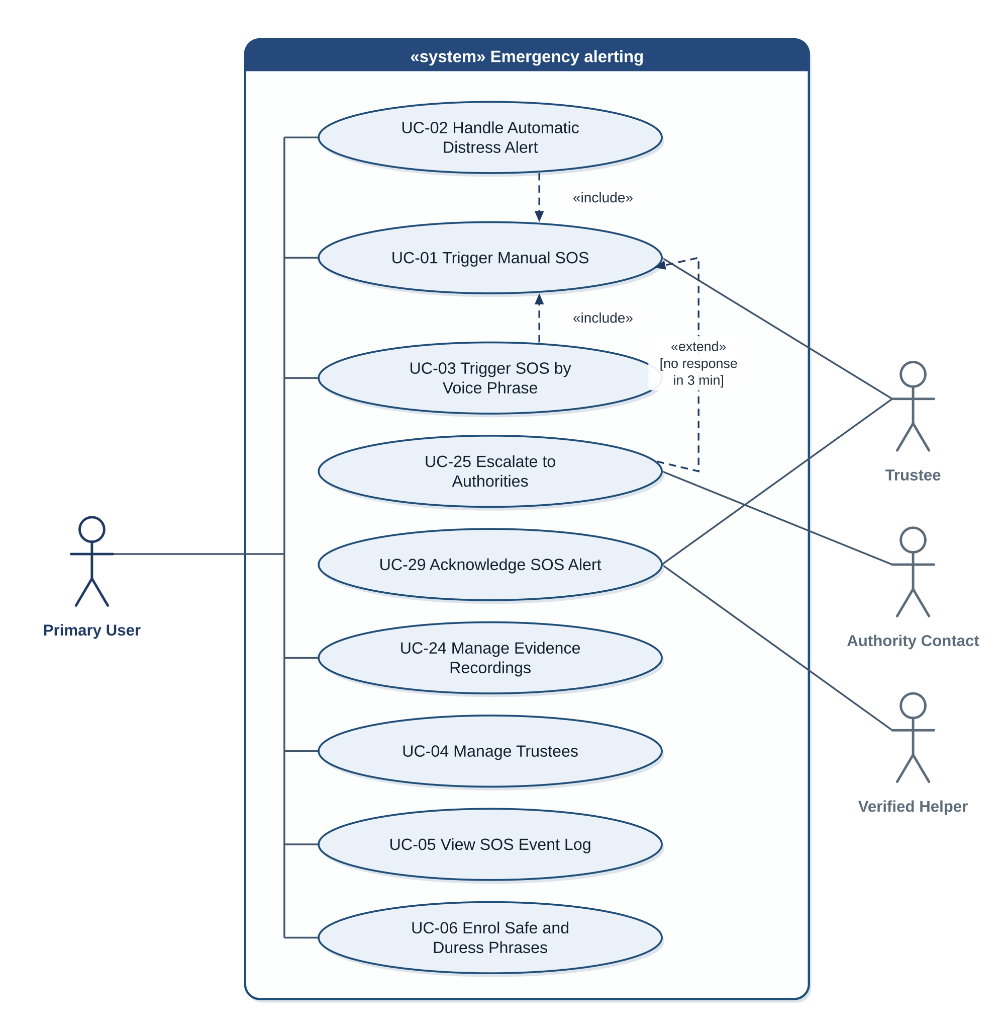
Figure 2: Use-case diagram: emergency alerting
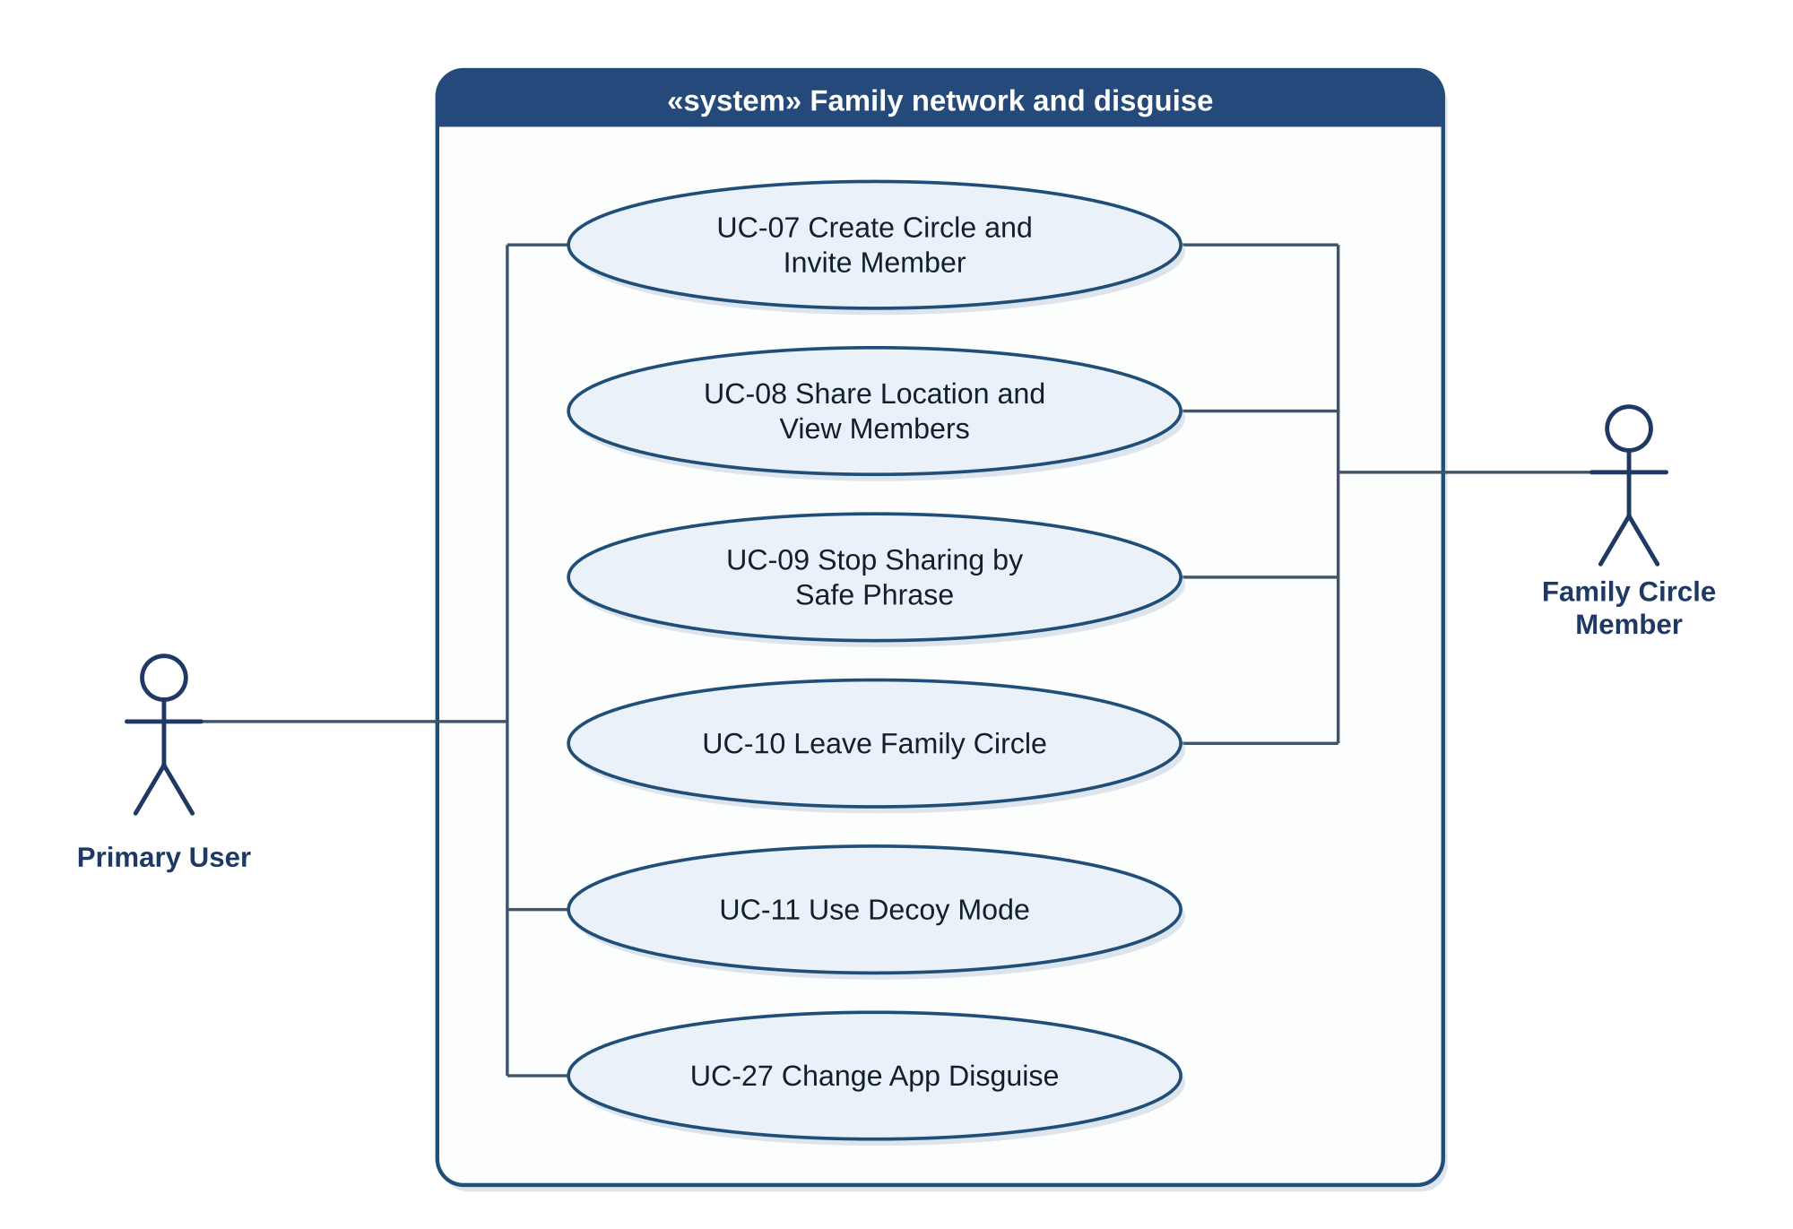
Figure 3: Use-case diagram: family network and disguise
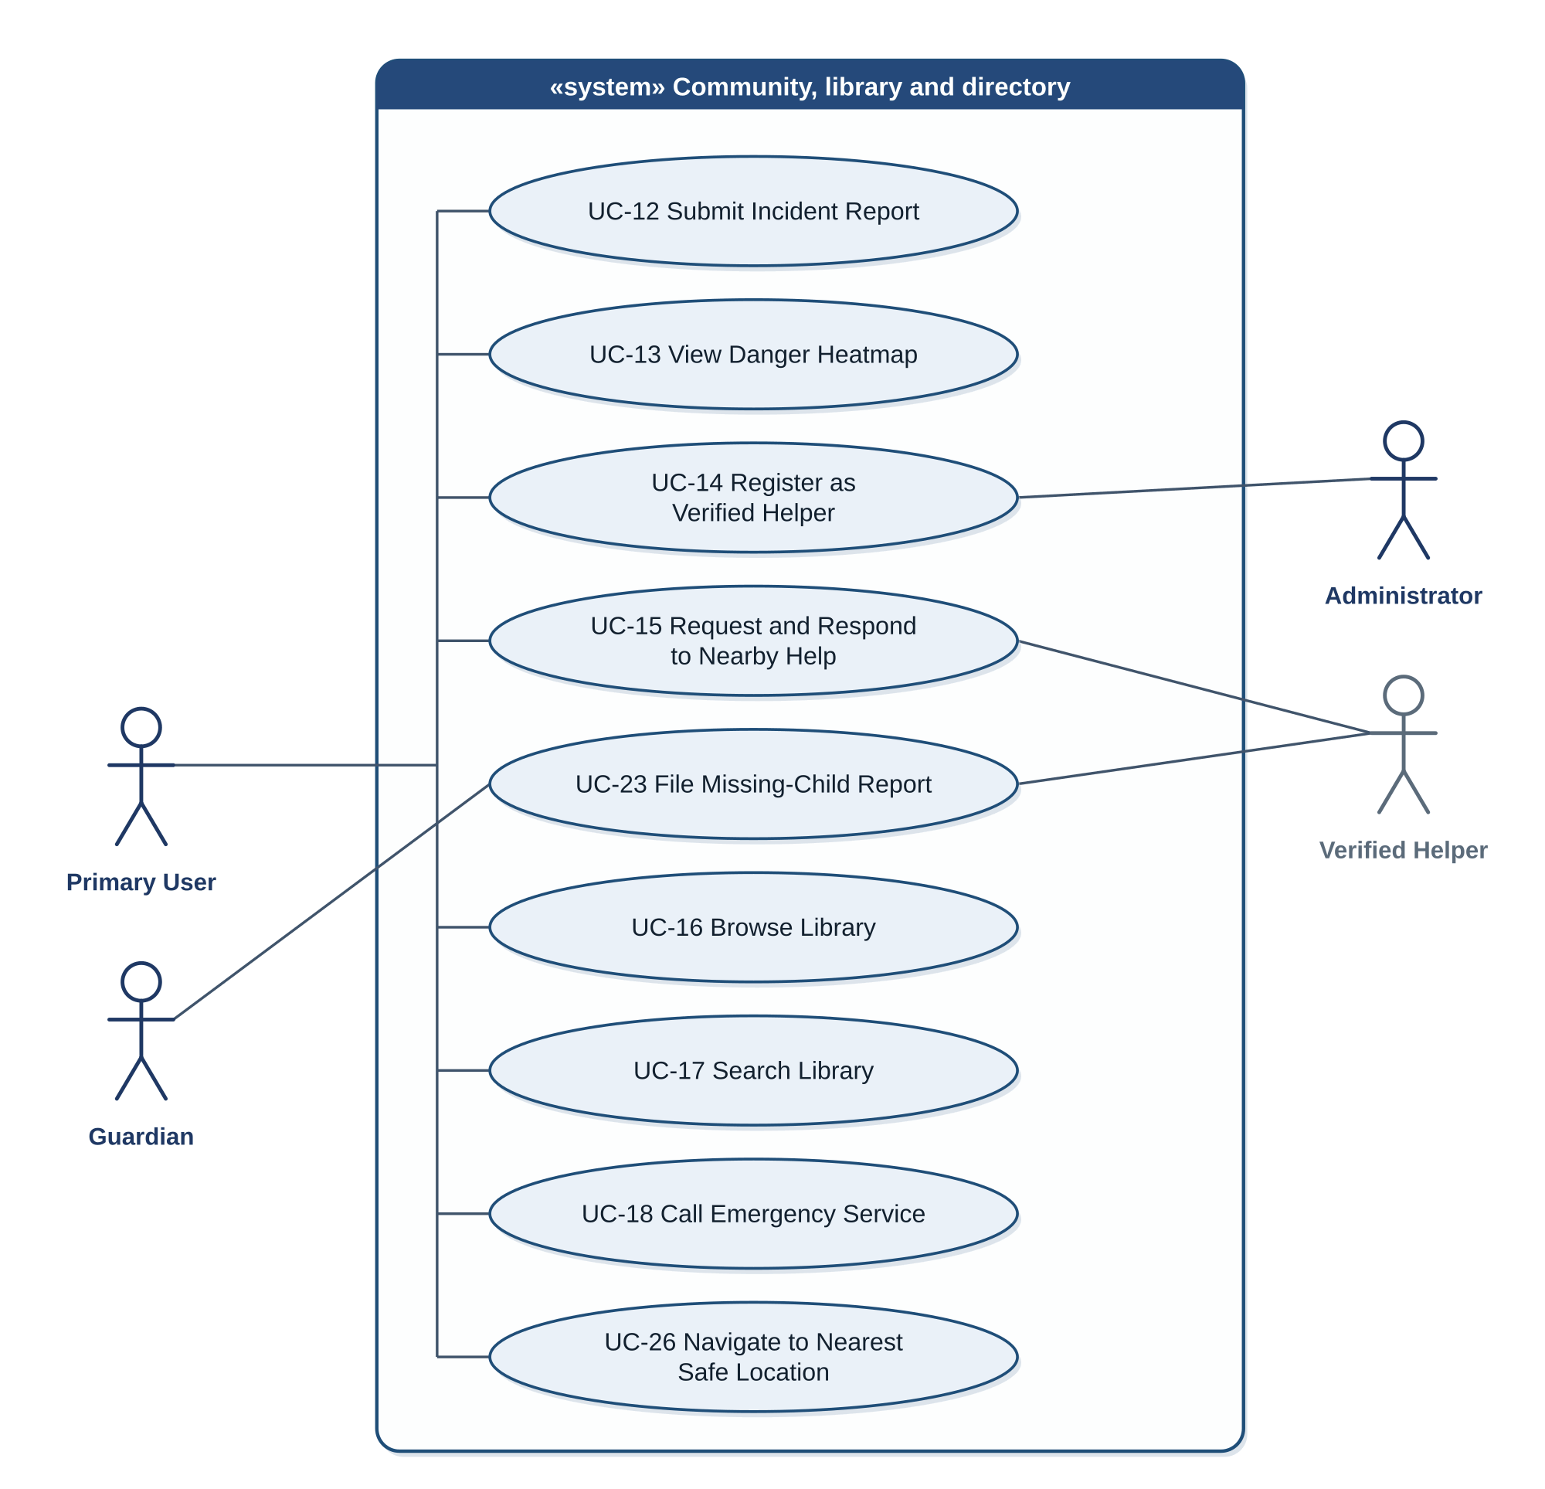
Figure 4: Use-case diagram: community, library and directory
Figure 5: Use-case diagram: account, consent and administration
Table 99: Use case list
Use Case ID | Use Case Name | Actors | Module | Related FRs | Business Rules
UC-01 | Trigger Manual SOS | Primary User; Trustee; Verified Helper | MOD-01 | FR-01.01 to FR-01.04, FR-12.02 | BR-01 to BR-06
UC-02 | Handle Automatic Distress Alert | Primary User | MOD-02 | FR-02.01 to FR-02.05 | BR-02, BR-07, BR-08
UC-03 | Trigger SOS by Voice Phrase | Primary User | MOD-03 | FR-03.03, FR-03.04 | BR-01 to BR-03
UC-04 | Manage Trustees | Primary User | MOD-01 | FR-01.05 | BR-04
UC-05 | View SOS Event Log | Primary User | MOD-01 | FR-01.06 | BR-05
UC-06 | Enrol Safe and Duress Phrases | Primary User | MOD-03 | FR-03.01, FR-03.02 | BR-07, BR-09
UC-07 | Create Circle and Invite Member | Primary User; Family Circle Member | MOD-04 | FR-04.01, FR-04.02 | BR-10
UC-08 | Share Location and View Members | Family Circle Member | MOD-05 | FR-05.01, FR-05.04, FR-05.05 | BR-12, BR-13
UC-09 | Stop Sharing by Safe Phrase | Family Circle Member | MOD-05 | FR-05.02, FR-05.03, FR-03.05 | BR-11
UC-10 | Leave Family Circle | Family Circle Member | MOD-04 | FR-04.03 | BR-14
UC-11 | Use Decoy Mode | Primary User | MOD-06 | FR-06.01 to FR-06.03 | BR-28
UC-12 | Submit Incident Report | Primary User | MOD-07 | FR-07.01, FR-07.05 | BR-15, BR-17
UC-13 | View Danger Heatmap | Primary User | MOD-07 | FR-07.02 to FR-07.04 | BR-16, BR-17
UC-14 | Register as Verified Helper | Primary User; Administrator | MOD-08 | FR-08.01, FR-16.03 | BR-18
UC-15 | Request and Respond to Nearby Help | Primary User; Verified Helper | MOD-08 | FR-08.02 to FR-08.04 | BR-19
UC-16 | Browse Library | Primary User | MOD-09 | FR-09.01 to FR-09.03 | BR-20
UC-17 | Search Library | Primary User | MOD-10 | FR-10.01 to FR-10.05 | BR-20
UC-18 | Call Emergency Service | Primary User | MOD-11 | FR-11.01 to FR-11.03 | BR-21
UC-19 | Sign Up and Log In | Primary User | MOD-14 | FR-14.01 to FR-14.03 | BR-22
UC-20 | Manage Consent and Privacy Settings | Primary User | MOD-15 | FR-15.01 to FR-15.03 | BR-09
UC-21 | Moderate Reports and Review Helpers | Administrator | MOD-16 | FR-16.01 to FR-16.03, FR-16.05 | BR-31
UC-22 | Monitor System Health | Administrator | MOD-16 | FR-16.04, FR-16.05 | BR-31
UC-23 | File Missing-Child Report | Guardian; Verified Helper; Trustee; Administrator | MOD-17 | FR-17.01 to FR-17.06 | BR-25 to BR-27
UC-24 | Manage Evidence Recordings | Primary User | MOD-18 | FR-18.01 to FR-18.05 | BR-23
UC-25 | Escalate to Authorities | Primary User; Authority Contact | MOD-19 | FR-19.01 to FR-19.06 | BR-24
UC-26 | Navigate to Nearest Safe Location | Primary User | MOD-20 | FR-20.01 to FR-20.03 | BR-30
UC-27 | Change App Disguise | Primary User | MOD-21 | FR-21.01 to FR-21.03 | BR-29
UC-28 | Recover Account | Primary User | MOD-14 | FR-14.04 | BR-22
UC-29 | Acknowledge SOS Alert | Trustee; Verified Helper | MOD-19 | FR-19.01, FR-08.03 | BR-24

Table 100: Use case specification UC-01: Trigger Manual SOS
Field | Description
Use Case ID | UC-01
Use Case Name | Trigger Manual SOS
Actors | Primary User; Trustee; Verified Helper
Description | The Primary User starts an SOS by hand. The system dispatches the alert to the trustees and, when enabled, to nearby helpers, sounds or withholds the alarm, and records evidence.
Trigger | The user holds the SOS control on the home screen for 1 second, or taps the SOS action on the lock screen.
Preconditions | The user has signed in on the device at least once; at least one trustee exists; the SMS permission is granted.
Postconditions | Success: an SOS event exists in the log; alerts are sent or queued; the siren plays (loud) or nothing is shown (silent); an evidence recording and the 3-minute timer have started. Failure: if the SMS permission is missing, alerts go on the remaining channels and a prompt is shown in loud mode.
Normal Flow | 1. The user holds the SOS control for 1 second (or taps the lock-screen action).  2. The system starts the SOS pipeline and records the trigger as "manual".  3. The system obtains the location: a fresh fix, or the cached location after 10 seconds.  4. The system starts the evidence recording and the no-response timer.  5. In loud mode the system plays the siren; in silent mode it shows and plays nothing.  6. The system sends SMS, push and email to each trustee on the enabled channels, and starts the nearby-help broadcast if enabled; anything that cannot be sent is queued.  7. In loud mode the system prepares the WhatsApp messages for the user to confirm.  8. The system updates the SOS event log with the delivery status of each channel.
Alternative Flows | A1 (step 1): the user releases before 1 second; nothing starts.  A2 (step 3): no fresh fix; the cached location is used and its age is stated.  A3 (step 6): at Tier 1 only SMS is sent and the other channels are queued.  A4 (step 5): the user stops the siren with the stop control.
Exceptions | E1: the SMS permission is missing; alerts go on the other channels and a permission prompt is shown in loud mode.  E2: the microphone cannot be used; no recording is made and the log notes it.
Business Rules | BR-01, BR-03, BR-04, BR-05, BR-06, BR-23, BR-24
Assumptions | AS-1, AS-2, AS-7

Table 101: Use case specification UC-02: Handle Automatic Distress Alert
Field | Description
Use Case ID | UC-02
Use Case Name | Handle Automatic Distress Alert
Actors | Primary User
Description | The monitoring service detects a possible distress sound, combines it with motion data and gives the user 20 seconds to cancel. If the user does not cancel, an SOS starts.
Trigger | The monitoring service detects a sudden loud sound above the ambient level.
Preconditions | Microphone detection is on with consent and permission; the monitoring service is running.
Postconditions | Success: either nothing was sent (the user cancelled) or an SOS with trigger "automatic" was started. In both cases no audio or sensor data was stored or sent.
Normal Flow | 1. The monitoring service detects a sudden rise in sound level.  2. The system runs the classifier on the buffered sound and obtains a distress score.  3. The system reads the accelerometer and gyroscope for the same window.  4. The fusion rule is satisfied.  5. The system starts the 20-second countdown: mild vibration and a cancel control, with the cancel method chosen in the settings.  6. The user does not cancel.  7. The system starts the SOS with trigger "automatic" (UC-01, steps 3 to 8).
Alternative Flows | A1 (step 2): the score is below the distress threshold; the system discards the buffer and returns to monitoring.  A2 (step 4): the fusion rule is not satisfied; no countdown starts.  A3 (step 6): the user cancels by an enabled method (swipe, spoken safe phrase or typed safe phrase); the vibration stops, nothing is sent and monitoring continues.
Exceptions | E1: the classifier model cannot be loaded; detection is turned off and the user is told.  E2: motion sensors are unavailable; the countdown starts only if the audio score is above the high-confidence threshold.  E3: the service is stopped by the system; it restarts (NFR-REL-03).
Business Rules | BR-02, BR-07, BR-08, BR-09
Assumptions | AS-3, AS-4

Table 102: Use case specification UC-03: Trigger SOS by Voice Phrase
Field | Description
Use Case ID | UC-03
Use Case Name | Trigger SOS by Voice Phrase
Actors | Primary User
Description | The Primary User starts an SOS by speaking the safe phrase (loud or default mode) or the duress phrase (silent).
Trigger | The keyword-spotting engine detects an enrolled phrase.
Preconditions | Voice activation is on with consent and permission; both phrases are enrolled; the engine is running.
Postconditions | Success: an SOS with trigger "voice" was started, or the user cancelled and nothing was sent.
Normal Flow | 1. The user speaks the safe phrase or the duress phrase.  2. The engine detects the phrase and reports which one it was.  3. The system starts the 20-second countdown: with vibration and a cancel control for the safe phrase, and silent and without any indication for the duress phrase.  4. The user does not cancel by any enabled method (swipe, spoken safe phrase or typed safe phrase).  5. The system starts the SOS with trigger "voice": in the default mode for the safe phrase, silent for the duress phrase (UC-01, steps 3 to 8).  6. For the duress phrase the system also shows the decoy screen.
Alternative Flows | A1 (step 2): the stop-sharing confirmation is open and the phrase is the safe phrase; the system treats it as a confirmation (UC-09) and starts no SOS.  A2 (step 4): the user cancels by an enabled method; nothing is sent.  A3 (step 4): the countdown is running and the spoken safe phrase is an enabled cancel method; the system treats the phrase as a cancel (FR-03.05) and starts no SOS.
Exceptions | E1: the engine cannot be loaded; voice activation is turned off, the user is told, and the manual SOS remains available.
Business Rules | BR-01, BR-02, BR-03, BR-07, BR-08
Assumptions | AS-3, AS-5

Table 103: Use case specification UC-09: Stop Sharing by Safe Phrase
Field | Description
Use Case ID | UC-09
Use Case Name | Stop Sharing by Safe Phrase
Actors | Family Circle Member
Description | A Family Circle Member stops sharing their location by speaking the safe phrase and then switching the sharing toggle off. No approval is needed and no other member is notified.
Trigger | The member opens the stop-sharing screen.
Preconditions | The member is in a circle and is sharing; voice activation is on and the safe phrase is enrolled.
Postconditions | Success: the member's sharing is off; other members see only the last published location with its time, labelled "Not live"; no message was sent to others.
Normal Flow | 1. The member opens the stop-sharing screen.  2. The system shows the stop-sharing screen with the sharing toggle locked and listens for the safe phrase in confirmation context.  3. The member speaks the safe phrase.  4. The system recognises it and unlocks the toggle.  5. The member switches the toggle off.  6. The system disables sharing and stops publishing location.  7. The system shows a private confirmation on the member's device only.
Alternative Flows | A1 (step 3): no phrase within 15 seconds; the toggle stays locked, the screen closes and sharing continues.  A2: the member chooses to leave the circle instead (UC-10).
Exceptions | E1: the voice engine is unavailable; the screen explains that the phrase cannot be confirmed and offers UC-10.  E2: there is no connection; publishing stops on the device at once and the status is synchronised when a connection returns.
Business Rules | BR-11, BR-12, BR-13
Assumptions | AS-5

Table 104: Use case specification UC-25: Escalate to Authorities
Field | Description
Use Case ID | UC-25
Use Case Name | Escalate to Authorities
Actors | Primary User; Authority Contact
Description | When nobody acknowledges an SOS in time, the system warns the user and then sends an escalation message to the configured authority numbers.
Trigger | The 3-minute no-response timer expires with no acknowledgement.
Preconditions | An SOS is active; at least one authority number is configured.
Postconditions | Success: the escalation message was sent or queued and the log has an entry. Cancelled: no message was sent and the log shows "cancelled".
Normal Flow | 1. The timer expires with no acknowledgement.  2. The system starts the 30-second warning with a one-tap cancel (vibration only in silent mode).  3. The user does not cancel.  4. The system composes the escalation message with name, callback number, location, time, trigger type and the evidence flag.  5. The system sends the message to each configured number by its channel (SMS by default).  6. The system records the escalation in the log.
Alternative Flows | A1 (before step 1): an acknowledgement arrives; the timer stops and no escalation occurs.  A2 (step 3): the user cancels; no escalation is sent.  A3 (step 5): the channel of a number is "call"; the system places the call.
Exceptions | E1: SMS cannot be sent; the message is queued and retried (BR-05).  E2: a configured number is invalid; the log records a failure for that number.
Business Rules | BR-05, BR-24, BR-32
Assumptions | AS-6, DEP-6

Table 105: Use case specification UC-23: File Missing-Child Report
Field | Description
Use Case ID | UC-23
Use Case Name | File Missing-Child Report
Actors | Guardian; Verified Helper; Trustee; Administrator
Description | A Guardian reports a missing child; the system alerts trusted contacts and nearby verified helpers and queues the report for moderation.
Trigger | The Guardian opens the missing-child report form.
Preconditions | The Guardian is signed in and has a data connection or accepts that the report will be queued.
Postconditions | Success: an active report exists; alerts were sent; the report is in the moderation queue.
Normal Flow | 1. The Guardian opens the form.  2. The Guardian enters the child's name, age, photo, description, last-seen place and time, and the contact number.  3. The Guardian confirms being the child's guardian.  4. The Guardian submits.  5. The system validates the data.  6. The system stores the report as "active".  7. The system alerts the guardian's trustees and the Verified Helpers within 5 km.  8. The system places the report in the moderation queue.
Alternative Flows | A1 (step 5): validation fails; the system shows the errors and keeps the data.  A2: the Guardian marks the child as found; the system stops alerts and deletes the photo.  A3: 72 hours pass without renewal; the status becomes "expired" and the photo is deleted.
Exceptions | E1: no connection; the report is queued and sent when a connection returns.  E2: an administrator removes the report as false; it disappears from all lists.
Business Rules | BR-25, BR-26, BR-27, BR-32
Assumptions | AS-8

Business Rules
The business rules in Table 106 are the policies, limits and constraints that govern the behaviour of the functional requirements. A functional requirement or use case refers to a rule by its identifier.
Table 106: Business rules
BR ID | Business Rule | Source or Rationale | Related FR or UC | Priority
BR-01 | Every SOS trigger (manual, automatic, voice) enters one dispatch pipeline. The trigger method is recorded and does not change the channels used. | Novel contribution: one shared trigger engine. | FR-01.01, FR-02.04, FR-03.04, FR-03.05; UC-01, UC-03 | High
BR-02 | Manual SOS has no countdown. Automatic, voice and duress-phrase triggers start a 20-second countdown that the user cancels by the method chosen in the settings (swiping the cancel control, speaking the safe phrase or typing the safe phrase); if it is cancelled nothing is sent. | Protects against false alarms without delaying a deliberate SOS. | FR-01.01, FR-02.03, FR-02.04, FR-03.04, FR-03.05; UC-01, UC-02, UC-03 | High
BR-03 | A silent SOS (silent default mode or duress phrase) produces no sound, vibration, visible alert or revealing notification, and dispatch continues; its 20-second countdown is silent in the same way, with no vibration and no on-screen indication. A loud SOS plays the siren until the user stops it. | Supports hiding while calling for help. | FR-01.03, FR-01.04, FR-02.04, FR-03.02, FR-03.04; UC-01, UC-03 | High
BR-04 | An alert is sent to each trustee on every channel that trustee has enabled; if none is enabled, SMS is used. SMS, push and email are automatic. WhatsApp requires the user to confirm the prepared message and is not used in a silent SOS. | WhatsApp cannot send a message without user interaction. | FR-01.02, FR-01.05; UC-01, UC-04 | High
BR-05 | At Tier 1 only SMS is used. At Tiers 2 and 3 all enabled channels are used. A message that cannot be delivered is queued and retried until delivered, and every attempt is logged. | Offline-first delivery. | FR-01.02, FR-01.06, FR-08.04, FR-12.01, FR-12.02, FR-12.03, FR-13.02; UC-01, UC-05, UC-25 | High
BR-06 | The SOS location is a fresh fix if one is obtained within 10 seconds; otherwise the last-known cached location is used and its age is stated in the message. | An older location is better than none. | FR-01.02, FR-12.02, FR-13.01; UC-01 | High
BR-07 | No audio, transcript or classifier output of the detection or voice engines leaves the device. | Privacy guarantee given to users. | FR-02.01, FR-02.02, FR-02.05, FR-03.01, FR-03.02, FR-03.03, FR-15.03; UC-02, UC-03, UC-06 | High
BR-08 | The detection and voice engines store no audio. The only stored audio is the evidence recording of BR-23. | Privacy guarantee given to users. | FR-02.01, FR-02.02, FR-02.05, FR-03.03; UC-02, UC-03 | High
BR-09 | Microphone detection, voice activation and location sharing are off until the user has given consent. Each has its own toggle, which takes effect immediately. The microphone and voice toggles can be changed at any time; location sharing can be switched on at any time and is switched off on the stop-sharing screen after the safe phrase (BR-11). | Informed consent. | FR-02.01, FR-03.01, FR-03.03, FR-15.01, FR-15.02, FR-18.05; UC-02, UC-06, UC-20 | High
BR-10 | Sharing between two people starts only after both have accepted. An invitation expires after 7 days. | Bilateral opt-in. | FR-04.01; UC-07 | High
BR-11 | A member can stop sharing at any time without anyone's approval, by speaking the safe phrase on the stop-sharing screen, which unlocks the sharing toggle, and then switching the toggle off. No other member receives any message about it. | Unilateral opt-out without confrontation. | FR-03.05, FR-05.02, FR-05.03; UC-09 | High
BR-12 | After a member stops sharing, others see only the last published location with its time, labelled "Not live". | A stale location cannot be mistaken for live tracking. | FR-05.04; UC-08, UC-09 | High
BR-13 | No hidden tracking: every member can see who is sharing, a sharing member sees a persistent indicator, and only a member can resume their own sharing. | Prevents covert surveillance. | FR-04.02, FR-05.01, FR-05.05; UC-08, UC-09 | High
BR-14 | Leaving a circle and stopping sharing are separate actions. Leaving removes the membership and deletes the member's stored location from the circle. | Separates ending membership from pausing. | FR-04.03; UC-10 | High
BR-15 | A user may submit at most 5 incident reports in 24 hours and no second report within 100 m and one hour. More than 10 reports in one cell within one hour go to moderation. | Prevents spam and malicious flagging. | FR-07.01, FR-07.05, FR-16.02; UC-12 | Medium
BR-16 | A report is weighted by 0.5 to the power of (age / 90 days). A cell score is the sum of the weights. | Shows current risk. | FR-07.03, FR-07.04; UC-13 | Medium
BR-17 | Reports are grouped by geohash cells of precision 7. A cell shows only category counts and never the identity of a reporter. | Anonymity of reporters. | FR-07.01, FR-07.02, FR-07.04; UC-12, UC-13 | Medium
BR-18 | A user becomes a Verified Helper only after the user has requested verification and uploaded the required documents and an administrator has reviewed them manually and approved the request; no document is verified automatically. An administrator can revoke it. The identity image is deleted after the decision. | Reduces misuse of the helper network. | FR-08.01, FR-16.03; UC-14 | Medium
BR-19 | A help request goes to Verified Helpers within the set radius (default 1 km). The exact location of the requester is shown only to a helper who accepts. | Limits exposure of the requester's location. | FR-08.02, FR-08.03; UC-15 | Medium
BR-20 | Library content is bundled and its search runs on the device. Search falls back to keyword search when the model is unavailable or the highest similarity is below 0.30. | Offline use and privacy of queries. | FR-09.01, FR-09.02, FR-09.03, FR-10.01, FR-10.02, FR-10.03, FR-10.04, FR-10.05, FR-13.02; UC-16, UC-17 | Medium
BR-21 | Directory entries with coordinates are ordered by distance when a location is available; otherwise by category and name. | The nearest help is the most useful. | FR-11.01, FR-11.02, FR-11.03; UC-18 | Medium
BR-22 | One account exists per phone number and is verified by a one-time code. Logging in on a new device with the same number ends sessions on other devices. | Simple identity and lost-device recovery. | FR-14.01, FR-14.02, FR-14.03, FR-14.04; UC-19, UC-28 | High
BR-23 | An evidence recording starts on every SOS, is encrypted, is stored only on the device, is never uploaded, and is deleted after the retention period (default 30 days; 7, 30 or 90 selectable). | Evidence stays with the user. | FR-14.04, FR-18.01, FR-18.02, FR-18.03, FR-18.04, FR-18.05; UC-01, UC-24 | Medium
BR-24 | If no acknowledgement arrives within 3 minutes of dispatch, a 30-second warning with cancel starts; if it is not cancelled the escalation message goes to the configured authority numbers. Any acknowledgement or a cancel stops the escalation. | Follow-through with a safeguard against false escalation. | FR-19.01, FR-19.02, FR-19.03, FR-19.04, FR-19.05, FR-19.06; UC-01, UC-25, UC-29 | Medium
BR-25 | A missing-child report is active, found or expired. It expires 72 hours after creation or renewal unless the guardian renews it. | Reports must not remain active indefinitely. | FR-17.01, FR-17.03; UC-23 | Medium
BR-26 | A child's photo is visible only to the guardian, the alerted trustees and the notified helpers while the report is active, and is deleted when the report is found or expired. | Child-data privacy. | FR-17.01, FR-17.02, FR-17.03, FR-17.06; UC-23 | Medium
BR-27 | A user may file at most 3 missing-child reports in 24 hours. Alerts for a report are sent at once, and an administrator reviews every report afterwards. A report removed as false is deleted from all lists, its further alerts stop and its author may be suspended. The application makes no direct connection to official systems. | Abuse prevention and clear boundary with official channels. | FR-16.02, FR-17.01, FR-17.04, FR-17.05; UC-23 | Medium
BR-28 | In Decoy Mode the application shows a neutral calculator; SOS, voice triggers, location updates and evidence recording continue underneath. A 2-second hold on the equals key returns to the real interface. | Protects the user when forced to unlock the phone. | FR-03.05, FR-06.01, FR-06.02, FR-06.03; UC-11 | High
BR-29 | The disguise offers three predefined neutral appearances and does not change functions, data or settings. | Disguise must not disable safety. | FR-21.01, FR-21.02, FR-21.03; UC-27 | Low
BR-30 | The nearest safe location is the nearest hospital or police station of the bundled directory by straight-line distance; directions are turn-by-turn when online and distance and direction when offline. | Works from stored data. | FR-20.01, FR-20.02, FR-20.03; UC-26 | Low
BR-31 | Only accounts with the administrator role can use the admin website. Every moderation or review decision is logged with the administrator and the time. | Accountability. | FR-16.01, FR-16.02, FR-16.03, FR-16.04, FR-16.05, FR-17.05; UC-21, UC-22 | Medium
BR-32 | A user's location is shared only with trustees (SOS), circle members (while sharing), helpers who have accepted, and authority numbers (escalation). | Data minimisation. | FR-01.02, FR-08.02, FR-15.03, FR-17.02, FR-19.05; UC-23, UC-25 | High

Non-Functional Requirements
The non-functional requirements are specific, quantitative and verifiable. Each has a measurable target and a verification method, and each target is a requirement that Chapter 6 verifies on the reference device and under the stated conditions. They are grouped by quality: reliability, performance, security, privacy, usability, and maintainability with other qualities (compatibility, availability, scalability, safety and robustness).
Table 107: Non-functional requirements: Reliability
ID | Requirement | Measurement or Target | Verification Method
NFR-REL-01 | The SOS by SMS shall be handed to the device SMS service for every trustee without a data connection. | At least 95% of 20 trials at Tier 1 hand the SMS to the SMS service within 5 seconds of the trigger. | Instrumented device test with data disabled.
NFR-REL-02 | Queued messages shall survive application termination and device restart. | 100% of queued messages remain after 10 forced stops and 5 restarts. | Test with forced stops and restarts.
NFR-REL-03 | The monitoring and voice services shall restart after being stopped by the system or after a restart. | Restart within 60 seconds in 9 of 10 trials when permissions and battery exemption are granted. | Device test.
NFR-REL-04 | The failure of one dispatch channel shall not prevent the others. | With each channel disabled in turn, all others still dispatch (100%). | Fault-injection test.
NFR-REL-05 | The application shall run without a crash or an application-not-responding event during continuous background monitoring. | Zero crashes in 8 hours on each test device. | Soak test.

Table 108: Non-functional requirements: Performance
ID | Requirement | Measurement or Target | Verification Method
NFR-PER-01 | The SOS dispatch shall start promptly after a manual trigger. | At least 95% of 20 trials start the first channel within 2 seconds of the completed hold. | Timed device test.
NFR-PER-02 | Distress classification shall complete promptly after a loud sound. | Result within 1.5 seconds of the end of the sound burst in 95% of trials. | Timed test with labelled clips.
NFR-PER-03 | The voice engine shall detect an enrolled phrase promptly. | Detection within 2 seconds of the end of the phrase in 90% of trials. | Timed test.
NFR-PER-04 | A change in sharing status shall reach other members' devices. | Within 5 seconds in 95% of trials at Tier 3. | Two-device timed test.
NFR-PER-05 | Semantic search shall return results quickly on the device. | Within 1 second for a library of up to 500 items on the reference device. | Timed test.
NFR-PER-06 | The heatmap shall load for the visible area. | Within 5 seconds at Tier 2 or 3; within 2 seconds from the cache offline. | Timed test.
NFR-PER-07 | The application shall start quickly. | Cold start to the home screen within 3 seconds on the reference device. | Timed test.
NFR-PER-08 | Evidence recording shall start promptly. | Within 1 second of the SOS start in 95% of trials. | Timed test.
NFR-PER-09 | The outbound queue shall flush promptly when the connection returns. | Within 30 seconds of Tier 2 or 3 being reached. | Timed test.
NFR-PER-10 | Continuous detection and voice monitoring shall have a bounded battery cost. | No more than 5% of battery capacity per hour with the screen off on the reference device. | Battery measurement over 3 hours.

Table 109: Non-functional requirements: Security
ID | Requirement | Measurement or Target | Verification Method
NFR-SEC-01 | All data sent between the application, the admin website and the backend shall be encrypted in transit. | TLS 1.2 or later for 100% of connections. | Network inspection.
NFR-SEC-02 | Evidence recordings shall be encrypted at rest and unreadable by other applications. | AES-256-GCM with a Keystore key; a file read by another application fails. | File and permission inspection.
NFR-SEC-03 | The backend shall enforce access rules so that users read only data they are entitled to under BR-10 to BR-14 and BR-32. | 100% of unauthorized read attempts in the rule tests are denied. | Security-rule unit tests.
NFR-SEC-04 | Only administrators shall access the admin website, and their actions shall be logged. | Non-administrator accounts are denied on all admin pages; every decision is logged. | Access test and log inspection.
NFR-SEC-05 | No audio payload shall be sent from the detection or voice engines. | Zero audio payloads in a network capture of 1 hour of monitoring including 10 detections. | Network capture.
NFR-SEC-06 | Identity images and child photos shall be readable only by those entitled to read them and shall be deleted after use. | Unauthorized reads are denied; deletion occurs at the decision or status change. | Storage-rule tests.
NFR-SEC-07 | The admin website shall show phone numbers masked. | All displayed numbers show only the last 3 digits. | Visual inspection.

Table 110: Non-functional requirements: Privacy
ID | Requirement | Measurement or Target | Verification Method
NFR-PRV-01 | No microphone function shall run before consent and permission. | Zero microphone access before consent in 10 fresh installations. | Permission and log inspection.
NFR-PRV-02 | Heatmap reports older than 12 months shall be removed from the backend. | No report older than 12 months remains after the scheduled clean-up. | Data inspection after clean-up.
NFR-PRV-03 | The privacy summary shall match actual data handling. | Every item of the summary is verified against the stored data in a review. | Review checklist.

Table 111: Non-functional requirements: Usability
ID | Requirement | Measurement or Target | Verification Method
NFR-USA-01 | The SOS shall be quick to reach. | One press-and-hold from the home screen; one tap from the lock screen. | Inspection.
NFR-USA-02 | New users shall complete onboarding easily. | At least 80% of test participants finish sign-up, one trustee and consent in under 5 minutes. | Usability test with at least 5 participants.
NFR-USA-03 | Touch targets shall be large. | At least 48 dp, and the SOS control at least 72 dp. | Layout inspection.
NFR-USA-04 | Text shall be readable. | Contrast ratio at least 4.5:1; layouts remain usable at 130% font scale. | Contrast tool and test at 130% scale.
NFR-USA-05 | Cancel actions shall need one tap. | The 20-second countdown and the 30-second escalation warning can each be cancelled with one tap. | Inspection and test.
NFR-USA-06 | Error messages shall state the problem and the next step. | At most two sentences each; every error path in the test plan shows one. | Inspection.

Table 112: Non-functional requirements: Maintainability, Portability and Other Qualities
ID | Requirement | Measurement or Target | Verification Method
NFR-MNT-01 | The application shall be organised in modules that correspond to MOD-01 to MOD-21 with defined interfaces. | Each module in its own package; business-logic unit-test coverage at least 70%. | Code structure review and coverage report.
NFR-MNT-02 | Thresholds, timers and limits shall be set in one configuration file. | All values of BR-02, BR-06, BR-15, BR-19 and BR-24 changed without code changes. | Configuration test.
NFR-MNT-03 | Every module shall have a short description of its public interface. | One description per module in the repository. | Documentation review.
NFR-CMP-01 | The application shall run on Android 8.0 and later. | Smoke test passed on at least 3 device models from different manufacturers. | Device test.
NFR-AVL-01 | The SOS by SMS shall not depend on the backend. | Zero backend calls on the SMS path. | Code and network inspection.
NFR-SCL-01 | The backend shall support the pilot scale within free-tier limits. | Up to 500 registered users and 100 concurrent users within quotas. | Quota calculation and load test.
NFR-SAF-01 | No automatic or voice SOS shall be dispatched without the 20-second cancel period. | 100% of automatic and voice SOS events in the test log show the countdown. | Log inspection.
NFR-SAF-02 | Distress detection shall meet a target accuracy on the project test set. | Precision and recall each at least 0.80 on a labelled clip set of at least 100 clips. | Evaluation script.
NFR-ROB-01 | A missing or corrupt model file shall disable only the affected feature. | SOS still works with each model file removed in turn. | Fault-injection test.
NFR-ROB-02 | Invalid input shall not crash the application. | No crash in 100 malformed-input cases. | Input test.
NFR-ROB-03 | Low storage shall not stop an SOS. | With storage full the SOS dispatches and the recording stops with a log entry. | Test with full storage.

External Interface Requirements
This section specifies how Muhaffiz communicates with its users and with external software, hardware and communication services. Table 113 summarizes the interfaces.

User Interface Requirements
- UI-1: The application shall follow Material Design 3 as provided by Flutter, with one colour scheme of dark teal, navy and mint used on all screens.
- UI-2: The application shall use the system sans-serif font at 14 sp or larger for body text, the Material icon set, and verb labels on buttons.
- UI-3: The application shall be designed for portrait orientation on phone screens from 320 dp wide. The home screen shall show the SOS control, the loud or silent toggle and a status strip with the connectivity tier and the state of detection and voice activation.
- UI-4: The application shall provide bottom navigation with Home, Family, Map, Library and More. Help, settings and the privacy summary shall be reachable from More.
- UI-5: Every control shall have a content description, and the focus order shall follow the reading order, so that a screen reader can be used.
- UI-6: Success messages shall appear as brief messages, errors shall appear next to the field with the next step, and notifications shall use separate Android channels for status, alerts and reminders. In a silent SOS the notification wording shall be neutral.
- UI-7: The interface language shall be English, and dates and times shall follow the device locale.
- UI-8: Information shall not be conveyed by colour alone; the heatmap shall have a legend with numeric ranges.
- UI-9: The screen designs in Section 4.5 are the committed designs of the key screens; other screens follow the same components.
- UI-10: The admin website shall be usable on screens 1024 px wide or wider and shall present lists as filterable tables.

Software Interfaces
- SI-1: The application and the admin website shall use Firebase Authentication for phone sign-in of users and email-and-password sign-in of administrators.
- SI-2: The application shall use Cloud Firestore with offline persistence for circles, locations, reports, helper status and acknowledgements.
- SI-3: The system shall use Firebase Cloud Messaging to deliver push notifications to trustees and helpers.
- SI-4: The system shall use Cloud Storage for identity images and child photos, protected by storage rules.
- SI-5: The system shall use Cloud Functions, called over HTTPS, for email dispatch, the acknowledgement endpoint, heatmap aggregation and scheduled expiry.
- SI-6: The application shall use the Google Maps SDK for Android for online maps.
- SI-7: The application shall load offline map data for up to three areas from an open map-data source that permits offline storage.
- SI-8: The application shall send SMS through the Android SMS manager, called through a platform channel.
- SI-9: The application shall prepare WhatsApp messages with the WhatsApp share link through an Android intent.
- SI-10: The application shall use the Android Keystore for the evidence encryption key.
- SI-11: The application shall run its sound-classification, keyword-spotting and sentence-embedding models with TensorFlow Lite or an equivalent on-device runtime.
- SI-12: The application shall use Android WorkManager to retry the outbound queue.
- SI-13: The application shall use SQLite as its on-device database.
- SI-14: The backend shall call an email delivery service from Cloud Functions.

Hardware Interfaces
- HI-1: The application shall read the microphone as 16 kHz mono audio for detection, voice activation and evidence recording. If the microphone is in use by another application, the affected function shall pause and resume when it is free.
- HI-2: The application shall read the accelerometer and gyroscope at 50 Hz or faster during a detection window.
- HI-3: The application shall obtain location from the fused location provider (GPS and network).
- HI-4: The application shall drive the vibration motor for the 20-second countdown and the 30-second warning.
- HI-5: The application shall play the siren through the alarm audio stream of the speaker.
- HI-6: The application shall use the telephony hardware to send SMS and place calls.
- HI-7: The application shall read the magnetometer, when present, to show compass direction offline.
- HI-8: The application shall read photos chosen by the user from the camera or gallery for the helper identity image and the child photo.

Communications Interfaces
- CI-1: SOS and escalation messages shall be sent as SMS over the cellular network, in as many message parts as the text needs.
- CI-2: Push notifications shall be delivered through Firebase Cloud Messaging.
- CI-3: Email alerts shall be sent from Cloud Functions through the email service.
- CI-4: WhatsApp messages shall be prepared as a share link for the WhatsApp application.
- CI-5: All data between the application, the admin website and the backend shall use HTTPS with TLS 1.2 or later; real-time updates shall use the Firestore real-time channel.
- CI-6: Calls shall be placed through the Android dialer.
- CI-7: A trustee without the application shall be able to acknowledge an alert through a web page served by Firebase Hosting and linked from the message.
Table 113: Summary of external interfaces
Interface ID | Interface Type | External Element | Data or Interaction | Protocol or Standard | Error Handling
SI-1 | Software | Firebase Authentication | One-time code sign-in; administrator sign-in | HTTPS / Firebase SDK | Wrong code rejected; lock after five attempts; offline use of safety functions continues.
SI-2 | Software | Cloud Firestore | Circles, locations, reports, helper status, acknowledgements | Firestore SDK (real-time) | Local cache used offline; writes retried on reconnection.
SI-3 | Software | Firebase Cloud Messaging | Push alerts and help requests | FCM over HTTPS | Failure logged; other channels continue.
SI-4 | Software | Cloud Storage | Identity images, child photos | HTTPS / Storage SDK | Upload retried; deletion confirmed.
SI-5 | Software | Cloud Functions | Email dispatch, acknowledgement, scheduled jobs | HTTPS callable | Errors logged and visible in health monitoring.
SI-6 | Software | Google Maps SDK | Map display, overlays | Maps SDK for Android | Offline: last data or offline map shown.
SI-8 | Software | Android SMS manager | SOS and escalation SMS | Android API | Missing permission prompts; failure queued and retried.
SI-9 | Software | WhatsApp | Prepared message | Share link / intent | Application missing: channel skipped.
HI-1 | Hardware | Microphone | Audio frames for detection, voice, evidence | 16 kHz mono PCM | In use elsewhere: pause and resume.
HI-2 | Hardware | Accelerometer, gyroscope | Motion window | 50 Hz or faster | Sensor missing: audio-only rule applies.
HI-3 | Hardware | Location provider | Position fixes | Fused location | No fix: cached location used.
HI-6 | Hardware | Telephony | SMS and calls | GSM SMS, voice | No signal: queued and retried.
CI-3 | Communication | Email service | Email alerts | HTTPS API | Failure logged; other channels continue.
CI-7 | Communication | Acknowledgement page | Trustee acknowledgement | HTTPS (Firebase Hosting) | Link opened offline: acknowledgement not recorded.

Chapter Summary
This chapter specified Muhaffiz through 87 functional requirements, 29 use cases, 32 business rules, 42 non-functional requirements and the external interface requirements. Each functional requirement has a source, rationale, business rule, dependencies, priority and acceptance criteria. Chapter 4 now translates these requirements into the design of the system.

System Design
Chapter Overview. This chapter translates the requirements of Chapter 3 into a design. Section 4.1 gives the design methodology and process model, Section 4.2 the architecture, Section 4.3 the design models, Section 4.4 the data design, Section 4.5 the human interface design, Section 4.6 the security, error-handling and logging design, and Section 4.7 the risk analysis and the milestone plan.

Design Methodology and Software Process Model
Muhaffiz is designed with an object-oriented method. The domain is expressed as classes with clear responsibilities (Section 4.3), behaviour is described with use cases, sequence, activity and state models, and the structure follows a layered architecture in which a small event-driven core handles triggers. This follows the practice described for software design descriptions [3] and for object-oriented systems [4]. Object orientation suits the product because its central problem, that many different triggers must lead to one consistent behaviour, maps directly to a shared set of classes (TriggerEngine, SosOrchestrator and DeliveryManager).
The software process is incremental and iterative, organized in short sprints that group into milestones. Each milestone delivers a working increment that is built on the previous one. The order of milestones is risk-driven: the modules whose feasibility is least certain, namely distress detection, offline voice activation and offline delivery, are built early so that problems are found while there is still time to change the approach. A team of two with a fixed academic schedule benefits from this: scope can be reduced late by dropping low-priority modules (Section 2.5) without disturbing the core. Section 4.7 gives the milestones and the risks.
The design follows five principles that come from the objectives of the project.
- Privacy by design: sensitive audio is processed and discarded on the device; the backend receives only what a feature needs.
- Offline first: the path that gets an alert out never depends on the backend; SMS and the local queue are on that path.
- One trigger pipeline: manual, automatic and voice triggers, the opt-out and the decoy all pass through shared components.
- Fail safe: a failing channel, model or sensor disables only itself, and manual SOS stays available.
- Configuration over code: thresholds, timers and limits are held in one configuration so that they can be tuned during evaluation.

Architectural Design
Architecture style. Muhaffiz combines three styles. The Android application uses a layered architecture (presentation, application, domain and data, and platform layers) so that screens do not depend on platform details. Inside the application, the triggers, the delivery pipeline and the escalation timers are event-driven: detectors publish events and managers react to them. The application and the admin website use a backend-as-a-service architecture, in which Firebase provides authentication, data, messaging, storage and server-side functions. Figure 6 shows the main parts and their connections.
Figure 6: Architecture of Muhaffiz (box-and-line view)
Decomposition. Table 114 maps the modules to the packages of the application and to the backend, and states what each package is responsible for.
Table 114: Decomposition of the system into packages
Package | Responsibility | Modules | Main interface
sos_core | Runs the SOS from start to close; owns the SOS event and its state. | MOD-01 | start(trigger, mode), cancel(), complete()
trigger_engine | Receives manual, automatic and voice triggers and applies the countdown rule. | MOD-01, 02, 03 | onManual(), onAutomatic(), onVoice()
detection_engine | Monitors sound level, classifies bursts, reads motion sensors and applies the fusion rule. | MOD-02 | start(), stop(), events
voice_engine | Offline keyword spotting for the safe and duress phrases; context-aware delivery of detections. | MOD-03 | start(), stop(), setContext(), events
evidence_vault | Records and encrypts audio; lists, exports and deletes recordings. | MOD-18 | startRecording(), list(), export()
escalation | Tracks acknowledgements, runs the timers, composes and sends the escalation message. | MOD-19 | onDispatched(), onAcknowledged()
delivery_manager, sms_gateway, offline_store | Detects the connectivity tier, sends on each channel, queues and retries; holds the local database and cache. | MOD-12, 13 | dispatch(), flush(), cache API
family_circle, location_sharing | Circles, invitations, movement-based location publication, opt-out and last-known display. | MOD-04, 05 | invite(), publish(), stopSharing()
heatmap, near_help, missing_child | Incident reports and cell scores, helper registration and requests, missing-child reports. | MOD-07, 08, 17 | submitReport(), broadcast(), file()
library, semantic_search, directory, safe_navigation | Bundled content, on-device search, emergency directory, nearest safe location. | MOD-09, 10, 11, 20 | search(), nearest(), call()
auth, consent, decoy_mode, app_disguise | Sign-in and sessions, consent and toggles, decoy screen, launcher appearance. | MOD-06, 14, 15, 21 | signIn(), toggle(), setAppearance()
Cloud Functions | Email dispatch, acknowledgement endpoint, heatmap aggregation, expiry and clean-up jobs. | MOD-01, 07, 17, 19 | HTTPS callable (Section 5.3)
admin_site | Administrator sign-in, overview, moderation, helper review and health monitoring. | MOD-16 | Firestore and Functions calls

Deployment view. Figure 7 shows where the parts run. The phone holds the application, the local database, the encrypted evidence and the on-device models. Firebase hosts the backend and the two web pages (the admin website and the alert page). Trustees reach the alert page and receive SMS, push, email and WhatsApp messages. Section 5.5 gives the environments and the deployment procedure.
Figure 7: Deployment view of Muhaffiz
Architecture decision records. Table 115 records the main decisions, the alternatives considered and the reasons.
Table 115: Architecture decision records
ADR | Decision | Alternatives considered | Rationale and consequence
ADR-01 | Flutter for the user interface, with Kotlin platform channels for services, SMS, sensors and launcher aliases. | Native Kotlin; React Native. | One code base for a two-person team; native code is limited to the parts Flutter cannot reach.
ADR-02 | Firebase as the backend platform. | Supabase; Cloudflare Workers and D1. | Phone authentication, real-time listeners, offline cache and push messaging come in one platform within free-tier limits.
ADR-03 | A pre-trained audio-event classifier of the YAMNet class, run with TensorFlow Lite on the phone [5]. | Cloud inference; training a custom model. | Keeps audio on the device and needs no training data or GPU. Accuracy is bounded by the pre-trained model and is evaluated (NFR-SAF-02).
ADR-04 | An open-source, offline keyword-spotting engine (the sherpa-onnx keyword spotter) for the two phrases [6]. | Picovoice Porcupine; openWakeWord; Vosk grammar mode. | Needs no network, account or access key (CON-7) and accepts a phrase typed as text. Accuracy on local accents is evaluated; the alternatives remain as fallbacks.
ADR-05 | A compact sentence-embedding model of the MiniLM class with embeddings computed before release [7]. | Keyword search only; hosted embedding service. | Search by meaning with no network call. The keyword fallback covers model failure.
ADR-06 | SMS through the Android SMS manager; WhatsApp through a share link that the user confirms. | WhatsApp Business API. | SMS needs no data. WhatsApp cannot be sent without user interaction, and the Business API needs paid, approved templates.
ADR-07 | SQLite through Drift for local data, with WorkManager for queue retries. | Key-value storage only. | A durable queue and relational queries survive restarts.
ADR-08 | AES-256-GCM encryption of evidence with a Keystore key; files in private storage, excluded from backup. | Plain files; cloud storage. | Evidence stays on the device and unreadable by other applications.
ADR-09 | Geohash cells of precision 7, aggregated by a scheduled Cloud Function. | PostGIS on a relational backend. | Works on Firestore without a second backend; cell queries are simple.
ADR-10 | Google Maps SDK for online maps; open map data for offline areas. | Google Maps only; open maps only. | Google's terms do not allow storing its tiles; open data can be stored for up to three areas.
ADR-11 | Riverpod for state management. | Bloc; Provider. | Testable, compile-safe providers fit the modular packages.
ADR-12 | The admin website is a separate Flutter web build on muhaffiz.me. | A page inside the user application; a separate JavaScript stack. | Separation from the user application (CON-11) with shared models and one language.
ADR-13 | Trustees without the application acknowledge through a hosted alert page linked in the message. | SMS reply parsing. | A link can be tracked reliably; SMS replies cannot be read without extra permissions.

Design Models
Muhaffiz is an object-oriented, partly event-driven system, so the models are chosen to explain structure, interaction and behaviour. The use-case diagrams are in Section 3.2.22. This section gives class diagrams for the main domains, system-sequence and detailed-sequence diagrams for the critical interactions, activity diagrams for workflows, state diagrams for entities with state-dependent behaviour, a component diagram, and an event-response table for the background behaviour. Data-flow diagrams are not used, because the system is not designed as a data-processing pipeline.

Class diagrams
The class diagrams are grouped by domain. Figure 8 shows the SOS core and its delivery: the SosOrchestrator creates a SosEvent for every SOS; the event has one ChannelDelivery for each trustee and channel; the DeliveryManager creates the deliveries, learns the tier from the ConnectivityMonitor and holds undelivered deliveries in the OutboundQueue. Figure 9 shows evidence and escalation: the EvidenceVault keeps the EvidenceRecordings of events, and the EscalationManager monitors an event, collects its Acknowledgements and, if needed, sends the escalation message to the AuthorityNumbers and logs it in EscalationRecords.
Figure 8: Class diagram: SOS core and delivery
Figure 9: Class diagram: evidence and escalation
Figure 10 shows detection: the AudioMonitor passes a burst to the SoundClassifier; the FusionRule combines the score with the MotionAnalyzer result and starts the CountdownController, which on expiry hands over to the TriggerEngine, and the TriggerEngine starts the SosOrchestrator. Figure 11 shows voice and consent: the KeywordSpotter uses the PhraseProfile and sends detected phrases to the TriggerEngine, to the SharingManager (stop-sharing context) and to DecoyMode; the ConsentSettings enable the monitor and the spotter.
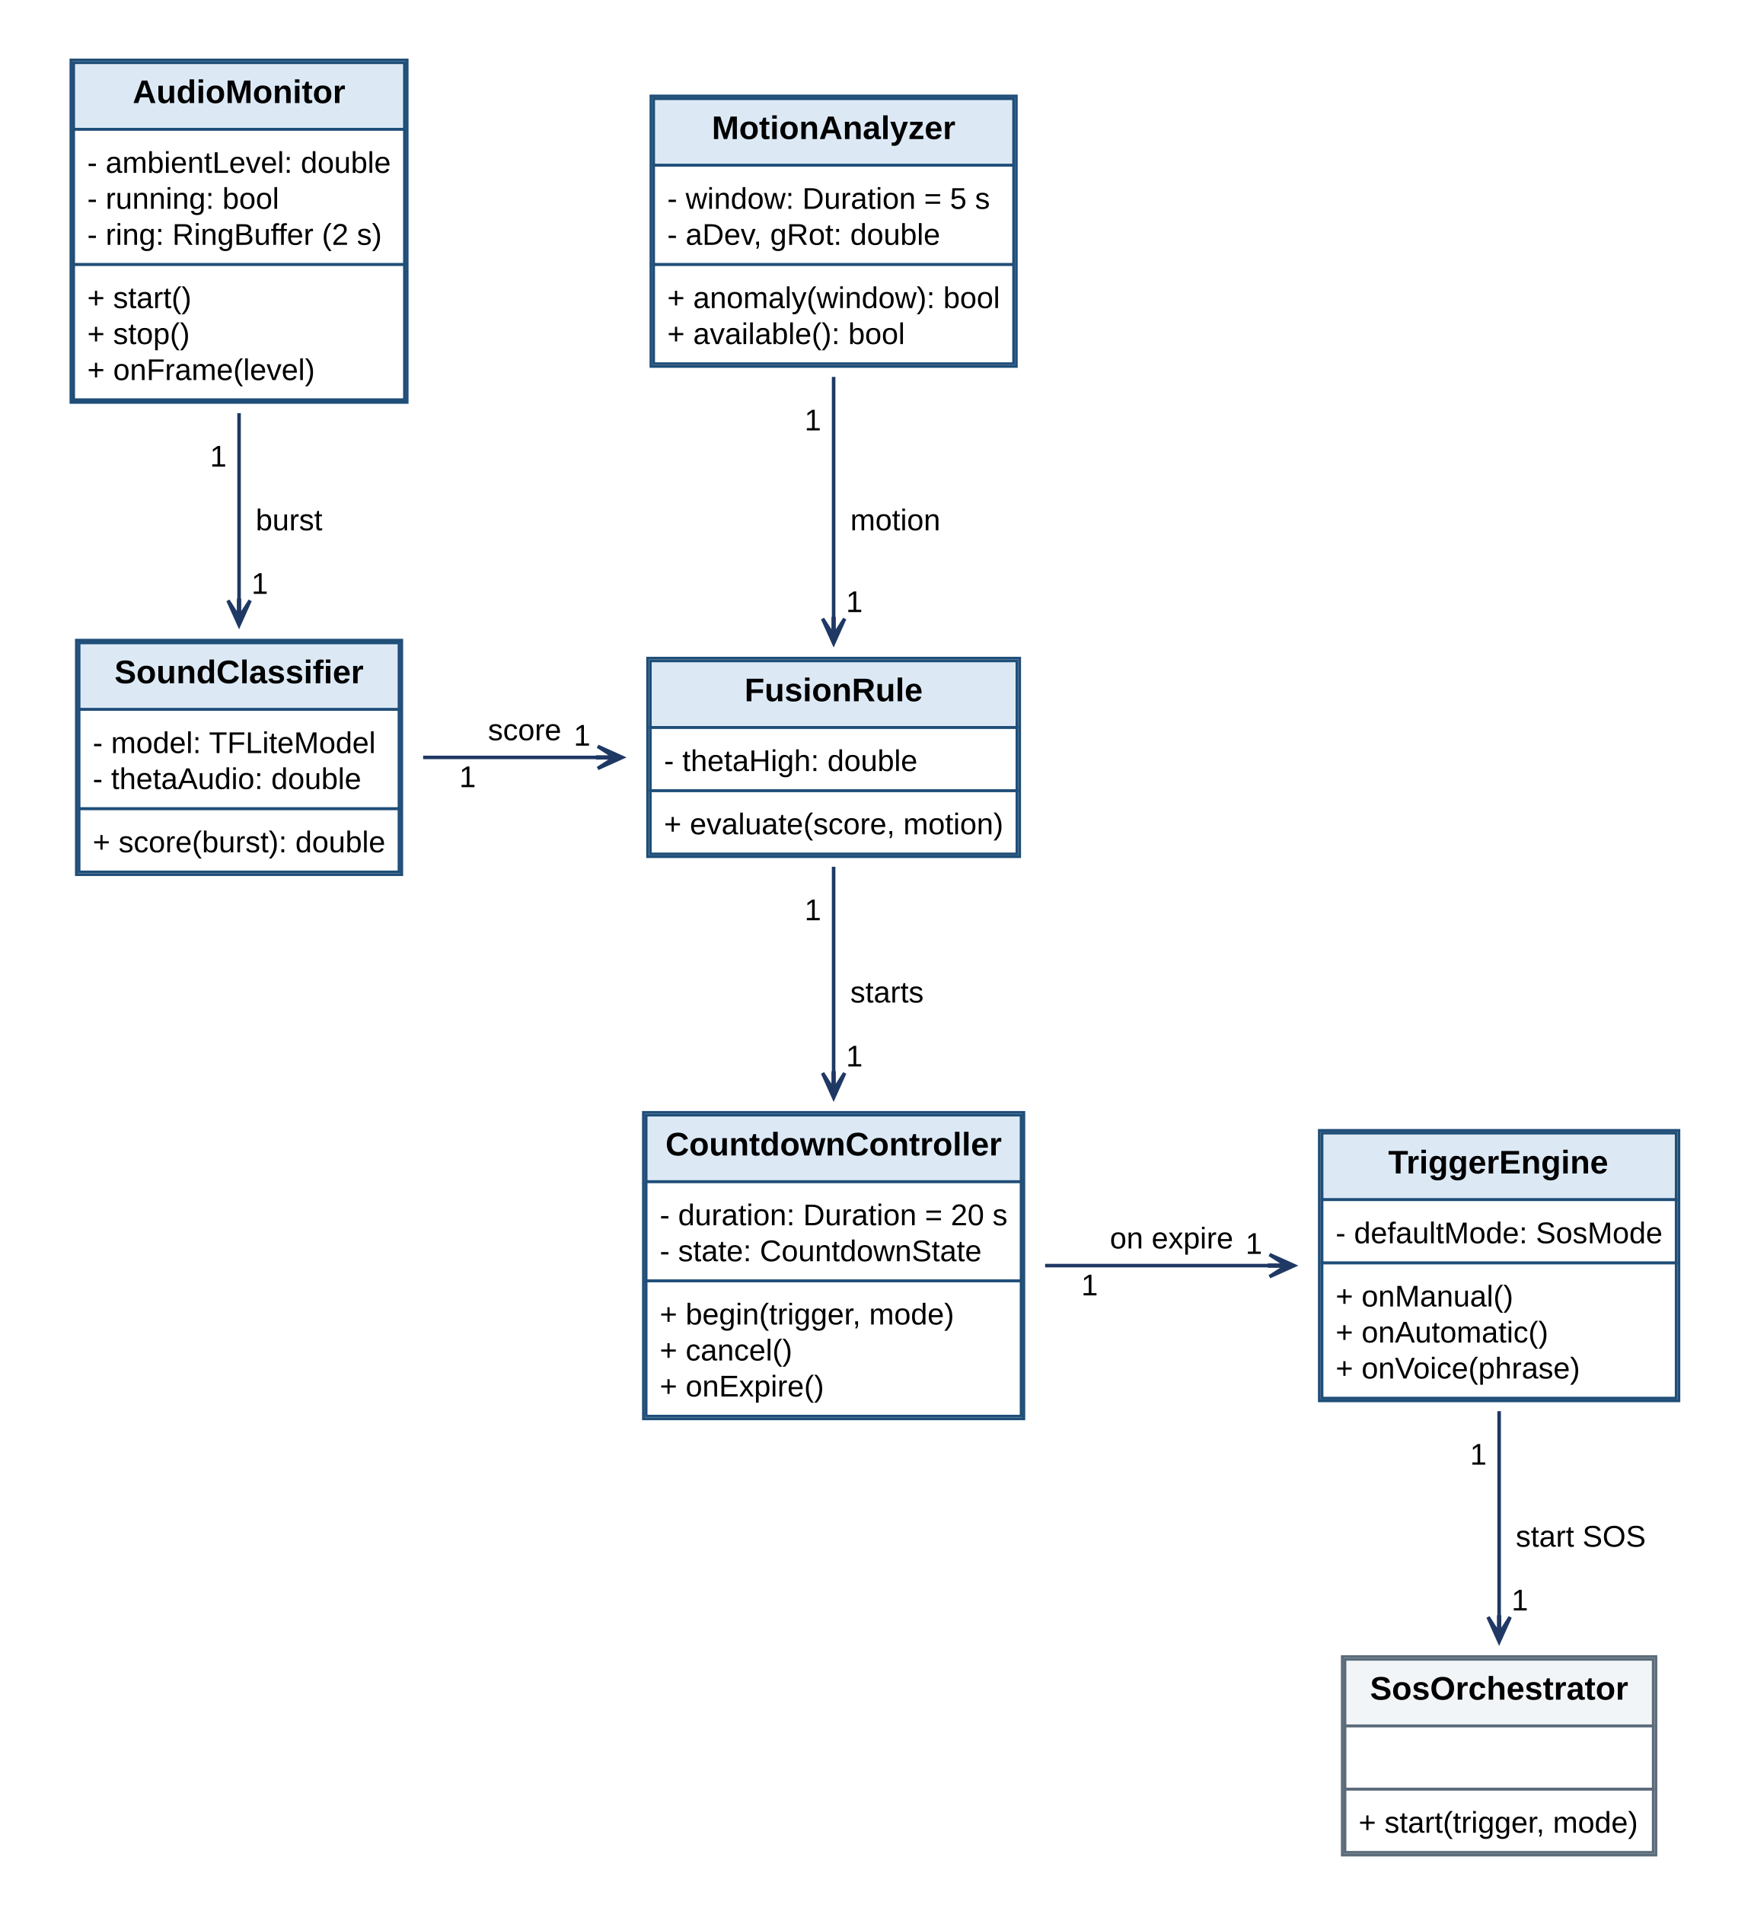
Figure 10: Class diagram: distress detection
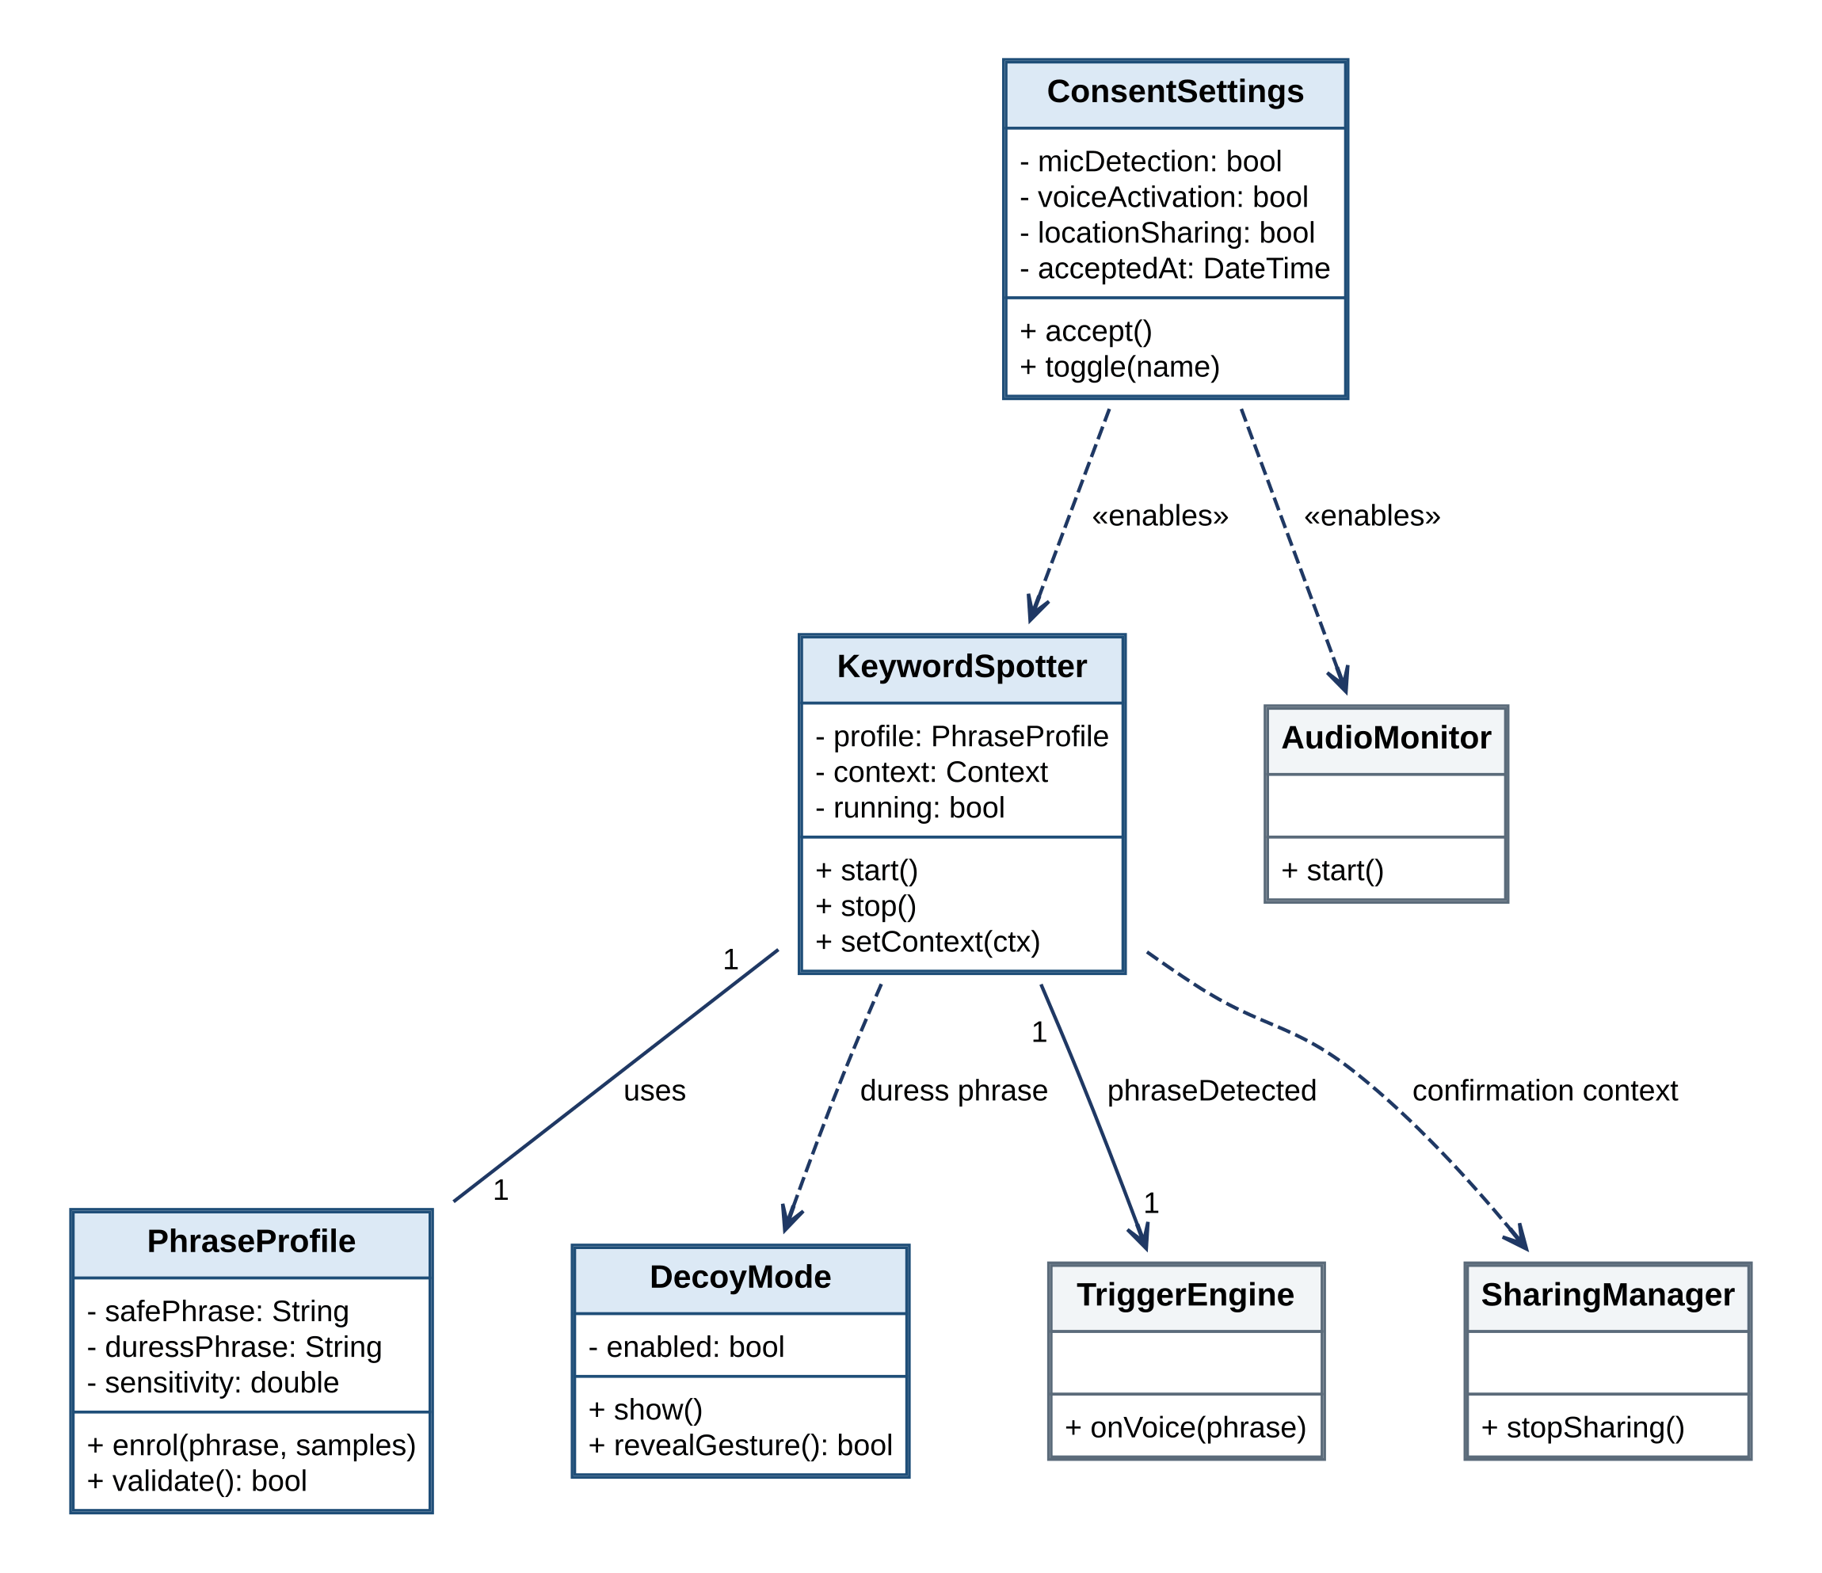
Figure 11: Class diagram: voice activation, consent and decoy
Figure 12 shows the family network: an Account creates Circles and has Memberships, a Circle issues Invitations, and a Membership shares a LocationShare under the control of the SharingManager. Figure 13 shows the community classes: Accounts submit IncidentReports that are counted in CellScores, apply to become a HelperProfile, create and answer HelpRequests, and file MissingChildReports.
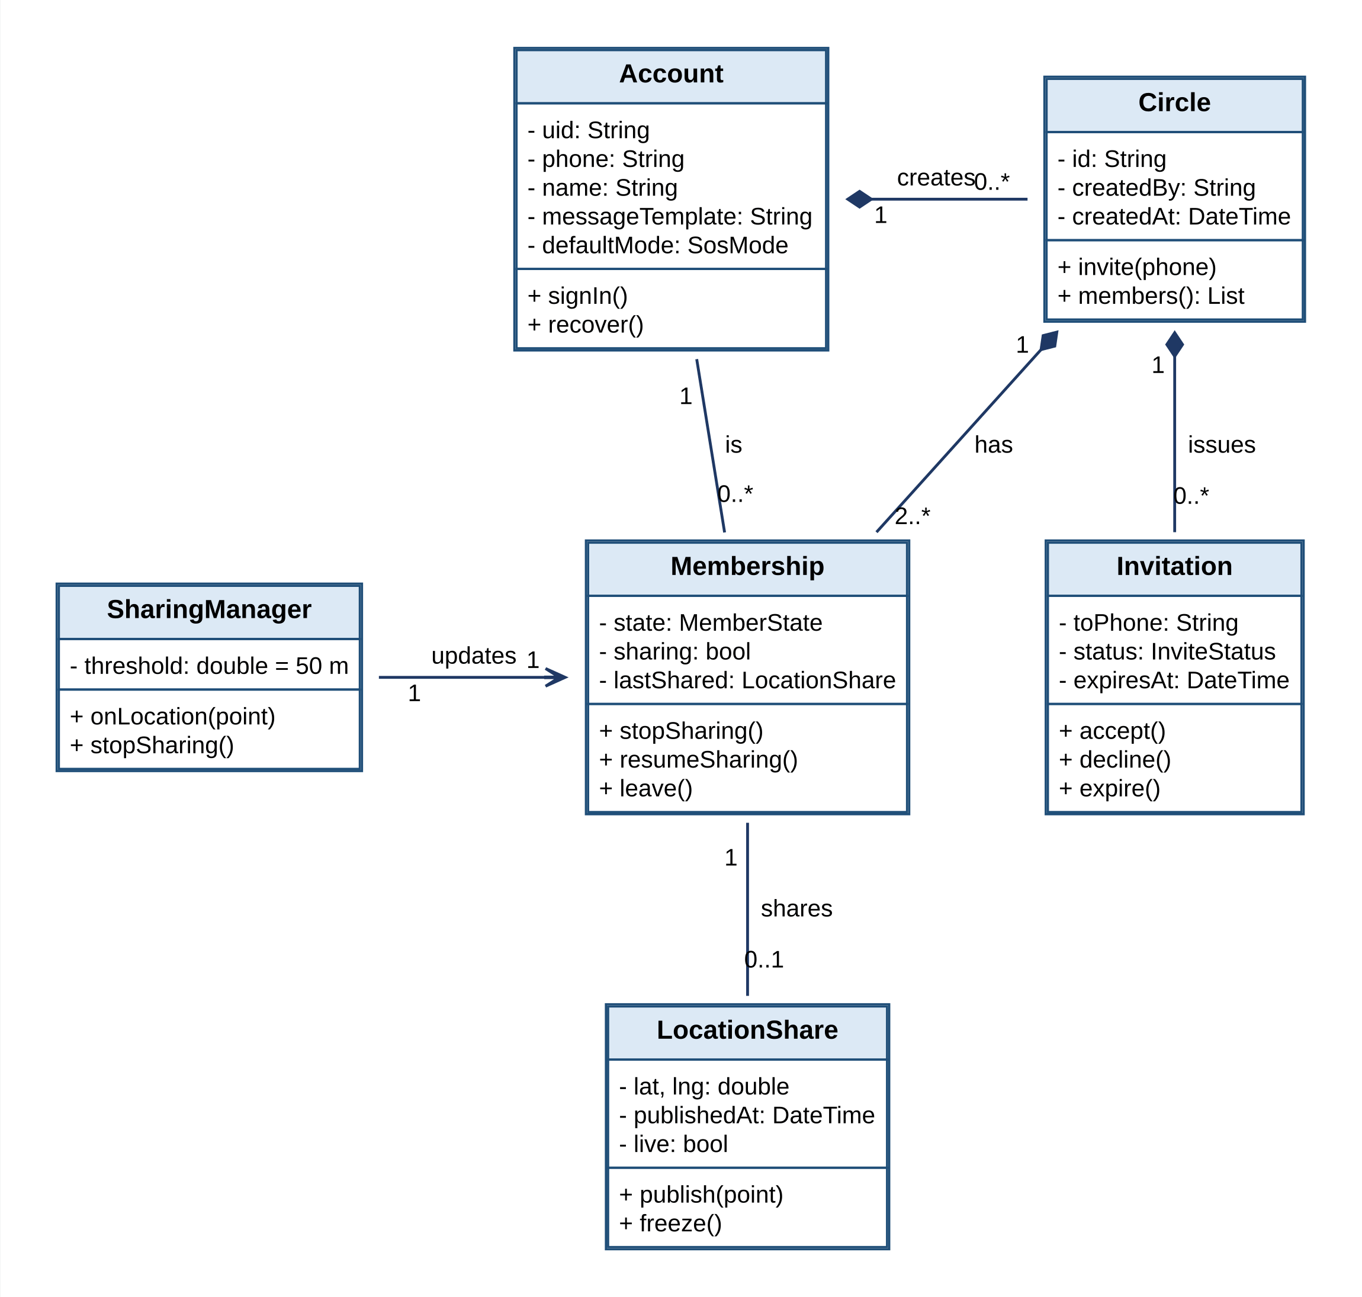
Figure 12: Class diagram: family network
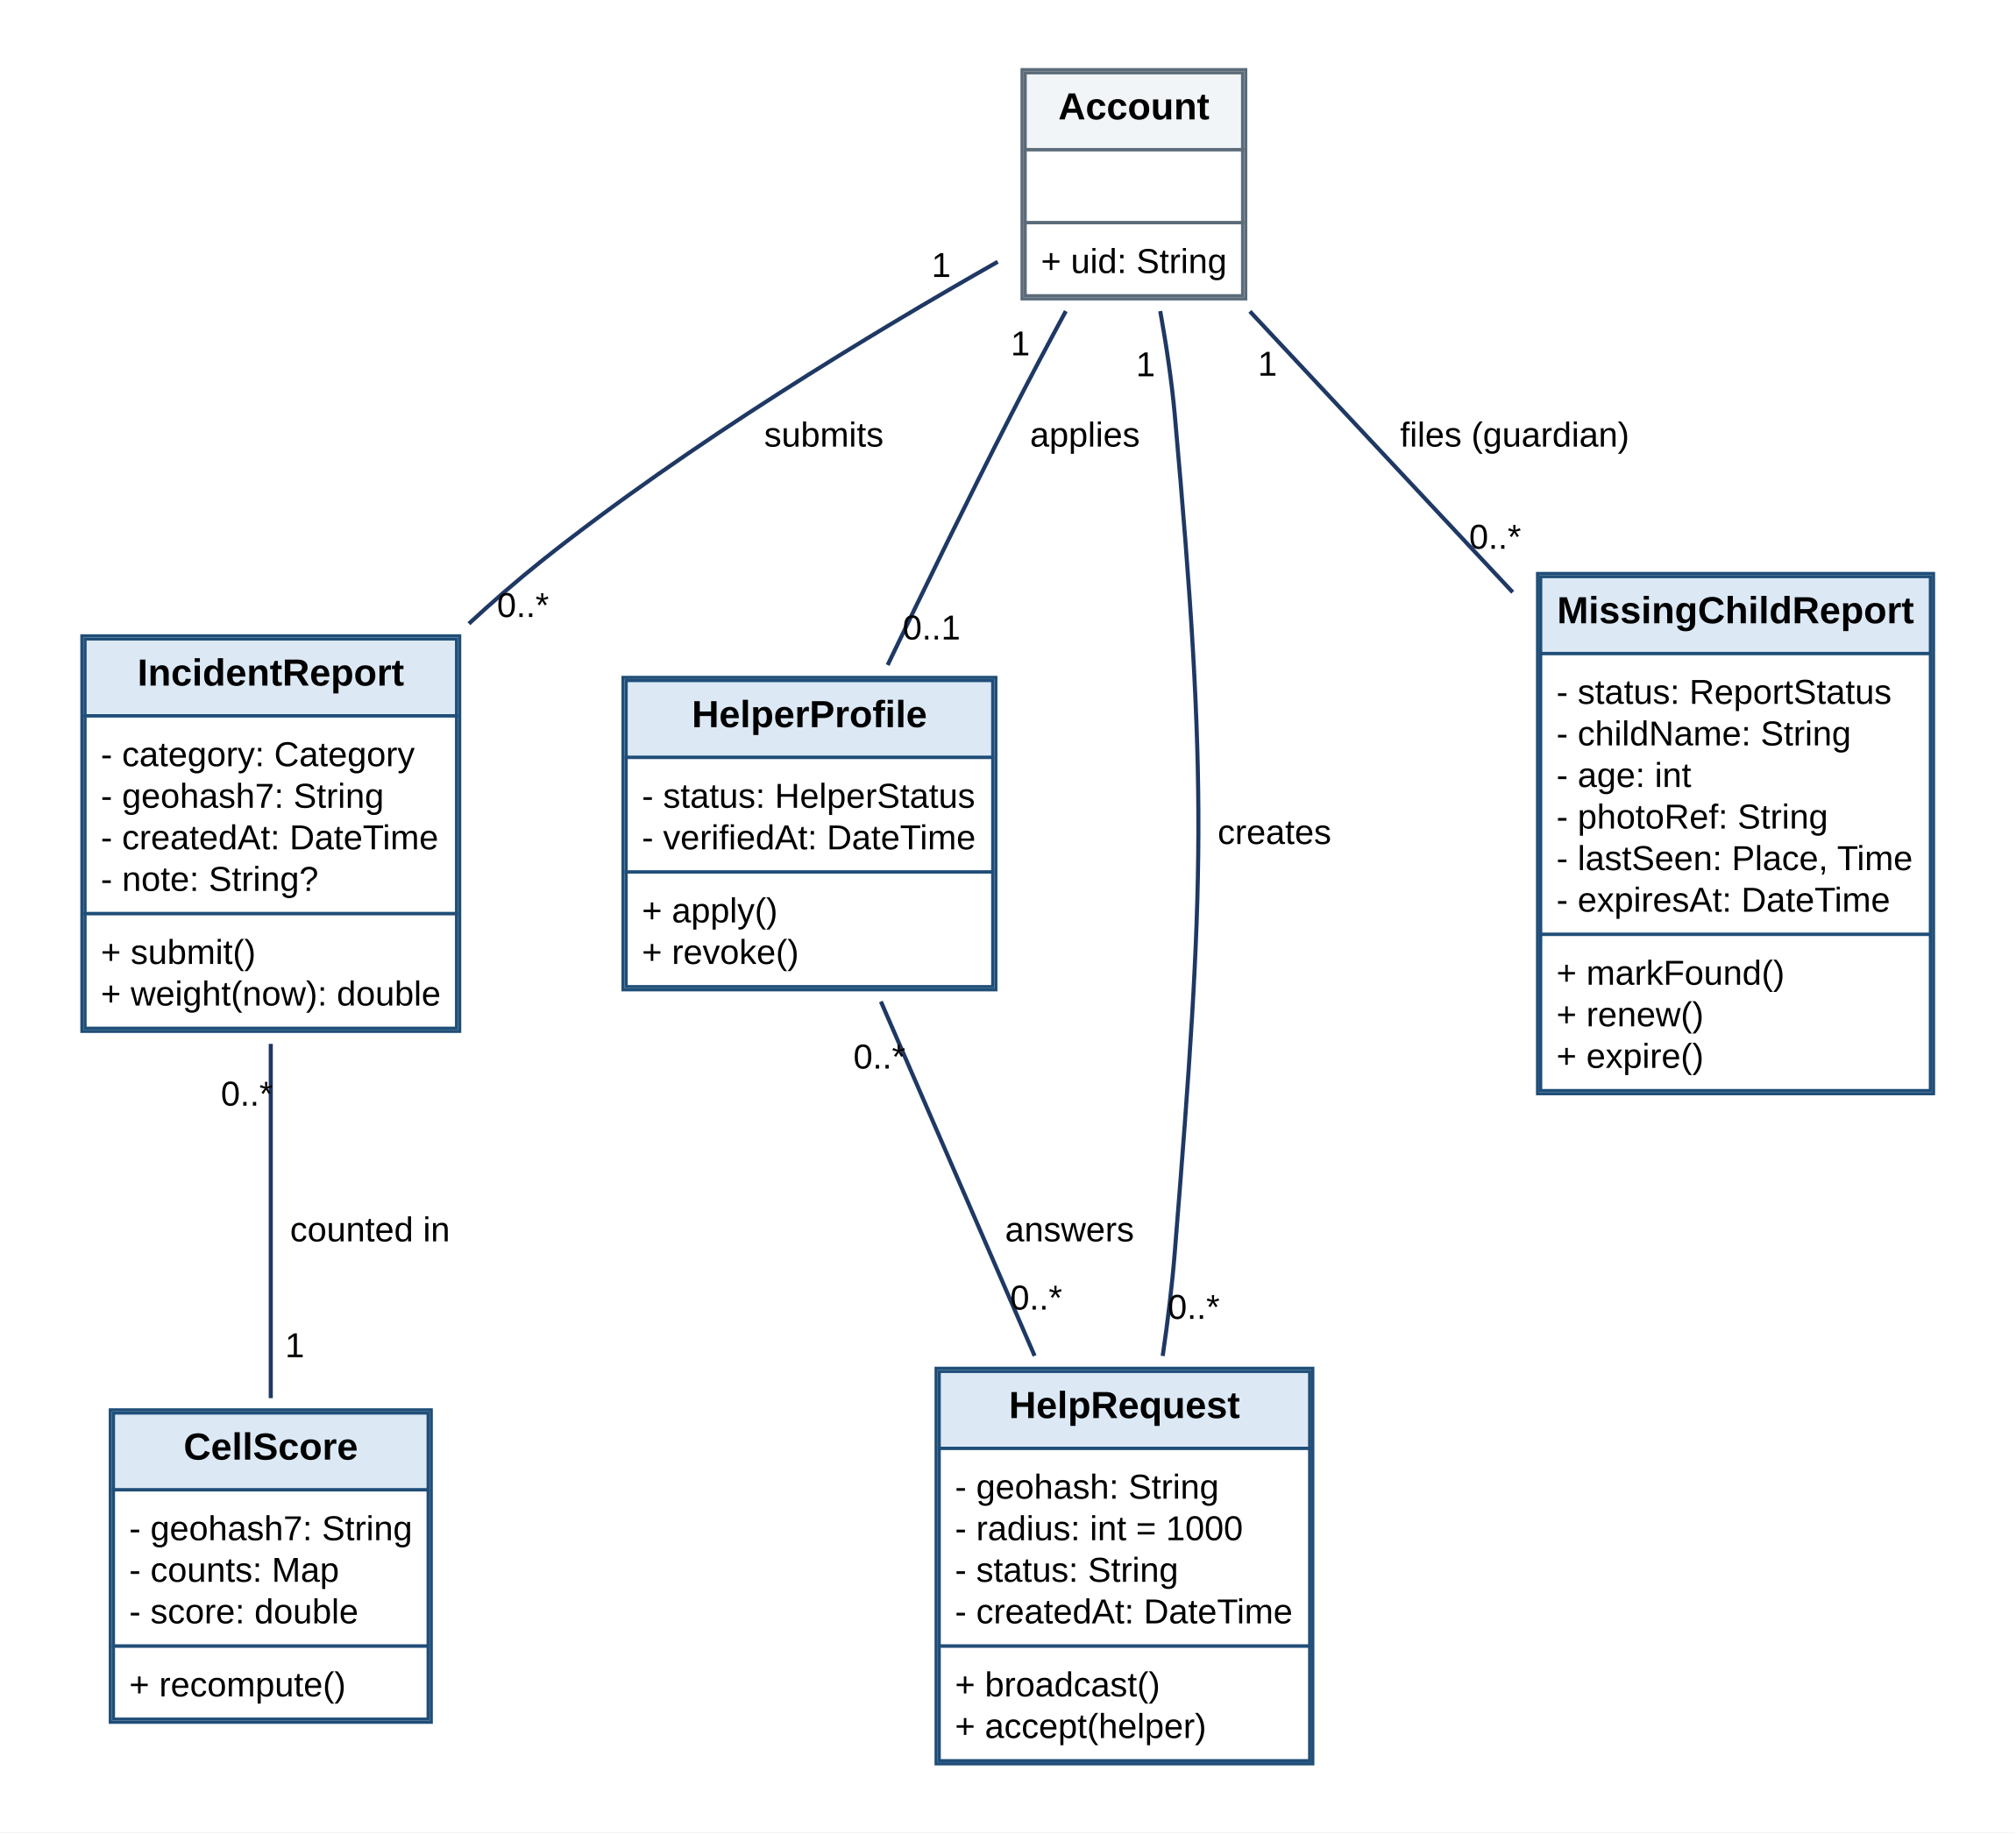
Figure 13: Class diagram: community
Figure 14 shows the knowledge classes: SemanticSearch ranks LibraryItems with a SentenceEmbedder and falls back to KeywordSearch, Bookmarks mark items, and the SafeLocationFinder chooses a DirectoryEntry. Figure 15 shows identity and administration: the AuthService opens a session, AppDisguise changes the launcher appearance, and an AdminUser reviews the ModerationQueue, which records AdminDecisions.
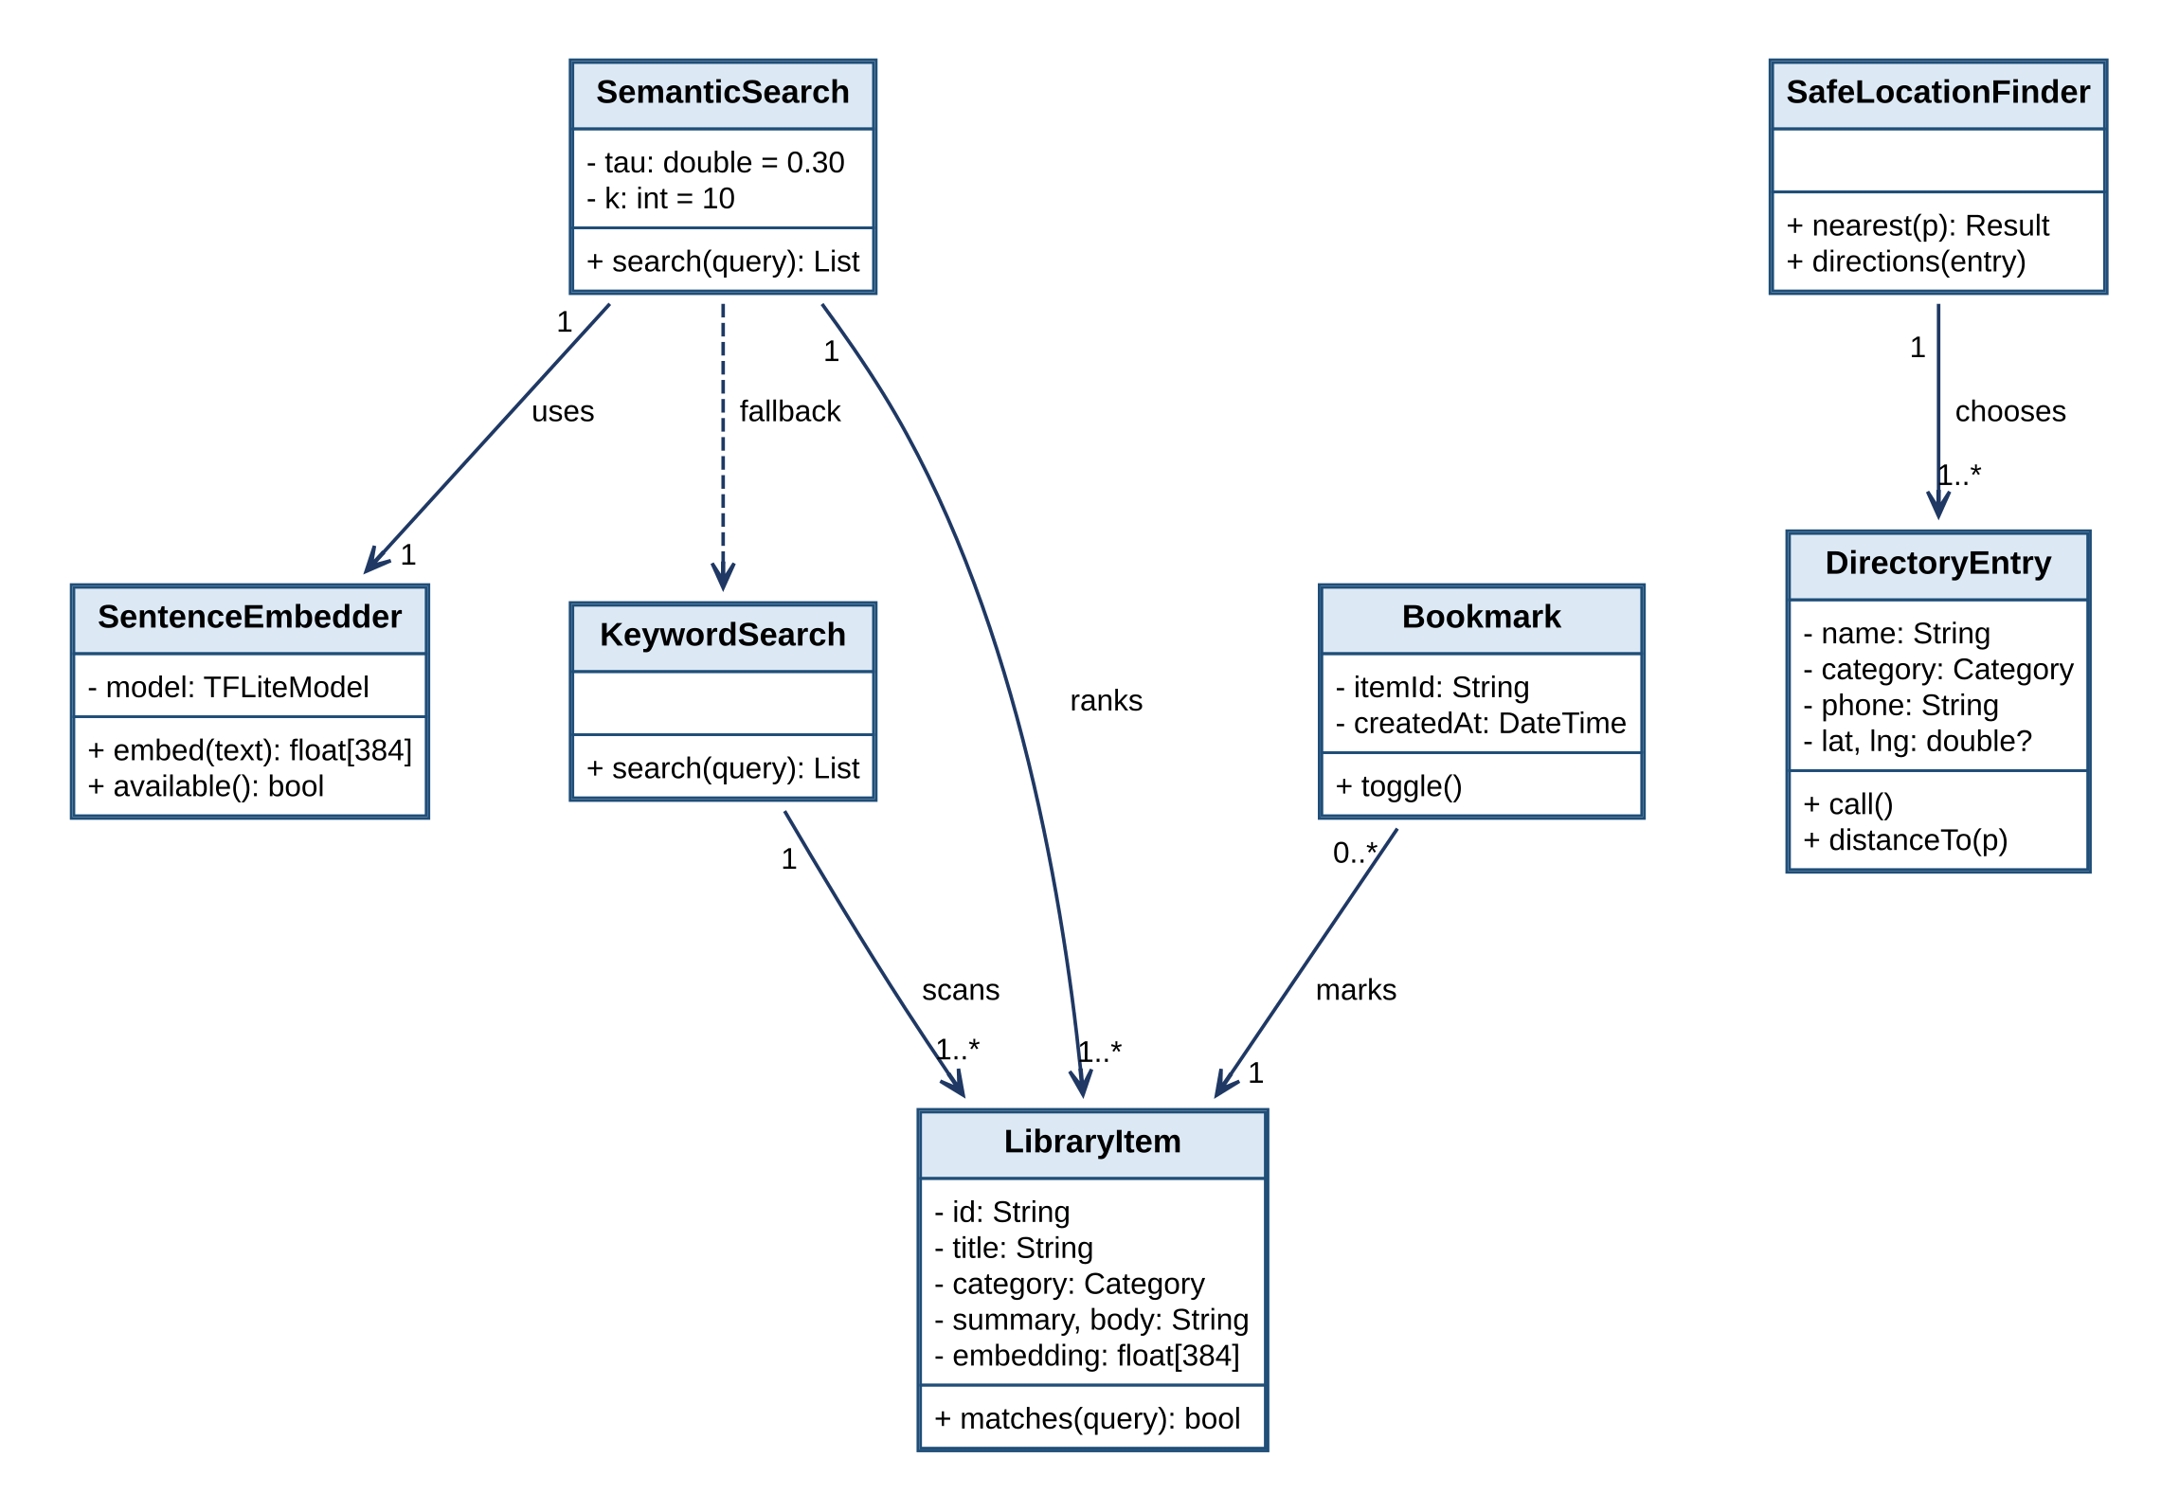
Figure 14: Class diagram: library, search and directory
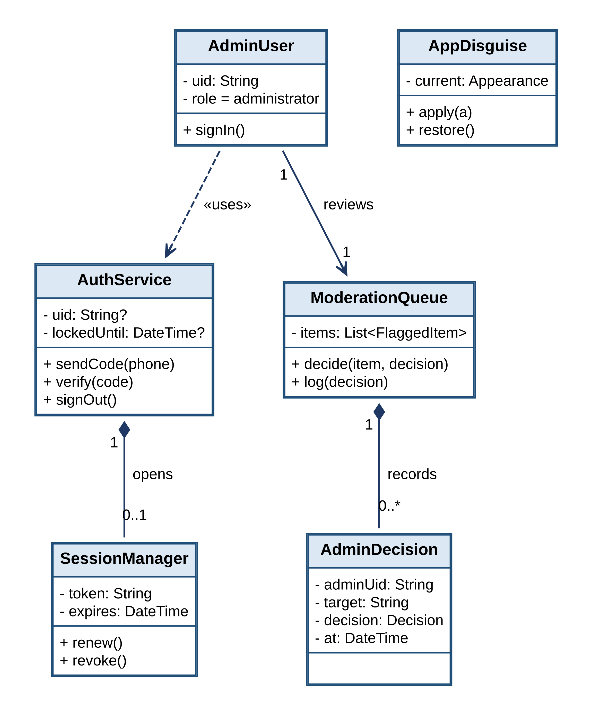
Figure 15: Class diagram: identity, disguise and administration

System-sequence and detailed-sequence diagrams
Figure 16 is the system-sequence diagram of the manual SOS (UC-01): it treats Muhaffiz as one unit and shows only the exchange with the user, the trustee and a helper. The detailed-sequence diagrams then show how the components cooperate. Figure 17 shows the dispatch of an SOS. Figure 18 shows automatic detection (UC-02) with its cancel path, and Figure 19 the voice trigger (UC-03). Figure 20 shows the stop-sharing by safe phrase (UC-09), including that no message reaches other members. Figure 21 shows the escalation (UC-25), and Figure 22 the retry of the outbound queue. Figure 23 shows the invitation and acceptance of a circle member (UC-07), Figure 24 the nearby-help request (UC-15), Figure 25 the missing-child report (UC-23), Figure 26 the semantic search (UC-17), Figure 27 the helper verification (UC-14), Figure 28 the incident report and heatmap (UC-12, UC-13), and Figure 29 the sign-in (UC-19).
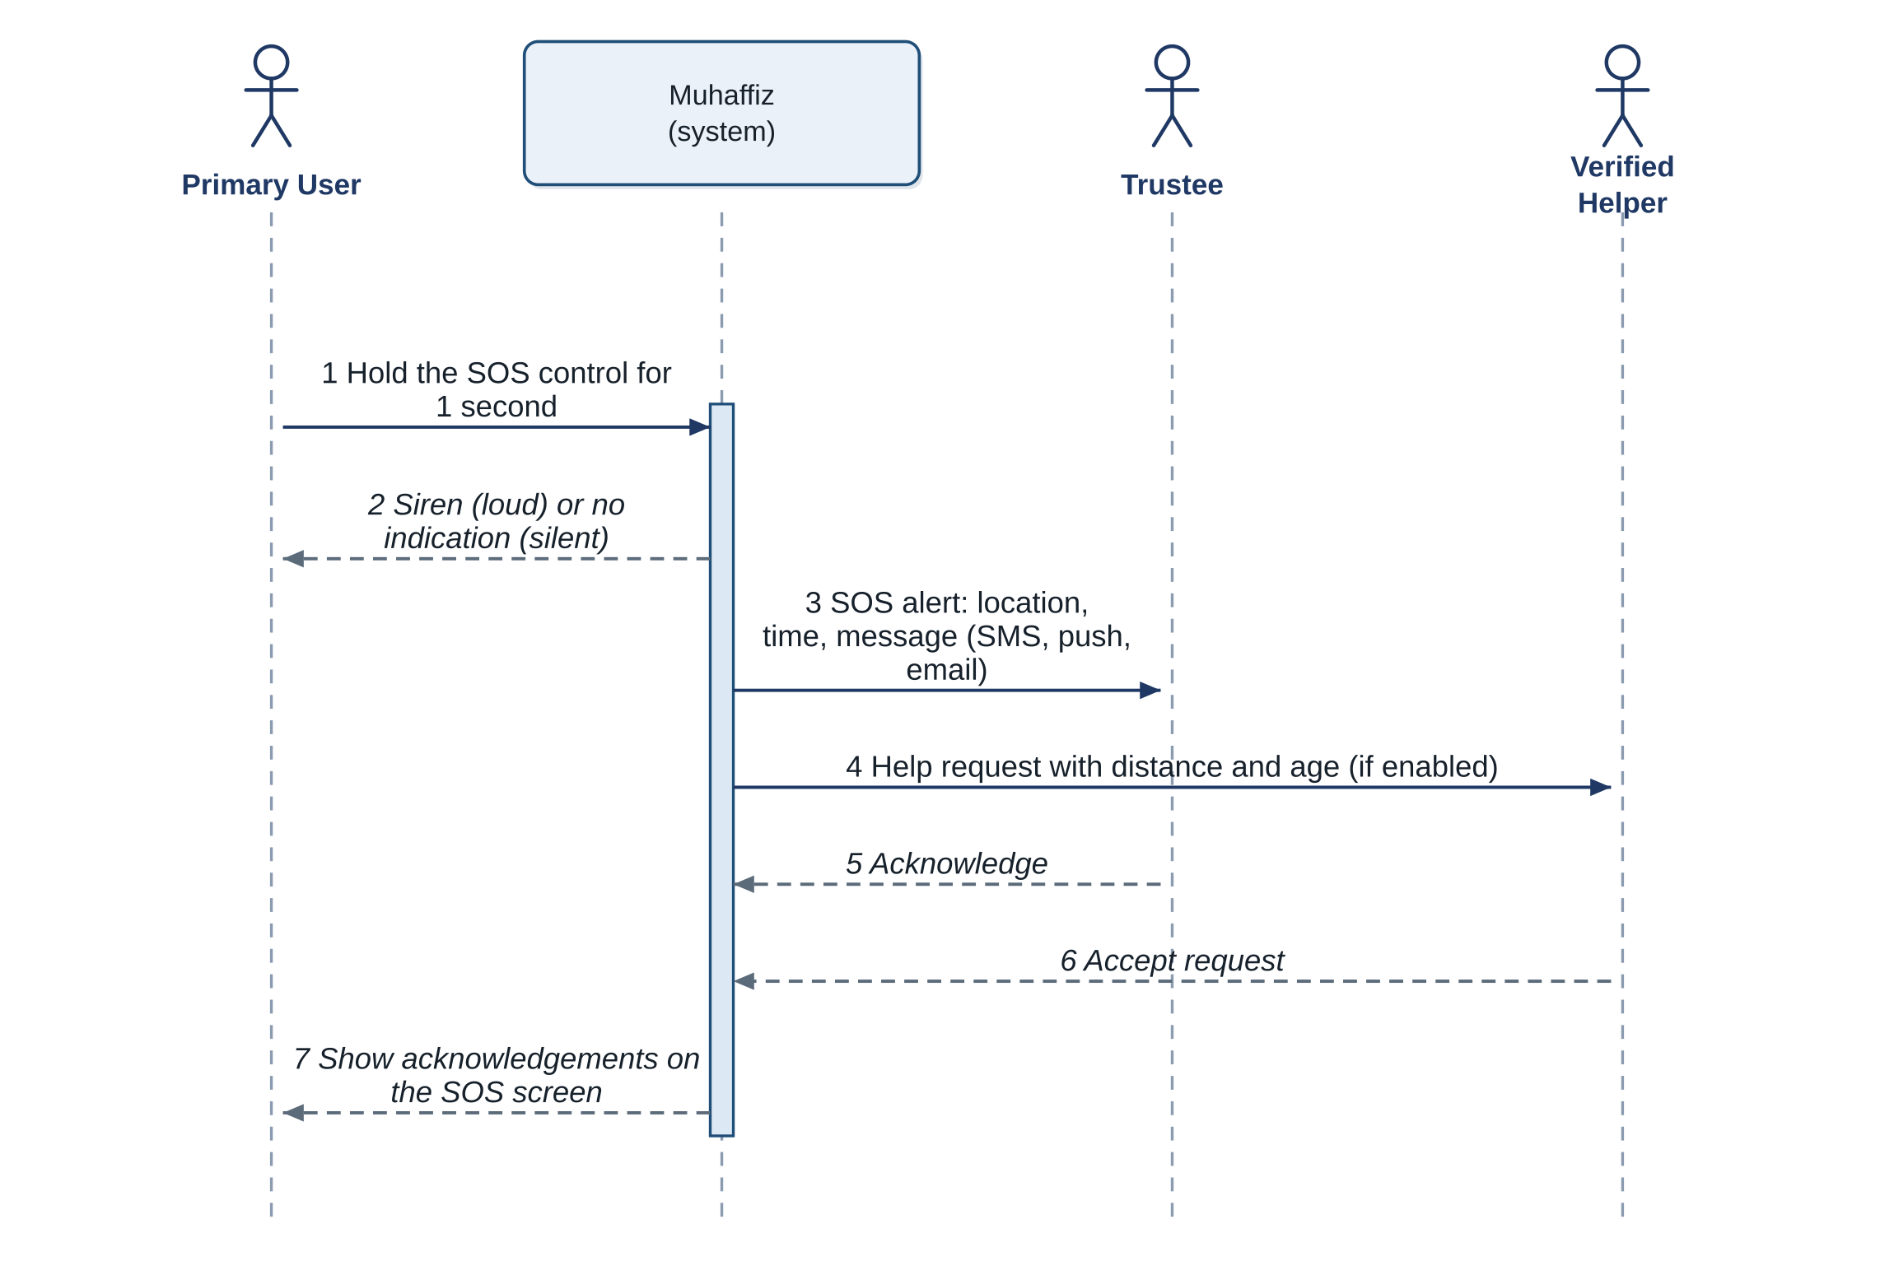
Figure 16: System-sequence diagram: manual SOS (UC-01)
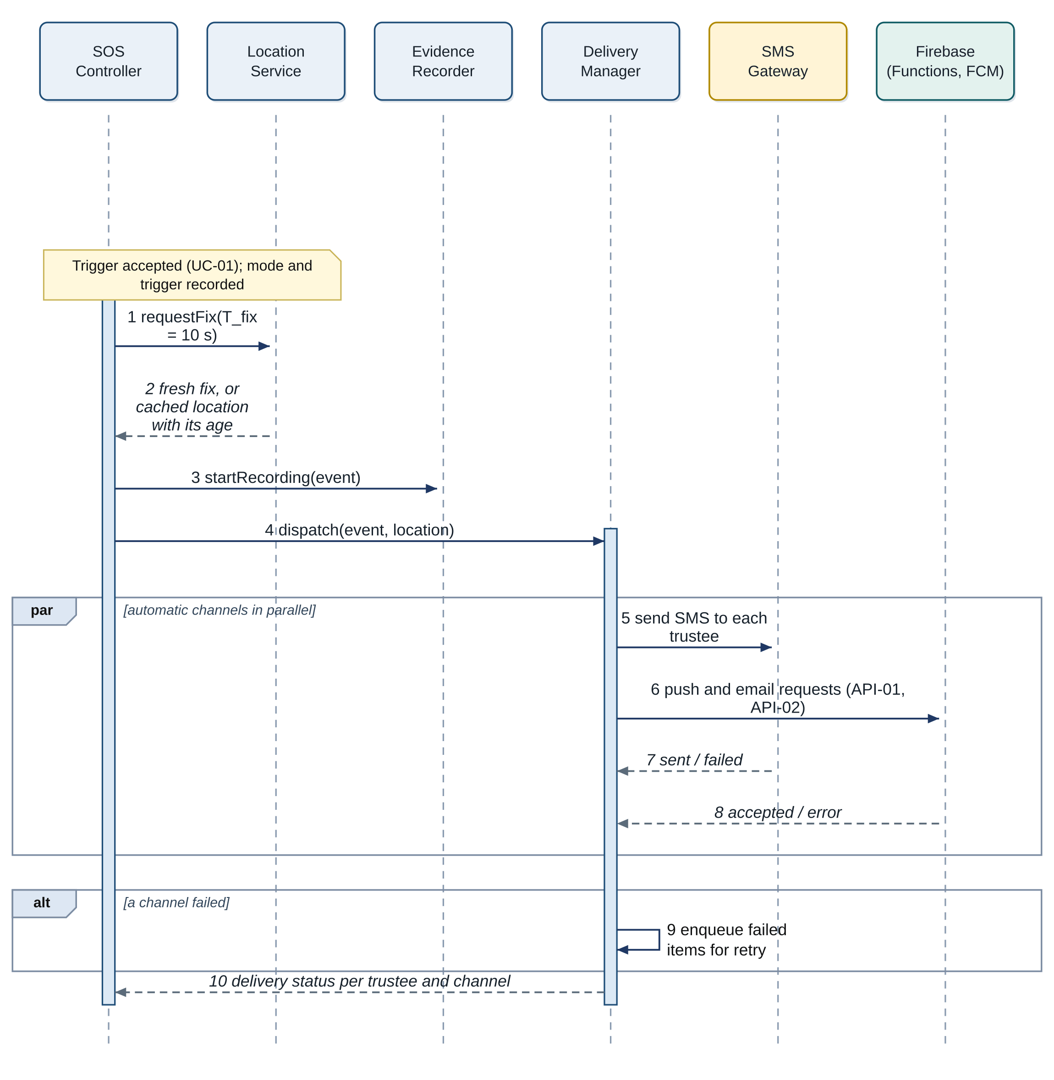
Figure 17: Detailed sequence: SOS dispatch
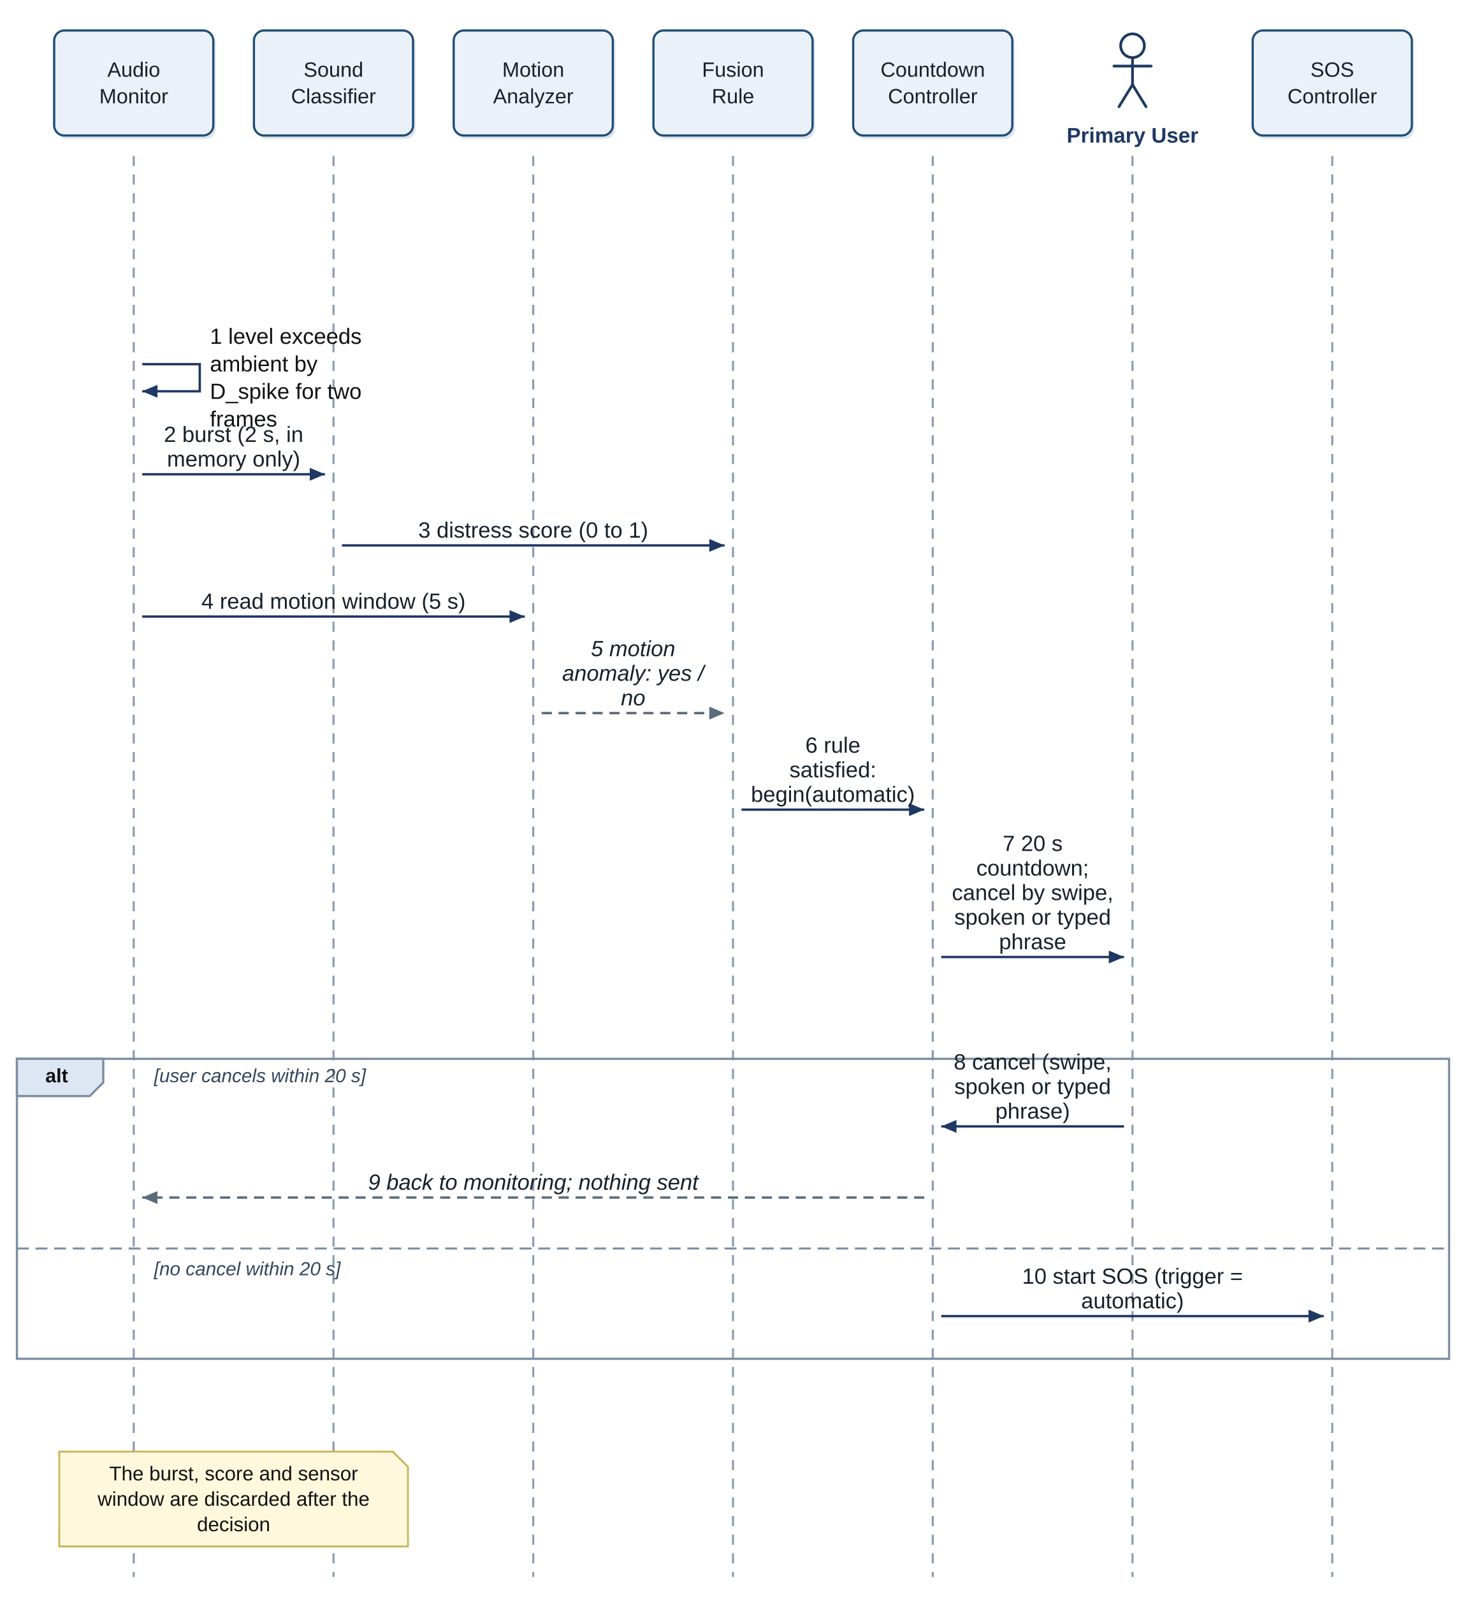
Figure 18: Detailed sequence: automatic distress detection (UC-02)
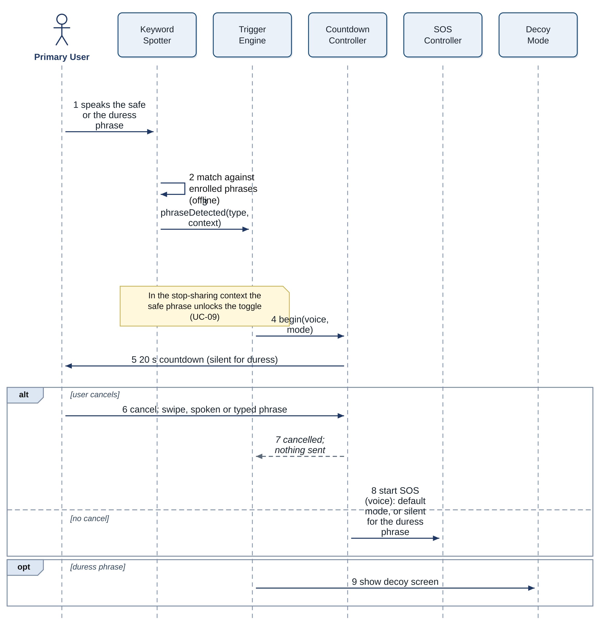
Figure 19: Detailed sequence: voice-triggered SOS (UC-03)
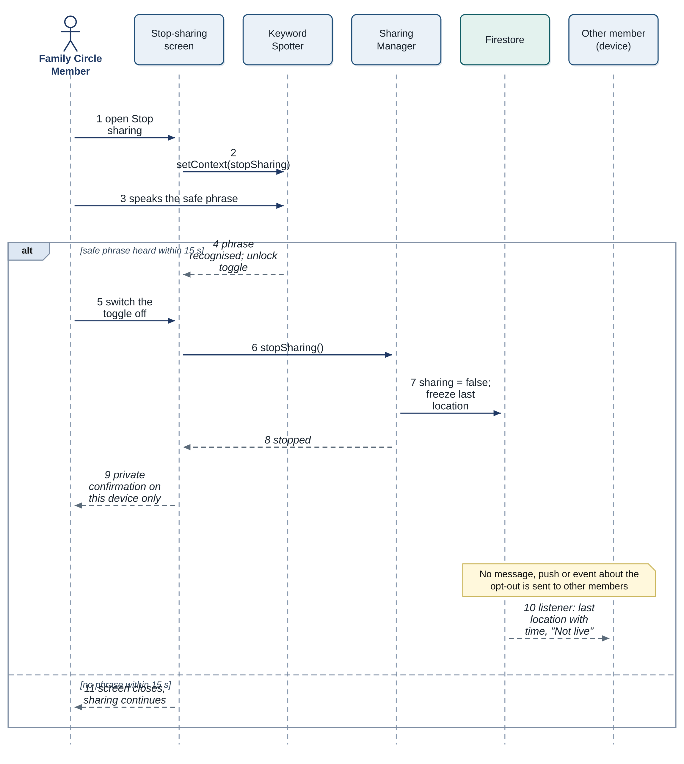
Figure 20: Detailed sequence: stop sharing by safe phrase (UC-09)
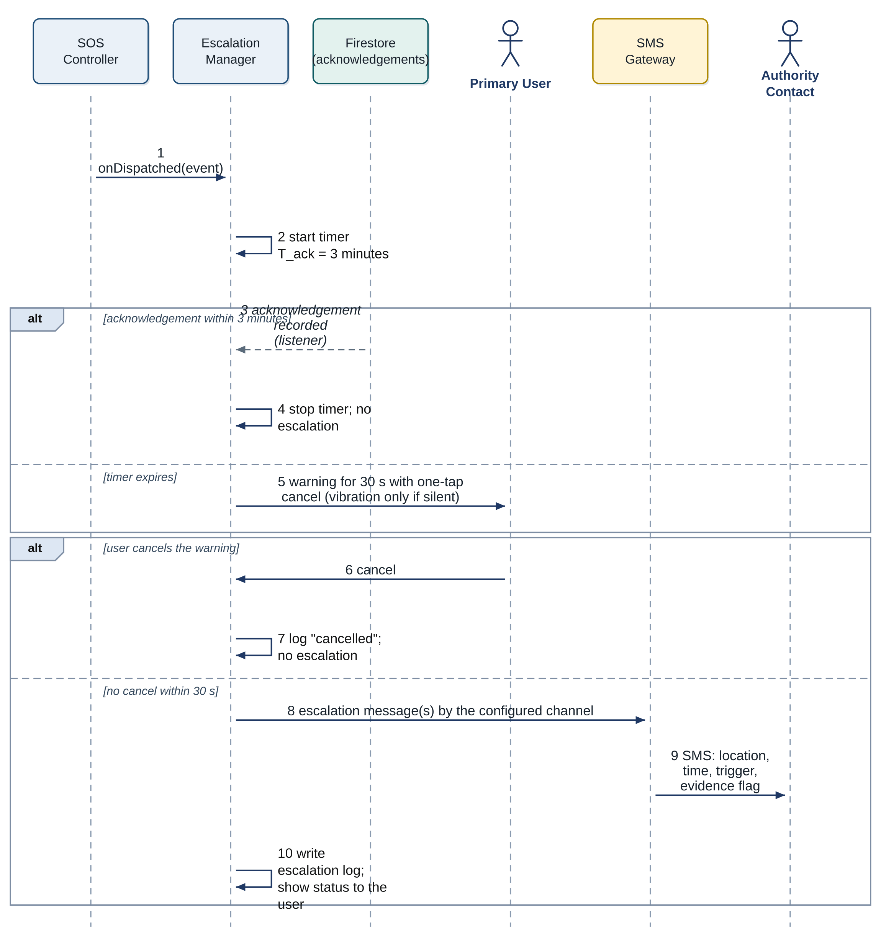
Figure 21: Detailed sequence: escalation to authorities (UC-25)
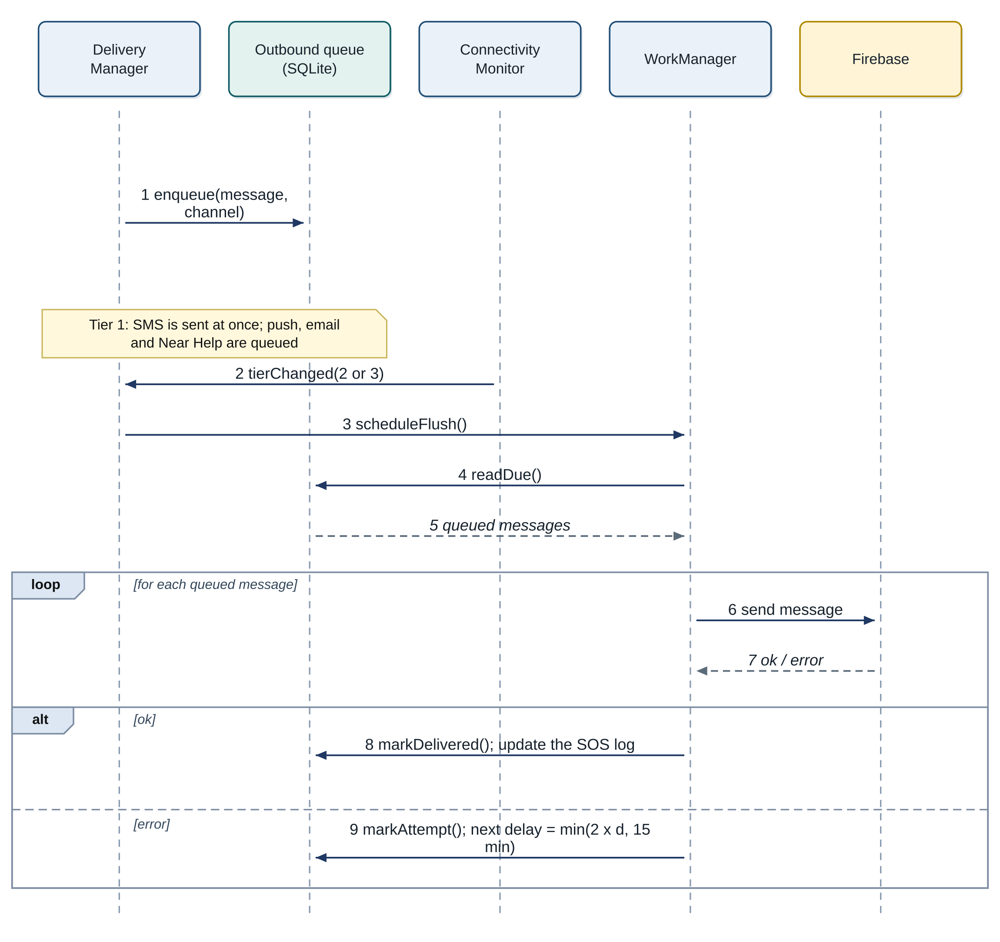
Figure 22: Detailed sequence: offline queue and retry
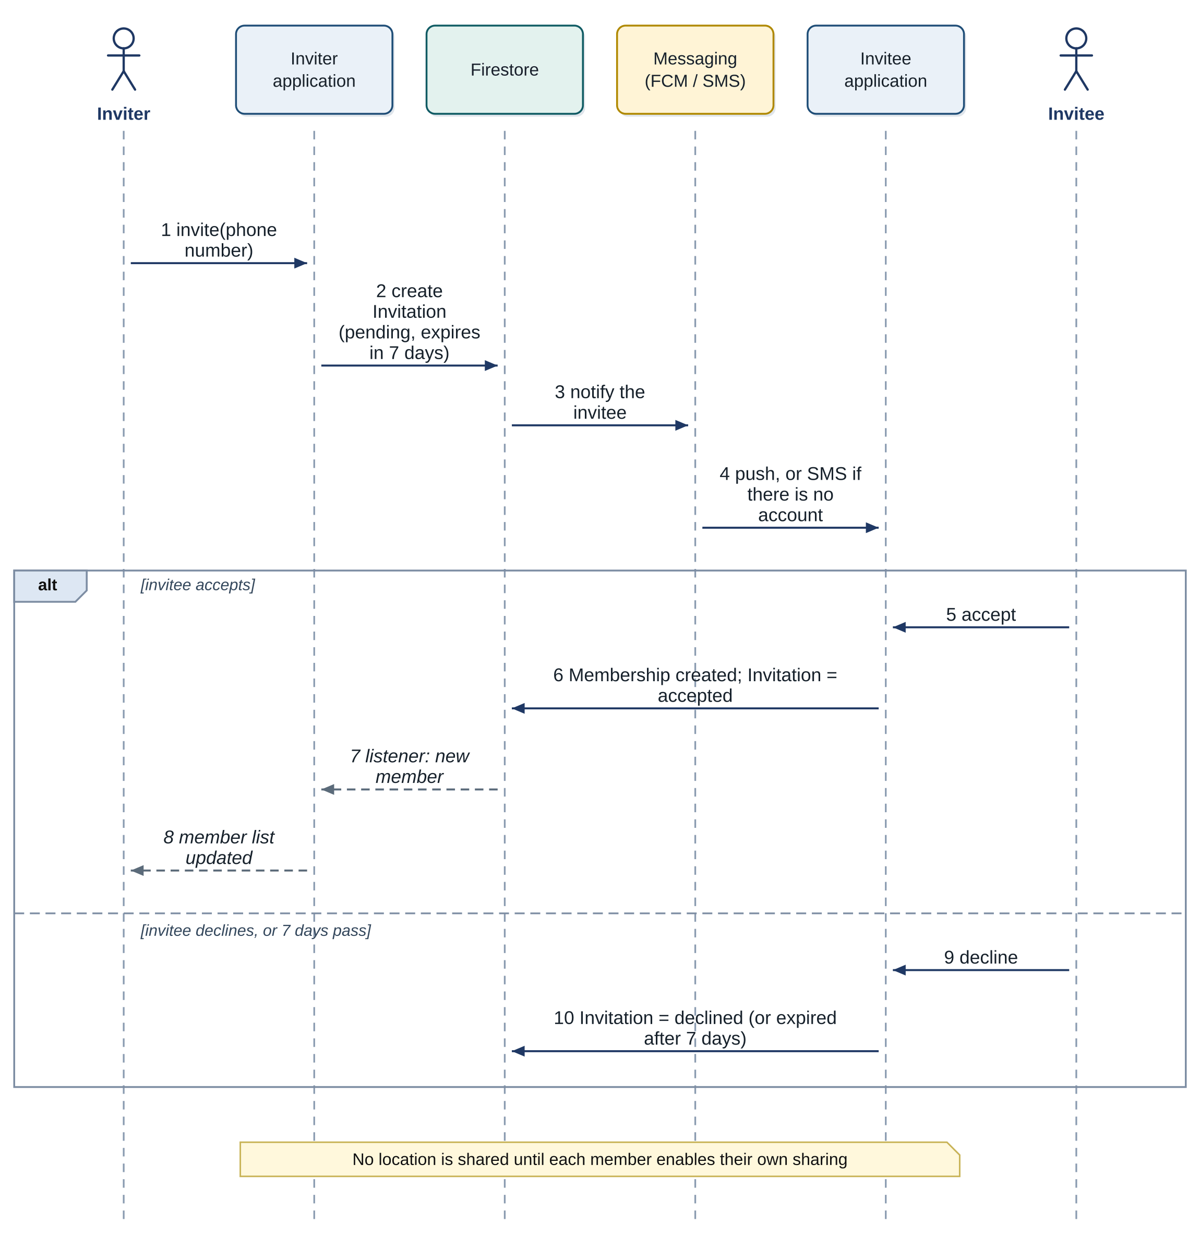
Figure 23: Detailed sequence: circle invitation (UC-07)
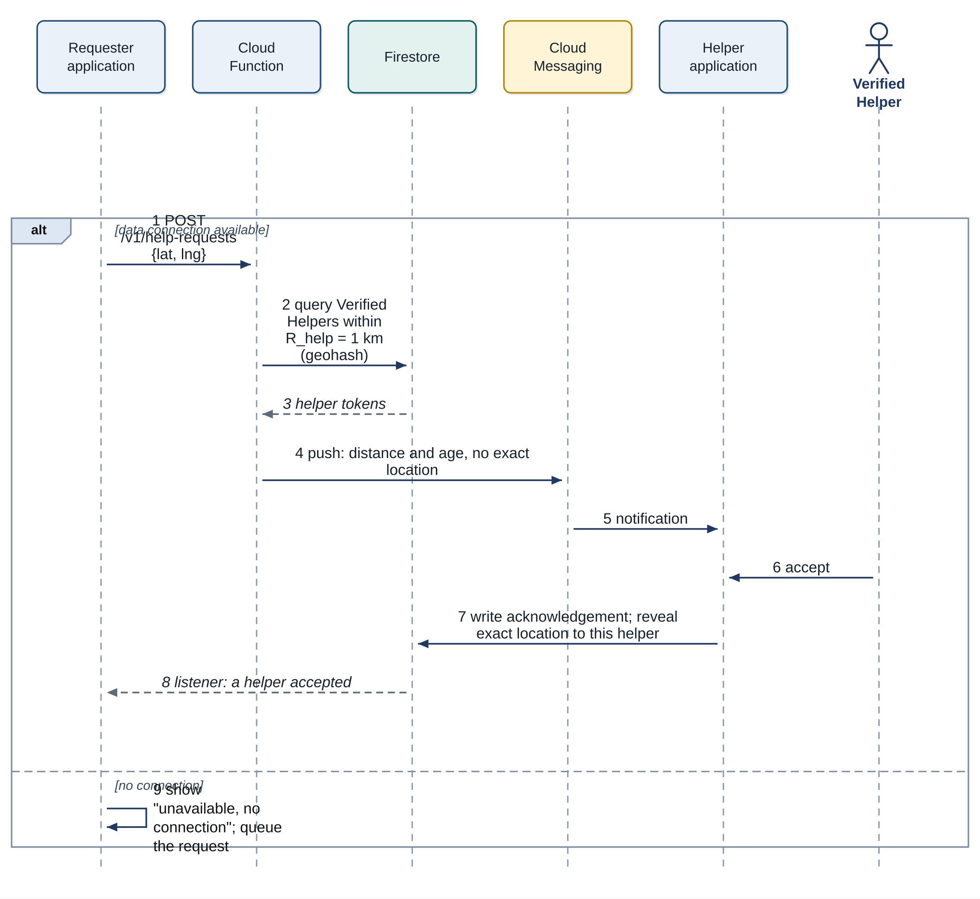
Figure 24: Detailed sequence: nearby help (UC-15)
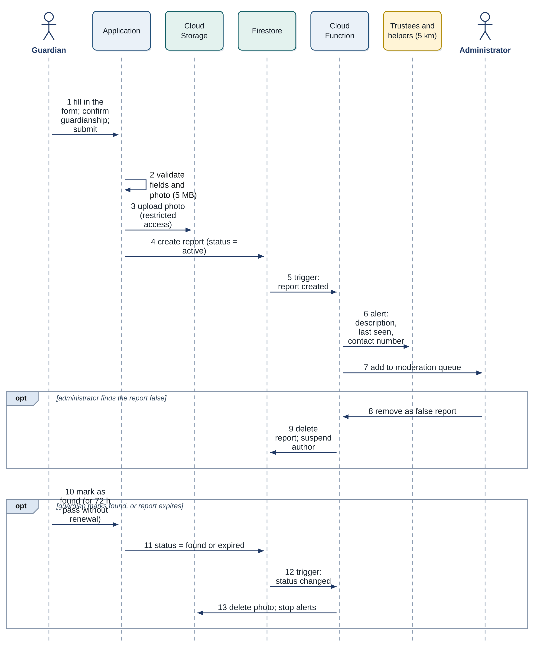
Figure 25: Detailed sequence: missing-child report (UC-23)
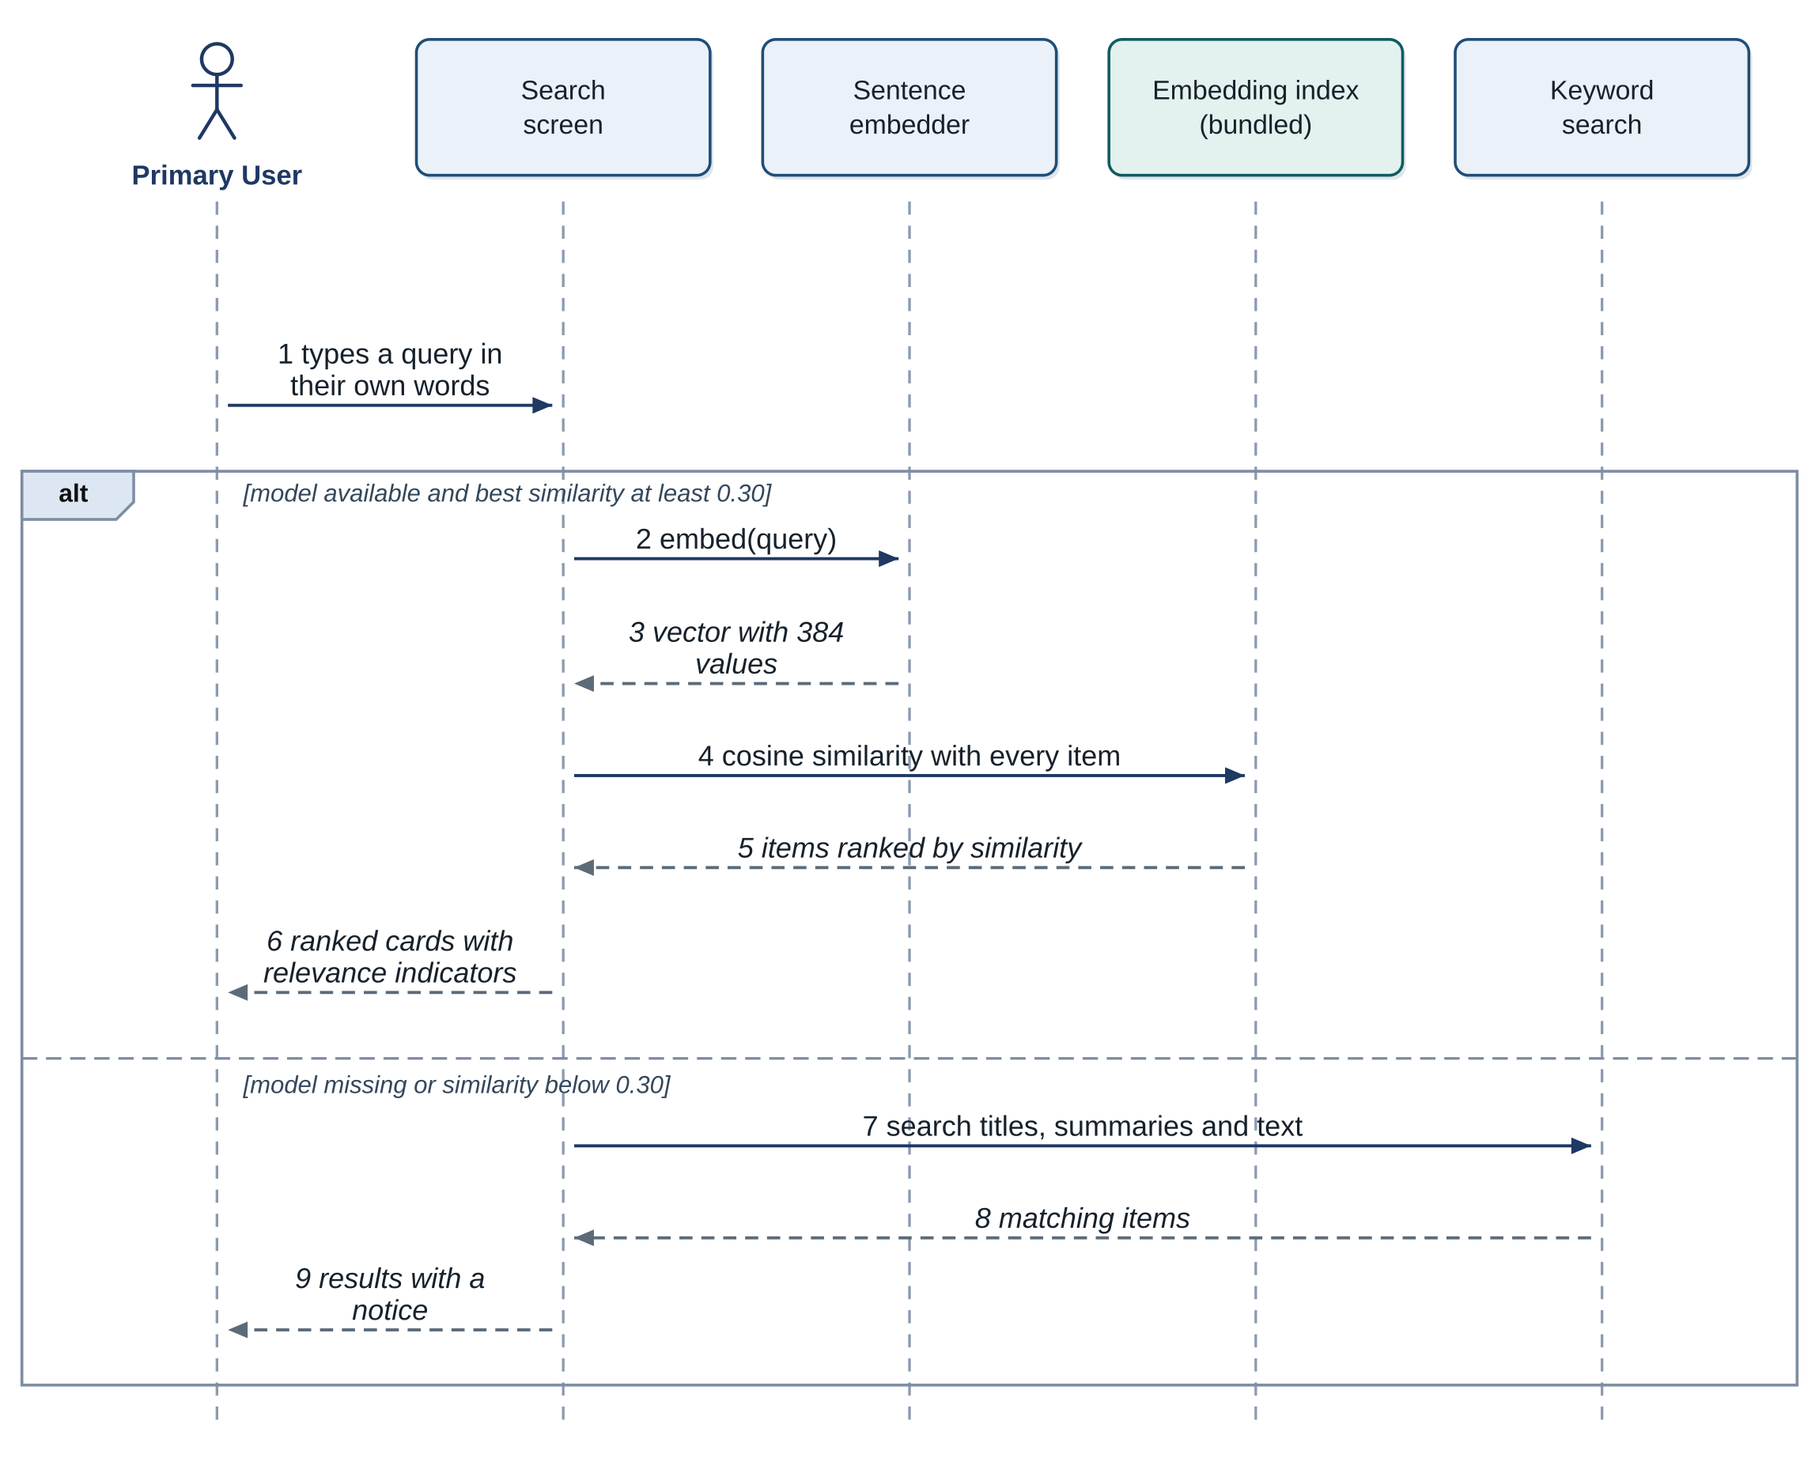
Figure 26: Detailed sequence: semantic library search (UC-17)
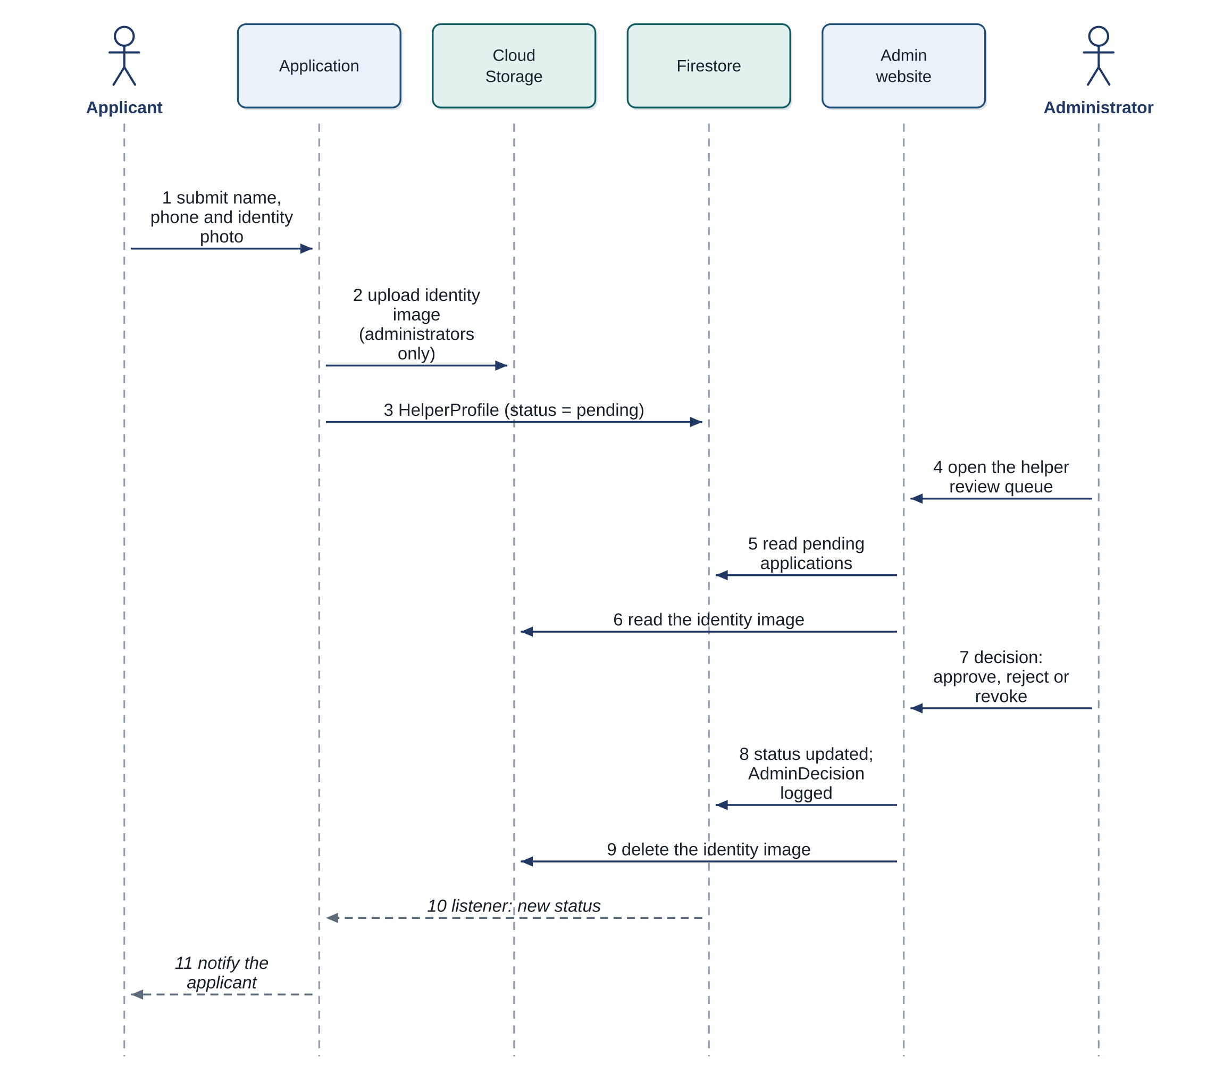
Figure 27: Detailed sequence: helper verification (UC-14)
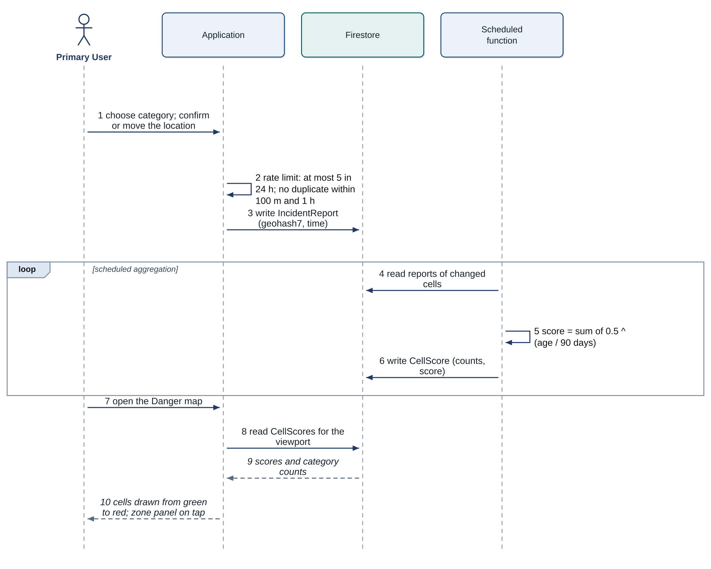
Figure 28: Detailed sequence: incident report and heatmap (UC-12, UC-13)
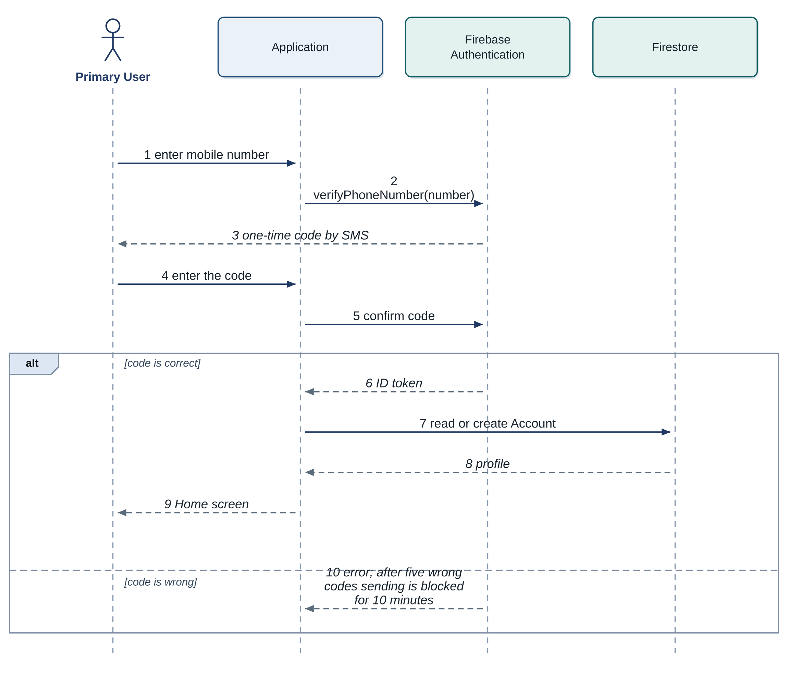
Figure 29: Detailed sequence: sign-in (UC-19)

Activity diagrams
Figure 30 shows the first phase of an SOS, from the trigger to the dispatch, with the work that runs in parallel after the SOS starts, and Figure 31 the response phase with the acknowledgement check and the escalation. Figure 32 shows the tiered delivery and its queue. Figure 33 shows how a detected phrase is handled in its context, and Figure 34 the semantic search with its fallback. Four workflows involve several parties and are drawn with swimlanes: Figure 35 the onboarding and consent, Figure 36 the missing-child report with moderation, Figure 37 the incident report and the heatmap aggregation, Figure 38 the helper verification and Figure 39 the nearby help.
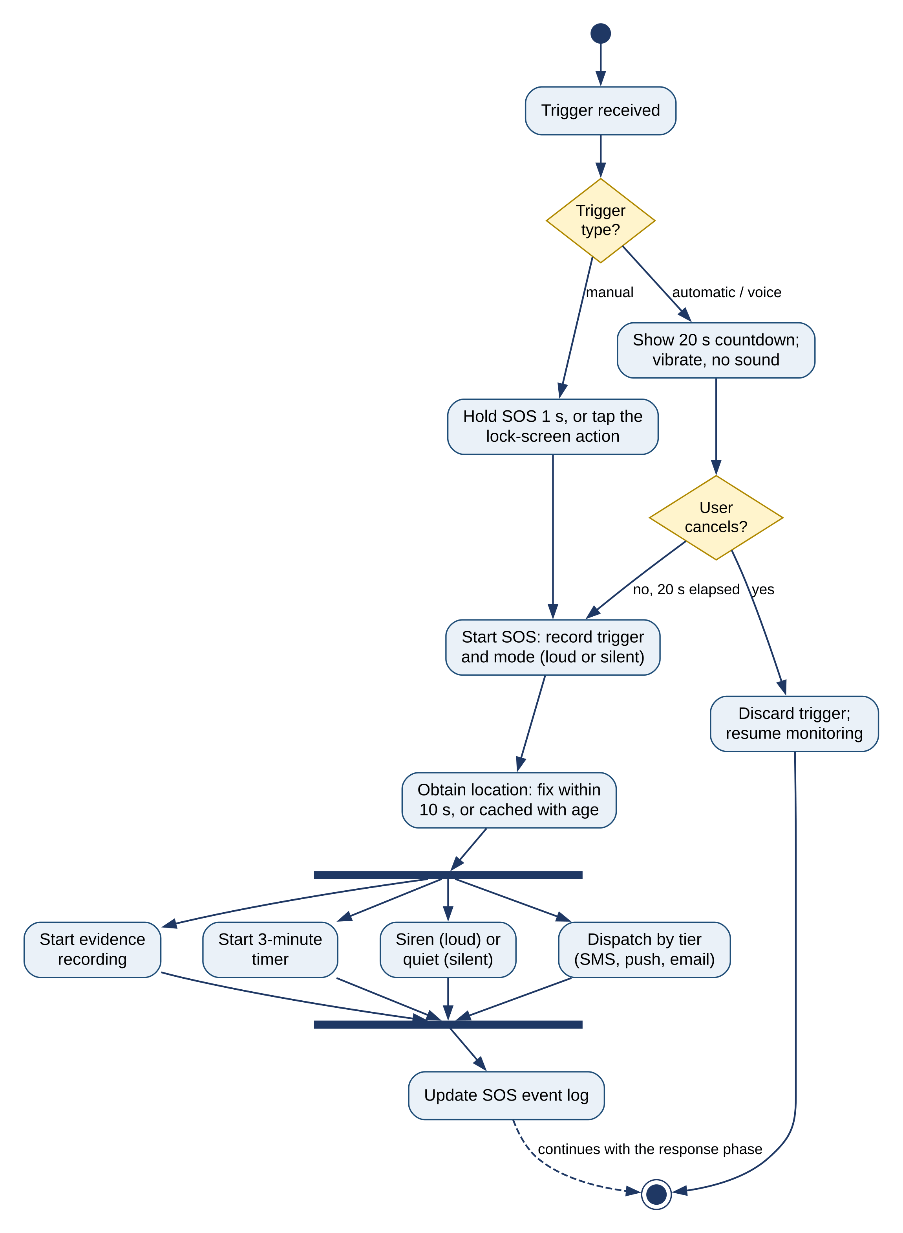
Figure 30: Activity diagram: SOS pipeline, trigger and dispatch
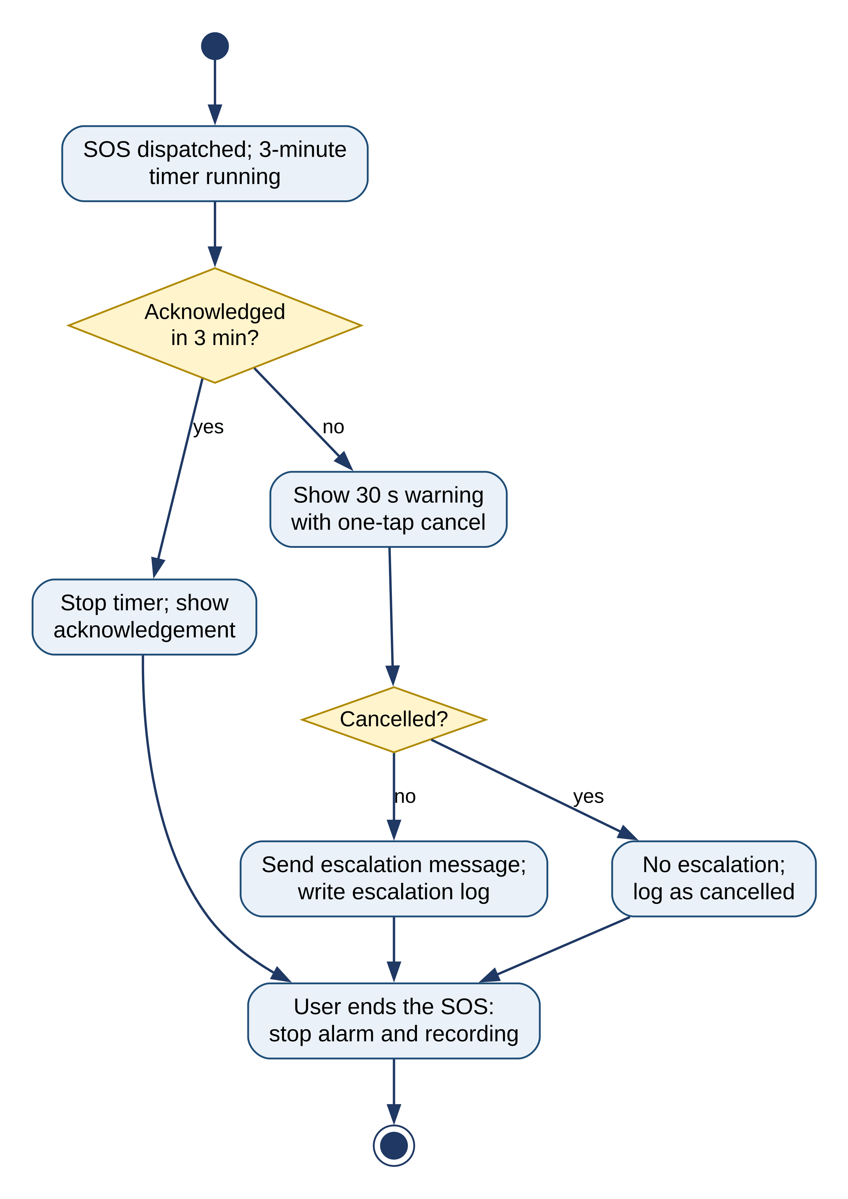
Figure 31: Activity diagram: SOS pipeline, response and escalation
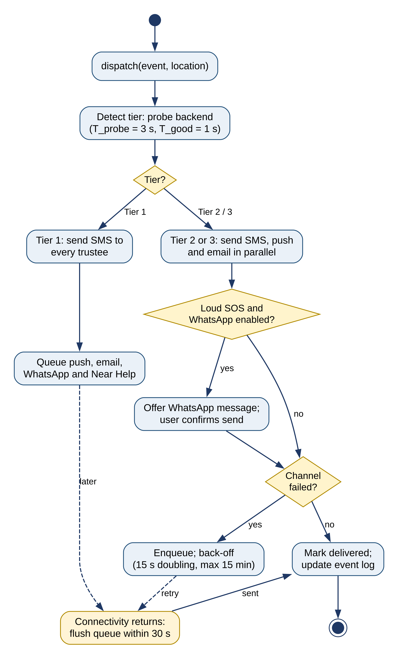
Figure 32: Activity diagram: tiered delivery and retry
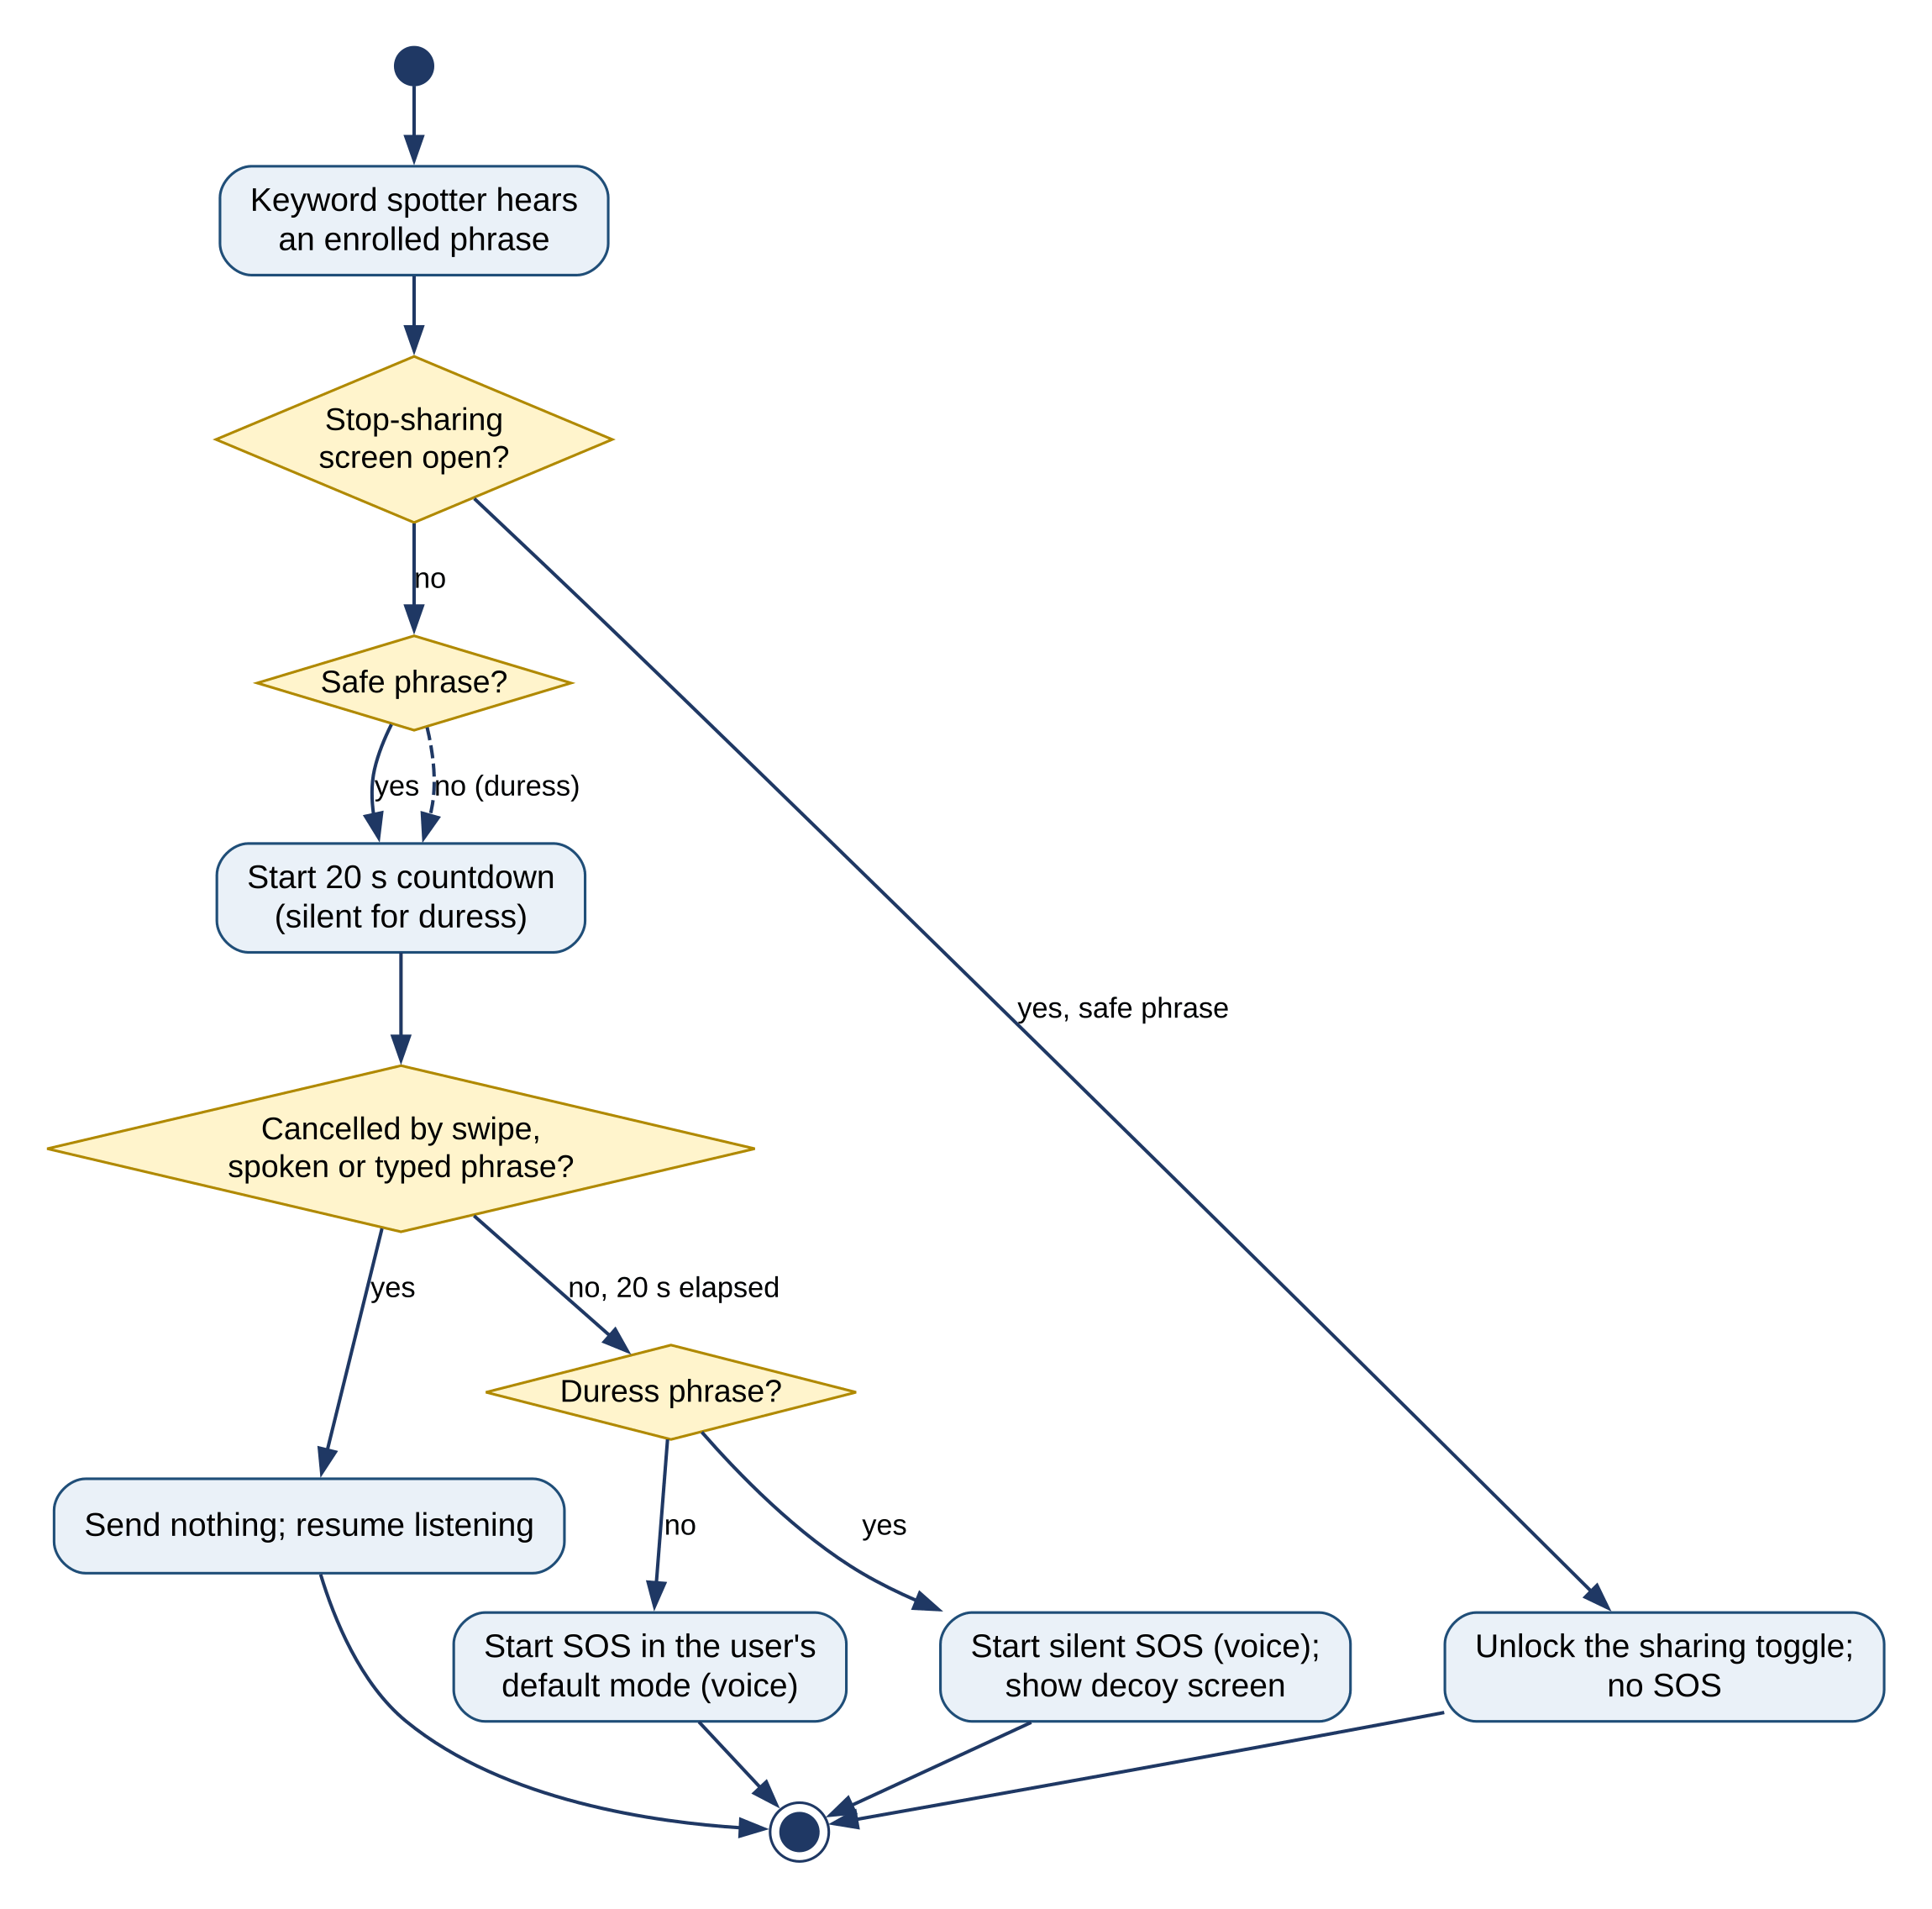
Figure 33: Activity diagram: phrase handling in context
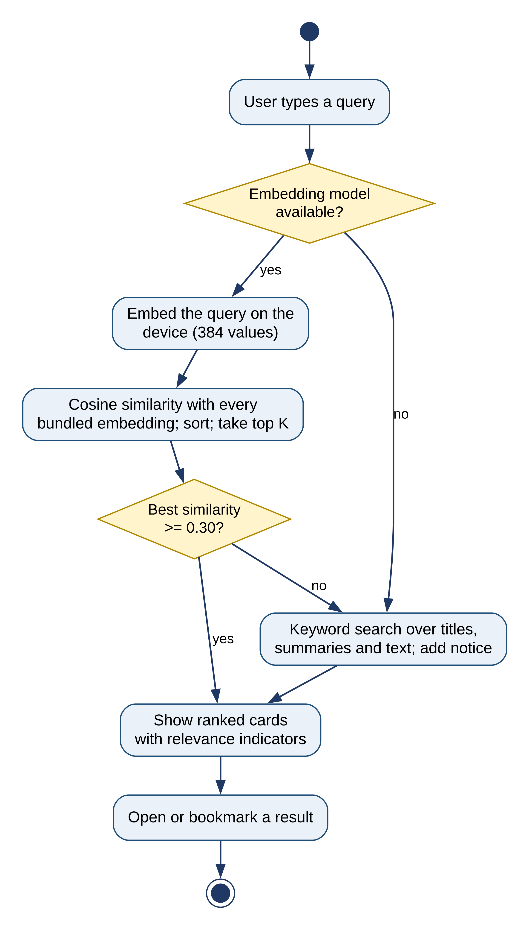
Figure 34: Activity diagram: semantic search with fallback
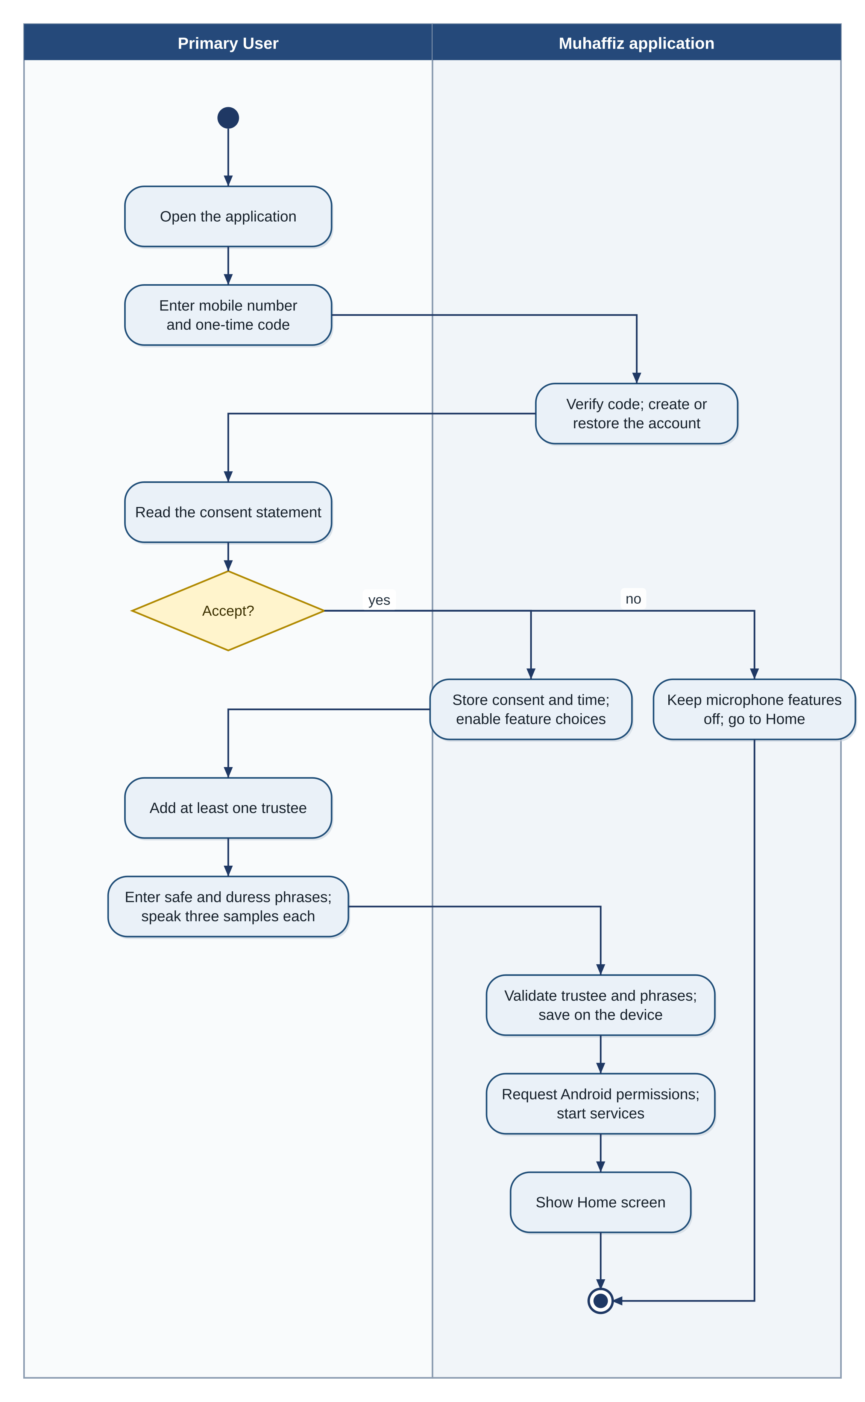
Figure 35: Activity diagram with swimlanes: onboarding and consent
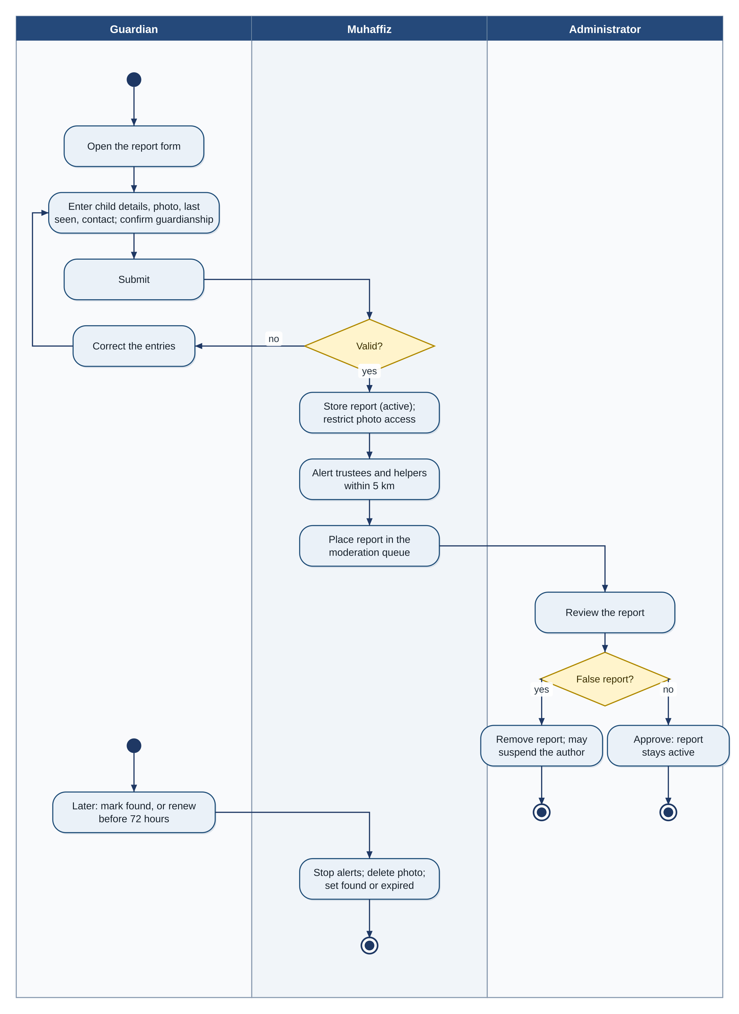
Figure 36: Activity diagram with swimlanes: missing-child report
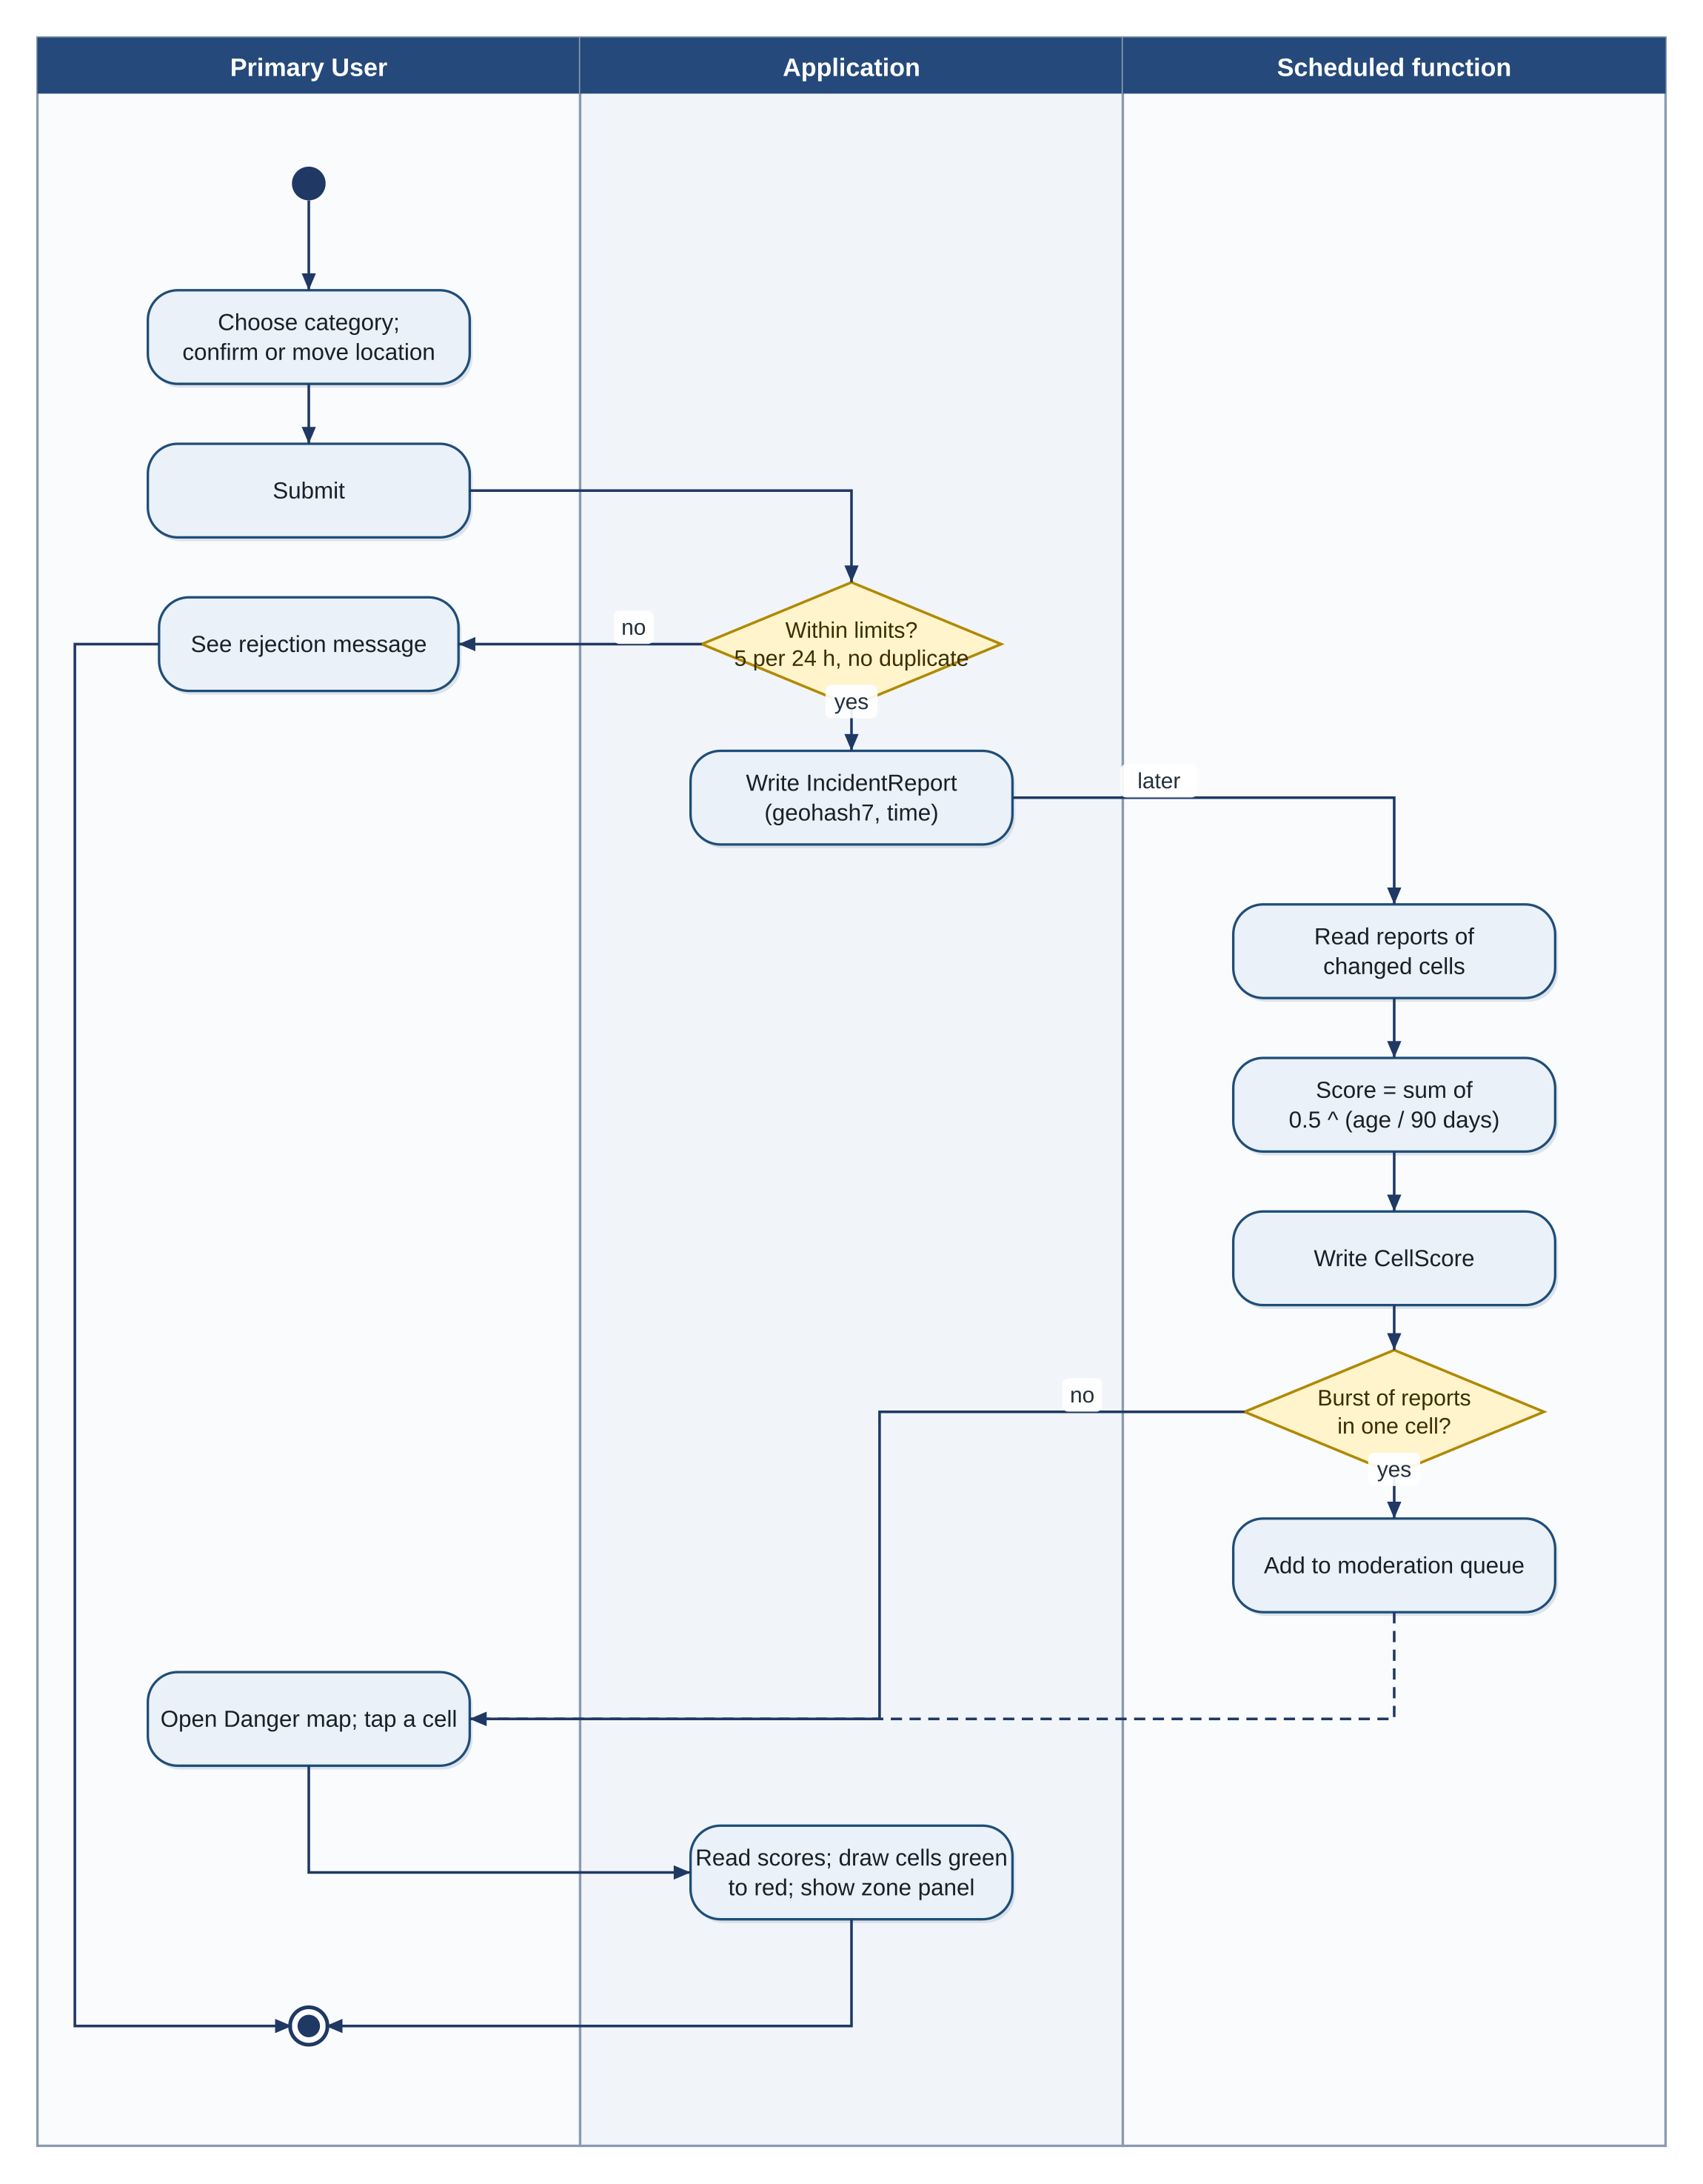
Figure 37: Activity diagram with swimlanes: incident report and heatmap
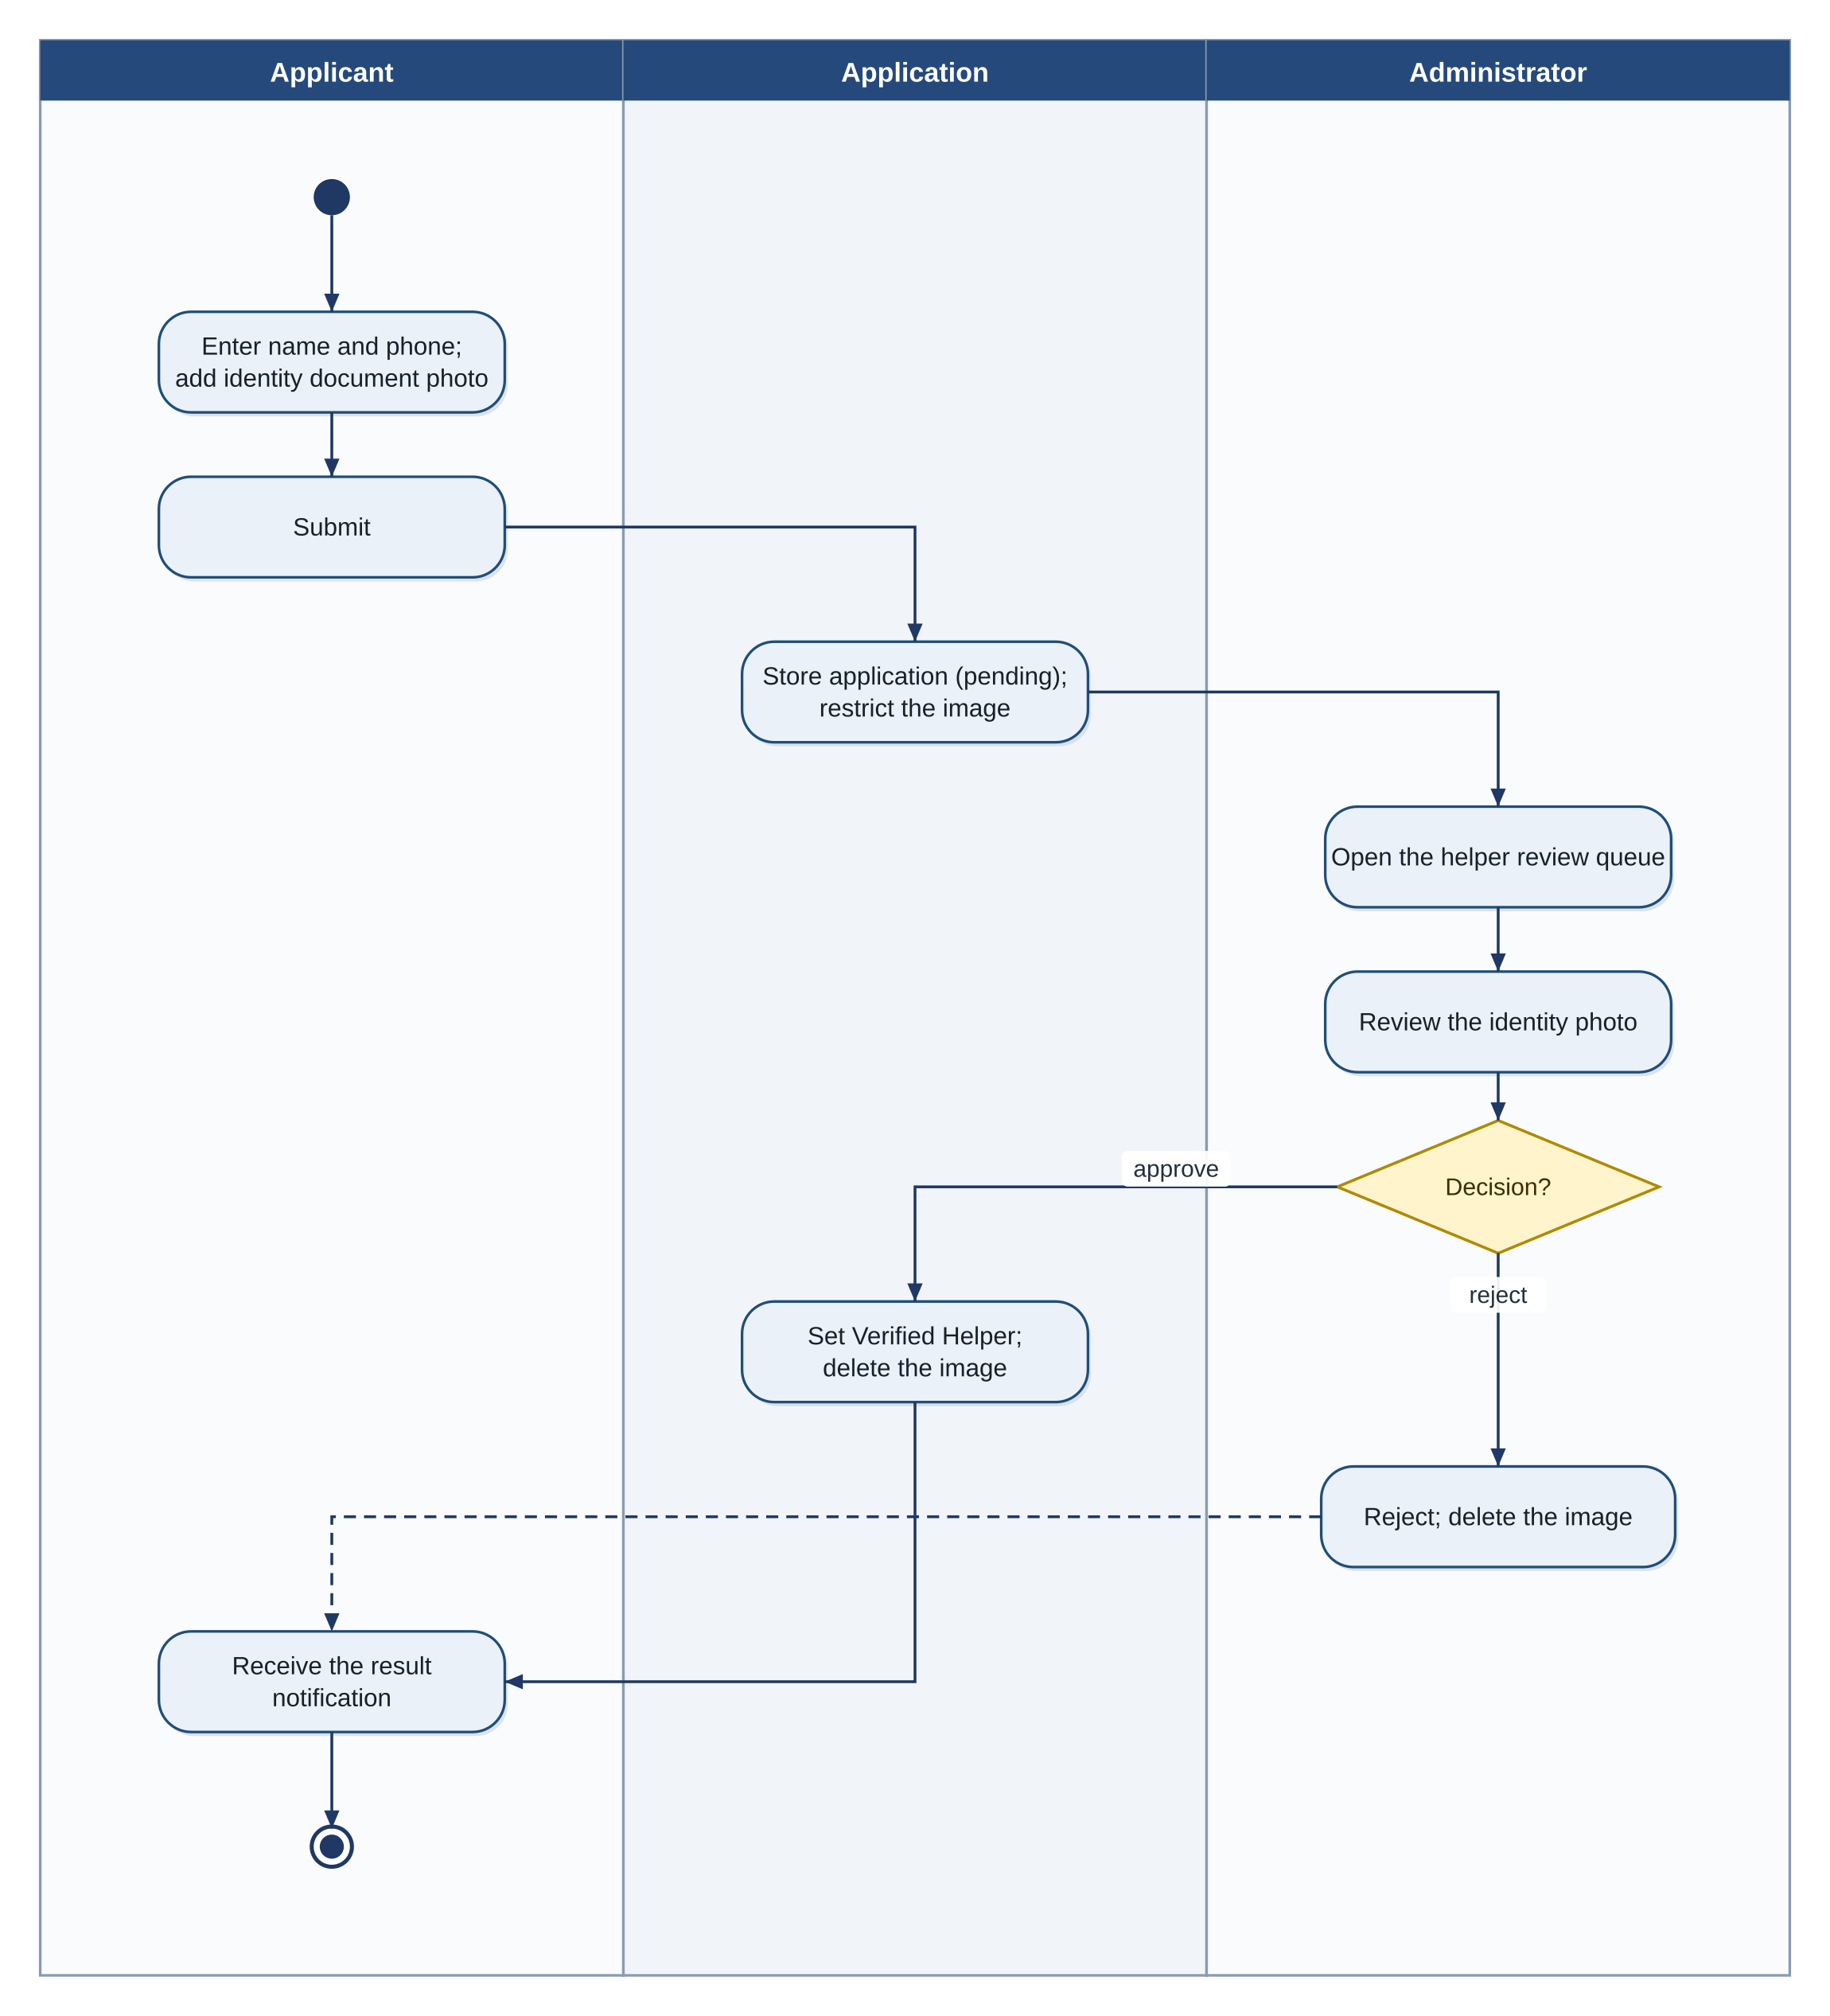
Figure 38: Activity diagram with swimlanes: helper verification
Figure 39: Activity diagram with swimlanes: nearby help

State diagrams
Figure 40 shows the first part of the life of an SOS event (trigger, countdown, dispatch) and Figure 41 the second part (response, escalation, close), with the actions performed on entering each state. Figure 42 shows the confirmation countdown. Figure 43 shows a circle member, including the stopped state in which others see only the last location, and Figure 44 the invitation. Figure 45 shows a missing-child report, Figure 46 a helper application, Figure 47 the connectivity tier, and Figure 48 an evidence recording.
Figure 40: State diagram: SOS event, trigger and dispatch
Figure 41: State diagram: SOS event, response and escalation
Figure 42: State diagram: confirmation countdown
Figure 43: State diagram: circle member and sharing
Figure 44: State diagram: circle invitation
Figure 45: State diagram: missing-child report
Figure 46: State diagram: Verified Helper application
Figure 47: State diagram: connectivity tier
Figure 48: State diagram: evidence recording

Component diagram and event-response table
Figure 49 shows the packages grouped by function and the runtime dependencies between the groups. The safety core depends on delivery and storage, which depends on the backend functions; identity and consent control the safety core; the family and community group uses delivery for push and queueing; and the knowledge group uses bundled data.
Figure 49: Component diagram
The detection, delivery and escalation behaviour is driven by events in the background, so Table 116 lists the important events, the state of the system when they occur and the response.
Table 116: Event-response table
Event | System State | Response
Sound level rises suddenly above the ambient level | Detection on; monitoring | Classify the buffered burst; read motion; apply the fusion rule (FR-02.02, FR-02.03).
Fusion rule satisfied | Monitoring | Start the 20-second countdown: vibration and a cancel control (FR-02.04).
User cancels during the countdown (swipe, spoken or typed safe phrase) | Countdown | Stop the vibration, send nothing, resume monitoring.
Countdown ends with no cancel | Countdown | Start the SOS with trigger "automatic" or "voice".
Safe phrase detected | Voice on; no stop-sharing screen open | Start the countdown and then the SOS (FR-03.04); during a countdown with spoken cancel enabled, cancel it (FR-03.05).
Safe phrase detected | Stop-sharing screen open | Unlock the sharing toggle; start no SOS; sharing stops when the toggle is switched off (FR-05.02).
Duress phrase detected | Voice on | Start the silent countdown (no vibration, no indication), then a silent SOS; show the decoy screen (FR-03.04, FR-06.01).
Connectivity tier changes | Any | Update the status strip; flush the queue if the tier is 2 or 3 (FR-12.01, FR-12.03).
Fresh location fix not obtained in 10 seconds | SOS starting | Use the cached location and state its age (FR-13.01).
Acknowledgement received | SOS active; timer running | Record it, stop the timer, show it (FR-19.01).
3-minute timer expires with no acknowledgement | SOS active | Start the 30-second warning (FR-19.03).
Warning ends with no cancel | Escalation warning | Send the escalation message and log it (FR-19.05, FR-19.06).
Device restarts | Detection or voice enabled | Restart the services and the queue worker (NFR-REL-03).
72 hours pass without renewal | Missing-child report active | Set "expired", delete the photo, stop alerts (FR-17.03).

Data Design
The information domain is divided into data held on the server in Cloud Firestore and data held only on the device. Firestore holds what must be shared between users: accounts, trustees, circles, memberships, invitations, shared locations, reports and cell scores, helper profiles and requests, acknowledgements, missing-child reports and administrator decisions. The device holds what must stay private or work offline: the SOS events and their deliveries, the outbound queue, the evidence recordings and their keys, the escalation records, the bundled library and directory, bookmarks and settings. Retention follows the rules of Chapter 3: evidence is deleted after the retention period (BR-23), heatmap reports older than 12 months are removed (NFR-PRV-02), photos are deleted when no longer needed (BR-26), and identity images are deleted after review (BR-18).
Data dictionary. Table 117 lists the entities in alphabetical order with their storage, attributes and meaning. Two further entities, the consent record and the authority numbers, are stored on the device as settings and are not drawn in the entity-relationship diagram.
Table 117: Data dictionary
Entity | Storage | Attributes (name: type) | Description
Acknowledgement | Server | id: string; sosId: string; source: enum(trustee, helper); at: timestamp | A confirmation by a trustee or a helper that they have seen the alert.
Account | Server | uid: string; phone: string; name: string; messageTemplate: string(160); defaultMode: enum; createdAt: timestamp | A registered user.
AdminDecision | Server | id: string; adminUid: string; target: string; decision: enum; at: timestamp | A logged moderation or review decision.
AuthorityNumber | Device | number: string; channel: enum(sms, call, share) | A configured authority number for escalation.
Bookmark | Device | itemId: string; createdAt: timestamp | A bookmarked library item.
CellScore | Server | geohash7: string; counts: map(category to int); score: double; updatedAt: timestamp | The aggregated, weighted report score of one cell.
ChannelDelivery | Device | id: string; sosId: string; trusteeId: string; channel: enum; status: enum; attempts: int; lastAttempt: timestamp | The delivery of one SOS message on one channel to one trustee.
Circle | Server | id: string; createdBy: string; createdAt: timestamp | A family circle.
ConsentRecord | Device | micDetection: bool; voiceActivation: bool; locationSharing: bool; acceptedAt: timestamp | The user's consent and toggles.
DirectoryEntry | Device (bundled) | id: string; name: string; category: enum; phone: string; lat, lng: double? | A hospital, police station, helpline or emergency number.
EscalationRecord | Device | id: string; sosId: string; number: string; channel: enum; status: enum; at: timestamp | One escalation message and its delivery.
EvidenceRecording | Device | id: string; sosId: string; startedAt: timestamp; duration: int; trigger: enum; encryptedPath: string | An encrypted audio recording made after an SOS.
HelperProfile | Server | uid: string; status: enum(pending, verified, rejected, revoked); verifiedAt: timestamp | The helper status of a user.
HelpRequest | Server | id: string; uid: string; geohash: string; radius: int; status: string; createdAt: timestamp | A request for nearby help.
IncidentReport | Server | id: string; uid: string; category: enum; note: string(280)?; geohash7: string; createdAt: timestamp; status: enum | A user report of an unsafe incident.
Invitation | Server | id: string; circleId: string; toPhone: string; status: enum; expiresAt: timestamp | An invitation to a circle.
LibraryItem | Device (bundled) | id: string; title: string; category: enum; summary: string; body: string; embedding: float[384] | A library article, video or link and its search embedding.
Membership | Server | id: string; circleId: string; uid: string; state: enum; sharing: bool; lastShared: (lat, lng, time) | The membership of a user in a circle and its sharing state.
MissingChildReport | Server | id: string; guardianUid: string; childName: string; age: int; photoRef: string; description: string; lastSeen: (place, time); status: enum; expiresAt: timestamp | A missing-child report.
QueueItem | Device | id: string; deliveryId: string; payload: blob; dueAt: timestamp | An outbound message waiting to be sent or retried.
SosEvent | Device | id: string; startedAt: timestamp; trigger: enum; mode: enum; location: (lat, lng); locationAge: int; status: enum | One SOS from start to close.
Trustee | Server and device | id: string; uid: string; name: string; phone: string; email: string?; channels: set | A contact who receives alerts.

ER diagrams. Figure 50, Figure 51, Figure 52 and Figure 53 show the entities. The first two show the entities held on the server in Cloud Firestore (accounts, trustees, circles and administrator decisions; then community data), and the last two the entities held on the device (SOS data, then bundled content and settings). Crow's-foot notation shows the cardinality of each relationship, and foreign keys (FK) name the related entity.
Figure 50: Entity-relationship diagram: server data, accounts and circles
Figure 51: Entity-relationship diagram: server data, community
Figure 52: Entity-relationship diagram: device data, SOS records
Figure 53: Entity-relationship diagram: device data, bundled content and settings
Normalization, indexes and constraints. The device database is relational and is kept in third normal form: a delivery refers to its SOS event and trustee by key, and a queue item refers to its delivery. The server data is document-oriented and is deliberately denormalized where a screen needs it in one read, for example the member's last shared location is stored inside the membership. Table 118 lists the indexes and the constraints that protect integrity.
Table 118: Indexes and constraints
Store | Index or Constraint | Purpose
Firestore | Index on Membership (circleId, state) | List the members of a circle and their state.
Firestore | Index on IncidentReport (geohash7, createdAt) | Load the reports of a cell and apply the 12-month limit.
Firestore | Index on HelperProfile (status) and geohash of the last position | Find verified helpers within a radius.
Firestore | Index on MissingChildReport (status, lastSeen geohash) | Find active reports near a place.
Firestore | Index on Acknowledgement (sosId, at) | Read the acknowledgements of one SOS.
Firestore rules | Account.phone is unique; (circleId, uid) is unique; age is between 0 and 17; enumerated values only | Integrity of server data.
Firestore rules | A user reads another user's location only under BR-10 to BR-14 and BR-32; only administrators read identity images | Confidentiality (NFR-SEC-03, NFR-SEC-06).
SQLite | Index on ChannelDelivery (sosId); index on QueueItem (dueAt); index on LibraryItem (category) | Fast log, retry and library queries.
SQLite | Foreign keys with delete cascade: deliveries and queue items are deleted with their SOS event | No orphan rows.

Human Interface Design
The interface is designed so that the most important action, the SOS, is available at once, and so that every protective feature is easy to reach but not obvious to a bystander. A new user passes through sign-in, consent, trustee setup and phrase enrolment, and then reaches the Home screen, from which the main areas are reached by the bottom navigation. Figure 54 shows the navigation flow, and Table 119 lists the screens with their purpose, objects, actions and related requirements.
Figure 54: Navigation flow of the application
Screen images. Figure 55 to Figure 59 show the key screens from the user's perspective: the Home, countdown and SOS-active screens, the family map, the danger map and the library search, and the decoy, stop-sharing, trustee and settings screens. The other screens are shown in Section 5.4.
Figure 55: Key screens: Home and countdown
Figure 56: Key screens: SOS active and family map
Figure 57: Key screens: danger map and library search
Figure 58: Key screens: decoy and stop sharing
Figure 59: Key screens: trustees and settings
Screen objects and actions. On the Home screen the large red SOS control starts an SOS when it is held for one second, the Loud and Silent switch selects the SOS mode, the status strip shows the connectivity tier and the state of detection and voice activation, and four tiles open the trustees, the evidence list, the directory and the safe-location guidance. On the countdown screen a ring shows the seconds left and a large button and the swipe, the spoken safe phrase or the typed safe phrase cancel the alert, as set in the settings; a loud countdown vibrates and makes no sound, and a silent countdown shows nothing. On the SOS-active screen a red banner shows that an SOS is active, a card for each trustee shows the delivery status per channel, a card shows the nearby helpers, and the Stop alarm and Evidence buttons act on the siren and the recording. The family map shows each member as a marker, a live member in green and a member who has stopped sharing in grey with the label "Not live", and a button opens the stop-sharing screen. The danger map shows green-to-red cells with a legend, and a tap on a cell opens a panel with the category counts. The library search screen has a field for a question in the user's words, category chips, an offline indicator, and result cards with a relevance bar. The decoy screen is a calculator that works normally; a two-second hold on the equals key opens the real application. The stop-sharing screen asks for the safe phrase, shows that the phone is listening, unlocks the sharing toggle when the phrase is recognised and states that nobody else is notified. The trustee screen lists trustees with a chip for each enabled channel.
Table 119: Screens of the application and the admin website
Screen ID and Name | User or Role | Purpose | Main Objects and Actions | Related FR or UC
S-01 Sign-in | Primary User | Verify the phone number | Number field, send code, code field, verify | FR-14.01, UC-19
S-02 Onboarding consent | Primary User | Obtain informed consent | Consent text, agree box, accept, not now | FR-15.01, FR-18.05, UC-20
S-03 Trustees | Primary User | Manage trustees and channels | Trustee cards, channel chips, add, edit, remove | FR-01.05, UC-04
S-04 Phrase enrolment | Primary User | Enrol the safe and duress phrases | Phrase fields, sample progress, record | FR-03.01, FR-03.02, UC-06
S-05 Home | Primary User | Start an SOS; see status | SOS control, mode switch, status strip, tiles, navigation | FR-01.01, FR-01.04, FR-12.01, UC-01
S-06 Countdown | Primary User | Cancel an automatic or voice alert | Ring, seconds, cancel button | FR-02.04, FR-03.04, UC-02, UC-03
S-07 SOS active | Primary User | Follow the SOS | Banner, delivery cards, helper card, stop alarm, evidence | FR-01.02, FR-01.03, FR-01.06, FR-19.01
S-08 Family circle | Family Circle Member | See members; invite; stop sharing | Map, member cards, invite, stop-sharing button | FR-04.01, FR-04.02, FR-05.04, UC-07, UC-08
S-09 Stop sharing | Family Circle Member | Stop sharing by safe phrase | Prompt, listening indicator, cancel, leave link | FR-05.02, FR-05.03, UC-09, UC-10
S-10 Danger map | Primary User | View the heatmap | Map, cells, legend, zone panel, report button | FR-07.04, UC-13
S-11 Incident report | Primary User | Report an incident | Category chips, location pin, note, submit | FR-07.01, UC-12
S-12 Nearby help | Primary User; Verified Helper | Request or answer help | Request card, accept, decline, offline notice | FR-08.02 to FR-08.04, UC-15
S-13 Helper registration | Primary User | Apply to become a helper | Name, phone, identity photo, submit, status | FR-08.01, UC-14
S-14 Library | Primary User | Browse and search | Search field, chips, result cards, bookmark | FR-09.01 to FR-10.05, UC-16, UC-17
S-15 Missing-child report | Guardian | File a report | Child fields, photo, guardian box, submit | FR-17.01, UC-23
S-16 Evidence list | Primary User | Manage recordings | Recording cards, export, delete, retention note | FR-18.03, FR-18.04, UC-24
S-17 Directory | Primary User | Call an emergency service | Entry cards, call buttons | FR-11.01 to FR-11.03, UC-18
S-18 Safe location | Primary User | Get guidance to the nearest safe place | Map, route line, distance card, open directions | FR-20.01 to FR-20.03, UC-26
S-19 Escalation warning | Primary User | Cancel an escalation | Seconds, cancel button | FR-19.03, UC-25
S-20 Escalation settings | Primary User | Set authority numbers and channels | Number cards, change, add | FR-19.04, UC-25
S-21 Settings and consent | Primary User | Change toggles and defaults | Switches, retention | FR-15.02, FR-14.03, UC-20
S-22 Privacy summary | Primary User | See what is stored and where | Three data cards | FR-15.03, UC-20
S-23 App disguise | Primary User | Choose an appearance | Option cards, apply | FR-21.01, FR-21.02, UC-27
S-24 Decoy | Primary User | Show a neutral screen | Calculator keys, hidden hold | FR-06.01, FR-06.02, UC-11
S-25 Admin overview | Administrator | See users, queues and delivery | Metric tiles, charts, bars | FR-16.01, FR-16.04, UC-22
S-26 Moderation queue | Administrator | Decide on flagged items | Table, approve, remove, reject | FR-16.02, FR-16.03, UC-21

Security, Error Handling and Logging Design
Authentication and authorization. Users authenticate with a one-time code sent to their phone number; administrators authenticate with email and password and hold an administrator role (FR-14.01, FR-16.05). Authorization is enforced on the server by Firestore and Storage rules, so that a client cannot read data it is not entitled to even if it is modified. Input validation is applied on the device and again by the rules and the functions. Sensitive data is handled by keeping audio on the device, encrypting evidence, deleting identity images and photos after use, and masking phone numbers in the admin website.
Error handling. A failure is handled where it occurs and isolated from the safety path: a failed channel is logged and queued, a failed model disables only its feature, a missing permission produces a prompt, and a full storage stops only the recording. User messages state the problem and the next step in at most two sentences (NFR-USA-06). Logging. The device keeps an SOS event log and an escalation log for the user, and a technical log at three levels (error, warning, information) that holds no audio, no transcript and no location trace. The backend logs function errors and delivery outcomes without user identities for the health monitoring of FR-16.04. Administrator decisions are logged with the administrator and the time. Logs on the device are private to the application, and server logs are readable only by administrators and the developers; technical logs are kept for 30 days. Table 120 lists the main threats, failures and events with their handling.
Table 120: Security, error handling and logging design
Design ID | Threat, Failure or Event | Control or Handling Strategy | Log or Alert | Related Requirement
SD-01 | A user tries to read another user's location | Firestore rules allow reads only under BR-10 to BR-14 and BR-32. | Denied requests counted in the backend log. | NFR-SEC-03, BR-32
SD-02 | A non-administrator opens the admin website | Role check on sign-in and in every rule; access denied. | Denied attempt logged. | FR-16.05, NFR-SEC-04
SD-03 | A one-time code is guessed | Lock for 10 minutes after five wrong codes; code expiry. | Lock events logged. | FR-14.01
SD-04 | An evidence file is copied from the device | AES-256-GCM encryption; key in the Keystore; private storage; no backup. | No log of file content. | FR-18.02, NFR-SEC-02
SD-05 | Audio would leave the device | The detection and voice packages have no network access; tests inspect traffic. | Test alert if traffic appears. | FR-02.05, NFR-SEC-05
SD-06 | A model file is missing or corrupt | Disable the feature, tell the user, keep manual SOS. | Warning logged on the device. | NFR-ROB-01
SD-07 | The SMS permission is missing | Prompt (loud mode) and use other channels. | Event logged with the missing permission. | FR-12.02, UC-01 E1
SD-08 | No data connection | Use SMS; queue the other channels; retry later. | Delivery status in the SOS log. | FR-12.03, BR-05
SD-09 | The monitoring service is stopped by the system | Restart by the system and after reboot; onboarding explains battery settings. | Restart logged. | FR-02.01, NFR-REL-03
SD-10 | A report spam or malicious flagging of an area | Rate limits, near-duplicate check, burst detection and moderation. | Moderation queue entry. | FR-07.05, BR-15
SD-11 | A person pretends to be a helper | Identity check by an administrator before approval; revocation. | Decision logged. | FR-08.01, FR-16.03, BR-18
SD-12 | A false missing-child report | Immediate review queue, removal, author suspension, rate limit. | Decision logged. | FR-17.05, BR-27
SD-13 | A child photo or identity image is exposed | Storage rules; deletion on found, expiry or decision. | Deletion logged. | FR-17.06, NFR-SEC-06
SD-14 | Malformed or oversized input | Validation on the device, in the rules and in the functions. | Rejected input counted. | NFR-ROB-02
SD-15 | Low storage during an SOS | Stop the recording; continue the SOS. | Entry in the SOS log. | NFR-ROB-03
SD-16 | The application is killed during an SOS | The queue and the SOS state are stored in SQLite and resumed at start. | Resume logged. | NFR-REL-02
SD-17 | A function or the backend fails | The safety path does not call the backend; functions are retried; errors are shown to administrators. | Function error log. | NFR-AVL-01, FR-16.04
SD-18 | The phone is forced open by another person | Decoy screen and app disguise; duress phrase. | No visible log entry. | FR-06.01, FR-21.01, BR-28

Risk Analysis and Sprint Plan
Table 121 lists the risks with their probability and impact (High, Medium or Low), their mitigation or contingency, and the owner. Muhammad Shamoil owns the detection, voice, search, SOS front end, decoy, consent, evidence, escalation and disguise modules and the interface design; Ali Raza owns the backend, family, location, heatmap, Near Help, missing-child, delivery, navigation, authentication and admin modules and the deployment.
Table 121: Risk analysis
Risk ID | Risk | Probability | Impact | Mitigation or Contingency | Owner
RSK-01 | The pre-trained sound classifier produces too many false alarms or misses. | Medium | High | Confirm-or-cancel countdown; fusion with motion; evaluate on labelled clips and tune thresholds; manual SOS is the primary path. | M. Shamoil
RSK-02 | The keyword spotter is unreliable for local accents or Urdu phrases. | Medium | High | Test with team and volunteer voices; use the sensitivity set at enrolment; fall back to openWakeWord or Vosk; manual SOS remains. | M. Shamoil
RSK-03 | Android stops background services to save battery. | High | High | Foreground services; request battery-optimisation exemption in onboarding; restart logic; test on several manufacturers. | M. Shamoil
RSK-04 | Battery use of monitoring is too high. | Medium | Medium | Spike gate keeps classification rare; measure against NFR-PER-10; reduce sampling if needed. | M. Shamoil
RSK-05 | SMS cannot be sent because of permission policy or carrier limits. | Medium | High | Request the permission clearly; test on several carriers; provide the other channels and the queue. | A. Raza
RSK-06 | WhatsApp cannot send without the user. | High | Low | Treated as user-confirmed; SMS, push and email are the automatic channels (BR-04). | A. Raza
RSK-07 | Near Help is not useful because few helpers are nearby. | High | Medium | Evaluate with simulated helpers and label them as such; fall back to trustees by SMS. | A. Raza
RSK-08 | Authorities do not act on, or accept, escalation messages. | Medium | High | Describe the hand-off precisely; let the user choose channels; confirm numbers before use (Appendix C). | M. Shamoil
RSK-09 | Privacy or consent concerns about listening. | Medium | High | Explicit consent, on-device processing, no audio storage, privacy summary, tests that inspect traffic and storage. | M. Shamoil
RSK-10 | Coercion defeats the consent model despite the safeguards. | Medium | Medium | Document the limit; use the safe phrase, the decoy and the last-known display; do not claim it is solved. | A. Raza
RSK-11 | Firebase free-tier limits are exceeded. | Low | Medium | Quota calculation; movement-based updates; scheduled aggregation; reduce listener scope. | A. Raza
RSK-12 | False or abusive reports and helper applications. | Medium | Medium | Rate limits, moderation queue, identity review, revocation. | A. Raza
RSK-13 | The schedule is too short for all 21 modules. | Medium | High | Build in priority order; the Low modules (MOD-20, MOD-21) are dropped first, then Medium modules, without touching the core. | Both
RSK-14 | Offline map data licence or size is a problem. | Medium | Low | Limit to three areas; choose a source that permits storage; guidance works with distance and direction alone. | A. Raza
RSK-15 | A device or Android version behaves differently. | Medium | Medium | Test on at least three device models; isolate platform code in the platform layer. | Both
RSK-16 | The microphone indicator of Android reveals recording in a silent SOS. | High | Low | Cannot be hidden; documented as a limitation; evidence can be switched off in the settings. | M. Shamoil

Table 122 lists the milestones in the order in which they are built. The plan uses milestones and not calendar dates; the dependencies show why the order is fixed.
Table 122: Milestone plan
Sprint or Milestone | Objectives | Requirements or Modules | Deliverables | Dependencies | Status
M1 Foundation | Project skeleton, theme, navigation, local database, authentication, consent flow, configuration | MOD-14, MOD-15, MOD-13 | Running application with sign-in, onboarding and settings | None | Scheduled
M2 Core SOS and delivery | Manual SOS, trustees, dispatch on all channels, loud and silent modes, tiers, queue and retry, event log | MOD-01, MOD-12, MOD-13 | Working SOS delivered by SMS at Tier 1 and by all channels at Tiers 2 and 3 | M1 | Scheduled
M3 Detection and voice | Monitoring service, classifier, fusion, countdown, keyword spotting, phrase enrolment, shared hook | MOD-02, MOD-03 | Automatic and voice SOS with cancel | M2 | Scheduled
M4 Family network and decoy | Circles, invitations, movement-based sharing, opt-out, last-known display, decoy | MOD-04, MOD-05, MOD-06 | Family map with duress-aware sharing; decoy screen | M1, M3 | Scheduled
M5 Community and admin | Incident reports, geohash aggregation, heatmap, helper registration, Near Help, admin site | MOD-07, MOD-08, MOD-16 | Heatmap, nearby help and moderation | M2 | Scheduled
M6 Knowledge | Library, semantic search, directory, safe-location guidance, offline maps | MOD-09, MOD-10, MOD-11, MOD-20 | Offline library with search; directory; guidance | M1 | Scheduled
M7 Follow-through | Evidence recording, escalation, missing-child report, app disguise | MOD-17, MOD-18, MOD-19, MOD-21 | Evidence, escalation, missing-child alerts, disguise | M2, M5 | Scheduled
M8 Evaluation and hardening | Test execution, detection and search evaluation, fixes, documentation | All modules | Test results, evaluation, final documents | M1 to M7 | Scheduled

Chapter Summary
This chapter chose an object-oriented, layered and partly event-driven design built in risk-driven milestones, recorded the main architecture decisions, presented the class, sequence, activity, state and component models, the data design with the entity-relationship diagram, the screens and their navigation, the security, error-handling and logging design, and the risks and milestones. Chapter 5 now describes the algorithms, external components, backend interfaces, user interface and deployment that realize this design.

Implementation and Deployment
Chapter Overview. This chapter describes how the design is realized. Section 5.1 gives the core algorithms with pseudocode, Section 5.2 lists the external APIs and SDKs, Section 5.3 specifies the interfaces of the project backend, Section 5.4 presents the user interface of each subsystem, and Section 5.5 describes the deployment. Source code is not reproduced.

Algorithms
The core behaviour of Muhaffiz is implemented by ten algorithms: the sound-level gate, the distress decision with fusion, the trigger and SOS pipeline, the tiered dispatch with retry, the phrase handling in context, the movement-based location publication, the heatmap cell score, the semantic search, the escalation timer, and the nearest safe location. Their constants are held in one configuration (NFR-MNT-02) and are listed in Table 123; the values are the defaults that the evaluation of Chapter 6 may tune.
Table 123: Algorithm parameters and default values
Parameter | Meaning | Default | Related
T_amb | Window for the rolling ambient sound level | 10 s | FR-02.01
D_spike | Rise above the ambient level that counts as a sudden loud sound, for at least two consecutive 30 ms frames | 15 dB | FR-02.01
T_buf | Length of the in-memory audio burst passed to the classifier | 2 s | FR-02.02
θ_audio | Distress score at or above which the audio result counts as distress | 0.60 | FR-02.03
θ_high | Distress score at or above which the audio result alone satisfies the fusion rule | 0.85 | FR-02.03
W_motion | Motion window around the burst (2 s before to 3 s after) | 5 s | FR-02.03
A_dev, G_rot | Motion anomaly: acceleration deviation from gravity, or rotation rate | 15 m/s²; 6 rad/s | FR-02.03
T_count | Confirmation countdown | 20 s | FR-02.04, BR-02
T_confirm | Time allowed for the safe phrase on the stop-sharing screen | 15 s | FR-05.02
T_fix | Wait for a fresh location fix at SOS start | 10 s | FR-13.01, BR-06
D_min | Movement that triggers a location publication | 50 m | FR-05.01
T_probe, T_good | Backend probe timeout; round-trip time for Tier 3 | 3 s; 1 s | FR-12.01
B0, B_max | First retry delay and maximum delay (doubling) | 15 s; 15 min | FR-12.03
P_geo, H | Geohash precision; report half-life | 7; 90 days | FR-07.02, FR-07.03
τ_sim, K | Similarity threshold for semantic results; number of results | 0.30; 10 | FR-10.04, FR-10.05
T_ack, T_warn | No-response timer; warning countdown | 180 s; 30 s | FR-19.02, FR-19.03
R_help, R_child | Helper radius; missing-child alert radius | 1 km; 5 km | FR-08.02, FR-17.02

Table 124: Algorithm: sound-level gate (A1)
Algorithm: sound-level gate (A1)
Input: a stream of 30 ms audio frames
Output: a burst of T_buf seconds when a sudden loud sound occurs, otherwise nothing
1: ambient ← 0; ring ← empty buffer of T_buf seconds; run ← 0
2: for each frame f from the microphone do:
3: level ← decibelLevel(f); push f into ring; discard the oldest frame
4: if level > ambient + D_spike then run ← run + 1 else run ← 0
5: if run ≥ 2 then
6: emit burst(copy of ring); run ← 0; clear ring
7: else if run = 0 then
8: ambient ← slidingMean(ambient, level, T_amb)
9: end for
10: all frames and the ring exist in memory only
Complexity: O(1) time per frame; O(T_buf) memory.

Table 125: Algorithm: distress decision with fusion (A2)
Algorithm: distress decision with fusion (A2)
Input: a burst from A1; the motion window
Output: a countdown request, or no action
1: score ← classifier.score(burst) // distress probability, no transcript
2: discard burst
3: if score < θ_audio then return none
4: motion ← motionAnomaly(window W_motion, A_dev, G_rot)
5: if motionSensorsAvailable = false then ok ← (score ≥ θ_high)
6: else ok ← (motion = true) or (score ≥ θ_high)
7: if ok = false then return none
8: return countdown(T_count, trigger = automatic)
Complexity: O(1) per burst after the classifier inference, which is a fixed-size neural-network pass.

Table 126: Algorithm: trigger arbitration and SOS pipeline (A3)
Algorithm: trigger arbitration and SOS pipeline (A3)
Input: a trigger t (manual, automatic or voice) and a mode m
Output: an SOS event with dispatch, evidence and timers started
1: if t = manual then goto start
2: show countdown for T_count (vibration if m = loud; none if m = silent)
3: if user cancels within T_count by an enabled method then return // nothing is sent
4: start:
5: event ← new SosEvent(t, m, now)
6: location ← fix within T_fix, else cachedLocation with its age
7: in parallel do:
8: evidence.start(event)
9: escalation.start(event, T_ack)
10: if m = loud then playSiren() else stayQuiet()
11: delivery.dispatch(event, location) // see A4
12: log(event)
Complexity: O(c) for c trustee-channel pairs.

Table 127: Algorithm: tiered dispatch and queue retry (A4)
Algorithm: tiered dispatch and queue retry (A4)
Input: an event, a location and the trustee list
Output: delivery statuses; undelivered messages queued
1: tier ← detectTier(T_probe, T_good)
2: for each trustee u do:
3: channels ← u.channels, or {sms} if empty
4: send SMS(u) // always, uses no data
5: if tier ≥ 2 then
6: for each channel c in {push, email} ∩ channels do send(c, u)
7: else enqueue({push, email, nearHelp}, u)
8: if whatsapp ∈ channels and m = loud then offerWhatsapp(u)
9: on result r of any send: if r = failed then enqueue(message) else markSent(message)
10: on tier change to ≥ 2: delay ← B0; for each queued item q do try send(q);
11: if failed then reschedule(q, min(2 × delay, B_max)) else markDelivered(q)
Complexity: O(c) per dispatch; each retry round is O(q) for q queued items.

Table 128: Algorithm: phrase handling in context (A5)
Algorithm: phrase handling in context (A5)
Input: a phrase detection p ∈ {safe, duress} and the current context
Output: an action
1: if context = countdown and p = safe and cancelBySpeech then
2: countdown.cancel(); return // nothing is sent
3: if context = stopSharingScreen and p = safe then
4: toggle.unlock(); return // sharing stops when the toggle is switched off
5: if p = safe then return trigger(voice, defaultMode) // A3 with countdown
6: if p = duress then
7: decoy.show(); return trigger(voice, silent)
8: if context = stopSharingScreen and no phrase within T_confirm then closeScreen()
Complexity: O(1) per detection.

Table 129: Algorithm: movement-based location publication (A6)
Algorithm: movement-based location publication (A6)
Input: location updates and the member's sharing flag
Output: published locations
1: last ← null
2: for each location update x do:
3: if sharing = false then continue
4: if last = null or distance(last, x) > D_min then
5: publish(x, now); last ← x
6: on stopSharing(): sharing ← false; freeze(last) // others see last, "Not live"
Complexity: O(1) per update.

Table 130: Algorithm: heatmap cell score (A7)
Algorithm: heatmap cell score (A7)
Input: the reports R of a cell
Output: the score of the cell and its category counts
1: score ← 0; counts ← empty map
2: for each report r in R do:
3: age ← now − r.createdAt (in days)
4: score ← score + 0.5 ^ (age / H)
5: counts[r.category] ← counts[r.category] + 1
6: return (score, counts) // colour = scale(score)
Complexity: O(n) per cell for n reports; run by a scheduled function per changed cell.

Table 131: Algorithm: semantic search with keyword fallback (A8)
Algorithm: semantic search with keyword fallback (A8)
Input: a query string q and the bundled embeddings E
Output: a ranked list of at most K items
1: if embedder.available = false then return keywordSearch(q)
2: v ← embedder.embed(q) // on device, 384 values
3: for each item i do: sim[i] ← dot(v, E[i]) / (norm(v) × norm(E[i]))
4: sort items by sim descending; top ← first K items
5: if sim[top[0]] < τ_sim then return keywordSearch(q)
6: return top with relevance = sim
Complexity: O(N·d) for N items and d = 384; embedding the query is one model pass.

Table 132: Algorithm: escalation timer (A9)
Algorithm: escalation timer (A9)
Input: an SOS event and the authority numbers
Output: an escalation message, a cancellation or an acknowledgement
1: wait up to T_ack for an acknowledgement
2: if acknowledgement received then stop; return
3: show warning for T_warn with one-tap cancel
4: if cancelled then log("cancelled"); return
5: msg ← compose(name, callback, location and age, time, trigger, evidenceExists)
6: for each number n do: send(msg, n.channel); log(n, status)
Complexity: O(a) for a authority numbers.

Table 133: Algorithm: nearest safe location (A10)
Algorithm: nearest safe location (A10)
Input: a position p and the directory entries with coordinates
Output: the nearest entry, its distance and its bearing
1: best ← null
2: for each entry e of category hospital or police do:
3: d ← haversine(p, e.position)
4: if best = null or d < best.d then best ← (e, d)
5: bearing ← initialBearing(p, best.e.position) // degrees from north
6: return (best.e, best.d, bearing)
Complexity: O(n) for n entries.

External APIs/SDKs
Table 134 lists the third-party APIs and SDKs. Versions are pinned in the dependency lock files of the project; the table gives the major version or the family.
Table 134: External APIs and SDKs
Name and Version | Description | Purpose of Usage | Endpoint, Function or Module
Flutter 3.x (stable) and Dart 3.x | Cross-platform UI toolkit and language. | User application and admin website. | All screens and packages.
Firebase Authentication (FlutterFire, current stable) | Identity service. | Phone sign-in and administrator sign-in. | verifyPhoneNumber, signInWithEmail.
Cloud Firestore (FlutterFire) | Real-time document database with offline cache. | Shared data and acknowledgements. | collection, snapshots, transactions.
Firebase Cloud Messaging | Push delivery. | Alerts and help requests. | send by token; topic by geohash.
Cloud Storage for Firebase | File storage with rules. | Identity images and child photos. | putFile, getDownloadURL, delete.
Cloud Functions for Firebase (Node.js) | Server-side functions. | Email, acknowledgement, scheduled jobs. | HTTPS callable; scheduled; Firestore triggers.
Firebase Hosting | Static and dynamic web hosting. | Admin website and alert page. | Custom domains, rewrites to functions.
Google Maps SDK for Android 18.x | Interactive maps. | Heatmap, family map and online guidance. | GoogleMap, Polygon, Marker.
Open map data and an open-source map renderer (for example MapLibre) | Offline map areas. | Maps without a connection. | Region download; offline style.
TensorFlow Lite 2.x | On-device inference runtime. | Sound classification; embedding. | Interpreter.run.
YAMNet-class audio-event model | Pre-trained sound classifier [5]. | Distress sound score. | Input 0.975 s frames; class scores.
sherpa-onnx keyword spotter | Open-source offline keyword spotting [6]. | Safe and duress phrases. | Keyword spotter with a typed phrase.
MiniLM-class sentence-embedding model (384 dimensions) | Sentence embeddings [7]. | Semantic library search. | embed(text).
Drift on SQLite | Local relational database. | Queue, log, library, directory. | Tables and DAOs.
Riverpod 2.x | State management. | Providers for all modules. | Provider, Notifier.
Android WorkManager 2.x | Persistent background work. | Queue retries; expiry jobs. | OneTimeWorkRequest.
Android SmsManager (API 26 and later) | SMS sending. | SOS and escalation SMS. | sendMultipartTextMessage.
Android Keystore | Hardware-backed key storage. | Evidence key. | KeyGenerator AES-256.
Fused Location Provider | Location source. | Fixes and movement. | requestLocationUpdates.
Email delivery service (to be selected, Appendix C) | Transactional email. | Email alerts. | HTTPS API called from a function.

REST API Specification
The project backend exposes the HTTPS interfaces in Table 135. The alert page and the interfaces used by it are served from the alert subdomain through Firebase Hosting rewrites (alert.muhaffiz.live); the administrator interfaces are served from muhaffiz.me under the path /api/v1. Requests and responses use JSON, except the alert page, which is HTML. Scheduled functions, which have no HTTP interface, compute the cell scores, expire missing-child reports and invitations, and remove reports older than 12 months.
Table 135: Project backend interfaces
API ID | Method | Endpoint | Purpose | Authentication | Request | Success Response | Errors
API-01 | POST | /v1/alerts/email | Send the email copy of an SOS (FR-01.02). | User ID token | {sosId, recipients[], text, lat, lng, time} | 202 {accepted} | 400 invalid; 401; 429 rate; 502 provider
API-02 | POST | /v1/alerts/push | Push an SOS to trustees who have the application. | User ID token | {sosId, phones[], text, lat, lng} | 202 {sent} | 400; 401; 429
API-03 | GET | /alert/{token} | Show the alert page with location and time. | Unguessable token | - | 200 HTML | 404 unknown; 410 expired
API-04 | POST | /alert/{token}/ack | Record a trustee acknowledgement (FR-19.01). | Unguessable token | {name?} | 200 {recorded} | 404; 409 duplicate; 410
API-05 | POST | /v1/help-requests | Create a help request and notify helpers in the radius (FR-08.02). | User ID token | {lat, lng} | 201 {id, notified} | 400; 401; 429
API-06 | GET | /v1/heatmap/cells | Return cell scores for the viewport (FR-07.04). | User ID token | ?bbox=... | 200 [{geohash7, score, counts}] | 400; 401
API-07 | POST | /api/v1/admin/reports/{id}/decision | Decide on a flagged report (FR-16.02). | Administrator token | {decision, suspendAuthor?} | 200 {status} | 403; 404; 409
API-08 | POST | /api/v1/admin/helpers/{uid}/decision | Approve, reject or revoke a helper (FR-16.03). | Administrator token | {decision} | 200 {status} | 403; 404; 409
API-09 | GET | /api/v1/admin/metrics | Return delivery success and errors (FR-16.04). | Administrator token | ?from&to | 200 {byChannel, errors[]} | 403; 400

Implemented User Interface
This section presents the interface of each subsystem that is not shown in Section 4.5. The mobile application is shown in Figure 60 to Figure 66, and the admin website in Figure 67 and Figure 68.
Figure 60: Mobile application: privacy summary and consent
Figure 61: Mobile application: sign-in and phrase enrolment
Figure 62: Mobile application: incident report and nearby help
Figure 63: Mobile application: helper registration and missing-child report
Figure 64: Mobile application: evidence and directory
Figure 65: Mobile application: safe-location guidance and escalation warning
Figure 66: Mobile application: escalation settings and app disguise
The onboarding screens collect the consent and prepare the safety features: the consent screen states what the microphone is used for and that processing stays on the phone; the sign-in screen verifies the phone number; the phrase screen enrols the safe and the duress phrase with three spoken samples each. The settings screen holds one switch for each sensor-based feature, and the privacy summary lists where data are kept. The incident form takes a category, a location that can be adjusted on the map and an optional note. The nearby-help screen shows a request with distance and age and the accept and decline buttons, and states plainly when it is unavailable offline. The evidence list shows each recording with export and delete actions, the directory offers a call button for each service, and the safe-location screen shows the nearest hospital or police station with its distance and direction. The escalation warning counts down from 30 seconds with a single cancel button.
Figure 67: Admin website: overview
Figure 68: Admin website: moderation queue
The admin website has a side menu with the overview, the moderation queue, the helper review and the health pages. The overview shows registration counts, pending helpers, items to review and the delivery success by channel, with phone numbers masked. The moderation queue lists flagged heatmap reports, missing-child reports and helper applications with the decision buttons; every decision is logged.

Deployment
Environments. Table 136 describes the three environments. The deployment view in Figure 7 shows where each part runs in production.
Table 136: Deployment environments
Environment | Purpose | Backend | Data | Access
Development | Daily work on each package | Firebase Local Emulator Suite and a development project | Generated test data | The two developers
Testing | Execution of the test plan on devices | A separate test Firebase project | Seeded accounts, reports and helpers, labelled as simulated | Developers and test users
Production | The system as used | The production Firebase project with muhaffiz.me and alert.muhaffiz.live | Real user data under the privacy rules | Users; administrators

Server setup. The Firebase projects are created with Authentication (phone and email providers), Cloud Firestore in native mode with the security rules and indexes of Section 4.4, Cloud Storage with its rules, Cloud Functions in a single region, Cloud Messaging and Hosting. The custom domains are connected to Firebase Hosting through DNS records: muhaffiz.me serves the admin website and alert.muhaffiz.live serves the alert page; HTTPS certificates are provisioned by the platform. Administrator accounts are created by the project owner and given the administrator role claim.
CI/CD. Source code is kept in a Git repository. On each push a pipeline analyses the code, runs the unit tests and the rule tests against the emulator, and builds the application package. A tagged release additionally deploys the rules, indexes, functions and hosting to the target project with the Firebase command line, and produces a signed installable package of the application for test users.
Backup and monitoring. Server data are exported with the Firebase command line before each release. Evidence recordings are deliberately excluded from every backup, because they exist only on the device (BR-23). Monitoring uses the usage dashboards of the platform for quota, a crash-reporting service for the application, and the Health page of the admin website for delivery success and backend errors (FR-16.04). Deployment diagram. Figure 7 is the deployment diagram of the system.

Chapter Summary
This chapter gave the default parameters and the pseudocode of ten core algorithms, the third-party APIs and SDKs, the nine backend interfaces, the screens of the application and the admin website, and the environments, setup, pipeline and monitoring used for deployment. Chapter 6 now defines how the system is tested and evaluated.

Testing, Evaluation and Conclusion
Chapter Overview. This chapter defines how the system is verified against its requirements. Sections 6.1 to 6.5 give the test cases at each level, Section 6.6 the test summary and defect log, Section 6.7 the requirements traceability matrix, and Section 6.8 the conclusion, limitations and future enhancements. Every functional requirement, business rule and non-functional requirement is covered by at least one test case, and the matrix shows which. The columns Actual Result, Observed Result and Result of each table record the outcome of the execution of the test case; a hyphen in these columns means that the test case has not yet been executed.
Tests are executed in the testing environment of Section 5.5. Where users or helpers are needed for a test, simulated accounts are used and are identified as simulated in the test log. The reference device is a mid-range Android phone running Android 8.0 or later, and its model is recorded in the test log. Timing and battery targets are measured on the reference device.

Unit Testing
Unit tests check individual functions, classes and algorithms with fixed inputs. Table 137 lists test cases UT-01 to UT-24.
Table 137: Unit test cases
No. | Test Case or Script | Input Attribute and Value | Expected Result | Actual Result | Result
UT-01 | Sound-level gate emits a burst (A1) | 20 s of quiet frames, then two consecutive frames 20 dB above ambient | Exactly one 2-second burst is emitted; ambient level is not raised by the loud frames. | - | -
UT-02 | Sound-level gate ignores a single loud frame (A1) | One frame 20 dB above ambient between quiet frames | No burst is emitted. | - | -
UT-03 | Fusion rule decision table (A2) | Scores 0.50, 0.70, 0.90 each with motion true, false and sensors unavailable | Countdown only for: 0.70 with motion; 0.90 with or without motion or sensors; 0.70 without sensors gives none; 0.50 gives none. | - | -
UT-04 | Manual trigger has no countdown (A3) | trigger = manual | The pipeline starts at once; no countdown is created. | - | -
UT-05 | Countdown boundary (A3) | Cancel at 19.9 s by each enabled method; cancel by a method that is not enabled; no cancel until 20.0 s | Cancel at 19.9 s sends nothing; a disabled method does not cancel; expiry at 20.0 s starts the SOS with the trigger recorded. | - | -
UT-06 | Tier 1 dispatch (A4) | tier = 1; 2 trustees with SMS and email | SMS sent to both; email queued; no push or email request made. | - | -
UT-07 | Retry back-off (A4) | Eight consecutive failures of one item | Delays 15, 30, 60, 120, 240, 480, 900, 900 seconds. | - | -
UT-08 | Phrase handling in context (A5) | Safe phrase on the stop-sharing screen; safe phrase on Home; safe phrase during a countdown with spoken cancel enabled; duress phrase | Toggle unlocked and no SOS; countdown starts; countdown cancelled and nothing sent; decoy shown and silent countdown starts. | - | -
UT-09 | Movement threshold (A6) | Updates at 49 m and 51 m from the last published position | No publication at 49 m; publication at 51 m. | - | -
UT-10 | Report weighting (A7) | Reports aged 0, 90 and 180 days | Weights 1.0, 0.5 and 0.25; cell score is their sum. | - | -
UT-11 | Semantic ranking and fallback (A8) | Fixture embeddings; a query with best similarity 0.55 and one with 0.20 | Ranked by similarity in the first case; keyword results in the second. | - | -
UT-12 | Escalation timing (A9) | Acknowledgement at 179 s; no acknowledgement | No escalation in the first case; warning at 180 s and message after 30 s in the second. | - | -
UT-13 | Nearest location distance (A10) | Two known coordinates and a three-entry directory | Haversine distance within 1% of the reference; the nearest entry is chosen. | - | -
UT-14 | Trustee validation | Phone "12ab"; empty name; 11th trustee | Each is rejected with a message. | - | -
UT-15 | Template validation | Template of 161 characters; empty template | Both rejected; 160 characters accepted. | - | -
UT-16 | Phrase validation | One-word phrase; six-word phrase; duress containing the safe phrase | Each rejected. | - | -
UT-17 | Report rate limiter | Six reports in 24 hours; two reports within 100 m and one hour | The sixth and the near-duplicate are rejected. | - | -
UT-18 | Evidence encryption | Encrypt and decrypt a sample; alter one byte of the ciphertext | Round trip returns the sample; the altered file fails authentication. | - | -
UT-19 | Geohash precision | Encode known points at precision 7; decode | Cells match the reference; decoded centre within one cell. | - | -
UT-20 | Retention selection | Recordings aged 6, 8 and 31 days with retention 7 and 30 days | Recordings older than the retention period are selected for deletion. | - | -
UT-21 | Invitation expiry | Invitation aged 6 days 23 hours and 7 days 1 hour | Pending in the first case; expired in the second. | - | -
UT-22 | Missing-child expiry and renewal | Report at 71 h, at 73 h, and renewed at 70 h | Active; expired with photo deleted; active with a new expiry time. | - | -
UT-23 | Directory ordering | Entries and a position; the same without a position | Nearest first with a position; by category and name without. | - | -
UT-24 | Locations age statement | Cached fix aged 3 minutes with no fresh fix in 10 s | Message contains the location and the text that it is 3 minutes old. | - | -

Functional Testing
Each use case is tested through the interface after unit testing. Table 138 lists test cases FT-01 to FT-29; the number of a functional test equals the number of its use case.
Table 138: Functional test cases
No. | Test Case or Script | Input Attribute and Value | Expected Result | Actual Result | Result
FT-01 | UC-01 Manual SOS | Hold SOS for 1 s with 2 trustees (SMS+push; email); loud mode | Dispatch starts within 1 s; siren plays; recording starts; per-channel statuses appear in the log. | - | -
FT-02 | UC-02 Automatic distress alert | Play a distress clip while moving the phone abruptly; do not cancel | Vibration for 20 s with no sound; SOS starts with trigger "automatic"; with a cancel by an enabled method nothing is sent. | - | -
FT-03 | UC-03 Voice SOS | Speak the safe phrase; then the duress phrase; cancel each countdown by swipe, spoken phrase and typed phrase; with the network off | Countdown then SOS (default mode) for the safe phrase; silent countdown, decoy and silent SOS for the duress phrase; each enabled method cancels. | - | -
FT-04 | UC-04 Manage trustees | Add, edit and remove a trustee; try an invalid number | Changes saved; invalid number rejected; removed trustee gets no later alert. | - | -
FT-05 | UC-05 SOS event log | Open the log after two SOS events | Time, location, trigger and per-channel status are shown and update. | - | -
FT-06 | UC-06 Enrol phrases | Enrol a safe and a duress phrase with three samples each | Phrases saved; invalid or equal phrases are rejected. | - | -
FT-07 | UC-07 Circle and invitation | Create a circle, invite a second user, accept; also decline and let one expire | Sharing starts only after acceptance; declined and expired invitations share nothing. | - | -
FT-08 | UC-08 Share and view members | Two members share; one moves 100 m; the other watches | Status and last-update time update; the sharing indicator is shown on the sharing device. | - | -
FT-09 | UC-09 Stop sharing by safe phrase | Open Stop sharing, try the locked toggle, speak the safe phrase and switch the toggle off; then repeat with no phrase | The toggle is locked until the phrase; sharing stops with a private confirmation and no message to others; without a phrase sharing continues. | - | -
FT-10 | UC-10 Leave circle | Leave a circle | Member removed; location deleted; no notification sent. | - | -
FT-11 | UC-11 Decoy mode | Turn on Decoy Mode; open the app; hold "=" for 2 s; send a duress SOS | Calculator shown; real app opens on the hold; SOS and location work underneath. | - | -
FT-12 | UC-12 Incident report | Submit a report; submit without a category; submit a 6th report in 24 h | Valid report stored; missing category and the 6th report rejected. | - | -
FT-13 | UC-13 Danger heatmap | Open the map with reports of different ages; tap a cell; go offline | Redder cells for higher scores; panel shows counts only; cached data shown offline with its time. | - | -
FT-14 | UC-14 Helper registration | Apply with an identity image; approve and reject as administrator | Status pending then verified or rejected; image deleted after the decision. | - | -
FT-15 | UC-15 Nearby help | Request help with one helper inside and one outside the radius; accept; then go offline | Only the inside helper is notified; exact location shown after accept; offline shows the unavailable message. | - | -
FT-16 | UC-16 Browse library | Open the library offline, filter, bookmark an item, restart | Articles open; filter works; bookmark persists. | - | -
FT-17 | UC-17 Search library | Search "help a friend after harassment" offline; search with the model file removed | Ranked cards with relevance indicators; keyword results with a notice when the model is missing. | - | -
FT-18 | UC-18 Emergency services | Open the directory with and without location; tap Call | Nearest first with location; call or dialer opens. | - | -
FT-19 | UC-19 Sign up and log in | Sign in with a valid code; with a wrong code five times | Signed in; lock for 10 minutes after five wrong codes. | - | -
FT-20 | UC-20 Consent and privacy | Decline consent; accept; switch each toggle | No microphone function before consent; each toggle works independently; summary matches behaviour. | - | -
FT-21 | UC-21 Moderation and helper review | Flag a report by burst; remove it; revoke a helper | Item appears in the queue; removal drops it from the heatmap; the decision is logged. | - | -
FT-22 | UC-22 Health monitoring | Open Health after 20 test SOS events with one channel disabled | Delivery success per channel and errors are shown without user identities. | - | -
FT-23 | UC-23 Missing-child report | File a report; mark found; let one expire; file a 4th in 24 h | Alerts to trustees and helpers within 5 km; photo deleted on found or expiry; 4th rejected. | - | -
FT-24 | UC-24 Evidence recordings | Start an SOS; list, export, delete and wait past retention | Recording starts within 1 s; encrypted; export and delete work; old recordings are removed. | - | -
FT-25 | UC-25 Escalation | SOS with no acknowledgement; cancel in one run; acknowledge in another | Warning at 3 minutes; message to Police 15 and Rescue 1122 by SMS if not cancelled; no message after cancel or acknowledgement. | - | -
FT-26 | UC-26 Safe-location guidance | Ask for the nearest safe location online and offline | Directions open online; distance and direction shown offline. | - | -
FT-27 | UC-27 App disguise | Apply each appearance; restore | Name and icon change; original restored; functions unchanged. | - | -
FT-28 | UC-28 Account recovery | Sign in on a second device with the same number | Account data restored; old device signed out; notice that evidence is not restored. | - | -
FT-29 | UC-29 Acknowledge alert | A trustee with the app and one with the link acknowledge | Both acknowledgements appear on the SOS screen and stop the timer. | - | -

Business Rules Testing
The business rules are tested with decision tables: each row gives the conditions of one case of the rule and the expected action. Table 139 lists test cases BRT-01 to BRT-32, one for each business rule BR-01 to BR-32 (the prefix BRT distinguishes a test case from the rule it tests).
Table 139: Business rule test cases
BR Test ID | Related BR | Conditions | Expected Action | Actual Action | Result
BRT-01 | BR-01 | Trigger = manual, automatic or voice | The same pipeline runs; trigger recorded. | - | -
BRT-02 | BR-02 | Manual; automatic cancelled by swipe, spoken phrase and typed phrase; automatic without cancel; duress phrase | No countdown; nothing sent; SOS after 20 s; silent countdown with no vibration. | - | -
BRT-03 | BR-03 | Mode = loud; mode = silent; duress phrase | Siren; no sound, vibration or visible alert, including during the countdown; silent SOS. | - | -
BRT-04 | BR-04 | Trustee with no channel; with WhatsApp in loud SOS; with WhatsApp in silent SOS | SMS used; WhatsApp offered for confirmation; WhatsApp not used. | - | -
BRT-05 | BR-05 | Tier 1; tier 2 or 3; channel failure | SMS only; all enabled channels; queued and retried until delivered. | - | -
BRT-06 | BR-06 | Fix within 10 s; no fix in 10 s | Fresh fix used; cached location with age. | - | -
BRT-07 | BR-07 | Network capture during detection and voice | No audio, transcript or classifier output leaves the device. | - | -
BRT-08 | BR-08 | Storage inspection after detection and voice use | No audio stored by these engines. | - | -
BRT-09 | BR-09 | Before consent; after consent; microphone toggle off; sharing toggle off without and with the safe phrase | Features off; features available; service stops at once; sharing stays on, then stops. | - | -
BRT-10 | BR-10 | Invitation pending; accepted; 7 days old | No sharing; sharing begins; expired. | - | -
BRT-11 | BR-11 | Safe phrase then toggle off; toggle without phrase | Stops at once; no message to others; no approval needed; the toggle stays locked without the phrase. | - | -
BRT-12 | BR-12 | After stopping | Others see the last location with time and "Not live". | - | -
BRT-13 | BR-13 | Sharing on; another member tries to switch it on | Indicator shown; the attempt is refused. | - | -
BRT-14 | BR-14 | Stop sharing; leave circle | Membership kept; membership and stored location removed. | - | -
BRT-15 | BR-15 | 6th report in 24 h; near-duplicate; burst in one cell | Rejected; rejected; sent to moderation. | - | -
BRT-16 | BR-16 | Reports aged 0, 90, 180 days | Weights 1, 0.5, 0.25. | - | -
BRT-17 | BR-17 | Tap a cell | Counts only; no reporter information. | - | -
BRT-18 | BR-18 | Pending; approved; revoked; after decision | No requests; requests received; none; image deleted. | - | -
BRT-19 | BR-19 | Helper inside radius; outside; before accept | Notified; not notified; exact location hidden. | - | -
BRT-20 | BR-20 | Model present with similarity 0.55; model missing; similarity 0.20 | Semantic results; keyword results; keyword results. | - | -
BRT-21 | BR-21 | With location; without location | Ordered by distance; by category and name. | - | -
BRT-22 | BR-22 | Second sign-in on a new device | Old sessions ended; one account per number. | - | -
BRT-23 | BR-23 | SOS by each trigger; retention reached; export | Recording starts and stays on device; deleted; only on request. | - | -
BRT-24 | BR-24 | Ack at 179 s; none; cancel in warning | No escalation; escalation after 30 s warning; no escalation. | - | -
BRT-25 | BR-25 | Active at 71 h; 73 h; renewed | Active; expired; new expiry. | - | -
BRT-26 | BR-26 | Active; found; expired; non-alerted user | Photo visible to entitled users; deleted; deleted; denied. | - | -
BRT-27 | BR-27 | 4th report in 24 h; new report; admin removes a false report | Rejected; alerts sent before review; removed, alerts stop and the author may be suspended. | - | -
BRT-28 | BR-28 | Decoy on; hold "=" for 1 s and 2 s | Calculator shown; stays; real app opens. | - | -
BRT-29 | BR-29 | Apply a disguise | Name and icon change; functions and data unchanged. | - | -
BRT-30 | BR-30 | Online; offline | Turn-by-turn directions; distance and direction. | - | -
BRT-31 | BR-31 | Non-administrator; administrator; a decision | Denied; allowed; logged with administrator and time. | - | -
BRT-32 | BR-32 | Location requested by a stranger; by a trustee; by a circle member while sharing | Denied; allowed during SOS; allowed while sharing. | - | -

Integration Testing
Integration tests check that modules, services, the database and external systems work together and that the interfaces between them behave as specified. Table 140 lists test cases IT-01 to IT-14.
Table 140: Integration test cases
No. | Integrated Component | Test Scenario | Expected Result | Actual Result | Result
IT-01 | Trigger engine to SOS core to delivery | Manual, automatic and voice triggers each produce the same dispatch | One pipeline: the channel set is identical; only the trigger label differs. | - | -
IT-02 | Detection engine and consent | Turn microphone detection off during monitoring | Service stops; no classification occurs; turning on again asks for the permission. | - | -
IT-03 | Delivery manager and outbound queue | Dispatch with data off, restart the phone, then enable data | SMS sent; others queued; queue survives restart; flushed within 30 s of connectivity. | - | -
IT-04 | Connectivity detection and status strip | Switch data off, to a slow link, to a fast link | Tier shown as 1, 2, 3. | - | -
IT-05 | Location service and cache | SOS with GPS disabled after a prior fix | Cached location used and its age stated. | - | -
IT-06 | Voice engine to location sharing | Safe phrase on the stop-sharing screen with two members | Sharing stops; last location visible to the other member as "Not live". | - | -
IT-07 | Voice engine to decoy mode | Duress phrase while the app is open | Decoy shown while the silent SOS dispatches. | - | -
IT-08 | SOS core to evidence vault | SOS by each trigger | A recording starts for each and is linked to the SOS event. | - | -
IT-09 | Escalation to acknowledgements and Firestore | Helper accepts during the 3-minute wait | Timer stops; no escalation. | - | -
IT-10 | Firestore rules and clients | Attempts by outsiders to read locations, photos and identity images | All denied. | - | -
IT-11 | Cloud Functions and email provider | Send an email alert with the provider disabled | Failure logged; other channels unaffected. | - | -
IT-12 | Heatmap aggregation and admin moderation | Burst of reports, then removal by an administrator | Cell score drops after removal; the decision is logged. | - | -
IT-13 | Library, embeddings and search | Search across all bundled items | Every item has an embedding; search returns relevant items. | - | -
IT-14 | Directory, location and navigation | Nearest safe location from the bundled directory | Hospital or police entry chosen and shown with distance. | - | -

Non-Functional Testing
Each measurable non-functional requirement is verified under the stated environment and workload. Table 141 lists test cases NF-01 to NF-42, one for each requirement of Section 3.4.
Table 141: Non-functional test cases
NF Test ID | Related NFR | Method and Environment | Target | Observed Result | Status
NF-01 | NFR-REL-01 | Instrumented device test with data disabled. (reference device) | At least 95% of 20 trials at Tier 1 hand the SMS to the SMS service within 5 seconds of the trigger. | - | -
NF-02 | NFR-REL-02 | Test with forced stops and restarts. (reference device) | 100% of queued messages remain after 10 forced stops and 5 restarts. | - | -
NF-03 | NFR-REL-03 | Device test. (reference device) | Restart within 60 seconds in 9 of 10 trials when permissions and battery exemption are granted. | - | -
NF-04 | NFR-REL-04 | Fault-injection test. (reference device) | With each channel disabled in turn, all others still dispatch (100%). | - | -
NF-05 | NFR-REL-05 | Soak test. (reference device) | Zero crashes in 8 hours on each test device. | - | -
NF-06 | NFR-PER-01 | Timed device test. (reference device) | At least 95% of 20 trials start the first channel within 2 seconds of the completed hold. | - | -
NF-07 | NFR-PER-02 | Timed test with labelled clips. (reference device) | Result within 1.5 seconds of the end of the sound burst in 95% of trials. | - | -
NF-08 | NFR-PER-03 | Timed test. (reference device) | Detection within 2 seconds of the end of the phrase in 90% of trials. | - | -
NF-09 | NFR-PER-04 | Two-device timed test. (reference device) | Within 5 seconds in 95% of trials at Tier 3. | - | -
NF-10 | NFR-PER-05 | Timed test. (reference device) | Within 1 second for a library of up to 500 items on the reference device. | - | -
NF-11 | NFR-PER-06 | Timed test. (reference device) | Within 5 seconds at Tier 2 or 3; within 2 seconds from the cache offline. | - | -
NF-12 | NFR-PER-07 | Timed test. (reference device) | Cold start to the home screen within 3 seconds on the reference device. | - | -
NF-13 | NFR-PER-08 | Timed test. (reference device) | Within 1 second of the SOS start in 95% of trials. | - | -
NF-14 | NFR-PER-09 | Timed test. (reference device) | Within 30 seconds of Tier 2 or 3 being reached. | - | -
NF-15 | NFR-PER-10 | Battery measurement over 3 hours. (reference device) | No more than 5% of battery capacity per hour with the screen off on the reference device. | - | -
NF-16 | NFR-SEC-01 | Network inspection. (reference device) | TLS 1.2 or later for 100% of connections. | - | -
NF-17 | NFR-SEC-02 | File and permission inspection. (reference device) | AES-256-GCM with a Keystore key; a file read by another application fails. | - | -
NF-18 | NFR-SEC-03 | Security-rule unit tests. (reference device) | 100% of unauthorized read attempts in the rule tests are denied. | - | -
NF-19 | NFR-SEC-04 | Access test and log inspection. (reference device) | Non-administrator accounts are denied on all admin pages; every decision is logged. | - | -
NF-20 | NFR-SEC-05 | Network capture. (reference device) | Zero audio payloads in a network capture of 1 hour of monitoring including 10 detections. | - | -
NF-21 | NFR-SEC-06 | Storage-rule tests. (reference device) | Unauthorized reads are denied; deletion occurs at the decision or status change. | - | -
NF-22 | NFR-SEC-07 | Visual inspection. (reference device) | All displayed numbers show only the last 3 digits. | - | -
NF-23 | NFR-PRV-01 | Permission and log inspection. (reference device) | Zero microphone access before consent in 10 fresh installations. | - | -
NF-24 | NFR-PRV-02 | Data inspection after clean-up. (reference device) | No report older than 12 months remains after the scheduled clean-up. | - | -
NF-25 | NFR-PRV-03 | Review checklist. (reference device) | Every item of the summary is verified against the stored data in a review. | - | -
NF-26 | NFR-USA-01 | Inspection. (reference device) | One press-and-hold from the home screen; one tap from the lock screen. | - | -
NF-27 | NFR-USA-02 | Usability test with at least 5 participants. (reference device) | At least 80% of test participants finish sign-up, one trustee and consent in under 5 minutes. | - | -
NF-28 | NFR-USA-03 | Layout inspection. (reference device) | At least 48 dp, and the SOS control at least 72 dp. | - | -
NF-29 | NFR-USA-04 | Contrast tool and test at 130% scale. (reference device) | Contrast ratio at least 4.5:1; layouts remain usable at 130% font scale. | - | -
NF-30 | NFR-USA-05 | Inspection and test. (reference device) | The 20-second countdown and the 30-second escalation warning can each be cancelled with one tap. | - | -
NF-31 | NFR-USA-06 | Inspection. (reference device) | At most two sentences each; every error path in the test plan shows one. | - | -
NF-32 | NFR-MNT-01 | Code structure review and coverage report. (reference device) | Each module in its own package; business-logic unit-test coverage at least 70%. | - | -
NF-33 | NFR-MNT-02 | Configuration test. (reference device) | All values of BR-02, BR-06, BR-15, BR-19 and BR-24 changed without code changes. | - | -
NF-34 | NFR-MNT-03 | Documentation review. (reference device) | One description per module in the repository. | - | -
NF-35 | NFR-CMP-01 | Device test. (reference device) | Smoke test passed on at least 3 device models from different manufacturers. | - | -
NF-36 | NFR-AVL-01 | Code and network inspection. (reference device) | Zero backend calls on the SMS path. | - | -
NF-37 | NFR-SCL-01 | Quota calculation and load test. (reference device) | Up to 500 registered users and 100 concurrent users within quotas. | - | -
NF-38 | NFR-SAF-01 | Log inspection. (reference device) | 100% of automatic and voice SOS events in the test log show the countdown. | - | -
NF-39 | NFR-SAF-02 | Evaluation script. (reference device) | Precision and recall each at least 0.80 on a labelled clip set of at least 100 clips. | - | -
NF-40 | NFR-ROB-01 | Fault-injection test. (reference device) | SOS still works with each model file removed in turn. | - | -
NF-41 | NFR-ROB-02 | Input test. (reference device) | No crash in 100 malformed-input cases. | - | -
NF-42 | NFR-ROB-03 | Test with full storage. (reference device) | With storage full the SOS dispatches and the recording stops with a log entry. | - | -

Test Summary and Defect Log
Table 142 summarizes the test cases by type, and Table 143 is the defect log.
Table 142: Test summary
Test Type | Planned | Executed | Passed | Failed | Blocked | Pass Rate
Unit | 24 | 0 | 0 | 0 | 0 | -
Functional | 29 | 0 | 0 | 0 | 0 | -
Business rules | 32 | 0 | 0 | 0 | 0 | -
Integration | 14 | 0 | 0 | 0 | 0 | -
Non-functional | 42 | 0 | 0 | 0 | 0 | -
Total | 141 | 0 | 0 | 0 | 0 | -

Table 143: Defect log
Defect ID | Description | Severity | Related Test | Status | Resolution or Rationale

Requirements Traceability Matrix
The matrix in Table 144 traces every functional requirement, business rule and non-functional requirement from its source to the design element, the implementation component and the test cases that verify it. A functional requirement is traced to the functional tests of the use cases that contain it, and to the unit and integration tests that name it. The Status column records the verification status of each requirement.
Table 144: Requirements traceability matrix
Requirement ID | Source | Design Element | Implementation Component | Test Case ID | Status
FR-01.01 | Feature Document 7.1.1 | Class diagram SOS core; sequence SOS dispatch | sos_core | FT-01, UT-04
FR-01.02 | Feature Document 7.1.2 | Class diagram SOS core; sequence SOS dispatch | sos_core | FT-01, IT-01, IT-11, UT-06
FR-01.03 | Feature Document 7.1.3 | Class diagram SOS core; sequence SOS dispatch | sos_core | FT-01
FR-01.04 | Feature Document 7.1.4 | Class diagram SOS core; sequence SOS dispatch | sos_core | FT-01
FR-01.05 | Feature Document 7.1.5 | Class diagram SOS core; sequence SOS dispatch | sos_core | FT-04, UT-14
FR-01.06 | Feature Document 7.1.6 | Class diagram SOS core; sequence SOS dispatch | sos_core | FT-05, IT-03
FR-02.01 | Feature Document 7.2.1 | Class diagram detection; sequence automatic detection; algorithms A1, A2 | detection_engine, trigger_engine | FT-02, IT-02, UT-01, UT-02
FR-02.02 | Feature Document 7.2.2 | Class diagram detection; sequence automatic detection; algorithms A1, A2 | detection_engine, trigger_engine | FT-02
FR-02.03 | Feature Document 7.2.3 | Class diagram detection; sequence automatic detection; algorithms A1, A2 | detection_engine, trigger_engine | FT-02, UT-03
FR-02.04 | Feature Document 7.2.4 | Class diagram detection; sequence automatic detection; algorithms A1, A2 | detection_engine, trigger_engine | FT-02, IT-01, UT-03, UT-05
FR-02.05 | Feature Document 7.2.5 | Class diagram detection; sequence automatic detection; algorithms A1, A2 | detection_engine, trigger_engine | FT-02
FR-03.01 | Feature Document 7.3.1 | Class diagram detection; algorithm A5 | voice_engine | FT-06, UT-16
FR-03.02 | Feature Document 7.3.2 | Class diagram detection; algorithm A5 | voice_engine | FT-06, UT-16
FR-03.03 | Feature Document 7.3.3 | Class diagram detection; algorithm A5 | voice_engine | FT-03
FR-03.04 | Feature Document 7.3.4 | Class diagram detection; algorithm A5 | voice_engine | FT-03, IT-01, UT-05, UT-08
FR-03.05 | Feature Document 7.3.5 | Class diagram detection; algorithm A5 | voice_engine | FT-09, IT-06, IT-07, UT-08
FR-04.01 | Feature Document 7.4.1 | Class diagram family; state diagram member | family_circle | FT-07, UT-21
FR-04.02 | Feature Document 7.4.2 | Class diagram family; state diagram member | family_circle | FT-07
FR-04.03 | Feature Document 7.4.3 | Class diagram family; state diagram member | family_circle | FT-10
FR-05.01 | Feature Document 7.5.1 | Sequence stop sharing; state diagram member; algorithm A6 | location_sharing | FT-08, UT-09
FR-05.02 | Feature Document 7.5.2 | Sequence stop sharing; state diagram member; algorithm A6 | location_sharing | FT-09, IT-06, UT-08
FR-05.03 | Feature Document 7.5.3 | Sequence stop sharing; state diagram member; algorithm A6 | location_sharing | FT-09
FR-05.04 | Feature Document 7.5.4 | Sequence stop sharing; state diagram member; algorithm A6 | location_sharing | FT-08, IT-06
FR-05.05 | Feature Document 7.5.5 | Sequence stop sharing; state diagram member; algorithm A6 | location_sharing | FT-08, IT-10
FR-06.01 | Feature Document 7.6.1 | Algorithm A5; activity SOS pipeline | decoy_mode | FT-11
FR-06.02 | Feature Document 7.6.2 | Algorithm A5; activity SOS pipeline | decoy_mode | FT-11
FR-06.03 | Feature Document 7.6.3 | Algorithm A5; activity SOS pipeline | decoy_mode | FT-11, IT-07
FR-07.01 | Feature Document 7.7.1 | Class diagram community; algorithm A7 | heatmap, scheduled functions | FT-12
FR-07.02 | Feature Document 7.7.2 | Class diagram community; algorithm A7 | heatmap, scheduled functions | FT-13, UT-10, UT-19
FR-07.03 | Feature Document 7.7.3 | Class diagram community; algorithm A7 | heatmap, scheduled functions | FT-13, UT-10
FR-07.04 | Feature Document 7.7.4 | Class diagram community; algorithm A7 | heatmap, scheduled functions | FT-13, IT-12
FR-07.05 | Feature Document 7.7.5 | Class diagram community; algorithm A7 | heatmap, scheduled functions | FT-12, IT-12, UT-17
FR-08.01 | Feature Document 7.8.1 | Class diagram community; state diagram helper | near_help | FT-14, IT-10
FR-08.02 | Feature Document 7.8.2 | Class diagram community; state diagram helper | near_help | FT-15
FR-08.03 | Feature Document 7.8.3 | Class diagram community; state diagram helper | near_help | FT-15, FT-29, IT-09
FR-08.04 | Feature Document 7.8.4 | Class diagram community; state diagram helper | near_help | FT-15
FR-09.01 | Feature Document 7.9.1 | Data design: LibraryItem | library | FT-16
FR-09.02 | Feature Document 7.9.2 | Data design: LibraryItem | library | FT-16
FR-09.03 | Feature Document 7.9.3 | Data design: LibraryItem | library | FT-16
FR-10.01 | Feature Document 7.10.1 | Algorithm A8; data design: LibraryItem | semantic_search | FT-17, IT-13
FR-10.02 | Feature Document 7.10.2 | Algorithm A8; data design: LibraryItem | semantic_search | FT-17
FR-10.03 | Feature Document 7.10.3 | Algorithm A8; data design: LibraryItem | semantic_search | FT-17, UT-11
FR-10.04 | Feature Document 7.10.4 | Algorithm A8; data design: LibraryItem | semantic_search | FT-17, UT-11
FR-10.05 | Feature Document 7.10.5 | Algorithm A8; data design: LibraryItem | semantic_search | FT-17, IT-13
FR-11.01 | Feature Document 7.11.1 | Data design: DirectoryEntry | directory | FT-18, IT-14
FR-11.02 | Feature Document 7.11.2 | Data design: DirectoryEntry | directory | FT-18
FR-11.03 | Feature Document 7.11.3 | Data design: DirectoryEntry | directory | FT-18, UT-23
FR-12.01 | Feature Document 7.12.1 | Activity tiered delivery; sequence offline queue; algorithm A4 | delivery_manager, sms_gateway | IT-04
FR-12.02 | Feature Document 7.12.2 | Activity tiered delivery; sequence offline queue; algorithm A4 | delivery_manager, sms_gateway | FT-01, UT-06
FR-12.03 | Feature Document 7.12.3 | Activity tiered delivery; sequence offline queue; algorithm A4 | delivery_manager, sms_gateway | IT-03, UT-07
FR-13.01 | Feature Document 7.13.1 | Data design: device entities | offline_store | IT-05, UT-24
FR-13.02 | Feature Document 7.13.2 | Data design: device entities | offline_store | IT-03
FR-14.01 | Feature Document 7.14.1 | Architecture; security design SD-03 | auth | FT-19
FR-14.02 | Feature Document 7.14.2 | Architecture; security design SD-03 | auth | FT-19
FR-14.03 | Feature Document 7.14.3 | Architecture; security design SD-03 | auth | FT-19, UT-15
FR-14.04 | Feature Document 7.14.4 | Architecture; security design SD-03 | auth | FT-28
FR-15.01 | Feature Document 7.15.1 | Class diagram detection: ConsentSettings | consent | FT-20
FR-15.02 | Feature Document 7.15.2 | Class diagram detection: ConsentSettings | consent | FT-20, IT-02
FR-15.03 | Feature Document 7.15.3 | Class diagram detection: ConsentSettings | consent | FT-20
FR-16.01 | Feature Document 7.16.1 | Architecture; security design SD-02 | admin_site | FT-21
FR-16.02 | Feature Document 7.16.2 | Architecture; security design SD-02 | admin_site | FT-21, IT-12
FR-16.03 | Feature Document 7.16.3 | Architecture; security design SD-02 | admin_site | FT-14, FT-21
FR-16.04 | Feature Document 7.16.4 | Architecture; security design SD-02 | admin_site | FT-22, IT-11
FR-16.05 | Added during specification: needed to protect FR-16.01 to FR-16.04 | Architecture; security design SD-02 | admin_site | FT-21, FT-22
FR-17.01 | Feature Document 7.17.1 | State diagram child report; data design | missing_child | FT-23
FR-17.02 | Feature Document 7.17.2 | State diagram child report; data design | missing_child | FT-23
FR-17.03 | Feature Document 7.17.3 | State diagram child report; data design | missing_child | FT-23, UT-22
FR-17.04 | Feature Document 7.17.4 | State diagram child report; data design | missing_child | FT-23
FR-17.05 | Feature Document 7.17.5 | State diagram child report; data design | missing_child | FT-23
FR-17.06 | Feature Document 7.17.6 | State diagram child report; data design | missing_child | FT-23, IT-10
FR-18.01 | Feature Document 7.18.1 | Class diagram SOS core: EvidenceRecording; SD-04 | evidence_vault | FT-24, IT-08
FR-18.02 | Feature Document 7.18.2 | Class diagram SOS core: EvidenceRecording; SD-04 | evidence_vault | FT-24, UT-18
FR-18.03 | Feature Document 7.18.3 | Class diagram SOS core: EvidenceRecording; SD-04 | evidence_vault | FT-24, IT-08
FR-18.04 | Feature Document 7.18.4 | Class diagram SOS core: EvidenceRecording; SD-04 | evidence_vault | FT-24, UT-20
FR-18.05 | Feature Document 7.18.5 | Class diagram SOS core: EvidenceRecording; SD-04 | evidence_vault | FT-24
FR-19.01 | Feature Document 7.19.1 | Sequence escalation; algorithm A9 | escalation | FT-25, FT-29, IT-09
FR-19.02 | Feature Document 7.19.2 | Sequence escalation; algorithm A9 | escalation | FT-25, UT-12
FR-19.03 | Feature Document 7.19.3 | Sequence escalation; algorithm A9 | escalation | FT-25, UT-12
FR-19.04 | Feature Document 7.19.4 | Sequence escalation; algorithm A9 | escalation | FT-25
FR-19.05 | Feature Document 7.19.5 | Sequence escalation; algorithm A9 | escalation | FT-25
FR-19.06 | Feature Document 7.19.6 | Sequence escalation; algorithm A9 | escalation | FT-25
FR-20.01 | Interview and survey | Algorithm A10 | safe_navigation | FT-26, IT-14, UT-13
FR-20.02 | Interview and survey | Algorithm A10 | safe_navigation | FT-26
FR-20.03 | Interview and survey | Algorithm A10 | safe_navigation | FT-26, IT-14
FR-21.01 | Interview and survey | Architecture; component diagram | app_disguise | FT-27
FR-21.02 | Interview and survey | Architecture; component diagram | app_disguise | FT-27
FR-21.03 | Interview and survey | Architecture; component diagram | app_disguise | FT-27
BR-01 | Business rule: Novel contribution: one shared trigger engine | Class diagram SOS core; sequence SOS dispatch | sos_core | BRT-01
BR-02 | Business rule: Protects against false alarms without delaying a deliberate SOS | Class diagram SOS core; sequence SOS dispatch | sos_core | BRT-02
BR-03 | Business rule: Supports hiding while calling for help | Class diagram SOS core; sequence SOS dispatch | sos_core | BRT-03
BR-04 | Business rule: WhatsApp cannot send a message without user interaction | Class diagram SOS core; sequence SOS dispatch | sos_core | BRT-04
BR-05 | Business rule: Offline-first delivery | Class diagram SOS core; sequence SOS dispatch | sos_core | BRT-05
BR-06 | Business rule: An older location is better than none | Class diagram SOS core; sequence SOS dispatch | sos_core | BRT-06
BR-07 | Business rule: Privacy guarantee given to users | Class diagram detection; sequence automatic detection; algorithms A1, A2 | detection_engine, trigger_engine | BRT-07
BR-08 | Business rule: Privacy guarantee given to users | Class diagram detection; sequence automatic detection; algorithms A1, A2 | detection_engine, trigger_engine | BRT-08
BR-09 | Business rule: Informed consent | Class diagram detection; sequence automatic detection; algorithms A1, A2 | detection_engine, trigger_engine | BRT-09
BR-10 | Business rule: Bilateral opt-in | Class diagram family; state diagram member | family_circle | BRT-10
BR-11 | Business rule: Unilateral opt-out without confrontation | Class diagram detection; algorithm A5 | voice_engine | BRT-11
BR-12 | Business rule: A stale location cannot be mistaken for live tracking | Sequence stop sharing; state diagram member; algorithm A6 | location_sharing | BRT-12
BR-13 | Business rule: Prevents covert surveillance | Class diagram family; state diagram member | family_circle | BRT-13
BR-14 | Business rule: Separates ending membership from pausing | Class diagram family; state diagram member | family_circle | BRT-14
BR-15 | Business rule: Prevents spam and malicious flagging | Class diagram community; algorithm A7 | heatmap, scheduled functions | BRT-15
BR-16 | Business rule: Shows current risk | Class diagram community; algorithm A7 | heatmap, scheduled functions | BRT-16
BR-17 | Business rule: Anonymity of reporters | Class diagram community; algorithm A7 | heatmap, scheduled functions | BRT-17
BR-18 | Business rule: Reduces misuse of the helper network | Class diagram community; state diagram helper | near_help | BRT-18
BR-19 | Business rule: Limits exposure of the requester's location | Class diagram community; state diagram helper | near_help | BRT-19
BR-20 | Business rule: Offline use and privacy of queries | Data design: LibraryItem | library | BRT-20
BR-21 | Business rule: The nearest help is the most useful | Data design: DirectoryEntry | directory | BRT-21
BR-22 | Business rule: Simple identity and lost-device recovery | Architecture; security design SD-03 | auth | BRT-22
BR-23 | Business rule: Evidence stays with the user | Architecture; security design SD-03 | auth | BRT-23
BR-24 | Business rule: Follow-through with a safeguard against false escalation | Sequence escalation; algorithm A9 | escalation | BRT-24
BR-25 | Business rule: Reports must not remain active indefinitely | State diagram child report; data design | missing_child | BRT-25
BR-26 | Business rule: Child-data privacy | State diagram child report; data design | missing_child | BRT-26
BR-27 | Business rule: Abuse prevention and clear boundary with official channels | Architecture; security design SD-02 | admin_site | BRT-27
BR-28 | Business rule: Protects the user when forced to unlock the phone | Class diagram detection; algorithm A5 | voice_engine | BRT-28
BR-29 | Business rule: Disguise must not disable safety | Architecture; component diagram | app_disguise | BRT-29
BR-30 | Business rule: Works from stored data | Algorithm A10 | safe_navigation | BRT-30
BR-31 | Business rule: Accountability | Architecture; security design SD-02 | admin_site | BRT-31
BR-32 | Business rule: Data minimisation | Class diagram SOS core; sequence SOS dispatch | sos_core | BRT-32
NFR-REL-01 | Non-functional requirements of Chapter 3 | Security design SD-08, SD-09, SD-16 | Cross-cutting | NF-01
NFR-REL-02 | Non-functional requirements of Chapter 3 | Security design SD-08, SD-09, SD-16 | Cross-cutting | NF-02
NFR-REL-03 | Non-functional requirements of Chapter 3 | Security design SD-08, SD-09, SD-16 | Cross-cutting | NF-03
NFR-REL-04 | Non-functional requirements of Chapter 3 | Security design SD-08, SD-09, SD-16 | Cross-cutting | NF-04
NFR-REL-05 | Non-functional requirements of Chapter 3 | Security design SD-08, SD-09, SD-16 | Cross-cutting | NF-05
NFR-PER-01 | Non-functional requirements of Chapter 3 | Algorithms A1 to A10; architecture | Cross-cutting | NF-06
NFR-PER-02 | Non-functional requirements of Chapter 3 | Algorithms A1 to A10; architecture | Cross-cutting | NF-07
NFR-PER-03 | Non-functional requirements of Chapter 3 | Algorithms A1 to A10; architecture | Cross-cutting | NF-08
NFR-PER-04 | Non-functional requirements of Chapter 3 | Algorithms A1 to A10; architecture | Cross-cutting | NF-09
NFR-PER-05 | Non-functional requirements of Chapter 3 | Algorithms A1 to A10; architecture | Cross-cutting | NF-10
NFR-PER-06 | Non-functional requirements of Chapter 3 | Algorithms A1 to A10; architecture | Cross-cutting | NF-11
NFR-PER-07 | Non-functional requirements of Chapter 3 | Algorithms A1 to A10; architecture | Cross-cutting | NF-12
NFR-PER-08 | Non-functional requirements of Chapter 3 | Algorithms A1 to A10; architecture | Cross-cutting | NF-13
NFR-PER-09 | Non-functional requirements of Chapter 3 | Algorithms A1 to A10; architecture | Cross-cutting | NF-14
NFR-PER-10 | Non-functional requirements of Chapter 3 | Algorithms A1 to A10; architecture | Cross-cutting | NF-15
NFR-SEC-01 | Non-functional requirements of Chapter 3 | Security design SD-01 to SD-07 | Cross-cutting | NF-16
NFR-SEC-02 | Non-functional requirements of Chapter 3 | Security design SD-01 to SD-07 | Cross-cutting | NF-17
NFR-SEC-03 | Non-functional requirements of Chapter 3 | Security design SD-01 to SD-07 | Cross-cutting | NF-18
NFR-SEC-04 | Non-functional requirements of Chapter 3 | Security design SD-01 to SD-07 | Cross-cutting | NF-19
NFR-SEC-05 | Non-functional requirements of Chapter 3 | Security design SD-01 to SD-07 | Cross-cutting | NF-20
NFR-SEC-06 | Non-functional requirements of Chapter 3 | Security design SD-01 to SD-07 | Cross-cutting | NF-21
NFR-SEC-07 | Non-functional requirements of Chapter 3 | Security design SD-01 to SD-07 | Cross-cutting | NF-22
NFR-PRV-01 | Non-functional requirements of Chapter 3 | Security design SD-05; data design | Cross-cutting | NF-23
NFR-PRV-02 | Non-functional requirements of Chapter 3 | Security design SD-05; data design | Cross-cutting | NF-24
NFR-PRV-03 | Non-functional requirements of Chapter 3 | Security design SD-05; data design | Cross-cutting | NF-25
NFR-USA-01 | Non-functional requirements of Chapter 3 | Human interface design | Cross-cutting | NF-26
NFR-USA-02 | Non-functional requirements of Chapter 3 | Human interface design | Cross-cutting | NF-27
NFR-USA-03 | Non-functional requirements of Chapter 3 | Human interface design | Cross-cutting | NF-28
NFR-USA-04 | Non-functional requirements of Chapter 3 | Human interface design | Cross-cutting | NF-29
NFR-USA-05 | Non-functional requirements of Chapter 3 | Human interface design | Cross-cutting | NF-30
NFR-USA-06 | Non-functional requirements of Chapter 3 | Human interface design | Cross-cutting | NF-31
NFR-MNT-01 | Non-functional requirements of Chapter 3 | Component diagram; configuration | Cross-cutting | NF-32
NFR-MNT-02 | Non-functional requirements of Chapter 3 | Component diagram; configuration | Cross-cutting | NF-33
NFR-MNT-03 | Non-functional requirements of Chapter 3 | Component diagram; configuration | Cross-cutting | NF-34
NFR-CMP-01 | Non-functional requirements of Chapter 3 | Architecture | Cross-cutting | NF-35
NFR-AVL-01 | Non-functional requirements of Chapter 3 | Activity tiered delivery | Cross-cutting | NF-36
NFR-SCL-01 | Non-functional requirements of Chapter 3 | Deployment view | Cross-cutting | NF-37
NFR-SAF-01 | Non-functional requirements of Chapter 3 | Algorithm A3; state diagram SOS | Cross-cutting | NF-38
NFR-SAF-02 | Non-functional requirements of Chapter 3 | Algorithm A3; state diagram SOS | Cross-cutting | NF-39
NFR-ROB-01 | Non-functional requirements of Chapter 3 | Security design SD-06, SD-14, SD-15 | Cross-cutting | NF-40
NFR-ROB-02 | Non-functional requirements of Chapter 3 | Security design SD-06, SD-14, SD-15 | Cross-cutting | NF-41
NFR-ROB-03 | Non-functional requirements of Chapter 3 | Security design SD-06, SD-14, SD-15 | Cross-cutting | NF-42

Conclusion, Limitations and Future Enhancements
Conclusion. Muhaffiz brings together in one Android application the functions that a person needs before, during and after an unsafe event: a manual, automatic and voice-triggered SOS through one shared pipeline; delivery that does not depend on a data connection; a family location model that the tracked person controls; a community danger map and verified nearby help; an offline library with search by meaning; evidence recording, escalation and a missing-child report; and an administration website. The six objectives of the project are realized by the following modules: the unified trigger engine and its countdown (BO-1) by MOD-01 to MOD-03; the three-tier delivery (BO-2) by MOD-12 and MOD-13; the bilateral opt-in and unilateral opt-out family model (BO-3) by MOD-04 and MOD-05; on-device detection and voice activation with no audio leaving the phone (BO-4) by MOD-02 and MOD-03; on-device semantic search (BO-5) by MOD-10; and the integrated application (BO-6) by all modules. The requirements, design and tests in this document are traced to one another so that each claim can be checked.
Limitations. The following limitations apply.
- The application runs on Android only.
- The sound classifier and the keyword spotter are pre-trained models; their accuracy bounds the accuracy of automatic and voice triggers, and accented speech may reduce it.
- WhatsApp messages need the user's confirmation, so SMS, push and email are the automatic channels.
- SMS needs cellular coverage, and the other channels need a data connection.
- Near Help is useful only where verified helpers are present, and its evaluation uses simulated helpers.
- Android may stop background services to save battery; the application asks for an exemption but cannot enforce it.
- Android 11 and later shows a microphone indicator that an application cannot hide, so evidence recording may be visible during a silent SOS.
- Consent based on a switch or a phrase can be defeated by physical coercion; the design reduces but does not remove this risk.
- Escalation messages go to numbers that the user configures; the application cannot ensure that an authority receives, accepts or acts on them, and it has no direct integration with official systems.
- Offline maps are available for up to three areas, and offline guidance gives distance and direction, not turn-by-turn directions.
- Semantic search covers the library only, and the interface is in English.
Future enhancements. The following work is possible after this project: an iOS version; Urdu and other languages for the interface and the phrases; fine-tuning the sound and keyword models on locally collected data; direct integration with official emergency and missing-child systems where they offer one; support for wearables and hardware panic buttons; offline turn-by-turn routing; larger offline map coverage; accessibility improvements for users with visual or hearing impairments; and semantic search across incident reports.

Chapter Summary
This chapter defined 24 unit, 29 functional, 32 business-rule, 14 integration and 42 non-functional test cases, the test summary and defect log, and a traceability matrix that links every requirement to its design, implementation and tests. It closed with the conclusion, the limitations and the future enhancements of Muhaffiz.

References
[1] World Health Organization, Violence Against Women Prevalence Estimates, 2018: Global, Regional and National Prevalence Estimates for Intimate Partner Violence Against Women and Global and Regional Prevalence Estimates for Non-Partner Sexual Violence Against Women. Geneva, Switzerland: WHO, 2021.
[2] Systems and Software Engineering: Life Cycle Processes: Requirements Engineering, ISO/IEC/IEEE Standard 29148:2018, 2018.
[3] IEEE Standard for Information Technology: Systems Design: Software Design Descriptions, IEEE Std 1016-2009, 2009.
[4] I. Sommerville, Software Engineering, 10th ed. Harlow, U.K.: Pearson, 2016.
[5] S. Hershey et al., "CNN architectures for large-scale audio classification," in Proc. IEEE Int. Conf. Acoust., Speech Signal Process. (ICASSP), New Orleans, LA, USA, 2017, pp. 131–135.
[6] T. N. Sainath and C. Parada, "Convolutional neural networks for small-footprint keyword spotting," in Proc. Interspeech, Dresden, Germany, 2015, pp. 1478–1482.
[7] N. Reimers and I. Gurevych, "Sentence-BERT: Sentence embeddings using Siamese BERT-networks," in Proc. Conf. Empirical Methods Natural Lang. Process. (EMNLP-IJCNLP), Hong Kong, China, 2019, pp. 3982–3992.

Appendix A: Use Case List
Table 145 lists all 29 use cases with the module, the requirements and the priority of the module. The use cases are specified in Section 3.2.22 (UC-01, UC-02, UC-03, UC-09, UC-23, UC-25) and in Appendix B.
Table 145: Use case list with descriptions
Use Case ID | Name | Actors | Module | Priority | Description
UC-01 | Trigger Manual SOS | Primary User; Trustee; Verified Helper | MOD-01 | High | The Primary User starts an SOS by hand. The system dispatches the alert to the trustees and, when enabled, to nearby helpers, sounds or withholds the alarm, and records evidence.
UC-02 | Handle Automatic Distress Alert | Primary User | MOD-02 | High | The monitoring service detects a possible distress sound, combines it with motion data and gives the user 20 seconds to cancel. If the user does not cancel, an SOS starts.
UC-03 | Trigger SOS by Voice Phrase | Primary User | MOD-03 | High | The Primary User starts an SOS by speaking the safe phrase (loud or default mode) or the duress phrase (silent).
UC-04 | Manage Trustees | Primary User | MOD-01 | High | The Primary User adds, edits and removes trustees and chooses the channels for each.
UC-05 | View SOS Event Log | Primary User | MOD-01 | High | The Primary User reviews past SOS events and the delivery status of each channel.
UC-06 | Enrol Safe and Duress Phrases | Primary User | MOD-03 | High | The user enters a safe phrase and a duress phrase and confirms each with spoken samples.
UC-07 | Create Circle and Invite Member | Primary User; Family Circle Member | MOD-04 | High | A Primary User creates a family circle and invites another person, who accepts or declines.
UC-08 | Share Location and View Members | Family Circle Member | MOD-05 | High | A member shares their location with the circle and views the other members.
UC-09 | Stop Sharing by Safe Phrase | Family Circle Member | MOD-05 | High | A Family Circle Member stops sharing their location by speaking the safe phrase and then switching the sharing toggle off. No approval is needed and no other member is notified.
UC-10 | Leave Family Circle | Family Circle Member | MOD-04 | High | A member leaves a circle completely.
UC-11 | Use Decoy Mode | Primary User | MOD-06 | High | The user turns on Decoy Mode so that the application shows a calculator, and returns to the real application by a hidden gesture.
UC-12 | Submit Incident Report | Primary User | MOD-07 | Medium | The user reports an unsafe incident.
UC-13 | View Danger Heatmap | Primary User | MOD-07 | Medium | The user views the danger map and the details of a zone.
UC-14 | Register as Verified Helper | Primary User; Administrator | MOD-08 | Medium | A Primary User applies to become a Verified Helper and an Administrator decides.
UC-15 | Request and Respond to Nearby Help | Primary User; Verified Helper | MOD-08 | Medium | A user requests nearby help, and Verified Helpers within the radius answer.
UC-16 | Browse Library | Primary User | MOD-09 | Medium | The user browses the library by category and bookmarks items.
UC-17 | Search Library | Primary User | MOD-10 | Medium | The user searches the library with a question in their own words.
UC-18 | Call Emergency Service | Primary User | MOD-11 | Medium | The user calls an emergency service from the directory.
UC-19 | Sign Up and Log In | Primary User | MOD-14 | High | The user signs up or logs in with a mobile number and a one-time code.
UC-20 | Manage Consent and Privacy Settings | Primary User | MOD-15 | High | The user gives consent and changes the permission and feature toggles.
UC-21 | Moderate Reports and Review Helpers | Administrator | MOD-16 | Medium | An Administrator reviews flagged reports and helper applications and decides.
UC-22 | Monitor System Health | Administrator | MOD-16 | Medium | An Administrator views delivery success and backend errors.
UC-23 | File Missing-Child Report | Guardian; Verified Helper; Trustee; Administrator | MOD-17 | Medium | A Guardian reports a missing child; the system alerts trusted contacts and nearby verified helpers and queues the report for moderation.
UC-24 | Manage Evidence Recordings | Primary User | MOD-18 | Medium | The user manages evidence recordings made after an SOS.
UC-25 | Escalate to Authorities | Primary User; Authority Contact | MOD-19 | Medium | When nobody acknowledges an SOS in time, the system warns the user and then sends an escalation message to the configured authority numbers.
UC-26 | Navigate to Nearest Safe Location | Primary User | MOD-20 | Low | The user gets directions to the nearest safe location.
UC-27 | Change App Disguise | Primary User | MOD-21 | Low | The user changes the launcher name and icon of the application.
UC-28 | Recover Account | Primary User | MOD-14 | High | The user recovers the account on a new device.
UC-29 | Acknowledge SOS Alert | Trustee; Verified Helper | MOD-19 | Medium | A trustee or helper acknowledges an alert, which stops the escalation timer.

Appendix B: Detailed Use Case Specifications
This appendix gives the specifications of the use cases that are not specified in Section 3.2.22, in the same format.
Table 146: Use case specification UC-04: Manage Trustees
Field | Description
Use Case ID | UC-04
Use Case Name | Manage Trustees
Actors | Primary User
Description | The Primary User adds, edits and removes trustees and chooses the channels for each.
Trigger | The user opens the Trustees screen.
Preconditions | The user is signed in.
Postconditions | The trustee list and channel preferences are saved.
Normal Flow | 1. The user opens the Trustees screen.  2. The user chooses to add a trustee.  3. The user enters a name and a mobile number, optionally an email, and selects channels.  4. The system validates the entries.  5. The system saves the trustee and shows it in the list.
Alternative Flows | A1: the user edits a trustee; the system saves the changes.  A2: the user removes a trustee; the system removes it from later alerts.
Exceptions | E1: invalid number or empty name; the system shows a message and keeps the entries.  E2: an eleventh trustee is added; the system refuses.
Business Rules | BR-04
Assumptions | AS-1

Table 147: Use case specification UC-05: View SOS Event Log
Field | Description
Use Case ID | UC-05
Use Case Name | View SOS Event Log
Actors | Primary User
Description | The Primary User reviews past SOS events and the delivery status of each channel.
Trigger | The user opens the SOS log.
Preconditions | At least one SOS has occurred.
Postconditions | No change.
Normal Flow | 1. The user opens the SOS log.  2. The system lists the events with time, location and trigger method.  3. The user opens an event.  4. The system shows the status per trustee and channel.
Alternative Flows | A1: a queued message is delivered while the screen is open; the status updates.
Exceptions | E1: no events; the system shows an empty list.
Business Rules | BR-05
Assumptions | -

Table 148: Use case specification UC-06: Enrol Safe and Duress Phrases
Field | Description
Use Case ID | UC-06
Use Case Name | Enrol Safe and Duress Phrases
Actors | Primary User
Description | The user enters a safe phrase and a duress phrase and confirms each with spoken samples.
Trigger | The user opens the phrase screen during onboarding or from the settings.
Preconditions | Voice activation consent is given and the microphone permission is granted.
Postconditions | Both phrases and their sensitivity are stored on the device.
Normal Flow | 1. The user types the safe phrase.  2. The system validates the phrase.  3. The user speaks it three times.  4. The system sets the sensitivity from the samples.  5. The user repeats steps 1 to 4 for the duress phrase.  6. The system saves both phrases.
Alternative Flows | A1 (step 3): a sample is not recognised; the system asks the user to repeat it.
Exceptions | E1: the phrase has fewer than two or more than five words, or the duress phrase equals or contains the safe phrase; the system rejects it.  E2: the keyword engine cannot be loaded; the system turns voice activation off and says so.
Business Rules | BR-07, BR-09
Assumptions | AS-5

Table 149: Use case specification UC-07: Create Circle and Invite Member
Field | Description
Use Case ID | UC-07
Use Case Name | Create Circle and Invite Member
Actors | Primary User; Family Circle Member
Description | A Primary User creates a family circle and invites another person, who accepts or declines.
Trigger | The user chooses to create a circle or invite a person.
Preconditions | Both users are signed in.
Postconditions | After acceptance both are members and may share; otherwise no sharing exists.
Normal Flow | 1. The inviter creates a circle (if none exists).  2. The inviter enters the invitee's phone number.  3. The system stores a pending invitation and notifies the invitee.  4. The invitee opens the invitation and accepts.  5. The system adds the invitee as a member.  6. Each member may then enable their own sharing.
Alternative Flows | A1 (step 4): the invitee declines; the invitation is closed.  A2: seven days pass; the invitation expires.
Exceptions | E1: the number has no account; the system sends an invitation message by SMS and keeps the invitation pending.
Business Rules | BR-10
Assumptions | AS-7

Table 150: Use case specification UC-08: Share Location and View Members
Field | Description
Use Case ID | UC-08
Use Case Name | Share Location and View Members
Actors | Family Circle Member
Description | A member shares their location with the circle and views the other members.
Trigger | The member enables sharing, or opens the Family screen.
Preconditions | The member belongs to a circle and has given location consent.
Postconditions | The member's location is published on movement; others see status and time.
Normal Flow | 1. The member enables sharing.  2. The system shows a persistent sharing indicator.  3. The device moves more than the threshold.  4. The system publishes the new location.  5. Other members see the marker and the update time.
Alternative Flows | A1: a member who has stopped sharing is shown with the last location and "Not live".
Exceptions | E1: no location permission; the system asks for it.  E2: no connection; the update is sent when the connection returns.
Business Rules | BR-12, BR-13
Assumptions | AS-1

Table 151: Use case specification UC-10: Leave Family Circle
Field | Description
Use Case ID | UC-10
Use Case Name | Leave Family Circle
Actors | Family Circle Member
Description | A member leaves a circle completely.
Trigger | The member chooses Leave circle.
Preconditions | The member belongs to the circle.
Postconditions | The member is removed and their stored location is deleted.
Normal Flow | 1. The member chooses Leave circle.  2. The system asks for confirmation.  3. The member confirms.  4. The system removes the membership and deletes the stored location.  5. The system shows a confirmation on the member's device.
Alternative Flows | A1: the member cancels; nothing changes.
Exceptions | E1: no connection; the leave is stored and sent when the connection returns, and publishing stops at once.
Business Rules | BR-14
Assumptions | -

Table 152: Use case specification UC-11: Use Decoy Mode
Field | Description
Use Case ID | UC-11
Use Case Name | Use Decoy Mode
Actors | Primary User
Description | The user turns on Decoy Mode so that the application shows a calculator, and returns to the real application by a hidden gesture.
Trigger | The user turns on Decoy Mode, or a duress-phrase SOS starts.
Preconditions | The user is signed in.
Postconditions | The decoy screen is shown until the hidden gesture is made.
Normal Flow | 1. The user turns on Decoy Mode in the settings.  2. The user opens the application.  3. The system shows the calculator.  4. Later the user holds the equals key for 2 seconds.  5. The system shows the real interface.
Alternative Flows | A1: a duress phrase starts a silent SOS; the system shows the calculator at once.
Exceptions | E1: a short press on the equals key only calculates.
Business Rules | BR-28
Assumptions | -

Table 153: Use case specification UC-12: Submit Incident Report
Field | Description
Use Case ID | UC-12
Use Case Name | Submit Incident Report
Actors | Primary User
Description | The user reports an unsafe incident.
Trigger | The user chooses Report on the map.
Preconditions | The user is signed in and has not reached the report limit.
Postconditions | A report is stored with a geohash and a time stamp.
Normal Flow | 1. The user chooses Report.  2. The system fills in the current location.  3. The user selects a category and may adjust the pin and add a note.  4. The user submits.  5. The system validates and stores the report and shows a confirmation.
Alternative Flows | A1: the user moves the pin to another place.
Exceptions | E1: the category is missing; the system asks for it.  E2: the sixth report in 24 hours or a near-duplicate; the system rejects it.
Business Rules | BR-15, BR-17
Assumptions | AS-8

Table 154: Use case specification UC-13: View Danger Heatmap
Field | Description
Use Case ID | UC-13
Use Case Name | View Danger Heatmap
Actors | Primary User
Description | The user views the danger map and the details of a zone.
Trigger | The user opens the Map tab.
Preconditions | The user is signed in.
Postconditions | No change.
Normal Flow | 1. The user opens the Map tab.  2. The system loads the cell scores for the visible area.  3. The system draws the cells from green to red.  4. The user taps a cell.  5. The system shows the report categories and counts.
Alternative Flows | A1: no connection; the last downloaded data is shown with its time.
Exceptions | E1: no data for the area; the system shows an empty map with a notice.
Business Rules | BR-16, BR-17
Assumptions | AS-8

Table 155: Use case specification UC-14: Register as Verified Helper
Field | Description
Use Case ID | UC-14
Use Case Name | Register as Verified Helper
Actors | Primary User; Administrator
Description | A Primary User applies to become a Verified Helper and an Administrator decides.
Trigger | The user chooses Become a helper.
Preconditions | The user is signed in.
Postconditions | The helper status is verified, rejected or revoked.
Normal Flow | 1. The user enters name and phone and adds a photo of an identity document.  2. The user submits.  3. The system stores the application as pending and restricts the image to administrators.  4. The Administrator reviews the image.  5. The Administrator approves.  6. The system sets the status to verified, notifies the user and deletes the image.
Alternative Flows | A1 (step 5): the Administrator rejects; the status is rejected and the image is deleted.
Exceptions | E1: the image is missing or unreadable; the system asks for another.
Business Rules | BR-18, BR-31
Assumptions | -

Table 156: Use case specification UC-15: Request and Respond to Nearby Help
Field | Description
Use Case ID | UC-15
Use Case Name | Request and Respond to Nearby Help
Actors | Primary User; Verified Helper
Description | A user requests nearby help, and Verified Helpers within the radius answer.
Trigger | The user chooses Request nearby help, or an SOS with nearby help enabled starts.
Preconditions | The user has a data connection for the broadcast.
Postconditions | Helpers who accepted know the requester's location.
Normal Flow | 1. The user requests nearby help.  2. The system creates the request and finds Verified Helpers within 1 km.  3. The system notifies them with distance and age.  4. A helper opens the request and accepts.  5. The system shows the exact location to that helper and records an acknowledgement.  6. The requester sees that a helper is coming.
Alternative Flows | A1 (step 4): a helper declines; nothing is shown to the requester.  A2: no data connection; the request is queued and the SOS continues by SMS.
Exceptions | E1: no helper in the radius; the system tells the requester.
Business Rules | BR-19, BR-32
Assumptions | AS-8

Table 157: Use case specification UC-16: Browse Library
Field | Description
Use Case ID | UC-16
Use Case Name | Browse Library
Actors | Primary User
Description | The user browses the library by category and bookmarks items.
Trigger | The user opens the Library tab.
Preconditions | None.
Postconditions | Bookmarks are stored on the device.
Normal Flow | 1. The user opens the Library tab.  2. The system lists the items.  3. The user chooses a category filter.  4. The system shows the matching items.  5. The user opens an item and bookmarks it.
Alternative Flows | A1: the item is a video or link and there is no connection; the system says a connection is needed.
Exceptions | E1: none.
Business Rules | BR-20
Assumptions | AS-9

Table 158: Use case specification UC-17: Search Library
Field | Description
Use Case ID | UC-17
Use Case Name | Search Library
Actors | Primary User
Description | The user searches the library with a question in their own words.
Trigger | The user submits a query.
Preconditions | The library is installed.
Postconditions | A ranked list is shown.
Normal Flow | 1. The user types a query.  2. The system embeds the query on the device.  3. The system ranks the items by cosine similarity.  4. The system shows result cards with relevance indicators.  5. The user opens or bookmarks a result.
Alternative Flows | A1: the model is unavailable or the best similarity is below 0.30; the system runs a keyword search and says so.
Exceptions | E1: empty query; the system asks for text.
Business Rules | BR-20
Assumptions | -

Table 159: Use case specification UC-18: Call Emergency Service
Field | Description
Use Case ID | UC-18
Use Case Name | Call Emergency Service
Actors | Primary User
Description | The user calls an emergency service from the directory.
Trigger | The user opens the directory and taps Call.
Preconditions | None.
Postconditions | A call or the dialer is opened.
Normal Flow | 1. The user opens the directory.  2. The system lists the entries, nearest first if a location is available.  3. The user taps Call on an entry.  4. The system places the call.
Alternative Flows | A1: the call permission is missing; the dialer opens with the number filled in.
Exceptions | E1: no location; the system orders entries by category and name.
Business Rules | BR-21
Assumptions | -

Table 160: Use case specification UC-19: Sign Up and Log In
Field | Description
Use Case ID | UC-19
Use Case Name | Sign Up and Log In
Actors | Primary User
Description | The user signs up or logs in with a mobile number and a one-time code.
Trigger | The user opens the application without a session.
Preconditions | A data connection exists.
Postconditions | The user is signed in.
Normal Flow | 1. The user enters a mobile number.  2. The system sends a one-time code.  3. The user enters the code.  4. The system verifies it and signs the user in.  5. The system creates the account if it does not exist.
Alternative Flows | A1: the account exists; the system restores the profile.
Exceptions | E1: wrong code; the system rejects it.  E2: five wrong codes; the system blocks new codes for 10 minutes.
Business Rules | BR-22
Assumptions | -

Table 161: Use case specification UC-20: Manage Consent and Privacy Settings
Field | Description
Use Case ID | UC-20
Use Case Name | Manage Consent and Privacy Settings
Actors | Primary User
Description | The user gives consent and changes the permission and feature toggles.
Trigger | Onboarding starts, or the user opens the settings.
Preconditions | The user is signed in.
Postconditions | Consent and toggles are stored.
Normal Flow | 1. The user reads the consent statement.  2. The user accepts.  3. The system stores the consent and enables the choice of features.  4. The user turns a feature on.  5. The system asks for the Android permission and starts the service.
Alternative Flows | A1 (step 2): the user declines; the microphone features stay off.  A2: the user turns a feature off; the system stops the service at once.
Exceptions | E1: the user denies the Android permission; the feature stays off and the system explains why.
Business Rules | BR-09
Assumptions | -

Table 162: Use case specification UC-21: Moderate Reports and Review Helpers
Field | Description
Use Case ID | UC-21
Use Case Name | Moderate Reports and Review Helpers
Actors | Administrator
Description | An Administrator reviews flagged reports and helper applications and decides.
Trigger | The Administrator opens the moderation or helper queue.
Preconditions | The Administrator is signed in.
Postconditions | The decision is applied and logged.
Normal Flow | 1. The Administrator opens the queue.  2. The system lists the items.  3. The Administrator opens an item.  4. The Administrator selects approve, remove or reject.  5. The system applies the decision and records the administrator and time.
Alternative Flows | A1: the Administrator suspends the author of a false report.
Exceptions | E1: another administrator already decided; the system shows the earlier decision.
Business Rules | BR-18, BR-27, BR-31
Assumptions | -

Table 163: Use case specification UC-22: Monitor System Health
Field | Description
Use Case ID | UC-22
Use Case Name | Monitor System Health
Actors | Administrator
Description | An Administrator views delivery success and backend errors.
Trigger | The Administrator opens the Health page.
Preconditions | The Administrator is signed in.
Postconditions | No change.
Normal Flow | 1. The Administrator opens the Health page.  2. The Administrator selects a period.  3. The system shows delivery success per channel and the list of backend errors.
Alternative Flows | A1: no data for the period; the system shows an empty state.
Exceptions | E1: the metrics service fails; the system shows an error.
Business Rules | BR-31
Assumptions | -

Table 164: Use case specification UC-24: Manage Evidence Recordings
Field | Description
Use Case ID | UC-24
Use Case Name | Manage Evidence Recordings
Actors | Primary User
Description | The user manages evidence recordings made after an SOS.
Trigger | An SOS starts, or the user opens the evidence list.
Preconditions | The microphone permission is granted.
Postconditions | Recordings are listed, exported or deleted according to the user's choice.
Normal Flow | 1. An SOS starts and the system starts recording.  2. The system encrypts and stores the recording on the device.  3. Later the user opens the evidence list.  4. The system shows time, location, trigger and duration.  5. The user exports or deletes a recording.  6. The system deletes recordings after the retention period.
Alternative Flows | A1: the user stops a recording.
Exceptions | E1: the microphone is unavailable; no recording is made and the log notes it.  E2: storage is full; the recording stops and the SOS continues.
Business Rules | BR-23
Assumptions | -

Table 165: Use case specification UC-26: Navigate to Nearest Safe Location
Field | Description
Use Case ID | UC-26
Use Case Name | Navigate to Nearest Safe Location
Actors | Primary User
Description | The user gets directions to the nearest safe location.
Trigger | The user taps Safe place.
Preconditions | A current or last-known location exists.
Postconditions | Directions or guidance are shown.
Normal Flow | 1. The user taps Safe place.  2. The system finds the nearest hospital or police station in the directory.  3. The system checks the connection.  4. Online, the system opens directions in the maps application.
Alternative Flows | A1 (step 3): offline; the system shows distance and direction, and a line on an offline map if one is stored.
Exceptions | E1: no location; the system asks the user to enable it.
Business Rules | BR-30
Assumptions | -

Table 166: Use case specification UC-27: Change App Disguise
Field | Description
Use Case ID | UC-27
Use Case Name | Change App Disguise
Actors | Primary User
Description | The user changes the launcher name and icon of the application.
Trigger | The user opens App disguise.
Preconditions | The user is signed in.
Postconditions | The chosen appearance is applied.
Normal Flow | 1. The user opens App disguise.  2. The user selects one of three appearances.  3. The user chooses Apply.  4. The system changes the launcher entry.
Alternative Flows | A1: the user restores the original appearance.
Exceptions | E1: the launcher does not refresh at once; the system tells the user that the change may appear later.
Business Rules | BR-29
Assumptions | -

Table 167: Use case specification UC-28: Recover Account
Field | Description
Use Case ID | UC-28
Use Case Name | Recover Account
Actors | Primary User
Description | The user recovers the account on a new device.
Trigger | The user signs in on a new device with the same number.
Preconditions | The user has access to the phone number.
Postconditions | Account data are restored and other sessions end.
Normal Flow | 1. The user enters the mobile number.  2. The user enters the one-time code.  3. The system signs in and restores profile, trustees and circles.  4. The system ends the sessions on other devices.  5. The system tells the user that evidence recordings are not restored.
Alternative Flows | A1: the old device is offline; its session ends when it reconnects.
Exceptions | E1: wrong code; see UC-19.
Business Rules | BR-22, BR-23
Assumptions | -

Table 168: Use case specification UC-29: Acknowledge SOS Alert
Field | Description
Use Case ID | UC-29
Use Case Name | Acknowledge SOS Alert
Actors | Trustee; Verified Helper
Description | A trustee or helper acknowledges an alert, which stops the escalation timer.
Trigger | A trustee opens an alert, or a helper accepts a request.
Preconditions | An SOS is active.
Postconditions | An acknowledgement is recorded.
Normal Flow | 1. The trustee receives the alert.  2. The trustee opens the application, or the link in the message.  3. The trustee confirms that they have seen the alert.  4. The system records the acknowledgement.  5. The user's SOS screen shows it and the timer stops.
Alternative Flows | A1: a helper accepts a request; the system records the acknowledgement.
Exceptions | E1: the link is opened offline; the acknowledgement is not recorded.  E2: a second acknowledgement by the same person; the system ignores the duplicate.
Business Rules | BR-24
Assumptions | AS-7

Appendix C: TBD List
Table 169 lists the items that depend on a decision or a confirmation outside this specification. Each is stated with the requirement that it affects and with the default that the document uses until the item is resolved.
Table 169: Items to be determined
ID | Item | Affected Requirements | Default Used in this Document
TBD-1 | Confirm the national emergency and helpline numbers (Police 15, Rescue 1122, the missing-child helpline 1099 and the women's helplines) and whether each accepts SMS from the public. | FR-11.01, FR-17.04, FR-19.04 | Numbers as listed; SMS is the default channel; call and share are selectable.
TBD-2 | Select the email delivery service and its free tier. | FR-01.02, SI-14 | A transactional email API called from a Cloud Function.
TBD-3 | Confirm the offline keyword spotter against the alternatives with accented speech. | FR-03.03, ADR-04 | The sherpa-onnx keyword spotter.
TBD-4 | Select the open map-data source and renderer and confirm its licence for offline storage. | FR-13.02, SI-7, DEP-7 | OpenStreetMap-derived data with an open-source renderer.
TBD-5 | Confirm the sources and licences of the library content. | FR-09.01, AS-9 | Curated articles from reputable sources, with attribution.
TBD-6 | Tune the algorithm thresholds after calibration on the evaluation data. | Table of algorithm parameters | The default values of the parameter table.
TBD-7 | Define the identity-check procedure details for helper approval. | FR-08.01, FR-16.03 | Administrator review of an identity document photo.
TBD-8 | Choose the three neutral names and icons of the app disguise. | FR-21.01 | Three neutral appearances, for example Calculator, Notes and Clock.

Appendix D: Sample Test Data
The following sample data are used to prepare the test cases of Chapter 6. Names, numbers and coordinates are invented.
Table 170: Sample trustees
Name | Phone | Email | Channels
Ayesha (sister) | +92 300 0000001 | ayesha@example.com | SMS, push, email
Bilal (friend) | +92 300 0000002 | - | SMS, WhatsApp
Mother | +92 300 0000003 | - | SMS

Table 171: Sample SOS message
Part | Content
Template | I need help. Please call me.
Added by the system | Name: Test User. Location: 33.6844, 73.0479 (fix 4 s old). Time: 17:42. Map: link.
Escalation message | Test User needs help. Callback +92 300 0000099. Location 33.6844, 73.0479. Time 17:45. Trigger: voice. Evidence recorded: yes.

Table 172: Sample incident reports
Category | Location (latitude, longitude) | Age (days) | Expected weight
Harassment | 33.6001, 73.0501 | 0 | 1.00
Theft | 33.6001, 73.0502 | 90 | 0.50
Felt unsafe | 33.6002, 73.0501 | 180 | 0.25

Table 173: Sample library queries
Query | Expected best item category
help a friend after harassment | After-incident care
how can I walk home safely at night | Prevention
what do I do if I am followed | Emergency response
I feel afraid and alone | Emotional support

Table 174: Sample audio test set (labelled clips)
Label | Examples | Minimum clips
Distress | Scream, shout for help, cry of fear | 50
Non-distress loud | Door slam, applause, traffic horn, cheering, dropped object | 50

Table 175: Sample directory entries
Name | Category | Phone | Latitude, longitude
Rescue 1122 | Emergency number | 1122 | -
Police | Emergency number | 15 | -
General Hospital (test) | Hospital | +92 51 0000000 | 33.6900, 73.0500
Police Station (test) | Police station | +92 51 0000001 | 33.6850, 73.0450

Document Status
This document is the Software Requirements Specification and Software Design Specification of Muhaffiz. It specifies what the system shall do and how it is designed. The chapters on implementation and testing describe the system as designed and as planned for verification. They are written in the present tense so that the document reads as one description of the system; they do not report results.
Readers should note the following. The sections on algorithms, interfaces, deployment and the user interface describe the intended realization of the design. The screens in Sections 4.5 and 5.4 are renderings of the committed interface design and not screenshots of a running application. The test cases of Chapter 6 are complete, but their Actual Result, Observed Result and Result columns show a hyphen, the executed, passed, failed and blocked counts are zero, and the defect log is empty, because no test has been executed and no result is claimed. The status columns of the milestone plan and of the traceability matrix state the planned or empty status and do not claim that any requirement has been implemented or verified. The survey percentages quoted in this document are percentages of the 73 respondents. The interview evidence consists of four interviews.
Quantities stated as targets, thresholds or limits, for example in the non-functional requirements and the algorithm parameters, are requirements or default design values and not measured results. Items that depend on outside confirmation are listed in Appendix C.

