 | Air University, Islamabad

Software Requirement Specification & Software Design Specification Document
(SRS & SDS DOCUMENT)

For
Project Title
Version 1.0
By
Student Name 1 22xxxx
Student Name 2 22xxxx
Student Name 3 22xxxx

Supervisor
Supervisor Name

Bachelor of Science in Software Engineering (20xx-20xx)

Revision History
Record every submitted revision. Add rows as required.

Name | Date | Reason for Changes | Version
[Enter] | [Enter] | [Enter] | [Enter]
[Enter] | [Enter] | [Enter] | [Enter]
[Enter] | [Enter] | [Enter] | [Enter]
[Enter] | [Enter] | [Enter] | [Enter]
[Enter] | [Enter] | [Enter] | [Enter]

Application Evaluation and Review History
Record committee comments, including comments given at scope evaluation in both the document and presentation, and state the action taken against each comment.

Comments by Committee | Action Taken
[Enter] | [Enter]
[Enter] | [Enter]
[Enter] | [Enter]
[Enter] | [Enter]
[Enter] | [Enter]

Approval
Role | Name | Signature | Date
Supervisor | [Enter]
FYP Head | Dr. Farhad

Table of Contents

Chapter 1: Introduction 1
1.1 Purpose 1
1.2 Scope 1
1.3 Modules 1
1.4 Definitions, Acronyms and Abbreviations 2
1.5 Document Overview 2
Chapter 2: Overall Description and Requirements Elicitation 3
2.1 Product Perspective 3
2.2 User Classes and Characteristics 3
2.3 Operating Environment 3
2.4 Design and Implementation Constraints, Assumptions and Dependencies 3
2.5 Requirement Identifying Techniques 4
Chapter 3: Software Requirements Specification 5
3.1 Functional Requirement Catalogue 5
3.2 Functional Requirement Specification 5
Use case Specification 5
3.3 Business Rules 6
3.4 Non-Functional Requirements 6
3.5 External Interface Requirements 7
Chapter 4: System Design 8
4.1 Design Methodology and Software Process Model 8
4.2 Architectural Design 8
4.3 Design Models 8
4.4 Data Design 9
4.5 Human Interface Design 9
4.6 Security, Error Handling and Logging Design 9
4.7 Risk Analysis and Sprint Plan 10
Chapter 5: Implementation and Deployment 11
5.1 Algorithms 11
5.2 External APIs/SDKs 13
5.3 REST API Specification 13
5.4 Implemented User Interface 13
5.5 Deployment 13
Chapter 6: Testing, Evaluation and Conclusion 14
6.1 Unit Testing 14
6.2 Functional Testing 14
6.3 Business Rules Testing 14
6.4 Integration Testing 15
6.5 Non-Functional Testing 15
6.6 Test Summary and Defect Log 15
6.7 Requirements Traceability Matrix 16
6.8 Conclusion, Limitations and Future Enhancements 16
References 17
Appendices: use case list, glossary, TBD list, sample test data 17
Formatting Guidelines 17
1. Chapter Structure 17
2. Typography 17
3. Spacing and Indentation 17
4. Automatic Generation of Headings, Captions and Lists 17
5. Citation Style: IEEE 18
6. Pre-Submission Checklist 18
Appendix A 19
Appendix B 19
Appendix C 20
Appendix D 20
Appendix E 47

Chapter 1: Introduction
This chapter introduces the software product, its intended readership, scope, major modules, terminology, and the organization of this SRS and SDS document.

Purpose
Identify the product or application whose requirements and design are specified. State the purpose of this document and its intended readers, such as supervisors, developers, project managers, users, testers, evaluators, and documentation writers.

Scope
- In scope
- Out of scope
- Benefits
Describe the software, the problem it addresses, its relationship to user and project goals, and its major capabilities. State clear boundaries so that evaluators can distinguish committed work from possible future work.

Scope Category | Description
In Scope | Functions, users, platforms, data, integrations and deliverables committed for this project.
Out of Scope | Related functions or extensions that will not be implemented in the current project.
Benefits | Expected value to users, the organization or the target domain.

Modules
List the major modules, features or user capabilities. Give each module a unique and persistent ID so it can be traced to requirements, design elements, implementation and tests.

Module ID | Module Name | Description | Primary Actor or User
[Enter] | [Enter] | [Enter] | [Enter]
[Enter] | [Enter] | [Enter] | [Enter]
[Enter] | [Enter] | [Enter] | [Enter]
[Enter] | [Enter] | [Enter] | [Enter]
[Enter] | [Enter] | [Enter] | [Enter]

Definitions, Acronyms and Abbreviations
Define domain-specific terms, abbreviations and acronyms used in the document. Arrange entries alphabetically.

Term or Acronym | Definition
[Enter] | [Enter]
[Enter] | [Enter]
[Enter] | [Enter]
[Enter] | [Enter]
[Enter] | [Enter]
[Enter] | [Enter]

Document Overview
Briefly explain the contents of the remaining chapters and appendices.

Chapter 2: Overall Description and Requirements Elicitation
This chapter presents the product context, anticipated users, operating environment, constraints, assumptions, dependencies, and techniques used to identify and validate requirements.

2.1 Product Perspective
Describe the product’s context and origin. State whether it is a new product, replacement, extension, or new version. Explain its relationship with existing systems and include a context diagram where useful.

2.2 User Classes and Characteristics
Identify every anticipated user class and describe relevant skills, access level, frequency of use, responsibilities and interactions.

User Class or Actor | Description | Expected Skills | Main Responsibilities or Interactions
[Enter] | [Enter] | [Enter] | [Enter]
[Enter] | [Enter] | [Enter] | [Enter]
[Enter] | [Enter] | [Enter] | [Enter]
[Enter] | [Enter] | [Enter] | [Enter]

Example user classes from a cafeteria ordering system are provided in Appendix A.

2.3 Operating Environment
Describe the hardware platform, operating systems and versions, client devices, browsers, servers, databases, networks, geographic locations and hosting organizations relevant to operation.

Environment Item | Specification or Version | Purpose
[Enter] | [Enter] | [Enter]
[Enter] | [Enter] | [Enter]
[Enter] | [Enter] | [Enter]
[Enter] | [Enter] | [Enter]
[Enter] | [Enter] | [Enter]
[Enter] | [Enter] | [Enter]

Example: OE-1: The system shall operate correctly on the supported versions of Chrome, Firefox, Edge and Safari identified in the approved compatibility matrix.

2.4 Design and Implementation Constraints, Assumptions and Dependencies
Describe factors that restrict design or implementation options, with a rationale for each. These may include mandated languages, frameworks, libraries, databases, devices, standards, payment providers, data formats, policies, legal requirements, budget or schedule limits.
- CON-1: The system shall use the institution-approved database platform.
- CON-2: The application shall use the approved development framework and version.
- CON-3: Online payments shall be processed only through the approved payment provider.
- CON-4: Textual interchange data shall use the specified structured format.
State assumptions that are believed to be true but are not guaranteed, and identify external systems, datasets, services, hardware, approvals or teams on which the project depends.

ID | Type | Statement | Rationale or Source | Impact if Invalid
[Enter] | [Enter] | [Enter] | [Enter] | [Enter]
[Enter] | [Enter] | [Enter] | [Enter] | [Enter]
[Enter] | [Enter] | [Enter] | [Enter] | [Enter]
[Enter] | [Enter] | [Enter] | [Enter] | [Enter]
[Enter] | [Enter] | [Enter] | [Enter] | [Enter]

2.5 Requirement Identifying Techniques
- Elicitation
- Stakeholders
- Prioritization
- Validation

Explain and justify the elicitation and analysis techniques used. Select techniques appropriate to the project; do not include diagrams merely for decoration. Each artifact must communicate a requirement, behavior, interaction or system boundary.
- Use cases: appropriate for interactive end-user applications.
- Event-response tables: useful for real-time or event-driven systems where important behavior occurs in the background.
- Storyboarding: useful for graphically intensive applications and interface-intensive workflows.
- Interviews, questionnaires, observation, document analysis, workshops and prototyping: use as appropriate to the stakeholders and domain.
- Prioritization: explain the method used, such as MoSCoW or High Medium Low.
- Validation: explain reviews, walkthroughs, prototypes or acceptance criteria used to confirm requirements.

Technique | Stakeholders or Source | Purpose | Evidence or Output
[Enter] | [Enter] | [Enter] | [Enter]
[Enter] | [Enter] | [Enter] | [Enter]
[Enter] | [Enter] | [Enter] | [Enter]
[Enter] | [Enter] | [Enter] | [Enter]
[Enter] | [Enter] | [Enter] | [Enter]

Chapter 3: Software Requirements Specification
This chapter specifies functional requirements, use cases, business rules, quality requirements and external interfaces. Requirements must be uniquely identified, clear, feasible, testable and traceable.

3.1 Functional Requirement Catalogue
Itemize the functional requirements associated with each feature or module. Requirements may be organized by feature, use case, process flow, mode of operation, user class, stimulus and response, or a justified combination.

FR ID | Feature or Module | Requirement Title | Priority | Dependencies
[Enter] | [Enter] | [Enter] | [Enter] | [Enter]
[Enter] | [Enter] | [Enter] | [Enter] | [Enter]
[Enter] | [Enter] | [Enter] | [Enter] | [Enter]
[Enter] | [Enter] | [Enter] | [Enter] | [Enter]
[Enter] | [Enter] | [Enter] | [Enter] | [Enter]
[Enter] | [Enter] | [Enter] | [Enter] | [Enter]
[Enter] | [Enter] | [Enter] | [Enter] | [Enter]

3.2 Functional Requirement Specification
Repeat the following table for every functional requirement. Describe the expected response to valid input, invalid input and anticipated error conditions. Use “shall” for mandatory requirements and retain the same ID throughout design, implementation and testing.
Attribute | Required Information
Identifier | Unique ID, for example FR-1.
Title | Short title of the requirement.
Requirement | User perspective: The [actor] shall be able to [action] [object] [conditions]. System perspective: [precondition or trigger], the system shall [expected response].
Source | Person, stakeholder, policy, document or analysis artifact from which the requirement originated.
Rationale | Reason the requirement is needed.
Business Rule | Applicable business-rule ID or rule statement, if required.
Dependencies | IDs of requirements or external elements on which this requirement depends.
Priority | High, Medium or Low, or the approved prioritization scheme.
Acceptance Criteria | Observable conditions that demonstrate correct implementation.

Use case Specification
Use cases describe actor-system interaction. Include a use-case diagram where helpful and repeat the detailed specification in Appendix B or within this section for each substantial use case.
Field | Guidance
Use Case ID | Unique identifier, for example UC-1.
Use Case Name | Short active verb phrase, for example Order a Meal.
Actors | People or external entities that interact with the system.
Description | Reason for the use case and expected outcome.
Trigger | Event that initiates the use case.
Preconditions | Conditions that must be true before execution begins.
Postconditions | State of the system after successful or unsuccessful completion.
Normal Flow | Numbered user actions and system responses under expected conditions.
Alternative Flows | Legitimate branches from numbered normal-flow steps.
Exceptions | Errors or exceptional conditions and required responses.
Business Rules | Applicable business-rule IDs or statements.
Assumptions | Relevant assumptions with sources where possible.

3.3 Business Rules
State policies, calculations, permissions, limits or domain constraints that govern functional behavior. Give each rule a unique ID. When a business rule is maintained separately, reference only its ID in the related use case and functional requirement.
BR ID | Business Rule | Source or Rationale | Related FR or UC | Priority
[Enter] | [Enter] | [Enter] | [Enter] | [Enter]
[Enter] | [Enter] | [Enter] | [Enter] | [Enter]
[Enter] | [Enter] | [Enter] | [Enter] | [Enter]
[Enter] | [Enter] | [Enter] | [Enter] | [Enter]
[Enter] | [Enter] | [Enter] | [Enter] | [Enter]

3.4 Non-Functional Requirements
Specify quality requirements that are separate from functional behavior and external interfaces. Every NFR shall be specific, quantitative and verifiable, with a measurable target and an explicit verification method.
- Reliability: failure frequency, recovery, fault detection, data protection and consequences of failure. Distinguish reliability from availability.
- Usability: learnability, ease of use, accessibility, error avoidance and recovery, and interaction efficiency.
- Performance: response time, throughput, resource use, concurrency or latency under stated load and network conditions.
- Security: protection objectives for data, identities and services; avoid prescribing a design solution unless it is itself a constraint.
- Maintainability: modularity, analyzability, modifiability, testability, documentation and update requirements.
- Other applicable qualities: availability, portability, scalability, compatibility, safety, privacy and robustness.

ID | Requirement | Measurement or Target | Verification Method
[Enter] | [Enter] | [Enter] | [Enter]
[Enter] | [Enter] | [Enter] | [Enter]
[Enter] | [Enter] | [Enter] | [Enter]
[Enter] | [Enter] | [Enter] | [Enter]
[Enter] | [Enter] | [Enter] | [Enter]

3.5 External Interface Requirements
Specify how the system communicates with users and with external software, hardware and communication services. Complex interfaces may be documented in a separate specification and referenced here.

- User Interface Requirements
- Applicable GUI or product-family standards.
- Fonts, icons, button labels, images, color schemes, focus order and common controls.
- Screen layout or resolution constraints.
- Common navigation, help and shortcut mechanisms.
- Message and notification conventions.
- Localization requirements.
- Accessibility accommodations.
- Mock-ups may communicate requirements but must be identified as conceptual unless they are committed designs.
- Software Interfaces
Describe connections with applications, databases, operating systems, tools, libraries, websites and integrated components. Identify names and versions where relevant.
Example: SI-1.1: The ordering system shall transmit ordered item quantities to the inventory system through the approved programmatic interface.
- Hardware Interfaces
Describe each software-hardware interface, including supported device types, data and control interactions, protocols, timing and failure handling, where applicable.
- Communications Interfaces
Specify communication functions such as email, messaging, browser access, network protocols and electronic forms.
Example: CI-1: The system shall send a confirmation through the channel selected in the user account after an order is accepted.

Interface ID | Interface Type | External Element | Data or Interaction | Protocol or Standard | Error Handling
[Enter] | [Enter] | [Enter] | [Enter] | [Enter] | [Enter]
[Enter] | [Enter] | [Enter] | [Enter] | [Enter] | [Enter]
[Enter] | [Enter] | [Enter] | [Enter] | [Enter] | [Enter]

Chapter 4: System Design
This chapter translates approved requirements into architecture, models, data structures, interface design, security controls, operational behavior and an implementation plan.

4.1 Design Methodology and Software Process Model
Explain and justify the design methodology, such as object-oriented or procedural design, and the software process model used. Show how the selected approach supports the project’s scope, risks, team and evaluation schedule.

4.2 Architectural Design
Describe the system context, major subsystems, responsibilities and connections. Begin with a simple box-and-line view and then map modules or components to the selected architectural style or pattern, such as layered, client-server, MVC, microservices or event-driven architecture. Avoid unnecessary internal detail at this level.

- Architecture style
- Decomposition
- Deployment view
- Architecture decision records (ADRs)

4.3 Design Models
Include only the design models applicable to the project’s architecture and development approach. Explain every model and ensure that all labels and relationships are readable. Do not mechanically include every diagram.
- Use case diagram
- Class diagram
- Sequence diagrams
- Activity diagram
- State diagram
- Component diagram
- Data flow diagrams
Object-oriented projects may use use-case, activity, class, system-sequence, detailed-sequence, state and component diagrams.
Procedural projects may use activity diagrams, data-flow diagrams extended to appropriate levels, structure charts and state diagrams.
Event-driven or real-time projects may use event-response tables, state models and timing or sequence views.

Model | Use When | Minimum Guidance
Use Case Diagram | Actor-system interaction is central. | Show actors, system boundary, use cases and justified include, extend or generalization relationships.
Activity Diagram | Workflow or concurrent behavior must be explained. | Show actions, decisions, flows, start/end and swimlanes where responsibility matters.
Class Diagram | Object-oriented domain or design structure is used. | Show important classes, attributes, operations and meaningful relationships with multiplicity.
Sequence Diagram | Time-ordered interaction among actors and components matters. | Show participants, lifelines, calls, returns, guards and relevant alternatives.
State Diagram | An entity or system has meaningful state-dependent behavior. | Show states, events, transitions, guards and initial/final states.
Data Flow Diagram | A procedural or data-processing view is useful. | Show processes, sources/sinks, data stores and balanced levels.
Component Diagram | Implementation components and dependencies need clarification. | Show deployable or replaceable components and provided/required interfaces.

4.4 Data Design
Explain how the information domain is transformed into data structures. Describe major entities, storage, processing, organization, retention, validation and integrity. Include an ER diagram or equivalent data model when applicable, and address normalization, indexes and constraints.
- Data dictionary
Alphabetically list the system entities or major data along with their types and descriptions. If you provided a functional description, list all the functions and function parameters. If you provided an OO description, list the objects and its attributes, methods and method parameters.
- ER diagram
- Normalization, indexes and constraints

4.5 Human Interface Design
Describe how users complete expected tasks and what feedback the system provides. Include navigation flow, conceptual or final screens, key screen objects and the actions associated with them.
- Screen images
Display screenshots showing the interface from the user’s perspective. These can be hand-drawn, or you can use an automated drawing tool. Just make them as accurate as possible. (Graph paper works well.)
- Screen objects and actions
A discussion of screen objects and actions associated with those objects
- Navigation flow

Screen ID and Name | User or Role | Purpose | Main Objects and Actions | Related FR or UC
[Enter] | [Enter] | [Enter] | [Enter] | [Enter]
[Enter] | [Enter] | [Enter] | [Enter] | [Enter]
[Enter] | [Enter] | [Enter] | [Enter] | [Enter]
[Enter] | [Enter] | [Enter] | [Enter] | [Enter]
[Enter] | [Enter] | [Enter] | [Enter] | [Enter]
[Enter] | [Enter] | [Enter] | [Enter] | [Enter]

4.6 Security, Error Handling and Logging Design
Describe authentication, authorization, input validation, sensitive-data handling, error propagation, user-facing messages, audit trails, logging levels, log protection, retention and monitoring. Trace design decisions to relevant security, privacy, reliability and maintainability requirements.

Design ID | Threat Failure or Event | Control or Handling Strategy | Log or Alert | Related Requirement
[Enter] | [Enter] | [Enter] | [Enter] | [Enter]
[Enter] | [Enter] | [Enter] | [Enter] | [Enter]
[Enter] | [Enter] | [Enter] | [Enter] | [Enter]
[Enter] | [Enter] | [Enter] | [Enter] | [Enter]

4.7 Risk Analysis and Sprint Plan
Identify technical, data, schedule, integration, privacy, security and usability risks. Define probability, impact, owner, mitigation and contingency. Map prioritized work to sprints or milestones and show dependencies.

Risk ID | Risk | Probability | Impact | Mitigation or Contingency | Owner
[Enter] | [Enter] | [Enter] | [Enter] | [Enter] | [Enter]
[Enter] | [Enter] | [Enter] | [Enter] | [Enter] | [Enter]
[Enter] | [Enter] | [Enter] | [Enter] | [Enter] | [Enter]
[Enter] | [Enter] | [Enter] | [Enter] | [Enter] | [Enter]
[Enter] | [Enter] | [Enter] | [Enter] | [Enter] | [Enter]
[Enter] | [Enter] | [Enter] | [Enter] | [Enter] | [Enter]

Sprint or Milestone | Objectives | Requirements or Modules | Deliverables | Dependencies | Status
[Enter] | [Enter] | [Enter] | [Enter] | [Enter] | [Enter]
[Enter] | [Enter] | [Enter] | [Enter] | [Enter] | [Enter]
[Enter] | [Enter] | [Enter] | [Enter] | [Enter] | [Enter]
[Enter] | [Enter] | [Enter] | [Enter] | [Enter] | [Enter]
[Enter] | [Enter] | [Enter] | [Enter] | [Enter] | [Enter]
[Enter] | [Enter] | [Enter] | [Enter] | [Enter] | [Enter]

Chapter 5: Implementation and Deployment
This chapter documents how the approved design was implemented and deployed. Do not reproduce source code; present only the algorithms, integrations, interfaces and operational configuration needed to understand and evaluate the system.

5.1 Algorithms
Describe algorithms used by major modules and provide pseudocode for core functionality. Use correct notation, define inputs and outputs, explain the logic and state computational complexity where relevant. Replace the project-specific examples from earlier drafts with algorithms that actually belong to the submitted project.
- Start attempt
- Autosave
- Auto-grading
- Complexity
Provide a pseudocode explanation regarding the functioning of the core features. Be sure to use the correct syntax and semantics for algorithm representations. Following are few examples of algorithms/pseudocode:
Algorithm 1 MHCF co-authorsBasedClustering
Input: n groups G_{n} where each group has set of papers (p_{r)}
Output: Set of system generated clusters/groups G_{n}
1: merge ← true
2: Flag ← false
3: While(merge==’true’) do:
4: merge ← false
5: for i in range (0: len(G)-1):
6: for j in range (i+1: len(G)):
7: if (similarCoauthors(G_{i}L_{co-authors}, G_{j}L_{co-authors}) == true) then
8: Flag ← true
9: Else (checkNameFragments(G_{i}L_{co-authors}, G_{j}L_{co-authors}) == true) then
10: Flag ← true
11: if (Flag == true) then
12: G_{i} ← G_{i} U G_{j}
13: G ← G.pop(j)
14: merge ← true
15: end if
16: end for
17: end for
18: end while
Algorithm 1.1 checkNameFragments
Input: two lists G_{i}L_{co-authors}, G_{j}L_{co-authors} where each list has co-authors
Output: Boolean value
1: Flag ← false
2: Count ← 0
3: foreach co-author1 in G_{i}L_{co-authors}:
4: coauthor1Fragments ← co-author1.split(‘ ’)
5: foreach co-author2 in G_{j}L_{co-authors}:
6: coauthor2Fragments ← co-author2.split(‘ ’) //split author name into name fragments
7: if (len(coauthor1Fragments) == 3 and len(coauthor2Fragments) == 3) then //both authors have three name fragments
8: if (len(coauthor1Fragments[0]) ≥ 3 and len(coauthor1Fragments[0]) ≥ 3) then
9: //both authors first name have more than three characters
10: if(coauthor1Fragments[0] == coauthor2Fragments[0]) and (coauthor1Fragments[2] == coauthor1Fragments[2])) then
11: //both authors have same full first and last name
12: if ((coauthor1Fragments[1] == coauthor2Fragments[1]) or (coauthor1Fragments[1][0] == coauthor2Fragments[1][0])) then
13: //both authors have same middle full name or same first character of middle name
14: Count++
15: end if
16: elseif ((coauthor1Fragments[0][0] == coauthor2Fragments[0][0] and coauthor1Fragments[0][1] == coauthor2Fragments[0][1] and coauthor1Fragments[0][2] == coauthor2Fragments[0][2]) and (coauthor1Fragments[2] == coauthor1Fragments[2])) then
17: //both authors have same first three characters of first name and full last name
18: if ((coauthor1Fragments[1] == coauthor2Fragments[1]) or (coauthor1Fragments[1][0] == coauthor2Fragments[1][0])) then
19: //both authors have same middle full name or same first character of middle name
20: Count++
21: endif
22: end elseif
23: elseif (len(coauthor1Fragments) > 3 and len(coauthor2Fragments) > 3)) then //both have more than three name fragments
24: if ((coauthor1Fragments[0][0] == coauthor2Fragments[0][0] and coauthor1Fragments[0][1] == coauthor2Fragments[0][1] and coauthor1Fragments[0][2] == coauthor2Fragments[0][2]) and ((coauthor1Fragments[len(coauthor1Fragments)-1] == coauthor2Fragments[len(coauthor2Fragments)-1]) or (coauthor1Fragments[len(coauthor1Fragments)-1][0] == coauthor2Fragments[len(coauthor2Fragments)-1][0]))) then
//both have same first three characters of first name and either full last name or first character of last name
25: if (coauthor1Fragments[1][0] == coauthor2Fragments[1][0]) then //both have same first character of their second name
26: count++
27: end if
28: end if
29: end elseif
30: end foreach
31: end foreach
32: if (count ≥ 1) then //number of similar co-authors excluding author in question
33: Flag ← true
34: endif
35: return Flag
Algorithm 2 MHCF titleBasedClustering |  | Algorithm 2.1 similarTitles
Input: n groups G_{n} where each group has set of papers p_{r} |  | Input: string literals of paper title, threshold_value
Output: Set of system generated clusters/groups G_{n} |  | Output: Boolean value
1: merge ← true, threshold-title ← threshold ← 0.85  2: While (merge ==’true’) do:  3: merge ← false  4: for i in range (0: len(G)-1):  5: for j in range (i+1: len(G)):  6: coathr-count = check-coauthors(G_{i} , G_{j})  7: if coathr-count ≥ 1 then  8: threshold-title ← threshold – 0.35  9: if similarTitles(G_{i_}title, G_{j_}title, threshold-title) then  10: G_{i} ← G_{i} U G_{j}  11: G ← G.pop(j)  12: merge ← true  13: end if  14: end for  15: end for  16: end while |  | 7.1: vector_{i}, vector_{j} ← Research2Vec (title_{i}, title_{j})  7.2: score = 1 – spatial.distance.cosine(vector_{i}, vector_{j})  7.3: if score ≥ threshold:  7.4: return true  7.5: else  7.6: return false  7.7: end if
Algorithm 2.2 check-coauthors
Input: Two groups co-authors list G_{i} and G_{j}
Output: Count of common co-authors (Number Value)
6.1: common = 0
6.2: if set (G_{i}) & set (G_{j}) then //if there exists a common co-author.
6.3: common ← set (G_{i}) & set (G_{j})
6.4: return len(common)
Algorithm 3 MHCF author_affiliationBasedClustering | Algorithm 3.1 cosinesimilarity
Input: n groups G_{n} where each group has set of papers p_{r} | Input: List of affiliations/emails within the G, threshold
Output: Set of system generated clusters/groups G_{n} | Output: Boolean value
1: merge ← true  2: While(merge==’true’) do:  3: merge ← false  4: for i in range (0: len(G)-1):  5: for j in range (i+1: len(G)):  6: if cosinesimilarity (G_{i}L_{affiliation}, G_{j}L_{affiliation}) then  7: G_{i} ← G_{i} U G_{j}  8: G ← G.pop(j)  9: merge ← true  10: end if  11: end for  12: end for  13: end while | 6.1: for m in range (0: len(G_{i}L_{aff}) - 1):  6.2 vector_{i} ← cosineSim (G_{i}L_{aff}[m])  6.3: for k in range (m+1: len(G_{j}L_{aff})):  6.4: vector_{j} ← cosineSim (G_{j}L_{aff}[k])  6.5: score = 1 – spatial.distance.cosine(vector_{i}, vector_{j})  6.6: if score ≥ threshold:  6.7: return true  6.8: end if  6.9: end for  6.10: end for  6.11: return false

5.2 External APIs/SDKs
Document third-party APIs and SDKs used in implementation, including version, purpose and the endpoint, function or class used.

Name and Version | Description | Purpose of Usage | Endpoint Function or Class Used
Stripe API (example version) | Payment integration | Sandbox or production payment processing | Payment-method or checkout endpoint used by the project
Cloudinary (example) | Image and video management | Upload and serve project media | Configured upload endpoint or SDK function

5.3 REST API Specification
For every project API, specify the route, method, authorization, inputs, outputs, status codes and error responses. Reference the implementation component and related requirements.

API ID | Method | Endpoint | Purpose | Authentication | Request | Success Response | Errors
[Enter] | [Enter] | [Enter] | [Enter] | [Enter] | [Enter] | [Enter] | [Enter]
[Enter] | [Enter] | [Enter] | [Enter] | [Enter] | [Enter] | [Enter] | [Enter]
[Enter] | [Enter] | [Enter] | [Enter] | [Enter] | [Enter] | [Enter] | [Enter]
[Enter] | [Enter] | [Enter] | [Enter] | [Enter] | [Enter] | [Enter] | [Enter]
[Enter] | [Enter] | [Enter] | [Enter] | [Enter] | [Enter] | [Enter] | [Enter]
[Enter] | [Enter] | [Enter] | [Enter] | [Enter] | [Enter] | [Enter] | [Enter]

5.4 Implemented User Interface
Present the implemented interface for each subsystem, such as a web, mobile, client or administration application. Explain the purpose, user role, main controls and behavior of each screen. Use appropriately sized images and link each screen to the related requirement or use case. Few Examples of User Interfaces are provided in Appendix E.

5.5 Deployment
Specify the development, testing, staging and production environments used for hosting and live testing. Document the hosting or cloud service, software and versions, server setup, environment variables or secrets handling, CI/CD process, backup, monitoring, rollback and deployment diagram. Do not disclose credentials or secret values.
- Environments
- Server setup
- CI/CD
- Backup and monitoring
- Deployment diagram

Chapter 6: Testing, Evaluation and Conclusion
This chapter demonstrates that the implemented system meets its functional and non-functional requirements. Testing must be completed before operational use and must include evidence, actual results and defect handling.

6.1 Unit Testing
Test individual functions, classes, components or modules to confirm that each unit performs as designed. Include valid, invalid and boundary inputs.

- Test cases UT-01 to UT-10

No. | Test Case or Script | Input Attribute and Value | Expected Result | Actual Result | Result
UT-01 | Validate a correctly formatted email address | Email: abc@gmail.com | Accept address and move focus | [Enter] | Pass or Fail
UT-02 | Reject an incorrectly formatted email address | Email: abc.gmail.com | Highlight field and display error | [Enter] | Pass or Fail

6.2 Functional Testing
Test each module against its functional requirements and use cases after unit testing.

- Test cases FT-01 to FT-19

No. | Test Case or Script | Input Attribute and Value | Expected Result | Actual Result | Result
FT-01 | Log in as a management user | Valid management credentials | Management home page and navigation load | [Enter] | Pass or Fail
FT-02 | Log in as a doctor user | Valid doctor credentials | Doctor home page and navigation load | [Enter] | Pass or Fail

6.3 Business Rules Testing
Use decision-table-based or other appropriate techniques to verify business rules, combinations of conditions and resulting actions.

- Test cases BR-01 to BR-08

BR Test ID | Related BR | Conditions | Expected Action | Actual Action | Result
[Enter] | [Enter] | [Enter] | [Enter] | [Enter] | [Enter]
[Enter] | [Enter] | [Enter] | [Enter] | [Enter] | [Enter]
[Enter] | [Enter] | [Enter] | [Enter] | [Enter] | [Enter]
[Enter] | [Enter] | [Enter] | [Enter] | [Enter] | [Enter]
[Enter] | [Enter] | [Enter] | [Enter] | [Enter] | [Enter]

6.4 Integration Testing
Test interactions among modules, services, databases, devices and external systems. Verify data flow, interface contracts, failure propagation and recovery.
Integration tests assess whether a set of classes that must work together do so without error. They
ensure that the interfaces and linkages between different parts of the system work properly. At this point, the classes have passed their individual unit tests, so the focus now is on the flow of control among the classes and on the data exchanged among them. Integration testing follows the same general procedures as unit testing: The tester develops a test plan that has a series of tests, which, in turn, have a test. Integration testing is often done by a set of programmers and/or systems analysts.

- Test cases IT-01 to IT-07

No. | Integrated Components | Test Scenario | Expected Result | Actual Result | Result
IT-01 | Appointment UI, scheduling service and database | Create an appointment from an available doctor schedule | Appointment is stored and displayed with the selected date and time | [Enter] | Pass or Fail
IT-02 | Scheduling service and notification service | Change an existing appointment | Updated appointment is stored and a notification is issued | [Enter] | Pass or Fail

6.5 Non-Functional Testing
Verify every measurable NFR under the stated environment and workload. Include performance, reliability, usability, security, maintainability and other applicable quality tests.

- Test cases NF-01 to NF-07

NF Test ID | Related NFR | Method and Environment | Target | Observed Result | Status
[Enter] | [Enter] | [Enter] | [Enter] | [Enter] | [Enter]
[Enter] | [Enter] | [Enter] | [Enter] | [Enter] | [Enter]
[Enter] | [Enter] | [Enter] | [Enter] | [Enter] | [Enter]
[Enter] | [Enter] | [Enter] | [Enter] | [Enter] | [Enter]
[Enter] | [Enter] | [Enter] | [Enter] | [Enter] | [Enter]
[Enter] | [Enter] | [Enter] | [Enter] | [Enter] | [Enter]

6.6 Test Summary and Defect Log
Test Type | Planned | Executed | Passed | Failed | Blocked | Pass Rate
[Enter] | [Enter] | [Enter] | [Enter] | [Enter] | [Enter] | [Enter]
[Enter] | [Enter] | [Enter] | [Enter] | [Enter] | [Enter] | [Enter]
[Enter] | [Enter] | [Enter] | [Enter] | [Enter] | [Enter] | [Enter]

Defect ID | Description | Severity | Related Test | Status | Resolution or Rationale
[Enter] | [Enter] | [Enter] | [Enter] | [Enter] | [Enter]
[Enter] | [Enter] | [Enter] | [Enter] | [Enter] | [Enter]
[Enter] | [Enter] | [Enter] | [Enter] | [Enter] | [Enter]
[Enter] | [Enter] | [Enter] | [Enter] | [Enter] | [Enter]

Requirements Traceability Matrix
Trace each requirement from its source to design, implementation and verification. No mandatory requirement should remain without design and test evidence.

Requirement ID | Source | Design Element | Implementation Component | Test Case ID | Status
[Enter] | [Enter] | [Enter] | [Enter] | [Enter] | [Enter]
[Enter] | [Enter] | [Enter] | [Enter] | [Enter] | [Enter]
[Enter] | [Enter] | [Enter] | [Enter] | [Enter] | [Enter]
[Enter] | [Enter] | [Enter] | [Enter] | [Enter] | [Enter]
[Enter] | [Enter] | [Enter] | [Enter] | [Enter] | [Enter]
[Enter] | [Enter] | [Enter] | [Enter] | [Enter] | [Enter]
[Enter] | [Enter] | [Enter] | [Enter] | [Enter] | [Enter]
[Enter] | [Enter] | [Enter] | [Enter] | [Enter] | [Enter]

Conclusion, Limitations and Future Enhancements
Summarize the implemented system and the extent to which objectives and requirements were achieved. State verified limitations honestly, distinguish incomplete work from deliberate scope boundaries, and identify realistic future enhancements.

References

Appendices: use case list, glossary, TBD list, sample test data

Formatting Guidelines

1. Chapter Structure
Each chapter shall begin with a Chapter Overview that states the purpose and scope of the chapter and outlines its contents. Each chapter shall end with a Chapter Summary that recapitulates the main points and links to the following chapter. Every chapter shall start on a new page.

2. Typography
- Font: Times New Roman
- Main headings (chapter titles): 16 pt, bold
- Subheadings (sections): 14 pt, bold
- Body text: 12 pt, justified
- Typeface: one consistent serif or sans-serif font throughout (for example, Times New Roman or Calibri)

3. Spacing and Indentation
- Line spacing: 1.5 lines throughout the body text
- Paragraph spacing: 1.5 lines (18 pt) after each paragraph
- First-line indent: the first line of each paragraph begins with a single tab (1.27 cm / 0.5 in), except for the first paragraph directly under a heading if your institution's template requires it flush left
- Margins: 2.54 cm (1 inch) on all sides, with page numbers in the footer

4. Automatic Generation of Headings, Captions and Lists
All structural elements shall be generated with the word processor's automatic features rather than typed by hand.
- Headings: apply the built-in styles Heading 1 (chapters, 16 pt), Heading 2 (sections, 14 pt), and Heading 3 if needed. Numbering shall be linked to the styles through a multilevel list (1, 1.1, 1.1.1).
- Captions: insert every figure and table caption with Insert Caption so numbering is automatic, for example "Fig. 4.1" and "Table 6.2". Figure captions go below the figure, and table captions go above the table.
- Cross-references: refer to figures, tables, and sections with Insert Cross-reference, never by typing the number.
- Generated lists: the Table of Contents, List of Figures, and List of Tables shall be inserted automatically and updated before submission (select all, then press F9).

5. Citation Style: IEEE
- In-text: cite with numbers in square brackets in order of first appearance, for example [1], [2], [4]–[6]. Place the citation before the punctuation, for example "...as specified in [1]."
- Reference list: place a section titled References at the end, numbered in the same order as the citations. Use the reference manager's IEEE style so that numbering is automatic.
Formats and examples
Source | Format
Book | [n] A. Author, Title of Book, xth ed. City, Country: Publisher, Year.
Journal article | [n] A. Author, B. Author, "Title of article," Abbrev. Journal Title, vol. x, no. x, pp. xxx–xxx, Mon. Year, doi: xxxx.
Conference paper | [n] A. Author, "Title of paper," in Proc. Abbrev. Conf. Name, City, Country, Year, pp. xxx–xxx.
Standard | [n] Title of Standard, Standard Number, Year.
Website | [n] Author or Organization. "Page title." Site name. URL (accessed Mon. DD, YYYY).
Example entries
- [1] I. Sommerville, Software Engineering, 10th ed. Harlow, U.K.: Pearson, 2016.
- [2] IEEE Standard for Information Technology—Systems Design—Software Design Descriptions, IEEE Std 1016-2009, 2009.
- [3] Systems and Software Engineering—Life Cycle Processes—Requirements Engineering, ISO/IEC/IEEE Standard 29148:2018, 2018.

6. Pre-Submission Checklist
- All headings use the built-in heading styles and appear correctly in the Table of Contents
- All captions are auto-numbered and cross-referenced
- Every chapter has an Overview and a Summary
- Every in-text citation matches an entry in the reference list, and vice versa
- Fonts, line spacing, and justification are consistent across the document

Appendix A
Example User Classes
User Class | Description
Patron | An employee who orders meals for pickup or delivery. Patrons may use the corporate intranet, a home computer or a mobile device and may occasionally place group orders.
Cafeteria Staff | Staff members receive orders, prepare and package meals, and request delivery. Training may be required.
Menu Manager | Maintains daily menus, availability and specials, and edits existing menus.
Meal Deliverer | Receives delivery requests, picks up orders and confirms whether delivery was completed.

Appendix B
Example Detailed Use Case
Field | Example
Use Case ID | UC-1
Use Case Name | Order a Meal
Actors | Patron; external payment and inventory systems where applicable.
Description | A patron views a menu for a selected date, chooses items and places an order for pickup or delivery.
Trigger | The patron chooses to place an order.
Preconditions | The patron is authenticated and has an approved payment method.
Post conditions | The accepted order is stored; inventory and delivery capacity are updated.
Normal Flow | 1. Patron selects a date.  2. System displays available items.  3. Patron selects items.  4. System displays totals.  5. Patron confirms delivery or pickup and payment.  6. System validates and accepts the order.  7. System stores the order and sends confirmation.
Alternative Flows | The patron modifies items, orders multiple meals, changes the date, or selects pickup instead of delivery. Reference the normal-flow step where each branch begins.
Exceptions | Cutoff time passed; no delivery slot; insufficient inventory; payment rejected; external service unavailable. Define the system response and recovery path for each.
Business Rules | BR-1: Delivery windows begin at approved intervals.  BR-2: Deliveries occur only within approved service hours.
Assumptions | Expected demand and ordering patterns are based on an identified source and review period.

Appendix C
Example Event Response Table
Event | System State | Response
Vehicle enters a left-turn lane | Left-turn signal is red and cross-traffic is green. | Start the cross-traffic green-to-amber countdown.
Green-to-amber timer reaches zero | Cross-traffic signal is green. | Turn cross-traffic amber and start the amber-to-red timer.
Amber-to-red timer reaches zero | Cross-traffic signal is amber. | Turn cross-traffic red, wait the defined safety interval, turn the left-turn signal green and start its timer.
Pedestrian presses the walk button | Walk sign is inactive and no request timer is active. | Start the walk-request timer.
Pedestrian presses the walk button again | Walk sign is inactive and the request timer is already active. | Do nothing or acknowledge the existing request.
Walk-request timer reaches its transition point | Traffic signal in the walk direction is green. | Change the relevant green traffic signals to amber.
Walk-request transition completes | Traffic signal in the walk direction is amber. | Change signals to red, wait the safety interval, activate Walk and start the Don’t Walk countdown.

Appendix D
Diagram Notation Reference
Include only notation relevant to diagrams used in the project. Insert the appropriate standard symbol in the Symbol column.

Use case diagram

Term | Definition | Symbol
Actor | External person or system that interacts with the subject. | [Insert standard symbol]
Use case | Major system functionality labeled with an active verb phrase. | [Insert standard symbol]
Subject boundary | Scope of the system or business process. | [Insert standard symbol]
Association | Interaction link between an actor and a use case. | [Insert standard symbol]
Include | Mandatory reused behavior invoked by a base use case. | [Insert standard symbol]
Extend | Optional or conditional behavior added to a base use case. | [Insert standard symbol]
Generalization | Specialization relationship among actors or use cases. | [Insert standard symbol]

Activity diagram
Term | Definition | Symbol
Action | Simple non-decomposable behavior. | [Insert standard symbol]
Activity | Set of coordinated actions. | [Insert standard symbol]
Object node | Object connected by object flows. | [Insert standard symbol]
Control flow | Sequence of execution. | [Insert standard symbol]
Object flow | Movement of an object between actions. | [Insert standard symbol]
Initial node | Beginning of behavior. | [Insert standard symbol]
Activity final | Stops all flows in the activity. | [Insert standard symbol]
Flow final | Stops one specific flow. | [Insert standard symbol]
Decision and merge | Split and reunite conditional paths. | [Insert standard symbol]
Fork and join | Split and reunite concurrent paths. | [Insert standard symbol]
Swimlane | Assigns actions to responsible actors or objects. | [Insert standard symbol]

Class diagram
Term | Definition | Symbol
Class | Named type with attributes and operations. | [Insert standard symbol]
Attribute | Property describing object state; derived attributes may use a slash. | [Insert standard symbol]
Operation | Function a class can perform, optionally with parameters. | [Insert standard symbol]
Association | Relationship among classes, normally with roles and multiplicities. | [Insert standard symbol]
Generalization | Kind-of relationship. | [Insert standard symbol]
Aggregation | Logical part-of relationship. | [Insert standard symbol]
Composition | Strong ownership or physical part-of relationship. | [Insert standard symbol]

Sequence diagram
Term | Definition | Symbol
Actor | External participant. | [Insert standard symbol]
Object or participant | Entity sending or receiving messages. | [Insert standard symbol]
Lifeline | Participant existence during the interaction. | [Insert standard symbol]
Execution occurrence | Period in which a participant performs behavior. | [Insert standard symbol]
Message | Call, signal or return between participants. | [Insert standard symbol]
Guard | Condition controlling a message or fragment. | [Insert standard symbol]
Destruction | End of an object’s existence. | [Insert standard symbol]
Frame | Context or combined fragment of an interaction. | [Insert standard symbol]

State diagram
Term | Definition | Symbol
State | Named condition of an object or system. | [Insert standard symbol]
Initial state | Starting point. | [Insert standard symbol]
Final state | Completion point. | [Insert standard symbol]
Event | Occurrence that may trigger a transition. | [Insert standard symbol]
Transition | Event-driven move from one state to another, optionally with guard/action. | [Insert standard symbol]
Frame | Context of the state machine. | [Insert standard symbol]

Appendix E
Examples:
User Interfaces:

Login Screen Home Screen

Login screen of our mobile app where user Home screen where total, delayed and
have to choose its role and its company. Other complaints are shown.

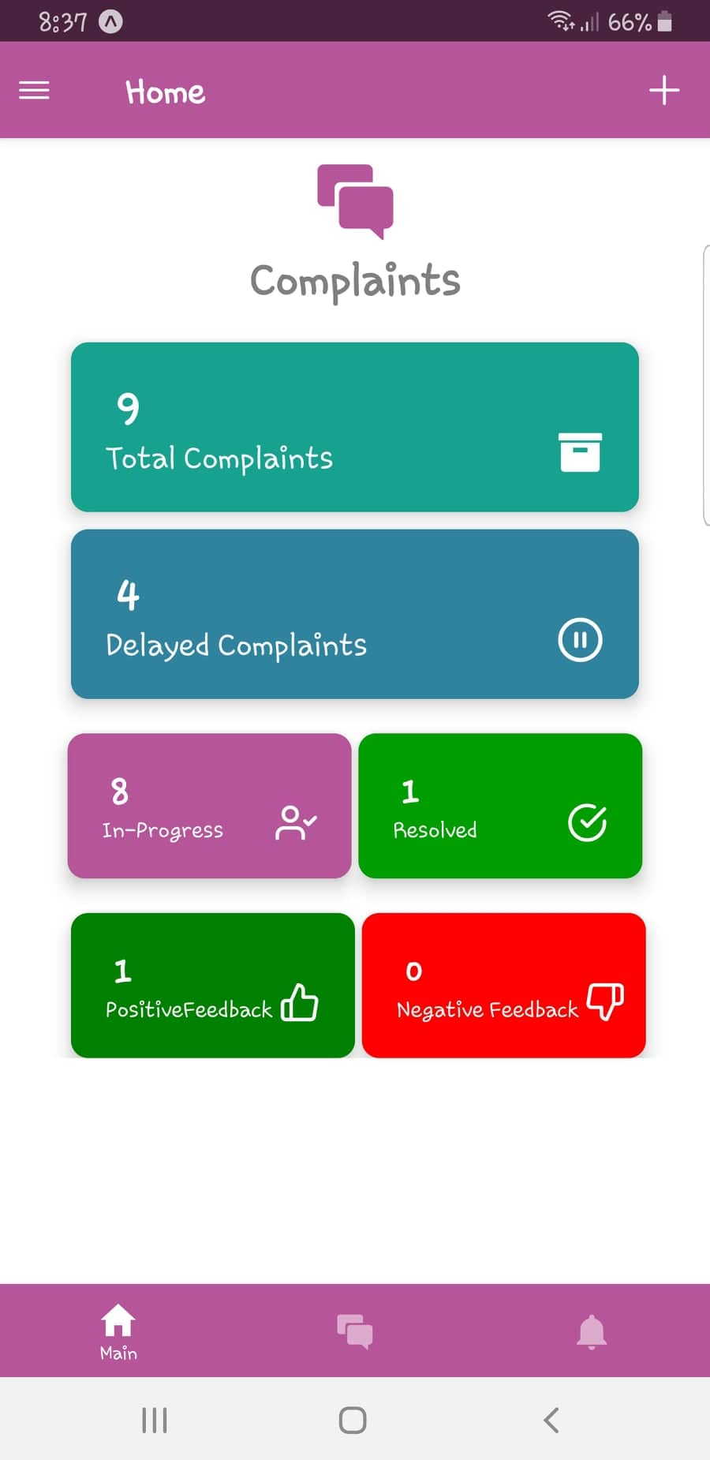
Figure 1Home Screen
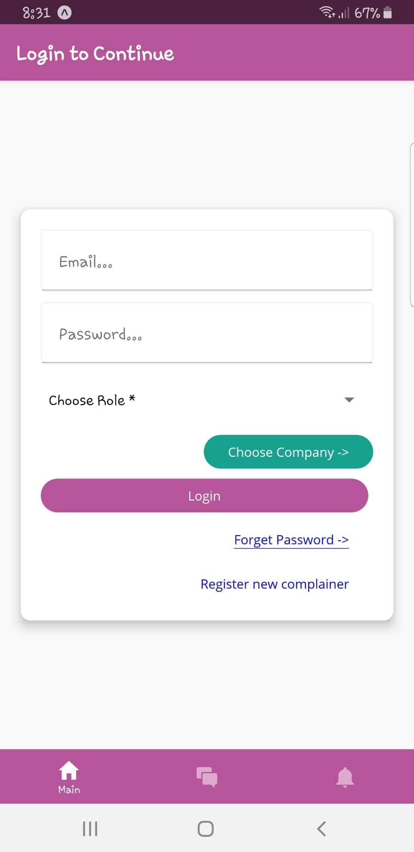
Figure 2 Login Screen

Assignee Dashboard
Complain Assignee can view the graphs of month-wise complains, Resolved complains, summary and a list of submitted complains.

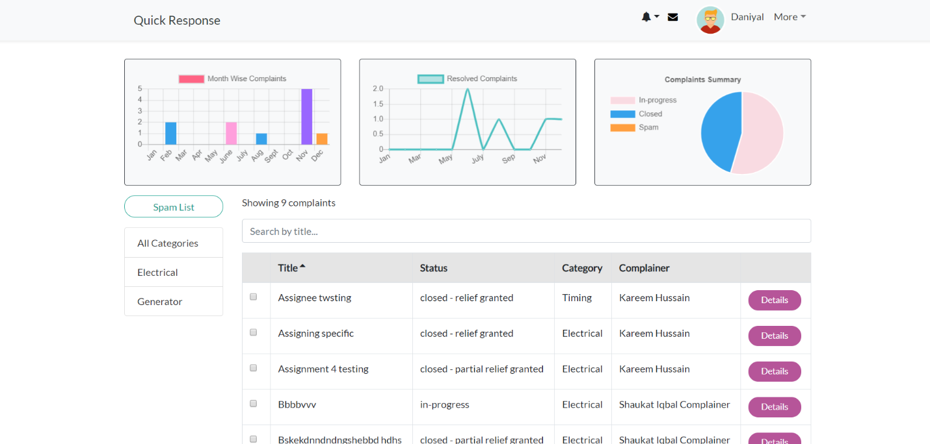
Figure 3 Assignee Dashboard
New Complaint
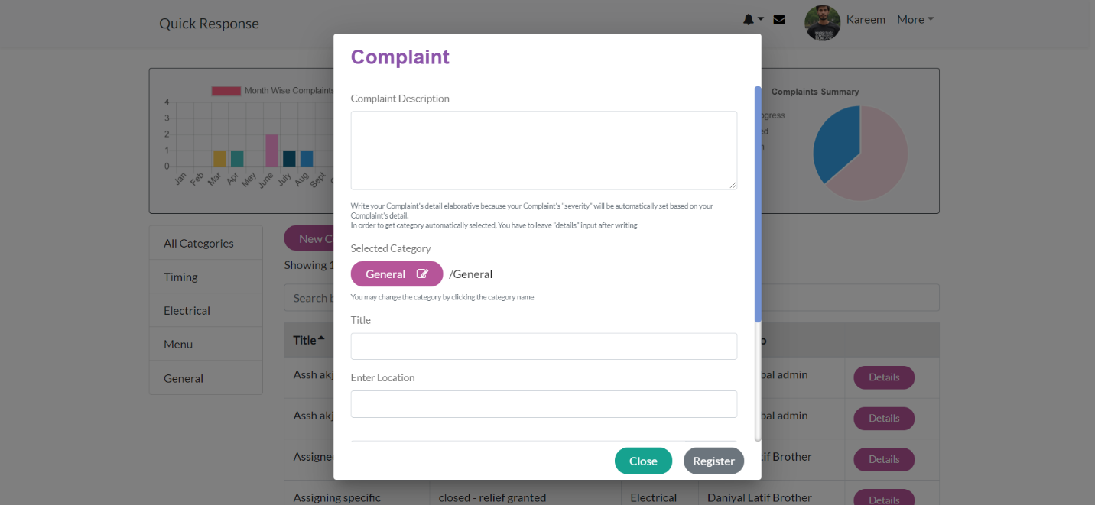
Complain Assignee and Complainer can create a new complain by providing Description, Category, Title, Location etc.
Figure 4 New Complaint

Box-and-line diagram

Box-and-line diagrams are often used to describe the business concepts and processes during the analysis phase of the software development lifecycle. These diagrams come with descriptions of components and connectors, as well as other descriptions that provide common inherent interpretations.

Example:

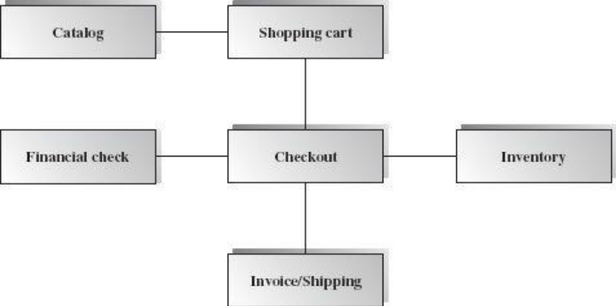
Lines in the box-and-line diagrams indicate the relationship among components
Figure A-1 Box-and-Line Diagram for an Online Shopping Business
- The semantic of lines may refer dependency, control flow, data flow, etc.
- Lines may be associated with arrows to indicate the process direction and sequence.
- A box-and-line diagram can be used as a business concept diagram describing its application domain and process concepts

Example of Architecture Pattern:

The figure A-2 shows an example of the logical package organization of the layered architecture. The top level deals with user interface, the next level is for utilities, and the one below utility provides core services. Each layer gets support from its lower adjacent layer by an interface implementation and from the related classes in the same layer.

A simple software system may consist of two layers: an interaction layer and a processing layer:
- The interaction layer provides user interfaces to clients, takes requests, validates and forwards requests to the processing layer for processing, and responds to clients.
- The processing layer receives the forwarded requests and performs the business logic process, accesses the database, returns the results to its upper layer, and lets the upper layer respond to clients since the upper layer has the GUI interface responsibility.
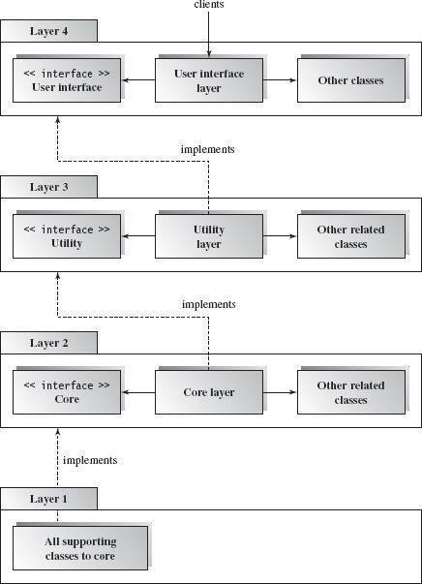
Figure A-2 Component-based Layered Architecture

Note: The Architecture pattern shall be selected according to the targeted system’s requirements and quality attributes. Above example is provided to demonstrate that how the system architecture is required to be presented.

Context Diagram:

The Cafeteria Ordering System is a new software system that replaces the current manual and telephone processes for ordering and picking up meals in the Process Impact cafeteria. The context diagram in Figure A-1 illustrates the external entities and system interfaces.
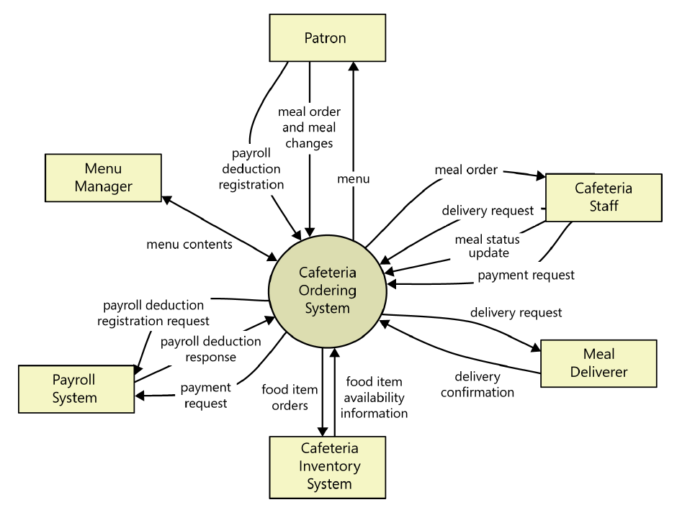
Figure A-1: Context diagram of the Cafeteria Ordering System.

User Classes and Characteristics

Table A-1 Shows user classes and characteristic for Cafeteria ordering system
User class | Description
Patron | A Patron is a Process Impact employee who wants to order meals to be delivered from the company cafeteria. There are about 600 potential Patrons, of which 300 are expected to use the COS an average of 5 times per week each. Patrons will sometimes order multiple meals for group events or guests. An estimated 60 percent of orders will be placed using the corporate intranet, with 40 percent of orders being placed from home or by smartphone or tablet apps.
Cafeteria Staff | The Process Impact cafeteria employs about 20 Cafeteria Staff who will receive orders from the COS, prepare meals, package them for delivery, and request delivery. Most of the Cafeteria Staff will need training in the use of the hardware and software for the COS.
Menu Manager | The Menu Manager is a cafeteria employee who establishes and maintains daily menus of the food items available from the cafeteria. Some menu items may not be available for delivery. The Menu Manager will also define the cafeteria’s daily specials. The Menu Manager will need to edit existing menus periodically.
Meal Deliverer | As the Cafeteria Staff prepare orders for delivery, they will issue delivery requests to a Meal Deliverer’s smartphone. The Meal Deliverer will pick up the food and deliver it to the Patron. A Meal Deliverer's other interactions with the COS will be to confirm that a meal was (or was not) delivered.

Example: Use case Diagram

Following use case diagram is of an appointment system in which all the use case diagram relationships are presented. In further in Table A-2 to the detail of use case diagram syntax is provided.

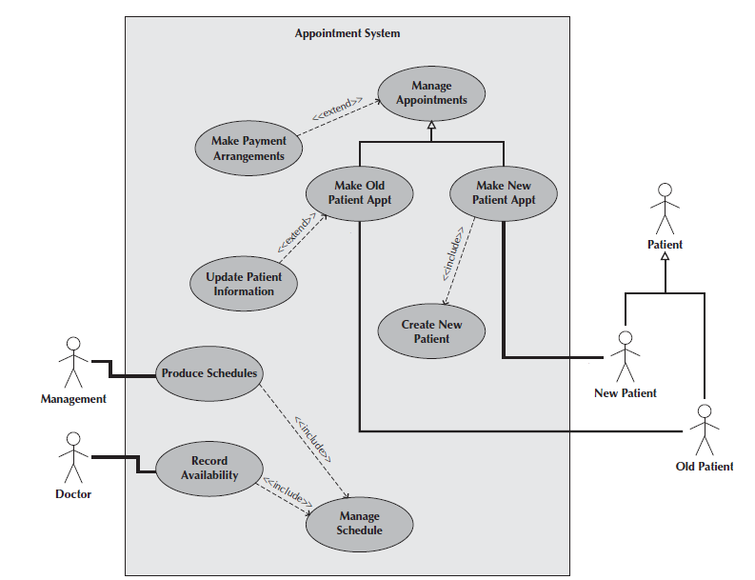

Figure A-2: Use Case Diagram of an Appointment System

Syntax for Use case Diagram

Table A-2 Syntax for Use case Diagram
An actor:  ■ Is a person or system that derives benefit from and is external to the subject.  ■ Is depicted as either a stick figure (default) or, if a nonhuman actor is involved, a  Rectangle with <<actor>> in it (alternative).  ■ Is labeled with its role.  ■ Can be associated with other actors using a specialization/superclass association,  Denoted by an arrow with a hollow arrowhead.  ■ Is placed outside the subject boundary. | 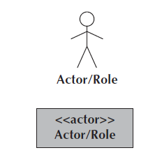
A use case:  ■ Represents a major piece of system functionality.  ■ Can extend another use case.  ■ Can include another use case.  ■ Is placed inside the system boundary.  ■ Is labeled with a descriptive verb–noun phrase. | 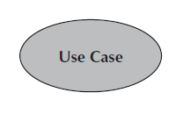
subject boundary:  ■ Includes the name of the subject inside or on top.  ■ Represents the scope of the subject, e.g., a system or an individual  Business process. | 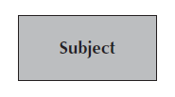
An association relationship:  ■ Links an actor with the use case(s) with which it interacts. | 
An include relationship:  ■ Represents the inclusion of the functionality of one use case within another.  ■ Has an arrow drawn from the base use case to the used use case. | 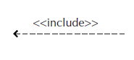
An extend relationship:  ■ Represents the extension of the use case to include optional behavior.  ■ Has an arrow drawn from the extension use case to the base use case. | 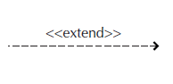
A generalization relationship:  ■ Represents a specialized use case to a more generalized one.  ■ Has an arrow drawn from the specialized use case to the base use case. | 

Detail Use Case Example
The Table A-3 below indicate a comprehensive use case template filled in with an example drawn from the Cafeteria ordering system (COS).
Table A-3 Show the detail use case template and example
Use Case ID: | Enter a unique numeric identifier for the Use Case. e.g. UC-1
Use Case Name: | Enter a short name for the Use Case using an active verb phrase. e.g.  Order a Meal
Actors: | [An actor is a person or other entity external to the software system being specified who interacts with the system and performs use cases to accomplish tasks.] e.g.
  Primary Actor: | Patron | Secondary Actors: | Cafeteria Inventory System
Description: | [Provide a brief description of the reason for and outcome of this use case.] e.g.  A Patron accesses the Cafeteria Ordering System from either the corporate intranet or external Internet, views the menu for a specific date, selects food items, and places an order for a meal to be picked up in the cafeteria or delivered to a specified location within a specified 15-minute time window.
Trigger: | [Identify the event that initiates the use case.]e.g.  A Patron indicates that he wants to order a meal.
Preconditions: | [List any activities that must take place, or any conditions that must be true, before the use case can be started.  PRE-1. Patron is logged into COS.  PRE-2. Patron is registered for meal payments by payroll deduction.
Postconditions: | [Describe the state of the system at the conclusion of the use case execution.  POST-1. Meal order is stored in COS with a status of “Accepted.”  POST-2. Inventory of available food items is updated to reflect items in this order.  POST-3. Remaining delivery capacity for the requested time window is updated.
Normal Flow: | [Provide a detailed description of the user actions and system responses that will take place during execution of the use case under normal, expected conditions.  1.0 Order a Single Meal  1. Patron asks to view menu for a specific date. (see 1.0. E1, 1.0.E2)  2. COS displays menu of available food items and the daily special.  3. Patron selects one or more food items from menu. (see 1.1)  4. Patron indicates that meal order is complete. (see 1.2)  5. COS displays ordered menu items, individual prices, and total price, including taxes and delivery charge.  6. Patron either confirms meal order (continue normal flow) or requests to modify meal order (return to step 2).  7. COS displays available delivery times for the delivery date.  8. Patron selects a delivery time and specifies the delivery location.  9. Patron specifies payment method.  10. COS confirms acceptance of the order.  11. COS sends Patron an email message confirming order details, price, and delivery instructions.  12. COS stores order, sends food item information to Cafeteria Inventory System, and updates available delivery times.
Alternative Flows: | [Document legitimate branches from the main flow to handle special conditions (also known as extensions). For each alternative flow reference the branching step number of the normal flow and the condition which must be true for this extension to be executed. e.g.  1.1 Order multiple identical meals  1. Patron requests a specified number of identical meals. (see 1.1. E1)  2. Return to step 4 of normal flow.  1.2 Order multiple meals  1. Patron asks to order another meal.  2. Return to step 1 of normal flow.  Note: Insert a new row for each distinctive alternative flow. ]
Exceptions: | 1.0. E1 Requested date is today and current time is after today’s order cutoff time  1. COS informs Patron that it’s too late to place an order for today.  2a. If Patron cancels the meal ordering process, then COS terminates use case.  2b. Else if Patron requests another date, then COS restarts use case.  1.0. E2 No delivery times left  1. COS informs Patron that no delivery times are available for the meal date.  2a. If Patron cancels the meal ordering process, then COS terminates use case.  2b. Else if Patron requests to pick the order up at the cafeteria, then continue with normal flow, but skip steps 7 and 8.  1.1. E1 Insufficient inventory to fulfill multiple meal order  1. COS informs Patron of the maximum number of identical meals he can order, based on current available inventory.  2a. If Patron modifies number of meals ordered, then return to step 4 of normal flow.  2b. Else if Patron cancels the meal ordering process, then COS terminates use case.
Business Rules | Use cases and business rules are intertwined. Some business rules constrain which roles can perform all or parts of a use case. Perhaps only users who have certain privilege levels can perform specific alternative flows. That is, the rule might impose preconditions that the system must test before letting the user proceed. Business rules can influence specific steps in the normal flow by defining valid input values or dictating how computations are to be performed e.g.  BR-1 Delivery time windows are 15 minutes, beginning on each quarter hour.  BR-2 Deliveries must be completed between 11:00 A.M. and 2:00 P.M. local time, inclusive.  Note: If you are maintaining the business rule in a separate table in SRS then only mention here their IDs.
Assumptions: | [List any assumptions.  - E.g. assume that 15 percent of Patrons will order the daily special (Source: previous 6 months of cafeteria data).

Event-Response Tables
In order to develop Event Response table first it is required to identify all possible events. Following is an example of events list and event-response table of highway intersection system.

The highway intersection system described earlier has to deal with various events, including these:
- A sensor detects a car approaching in one of the through lanes.
- A sensor detects a car approaching in a left-turn lane.
- A pedestrian presses a button to request to cross a street.
- One of many timers counts down to zero.

Table A-4 presents a fragment of what an event-response table might look like for such a system. Each expected system behavior consists of a combination of event, system state, and response.
Note: You may add more information to event-response table in order to perform detail requirement analysis which includes:
- The event frequency (how many times the event takes place in a given time period, or a limit to how many times it can occur).
- Data elements that are needed to process the event.
- The state of the system after the event responses are executed.

Table A-4 Partial Event-Response Table for a Highway Intersection
Event | System State | Response
Road sensor detects  vehicle entering left-turn  Lane. | Left-turn signal is red. Cross-traffic signal is green. | Start green-to-amber  countdown timer for cross-traffic  Signal.
Green-to-amber  countdown timer reaches  Zero. | Cross-traffic signal is green. | 1. Turn cross-traffic signal amber.  2. Start amber-to-red countdown timer.
Amber-to-red  countdown timer reaches  Zero. | Cross-traffic signal is amber. | 1. Turn cross-traffic signal red.  2. Wait 1 second.  3. Turn left-turn signal green.  4. Start left-turn-signal countdown timer.
Pedestrian presses a  specific walk-request  Button. | Pedestrian sign is solid Don’t Walk.  Walk-request countdown timer is not activated. | Start walk-request countdown timer.
Pedestrian presses  Walk-request button. | Pedestrian sign is solid Don’t Walk.  Walk-request countdown timer is activated. | Do nothing.
Walk-request  countdown timer reaches  zero plus the amber  Display time. | Traffic signal in walk  Direction is green. | Change all green traffic signals to amber.
Walk-request  countdown timer reaches  Zero. | Traffic signal in walk  Direction is amber. | 1. Change all amber traffic signals to red.  2. Wait 1 second.  3. Set pedestrian sign to Walk.  4. Start don’t-walk countdown timer.

Story Boarding
Following is an example of story boarding which is used to identify and analyze graphically intensive applications.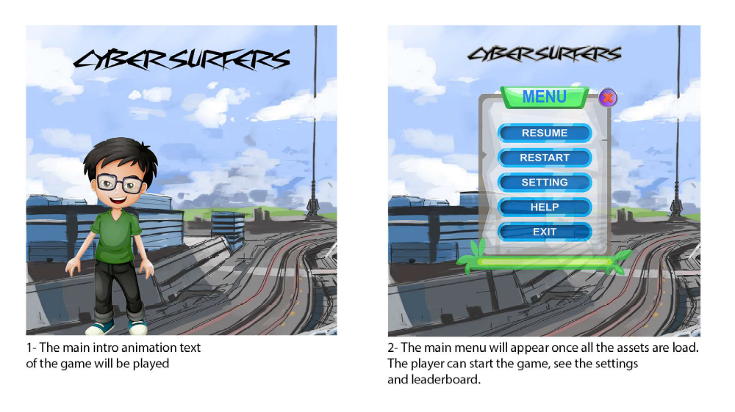
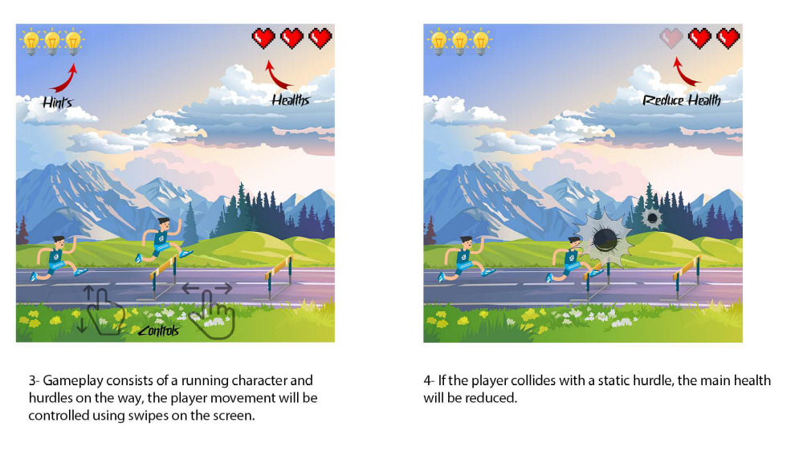
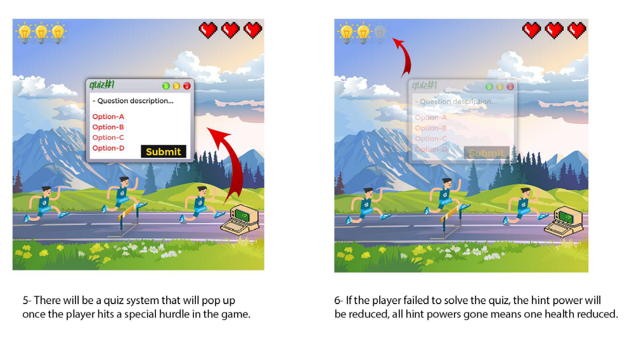

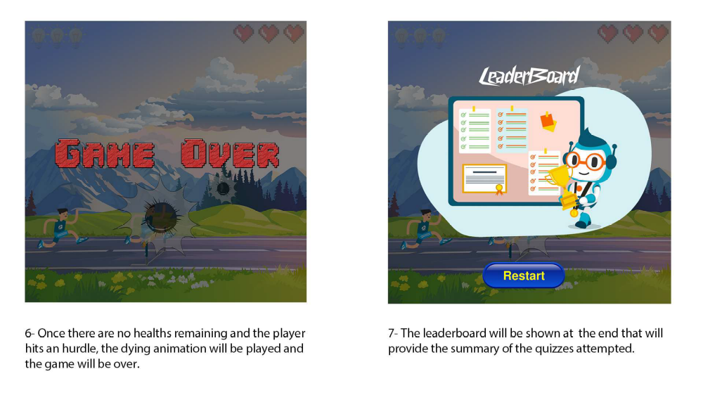

Activity Diagram

Following activity diagram is of an appointment system presenting make an appointment process in which all diagram’s elements are presented. In further in Table B-1 to the detail of activity diagram syntax is provided.

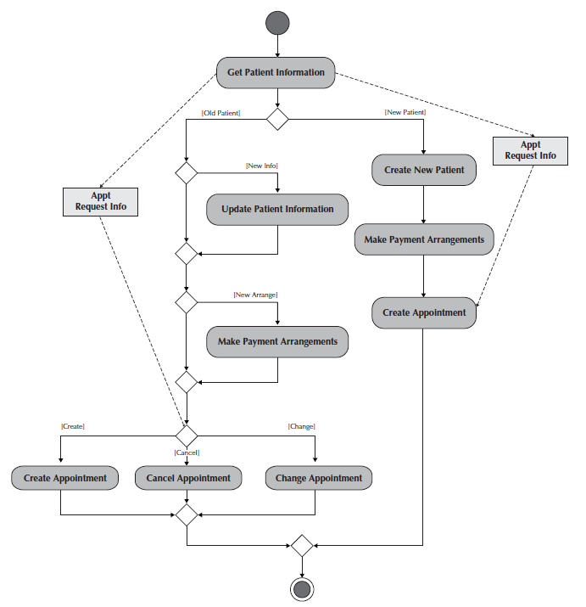
Example
Figure B-1 Activity Diagram for Make an Appointment Process

Activity Diagram Syntax
Table B- 1Activity Diagram Syntax
Term and definition | Symbol
An action:  - Is a simple, non-decomposable piece of behavior.  - Is labeled by its name. | 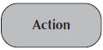
An activity:  - Is used to represent a set of actions.  - Is labeled by its name. | 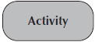
An object node:  - Is used to represent an object that is connected to a set of object flows.  - Is labeled by its class name. | 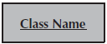
A control flow:
- Shows the sequence of execution.
An object flow:
- Shows the flow of an object from one activity (or action) to another activity (or action).
An initial node:  - Portrays the beginning of a set of actions or activities. | 
A final-activity node:  - Is used to stop all control flows and object flows in an activity (or action). | 
A final-flow node:  - Is used to stop a specific control flow or object flow. | 
A decision node:  - Is used to represent a test condition to ensure that the control flow or object flow only goes down one path.  - Is labeled with the decision criteria to continue down the specific path. | 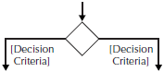
A merge node:  - Is used to bring back together different decision paths that were created using a decision node. | 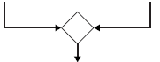
A fork node:  - Is used to split behavior into a set of parallel or concurrent flows of activities (or action) | 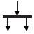
A join node:  - Is used to bring back together a set of parallel or concurrent flows of activities (or action) | 
A swim lane:  - Is used to break up an activity diagram into rows and columns to assign the individual activities (or actions) to the individuals or objects that are responsible for executing the activity (or action)  - Is labeled with the name of the individual or object responsible | 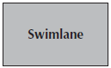
Class Diagram

Following class diagram is of an appointment system in which all class diagrams elements are presented. In further in Table B-2 to the detail of class diagram syntax is provided.

Example
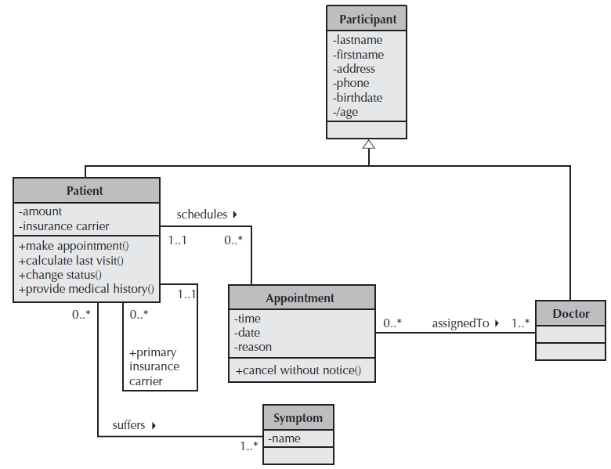
Figure B-2 Class Diagram for an Appointment System

Class Diagram Syntax

Table B- 2 Class Diagram Syntax
Term and definition | Symbol
A class:  - Has a name typed in bold and centered in its top compartment.  - Has a list of attributes in its middle compartment.  - Represents a kind of person, place, or thing about which the system will need to capture and store information.  - Has a list of operations in its bottom compartment.  - Does not explicitly show operations that are available to all classes. | 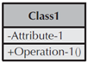
An attribute:  - Represents properties that describe the state of an object.  - Can be derived from other attributes, shown by placing a slash before the attribute’s name. | attribute name  /derived attribute name
An operation:  - Represents the actions or functions that a class can perform.  - Can be classified as a constructor, query, or update operation.  - Includes parentheses that may contain parameters or information needed to perform the operation. | operation name ()
An association:  - Represents a relationship between multiple classes or a class and itself.  - Is labeled using a verb phrase or a role name, whichever better represents the relationship.  - Can exist between one or more classes.  - Contains multiplicity symbols, which represent the minimum and maximum times a class instance can be associated with the related class instance. | 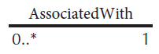
A generalization:  - Represents a-kind-of relationship between multiple classes. | 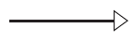
An aggregation:  - Represents a logical a-part-of relationship between multiple classes or a class and itself.  - Is a special form of an association. | 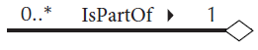
A composition:  - Represents a physical a-part-of relationship between multiple classes or a class and itself  - Is a special form of an association. | 

Sequence Diagram

Following example shows an instance sequence diagram that depicts the objects and messages for the Make Old Patient Appt use case, which describes the process by which an existing patient creates a new appointment or cancels or reschedules an appointment. In further in Table B-3 to the detail of class diagram syntax is provided.

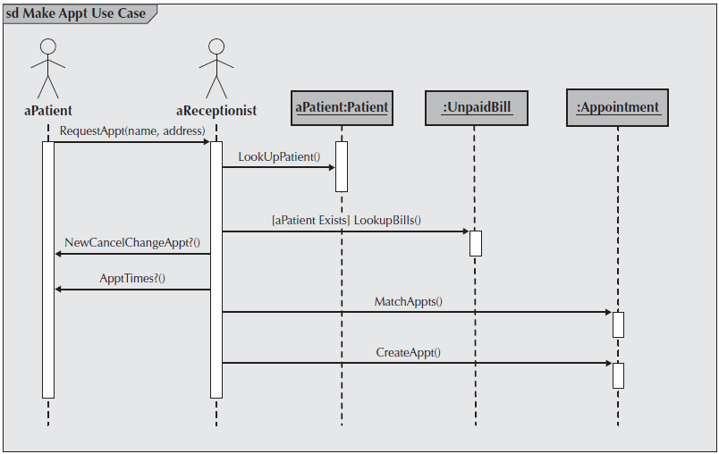
Example
Figure B-3 Example Sequence Diagram

Sequence diagram Syntax

Table B-3 Sequence Diagram Syntax
Term and definition | Symbol
An actor:  - Is a person or system that derives benefit from and is external to the system.  - Participates in a sequence by sending and/or receiving messages.  - Is placed across the top of the diagram.  - Is depicted either as a stick figure (default) or, if a nonhuman actor is involved, as a rectangle with <<actor>> in it (alternative). | 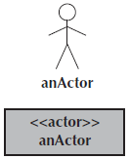
An object:  - Participates in a sequence by sending and/or receiving messages.  - Is placed across the top of the diagram. | 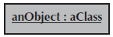
A lifeline:
- Denotes the life of an object during a sequence.
- Contains an X at the point at which the class no longer interacts.
An execution occurrence:
- Is a long narrow rectangle placed atop a lifeline.
- Denotes when an object is sending or receiving messages.
A message:  - Conveys information from one object to another one.  - An operation call is labeled with the message being sent and a solid arrow, whereas a return is labeled with the value being returned and shown as a dashed arrow. | 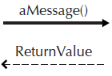
A guard condition:  - Represents a test that must be met for the message to be sent. | 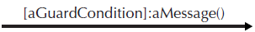
For object destruction:
- An X is placed at the end of an object’s lifeline to show that it is going out of existence.
A frame:  - Indicates the context of the sequence diagram. | 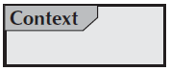

Behavioral State Machine Diagram

Following example of a behavioral state machine representing the patient class in the context of a hospital environment. From this diagram, we can tell that a patient enters a hospital and is admitted after checking in. If a doctor finds the patient to be healthy, he or she is released and is no longer considered a patient after two weeks elapse. If a patient is found to be unhealthy, he or she remains under observation until the diagnosis changes.

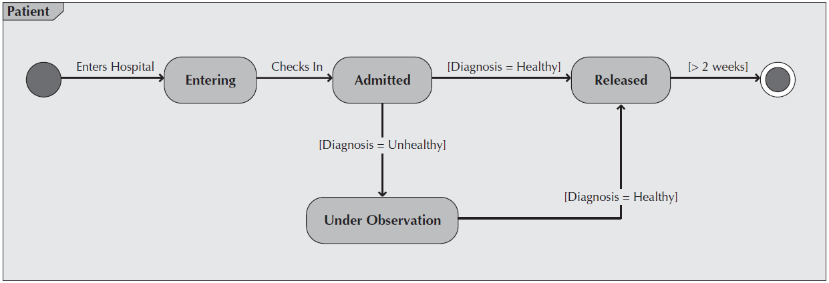
Example
Figure B-4 Sample Behavioral State Machine Diagram

Behavioral State Machine Diagram Syntax

Table B-4 Behavioral State Machine Diagram Syntax
Term and definition | Symbol
A state:  - Is shown as a rectangle with rounded corners.  - Has a name that represents the state of an object. | 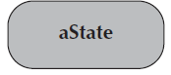
An initial state:
- Is shown as a small, filled-in circle.
- Represents the point at which an object begins to exist.
A final state:  - Is shown as a circle surrounding a small, filled-in circle (bull's-eye).  - Represents the completion of activity. | 
An event:
- Is a noteworthy occurrence that triggers a change in state.
- Can be a designated condition becoming true, the receipt of an explicit signal from one object to another, or the passage of a designated period of time.
- Is used to label a transition.
A transition:
- Indicates that an object in the first state will enter the second state.
- Is triggered by the occurrence of the event labeling the transition.
- Is shown as a solid arrow from one state to another, labeled by the event name.
A frame:  - Indicates the context of the behavioral state machine. | 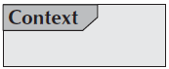

Data Flow Diagram

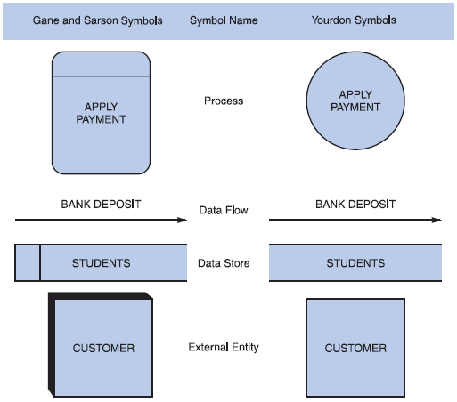
Data flow diagram symbols, symbol names, and examples
Figure B-5 Data flow diagram symbols, symbol names, and examples of the Gane and Sarson and Yourdon symbol sets.

Guidelines for Drawing DFDs

Step 1: Draw a Context Diagram: The first step in constructing a set of DFDs is to draw a context diagram. A context diagram is a top-level view of an information system that shows the system’s boundaries and scope. Data stores are not shown in the context diagram because they are contained within the system and remain hidden until more detailed diagrams are created.

Example
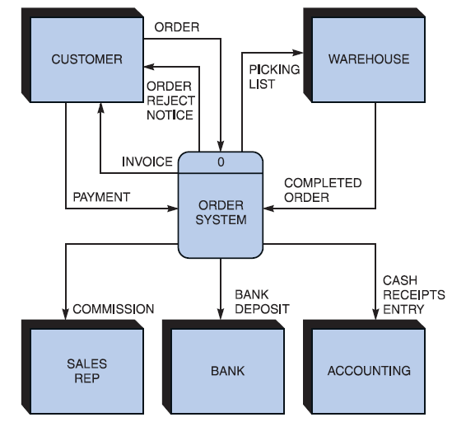

Figure B-6 Context diagram DFD for an order system.
Step 2: Draw a Diagram 0 DFD: To show the detail inside the black box, you create DFD diagram 0. Diagram 0 zooms in on the system and shows major internal processes, data flows, and data stores. Diagram 0 also repeats the entities and data flows that appear in the context diagram. When you expand the context diagram into DFD diagram 0, you must retain all the connections that flow into and out of process 0.
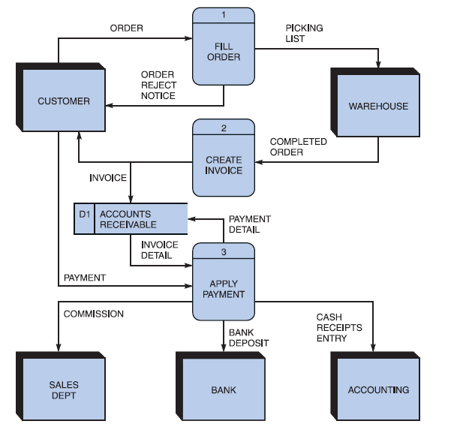
Example
Figure B-7 Diagram 0 DFD for the order system.

Step 3: Draw the Lower-Level Diagrams:
To create lower-level diagrams, you must use leveling and balancing techniques. Leveling is the process of drawing a series of increasingly detailed diagrams, until all functional primitives are identified.
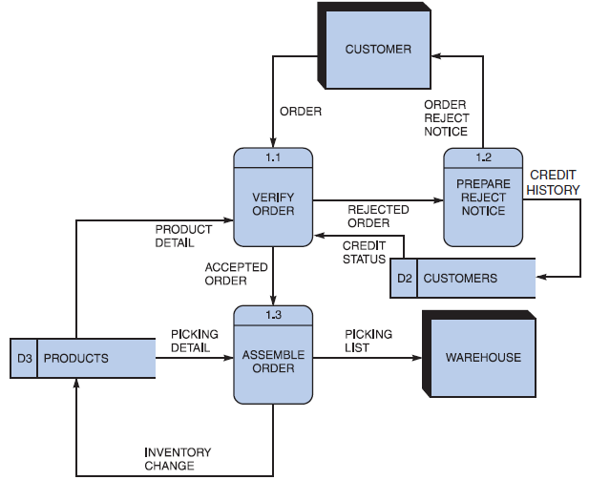
Leveling Example
Figure B-8 Diagram 1 DFD shows details of the FILL ORDER process in the order system.

Balancing maintains consistency among a set of DFDs by ensuring that input and output data flows align properly.
Balancing Example
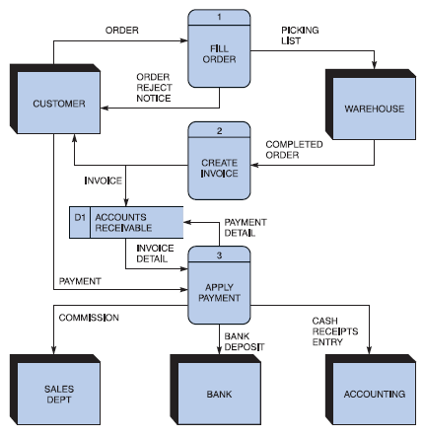
Order System Diagram 0 DFD

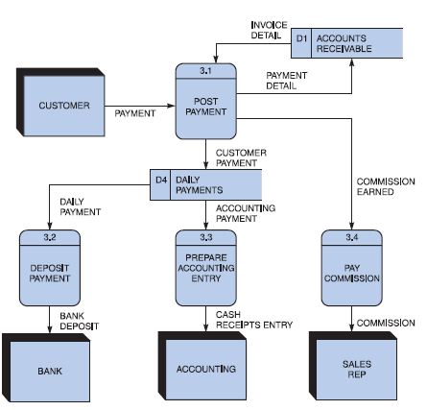
Order System Diagram 3 DFD
The order system diagram 0 is shown at the top of the figure and exploded diagram 3 DFD (for the APPLY PAYMENT process) is shown at the bottom. The two DFDs are balanced, because child diagram at the bottom has the same input and output flows as the parent process 3 shown at the top.

Appendix F
Business Rules Testing
Methodology for creating decision table:

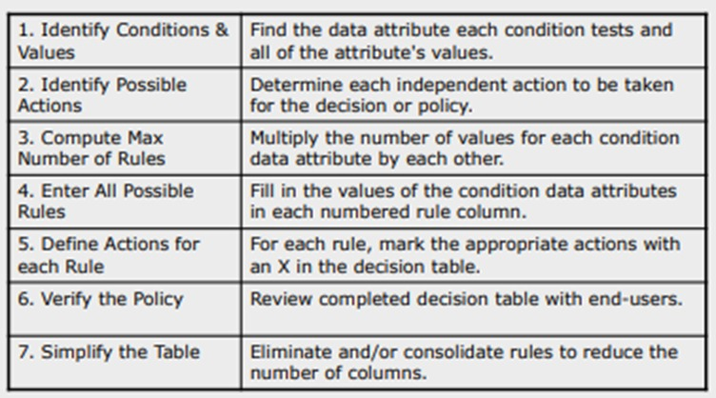

Example:

The provided example is of a super store.
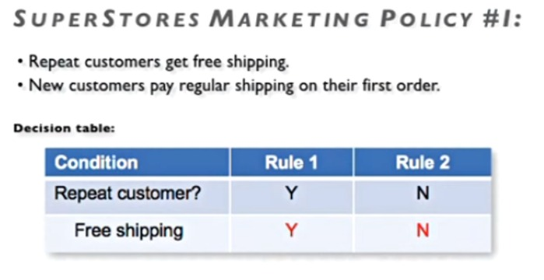
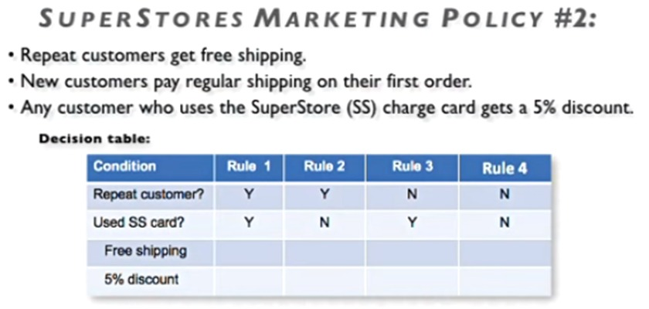
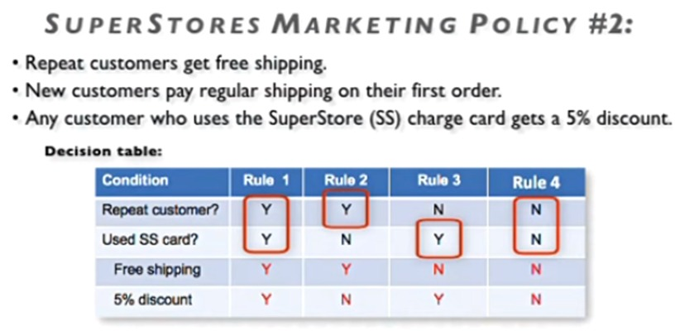

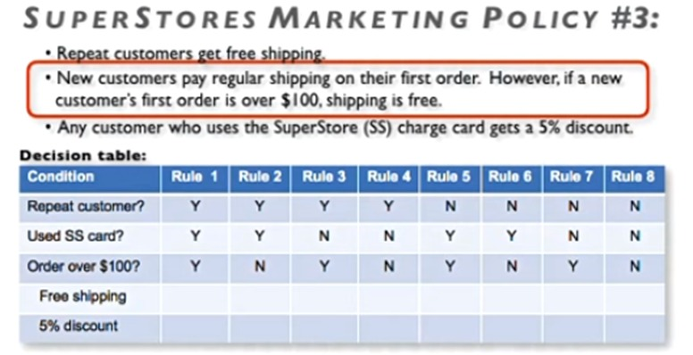

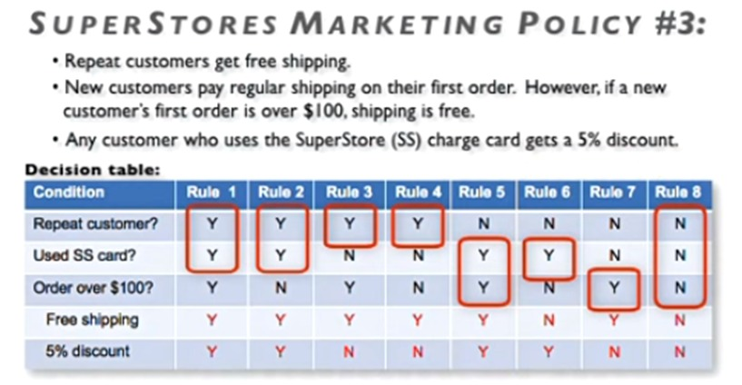

- Now Combine rules where it is apparent that an alternative does not make a difference in the outcome

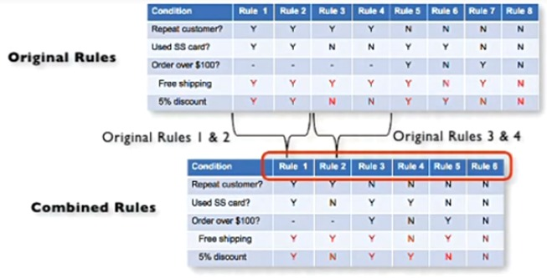

This is the final table and now you have to create test cases on every rule. In above example there are 6 rules so there shall be 6 test cases.

Appendix G
General Coding Standards
- Use consistent naming and formatting conventions.
- Keep functions and modules focused and cohesive.
- Validate inputs and handle exceptions deliberately.
- Do not hard-code credentials, secrets or environment-specific configuration.
- Document public interfaces and non-obvious decisions.
- Use version control with meaningful commits and peer review where possible.
- Add automated tests for critical logic and regressions.

