水稻稻飞虱抗性微效位点与功能修饰基因证据报告
基于RiceMind完整分页句子证据
报告日期：2026-06-12

摘要
本报告基于RiceMind完整分页句子证据，梳理水稻宿主中不属于经典Bph/Wbph主效抗性基因、但能够改变稻飞虱抗性强度、信号输出、结构防御或生长-防御权衡的遗传节点。合并证据覆盖911篇唯一PMID，年份范围为1989-2025年；最终形成32个功能修饰候选，其中高优先级研究候选6个。
报告严格区分数量遗传学意义上的微效QTL与反向遗传学验证的功能修饰基因。多数调控基因缺少可跨群体比较的PVE、加性效应或自然等位变异数据，因此统一表述为“功能修饰位点，效应量未量化”，不将其等同于主效抗性基因或成熟育种靶点。

1. 定义与判定边界
- 严格微效QTL：原研究明确报告minor QTL、数量抗性或小效应数量位点，并具有分离群体或关联群体证据。
- 功能修饰位点：不是经典主效Bph/Wbph基因，但敲除、沉默、过表达或特定等位变异会改变抗性表型。
- 探索性候选：仅有表达、组学或文本共现证据，未进行遗传扰动和抗性终点验证。
RiceMind证据置信度、遗传效应大小和育种成熟度是三个独立评价轴，不能互相替代。

2. 检索范围与完整性
RiceMind检索词 | 句子记录 | 分页 | 完整性
brown planthopper resistance | 4678 | 10 | 完整
Brown planthopper damage | 707 | 2 | 完整
white-backed planthopper resistance | 298 | 1 | 完整
Whitebacked planthopper damage | 310 | 1 | 完整
planthopper | 5160 | 11 | 完整
宽泛检索词planthopper仅用于查漏。昆虫自身Nl基因、杀虫剂抗性基因、经典主效抗性基因和仅有表达响应的组学候选均不直接进入功能微效位点主表。

3. 严格数量遗传学意义上的微效QTL
严格微效QTL是最接近育种学定义的对象，但也是当前RiceMind句子层面信息最不完整的部分。历史研究已证明BPH/WBPH抗性包含数量性组分，但许多记录缺少位点名称、标记区间和效应量。
位点或群体 | 虫种 | PMID | 当前可下结论
Lemont/Teqing数量抗性QTL组合 | BPH | 12582694 | RiceMind句证未保留各QTL名称、效应值和区间，不能进一步按主效/微效拆分。
IR64的7个微效QTL | BPH | 29282566 | 当前RiceMind句证为后续论文转述，缺少原始QTL名称、标记和效应量；只能作为历史线索。
ADR52的伴随微效QTL | BPH/WBPH/GLH | 27300326;29282566 | 主效基因为BPH25/BPH26；微效QTL在当前句证中未被逐一解析。
Rathu Heenati的BPH32相关小效应组分 | BPH | 30888525 | BPH32在其他研究中作为命名抗性基因出现，效应分类具有群体和分析背景依赖，不能全局标记为微效。
MAGIC群体Qbph7/SNP簇 | BPH | 33066559 | 属于关联位点而非已验证因果基因；RiceMind句证未提供单个位点PVE。
2024年自然群体GWAS与基因组预测位点 | BPH | 38576786 | 候选位点和基因尚需因果验证；更适合数量抗性选择而非单基因结论。

4. 功能修饰候选总览
下列候选能够解释抗性如何被放大、削弱或重新分配，但不能替代经典Bph/Wbph基因解释抗性的主要遗传来源。BR0-BR3为本报告使用的育种成熟度描述，不是RiceMind官方置信等级。
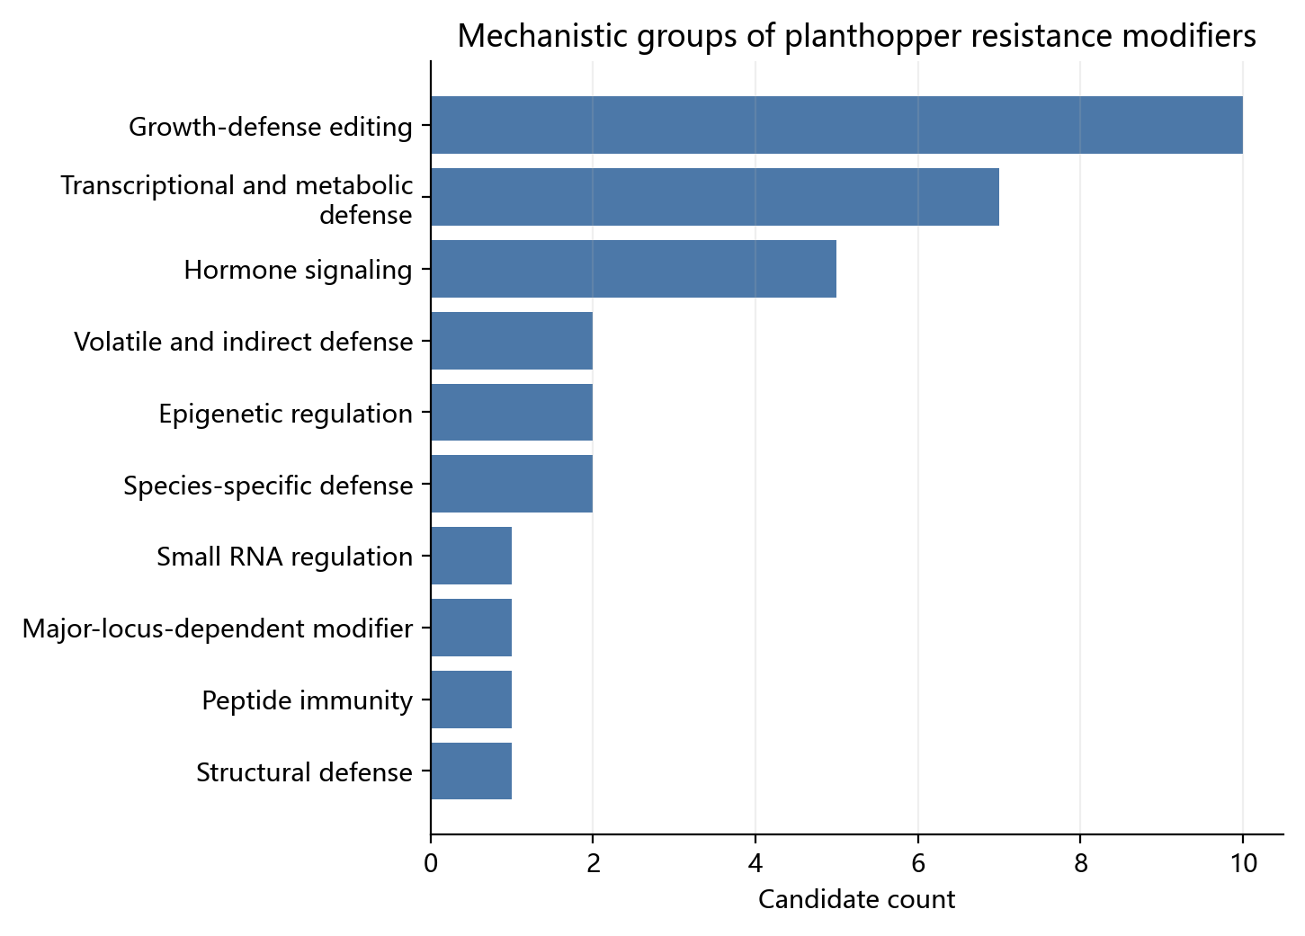
图1 功能修饰候选的机制类别分布。该图表示候选数量，不表示遗传效应大小。
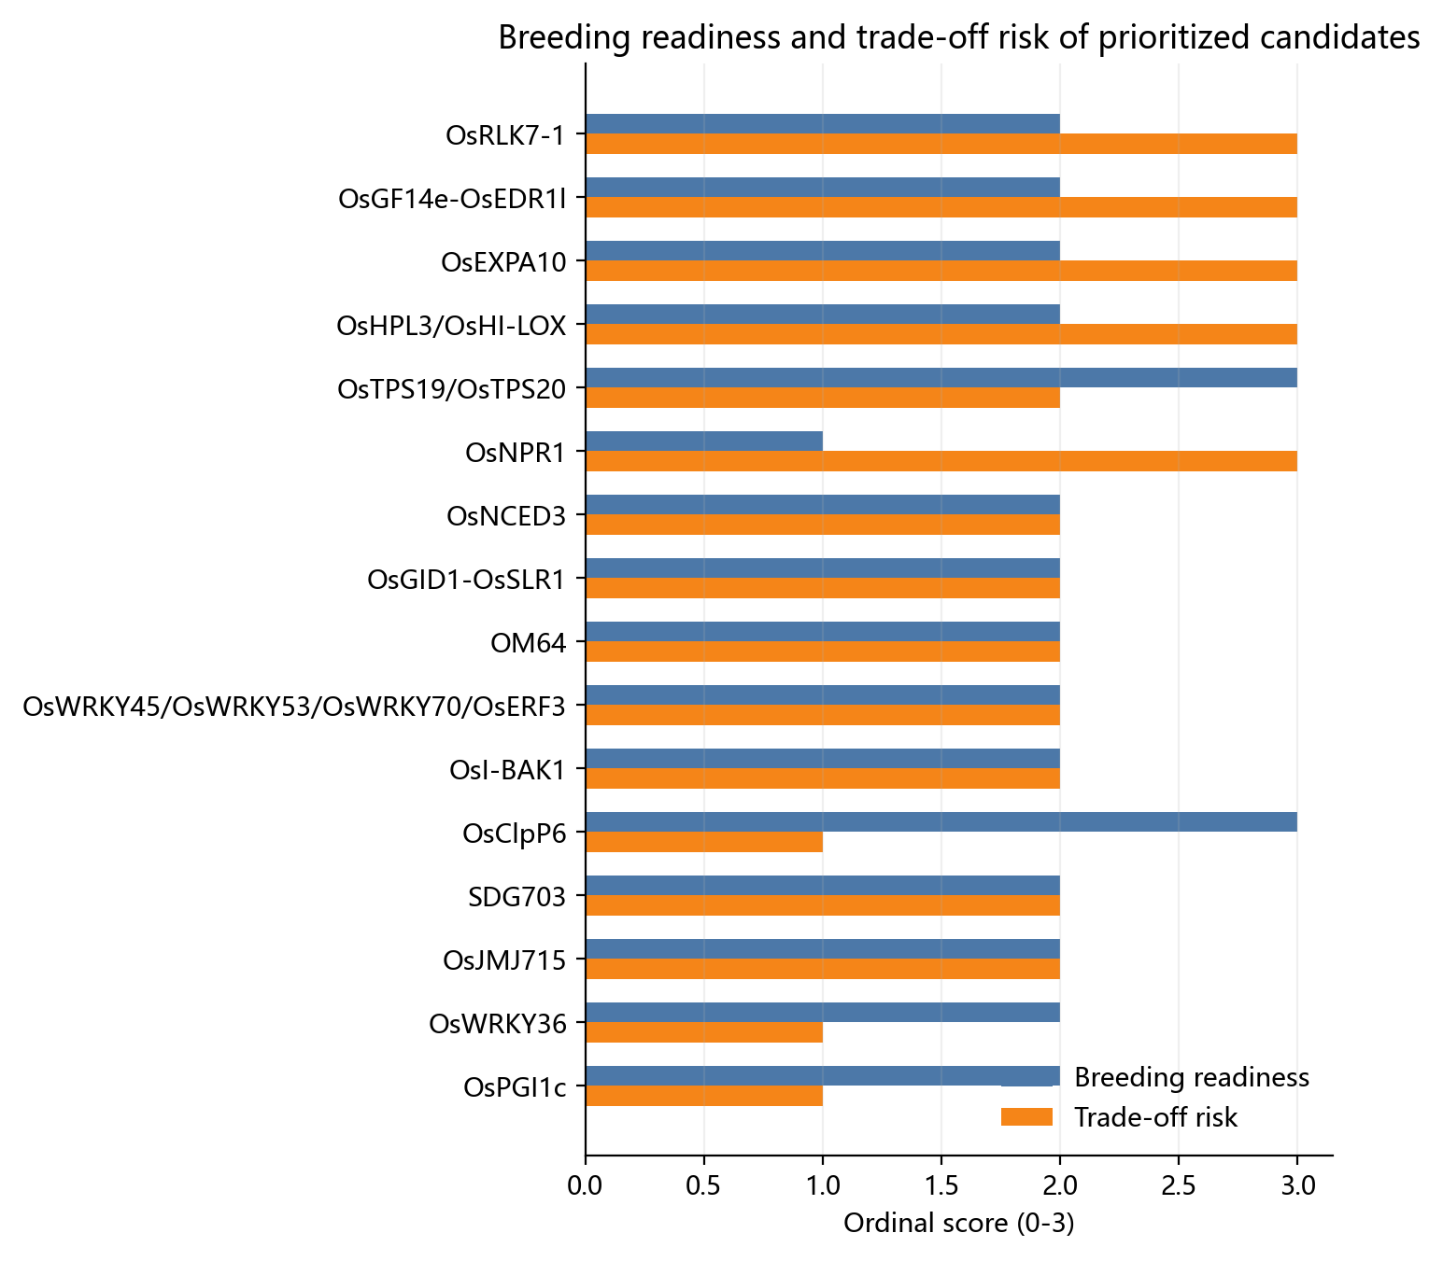
图2 候选的育种成熟度与权衡风险。右上区域需要重点审查多效性，不能仅凭增抗表型推进。
候选 | 虫种 | 作用方向 | 成熟度 | 优先级
OsClpP6 | BPH | 负调控 | BR3 | 高
OsTPS19/OsTPS20 | BPH | 正调控 | BR3 | 高
OsWRKY36 | BPH/WBPH/SBPH | 负调控 | BR2 | 高
JAZ10/FJ10 | BPH | 特定移码等位变异增抗 | BR2 | 高
OsPGI1c | BPH | 正调控 | BR2 | 高
OsmiR396-OsGRF8-OsF3H | BPH/WBPH | OsF3H正调控 | BR2 | 高
OsGF14e-OsEDR1l | BPH | 负调控 | BR2 | 中
OsMYB1-OsSPL14 | BPH | 依赖拮抗关系 | BR2 | 中
MYC2-JAMYB | BPH | 正调控 | BR2 | 中
OsmiR319-OsPCF5 | BPH | OsmiR319负调控 | BR2 | 中
OsNCED3 | BPH | 正调控 | BR2 | 中
OsRCI-1 | BPH | 正调控 | BR2 | 中
SDG703 | BPH/WBPH/SBPH | 负调控 | BR2 | 中
OsEBF2 | BPH | 正调控 | BR2 | 中
OsJMJ715 | BPH | 负调控 | BR2 | 中
OsI-BAK1 | BPH | 负调控 | BR2 | 中
OM64 | BPH及咀嚼式害虫 | 负调控 | BR2 | 中
MYB22-TOPLESS-HDAC1 | BPH | 正调控 | BR2 | 中
OsWRKY71 | BPH | 正向依赖 | BR2 | 中
OsPep3-OsPEPRs | BPH/WBPH | 正调控 | BR2 | 中
OsEXO70H3 | BPH | 正调控 | BR2 | 中
OsMYB30-OsPAL6/OsPAL8 | BPH | 正调控 | BR2 | 中
OsMKK3 | BPH | 正调控 | BR2 | 中
OsGID1-OsSLR1 | BPH | 背景与节点依赖 | BR2 | 中
OsWRKY45/OsWRKY53/OsWRKY70/OsERF3 | BPH | 方向因成员而异 | BR2 | 中
OsCM | WBPH | 正调控 | BR2 | 中
OsRLK7-1 | BPH/WBPH/SBPH | 负调控 | BR2 | 低
OsEXPA10 | BPH | 负调控抗性 | BR2 | 低
OsHPL3/OsHI-LOX | BPH/WBPH及咀嚼式害虫 | 虫种依赖 | BR2 | 低
OsSPL10 | BPH | 调控方向依赖研究材料 | BR1 | 低
OsHLH61-OsbHLH96 | BPH | 调控抗性 | BR1 | 低
OsNPR1 | WBPH/BPH | 对WBPH可能负调控 | BR1 | 低

5. 关键候选的科学解释

5.1 优先进行多背景验证的候选
OsClpP6、JAZ10/FJ10、OsWRKY36、OsPGI1c和OsTPS19/OsTPS20构成当前最值得进一步验证的一组候选。OsClpP6已有实验室、田间和初步产量信息；FJ10提示特定移码等位变异可缓解生长-防御冲突；OsWRKY36敲除具有跨BPH、WBPH和SBPH的表型；OsPGI1c同时促进生长与抗性；OsTPS19/20具有田间抗虫和无显著产量性状损失证据，但需要监测二化螟等非目标害虫。[38612510, 39693337, 40042898, 39796027, 39340817]

5.2 生长-防御负调控节点
OsGF14e-OsEDR1l、OsRLK7-1、OsEXPA10和OsNCED3说明解除负调控能够增强抗性，但同时可能造成生长、根系、粒重或产量损失。[39853648, 37834016, 29619515, 38988632] 对这类位点更合理的策略是弱等位基因、启动子编辑、组织特异表达或诱导型调控，而不是默认完全敲除。

5.3 代谢与结构防御修饰网络
OsMYB30-OsPAL6/8、OsmiR396-OsGRF8-OsF3H、MYB22-TOPLESS-HDAC1和OsEXO70H3将苯丙烷、黄酮、SA、木质素和细胞壁分泌连接到抗性执行过程。[31848246, 30734457, 37149887, 35119102] 这些证据支持其机制价值，但尚不能证明它们在自然群体中普遍解释大比例抗性变异。
OsF3H同时具有BPH功能证据和WBPH QTL/过表达支持，是连接数量定位与机制验证的代表对象。[30734457, 32895423, 33401742, 36499636] 由于不同群体和虫种中的效应类别尚未统一，本报告将其界定为QTL支持的功能修饰基因。

5.4 主效基因依赖与虫种特异性
OsWRKY71是Bph15介导抗性的下游修饰节点，不能作为独立抗性来源与Bph15并列。[38023936] OsHPL3、OsHI-LOX和OsNPR1则显示同一节点对BPH、WBPH、咀嚼式害虫或病原菌可能产生相反效应。[22519706, 19656341, 38891303, 40042898] 这类候选必须按目标虫种和多胁迫组合进行评价。

6. 育种与实验优先级
- OsClpP6：优先验证稳定编辑等位基因、跨背景田间抗性和产量。
- JAZ10/FJ10：优先复现特定移码等位变异，而不是一般性完全敲除。
- OsWRKY36：测试不同籼粳背景、多个BPH/WBPH种群和成熟期产量。
- OsPGI1c：验证生长与抗性双增益能否跨环境保持。
- OsTPS19/OsTPS20：开展多害虫和天敌群落联合评价，防止虫谱替换。
- OsF3H调控轴：开展自然等位变异、代谢定量和BPH/WBPH双虫种验证。
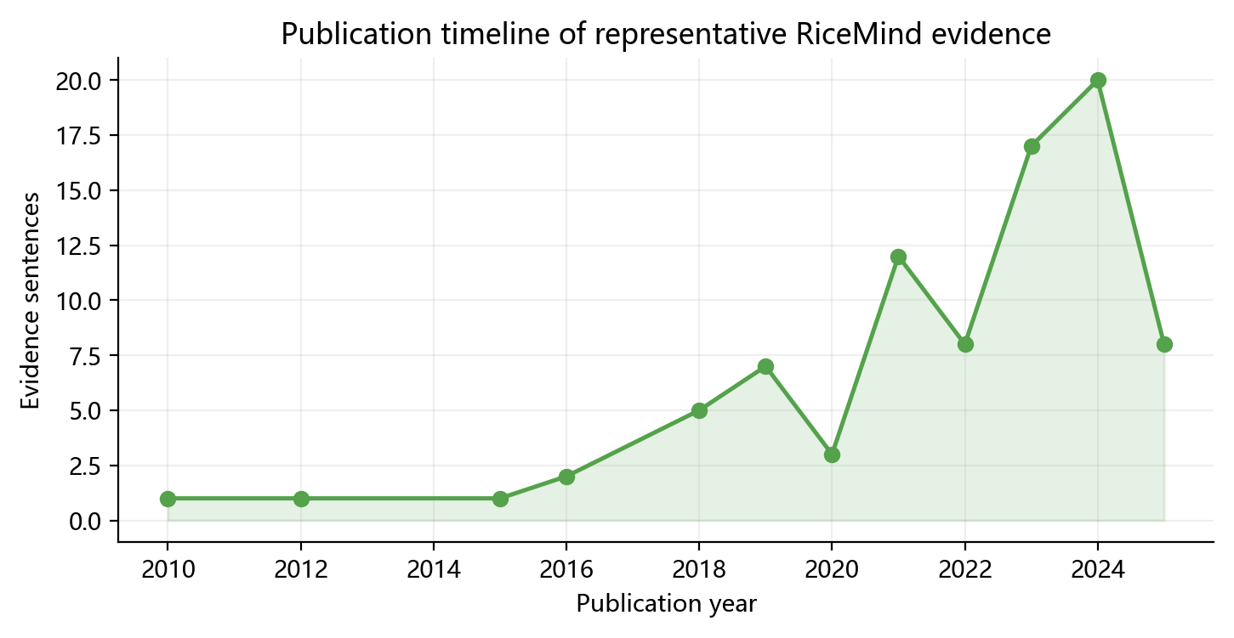
图3 入选候选代表性证据的发表年份分布，反映研究关注与功能验证积累。

7. 不能归入微效位点的边界对象
对象 | 示例 | 本报告处理
经典Bph/Wbph主效抗性基因 | Bph1/2/3/6/9/14/15/18/25/26/29/32等；Wbph1-Wbph6 | 不纳入微效位点清单。即使其下游存在复杂网络，也不能因机制未完全阐明而降格为微效。
qWL6 | WBPH产卵诱导坏死/杀卵反应QTL | 原文明确称major QTL，因此作为边界对象说明，不归入微效QTL。
Bph3/OsLecRK基因簇 | OsLecRK1/2/3 | 属于经典抗性基因簇语境，不能把其中成员简单列为独立微效位点。
仅表达响应的OsWRKY/OsNAC及组学候选 | WBPH诱导的多个OsWRKY、OsNAC、lncRNA和circRNA | 缺少遗传扰动与抗性终点时，仅列为探索候选，不进入功能微效位点主表。
昆虫基因和杀虫剂抗性基因 | Nl开头基因、CYP/P450等昆虫适应或药剂抗性基因 | 不属于水稻宿主抗性位点，全部排除。

8. 证据局限
- RiceMind句子证据不稳定保存QTL效应量、LOD、PVE、加性效应和完整材料背景。
- 转基因或RNAi效应不等同于自然群体中的微效等位变异。
- 文献与句子数量代表关注度，不代表遗传效应大小或育种价值。
- BPH、WBPH和SBPH必须分开评价，同一基因可能产生相反方向。
- 严格微效QTL的标记、区间和效应量需要回到原始定位论文及补充数据核验。

9. 结论
水稻稻飞虱抗性包含数量性和微效遗传组分，但当前可直接命名、具有明确效应量并可用于标记选择的微效QTL证据，远少于功能修饰基因证据。经典Bph/Wbph基因决定主要抗性入口；OsClpP6、JAZ10/FJ10、OsWRKY36、OsPGI1c、OsTPS19/20、OsF3H等节点调节防御强度、虫种范围和生长代价。
下一步应为这些修饰节点补齐自然等位变异、多背景效应量、多生物型稳定性、田间产量和多害虫权衡数据，并把它们作为主效抗性基因的背景优化因子进行验证，而不是用其替代主效基因解释抗性如何产生。

参考文献索引
PMID 40169387 (2025). The MYC2-JAMYB transcriptional cascade regulates rice resistance to brown planthoppers. The New phytologist.
PMID 40042898 (2025). A WRKY transcription factor confers broad-spectrum resistance to biotic stresses and yield stability in rice. Proceedings of the National Academy of Sciences of the United States of America.
PMID 39853648 (2025). An Insect Effector Mimics Its Host Immune Regulator to Undermine Plant Immunity. Advanced science (Weinheim, Baden-Wurttemberg, Germany).
PMID 39796027 (2024). A Cytosolic Phosphoglucose Isomerase, OsPGI1c, Enhances Plant Growth and Herbivore Resistance in Rice. International journal of molecular sciences.
PMID 39724382 (2024). OsMYB1 antagonizes OsSPL14 to mediate rice resistance to brown planthopper and Xanthomonas oryzae pv. oryzae. Plant cell reports.
PMID 39693337 (2024). A frameshift mutation in JAZ10 resolves the growth versus defense dilemma in rice. Proceedings of the National Academy of Sciences of the United States of America.
PMID 39340817 (2024). Limonene enhances rice plant resistance to a piercing-sucking herbivore and rice pathogens. Plant biotechnology journal.
PMID 38988632 (2024). A key ABA biosynthetic gene OsNCED3 is a positive regulator in resistance to Nilaparvata lugens in Oryza sativa. Frontiers in plant science.
PMID 38891303 (2024). OsRCI-1-Mediated GLVs Enhance Rice Resistance to Brown Planthoppers. Plants (Basel, Switzerland).
PMID 38612510 (2024). Silencing an ATP-Dependent Caseinolytic Protease Proteolytic Subunit Gene Enhances the Resistance of Rice to Nilaparvata lugens. International journal of molecular sciences.
PMID 38576786 (2024). Genome-wide association study and genomic prediction for resistance to brown planthopper in rice. Frontiers in plant science.
PMID 38520013 (2024). OsmiR319-OsPCF5 modulate resistance to brown planthopper in rice through association with MYB proteins. BMC biology.
PMID 38023936 (2023). Knockout of OsWRKY71 impairs Bph15-mediated resistance against brown planthopper in rice. Frontiers in plant science.
PMID 37834016 (2023). Knocking Out OsRLK7-1 Impairs Rice Growth and Development but Enhances Its Resistance to Planthoppers. International journal of molecular sciences.
PMID 37819387 (2023). Integration of transcriptome and metabolome analyses reveals the role of OsSPL10 in rice defense against brown planthopper. Plant cell reports.
PMID 37629184 (2023). SET Domain Group 703 Regulates Planthopper Resistance by Suppressing the Expression of Defense-Related Genes. International journal of molecular sciences.
PMID 37149887 (2023). A novel transcriptional repressor complex MYB22-TOPLESS-HDAC1 promotes rice resistance to brown planthopper by repressing F3'H expression. The New phytologist.
PMID 36462682 (2023). The F-box protein OsEBF2 confers the resistance to the brown planthopper (Nilparvata lugens Stål). Plant science : an international journal of experimental plant biology.
PMID 36499636 (2022). Enhancing the Expression of the OsF3H Gene in Oryza sativa Leads to the Regulation of Multiple Biosynthetic Pathways and Transcriptomic Changes That Influence Insect Resistance. International journal of molecular sciences.
PMID 36064309 (2022). Transcriptome profiling in rice reveals a positive role for OsNCED3 in defense against the brown planthopper, Nilaparvata lugens. BMC genomics.
PMID 35119102 (2022). Necessity of rice resistance to planthoppers for OsEXO70H3 regulating SAMSL excretion and lignin deposition in cell walls. The New phytologist.
PMID 35068048 (2022). Plant elicitor peptide signalling confers rice resistance to piercing-sucking insect herbivores and pathogens. Plant biotechnology journal.
PMID 34943188 (2021). Biological Efficacy of Cochlioquinone-9, a Natural Plant Defense Compound for White-Backed Planthopper Control in Rice. Biology.
PMID 34884830 (2021). Silencing an E3 Ubiquitin Ligase Gene OsJMJ715 Enhances the Resistance of Rice to a Piercing-Sucking Herbivore by Activating ABA and JA Signaling Pathways. International journal of molecular sciences.
PMID 34830062 (2021). Silencing a Simple Extracellular Leucine-Rich Repeat Gene OsI-BAK1 Enhances the Resistance of Rice to Brown Planthopper Nilaparvata lugens. International journal of molecular sciences.
PMID 34829551 (2021). Over-Expression of Chorismate Mutase Enhances the Accumulation of Salicylic Acid, Lignin, and Antioxidants in Response to the White-Backed Planthopper in Rice Plants. Antioxidants (Basel, Switzerland).
PMID 33401742 (2021). Identification of F3H, Major Secondary Metabolite-Related Gene That Confers Resistance against Whitebacked Planthopper through QTL Mapping in Rice. Plants (Basel, Switzerland).
PMID 33066559 (2020). Multiple Genome Wide Association Mapping Models Identify Quantitative Trait Nucleotides for Brown Planthopper (Nilaparvata lugens) Resistance in MAGIC Indica Population of Rice. Vaccines.
PMID 32895423 (2020). Overexpression of OsF(3)H modulates WBPH stress by alteration of phenylpropanoid pathway at a transcriptomic and metabolomic level in Oryza sativa. Scientific reports.
PMID 32542992 (2020). Deficiency of mitochondrial outer membrane protein 64 confers rice resistance to both piercing-sucking and chewing insects in rice. Journal of integrative plant biology.
PMID 31848246 (2020). An R2R3 MYB transcription factor confers brown planthopper resistance by regulating the phenylalanine ammonia-lyase pathway in rice. Proceedings of the National Academy of Sciences of the United States of America.
PMID 31226870 (2019). OsMKK3, a Stress-Responsive Protein Kinase, Positively Regulates Rice Resistance to Nilaparvata lugens via Phytohormone Dynamics. International journal of molecular sciences.
PMID 30888525 (2019). Identification of spontaneous mutation for broad-spectrum brown planthopper resistance in a large, long-term fast neutron mutagenized rice population. Rice (New York, N.Y.).
PMID 30796564 (2019). OsHLH61-OsbHLH96 influences rice defense to brown planthopper through regulating the pathogen-related genes. Rice (New York, N.Y.).
PMID 30734457 (2019). The OsmiR396-OsGRF8-OsF3H-flavonoid pathway mediates resistance to the brown planthopper in rice (Oryza sativa). Plant biotechnology journal.
PMID 30217023 (2018). Overexpression of OsGID1 Enhances the Resistance of Rice to the Brown Planthopper Nilaparvata lugens. International journal of molecular sciences.
PMID 29619515 (2018). OsEXPA10 mediates the balance between growth and resistance to biotic stress in rice. Plant cell reports.
PMID 29282566 (2017). Marker assisted pyramiding of Bph6 and Bph9 into elite restorer line 93-11 and development of functional marker for Bph9. Rice (New York, N.Y.).
PMID 28666057 (2017). Silencing OsSLR1 enhances the resistance of rice to the brown planthopper Nilaparvata lugens. Plant, cell & environment.
PMID 27300326 (2016). Recent progress on the genetics and molecular breeding of brown planthopper resistance in rice. Rice (New York, N.Y.).
PMID 27258255 (2016). The Transcription Factor OsWRKY45 Negatively Modulates the Resistance of Rice to the Brown Planthopper Nilaparvata lugens. International journal of molecular sciences.
PMID 27031005 (2016). OsWRKY53, a versatile switch in regulating herbivore-induced defense responses in rice. Plant signaling & behavior.
PMID 26083713 (2015). Prioritizing plant defence over growth through WRKY regulation facilitates infestation by non-target herbivores. eLife.
PMID 23228240 (2012). Identification of transcription factors potential related to brown planthopper resistance in rice via microarray expression profiling. BMC genomics.
PMID 22519706 (2012). The rice hydroperoxide lyase OsHPL3 functions in defense responses by modulating the oxylipin pathway. The Plant journal : for cell and molecular biology.
PMID 21831212 (2011). An EAR-motif-containing ERF transcription factor affects herbivore-induced signaling, defense and resistance in rice. The Plant journal : for cell and molecular biology.
PMID 19891707 (2010). Role of hydroperoxide lyase in white-backed planthopper (Sogatella furcifera Horváth)-induced resistance to bacterial blight in rice, Oryza sativa L. The Plant journal : for cell and molecular biology.
PMID 19656341 (2009). Silencing OsHI-LOX makes rice more susceptible to chewing herbivores, but enhances resistance to a phloem feeder. The Plant journal : for cell and molecular biology.
PMID 12582694 (2002). RFLP-facilitated investigation of the quantitative resistance of rice to brown planthopper ( Nilaparvata lugens). TAG. Theoretical and applied genetics. Theoretische und angewandte Genetik.

