FloraFetch
Documentation — First Deliverable
Version 1.0



Group ID: S26PROJECTD64C1
Supervisor: Muhammad Hassaan

Revision History
Date (dd/mm/yyyy) | Version | Description | Author
13/05/2026 | 1.0 | Initial Documentation — First Deliverable | Bc240418186

Table of Contents

- Introduction of document
- Scope (of the project)
- Functional Requirements Non Functional requirements
- Use Case Diagarm
- Work Plan
- Entity Relationship Diagram (ERD)
- Database Design
- Interface Design

- Introduction of Document
<Write here in detail about what you have included in this document and also write about the benefits and purpose of this phase in a software development project >
- Scope (of the project)
<Write here in detail about the scope of your project>
- Functional Requirements Non Functional requirements
<Write here in detail about the functional and non-functional requirements of your system in separate headings>

- Use Case Diagarm
<Provide Use Case Diagram of the system >
- Work Plan
<Provide Gantt chart of your final project>

- Entity Relationship Diagram (ERD) (To be developed using Microsoft Visio or any other drawing software of your choice)
<Provide Entity Relationship Diagram (ERD) of your system>

- Database Design

<Provide Database Design Diagram of the system>

- Interface Design

<Provide here the screenshots (GUI) of the system (Provide 3 or 4 main GUIs/interfaces, to show the most important features of the application as you are visualizing your application to be, in actual development phase. You can update these GUIs in Final Report and Final Presentation, in case they are changed after the actual development.>

1. Introduction of Document

1.1 Purpose of this Document
This document serves as the First Deliverable for the FloraFetch project, developed as part of the CS519 course requirement for Spring 2026. It constitutes the Software Requirements Specification (SRS) and initial design blueprint for the FloraFetch web-based plant e-commerce platform. The document has been prepared to provide a thorough and unambiguous description of the system that is to be built, covering what the system will do, the boundaries within which it will operate, and the quality standards it must satisfy.
The primary audience of this document includes the project supervisor, the evaluation committee.

1.2 What This Document Contains
This document is organized into eight major sections, each addressing a distinct phase or artifact of the early software development lifecycle:
- Scope: Defines the boundaries of the FloraFetch system — what the platform will do and what it will intentionally exclude.
- Functional Requirements: A complete, traceable list of 18 functional requirements organized into six modules, describing every feature and behaviour the system must support.
- Non-Functional Requirements: Fourteen quality and technical constraints covering performance, security, usability, reliability, scalability, maintainability, SEO, and browser compatibility.
- Use Case Diagram: A UML diagram illustrating the interaction between the two primary actors (Customer and Admin) and the core use cases of the system.
- Work Plan (Gantt Chart): A three-week project timeline that maps every major deliverable and development activity to a specific week, enabling progress tracking.
- Entity Relationship Diagram (ERD): A data-modelling diagram identifying all entities, their attributes, and the relationships between them.
- Database Design: A detailed schema-level design showing the actual tables, columns, data types, primary keys, and foreign key constraints that will be implemented.
- Interface Design: Wireframe-level screenshots of the four most important pages of the application, illustrating the visual layout and user experience before development begins.

1.3 Importance and Benefits of this Phase
The requirements and design phase — represented by this document — is widely recognized as the most cost-effective phase to invest in during the software development lifecycle. Research in software engineering consistently shows that a defect identified and corrected during requirements analysis costs significantly less to fix than the same defect discovered during testing or after deployment. For a project like FloraFetch, which involves multiple interrelated modules (authentication, inventory, ordering, payments, tracking, and community reviews), a clear upfront specification prevents feature creep and ensures all team members build towards the same goal.
Furthermore, producing this document forces the development team to think critically about edge cases — for example, how the system handles cart persistence when a user logs out, or how admin notes attached to order status updates should be displayed to customers. These decisions, when made during the requirements phase, produce a more coherent and maintainable system.

2. Scope of the Project

2.1 Project Overview
FloraFetch is a web-based e-commerce platform dedicated to the online sale and home delivery of live plant species and gardening accessories. The platform targets two distinct user groups: individual consumers — referred to as "plant parents" — who wish to purchase healthy plants from the comfort of their homes, and local nurseries that require a modern digital channel to manage their inventory and reach a wider customer base.
The platform is being developed in response to the growing urban gardening movement. As more people in urban and semi-urban areas cultivate indoor and outdoor green spaces, the demand for a trustworthy, specialized plant marketplace — one that addresses the unique logistical challenges of shipping living organisms — has increased considerably. FloraFetch directly addresses this demand.

2.2 Objectives
- Provide a centralized, user-friendly marketplace for purchasing a wide variety of plant species and gardening tools online.
- Enable local nurseries and plant sellers to list, manage, and fulfill orders through an admin dashboard without requiring technical expertise.
- Build customer trust through a Cash on Delivery payment model that allows buyers to inspect live plants before making payment.
- Deliver a reliable, end-to-end order tracking system that keeps customers informed at every stage of plant preparation and transit.
- Foster a plant-care community by allowing verified purchasers to share reviews, photos, and receive expert advice from the platform admin.

2.3 In Scope
The following features and modules are explicitly within the scope of the FloraFetch project:
User Management
- Guest browsing — any visitor can search and view plant listings without creating an account.
- Customer registration using email or phone number, with secure login and session management.
- Customer profile management including multiple saved delivery addresses and a Plant History section.
- Admin account with access to a comprehensive dashboard covering users, orders, inventory, and reviews.

Product and Inventory Management
- Full CRUD (Create, Read, Update, Delete) operations for plant listings, performed by the admin.
- Each listing includes botanical name, common name, price (PKR), size options, sunlight requirements, watering frequency, soil type, temperature range, stock quantity, and high-quality product images.
- Five product categories: Indoor, Outdoor, Succulents, Flowering, and Medicinal.
- Advanced filtering by Low Maintenance, Pet Friendly, Price Range, and Growth Rate.
- A dedicated Plant Care Guide page for every product, including a Frequently Bought With section.
Shopping and Checkout
- Persistent shopping cart that retains items across user sessions.
- Multi-step checkout flow including delivery date selection and special handling instructions for delicate plants.
- Cash on Delivery as the sole payment method, with automated order confirmation sent upon order placement.
Order Tracking
- Four-stage order lifecycle: Order Confirmed, Plant Selection/Quality Check, In Transit, and Delivered.
- Admin ability to manually advance order status and attach notes visible to the customer.
Feedback and Community
- Verified-purchase reviews including star ratings, plant health ratings, written text, and optional photos.
- Admin moderation and Expert Advice responses on all customer reviews.
Technical Scope
- Fully responsive web application supporting screen widths from 320px to 1920px.
- WCAG 2.1 AA accessibility compliance with a target Lighthouse accessibility score of 90 or above.
- Server-side rendering for SEO — all plant listing pages will be indexable by search engines.
- Deployment on cloud platforms (Vercel and PlanetScale/Railway) targeting 99% uptime during evaluation.

2.4 Out of Scope
The following items are explicitly outside the scope of this project and will not be implemented:
- Online Payment Gateways: Credit/debit card processing, mobile wallets (JazzCash, EasyPaisa), or any form of online payment is not included. Only Cash on Delivery is supported.
- Mobile Applications: No native iOS or Android applications will be built. FloraFetch is a web-only platform, though it is fully mobile-responsive.
Third-Party Logistics Integration: The platform will not integrate with courier APIs (e.g., TCS, Leopards). Order status will be updated manually by the admin.
- Vendor/Seller Accounts: Multiple vendor accounts or a marketplace model allowing different nurseries to manage their own dashboards independently are not in scope. A single admin manages all products.
- Subscription or Loyalty Programs: Plant subscription boxes, loyalty point systems, or membership tiers are out of scope for this version.
- Multi-Language Support: The platform will be developed in English only. Urdu or other language support is not included in this version.
- Live Chat or Chatbot: Real-time customer support chat or AI-driven chatbots are not part of this deliverable.

2.5 Target Users
- Customers (Primary): Urban and suburban residents aged 18-45 interested in indoor/outdoor gardening, plant parenting, and home decoration using plants. Users who value convenience and trust in product quality.
- Admin (Secondary): A platform manager or nursery operator responsible for maintaining product listings, processing orders, moderating the review community, and updating order statuses.
- Guests (Tertiary): Unregistered visitors who browse the catalog, read plant care guides, and use the search and filter features before deciding to register.

3. Functional Requirements
Functional requirements describe what the FloraFetch system must do — every feature, behaviour, and action the system must support. Each requirement is assigned a unique ID (FR-001, FR-002 …) for traceability throughout the project. Requirements are grouped into six modules based on the area of the system they belong to.
Req. ID | Feature | Description | Actor | Priority
Module 1 — User Registration and Account Management
FR-001 | User sign-up | New users can create an account using their email address or phone number. The system validates that the email or phone number is not already registered before creating the account. | Guest | High
FR-002 | Login and logout | Registered users log in with their email and password. Passwords are stored as bcrypt hashes and are never stored as plain text. The user session is completely destroyed upon logout. | Customer | High
FR-003 | Profile management | Users can update their personal details (name, email, phone) and save multiple delivery addresses labeled as Home or Office. All previous purchases are accessible under a "Plant History" section in the user profile. | Customer | Medium
FR-004 | Admin dashboard | The admin has access to a control panel that provides a comprehensive overview of the platform, including total sales, active users, stock levels, and pending reviews. The admin can activate or deactivate any user account from this panel. | Admin | High
Module 2 — Plant and Product Management
FR-005 | Add / edit / delete products | Admin can create, update, and remove plant listings. Each listing includes: botanical name, common name, price (PKR), size (Small / Medium / Large), sunlight requirement, watering frequency, soil type, temperature range, and current stock quantity. | Admin | High
FR-006 | Product categories | All plants are organized into one of five categories: Indoor, Outdoor, Succulents, Flowering, or Medicinal. The admin manages the category list and assigns each product to its correct category. | Admin | High
FR-007 | Product search | A search bar is available on every page. Users can search for plants by common name, botanical name, or category keyword. Results appear immediately as the user types. | Guest | High
FR-008 | Product filtering | Users can filter the plant catalog using exactly four filter criteria: (1) Low Maintenance — yes or no, (2) Pet Friendly — yes or no, (3) Price Range — minimum and maximum slider, (4) Growth Rate — slow or fast. | Guest | Medium
FR-009 | Plant care guide page | Each product has a dedicated detail page displaying: multiple high-quality images, soil type recommendations, temperature range, sunlight requirements, watering frequency, a care difficulty badge, and a "Frequently Bought With" section suggesting related products such as fertilizers and pots. | Guest | Medium
Module 3 — Shopping Cart and Checkout
FR-010 | Shopping cart | Logged-in users can add plants and gardening tools to their cart, adjust quantities for each item, and remove items. The cart persists across sessions — if the user logs out and back in, the cart items are still present. A running "Green Total" is displayed. | Customer | High
FR-011 | Checkout process | The checkout follows a clear multi-step flow: (1) Review cart items, (2) Select or add a delivery address, (3) Choose a preferred delivery date, (4) Add special handling instructions for delicate items, (5) Confirm the order. | Customer | High
FR-012 | Special handling instructions | During checkout, customers can enter a free-text note with specific handling instructions for delicate living plants — for example, "Fragile leaves, please lay flat during transit." This note is visible to admin when preparing the shipment. | Customer | Medium
Module 4 — Payment and Order Confirmation
FR-013 | Cash on delivery (COD) | The only supported payment method is Cash on Delivery. Customers pay the delivery person physically upon receipt of their order. This builds trust by allowing customers to inspect the condition of living plants before making any payment. No online payment gateway is used. | Customer | High
FR-014 | Order confirmation | Immediately after an order is successfully placed, the system sends an automated confirmation message to the customer. The confirmation includes: the Order ID, a list of items ordered, the total amount, and the estimated delivery date. The product stock count is reduced immediately. | Customer | High
Module 5 — Order Tracking and Logistics
FR-015 | Order status tracking | Every order progresses through exactly four stages: (1) Order Confirmed, (2) Plant Selection / Quality Check — the nursery team selects the healthiest specimen and prepares specialized packaging, (3) In Transit, (4) Delivered. Customers can see the current stage at any time from their profile. | Customer | High
FR-016 | Admin order status update | Admin manually advances an order's status from the dashboard by selecting the next stage from a dropdown menu. Admin can also attach a note to the status update — for example, "Packaged in humidity-controlled box." The customer sees the updated status immediately. | Admin | High
Module 6 — Feedback and Care Community
FR-017 | Customer reviews | Only verified purchasers can leave a review for a product. A review consists of: (1) an overall star rating from 1 to 5, (2) a separate health rating for the condition of the plant upon arrival (1 to 5), (3) written review text, and (4) an optional photo of the plant in its new home. | Customer | Medium
FR-018 | Admin review moderation | All new reviews are hidden from the public until an admin approves them. Admin can approve, reject, or delete any review. Admin can also reply to any review with an "Expert Advice" response, which appears publicly beneath the customer's review. | Admin | Medium

3.1. Non-Functional Requirements
Non-functional requirements define the quality standards and technical constraints the system must satisfy. Unlike functional requirements — which describe what the system will do — non-functional requirements describe how well it will do it. These requirements will govern every architectural and implementation decision made throughout the development phase.
For the frontend, the plan is to use Next.js 14 with React 18 because it provides both Server-Side Rendering (SSR) and Static Site Generation (SSG) out of the box, which will significantly improve page load speed and SEO for plant listing pages. Tailwind CSS will be used for styling because its utility-first approach and mobile-first breakpoint system will make building a responsive layout faster and more consistent across screen sizes.
For the backend, Next.js API Routes running on Node.js will be used to handle all server-side logic — this avoids the need for a separate backend server and keeps the entire codebase in one project. Prisma ORM will be used to communicate with the MySQL 8.0 database because it generates type-safe queries, eliminates raw SQL exposure, and makes schema migrations straightforward. NextAuth.js will handle user authentication and session management using secure HTTP-only cookies.
Each requirement below includes an acceptance criterion — a concrete, testable condition that will confirm whether the requirement has been met before final submission.
Req. ID | Category | Requirement | Description & Acceptance Criteria
NFR-001 | Performance | Page load speed | All main pages must load within 3 seconds on a standard broadband connection. Next.js SSR and SSG will pre-render pages on the server, so the browser receives ready HTML instead of waiting for JavaScript to run first. Verified using Google Lighthouse — target performance score of 85 or above.
NFR-002 | Performance | Search & filter response | Filter changes must reflect in under 300ms (client-side React state, no page reload). Search queries hitting the database must return results within 1.5 seconds for a catalog of up to 500 products. Verified using browser DevTools Network tab timing.
NFR-003 | Performance | Image optimization | All product images will be served through the Next.js <Image> component, which automatically compresses images, converts them to WebP format, and lazy-loads them. No product image will exceed 200KB after optimization. Verified via Chrome DevTools Network tab — filter by Img type and check transfer sizes.
NFR-004 | Security | Authentication & session security | NextAuth.js will manage all user sessions using HTTP-only cookies, which are inaccessible to JavaScript and therefore protected against XSS-based token theft. All passwords will be hashed using bcrypt (cost factor ≥ 10) before being stored in the database — no plain-text password will exist anywhere. Verified by inspecting the database directly and checking DevTools → Application → Cookies for the HttpOnly flag.
NFR-005 | Security | API route protection | Every Next.js API route that handles a sensitive operation — placing orders, updating order status, managing inventory, moderating reviews — will verify a valid NextAuth session token before processing the request. Unauthenticated requests will receive a 401 Unauthorized response. Admin-only routes will return 403 Forbidden for non-admin users. Verified by manually calling protected endpoints without a valid session using a REST client such as Postman or Thunder Client.
NFR-006 | Security | SQL injection prevention | Prisma ORM will be used for all database communication. Prisma uses parameterized queries by default — user input is never interpolated directly into SQL strings, making injection attacks structurally impossible through normal operations. No raw SQL containing user input will exist anywhere in the codebase. Verified through code review of all API route and service files.
NFR-007 | Security | XSS prevention | React JSX automatically escapes all dynamic values rendered inside curly braces — for example, {review.text} is sanitized before output. dangerouslySetInnerHTML will not be used anywhere in the project. Verified by entering <script>alert('xss')</script> into all user-facing input fields — the script must not execute.
NFR-008 | Usability | Mobile responsiveness | Every page must render correctly on screen widths from 320px (small mobile) to 1920px (large desktop) with zero horizontal scrolling or broken layouts. Tailwind CSS responsive prefixes (sm: md: lg: xl:) will be used throughout all layout components. Verified using Chrome DevTools device toolbar across at least five device presets including iPhone SE, iPhone 14, iPad, and full desktop.
NFR-009 | Usability | Accessibility | The platform will meet WCAG 2.1 AA minimum standards. All images will have descriptive alt text. All form fields will have visible <label> elements. Color contrast for body text will meet the minimum ratio of 4.5:1. Verified using Google Lighthouse accessibility audit — target score of 90 or above.
NFR-010 | Reliability | System availability | The platform must maintain 99% uptime during all evaluation and demonstration weeks in the semester. Any maintenance downtime will be scheduled outside of business hours and announced in advance. The application will be deployed on a stable hosting platform (Vercel for the Next.js app, PlanetScale or Railway for MySQL) to minimize unplanned downtime.
NFR-011 | Scalability | Concurrent users | The system must handle at least 100 simultaneous users browsing, filtering, and placing orders without performance degradation or server errors. Node.js handles concurrent requests asynchronously through its event loop, making it well-suited for this level of load. Verified using a browser-based load simulation tool before final submission.
NFR-012 | Maintainability | Code structure & standards | The codebase will follow the Next.js 14 App Router file-based structure with clear separation of concerns — UI components in /components, page layouts in /app, API logic in /app/api, and database queries in /lib. All React components will be functional components using hooks — no class components. ESLint with the Next.js recommended ruleset must pass with zero errors. All major functions and components will have JSDoc comments. Verified by running eslint . in the project root before submission.
NFR-013 | SEO | Search engine optimization | Every plant detail page will have a unique <title> and meta description generated server-side using Next.js generateMetadata. Because Next.js renders HTML on the server, search engine crawlers will receive fully-formed page content without needing to execute JavaScript. Verified by right-clicking any product page → View Page Source — meta tags must be present in the raw HTML.
NFR-014 | Compatibility | Browser support | All features must work correctly on Google Chrome v110+, Mozilla Firefox v110+, and Microsoft Edge v110+ with no visual or functional differences. Next.js compiles modern JavaScript through its built-in SWC compiler, which automatically handles cross-browser compatibility. Verified by manually testing all major user flows on each browser before final submission.

4. UML Diagram

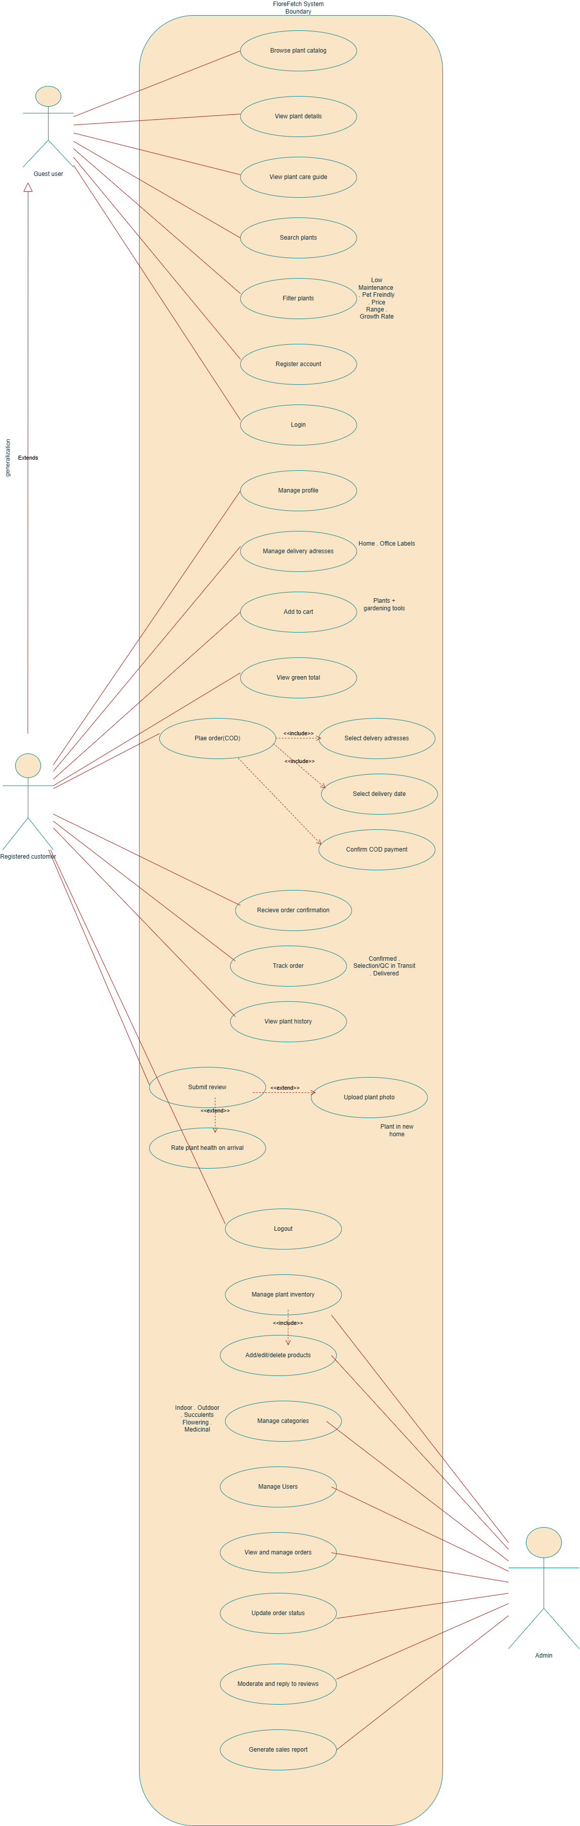

5. WorkPlan

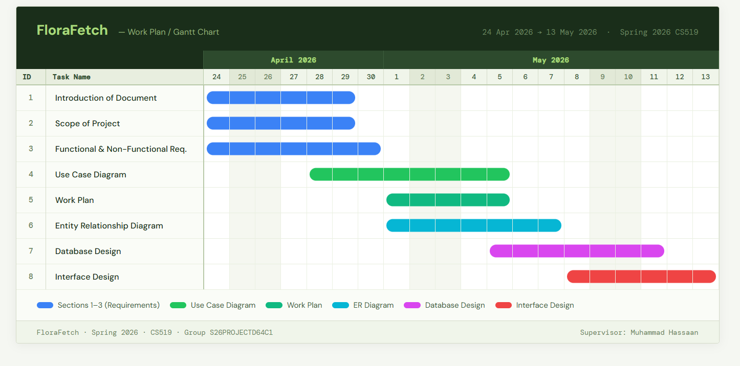

6. ER Diagram

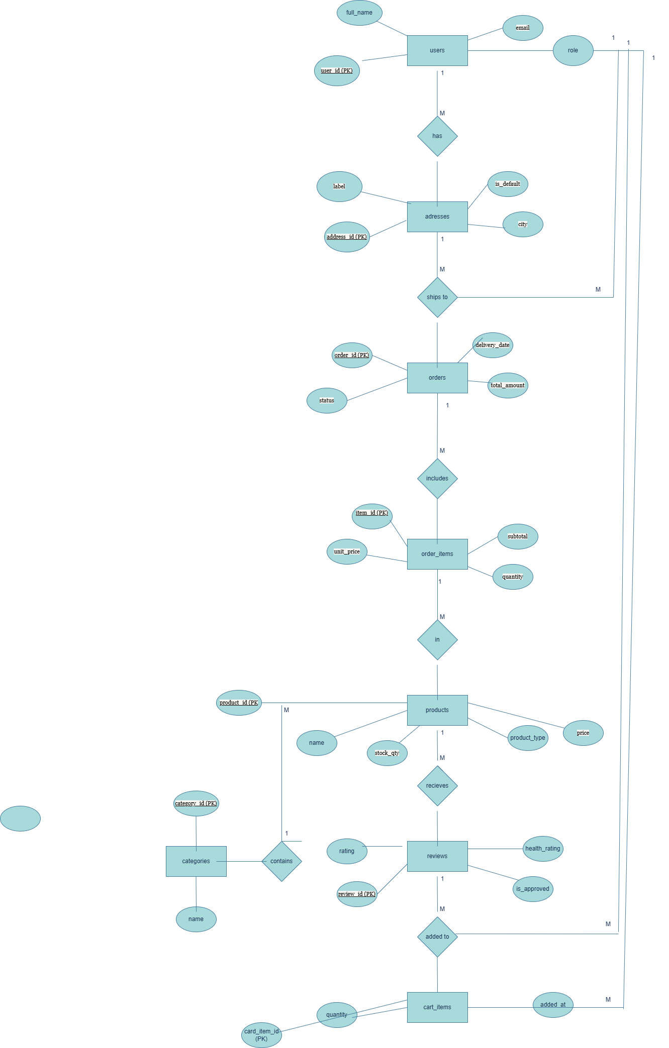
7. DataBase Diagram

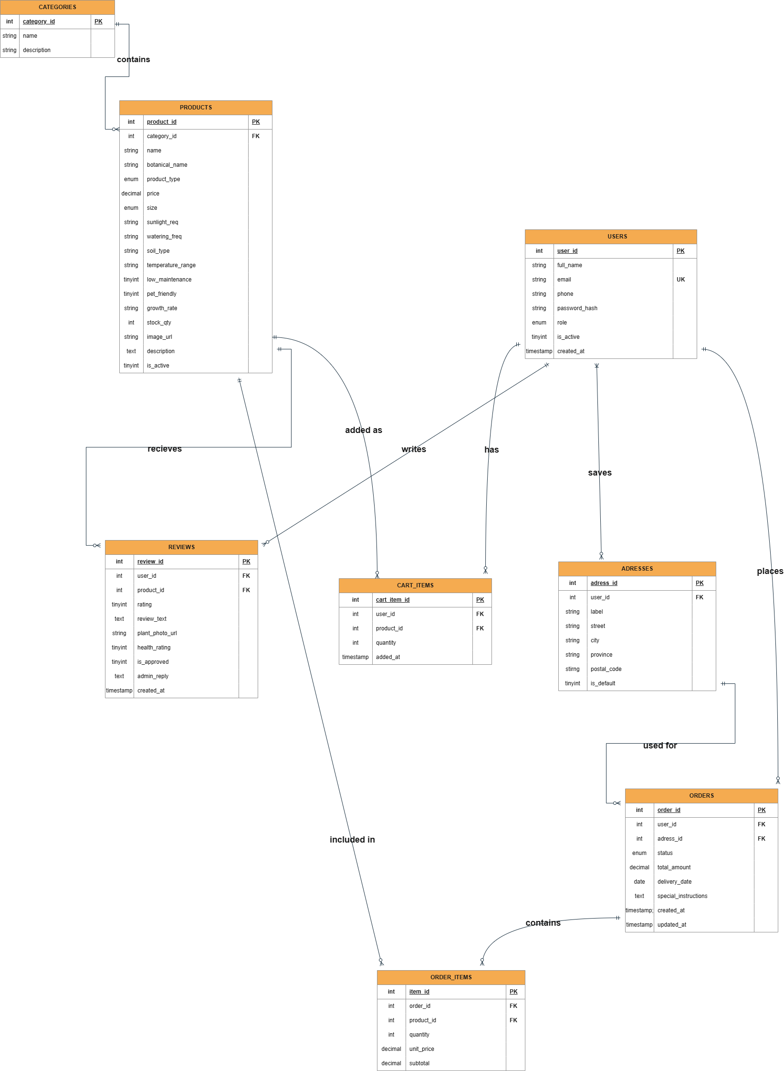

8. Interface Design
SCREEN 1:HOME PAGE

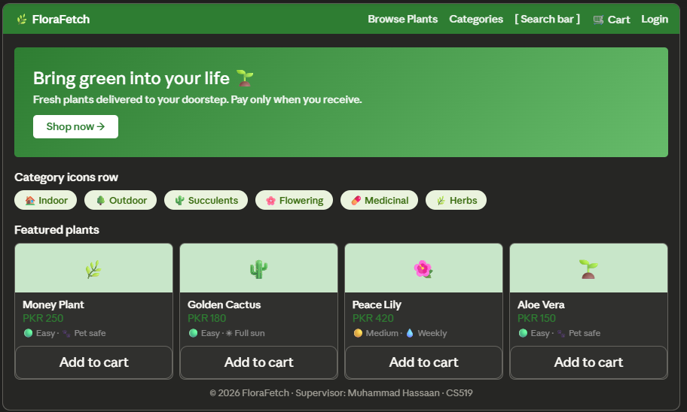

SCREEN 2:PLANT DETAIL PAGE

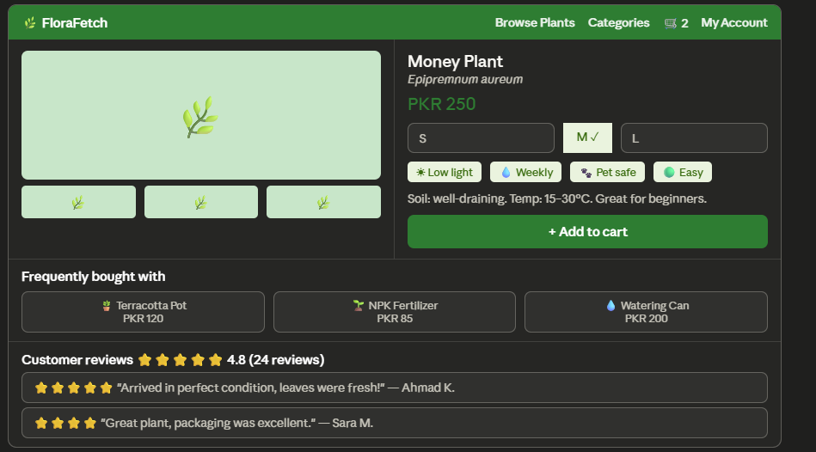

SCREEN 3:CART AND CHECKOUT

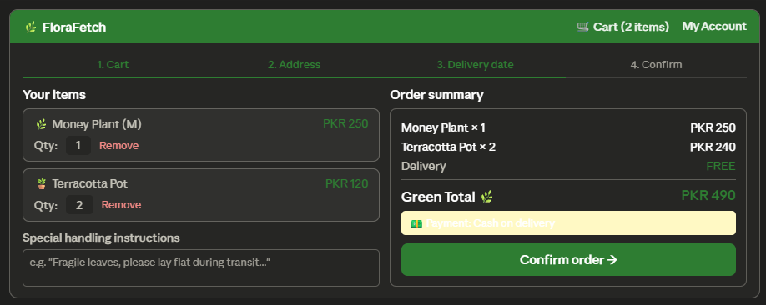

SCREEN 4:ADMIN DASHBOARD

