Mata Kuliah S1 Sensor dan Transduser

Laporan Tugas Praktikum ke-12

Jumat, 8 Mei 2020

Kelompok 1 Senin

1. Dea Nofitasari        G74170032
2. Muhammad Iqbal    G74170038
3. Wimpi Pangkawati G74170058
4. Imam Muhajir        G74170064
5. Arine Fitriani        G74170067
6. Asmaul Chusna Al A. G84170019

**Mengenal Data ICDD dan Menganalisis Data XRD untuk Struktur Kristal Heksagonal**

1. Tentukanlah berapa $Å$ kah parameter kisi struktur heksagonal material Ni0,96S dari data ICDD di bawah ini:

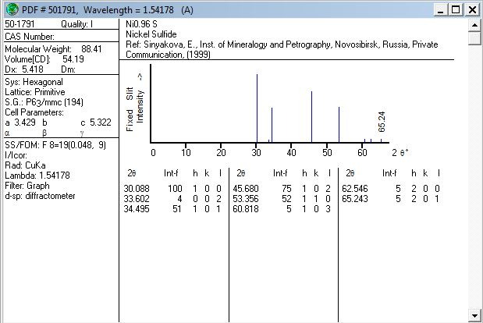

Jawab

|  |  |  |  |  |  |  |  |  |  |
| --- | --- | --- | --- | --- | --- | --- | --- | --- | --- |
| **No** | **2θ** | **θ** | **sin θ** | **sin 2θ** | **sin² θ** | **sin² 2θ** | **h** | **k** | **l** |
| 1 | 30,088 | 15,044 | 0,2595607 | 0,5013295 | 0,0673718 | 0,2513313 | 1 | 0 | 0 |
| 2 | 33,602 | 16,801 | 0,2890485 | 0,5534206 | 0,083549 | 0,3062744 | 0 | 0 | 2 |
| 3 | 34,495 | 17,2475 | 0,2964999 | 0,5663343 | 0,0879122 | 0,3207346 | 1 | 0 | 1 |
| 4 | 45,68 | 22,84 | 0,3881591 | 0,7154489 | 0,1506675 | 0,5118671 | 1 | 0 | 2 |
| 5 | 53,356 | 26,678 | 0,4489759 | 0,8023594 | 0,2015794 | 0,6437806 | 1 | 1 | 0 |
| 6 | 60,818 | 30,409 | 0,5061692 | 0,8730753 | 0,2562073 | 0,7622605 | 1 | 0 | 3 |
| 7 | 62,546 | 31,273 | 0,5191164 | 0,8873813 | 0,2694818 | 0,7874455 | 2 | 0 | 0 |
| 8 | 65,243 | 32,6215 | 0,5390869 | 0,908092 | 0,2906147 | 0,8246311 | 2 | 0 | 1 |

|  |  |  |  |  |  |  |  |  |  |
| --- | --- | --- | --- | --- | --- | --- | --- | --- | --- |
| **α** | **γ** | **δ** | **α²** | **γ²** | **δ²** | **αδ** | **αγ** | **γδ** | **α sin² θ** |
| 1 | 0 | 2,513313 | 1 | 0 | 6,3167421 | 2,513313 | 0 | 0 | 0,0673718 |
| 0 | 4 | 3,0627439 | 0 | 16 | 9,3804 | 0 | 0 | 12,250975 | 0 |
| 1 | 1 | 3,2073456 | 1 | 1 | 10,287066 | 3,2073456 | 1 | 3,2073456 | 0,0879122 |
| 1 | 4 | 5,1186712 | 1 | 16 | 26,200795 | 5,1186712 | 4 | 20,474685 | 0,1506675 |
| 3 | 0 | 6,4378056 | 9 | 0 | 41,445341 | 19,313417 | 0 | 0 | 0,6047382 |
| 1 | 9 | 7,6226048 | 1 | 81 | 58,104104 | 7,6226048 | 9 | 68,603443 | 0,2562073 |
| 4 | 0 | 7,8744551 | 16 | 0 | 62,007042 | 31,49782 | 0 | 0 | 1,0779273 |
| 4 | 1 | 8,2463111 | 16 | 1 | 68,001647 | 32,985245 | 4 | 8,2463111 | 1,1624586 |
|  |  |  | 45 | 115 | 281,74314 | 102,25842 | 18 | 112,78276 | 3,4072829 |

|  |  |
| --- | --- |
| **γ sin² θ** | **δ sin² θ** |
| 0 | 0,1693264 |
| 0,3341962 | 0,2558893 |
| 0,0879122 | 0,2819648 |
| 0,6026699 | 0,7712172 |
| 0 | 1,2977289 |
| 2,3058657 | 1,952967 |
| 0 | 2,1220226 |
| 0,2906147 | 2,3964989 |
| 3,6212586 | 9,2476151 |

Penentuan determinan menurut metode *Cramer*

|  |  |  |  |
| --- | --- | --- | --- |
| Σαsin² θ | CΣα² | BΣαγ | AΣαδ |
| Σγsin² θ | CΣαγ | BΣγ² | AΣγδ |
| Σδsin² θ | CΣαδ | BΣγδ | AΣδ² |

Maka akan menjadi

|  |  |  |  |
| --- | --- | --- | --- |
| 3,40728 | 45 | 18 | 102,258 |
| 3,62126 | 18 | 115 | 112,783 |
| 9,24762 | 102,258 | 112,783 | 281,743 |

Di mana penulisan matriks ordo 3x3 akan menjadi:

|  |  |  |  |  |
| --- | --- | --- | --- | --- |
| 45 | 18 | 102,258 | C | 3,40728 |
| 18 | 115 | 112,783 | B | 3,62126 |
| 102,258 | 112,783 | 281,743 | A | 9,24762 |

Mencari determinan A, A1, dan A2 dengan berbantuan fungsi MDETERM

|  |  |  |  |
| --- | --- | --- | --- |
| 45 | 18 | 102,258 | **Determinan A** |
| 18 | 115 | 112,783 |
| 102,258 | 112,783 | 281,743 | **6995,553782** |

**DET A** = [((45 x 115 x 281.743) + (18 x 112.783 x 102.258) + (102.258 x 18 x112.783))

- ((45 x 112.783 x 112.783) + (18 x 18 x 281.743) + (102.258 x 115 x 102.258))]

= 6995.553782

|  |  |  |  |
| --- | --- | --- | --- |
| 3,40728 | 18 | 102,258 | **Determinan A1** |
| 3,62126 | 115 | 112,783 |
| 9,24762 | 112,783 | 281,743 | **480,3682655** |

**DET A1** = [((3.40728 x 115 x 281.743) + (18 x 112.783 x 9.24762) + (102.258x3.62126 x 112.783))- ((3.40728 x 112.783 x 112.783) + (18 x 93.6216 x 281.743) + (102.258 x 115 x 9.24762))]

= 480.3682655

|  |  |  |  |
| --- | --- | --- | --- |
| 45 | 3,40728 | 102,258 | **Determinan A2** |
| 18 | 3,62126 | 112,783 |
| 102,258 | 9,24762 | 281,743 | **149,6458029** |

**DET A2** = [((45 x 3.62126 x 281.743) + (3.40728 x 112.783 x 102.258) + (102.258 x 18 x 9.24762) - ((45 x 112.783 x 9.24762) + (3.40728 x 18 x 281.743) + (102.258 x 3.62126 x 102.258))

= 149.6458029

|  |  |  |  |
| --- | --- | --- | --- |
| 45 | 18 | 3,40728 | **Determinan A3** |
| 18 | 115 | 3,62126 |
| 102,258 | 112,783 | 9,24762 | **-4,638891415** |

**DET A3 =** [((45 x 115 x 9.24762) + (18 x 3.62126 x 102.258) + (3.40728 x 18 x 112.783)) - ((45 x 3.62126 x 112.783) + (18 x 18 x 9.24762) + (3.40728 x 115 x 102.258))]

= -4.638891415

Mencari C agar dapat menemukan konstanta kisi (a):

|  |  |
| --- | --- |
| C = Det (A1/A) | |
| C | 0,06867 |

C = Det (A1/A)

= $\frac{480.3682655}{6995.553782}$

= 0.06867

Mencari B agar dapat menemukan konstanta kisi (c):

|  |  |
| --- | --- |
| B = Det (A2/A) | |
| B | 0,02139 |

B = Det (A2/A)

= $\frac{149.6458029}{6995.553782}$

= 0.02139

Mencari konstanta kisi (a):

|  |  |
| --- | --- |
| diketahui λ (Å) | 1,54178 |

|  |  |
| --- | --- |
| a=λ/SQRT(3*C)) | |
| a(Å) | 3,39692279 |

$$a=\frac{λ}{\sqrt{3C}}$$

$$a=\frac{1.54178}{(\sqrt{3x0.06876})}$$

$$a=3.39692279 Å$$

Mencari konstanta kisi (c):

|  |  |  |  |
| --- | --- | --- | --- |
| diketahui λ (Å) | | 1,54178 | |
|  |  |  |  |
| c=λ/(2*sqrt(B)) | | |  |
| c(Å) | 5,270735122 | |  |

|  |  |
| --- | --- |
| Data Literatur | |
| a(Å) | 3,429 |
| c(Å) | 5,322 |

Nilai galat

|  |  |  |  |
| --- | --- | --- | --- |
| Aδ | A | D | Galat |
| -0,0017 | -0,0007 | -0,0066 | -0,0017 |
| -0,002 | -0,0007 | -0,0066 | -0,002 |
| -0,0021 | -0,0007 | -0,0066 | -0,0021 |
| -0,0034 | -0,0007 | -0,0066 | -0,0034 |
| -0,0043 | -0,0007 | -0,0066 | -0,0051 |
| -0,0051 | -0,0007 | -0,0066 | -0,0051 |
| -0,0052 | -0,0007 | -0,0066 | -0,0052 |
| -0,0055 | -0,0007 | -0,0066 | -0,0055 |
|  |  |  | -0.03002 | Rata-rata galat | -0.3752% |
|  |  |  | -0.00375 |

2. Tentukanlah berapa $Å$ kah parameter kisi struktur heksagonal material GaNdari data ICDD di bawah ini: (ambil 12 puncak pertama)

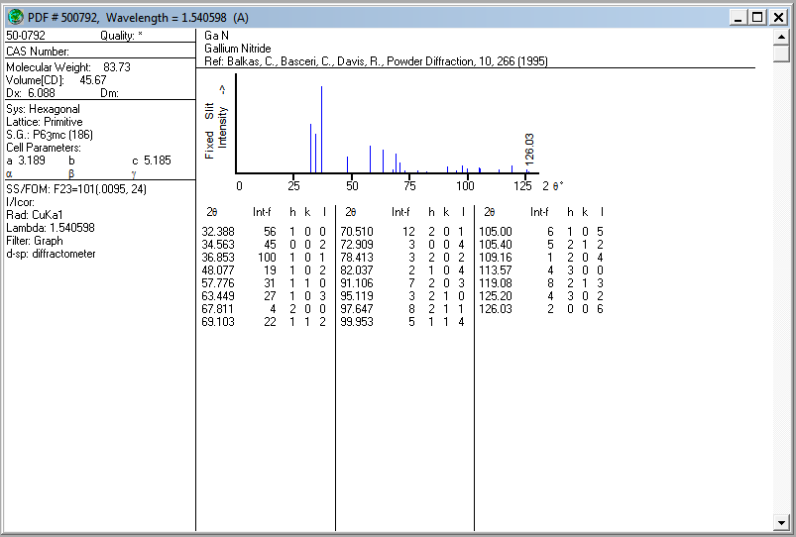

|  |  |  |  |  |  |  |  |  |  |  |  |
| --- | --- | --- | --- | --- | --- | --- | --- | --- | --- | --- | --- |
| **No** | **2θ (deg.)** | **θ (deg.)** | **2θ (rad.)** | **θ (rad.)** | **sin θ** | **sin 2θ** | **sin² θ** | **sin² 2θ** | **h** | **k** | **l** |
| 1 | 32.388 | 16.194 | 0.565277 | 0.282639 | 0.278891 | 0.53565 | 0.07778 | 0.286921 | 1 | 0 | 0 |
| 2 | 34.563 | 17.2815 | 0.603238 | 0.301619 | 0.297067 | 0.567312 | 0.088249 | 0.321843 | 0 | 0 | 2 |
| 3 | 36.853 | 18.4265 | 0.643206 | 0.321603 | 0.316088 | 0.599764 | 0.099912 | 0.359717 | 1 | 0 | 1 |
| 4 | 48.077 | 24.0385 | 0.839102 | 0.419551 | 0.40735 | 0.744043 | 0.165934 | 0.553601 | 1 | 0 | 2 |
| 5 | 57.776 | 28.888 | 1.008381 | 0.504191 | 0.483099 | 0.84597 | 0.233385 | 0.715665 | 1 | 1 | 0 |
| 6 | 63.449 | 31.7245 | 1.107394 | 0.553697 | 0.525835 | 0.894537 | 0.276503 | 0.800196 | 1 | 0 | 3 |
| 7 | 67.811 | 33.9055 | 1.183525 | 0.591763 | 0.557825 | 0.925943 | 0.311168 | 0.857371 | 2 | 0 | 0 |
| 8 | 69.103 | 34.5515 | 1.206075 | 0.603037 | 0.567147 | 0.934223 | 0.321655 | 0.872773 | 1 | 1 | 2 |
| 9 | 70.51 | 35.255 | 1.230632 | 0.615316 | 0.577216 | 0.9427 | 0.333179 | 0.888683 | 2 | 0 | 1 |
| 10 | 72.909 | 36.4545 | 1.272502 | 0.636251 | 0.594184 | 0.955839 | 0.353055 | 0.913629 | 0 | 0 | 4 |
| 11 | 78.413 | 39.2065 | 1.368565 | 0.684283 | 0.632117 | 0.979621 | 0.399572 | 0.959657 | 2 | 0 | 2 |
| 12 | 82.037 | 41.0185 | 1.431816 | 0.715908 | 0.656303 | 0.990358 | 0.430733 | 0.980808 | 1 | 0 | 4 |

|  |  |  |  |  |  |  |  |  |  |  |  |
| --- | --- | --- | --- | --- | --- | --- | --- | --- | --- | --- | --- |
| **α** | **γ** | **δ** | **α²** | **γ²** | **δ²** | **αδ** | **αγ** | **γδ** | **α sin² θ** | **γ sin² θ** | **δ sin² θ** |
| 1 | 0 | 2.869209 | 1 | 0 | 8.232358 | 2.869208664 | 0 | 0 | 0.07778 | 0 | 0.223167 |
| 0 | 4 | 3.21843 | 0 | 16 | 10.35829 | 0 | 0 | 12.87372 | 0 | 0.352994 | 0.284022 |
| 1 | 1 | 3.597169 | 1 | 1 | 12.93962 | 3.597169016 | 1 | 3.597169 | 0.099912 | 0.099912 | 0.359399 |
| 1 | 4 | 5.536006 | 1 | 16 | 30.64736 | 5.536005827 | 4 | 22.14402 | 0.165934 | 0.663737 | 0.918614 |
| 3 | 0 | 7.15665 | 9 | 0 | 51.21764 | 21.4699512 | 0 | 0 | 0.700154 | 0 | 1.670252 |
| 1 | 9 | 8.001962 | 1 | 81 | 64.03139 | 8.001961553 | 9 | 72.01765 | 0.276503 | 2.488526 | 2.212565 |
| 4 | 0 | 8.573706 | 16 | 0 | 73.50844 | 34.29482557 | 0 | 0 | 1.244674 | 0 | 2.667867 |
| 3 | 4 | 8.727729 | 9 | 16 | 76.17325 | 26.18318692 | 12 | 34.91092 | 0.964966 | 1.286622 | 2.807322 |
| 4 | 1 | 8.886828 | 16 | 1 | 78.97571 | 35.54731177 | 4 | 8.886828 | 1.332715 | 0.333179 | 2.960903 |
| 0 | 16 | 9.136286 | 0 | 256 | 83.47171 | 0 | 0 | 146.1806 | 0 | 5.648879 | 3.22561 |
| 4 | 4 | 9.59657 | 16 | 16 | 92.09416 | 38.3862802 | 16 | 38.38628 | 1.598289 | 1.598289 | 3.834522 |
| 1 | 16 | 9.808084 | 1 | 256 | 96.19852 | 9.808084459 | 16 | 156.9294 | 0.430733 | 6.891731 | 4.224668 |
|  |  |  | 71 | 659 | 677.8485 | 185.6939852 | 62 | 495.9265 | 6.89166 | 19.36387 | 25.38891 |
|  |  |  | **Σα²** | **Σγ²** | **Σδ²** | **Σαδ** | **Σαγ** | **Σγδ** | **Σαsin² θ** | **Σγsin² θ** | **Σδsin² θ** |

|  |  |  |  |  |  |
| --- | --- | --- | --- | --- | --- |
| Penentuan determinan menurut metode *Cramer* | | | | | |
|  | Σαsin² θ | CΣα² | BΣαγ | AΣαδ |  |
|  | Σγsin² θ | CΣαγ | BΣγ² | AΣγδ |  |
|  | Σδsin² θ | CΣαδ | BΣγδ | AΣδ² |  |

|  |  |  |  |  |  |
| --- | --- | --- | --- | --- | --- |
| Maka akan menjadi | | | | | |
|  | 6.89166 | 71 | 62 | 185.694 |  |
|  | 19.36387 | 62 | 659 | 495.9265 |  |
|  | 25.38891 | 185.694 | 495.9265 | 677.8485 |  |

|  |  |  |  |  |  |  |
| --- | --- | --- | --- | --- | --- | --- |
| Di mana penulisan matriks ordo 3x3 akan menjadi: | | | | | | |
|  | 71 | 62 | 185.694 | C | 6.89166 |  |
|  | 62 | 659 | 495.9265 | B | 19.36387 |  |
|  | 185.694 | 495.9265 | 677.8485 | A | 25.38891 |  |

Mencari determinan A, A1, A2, dan A3 dengan berbantuan fungsi MDETERM

|  |  |  |  |
| --- | --- | --- | --- |
| 71 | 62 | 185.694 | **Determinan A** |
| 62 | 659 | 495.9265 |
| 185.694 | 495.9265 | 677.8485 | **343665.8658** |

**DET A** = [((71 x 659 x 677.8485) + (62 x 495.9265 x 185.694) + (185.694x62 x495.9265))

- ((62 x 62 x 677.8485 ) + (71 x 495.9265 x 495.9265) + (185.694 x 659 x 185.694))] = 343665.8658

|  |  |  |  |
| --- | --- | --- | --- |
| 6.89166 | 62 | 185.694 | **Determinan A1** |
| 19.36387 | 659 | 495.9265 |
| 25.38891 | 495.9265 | 677.8485 | **26738.83551** |

**DET A1** = [((6.89166 x 659 x 677.8485) + (62 x 495.9265 x 19.36387) + (185.694x19.36387

x495.9265)) - ((62 x 19.36387 x 677.8485 ) + ( 6.89166x 495.9265 x 495.9265) +

(185.694 x 659 x 25.38891 ))] = 26738.83551

|  |  |  |  |
| --- | --- | --- | --- |
| 71 | 6.89166 | 185.694 | **Determinan A2** |
| 62 | 19.36387 | 495.9265 |
| 185.694 | 25.38891 | 677.8485 | **7583.330274** |

**DET A2** = [((71x 19.36387 x 677.8485) + (6.89166x 495.9265 x185.694) + (185.694x62

X 25.38891)) - ((6.89166 x 62x 677.8485 ) + (71x495.9265 x 25.38891) +

(185.694 x 25.38891 x185.694))] = 7583.330274

|  |  |  |  |
| --- | --- | --- | --- |
| 71 | 62 | 6.89166 | **Determinan A3** |
| 62 | 659 | 19.36387 |
| 185.694 | 495.9265 | 25.38891 | **-1.052339165** |

**DET A3** = [((71x 659 x25.38891) + (62x19.36387 x185.694) + (6.89166x62x

495.9265)) - ((62 x 62x 25.38891) + (71x19.36387x 495.9265) +

(6.89166x 659x185.694))] = -1.052339165

|  |  |  |  |  |  |
| --- | --- | --- | --- | --- | --- |
| Mencari C agar dapat menemukan konstanta kisi (a): | | | | | |
|  |  | C = Det (A1/A) | |  |  |
|  |  | C | 0.077805 |  |  |

C = Det (A1/A) = $\frac{26738.83551}{343665.8658}$ = 0.077805

|  |  |  |  |  |  |
| --- | --- | --- | --- | --- | --- |
| Mencari B agar dapat menemukan konstanta kisi (c): | | | | | |
|  |  | B = Det (A2/A) | |  |  |
|  |  | B | 0.022066 |  |  |

B = Det (A2/A) = $\frac{7583.330274}{343665.8658}$ = 0.022066

|  |  |  |  |  |  |
| --- | --- | --- | --- | --- | --- |
| Mencari A agar dapat menemukan nilai galat | | | | | |
|  |  | A = Det (A3/A) | |  |  |
|  |  | A | -3.1E-06 |  |  |

A = Det (A3/A) = = -3.1 x 10-6

|  |
| --- |
| diketahui λ (Å) |
| 1.54178 |

|  |  |  |
| --- | --- | --- |
| Mencari konstanta kisi (a): | | |
| a=λ/SQRT(3*C)) | | Data Literatur |
| a(Å) | 3.191234621 | 3.189 |

|  |  |  |
| --- | --- | --- |
| Mencari konstanta kisi (c): | | |
| c=λ/(2*sqrt(B)) | | Data Literatur |
| c(Å) | 5.189561055 | 5.185 |

|  |  |  |  |  |  |
| --- | --- | --- | --- | --- | --- |
| Aδ | A | D | Galat |  |  |
| -8.7858E-06 | -3.1E-06 | -3.1E-05 | -8.8E-06 |  |  |
| 0 | -3.1E-06 | -3.1E-05 | 0 |  |  |
| -1.1015E-05 | -3.1E-06 | -3.1E-05 | -1.1E-05 |  |  |
| -1.6952E-05 | -3.1E-06 | -3.1E-05 | -1.7E-05 |  |  |
| -6.5743E-05 | -3.1E-06 | -3.1E-05 | -2.5E-05 |  |  |
| -2.4503E-05 | -3.1E-06 | -3.1E-05 | -2.5E-05 |  |  |
| -0.00010501 | -3.1E-06 | -3.1E-05 | -0.00011 |  |  |
| -8.0176E-05 | -3.1E-06 | -3.1E-05 | -8E-05 |  |  |
|  |  |  | -0.00027 | Rata-rata galat | -0.0034% |
|  |  |  | -3.4E-05 |

3. Tentukanlah berapa kah parameter kisi struktur heksagonal material SmAlO3 dari data ICDD di bawah ini:

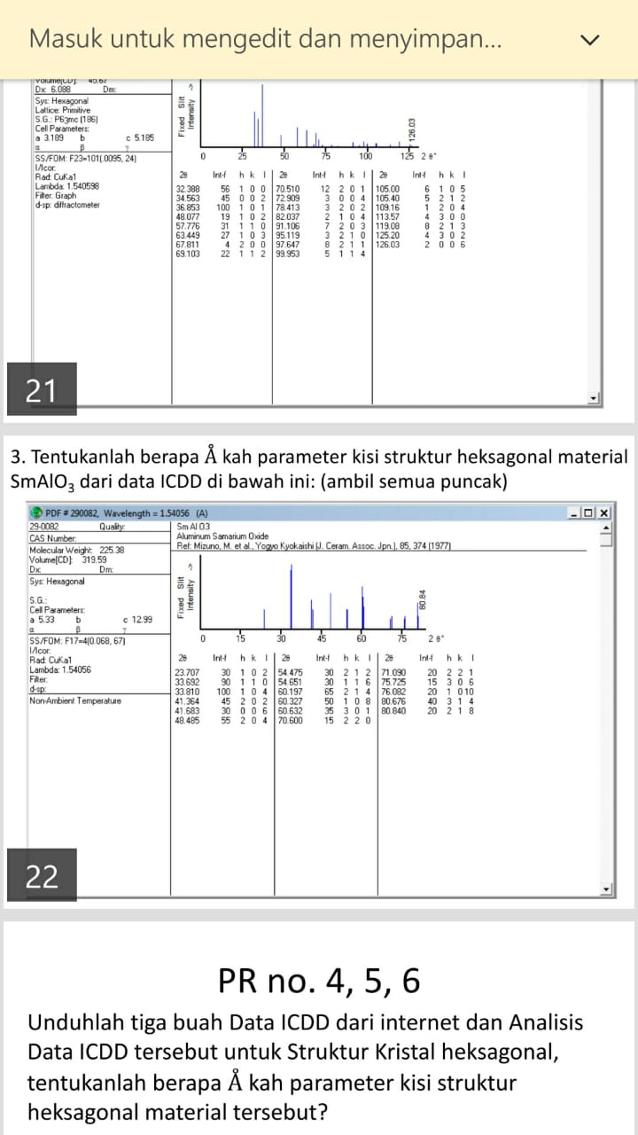

|  |  |  |  |  |  |  |  |  |  |  |  |
| --- | --- | --- | --- | --- | --- | --- | --- | --- | --- | --- | --- |
| **No** | **2θ (deg.)** | **θ (deg.)** | **2θ (rad.)** | **θ (rad.)** | **sin θ** | **sin 2θ** | **sin² θ** | **sin² 2θ** | **h** | **k** | **l** |
| 1 | 23.707 | 11.8535 | 0.413765 | 0.206883 | 0.20541 | 0.40205964 | 0.042193 | 0.161652 | 1 | 0 | 2 |
| 2 | 33.692 | 16.846 | 0.588036 | 0.294018 | 0.2898 | 0.55472826 | 0.083984 | 0.307723 | 1 | 1 | 0 |
| 3 | 33.81 | 16.905 | 0.590096 | 0.295048 | 0.290786 | 0.55644064 | 0.084556 | 0.309626 | 1 | 0 | 4 |
| 4 | 41.364 | 20.682 | 0.721938 | 0.360969 | 0.353181 | 0.66084043 | 0.124737 | 0.43671 | 2 | 0 | 2 |
| 5 | 41.683 | 20.8415 | 0.727506 | 0.363753 | 0.355784 | 0.66500879 | 0.126582 | 0.442237 | 0 | 0 | 6 |
| 6 | 48.485 | 24.2425 | 0.846223 | 0.423111 | 0.410599 | 0.74878222 | 0.168592 | 0.560675 | 2 | 0 | 4 |
| 7 | 54.475 | 27.2375 | 0.950768 | 0.475384 | 0.45768 | 0.81386206 | 0.209471 | 0.662371 | 2 | 1 | 2 |
| 8 | 54.651 | 27.3255 | 0.95384 | 0.47692 | 0.459045 | 0.8156431 | 0.210722 | 0.665274 | 1 | 1 | 6 |
| 9 | 60.197 | 30.0985 | 1.050636 | 0.525318 | 0.501488 | 0.86773943 | 0.25149 | 0.752972 | 2 | 1 | 4 |
| 10 | 60.327 | 30.1635 | 1.052905 | 0.526452 | 0.502469 | 0.8688649 | 0.252475 | 0.754926 | 1 | 0 | 8 |
| 11 | 60.632 | 30.316 | 1.058228 | 0.529114 | 0.504769 | 0.87148785 | 0.254791 | 0.759491 | 3 | 0 | 1 |
| 12 | 70.6 | 35.3 | 1.232202 | 0.616101 | 0.577858 | 0.94322266 | 0.333919 | 0.889669 | 2 | 2 | 0 |
| 13 | 71.09 | 35.545 | 1.240755 | 0.620377 | 0.581342 | 0.94602881 | 0.337959 | 0.894971 | 2 | 2 | 1 |
| 14 | 75.725 | 37.8625 | 1.321651 | 0.660825 | 0.613769 | 0.96912341 | 0.376712 | 0.9392 | 3 | 0 | 6 |
| 15 | 76.082 | 38.041 | 1.327881 | 0.663941 | 0.616225 | 0.97064096 | 0.379734 | 0.942144 | 1 | 0 | 10 |
| 16 | 80.676 | 40.338 | 1.408062 | 0.704031 | 0.647295 | 0.98678794 | 0.418991 | 0.97375 | 3 | 1 | 4 |
| 17 | 80.84 | 40.42 | 1.410924 | 0.705462 | 0.648386 | 0.98724764 | 0.420404 | 0.974658 | 2 | 1 | 8 |

|  |  |  |  |  |  |  |  |  |  |  |  |
| --- | --- | --- | --- | --- | --- | --- | --- | --- | --- | --- | --- |
| **α** | **γ** | **δ** | **α²** | **γ²** | **δ²** | **αδ** | **αγ** | **γδ** | **α sin² θ** | **γ sin² θ** | **δ sin² θ** |
| 1 | 4 | 1.61652 | 1 | 16 | 2.613136 | 1.61652 | 4 | 6.466078 | 0.04219326 | 0.168773 | 0.068206 |
| 3 | 0 | 3.077234 | 9 | 0 | 9.469372 | 9.231703 | 0 | 0 | 0.25195262 | 0 | 0.258439 |
| 1 | 16 | 3.096262 | 1 | 256 | 9.586838 | 3.096262 | 16 | 49.54019 | 0.08455632 | 1.352901 | 0.261809 |
| 4 | 4 | 4.367101 | 16 | 16 | 19.07157 | 17.4684 | 16 | 17.4684 | 0.49894713 | 0.498947 | 0.544738 |
| 0 | 36 | 4.422367 | 0 | 1296 | 19.55733 | 0 | 0 | 159.2052 | 0 | 4.556961 | 0.559793 |
| 4 | 16 | 5.606748 | 16 | 256 | 31.43562 | 22.42699 | 64 | 89.70797 | 0.6743678 | 2.697471 | 0.945253 |
| 7 | 4 | 6.623715 | 49 | 16 | 43.87359 | 46.366 | 28 | 26.49486 | 1.46629656 | 0.837884 | 1.387476 |
| 3 | 36 | 6.652737 | 9 | 1296 | 44.25891 | 19.95821 | 108 | 239.4985 | 0.63216693 | 7.586003 | 1.40188 |
| 7 | 16 | 7.529717 | 49 | 256 | 56.69664 | 52.70802 | 112 | 120.4755 | 1.76043211 | 4.023845 | 1.893651 |
| 1 | 64 | 7.549262 | 1 | 4096 | 56.99136 | 7.549262 | 64 | 483.1528 | 0.25247536 | 16.15842 | 1.906003 |
| 9 | 1 | 7.594911 | 81 | 1 | 57.68267 | 68.3542 | 9 | 7.594911 | 2.29312305 | 0.254791 | 1.935118 |
| 12 | 0 | 8.89669 | 144 | 0 | 79.15109 | 106.7603 | 0 | 0 | 4.00703321 | 0 | 2.970778 |
| 12 | 1 | 8.949705 | 144 | 1 | 80.09722 | 107.3965 | 12 | 8.949705 | 4.05550478 | 0.337959 | 3.024631 |
| 9 | 36 | 9.392002 | 81 | 1296 | 88.2097 | 84.52802 | 324 | 338.1121 | 3.39040721 | 13.56163 | 3.538079 |
| 1 | 100 | 9.421439 | 1 | 10000 | 88.76351 | 9.421439 | 100 | 942.1439 | 0.3797335 | 37.97335 | 3.577636 |
| 13 | 16 | 9.737504 | 169 | 256 | 94.81899 | 126.5876 | 208 | 155.8001 | 5.44688833 | 6.703863 | 4.079931 |
| 7 | 64 | 9.746579 | 49 | 4096 | 94.9958 | 68.22605 | 448 | 623.7811 | 2.94282801 | 26.90586 | 4.097501 |
|  |  |  | 820 | 23154 | 877.2733 | 751.6954 | 1513 | 3268.391 | 28.1789062 | 123.6187 | 32.45092 |
|  |  |  | **Σα²** | **Σγ²** | **Σδ²** | **Σαδ** | **Σαγ** | **Σγδ** | **Σαsin² θ** | **Σγsin² θ** | **Σδsin² θ** |

|  |  |  |  |  |  |  |
| --- | --- | --- | --- | --- | --- | --- |
| Penentuan determinan menurut metode *Cramer* | | | | | |  |
|  | Σαsin² θ | CΣα² | BΣαγ | AΣαδ |  |  |
|  | Σγsin² θ | CΣαγ | BΣγ² | AΣγδ |  |  |
|  | Σδsin² θ | CΣαδ | BΣγδ | AΣδ² |  |  |
|  |  |  |  |  |  |  |
| Maka akan menjadi | | | | | |  |
|  | 28.17891 | 820 | 1513 | 751.6954 |  |  |
|  | 123.6187 | 1513 | 23154 | 3268.391 |  |  |
|  | 32.45092 | 751.6954 | 3268.391 | 877.2733 |  |  |
|  |  |  |  |  |  |  |
| Di mana penulisan matriks ordo 3x3 akan menjadi: | | | | | | |
|  | 820 | 1513 | 751.6954 | C | 28.18 |  |
|  | 1513 | 23154 | 3268.391 | B | 123.6 |  |
|  | 751.6954 | 3268.391 | 877.2733 | A | 32.45 |  |

Mencari determinanA, A1,A2, dan A3 dengan bantuan fungsi MDETERM

|  |  |  |  |
| --- | --- | --- | --- |
| 820 | 1513 | 751.6954 | **Determinan A** |
| 1513 | 23154 | 3268.391 |
| 751.6954 | 3268.391 | 877.2733 | **239684935.7** |
|  |  |  |  |

**DET A** = [((820x 23154 x 877.2733) + (1513 x 3268.391 x 751.6954) + (751.6954x1513

x3268.391)) - ((820 x 3268.391 x 3268.391 ) + ( 1513 x 1513 x 877.2733) +

(751.6954 x 23154 x 751.6954 ))] = 239684935.7

|  |  |  |  |
| --- | --- | --- | --- |
| 28.17891 | 1513 | 751.6954 | **Determinan A1** |
| 123.6187 | 23154 | 3268.391 |
| 32.45092 | 3268.391 | 877.2733 | **6664801.437** |

**DET A1** = [((28.17891x 23154 x 877.2733) + (1513 x 3268.391 x 32.45092) + (751.6954x123.6187x3268.391)) - ((28.17891 x 3268.391 x 3268.391 ) + ( 1513 x 123.6187 x 877.2733) + (751.6954 x 23154 x 32.45092))] = 6664801.437

|  |  |  |  |
| --- | --- | --- | --- |
| 820 | 28.1789062 | 751.6954 | **Determinan A2** |
| 1513 | 123.618656 | 3268.391 |
| 751.6954 | 32.4509203 | 877.2733 | **841077.8931** |

**DET A2** = [((820x123.618656 x 877.2733) + (28.1789062 x 3268.391 x 751.6954) +(751.6954x 6187 x 32.4509203)) - ((820x 32.4509203x 3268.391) + (1513x 28.1789062 x 877.2733) + (751.6954 x 123.618656 x 751.6954))] = 841077.8931

|  |  |  |  |
| --- | --- | --- | --- |
| 820 | 1513 | 28.17891 | **Determinan A3** |
| 1513 | 23154 | 123.6187 |
| 751.6954 | 3268.391 | 32.45092 | **21757.1369** |

**DET A3** = [((820x 23154 x 32.45092) + (1513 x 123.6187x 751.6954) + (28.17891x1513

x3268.391)) - ((820 x 3268.391 x 123.6187) + ( 1513 x 1513 x 32.45092) +

(28.17891x 23154 x 751.6954 ))] = 217557.1369

|  |  |  |  |  |  |
| --- | --- | --- | --- | --- | --- |
| Mencari C agar dapat menemukan konstanta kisi (a): | | | | | |
|  |  | C = Det (A1/A) | |  |  |
|  |  | C | 0.027807 |  |  |

C = Det (A1/A) = $\frac{6664801.437}{239684935.7}$ = 0.027807

|  |  |  |  |  |  |
| --- | --- | --- | --- | --- | --- |
| Mencari B agar dapat menemukan konstanta kisi (c): | | | | | |
|  |  | B = Det (A2/A) | |  |  |
|  |  | B | 0.003509 |  |  |

B = Det (A2/A) = $\frac{841077.8931}{239684935.7}$ = 0.003509

|  |  |  |  |  |  |
| --- | --- | --- | --- | --- | --- |
| Mencari A agar dapat menemukan nilai galat | | | | | |
|  |  | A = Det (A3/A) | |  |  |
|  |  | A | 9.0774E-05 |  |  |

A = Det (A3/A) = $\frac{217557.1369}{239684935.7}$ = 9.0774E-05

|  |  |  |  |  |
| --- | --- | --- | --- | --- |
| Mencari konstanta kisi (a): | | | | |
| a=λ/SQRT(3*C)) | | Data Literatur | | |
| a(Å) | 5.333898562 | 5.33 | Mizuno,M et al 1977 |  |

|  |  |  |  |  |
| --- | --- | --- | --- | --- |
| Mencari konstanta kisi (c): | | | | |
| c=λ/(2*sqrt(B)) | | Data Literatur | | |
| c(Å) | 13.00321916 | 12.99 | Mizuno,M et al 1977 |  |

|  |  |  |  |  |  |
| --- | --- | --- | --- | --- | --- |
| δ | A | D | Galat |  |  |
| 0.000147 | 9.07739E-05 | 0.000908 | 0.000147 |  |  |
| 0.000279 | 9.07739E-05 | 0.000908 | 0.000279 |  |  |
| 0.000281 | 9.07739E-05 | 0.000908 | 0.000281 |  |  |
| 0.000396 | 9.07739E-05 | 0.000908 | 0.000396 |  |  |
| 0.000401 | 9.07739E-05 | 0.000908 | 0.000401 |  |  |
| 0.000509 | 9.07739E-05 | 0.000908 | 0.000509 |  |  |
| 0.000601 | 9.07739E-05 | 0.000908 | 0.000601 |  |  |
| 0.000604 | 9.07739E-05 | 0.000908 | 0.000604 |  |  |
| 0.000684 | 9.07739E-05 | 0.000908 | 0.000684 |  |  |
| 0.000685 | 9.07739E-05 | 0.000908 | 0.000685 |  |  |
| 0.000689 | 9.07739E-05 | 0.000908 | 0.000689 |  |  |
| 0.000808 | 9.07739E-05 | 0.000908 | 0.000808 |  |  |
| 0.000812 | 9.07739E-05 | 0.000908 | 0.000812 |  |  |
| 0.000853 | 9.07739E-05 | 0.000908 | 0.000853 |  |  |
| 0.000855 | 9.07739E-05 | 0.000908 | 0.000855 |  |  |
| 0.000884 | 9.07739E-05 | 0.000908 | 0.000884 |  |  |
| 0.000885 | 9.07739E-05 | 0.000908 | 0.000885 |  |  |
|  |  |  | 0.010374 | Rata-rata galat | 0.0610% |
|  |  |  | 0.00061 |

No. 4,5,6

Unduhlah tiga buah Data ICDD dari internet dan Analisis Data ICDD tersebut untuk Struktur Kristal heksagonal, tentukanlah berapa $Å$ kah parameter kisi struktur heksagonal material tersebut?

1. Material : (NH4)H2Co2O(OH)(MoO4)1.6(WO4)0.4

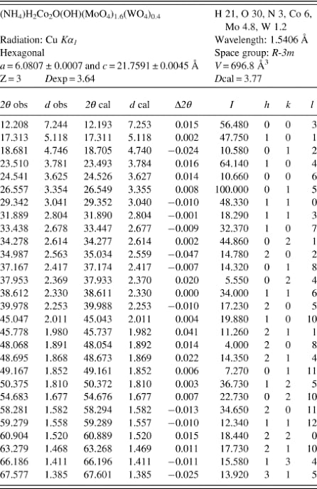

Jawab

|  |  |  |  |  |  |  |  |  |
| --- | --- | --- | --- | --- | --- | --- | --- | --- |
| **No** | **2θ (deg.)** | **θ (deg.)** | **2θ (rad.)** | **θ (rad.)** | **sin θ** | **sin 2θ** | **sin² θ** | **sin² 2θ** |
| 1 | 12,208 | 6,104 | 0,213069795 | 0,106534898 | 0,106333489 | 0,211461267 | 0,011306811 | 0,044715868 |
| 2 | 17,313 | 8,6565 | 0,302168853 | 0,151084427 | 0,150510294 | 0,297591495 | 0,022653349 | 0,088560698 |
| 3 | 18,681 | 9,3405 | 0,326044958 | 0,163022479 | 0,162301348 | 0,320298866 | 0,026341728 | 0,102591364 |
| 4 | 23,51 | 11,755 | 0,410326907 | 0,205163454 | 0,203727188 | 0,39890912 | 0,041504767 | 0,159128486 |
| 5 | 24,541 | 12,2705 | 0,428321252 | 0,214160626 | 0,212527305 | 0,415344291 | 0,045167855 | 0,17251088 |
| 6 | 26,557 | 13,2785 | 0,463507089 | 0,231753545 | 0,22968454 | 0,447087907 | 0,052754988 | 0,199887596 |
| 7 | 29,342 | 14,671 | 0,512114509 | 0,256057255 | 0,253268334 | 0,49002158 | 0,064144849 | 0,240121149 |
| 8 | 31,889 | 15,9445 | 0,556568045 | 0,278284023 | 0,274706093 | 0,528275334 | 0,075463438 | 0,279074829 |
| 9 | 33,438 | 16,719 | 0,583603195 | 0,291801598 | 0,28767813 | 0,551034311 | 0,082758706 | 0,303638812 |
| 10 | 34,278 | 17,139 | 0,598263961 | 0,29913198 | 0,294690845 | 0,563208808 | 0,086842694 | 0,317204162 |
| 11 | 34,987 | 17,4935 | 0,610638345 | 0,305319173 | 0,300597602 | 0,573390562 | 0,090358918 | 0,328776736 |
| 12 | 37,167 | 18,5835 | 0,648686523 | 0,324343262 | 0,318686358 | 0,604140246 | 0,101560995 | 0,364985437 |
| 13 | 37,953 | 18,9765 | 0,662404811 | 0,331202406 | 0,32518032 | 0,615014859 | 0,105742241 | 0,378243277 |
| 14 | 38,612 | 19,306 | 0,673906531 | 0,336953265 | 0,330613226 | 0,624043264 | 0,109305105 | 0,389429996 |
| 15 | 39,978 | 19,989 | 0,697747728 | 0,348873864 | 0,341839729 | 0,642493422 | 0,1168544 | 0,412797798 |

|  |  |  |  |  |  |  |  |  |
| --- | --- | --- | --- | --- | --- | --- | --- | --- |
| **h** | **k** | **l** | **α** | **γ** | **δ** | **α²** | **γ²** | **δ²** |
| 0 | 0 | 1 | 0 | 1 | 0,447158676 | 0 | 1 | 0,199950882 |
| 1 | 0 | 1 | 1 | 1 | 0,885606978 | 1 | 1 | 0,784299719 |
| 0 | 1 | 2 | 1 | 4 | 1,025913637 | 1 | 16 | 1,05249879 |
| 1 | 0 | 4 | 1 | 16 | 1,59128486 | 1 | 256 | 2,532187507 |
| 0 | 0 | 6 | 0 | 36 | 1,725108801 | 0 | 1296 | 2,976000376 |
| 0 | 1 | 5 | 1 | 25 | 1,998875962 | 1 | 625 | 3,995505112 |
| 1 | 1 | 0 | 3 | 0 | 2,401211492 | 9 | 0 | 5,765816631 |
| 1 | 1 | 3 | 3 | 9 | 2,790748286 | 9 | 81 | 7,788275998 |
| 1 | 0 | 7 | 1 | 49 | 3,036388119 | 1 | 2401 | 9,219652812 |
| 0 | 2 | 1 | 4 | 1 | 3,172041619 | 16 | 1 | 10,06184803 |
| 2 | 0 | 2 | 4 | 4 | 3,287767365 | 16 | 16 | 10,80941424 |
| 0 | 1 | 8 | 1 | 64 | 3,649854372 | 1 | 4096 | 13,32143694 |
| 0 | 2 | 4 | 4 | 16 | 3,782432772 | 16 | 256 | 14,30679767 |
| 1 | 1 | 6 | 3 | 36 | 3,894299957 | 9 | 1296 | 15,16557216 |
| 2 | 0 | 5 | 4 | 25 | 4,127977978 | 16 | 625 | 17,04020218 |
|  |  |  |  |  |  | 97 | 10967 | 115,0194591 |
|  |  |  |  |  |  | **Σα²** | **Σγ²** | **Σδ²** |

|  |  |  |  |  |  |
| --- | --- | --- | --- | --- | --- |
| **αδ** | **αγ** | **γδ** | **α sin² θ** | **γ sin² θ** | **δ sin² θ** |
| 0 | 0 | 0,447158676 | 0 | 0,011306811 | 0,005055939 |
| 0,885606978 | 1 | 0,885606978 | 0,022653349 | 0,022653349 | 0,020061964 |
| 1,025913637 | 4 | 4,103654546 | 0,026341728 | 0,10536691 | 0,027024337 |
| 1,59128486 | 16 | 25,46055777 | 0,041504767 | 0,664076275 | 0,066045908 |
| 0 | 0 | 62,10391684 | 0 | 1,626042786 | 0,077919464 |
| 1,998875962 | 25 | 49,97189905 | 0,052754988 | 1,318874695 | 0,105450677 |
| 7,203634477 | 0 | 0 | 0,192434547 | 0 | 0,154025348 |
| 8,372244859 | 27 | 25,11673458 | 0,226390313 | 0,679170938 | 0,210599459 |
| 3,036388119 | 49 | 148,7830179 | 0,082758706 | 4,055176618 | 0,251287553 |
| 12,68816648 | 4 | 3,172041619 | 0,347370776 | 0,086842694 | 0,27546864 |
| 13,15106946 | 16 | 13,15106946 | 0,361435673 | 0,361435673 | 0,297079102 |
| 3,649854372 | 64 | 233,5906798 | 0,101560995 | 6,499903681 | 0,370682842 |
| 15,12973109 | 64 | 60,51892434 | 0,422968963 | 1,691875852 | 0,399962917 |
| 11,68289987 | 108 | 140,1947985 | 0,327915315 | 3,934983776 | 0,425666865 |
| 16,51191191 | 100 | 103,1994494 | 0,467417601 | 2,921360008 | 0,482372391 |
| 96,92758207 | 478 | 870,6995094 | 2,67350772 | 23,97907007 | 3,168703406 |
| **Σαδ** | **Σαγ** | **Σγδ** | **Σαsin² θ** | **Σγsin² θ** | **Σδsin² θ** |

|  |  |  |  |  |  |  |  |
| --- | --- | --- | --- | --- | --- | --- | --- |
| Penentuan determinan menurut metode Cramer | | | | | |  |  |
|  | Σαsin² θ | CΣα² | BΣαγ | AΣαδ |  |  |  |
|  | Σγsin² θ | CΣαγ | BΣγ² | AΣγδ |  |  |  |
|  | Σδsin² θ | CΣαδ | BΣγδ | AΣδ² |  |  |  |
|  |  |  |  |  |  |  |  |
| Maka akan menjadi | | | | | |  |  |
|  | 2,67350772 | 97 | 478 | 96,92758207 |  |  |  |
|  | 23,97907007 | 478 | 10967 | 870,6995094 |  |  |  |
|  | 3,168703406 | 96,92758207 | 870,6995094 | 115,0194591 |  |  |  |
|  |  |  |  |  |  |  |  |
| Di mana penulisan matriks ordo 3x3 akan menjadi: | | | | | | |  |
|  | 97 | 478 | 96,92758207 | C | 2,67350772 |  |  |
|  | 478 | 10967 | 870,6995094 | B | 23,97907007 |  |  |
|  | 96,92758207 | 870,6995094 | 115,0194591 | A | 3,168703406 |  |  |
|  |  |  |  |  |  |  |  |
| Mencari determinan A, A1, A2, dan A3 dengan berbantuan fungsi MDETERM | | | | | | | |
|  |  |  |  |  |  |  |  |
|  | 97 | 478 | 96,92758207 | **Determinan A** | | |  |
|  | 478 | 10967 | 870,6995094 |  |
|  | 96,92758207 | 870,6995094 | 115,0194591 | **187011,5441** | | |  |

**DET A** = [((97 x 10967 x 115,0194591) + (478 x 870,6995094 x 96,92758207) + (96,92758207x 478 x 870,6995094)) - ((96,92758207x 10967 x 96,92758207) + (97x 870,6995094 x 870,6995094) + (478x 478 x 115,0194591))] = **187011,5441**

|  |  |  |  |
| --- | --- | --- | --- |
| 2,67350772 | 478 | 96,92758207 | **Determinan A1** |
| 23,97907007 | 10967 | 870,6995094 |
| 3,168703406 | 870,6995094 | 115,0194591 | **1384,352269** |

**DET A1** = [(( 2,67350772x 10967 x 115,0194591) + (478 x 870,6995094 x 3,168703406) + (96,92758207x 23,97907007 x 870,6995094)) - ((96,92758207x 10967 x 3,168703406) + (2,67350772x 870,6995094 x 870,6995094) + (478x23,97907007 x 115,0194591))] = **1384,352269**

|  |  |  |  |
| --- | --- | --- | --- |
| 97 | 2,67350772 | 96,92758207 | **Determinan A2** |
| 478 | 23,97907007 | 870,6995094 |
| 96,92758207 | 3,168703406 | 115,0194591 | **80,56357002** |

**DET A2** = [((97 x 23,97907007 x 115,0194591) + (2,67350772 x 870,6995094 x 96,92758207) + (96,92758207x 478 x 3,168703406)) - ((96,92758207x 23,97907007 x 96,92758207) + (97x 870,6995094 x 3,168703406) + (2,67350772x 478 x 115,0194591))] = **80,56357002**

|  |  |  |  |
| --- | --- | --- | --- |
| 97 | 478 | 2,67350772 | **Determinan A3** |
| 478 | 10967 | 23,97907007 |
| 96,92758207 | 870,6995094 | 3,168703406 | **3375,563934** |

**DET A** = [((97 x 10967 x 3,168703406) + (478 x 23,97907007x 96,92758207) + (2,67350772x 478 x 870,6995094)) - ((2,67350772x 10967 x 96,92758207) + (97x 23,97907007 x 870,6995094) + (478x 478 x 3,168703406))] =**3375,563934**

|  |  |  |  |  |  |
| --- | --- | --- | --- | --- | --- |
| Mencari C agar dapat menemukan konstanta kisi (a): | | | | | |
|  |  | C = Det (A1/A) | |  |  |
|  |  | C | 0,007402496 |  |  |



|  |  |  |  |  |  |
| --- | --- | --- | --- | --- | --- |
| Mencari B agar dapat menemukan konstanta kisi (c): | | | | | |
|  |  | B = Det (A2/A) | |  |  |
|  |  | B | 0,000430795 |  |  |



|  |  |  |  |  |  |
| --- | --- | --- | --- | --- | --- |
| Mencari A agar dapat menemukan nilai galat | | | | | |
|  |  | A = Det (A3/A) | |  |  |
|  |  | A | 0,01805003 |  |  |



|  |
| --- |
| diketahui λ (Å) |
| 1,54178 |

|  |  |  |  |  |
| --- | --- | --- | --- | --- |
| Mencari konstanta kisi (a): | | | | |
| a=λ/SQRT(3*C)) | | Data Literatur | | |
| a(Å) | 10,3460049 | 6,0807 | Razik dkk 1990 |  |



**

|  |  |  |  |  |
| --- | --- | --- | --- | --- |
| Mencari konstanta kisi (c): | | | | |
| c=λ/(2*sqrt(B)) | | Data Literatur | | |
| c(Å) | 37,14131437 | 21,7591 | Razik dkk 1990 |  |



Nilai galat

|  |  |  |  |  |  |
| --- | --- | --- | --- | --- | --- |
| Aδ | A | D | Galat |  |  |
| 0,008071227 | 0,01805003 | 0,180500297 | 0,008071227 |  |  |
| 0,015985232 | 0,01805003 | 0,180500297 | 0,015985232 |  |  |
| 0,018517772 | 0,01805003 | 0,180500297 | 0,018517772 |  |  |
| 0,028722739 | 0,01805003 | 0,180500297 | 0,028722739 |  |  |
| 0,031138265 | 0,01805003 | 0,180500297 | 0,036079771 |  |  |
| 0,036079771 | 0,01805003 | 0,180500297 | 0,036079771 |  |  |
| 0,043341939 | 0,01805003 | 0,180500297 | 0,043341939 |  |  |
| 0,05037309 | 0,01805003 | 0,180500297 | 0,05037309 |  |  |
|  |  |  | 0,23717154 | Rata-rata galat | 2,9646% |
|  |  |  | 0,029646443 |

5. Material: Cadmium Tellurium Selenide (CdSe0.6Te0.4)

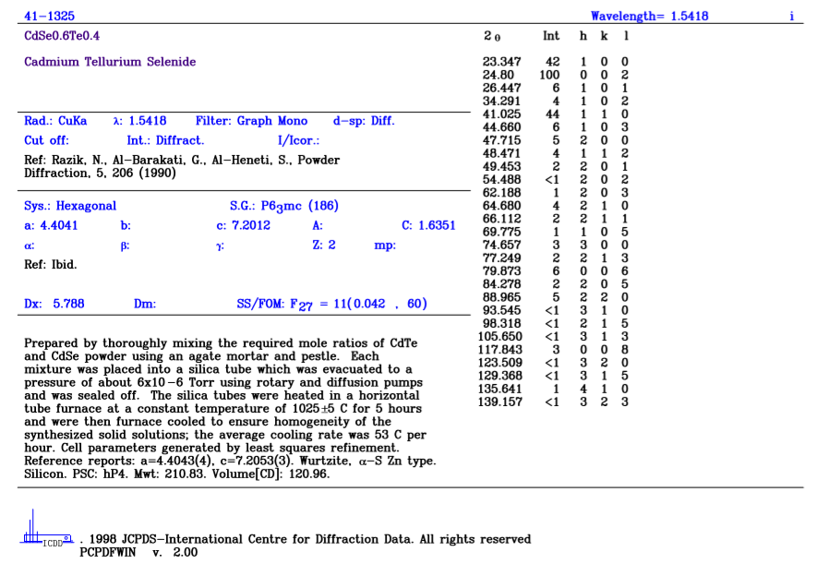

Jawab

|  |  |  |  |  |  |  |  |  |
| --- | --- | --- | --- | --- | --- | --- | --- | --- |
| **No** | **2θ (deg.)** | **θ (deg.)** | **2θ (rad.)** | **θ (rad.)** | **sin θ** | **sin 2θ** | **sin² θ** | **sin² 2θ** |
| 1 | 23.347 | 11.6735 | 0.407482 | 0.203741 | 0.202334 | 0.396299 | 0.040939 | 0.157053 |
| 2 | 24.8 | 12.4 | 0.432842 | 0.216421 | 0.214735 | 0.419452 | 0.046111 | 0.17594 |
| 3 | 26.447 | 13.2235 | 0.461587 | 0.230794 | 0.22875 | 0.44537 | 0.052327 | 0.198354 |
| 4 | 34.291 | 17.1455 | 0.598491 | 0.299245 | 0.294799 | 0.563396 | 0.086907 | 0.317415 |
| 5 | 41.025 | 20.5125 | 0.716021 | 0.358011 | 0.350412 | 0.656388 | 0.122788 | 0.430846 |
| 6 | 44.66 | 22.33 | 0.779464 | 0.389732 | 0.379941 | 0.702898 | 0.144355 | 0.494066 |
| 7 | 47.715 | 23.8575 | 0.832784 | 0.416392 | 0.404463 | 0.739807 | 0.163591 | 0.547315 |
| 8 | 48.471 | 24.2355 | 0.845979 | 0.422989 | 0.410488 | 0.74862 | 0.1685 | 0.560432 |
| 9 | 49.453 | 24.7265 | 0.863118 | 0.431559 | 0.418287 | 0.759873 | 0.174964 | 0.577407 |
| 10 | 54.488 | 27.244 | 0.950995 | 0.475498 | 0.457781 | 0.813994 | 0.209563 | 0.662586 |
| 11 | 62.188 | 31.094 | 1.085385 | 0.542693 | 0.516444 | 0.884483 | 0.266714 | 0.782311 |
| 12 | 64.68 | 32.34 | 1.128879 | 0.564439 | 0.534942 | 0.903933 | 0.286163 | 0.817095 |
| 13 | 66.112 | 33.056 | 1.153872 | 0.576936 | 0.545458 | 0.914339 | 0.297525 | 0.836015 |
| 14 | 69.775 | 34.8875 | 1.217803 | 0.608902 | 0.571967 | 0.938342 | 0.327146 | 0.880486 |
| 15 | 74.657 | 37.3285 | 1.30301 | 0.651505 | 0.606384 | 0.964359 | 0.367702 | 0.929988 |

|  |  |  |  |  |  |  |  |  |
| --- | --- | --- | --- | --- | --- | --- | --- | --- |
| **h** | **k** | **l** | **α** | **γ** | **δ** | **α²** | **γ²** | **δ²** |
| 1 | 0 | 0 | 1 | 0 | 1.570527 | 1 | 0 | 2.466556 |
| 0 | 0 | 2 | 0 | 4 | 1.7594 | 0 | 16 | 3.09549 |
| 1 | 0 | 1 | 1 | 1 | 1.983542 | 1 | 1 | 3.934441 |
| 1 | 0 | 2 | 1 | 4 | 3.174154 | 1 | 16 | 10.07525 |
| 1 | 1 | 0 | 3 | 0 | 4.308456 | 9 | 0 | 18.56279 |
| 1 | 0 | 3 | 1 | 9 | 4.94066 | 1 | 81 | 24.41012 |
| 2 | 0 | 0 | 4 | 0 | 5.473148 | 16 | 0 | 29.95535 |
| 1 | 1 | 2 | 3 | 4 | 5.604323 | 9 | 16 | 31.40843 |
| 2 | 0 | 1 | 4 | 1 | 5.774069 | 16 | 1 | 33.33988 |
| 2 | 0 | 2 | 4 | 4 | 6.62586 | 16 | 16 | 43.90203 |
| 2 | 0 | 3 | 4 | 9 | 7.823107 | 16 | 81 | 61.201 |
| 2 | 1 | 0 | 7 | 0 | 8.170954 | 49 | 0 | 66.7645 |
| 2 | 1 | 1 | 7 | 1 | 8.360154 | 49 | 1 | 69.89218 |
| 1 | 0 | 5 | 1 | 25 | 8.804862 | 1 | 625 | 77.5256 |
| 3 | 0 | 0 | 9 | 0 | 9.299885 | 81 | 0 | 86.48786 |
|  |  |  |  |  |  | 266 | 854 | 563.0215 |
|  |  |  |  |  |  | **Σα²** | **Σγ²** | **Σδ²** |

|  |  |  |  |  |  |
| --- | --- | --- | --- | --- | --- |
| **αδ** | **αγ** | **γδ** | **α sin² θ** | **γ sin² θ** | **δ sin² θ** |
| 1.570527 | 0 | 0 | 0.040939 | 0 | 0.064296 |
| 0 | 0 | 7.037602 | 0 | 0.184445 | 0.081128 |
| 1.983542 | 1 | 1.983542 | 0.052327 | 0.052327 | 0.103792 |
| 3.174154 | 4 | 12.69661 | 0.086907 | 0.347626 | 0.275855 |
| 12.92537 | 0 | 0 | 0.368365 | 0 | 0.529028 |
| 4.94066 | 9 | 44.46594 | 0.144355 | 1.299193 | 0.713208 |
| 21.89259 | 0 | 0 | 0.654362 | 0 | 0.895355 |
| 16.81297 | 12 | 22.41729 | 0.505501 | 0.674002 | 0.944331 |
| 23.09628 | 4 | 5.774069 | 0.699857 | 0.174964 | 1.010255 |
| 26.50344 | 16 | 26.50344 | 0.838253 | 0.838253 | 1.388537 |
| 31.29243 | 36 | 70.40796 | 1.066856 | 2.400426 | 2.086532 |
| 57.19668 | 0 | 0 | 2.003143 | 0 | 2.338227 |
| 58.52108 | 7 | 8.360154 | 2.082675 | 0.297525 | 2.487354 |
| 8.804862 | 25 | 220.1216 | 0.327146 | 8.178654 | 2.880477 |
| 83.69896 | 0 | 0 | 3.309314 | 0 | 3.419582 |
| 352.4135 | 114 | 419.7682 | 12.18 | 14.44742 | 19.21796 |
| **Σαδ** | **Σαγ** | **Σγδ** | **Σαsin² θ** | **Σγsin² θ** | **Σδsin² θ** |

|  |  |  |  |  |  |  |  |
| --- | --- | --- | --- | --- | --- | --- | --- |
| Penentuan determinan menurut metode *Cramer* | | | | | |  |  |
|  | Σαsin² θ | CΣα² | BΣαγ | AΣαδ |  |  |  |
|  | Σγsin² θ | CΣαγ | BΣγ² | AΣγδ |  |  |  |
|  | Σδsin² θ | CΣαδ | BΣγδ | AΣδ² |  |  |  |
|  |  |  |  |  |  |  |  |
| Maka akan menjadi | | | | | |  |  |
|  | 12.18 | 266 | 114 | 352.4135 |  |  |  |
|  | 14.44742 | 114 | 854 | 419.7682 |  |  |  |
|  | 19.21796 | 352.4135 | 419.7682 | 563.0215 |  |  |  |
|  |  |  |  |  |  |  |  |
| Di mana penulisan matriks ordo 3x3 akan menjadi: | | | | | | |  |
|  | 266 | 114 | 352.4135 | C | 12.18 |  |  |
|  | 114 | 854 | 419.7682 | B | 14.44742 |  |  |
|  | 352.4135 | 419.7682 | 563.0215 | A | 19.21796 |  |  |
|  |  |  |  |  |  |  |  |
| Mencari determinan A, A1, A2, dan A3 dengan berbantuan fungsi MDETERM | | | | | | | |
|  |  |  |  |  |  |  |  |
|  | 266 | 114 | 352.4135 | **Determinan A** | | |  |
|  | 114 | 854 | 419.7682 |  |
|  | 352.4135 | 419.7682 | 563.0215 | **1376269.332** | | |  |

**DET A** = [((266 x 854 x 563.0215) + (114 x 419.7682 x 352.4135) + (352.4135 x 114 x 419.7682)) - ((352.4135 x 854 x 352.4135) + (266 x 419.7682 x 419.7682) + (114 x 114 x 563.0215))] = **1376269.332**

|  |  |  |  |
| --- | --- | --- | --- |
| 12.18 | 114 | 352.4135 | **Determinan A1** |
| 14.44742 | 854 | 419.7682 |
| 19.21796 | 419.7682 | 563.0215 | **55934.91405** |

**DET A1** = [((12.18 x 854 x 563.0215) + (114 x 419.7682 x 19.21796) + (352.4135 x 14.44742 x 419.7682)) - ((352.4135 x 854 x 19.21796) + (12.18 x 419.7682 x 419.7682) + (114 x 14.44742 x 563.0215))] = **55934.91405**

|  |  |  |  |
| --- | --- | --- | --- |
| 266 | 12.18 | 352.4135 | **Determinan A2** |
| 114 | 14.44742 | 419.7682 |
| 352.4135 | 19.21796 | 563.0215 | **15681.37888** |

**DET A2** = [((266 x 14.44742 x 563.0215) + (12.18 x 419.7682 x 352.4135) + (352.4135 x 114 x 19.21796)) - ((352.4135 x 14.44742 x 352.4135) + (266 x 419.7682 x 19.21796) + (12.18 x 114 x 563.0215))] = **15681.37888**

|  |  |  |  |
| --- | --- | --- | --- |
| 266 | 114 | 12.18 | **Determinan A3** |
| 114 | 854 | 14.44742 |
| 352.4135 | 419.7682 | 19.21796 | **274.0994789** |

**DET A3** = [((266 x 854 x 19.21796) + (114 x 14.44742 x 352.4135) + (12.18 x 114 x 419.7682)) - ((12.18 x 854 x 352.4135) + (266 x 14.44742 x 419.7682) + (114 x 114 x 19.21796))] = **274.0994789**

|  |  |  |  |  |  |
| --- | --- | --- | --- | --- | --- |
| Mencari C agar dapat menemukan konstanta kisi (a): | | | | | |
|  |  | C = Det (A1/A) | |  |  |
|  |  | C | 0.040642 |  |  |

C = Det (A1/A) = $\frac{55934.91405}{1376269.332}$ = 0.040642

|  |  |  |  |  |  |
| --- | --- | --- | --- | --- | --- |
| Mencari B agar dapat menemukan konstanta kisi (c): | | | | | |
|  |  | B = Det (A2/A) | |  |  |
|  |  | B | 0.011394 |  |  |

B = Det (A2/A) = $\frac{15681.37888}{1376269.332}$ = 0.011394

|  |  |  |  |  |  |
| --- | --- | --- | --- | --- | --- |
| Mencari A agar dapat menemukan nilai galat | | | | | |
|  |  | A = Det (A3/A) | |  |  |
|  |  | A | 0.000199 |  |  |

A = Det (A3/A) = $\frac{274.0994789}{1376269.332}$ = 0.000199

|  |
| --- |
| diketahui λ (Å) |
| 1.54178 |

|  |  |  |  |  |
| --- | --- | --- | --- | --- |
| Mencari konstanta kisi (a): | | | | |
| a=λ/SQRT(3*C)) | | Data Literatur | | |
| a(Å) | 4.415419883 | 4.4041 | Razik dkk 1990 |  |

|  |  |  |  |  |
| --- | --- | --- | --- | --- |
| Mencari konstanta kisi (c): | | | | |
| c=λ/(2*sqrt(B)) | | Data Literatur | | |
| c(Å) | 7.221908876 | 7.2012 | Razik dkk 1990 |  |

$$c=\frac{λ}{2\sqrt{B}}=\frac{1.54178}{(2\sqrt{3x0.011394})}=7.221908876 Å$$

Nilai Galat

|  |  |  |  |  |  |
| --- | --- | --- | --- | --- | --- |
| Aδ | A | D | Galat |  |  |
| 0.000313 | 0.000199 | 0.001992 | 0.000313 |  |  |
| 0.00035 | 0.000199 | 0.001992 | 0.00035 |  |  |
| 0.000395 | 0.000199 | 0.001992 | 0.000395 |  |  |
| 0.000632 | 0.000199 | 0.001992 | 0.000632 |  |  |
| 0.000858 | 0.000199 | 0.001992 | 0.000984 |  |  |
| 0.000984 | 0.000199 | 0.001992 | 0.000984 |  |  |
| 0.00109 | 0.000199 | 0.001992 | 0.00109 |  |  |
| 0.001116 | 0.000199 | 0.001992 | 0.001116 |  |  |
|  |  |  | 0.005865 | Rata-rata galat | 0.0733% |
|  |  |  | 0.000733 |