Ain Shams University

Faculty of Engineering

Computer and Systems Engineering Department

**CSE 371: Software Engineering**

**Final Project**

**Supervisor**

Prof: Omar Amin 7abeb el malaeen

**Team members**

Muhammad Karam Helmy Farahat (33816)

Muhammad Nashaat Refaie (33822)

Mahmoud Ahmed Mahmoud Ahmed (33823)

Muhammad Anwer Saeed (33xxxx)

* Abstract

An interactive educational web application which enable the interaction between the student and his teacher. Allowing the student to view the studying material online and have a discussion with his teacher and classmates.

* Project Repository

<https://github.com/muhakh/CSE371Project>

* Design
* Use Cases Diagram
* Class Diagram

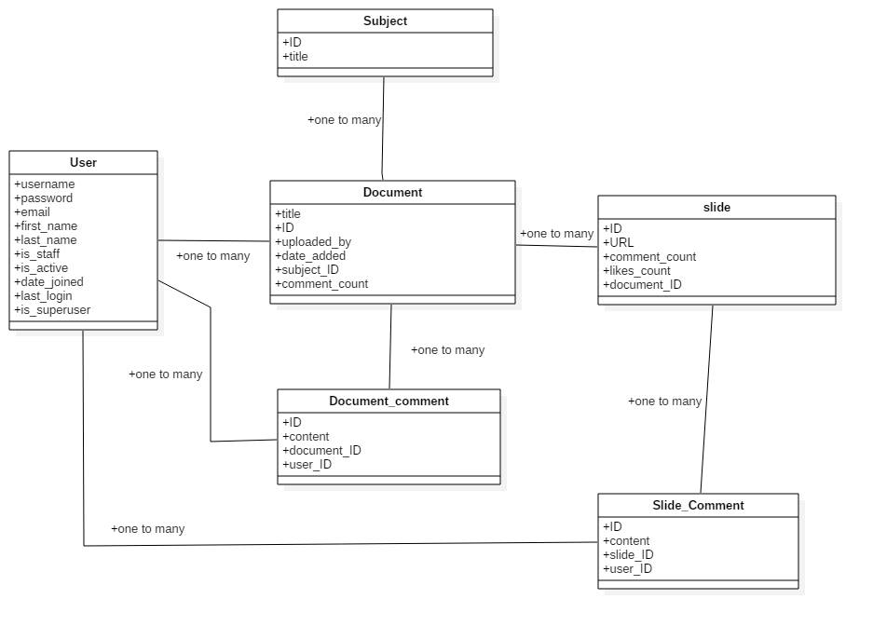

* **Contributions**
* Muhammad Karam

Agmad wahed Fenaaaaaaa

* Muhammad Nashaat

Wrote the part responsible of converting a material document into series of pages in image format.

participated in subject model and views

* Mahmoud Ahmed
* Muhammad Anwer