Task 1:

Step 1:

Step 2:

Done for all router:

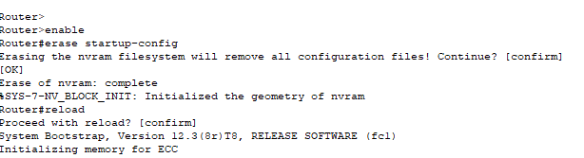

Task2:

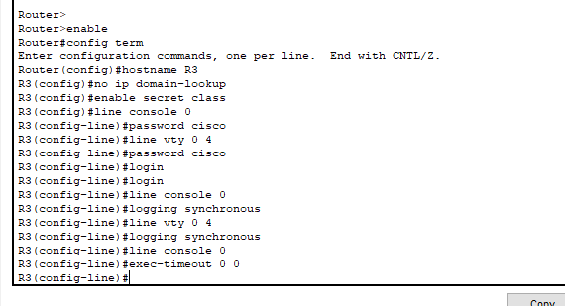

Task 3:

Step 2:

It is false because it was down

To make it true we need to:

1. **Enable the interface**: After configuring the IP address, the interface needs to be activated using the no shutdown command. By default, router interfaces are in a "shutdown" state when configured, which means they are administratively down and cannot pass traffic.
2. **Verify the interface status**: Use the show ip interface brief command to check the status of the interface. Ensure that it shows as "up" both for the interface status and the line protocol.
3. **Check for route updates**: After bringing the interface up, Cisco IOS will automatically add the connected network to the routing table if everything is configured correctly. You can verify this using the show ip route command.

Once the interface is up, the route should change from False to True, and the connected network will appear in the routing table.

Step 3:

Yes to all

Step 4:

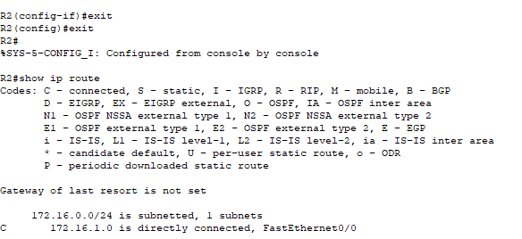

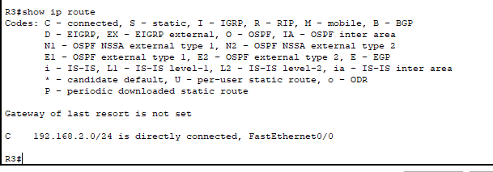

Step 5-9:

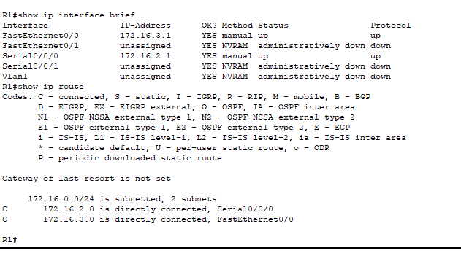

All answer to Step 9 is “yes”.

Step 10:

Show ip route

Step 11:

Task4:

Done

Task 5:

Done

Task 6:

Step 1:

Yes to all and yes they are pinging.

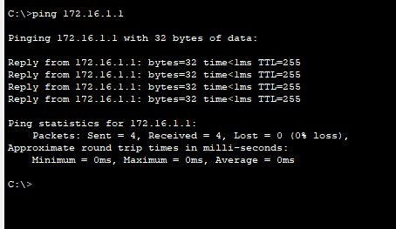

Step 2:

Yes to all and yes they are.

Step 3:

1. **IP Addressing:** devices in different subnets cannot directly communicate with each other without a router acting as an intermediary.
2. **Routing:** For communication between devices in different subnets, the packets must be routed through the routers. However, the routers are not configured with routes to the other subnet. They only know about their own subnet and the directly connected router.
3. **Default Gateway:** When a device tries to ping a host in a different subnet, it sends the packet to its default gateway. Since the router doesn't have a route to the destination subnet, it drops the packet.

Task 7:

Step 1:

Yes

R1: fa0/0 and s0/0/0

R3: fa0/0 and s0/0/1

Because its acting as a main router and is connected to 2 router below so its connected to fa0/0 , s0/0/0 and s0/0/1.

Step2:

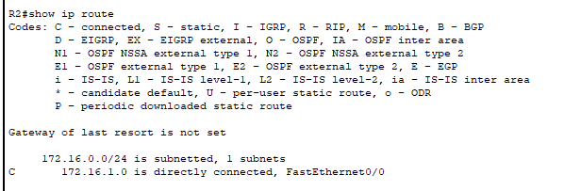

Show ip route

A)none

b)none

c)none

d)

e) To enable pinging between indirectly connected devices, we can implement routing protocols on the routers. Routing protocols allow routers to exchange network information and learn about remote networks. This information is then used to build routing tables that contain routes to different networks.

Task 8: