DATABASE SYSTEMS – PROJECT REPORT

Project Title: SporticsEventManager

Course: Database Systems
Instructor: Miss Fatima Gado
Semester / Section: BCS-5D

Group Members:
- Syed Muhammad Shubair Haider – 23K0753
- Muhammad Ayesh – K23-0593
- Muhammad Hammad – I23-0544

Submission Date: 27-Nov-25

2. Abstract
SporticsEventManager is a comprehensive web-based application designed to streamline the management of sports events, specifically tailored for university-level competitions like "League of Glory" (LOG) and "Olympiad". The system facilitates user registration, team management, court bookings, and match scheduling. It features a role-based access control system (Admin, Captain, Player, General User) to ensure secure and organized operations. The backend is built with Django REST Framework, providing a robust API, while the frontend utilizes Next.js for a responsive and dynamic user interface. This project aims to digitize manual processes, improve data accuracy, and enhance the overall experience for participants and organizers.

3. Introduction
Background: Managing large-scale sports events involves complex coordination between teams, players, and resources (courts/fields). Traditional manual methods are prone to errors and inefficiencies.
Motivation: The need for a centralized platform to handle registrations, scheduling, and real-time updates for university sports events drove the development of this system.
Objectives:
- Provide a user-friendly interface for event registration and management.
- Automate scheduling and scoring of matches.
- Manage resources like sports courts effectively.
- Maintain accurate records of players, teams, and match results.
Scope: The system covers user authentication, two main event modules (LOG and Olympiad), court booking, and administrative controls.
Limitations: Currently limited to a specific set of sports and event types. Payment integration is simulated.

4. System Requirements & Analysis
Functional Requirements:
- User Management: Registration, Login, Role assignment.
- Event Management: Create/Manage LOG and Olympiad events.
- Team Management: Create teams, draft players (LOG), register teams (Olympiad).
- Court Booking: View availability, book slots.
- Match Management: Schedule matches, record scores, update leaderboards.

Non-Functional Requirements:
- Security: JWT Authentication, Role-based access.
- Performance: Fast response times for API calls.
- Usability: Intuitive UI/UX.
- Scalability: Modular architecture to support future expansions.

User Roles:
- Admin: Full system access.
- House Captain: Manages house teams and drafts players.
- Player: Registers for sports and joins teams.
- General User: Views info and books courts.
5.
6. Database Implementation
## 6.1 SQL Table Creation Scripts

### 6.1.1 User Management Tables

```sql
-- Custom User Model (extends Django's AbstractUser)
CREATE TABLE "core_user" (
"id" INTEGER NOT NULL PRIMARY KEY AUTOINCREMENT,
"password" VARCHAR(128) NOT NULL,
"last_login" DATETIME NULL,
"is_superuser" BOOLEAN NOT NULL,
"username" VARCHAR(150) NOT NULL UNIQUE,
"first_name" VARCHAR(150) NOT NULL,
"last_name" VARCHAR(150) NOT NULL,
"email" VARCHAR(254) NOT NULL,
"is_staff" BOOLEAN NOT NULL,
"is_active" BOOLEAN NOT NULL,
"date_joined" DATETIME NOT NULL,
"role" VARCHAR(20) NOT NULL DEFAULT 'general',
"contact_no" VARCHAR(20) NULL,
"department" VARCHAR(50) NULL,
"registration_date" DATETIME NOT NULL DEFAULT CURRENT_TIMESTAMP,
CHECK ("role" IN ('general', 'player', 'captain', 'admin'))
);

-- User Groups (Many-to-Many)
CREATE TABLE "core_user_groups" (
"id" INTEGER NOT NULL PRIMARY KEY AUTOINCREMENT,
"user_id" BIGINT NOT NULL REFERENCES "core_user" ("id") ON DELETE CASCADE,
"group_id" INTEGER NOT NULL REFERENCES "auth_group" ("id") ON DELETE CASCADE,
UNIQUE ("user_id", "group_id")
);

-- User Permissions (Many-to-Many)
CREATE TABLE "core_user_user_permissions" (
"id" INTEGER NOT NULL PRIMARY KEY AUTOINCREMENT,
"user_id" BIGINT NOT NULL REFERENCES "core_user" ("id") ON DELETE CASCADE,
"permission_id" INTEGER NOT NULL REFERENCES "auth_permission" ("id") ON DELETE CASCADE,
UNIQUE ("user_id", "permission_id")
);

CREATE INDEX "idx_user_username" ON "core_user" ("username");
CREATE INDEX "idx_user_role" ON "core_user" ("role");
CREATE INDEX "idx_user_groups_user" ON "core_user_groups" ("user_id");
CREATE INDEX "idx_user_permissions_user" ON "core_user_user_permissions" ("user_id");
```

### 6.1.2 Sport and House Tables

```sql
-- Sports Table
CREATE TABLE "core_sport" (
"id" INTEGER NOT NULL PRIMARY KEY AUTOINCREMENT,
"sports_name" VARCHAR(100) NOT NULL UNIQUE,
"min_players" INTEGER NOT NULL DEFAULT 1,
"max_players" INTEGER NOT NULL DEFAULT 11,
"is_availableinLog" BOOLEAN NOT NULL DEFAULT FALSE,
"is_availableinOlympiad" BOOLEAN NOT NULL DEFAULT TRUE,
"status" VARCHAR(20) NOT NULL DEFAULT 'Sports',
CHECK ("status" IN ('General', 'Esports', 'Sports'))
);

-- Houses Table
CREATE TABLE "core_house" (
"id" INTEGER NOT NULL PRIMARY KEY AUTOINCREMENT,
"house_name" VARCHAR(100) NOT NULL,
"captain_id" BIGINT NULL REFERENCES "core_user" ("id") ON DELETE SET NULL,
"status" VARCHAR(20) NOT NULL DEFAULT 'pending',
"created_at" DATETIME NOT NULL DEFAULT CURRENT_TIMESTAMP,
CHECK ("status" IN ('pending', 'active', 'inactive'))
);

-- House Captain Details
CREATE TABLE "core_housecaptain" (
"id" INTEGER NOT NULL PRIMARY KEY AUTOINCREMENT,
"user_id" BIGINT NOT NULL UNIQUE REFERENCES "core_user" ("id") ON DELETE CASCADE,
"house_id" BIGINT NOT NULL REFERENCES "core_house" ("id") ON DELETE CASCADE
);

-- House Proposal
CREATE TABLE "core_houseproposal" (
"id" INTEGER NOT NULL PRIMARY KEY AUTOINCREMENT,
"house_id" BIGINT NOT NULL UNIQUE REFERENCES "core_house" ("id") ON DELETE CASCADE,
"captain_id" BIGINT NOT NULL REFERENCES "core_user" ("id") ON DELETE CASCADE,
"status" VARCHAR(20) NOT NULL DEFAULT 'pending',
"created_at" DATETIME NOT NULL DEFAULT CURRENT_TIMESTAMP,
CHECK ("status" IN ('pending', 'approved', 'rejected'))
);

-- Sport Captain Details (for House Proposals)
CREATE TABLE "core_sportcaptaindetail" (
"id" INTEGER NOT NULL PRIMARY KEY AUTOINCREMENT,
"proposal_id" BIGINT NOT NULL REFERENCES "core_houseproposal" ("id") ON DELETE CASCADE,
"sport_id" BIGINT NOT NULL REFERENCES "core_sport" ("id") ON DELETE CASCADE,
"name" VARCHAR(150) NOT NULL,
"roll_no" VARCHAR(50) NOT NULL,
"email" VARCHAR(254) NOT NULL,
UNIQUE ("proposal_id", "sport_id")
);

CREATE INDEX "idx_house_captain" ON "core_house" ("captain_id");
CREATE INDEX "idx_house_status" ON "core_house" ("status");
CREATE INDEX "idx_sport_name" ON "core_sport" ("sports_name");
```

### 6.1.3 Player and Team Tables

```sql
-- Player Profile
CREATE TABLE "core_player" (
"id" INTEGER NOT NULL PRIMARY KEY AUTOINCREMENT,
"user_id" BIGINT NOT NULL UNIQUE REFERENCES "core_user" ("id") ON DELETE CASCADE,
"joined_at" DATETIME NOT NULL DEFAULT CURRENT_TIMESTAMP
);

-- Player Registration for Sports
CREATE TABLE "core_playerregistration" (
"id" INTEGER NOT NULL PRIMARY KEY AUTOINCREMENT,
"user_id" BIGINT NOT NULL REFERENCES "core_user" ("id") ON DELETE CASCADE,
"sport_id" BIGINT NOT NULL REFERENCES "core_sport" ("id") ON DELETE CASCADE,
"status" VARCHAR(10) NOT NULL DEFAULT 'pending',
CHECK ("status" IN ('pending', 'approved', 'rejected'))
);

-- Player Sport Registration (Legacy/Alternate)
CREATE TABLE "core_playersportregistration" (
"id" INTEGER NOT NULL PRIMARY KEY AUTOINCREMENT,
"player_id" BIGINT NOT NULL REFERENCES "core_player" ("id") ON DELETE CASCADE,
"sport_id" BIGINT NOT NULL REFERENCES "core_sport" ("id") ON DELETE CASCADE,
"approved_by_admin" BOOLEAN NOT NULL DEFAULT FALSE,
"remarks" TEXT NULL,
UNIQUE ("player_id", "sport_id")
);

-- Team Table
CREATE TABLE "core_team" (
"id" INTEGER NOT NULL PRIMARY KEY AUTOINCREMENT,
"team_name" VARCHAR(100) NOT NULL,
"event_type" VARCHAR(20) NOT NULL,
"sport_id" BIGINT NOT NULL REFERENCES "core_sport" ("id") ON DELETE CASCADE,
"house_id" BIGINT NULL REFERENCES "core_house" ("id") ON DELETE SET NULL,
"created_by_id" BIGINT NULL REFERENCES "core_user" ("id") ON DELETE SET NULL,
"captain_id" BIGINT NULL REFERENCES "core_user" ("id") ON DELETE SET NULL,
"created_at" DATETIME NOT NULL DEFAULT CURRENT_TIMESTAMP,
CHECK ("event_type" IN ('LOG'))
);

-- Team Players (Draft System)
CREATE TABLE "core_teamplayer" (
"id" INTEGER NOT NULL PRIMARY KEY AUTOINCREMENT,
"team_id" BIGINT NOT NULL REFERENCES "core_team" ("id") ON DELETE CASCADE,
"player_id" BIGINT NOT NULL REFERENCES "core_player" ("id") ON DELETE CASCADE,
"is_captain" BOOLEAN NOT NULL DEFAULT FALSE,
"status" VARCHAR(20) NOT NULL DEFAULT 'drafted',
"draft_round" INTEGER NULL,
"added_at" DATETIME NOT NULL DEFAULT CURRENT_TIMESTAMP,
CHECK ("status" IN ('drafted', 'active', 'released')),
UNIQUE ("team_id", "player_id")
);

CREATE INDEX "idx_team_sport" ON "core_team" ("sport_id");
CREATE INDEX "idx_team_house" ON "core_team" ("house_id");
CREATE INDEX "idx_team_event_type" ON "core_team" ("event_type");
CREATE INDEX "idx_teamplayer_team" ON "core_teamplayer" ("team_id");
CREATE INDEX "idx_teamplayer_player" ON "core_teamplayer" ("player_id");
```

### 6.1.4 Court Booking System Tables

```sql
-- Courts Table
CREATE TABLE "core_courts" (
"id" INTEGER NOT NULL PRIMARY KEY AUTOINCREMENT,
"court_name" VARCHAR(100) NOT NULL,
"location" VARCHAR(100) NOT NULL DEFAULT '',
"hourly_rate" DECIMAL(10, 2) NOT NULL DEFAULT 0.00,
"status" BOOLEAN NOT NULL DEFAULT TRUE
);

-- Booking Table
CREATE TABLE "core_booking" (
"id" INTEGER NOT NULL PRIMARY KEY AUTOINCREMENT,
"court_id" BIGINT NOT NULL REFERENCES "core_courts" ("id") ON DELETE CASCADE,
"user_id" BIGINT NOT NULL REFERENCES "core_user" ("id") ON DELETE CASCADE,
"date" DATE NOT NULL,
"start_time" TIME NOT NULL,
"end_time" TIME NOT NULL,
"total_cost" DECIMAL(10, 2) NOT NULL DEFAULT 0.00,
"status" VARCHAR(20) NOT NULL DEFAULT 'pending',
"created_at" DATETIME NOT NULL DEFAULT CURRENT_TIMESTAMP,
CHECK ("status" IN ('pending', 'approved', 'rejected')),
CHECK ("end_time" > "start_time")
);

CREATE INDEX "idx_booking_court" ON "core_booking" ("court_id");
CREATE INDEX "idx_booking_user" ON "core_booking" ("user_id");
CREATE INDEX "idx_booking_date" ON "core_booking" ("date");
CREATE INDEX "idx_booking_status" ON "core_booking" ("status");
```

### 6.1.5 Olympiad Module Tables

```sql
-- Sport Registration (Olympiad Entry Fees)
CREATE TABLE "core_sportregistration" (
"id" INTEGER NOT NULL PRIMARY KEY AUTOINCREMENT,
"sport_id" BIGINT NOT NULL UNIQUE REFERENCES "core_sport" ("id") ON DELETE CASCADE,
"entry_fee" DECIMAL(8, 2) NOT NULL,
"note" VARCHAR(255) NULL
);

-- Team Registration (Olympiad Teams)
CREATE TABLE "core_teamregistration" (
"id" INTEGER NOT NULL PRIMARY KEY AUTOINCREMENT,
"sport_id" BIGINT NOT NULL REFERENCES "core_sport" ("id") ON DELETE CASCADE,
"team_name" VARCHAR(150) NOT NULL,
"captain_id" BIGINT NOT NULL REFERENCES "core_user" ("id") ON DELETE CASCADE,
"approved" BOOLEAN NOT NULL DEFAULT FALSE,
"rejected" BOOLEAN NOT NULL DEFAULT FALSE,
"rejection_reason" TEXT NULL,
"created_at" DATETIME NOT NULL DEFAULT CURRENT_TIMESTAMP
);

-- Olympiad Player Details
CREATE TABLE "core_olympiadplayer" (
"id" INTEGER NOT NULL PRIMARY KEY AUTOINCREMENT,
"team_id" BIGINT NOT NULL REFERENCES "core_teamregistration" ("id") ON DELETE CASCADE,
"name" VARCHAR(150) NOT NULL,
"age" INTEGER NOT NULL CHECK ("age" >= 0)
);

-- Olympiad Settings (Singleton)
CREATE TABLE "core_olympiadsettings" (
"id" INTEGER NOT NULL PRIMARY KEY CHECK ("id" = 1),
"registration_open" BOOLEAN NOT NULL DEFAULT FALSE
);

CREATE INDEX "idx_teamreg_sport" ON "core_teamregistration" ("sport_id");
CREATE INDEX "idx_teamreg_captain" ON "core_teamregistration" ("captain_id");
CREATE INDEX "idx_olympiadplayer_team" ON "core_olympiadplayer" ("team_id");
```

### 6.1.6 Match and Competition Tables

```sql
-- General Match Table
CREATE TABLE "core_match" (
"id" INTEGER NOT NULL PRIMARY KEY AUTOINCREMENT,
"sport_id" BIGINT NOT NULL REFERENCES "core_sport" ("id") ON DELETE CASCADE,
"event_type" VARCHAR(20) NOT NULL DEFAULT 'OLYMPIAD',
-- LOG Teams
"team1_id" BIGINT NULL REFERENCES "core_team" ("id") ON DELETE CASCADE,
"team2_id" BIGINT NULL REFERENCES "core_team" ("id") ON DELETE CASCADE,
"winner_id" BIGINT NULL REFERENCES "core_team" ("id") ON DELETE SET NULL,
-- Olympiad Teams
"olympiad_team1_id" BIGINT NULL REFERENCES "core_teamregistration" ("id") ON DELETE CASCADE,
"olympiad_team2_id" BIGINT NULL REFERENCES "core_teamregistration" ("id") ON DELETE CASCADE,
"olympiad_match_winner_id" BIGINT NULL REFERENCES "core_teamregistration" ("id") ON DELETE SET NULL,
-- Match Details
"date" DATETIME NOT NULL,
"time" TIME NULL,
"location" VARCHAR(200) NULL,
"round" VARCHAR(50) NOT NULL,
"status" VARCHAR(20) NOT NULL DEFAULT 'scheduled',
"score_team1" INTEGER NULL,
"score_team2" INTEGER NULL,
"notes" TEXT NULL,
CHECK ("event_type" IN ('LOG', 'OLYMPIAD')),
CHECK ("round" IN ('knockout', 'round_robin', 'quarter_final', 'semi_final', 'final')),
CHECK ("status" IN ('scheduled', 'completed', 'cancelled'))
);

CREATE INDEX "idx_match_sport" ON "core_match" ("sport_id");
CREATE INDEX "idx_match_event_type" ON "core_match" ("event_type");
CREATE INDEX "idx_match_date" ON "core_match" ("date");
CREATE INDEX "idx_match_status" ON "core_match" ("status");
```

### 6.1.7 LOG (League of Games) Module Tables

```sql
-- LOG Module Settings (Singleton)
CREATE TABLE "core_logmodulesettings" (
"id" INTEGER NOT NULL PRIMARY KEY CHECK ("id" = 1),
"house_proposals_open" BOOLEAN NOT NULL DEFAULT FALSE,
"player_registration_open" BOOLEAN NOT NULL DEFAULT FALSE,
"houses_finalized" BOOLEAN NOT NULL DEFAULT FALSE,
"registration_finalized" BOOLEAN NOT NULL DEFAULT FALSE,
"updated_at" DATETIME NOT NULL DEFAULT CURRENT_TIMESTAMP,
"updated_by_id" BIGINT NULL REFERENCES "core_user" ("id") ON DELETE SET NULL
);

-- LOG Match
CREATE TABLE "core_logmatch" (
"id" INTEGER NOT NULL PRIMARY KEY AUTOINCREMENT,
"sport_id" BIGINT NOT NULL REFERENCES "core_sport" ("id") ON DELETE CASCADE,
"house_a_id" BIGINT NOT NULL REFERENCES "core_house" ("id") ON DELETE CASCADE,
"house_b_id" BIGINT NOT NULL REFERENCES "core_house" ("id") ON DELETE CASCADE,
"team_a_id" BIGINT NULL REFERENCES "core_team" ("id") ON DELETE SET NULL,
"team_b_id" BIGINT NULL REFERENCES "core_team" ("id") ON DELETE SET NULL,
"scheduled_date" DATETIME NOT NULL,
"venue" VARCHAR(200) NULL,
"status" VARCHAR(20) NOT NULL DEFAULT 'scheduled',
"house_a_score" VARCHAR(50) NULL,
"house_b_score" VARCHAR(50) NULL,
"winner_id" BIGINT NULL REFERENCES "core_house" ("id") ON DELETE SET NULL,
"is_draw" BOOLEAN NOT NULL DEFAULT FALSE,
"created_by_id" BIGINT NULL REFERENCES "core_user" ("id") ON DELETE SET NULL,
"created_at" DATETIME NOT NULL DEFAULT CURRENT_TIMESTAMP,
"updated_at" DATETIME NOT NULL DEFAULT CURRENT_TIMESTAMP,
CHECK ("status" IN ('scheduled', 'in_progress', 'completed', 'cancelled'))
);

-- LOG Leaderboard
CREATE TABLE "core_logleaderboard" (
"id" INTEGER NOT NULL PRIMARY KEY AUTOINCREMENT,
"house_id" BIGINT NOT NULL REFERENCES "core_house" ("id") ON DELETE CASCADE,
"sport_id" BIGINT NOT NULL REFERENCES "core_sport" ("id") ON DELETE CASCADE,
"matches_played" INTEGER NOT NULL DEFAULT 0,
"wins" INTEGER NOT NULL DEFAULT 0,
"draws" INTEGER NOT NULL DEFAULT 0,
"losses" INTEGER NOT NULL DEFAULT 0,
"points" INTEGER NOT NULL DEFAULT 0,
"goals_for" INTEGER NOT NULL DEFAULT 0,
"goals_against" INTEGER NOT NULL DEFAULT 0,
"goal_difference" INTEGER NOT NULL DEFAULT 0,
"updated_at" DATETIME NOT NULL DEFAULT CURRENT_TIMESTAMP,
UNIQUE ("house_id", "sport_id")
);

-- LOG Sport Winner
CREATE TABLE "core_logsportwinner" (
"id" INTEGER NOT NULL PRIMARY KEY AUTOINCREMENT,
"sport_id" BIGINT NOT NULL UNIQUE REFERENCES "core_sport" ("id") ON DELETE CASCADE,
"winner_id" BIGINT NULL REFERENCES "core_house" ("id") ON DELETE CASCADE,
"is_tie" BOOLEAN NOT NULL DEFAULT FALSE,
"manually_set" BOOLEAN NOT NULL DEFAULT FALSE,
"created_at" DATETIME NOT NULL DEFAULT CURRENT_TIMESTAMP,
"updated_at" DATETIME NOT NULL DEFAULT CURRENT_TIMESTAMP
);

-- LOG Conclusion
CREATE TABLE "core_logconclusion" (
"id" INTEGER NOT NULL PRIMARY KEY AUTOINCREMENT,
"champion_id" BIGINT NULL REFERENCES "core_house" ("id") ON DELETE CASCADE,
"runner_up_id" BIGINT NULL REFERENCES "core_house" ("id") ON DELETE CASCADE,
"is_concluded" BOOLEAN NOT NULL DEFAULT FALSE,
"concluded_at" DATETIME NULL,
"concluded_by_id" BIGINT NULL REFERENCES "core_user" ("id") ON DELETE SET NULL,
"final_standings" TEXT NULL,
"created_at" DATETIME NOT NULL DEFAULT CURRENT_TIMESTAMP,
"updated_at" DATETIME NOT NULL DEFAULT CURRENT_TIMESTAMP
);

CREATE INDEX "idx_logmatch_sport" ON "core_logmatch" ("sport_id");
CREATE INDEX "idx_logmatch_scheduled_date" ON "core_logmatch" ("scheduled_date");
CREATE INDEX "idx_logleaderboard_house_sport" ON "core_logleaderboard" ("house_id", "sport_id");
CREATE INDEX "idx_logleaderboard_points" ON "core_logleaderboard" ("points" DESC, "goal_difference" DESC);
```

### 6.1.8 Draft System Tables

```sql
-- Draft Session
CREATE TABLE "core_draftsession" (
"id" INTEGER NOT NULL PRIMARY KEY AUTOINCREMENT,
"sport_id" BIGINT NOT NULL UNIQUE REFERENCES "core_sport" ("id") ON DELETE CASCADE,
"status" VARCHAR(20) NOT NULL DEFAULT 'not_started',
"current_round" INTEGER NOT NULL DEFAULT 1,
"current_pick_index" INTEGER NOT NULL DEFAULT 0,
"created_at" DATETIME NOT NULL DEFAULT CURRENT_TIMESTAMP,
"started_at" DATETIME NULL,
"completed_at" DATETIME NULL,
CHECK ("status" IN ('not_started', 'in_progress', 'completed'))
);

-- Draft Pick
CREATE TABLE "core_draftpick" (
"id" INTEGER NOT NULL PRIMARY KEY AUTOINCREMENT,
"team_id" BIGINT NOT NULL REFERENCES "core_team" ("id") ON DELETE CASCADE,
"player_id" BIGINT NOT NULL REFERENCES "core_playerregistration" ("id") ON DELETE CASCADE,
"picked_by_id" BIGINT NOT NULL REFERENCES "core_user" ("id") ON DELETE CASCADE,
"status" VARCHAR(10) NOT NULL DEFAULT 'pending',
"round_number" INTEGER NOT NULL DEFAULT 1,
"pick_order" INTEGER NOT NULL DEFAULT 0,
"picked_at" DATETIME NOT NULL DEFAULT CURRENT_TIMESTAMP,
CHECK ("status" IN ('pending', 'approved', 'rejected')),
UNIQUE ("team_id", "player_id")
);

-- Notification
CREATE TABLE "core_notification" (
"id" INTEGER NOT NULL PRIMARY KEY AUTOINCREMENT,
"to_admin" BOOLEAN NOT NULL DEFAULT FALSE,
"message" TEXT NOT NULL,
"created_at" DATETIME NOT NULL DEFAULT CURRENT_TIMESTAMP
);

CREATE INDEX "idx_draftpick_team" ON "core_draftpick" ("team_id");
CREATE INDEX "idx_draftpick_player" ON "core_draftpick" ("player_id");
CREATE INDEX "idx_draftpick_status" ON "core_draftpick" ("status");
```

## 6.2 Sample Data Insertion Scripts

### 6.2.1 User Data

```sql
-- Insert Admin User
INSERT INTO core_user (username, password, email, first_name, last_name, role, is_staff, is_superuser, is_active, date_joined, registration_date)
VALUES ('admin', 'pbkdf2_sha256$600000$...', 'admin@sportics.com', 'Admin', 'User', 'admin', 1, 1, 1, datetime('now'), datetime('now'));

-- Insert General Users
INSERT INTO core_user (username, password, email, first_name, last_name, role, contact_no, department, is_staff, is_superuser, is_active, date_joined, registration_date)
VALUES
('john_doe', 'pbkdf2_sha256$600000$...', 'john@university.edu', 'John', 'Doe', 'general', '03001234567', 'Computer Science', 0, 0, 1, datetime('now'), datetime('now')),
('jane_smith', 'pbkdf2_sha256$600000$...', 'jane@university.edu', 'Jane', 'Smith', 'general', '03009876543', 'Software Engineering', 0, 0, 1, datetime('now'), datetime('now')),
('ali_ahmed', 'pbkdf2_sha256$600000$...', 'ali@university.edu', 'Ali', 'Ahmed', 'captain', '03001111111', 'Business Admin', 0, 0, 1, datetime('now'), datetime('now'));
```

### 6.2.2 Sports Data

```sql
-- Insert Sports
INSERT INTO core_sport (sports_name, min_players, max_players, is_availableinLog, is_availableinOlympiad, status)
VALUES
('Football', 11, 11, 1, 1, 'Sports'),
('Cricket', 11, 11, 1, 1, 'Sports'),
('Basketball', 5, 5, 1, 1, 'Sports'),
('Volleyball', 6, 6, 1, 1, 'Sports'),
('Badminton', 1, 2, 1, 1, 'Sports'),
('Table Tennis', 1, 2, 1, 1, 'Sports'),
('Chess', 1, 1, 0, 1, 'General'),
('PUBG Mobile', 4, 4, 0, 1, 'Esports'),
('FIFA', 1, 1, 0, 1, 'Esports'),
('Counter Strike', 5, 5, 0, 1, 'Esports');
```

### 6.2.3 Houses Data

```sql
-- Insert Houses
INSERT INTO core_house (house_name, captain_id, status, created_at)
VALUES
('Red Dragons', 3, 'active', datetime('now')),
('Blue Tigers', NULL, 'pending', datetime('now')),
('Green Eagles', NULL, 'active', datetime('now')),
('Yellow Lions', NULL, 'active', datetime('now'));
```

### 6.2.4 Courts Data

```sql
-- Insert Courts
INSERT INTO core_courts (court_name, location, hourly_rate, status)
VALUES
('Court A - Main Ground', 'Sports Complex, Block A', 500.00, 1),
('Court B - Indoor Arena', 'Sports Complex, Block B', 750.00, 1),
('Court C - Basketball Court', 'Sports Complex, Block C', 600.00, 1),
('Court D - Badminton Hall', 'Indoor Sports, Hall 1', 400.00, 1),
('Court E - Table Tennis', 'Indoor Sports, Hall 2', 300.00, 1);
```

### 6.2.5 Sport Registration (Olympiad Fees)

```sql
-- Insert Sport Registration with Entry Fees
INSERT INTO core_sportregistration (sport_id, entry_fee, note)
VALUES
(1, 5000.00, 'Football team registration - includes jersey'),
(2, 4500.00, 'Cricket team registration - includes equipment'),
(3, 3000.00, 'Basketball team registration'),
(4, 2500.00, 'Volleyball team registration'),
(7, 1000.00, 'Individual chess registration'),
(8, 3500.00, 'PUBG Mobile squad registration');
```

### 6.2.6 Module Settings

```sql
-- Initialize LOG Module Settings
INSERT INTO core_logmodulesettings (id, house_proposals_open, player_registration_open, houses_finalized, registration_finalized, updated_at)
VALUES (1, 0, 0, 0, 0, datetime('now'));

-- Initialize Olympiad Settings
INSERT INTO core_olympiadsettings (id, registration_open)
VALUES (1, 1);
```

## 6.3 Complex Queries

### 6.3.1 User and Player Management Queries

```sql
-- Get all players with their registered sports
SELECT
u.username,
u.first_name,
u.last_name,
u.email,
u.department,
s.sports_name,
pr.status AS registration_status
FROM core_user u
INNER JOIN core_playerregistration pr ON u.id = pr.user_id
INNER JOIN core_sport s ON pr.sport_id = s.id
WHERE pr.status = 'approved'
ORDER BY u.username, s.sports_name;

-- Get house captains with their houses
SELECT
h.house_name,
u.username AS captain_username,
u.first_name,
u.last_name,
u.email,
h.status AS house_status
FROM core_house h
INNER JOIN core_user u ON h.captain_id = u.id
ORDER BY h.house_name;

-- Count players registered for each sport
SELECT
s.sports_name,
COUNT(pr.id) AS total_registrations,
SUM(CASE WHEN pr.status = 'approved' THEN 1 ELSE 0 END) AS approved_count,
SUM(CASE WHEN pr.status = 'pending' THEN 1 ELSE 0 END) AS pending_count,
SUM(CASE WHEN pr.status = 'rejected' THEN 1 ELSE 0 END) AS rejected_count
FROM core_sport s
LEFT JOIN core_playerregistration pr ON s.id = pr.sport_id
GROUP BY s.id, s.sports_name
ORDER BY total_registrations DESC;
```

### 6.3.2 Court Booking Queries

```sql
-- Get all bookings for a specific date
SELECT
b.id,
c.court_name,
u.username,
b.date,
b.start_time,
b.end_time,
b.total_cost,
b.status
FROM core_booking b
INNER JOIN core_courts c ON b.court_id = c.id
INNER JOIN core_user u ON b.user_id = u.id
WHERE b.date = '2025-11-27'
ORDER BY c.court_name, b.start_time;

-- Check for conflicting bookings (time overlap detection)
SELECT
b1.id AS booking_id,
c.court_name,
b1.date,
b1.start_time,
b1.end_time,
b1.status
FROM core_booking b1
INNER JOIN core_courts c ON b1.court_id = c.id
WHERE b1.court_id = 1
AND b1.date = '2025-11-27'
AND b1.status = 'approved'
AND EXISTS (
SELECT 1
FROM core_booking b2
WHERE b2.court_id = b1.court_id
AND b2.date = b1.date
AND b2.id != b1.id
AND b2.status = 'approved'
AND (
(b2.start_time < b1.end_time AND b2.end_time > b1.start_time)
)
);

-- Get user's booking history with total spent
SELECT
u.username,
u.first_name,
u.last_name,
COUNT(b.id) AS total_bookings,
SUM(b.total_cost) AS total_spent,
SUM(CASE WHEN b.status = 'approved' THEN b.total_cost ELSE 0 END) AS approved_spent
FROM core_user u
LEFT JOIN core_booking b ON u.id = b.user_id
GROUP BY u.id, u.username, u.first_name, u.last_name
HAVING total_bookings > 0
ORDER BY total_spent DESC;
```

### 6.3.3 LOG Module Queries

```sql
-- Get LOG Leaderboard for a specific sport
SELECT
h.house_name,
ll.matches_played,
ll.wins,
ll.draws,
ll.losses,
ll.points,
ll.goals_for,
ll.goals_against,
ll.goal_difference
FROM core_logleaderboard ll
INNER JOIN core_house h ON ll.house_id = h.id
INNER JOIN core_sport s ON ll.sport_id = s.id
WHERE s.sports_name = 'Football'
ORDER BY ll.points DESC, ll.goal_difference DESC, ll.goals_for DESC;

-- Get overall LOG standings (all sports combined)
SELECT
h.house_name,
SUM(ll.points) AS total_points,
SUM(ll.wins) AS total_wins,
SUM(ll.matches_played) AS total_matches,
COUNT(DISTINCT ll.sport_id) AS sports_participated
FROM core_house h
INNER JOIN core_logleaderboard ll ON h.id = ll.house_id
WHERE h.status = 'active'
GROUP BY h.id, h.house_name
ORDER BY total_points DESC, total_wins DESC;

-- Get upcoming LOG matches
SELECT
s.sports_name,
ha.house_name AS house_a,
hb.house_name AS house_b,
lm.scheduled_date,
lm.venue,
lm.status
FROM core_logmatch lm
INNER JOIN core_sport s ON lm.sport_id = s.id
INNER JOIN core_house ha ON lm.house_a_id = ha.id
INNER JOIN core_house hb ON lm.house_b_id = hb.id
WHERE lm.status = 'scheduled'
AND lm.scheduled_date >= datetime('now')
ORDER BY lm.scheduled_date;

-- Get LOG match results with winners
SELECT
s.sports_name,
ha.house_name AS house_a,
hb.house_name AS house_b,
lm.house_a_score,
lm.house_b_score,
CASE
WHEN lm.is_draw THEN 'Draw'
ELSE w.house_name
END AS result,
lm.scheduled_date
FROM core_logmatch lm
INNER JOIN core_sport s ON lm.sport_id = s.id
INNER JOIN core_house ha ON lm.house_a_id = ha.id
INNER JOIN core_house hb ON lm.house_b_id = hb.id
LEFT JOIN core_house w ON lm.winner_id = w.id
WHERE lm.status = 'completed'
ORDER BY lm.scheduled_date DESC;
```

### 6.3.4 Olympiad Module Queries

```sql
-- Get all Olympiad team registrations with captain details
SELECT
tr.team_name,
s.sports_name,
u.username AS captain,
u.email,
COUNT(op.id) AS player_count,
tr.approved,
tr.rejected,
tr.created_at
FROM core_teamregistration tr
INNER JOIN core_sport s ON tr.sport_id = s.id
INNER JOIN core_user u ON tr.captain_id = u.id
LEFT JOIN core_olympiadplayer op ON tr.id = op.team_id
GROUP BY tr.id, tr.team_name, s.sports_name, u.username, u.email, tr.approved, tr.rejected, tr.created_at
ORDER BY tr.created_at DESC;

-- Get Olympiad matches by sport
SELECT
s.sports_name,
t1.team_name AS team1,
t2.team_name AS team2,
m.date,
m.location,
m.round,
m.status,
m.score_team1,
m.score_team2,
CASE
WHEN m.olympiad_match_winner_id IS NOT NULL THEN w.team_name
ELSE 'TBD'
END AS winner
FROM core_match m
INNER JOIN core_sport s ON m.sport_id = s.id
INNER JOIN core_teamregistration t1 ON m.olympiad_team1_id = t1.id
INNER JOIN core_teamregistration t2 ON m.olympiad_team2_id = t2.id
LEFT JOIN core_teamregistration w ON m.olympiad_match_winner_id = w.id
WHERE m.event_type = 'OLYMPIAD'
ORDER BY s.sports_name, m.date;

-- Get sport-wise registration statistics
SELECT
s.sports_name,
sr.entry_fee,
COUNT(tr.id) AS total_teams,
SUM(CASE WHEN tr.approved THEN 1 ELSE 0 END) AS approved_teams,
SUM(CASE WHEN tr.rejected THEN 1 ELSE 0 END) AS rejected_teams,
SUM(CASE WHEN NOT tr.approved AND NOT tr.rejected THEN 1 ELSE 0 END) AS pending_teams
FROM core_sport s
LEFT JOIN core_sportregistration sr ON s.id = sr.sport_id
LEFT JOIN core_teamregistration tr ON s.id = tr.sport_id
WHERE s.is_availableinOlympiad = 1
GROUP BY s.id, s.sports_name, sr.entry_fee
ORDER BY total_teams DESC;
```

### 6.3.5 Draft System Queries

```sql
-- Get draft session status for all sports
SELECT
s.sports_name,
ds.status AS draft_status,
ds.current_round,
ds.started_at,
ds.completed_at,
COUNT(dp.id) AS total_picks
FROM core_sport s
LEFT JOIN core_draftsession ds ON s.id = ds.sport_id
LEFT JOIN core_draftpick dp ON dp.team_id IN (
SELECT id FROM core_team WHERE sport_id = s.id
)
WHERE s.is_availableinLog = 1
GROUP BY s.id, s.sports_name, ds.status, ds.current_round, ds.started_at, ds.completed_at
ORDER BY s.sports_name;

-- Get draft picks for a specific team
SELECT
t.team_name,
h.house_name,
u.username AS player_name,
u.department,
dp.round_number,
dp.pick_order,
dp.status,
dp.picked_at
FROM core_draftpick dp
INNER JOIN core_team t ON dp.team_id = t.id
INNER JOIN core_house h ON t.house_id = h.id
INNER JOIN core_playerregistration pr ON dp.player_id = pr.id
INNER JOIN core_user u ON pr.user_id = u.id
WHERE t.id = 1
ORDER BY dp.round_number, dp.pick_order;

-- Get available players for draft (not yet picked)
SELECT
u.username,
u.first_name,
u.last_name,
u.department,
s.sports_name,
pr.status
FROM core_playerregistration pr
INNER JOIN core_user u ON pr.user_id = u.id
INNER JOIN core_sport s ON pr.sport_id = s.id
WHERE pr.status = 'approved'
AND s.sports_name = 'Football'
AND NOT EXISTS (
SELECT 1
FROM core_draftpick dp
WHERE dp.player_id = pr.id
AND dp.status = 'approved'
)
ORDER BY u.username;
```

## 6.4 Views

### 6.4.1 Active Users View

```sql
CREATE VIEW vw_active_users AS
SELECT
u.id,
u.username,
u.first_name,
u.last_name,
u.email,
u.role,
u.department,
u.registration_date,
COUNT(DISTINCT b.id) AS total_bookings,
COUNT(DISTINCT pr.id) AS sports_registered
FROM core_user u
LEFT JOIN core_booking b ON u.id = b.user_id
LEFT JOIN core_playerregistration pr ON u.id = pr.user_id
WHERE u.is_active = 1
GROUP BY u.id, u.username, u.first_name, u.last_name, u.email, u.role, u.department, u.registration_date;
```

### 6.4.2 Court Availability View

```sql
CREATE VIEW vw_court_availability AS
SELECT
c.id AS court_id,
c.court_name,
c.location,
c.hourly_rate,
c.status AS court_status,
COUNT(b.id) AS total_bookings,
SUM(CASE WHEN b.status = 'approved' THEN 1 ELSE 0 END) AS approved_bookings,
SUM(b.total_cost) AS total_revenue
FROM core_courts c
LEFT JOIN core_booking b ON c.id = b.court_id
GROUP BY c.id, c.court_name, c.location, c.hourly_rate, c.status;
```

### 6.4.3 LOG Overall Standings View

```sql
CREATE VIEW vw_log_overall_standings AS
SELECT
h.id AS house_id,
h.house_name,
u.username AS captain,
SUM(ll.points) AS total_points,
SUM(ll.wins) AS total_wins,
SUM(ll.draws) AS total_draws,
SUM(ll.losses) AS total_losses,
SUM(ll.matches_played) AS total_matches,
COUNT(DISTINCT ll.sport_id) AS sports_count
FROM core_house h
LEFT JOIN core_user u ON h.captain_id = u.id
LEFT JOIN core_logleaderboard ll ON h.id = ll.house_id
WHERE h.status = 'active'
GROUP BY h.id, h.house_name, u.username
ORDER BY total_points DESC, total_wins DESC;
```

### 6.4.4 Olympiad Team Details View

```sql
CREATE VIEW vw_olympiad_teams AS
SELECT
tr.id AS team_id,
tr.team_name,
s.sports_name,
u.username AS captain,
u.email AS captain_email,
COUNT(op.id) AS player_count,
tr.approved,
tr.rejected,
sr.entry_fee,
tr.created_at
FROM core_teamregistration tr
INNER JOIN core_sport s ON tr.sport_id = s.id
INNER JOIN core_user u ON tr.captain_id = u.id
LEFT JOIN core_olympiadplayer op ON tr.id = op.team_id
LEFT JOIN core_sportregistration sr ON s.id = sr.sport_id
GROUP BY tr.id, tr.team_name, s.sports_name, u.username, u.email, tr.approved, tr.rejected, sr.entry_fee, tr.created_at;
```

## 6.5 Triggers

### 6.5.1 Update Leaderboard on Match Completion

```sql
-- Trigger to auto-update LOG leaderboard when match is completed
CREATE TRIGGER trg_update_leaderboard_after_match
AFTER UPDATE OF status ON core_logmatch
WHEN NEW.status = 'completed' AND OLD.status != 'completed'
BEGIN
-- Update house A leaderboard
INSERT OR REPLACE INTO core_logleaderboard (house_id, sport_id, matches_played, wins, draws, losses, points, updated_at)
SELECT
NEW.house_a_id,
NEW.sport_id,
COALESCE((SELECT matches_played FROM core_logleaderboard WHERE house_id = NEW.house_a_id AND sport_id = NEW.sport_id), 0) + 1,
COALESCE((SELECT wins FROM core_logleaderboard WHERE house_id = NEW.house_a_id AND sport_id = NEW.sport_id), 0) +
CASE WHEN NEW.winner_id = NEW.house_a_id THEN 1 ELSE 0 END,
COALESCE((SELECT draws FROM core_logleaderboard WHERE house_id = NEW.house_a_id AND sport_id = NEW.sport_id), 0) +
CASE WHEN NEW.is_draw = 1 THEN 1 ELSE 0 END,
COALESCE((SELECT losses FROM core_logleaderboard WHERE house_id = NEW.house_a_id AND sport_id = NEW.sport_id), 0) +
CASE WHEN NEW.winner_id = NEW.house_b_id THEN 1 ELSE 0 END,
COALESCE((SELECT points FROM core_logleaderboard WHERE house_id = NEW.house_a_id AND sport_id = NEW.sport_id), 0) +
CASE
WHEN NEW.winner_id = NEW.house_a_id THEN 3
WHEN NEW.is_draw = 1 THEN 1
ELSE 0
END,
datetime('now');

-- Update house B leaderboard
INSERT OR REPLACE INTO core_logleaderboard (house_id, sport_id, matches_played, wins, draws, losses, points, updated_at)
SELECT
NEW.house_b_id,
NEW.sport_id,
COALESCE((SELECT matches_played FROM core_logleaderboard WHERE house_id = NEW.house_b_id AND sport_id = NEW.sport_id), 0) + 1,
COALESCE((SELECT wins FROM core_logleaderboard WHERE house_id = NEW.house_b_id AND sport_id = NEW.sport_id), 0) +
CASE WHEN NEW.winner_id = NEW.house_b_id THEN 1 ELSE 0 END,
COALESCE((SELECT draws FROM core_logleaderboard WHERE house_id = NEW.house_b_id AND sport_id = NEW.sport_id), 0) +
CASE WHEN NEW.is_draw = 1 THEN 1 ELSE 0 END,
COALESCE((SELECT losses FROM core_logleaderboard WHERE house_id = NEW.house_b_id AND sport_id = NEW.sport_id), 0) +
CASE WHEN NEW.winner_id = NEW.house_a_id THEN 1 ELSE 0 END,
COALESCE((SELECT points FROM core_logleaderboard WHERE house_id = NEW.house_b_id AND sport_id = NEW.sport_id), 0) +
CASE
WHEN NEW.winner_id = NEW.house_b_id THEN 3
WHEN NEW.is_draw = 1 THEN 1
ELSE 0
END,
datetime('now');
END;
```

### 6.5.2 Prevent Booking Conflicts

```sql
-- Trigger to prevent overlapping court bookings
CREATE TRIGGER trg_prevent_booking_conflict
BEFORE INSERT ON core_booking
BEGIN
SELECT CASE
WHEN EXISTS (
SELECT 1
FROM core_booking
WHERE court_id = NEW.court_id
AND date = NEW.date
AND status = 'approved'
AND (
(NEW.start_time < end_time AND NEW.end_time > start_time)
)
)
THEN RAISE(ABORT, 'Booking conflict: This time slot is already booked')
END;
END;
```

### 6.5.3 Auto-calculate Booking Cost

```sql
-- Trigger to automatically calculate booking cost based on hours and hourly rate
CREATE TRIGGER trg_calculate_booking_cost
BEFORE INSERT ON core_booking
FOR EACH ROW
BEGIN
UPDATE core_booking
SET total_cost = (
SELECT
c.hourly_rate * (
(strftime('%s', NEW.end_time) - strftime('%s', NEW.start_time)) / 3600.0
)
FROM core_courts c
WHERE c.id = NEW.court_id
)
WHERE rowid = NEW.rowid;
END;
```

### 6.5.4 Update User Role on Player Registration

```sql
-- Trigger to update user role to 'player' when they register for a sport
CREATE TRIGGER trg_update_user_role_on_registration
AFTER INSERT ON core_player
BEGIN
UPDATE core_user
SET role = 'player'
WHERE id = NEW.user_id AND role = 'general';
END;
```

### 6.5.5 Create Notification on Draft Pick

```sql
-- Trigger to create notification when a draft pick is made
CREATE TRIGGER trg_notify_on_draft_pick
AFTER INSERT ON core_draftpick
BEGIN
INSERT INTO core_notification (to_admin, message, created_at)
VALUES (
1,
'New draft pick submitted for team ID ' || NEW.team_id || ' - Player ID ' || NEW.player_id || ' awaiting approval',
datetime('now')
);
END;
```

### 6.5.6 Prevent House Deletion with Active Teams

```sql
-- Trigger to prevent deletion of houses that have active teams
CREATE TRIGGER trg_prevent_house_deletion
BEFORE DELETE ON core_house
BEGIN
SELECT CASE
WHEN EXISTS (
SELECT 1
FROM core_team
WHERE house_id = OLD.id
)
THEN RAISE(ABORT, 'Cannot delete house with existing teams')
END;
END;
```

## 6.6 Stored Procedures (Using Django ORM Methods)

While SQLite doesn't support traditional stored procedures, Django provides equivalent functionality through model methods and managers. Here are key examples:

### 6.6.1 Finalize LOG Module

```python
# In models.py - LogConclusion.conclude() method
def conclude(self, user):
"""Conclude LOG and determine champion/runner-up"""
houses = House.objects.all()
standings = []

for house in houses:
stats = LogLeaderboard.objects.filter(house=house).aggregate(
total_points=Sum('points'),
total_wins=Sum('wins'),
total_matches=Sum('matches_played')
)
standings.append({
'house_id': house.id,
'house_name': house.house_name,
'total_points': stats['total_points'] or 0,
'total_wins': stats['total_wins'] or 0,
})

standings.sort(key=lambda x: (x['total_points'], x['total_wins']), reverse=True)

if len(standings) >= 1:
self.champion = House.objects.get(id=standings[0]['house_id'])
if len(standings) >= 2:
self.runner_up = House.objects.get(id=standings[1]['house_id'])

self.is_concluded = True
self.concluded_at = timezone.now()
self.concluded_by = user
self.final_standings = standings
self.save()
```

### 6.6.2 Recalculate Leaderboard Statistics

```python
# In models.py - LogLeaderboard.recalculate_stats() method
def recalculate_stats(self):
"""Recalculate all statistics from completed matches"""
matches_as_a = LogMatch.objects.filter(
sport=self.sport, house_a=self.house, status='completed'
)
matches_as_b = LogMatch.objects.filter(
sport=self.sport, house_b=self.house, status='completed'
)

self.matches_played = 0
self.wins = 0
self.draws = 0
self.losses = 0
self.points = 0

for match in matches_as_a:
self.matches_played += 1
if match.is_draw:
self.draws += 1
self.points += 1
elif match.winner == self.house:
self.wins += 1
self.points += 3
else:
self.losses += 1

for match in matches_as_b:
self.matches_played += 1
if match.is_draw:
self.draws += 1
self.points += 1
elif match.winner == self.house:
self.wins += 1
self.points += 3
else:
self.losses += 1

self.save()
```

## 6.7 Database Indexes for Performance Optimization

```sql
-- Additional performance indexes
CREATE INDEX idx_booking_date_court ON core_booking(date, court_id);
CREATE INDEX idx_booking_user_status ON core_booking(user_id, status);
CREATE INDEX idx_match_sport_date ON core_match(sport_id, date);
CREATE INDEX idx_logmatch_sport_status ON core_logmatch(sport_id, status);
CREATE INDEX idx_playerreg_sport_status ON core_playerregistration(sport_id, status);
CREATE INDEX idx_teamreg_sport_approved ON core_teamregistration(sport_id, approved);
CREATE INDEX idx_draftpick_round_order ON core_draftpick(round_number, pick_order);
```

## 6.8 Database Backup and Maintenance Scripts

### 6.8.1 Backup Script

```sql
-- SQLite Backup using .backup command
.backup 'sportics_backup_2025_11_27.db'

-- Or using Python script
-- python manage.py dumpdata > backup.json
```

### 6.8.2 Database Integrity Check

```sql
-- Check database integrity
PRAGMA integrity_check;

-- Check foreign key constraints
PRAGMA foreign_key_check;

-- Analyze database for query optimization
ANALYZE;
```

### 6.8.3 Database Statistics

```sql
-- Get table row counts
SELECT
'Users' AS table_name, COUNT(*) AS row_count FROM core_user
UNION ALL SELECT 'Sports', COUNT(*) FROM core_sport
UNION ALL SELECT 'Houses', COUNT(*) FROM core_house
UNION ALL SELECT 'Teams', COUNT(*) FROM core_team
UNION ALL SELECT 'Players', COUNT(*) FROM core_player
UNION ALL SELECT 'Bookings', COUNT(*) FROM core_booking
UNION ALL SELECT 'Matches', COUNT(*) FROM core_match
UNION ALL SELECT 'LOG Matches', COUNT(*) FROM core_logmatch
UNION ALL SELECT 'Olympiad Teams', COUNT(*) FROM core_teamregistration;
```

---

**Note:** This database implementation uses Django ORM with SQLite as the database backend. All migrations are managed through Django's migration system, and complex business logic is implemented in model methods and Django signals rather than traditional database stored procedures and triggers.

7. Application
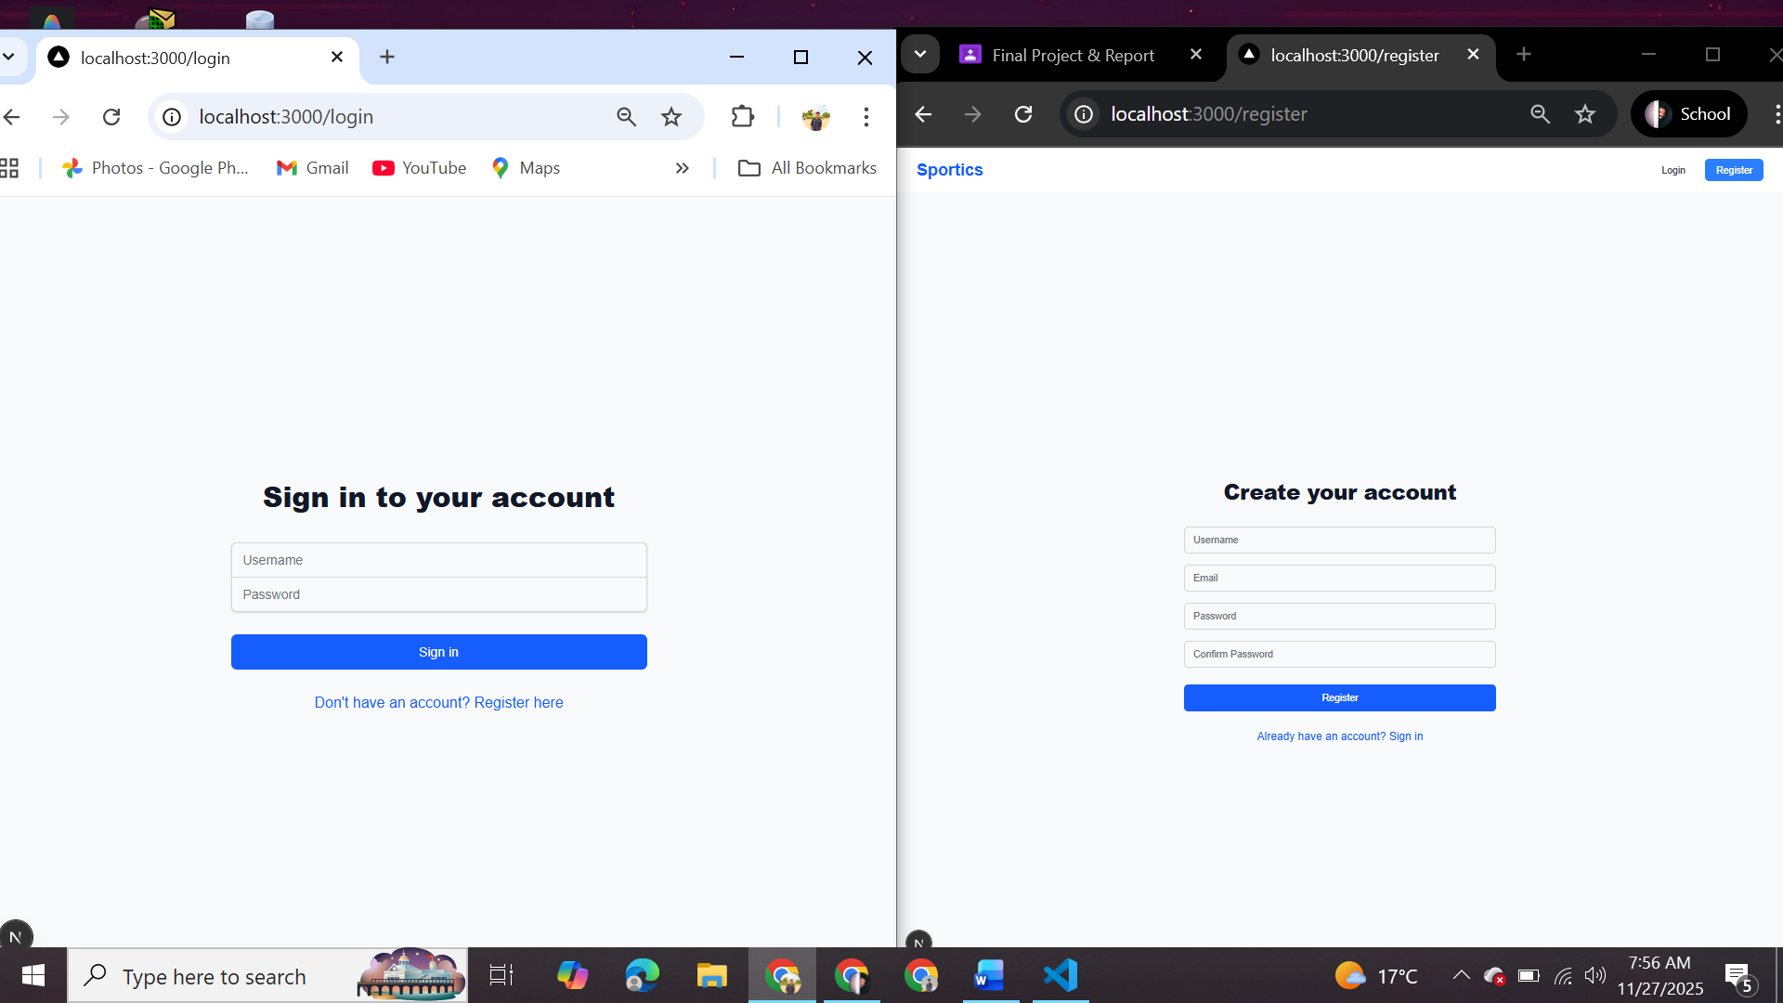
Signup and login Page

User and Admin Dashboard
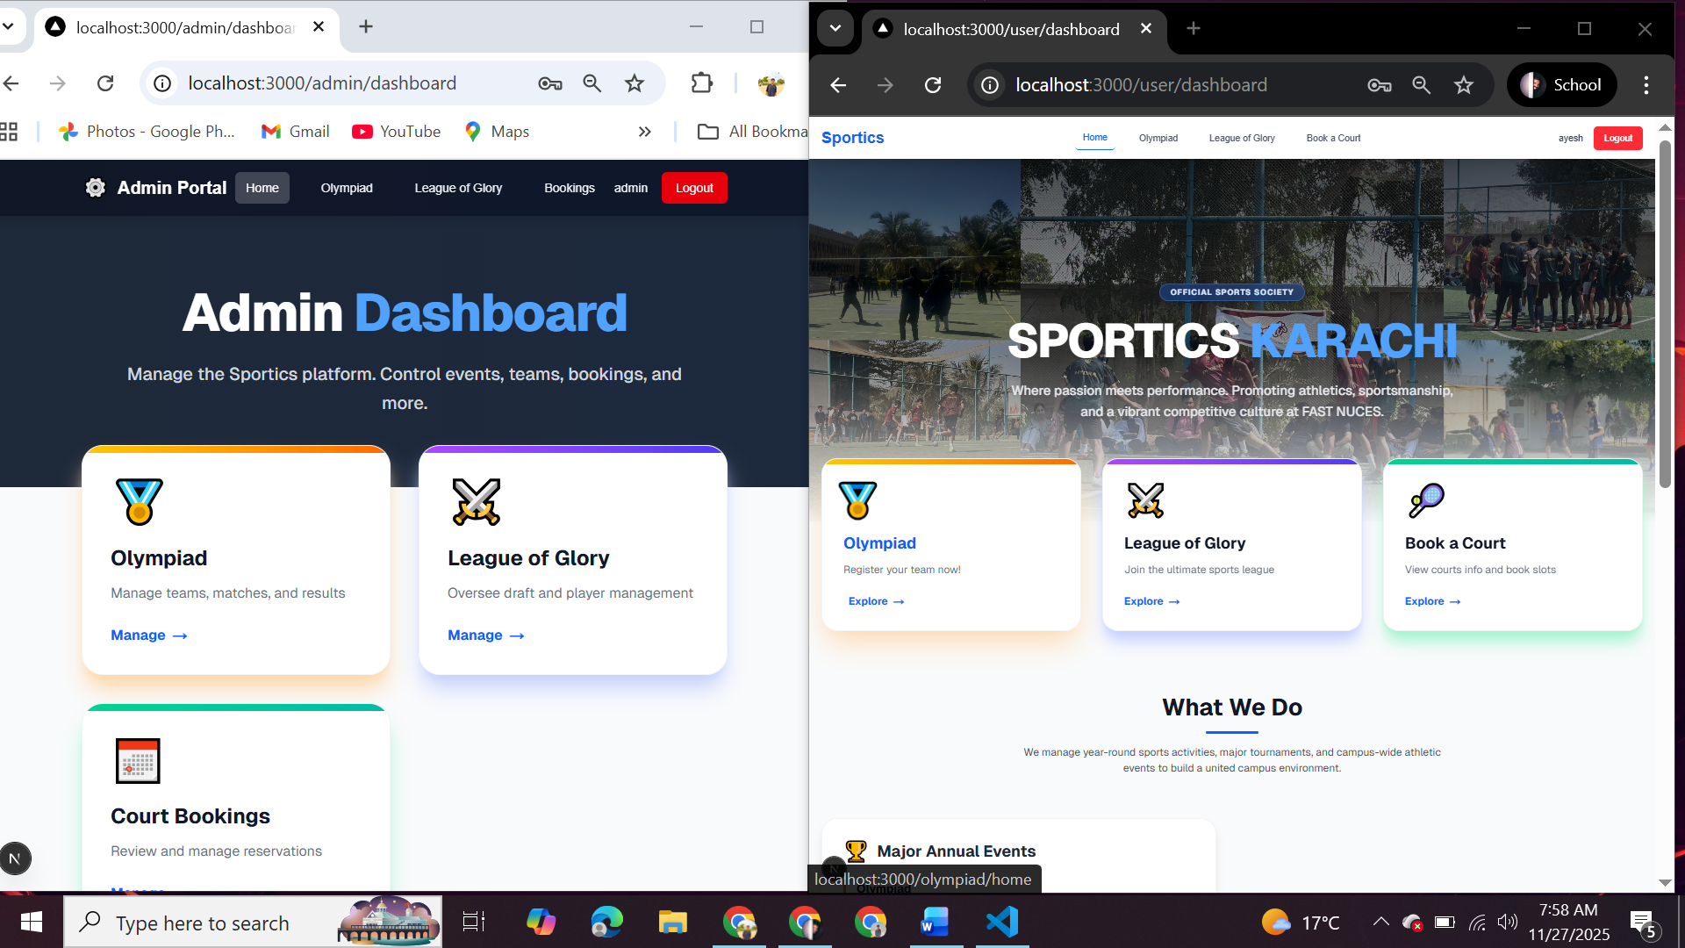

User Can view available courts ,can book a court based on and date and time also can see their previous bookings
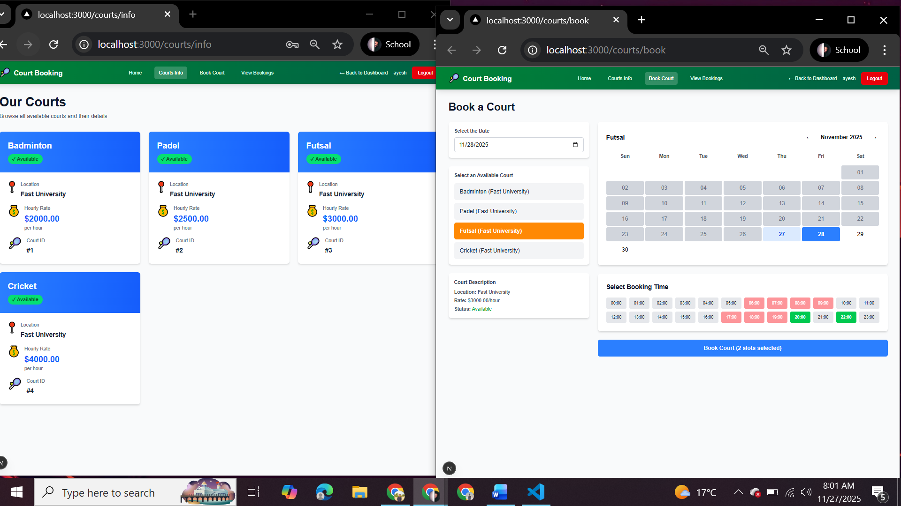

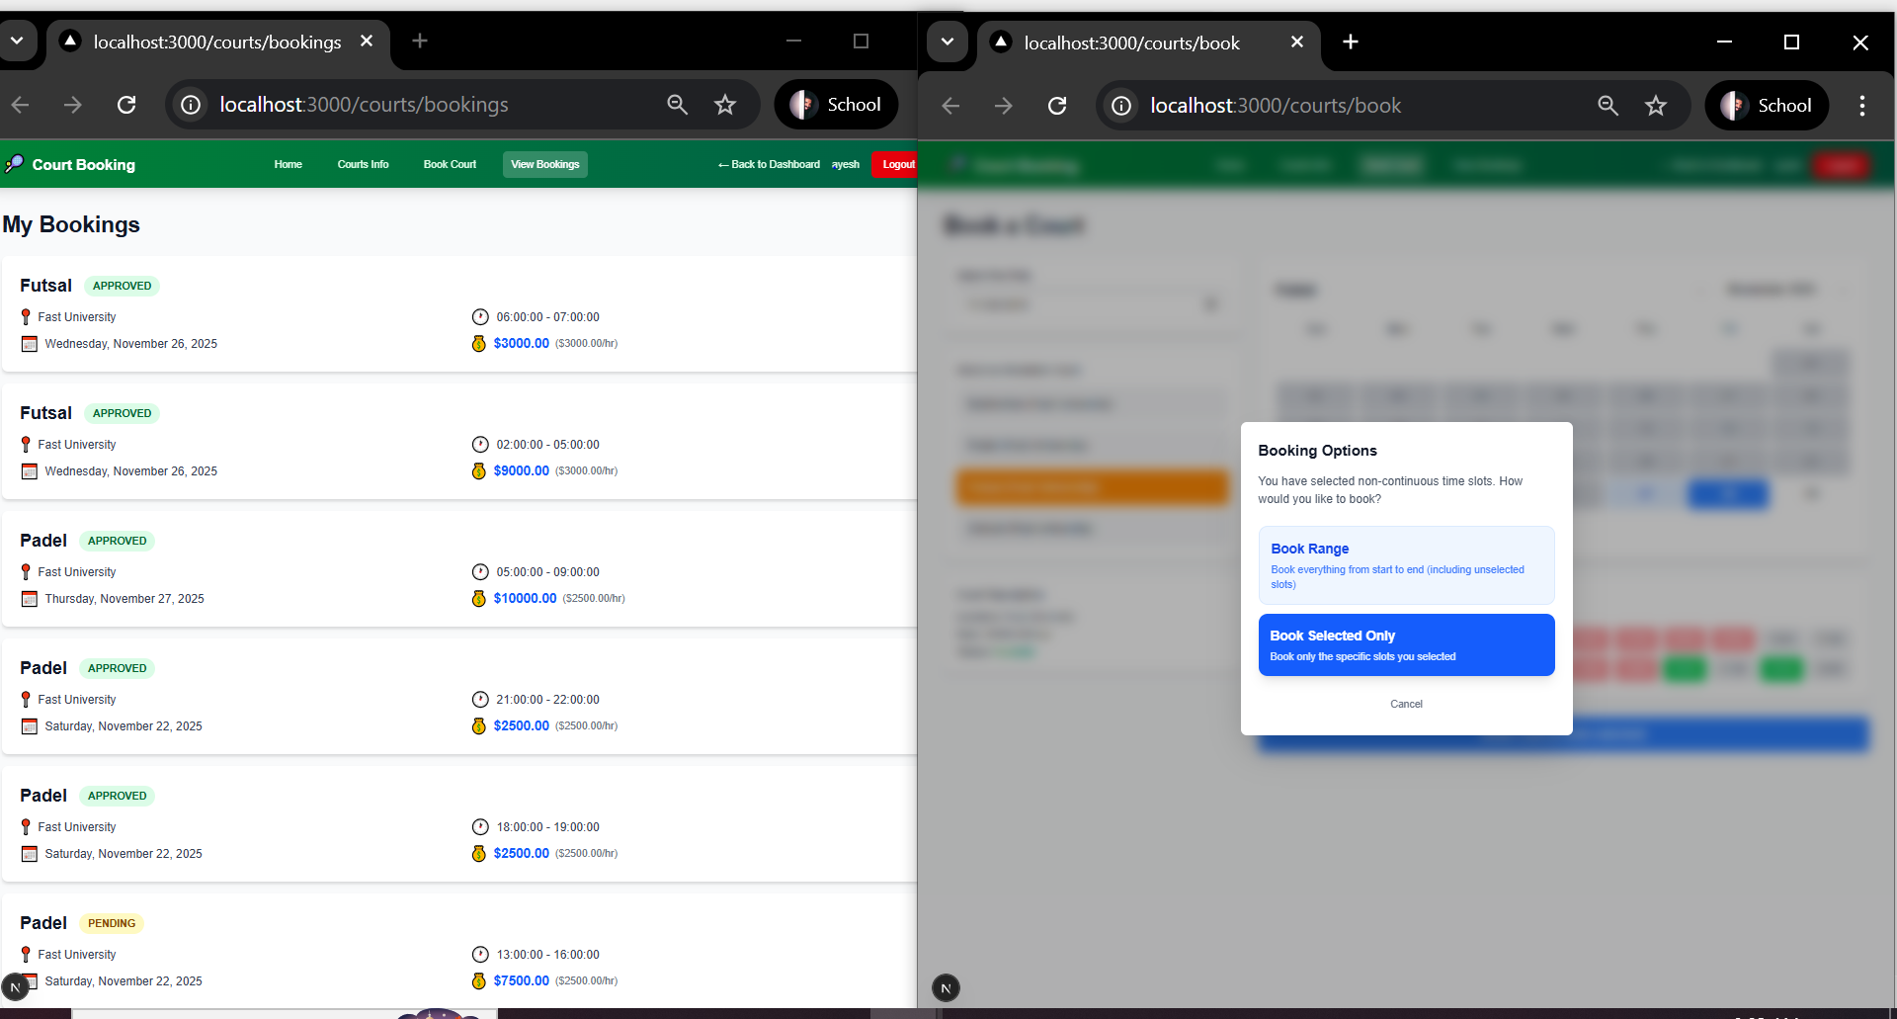

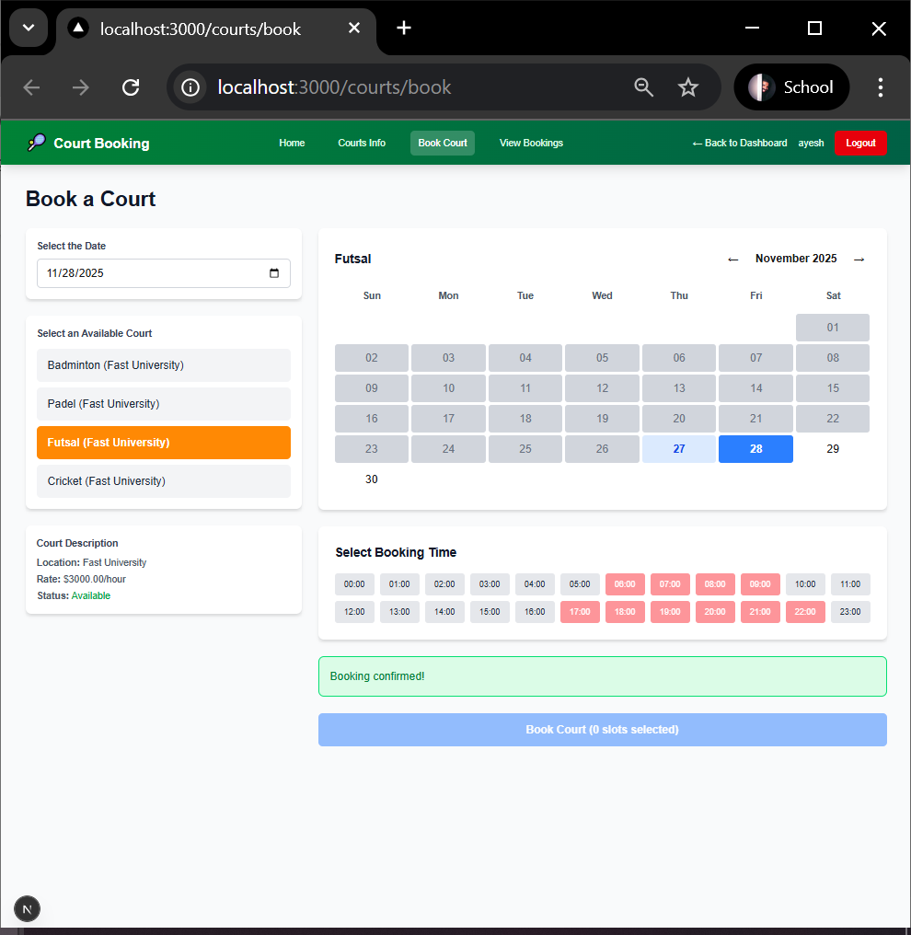

Admin Can Manage bookings i.e Approve or Reject also can see booking history
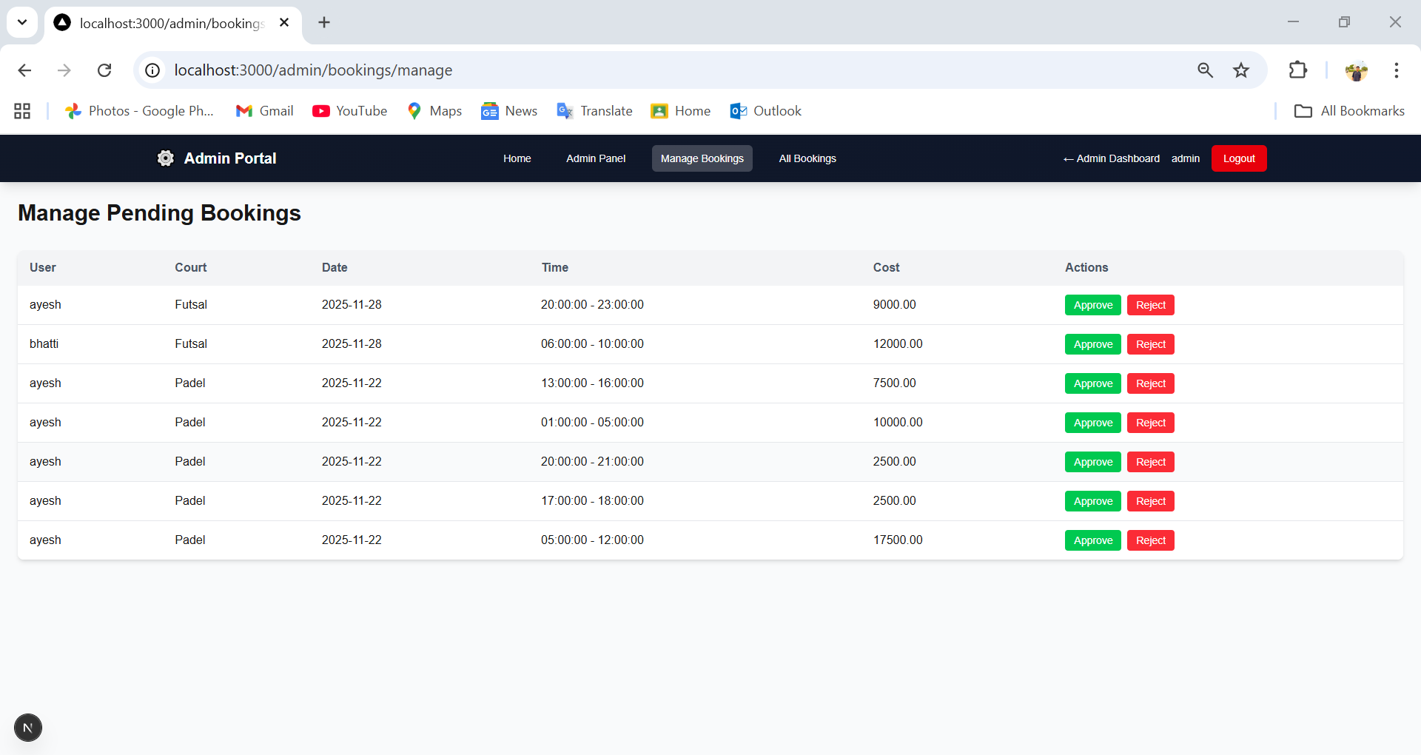

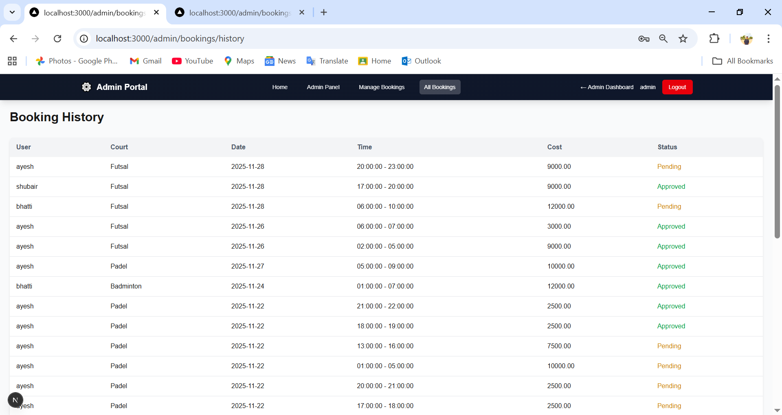

For Olympiad User can see the sports available their registration fees and can register his team to any sports also user can see their matches schedule and results
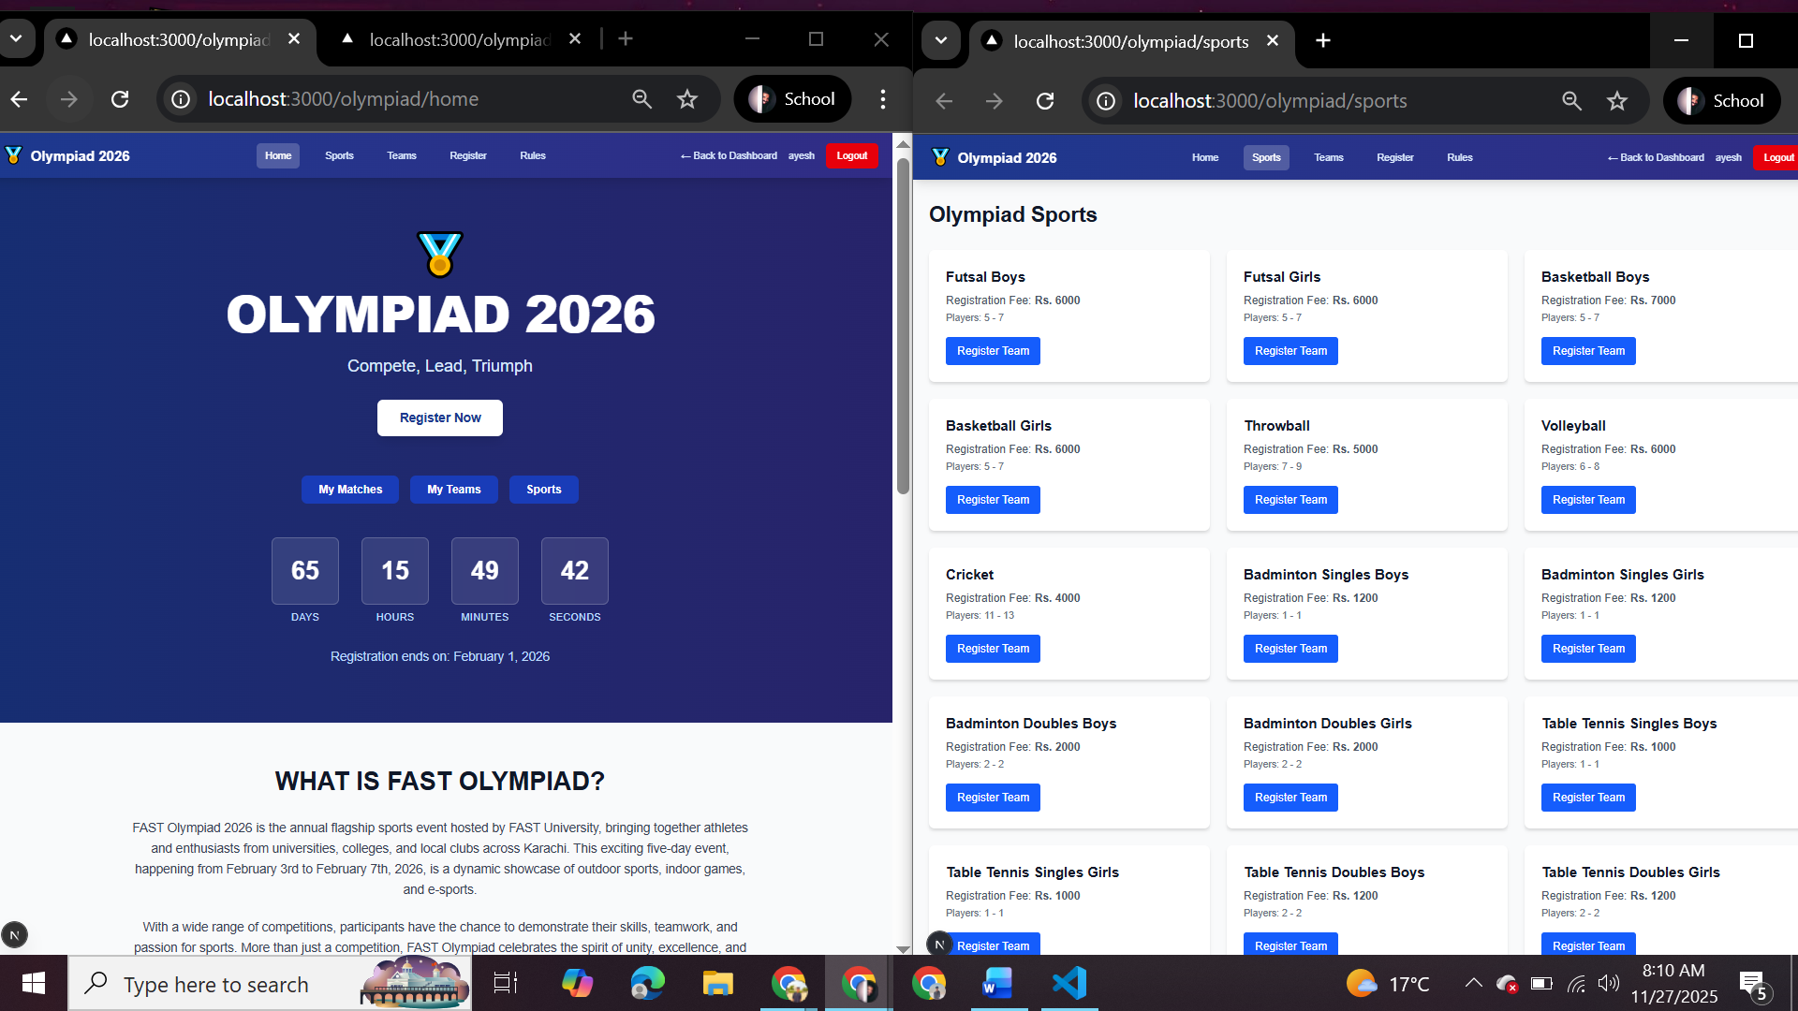

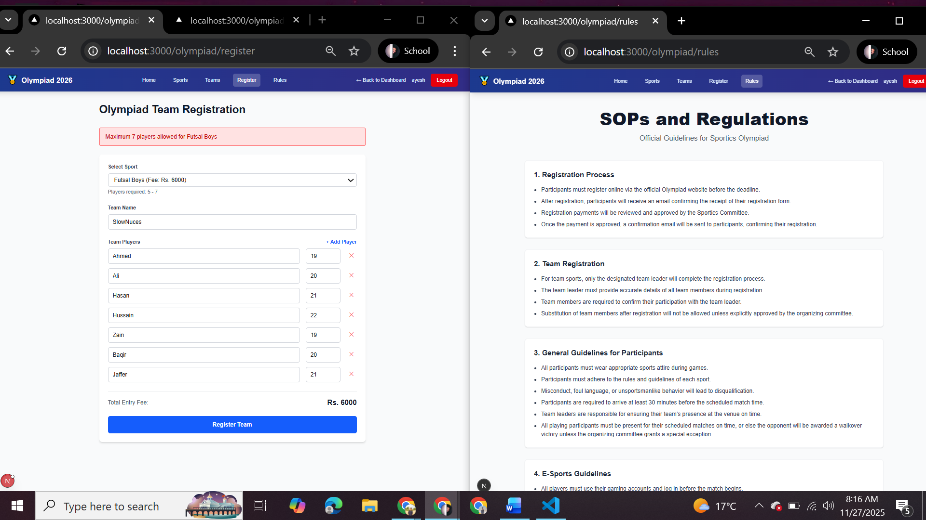

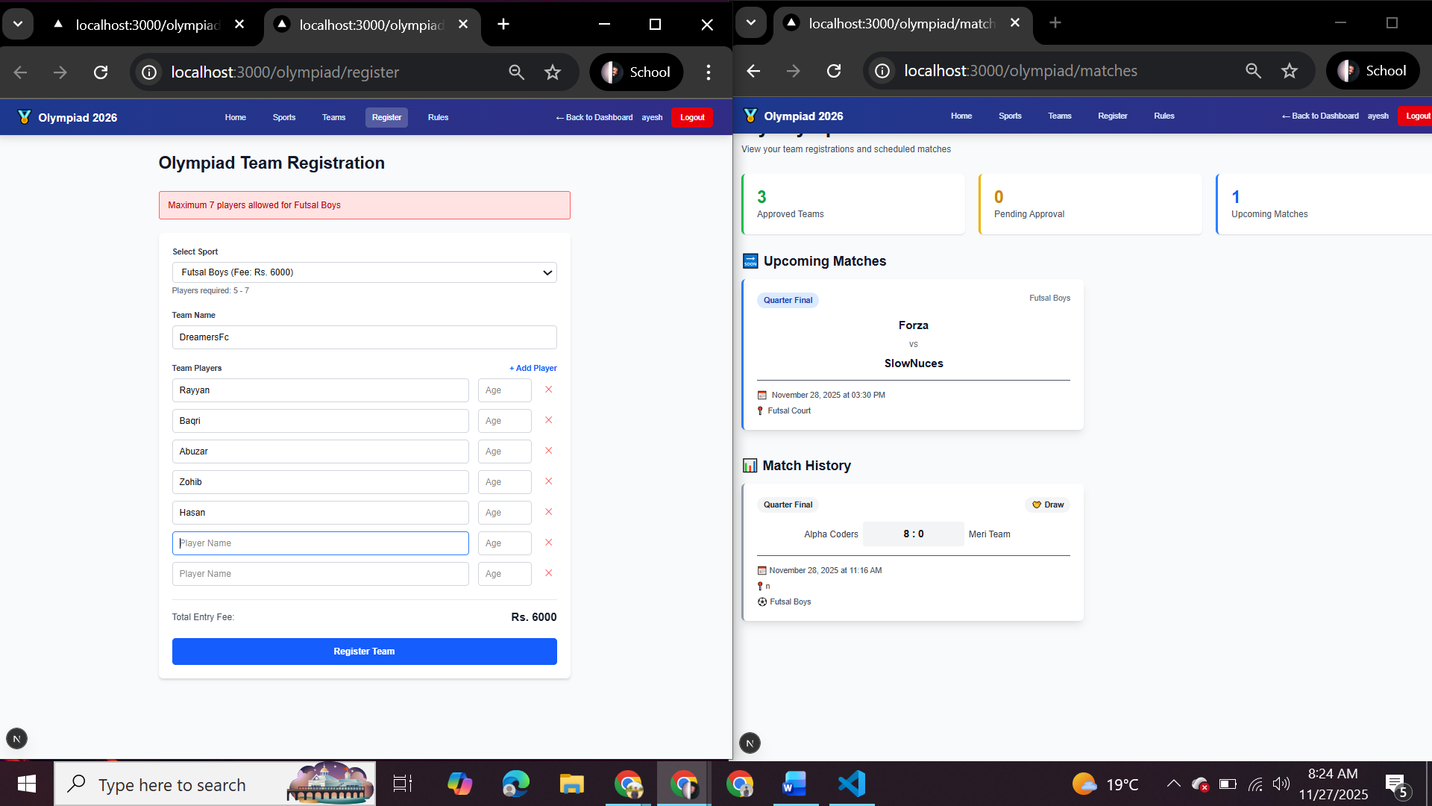

Admin can approve or reject team registration also have option to start or stop team registrations and can schedule matches and post their result
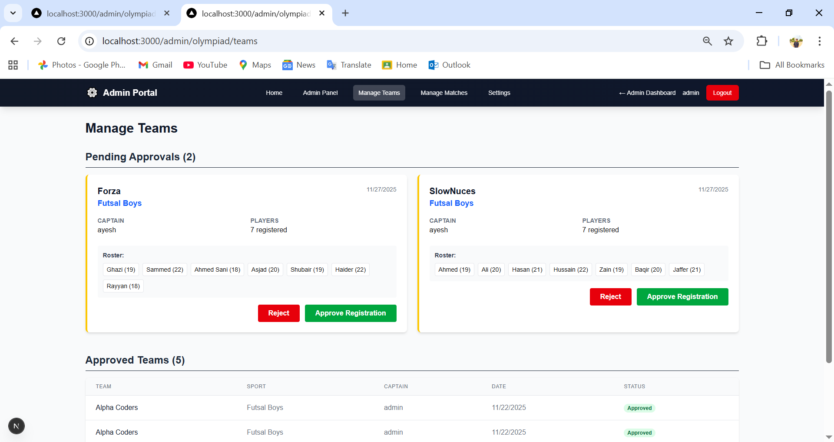

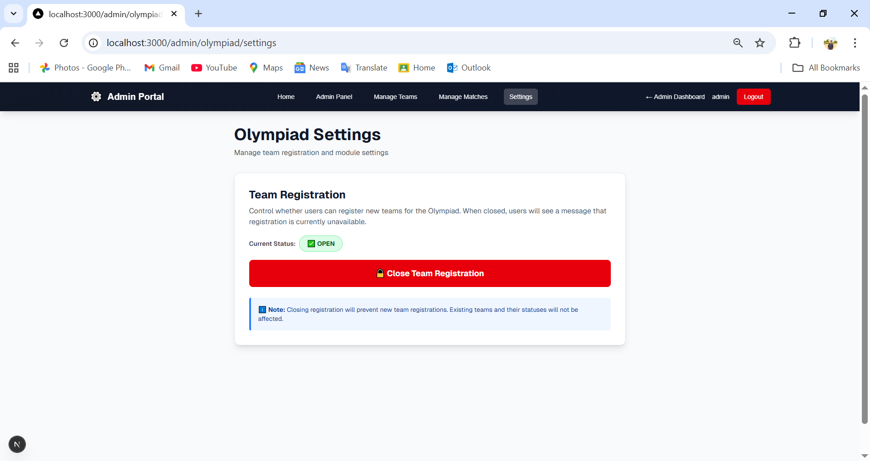

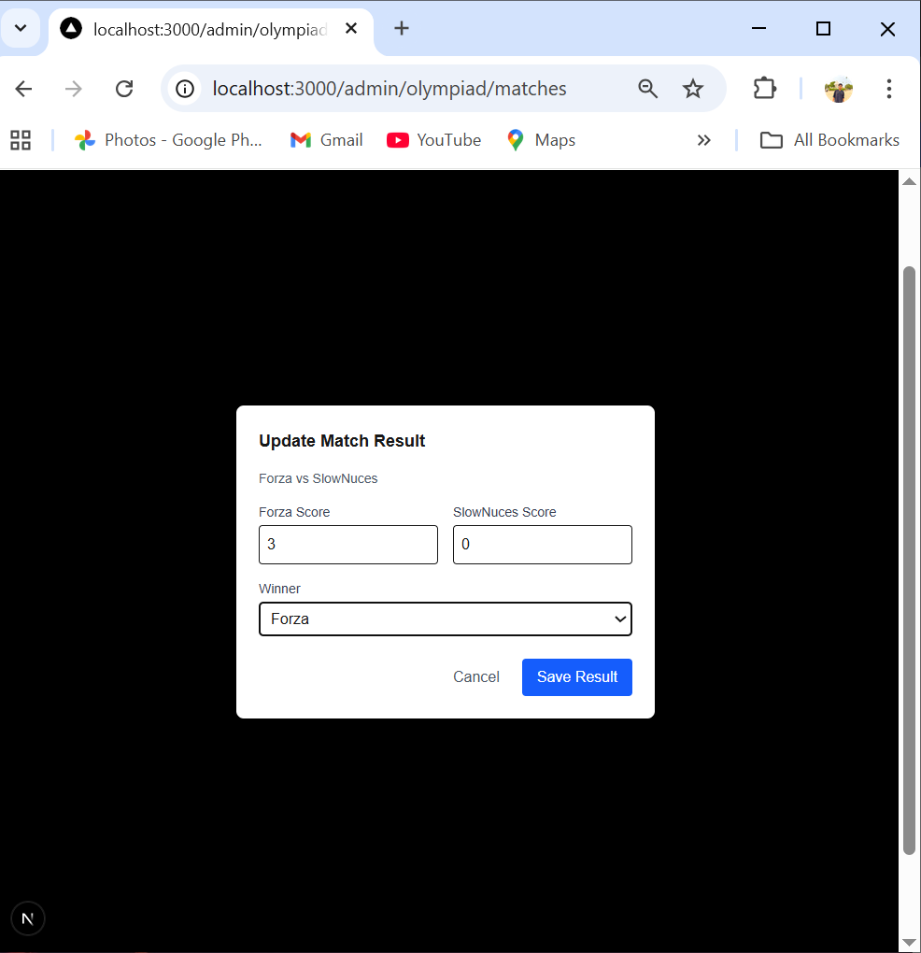
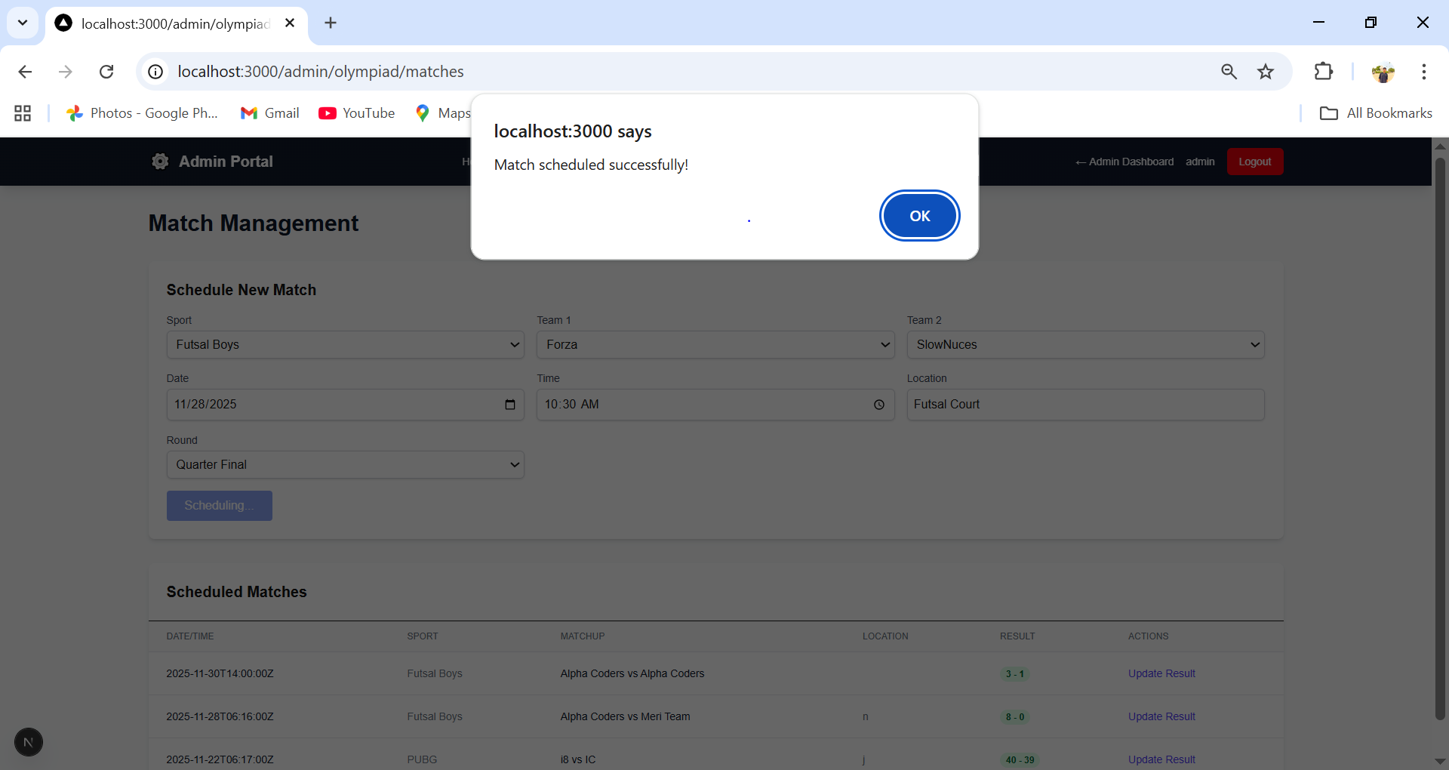

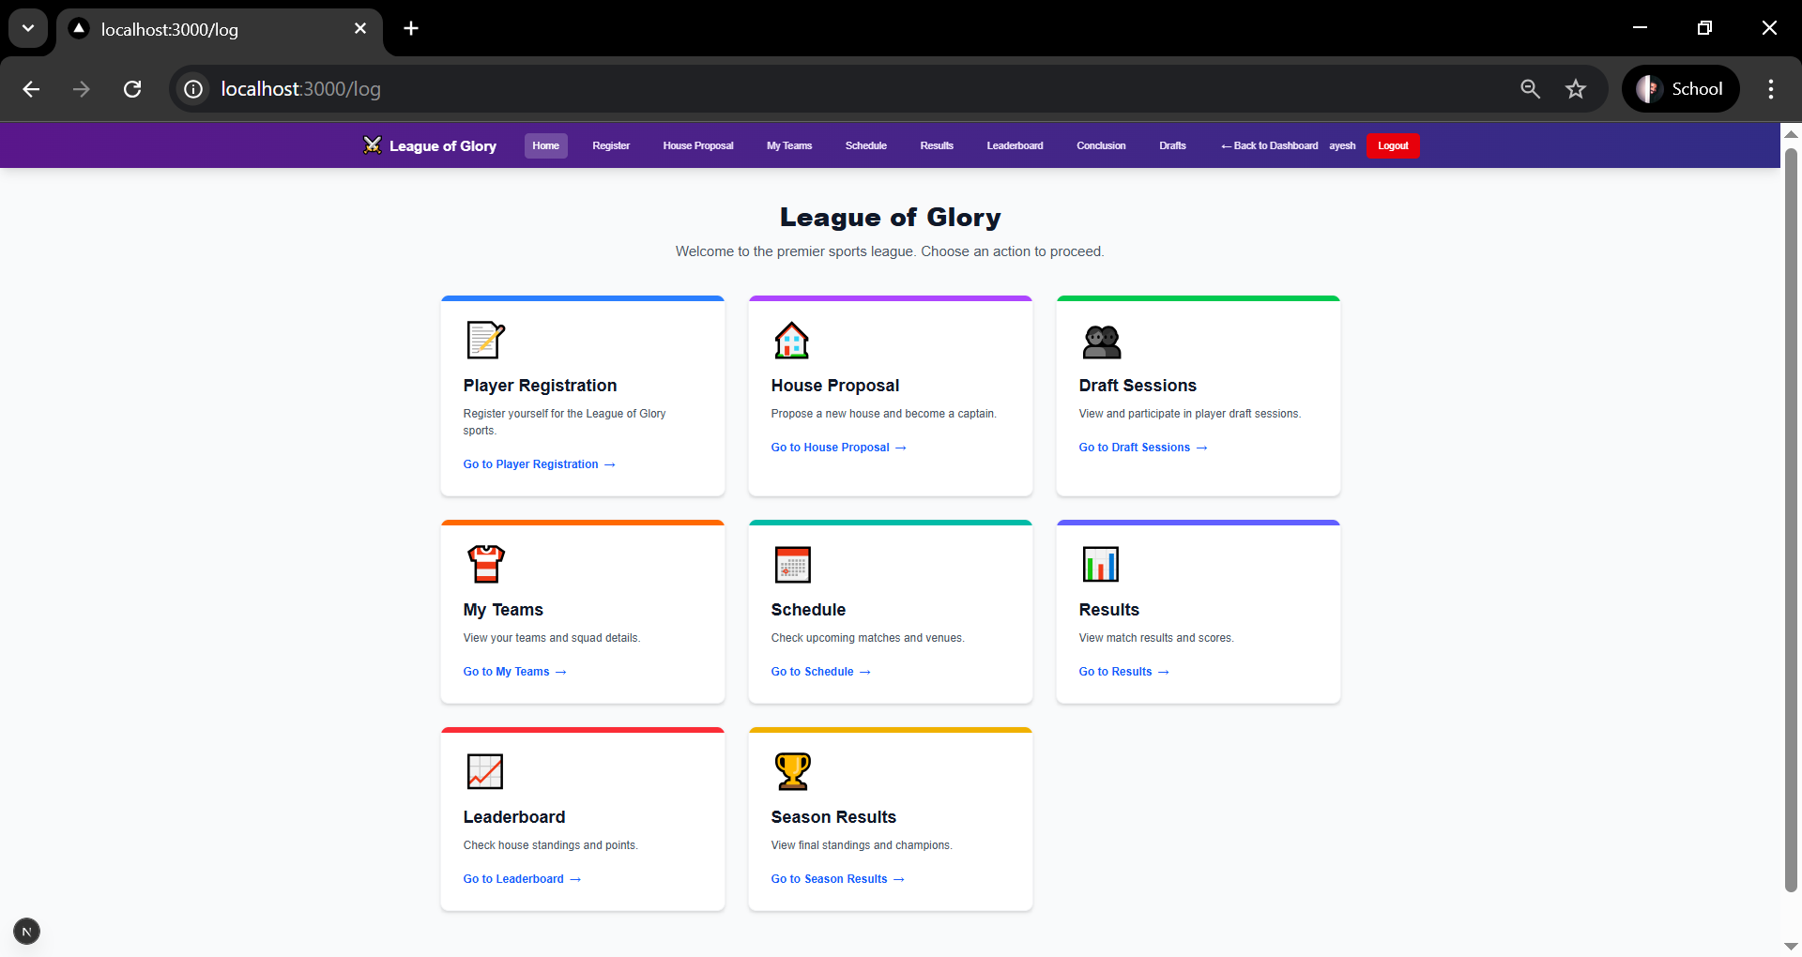

User can register as a player , propose a house , if house captain then take part in drafting
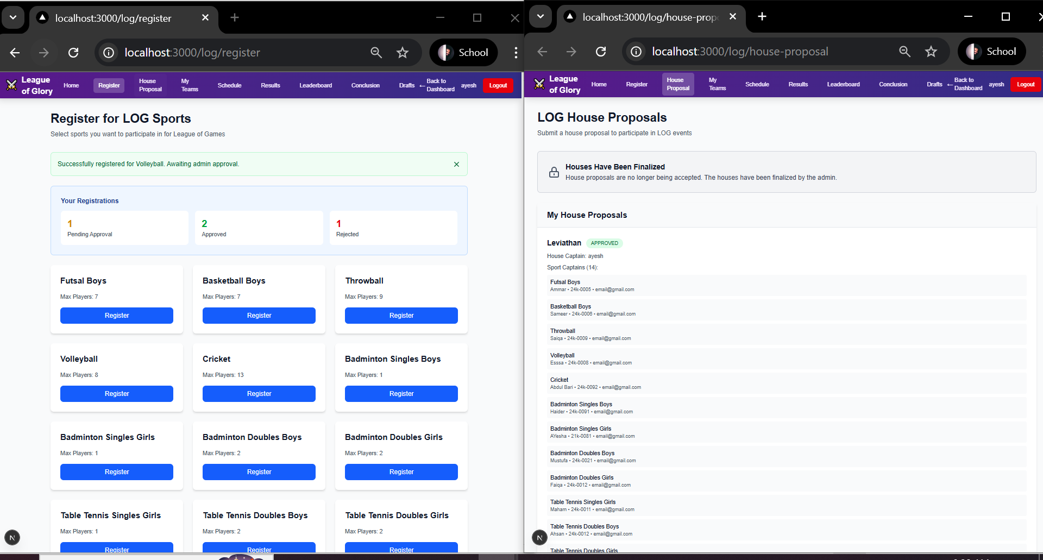
Can his team view the schedule results of matches and leaderboard

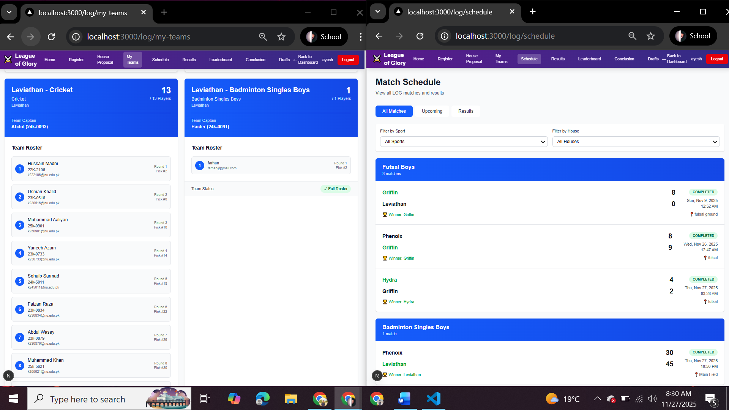

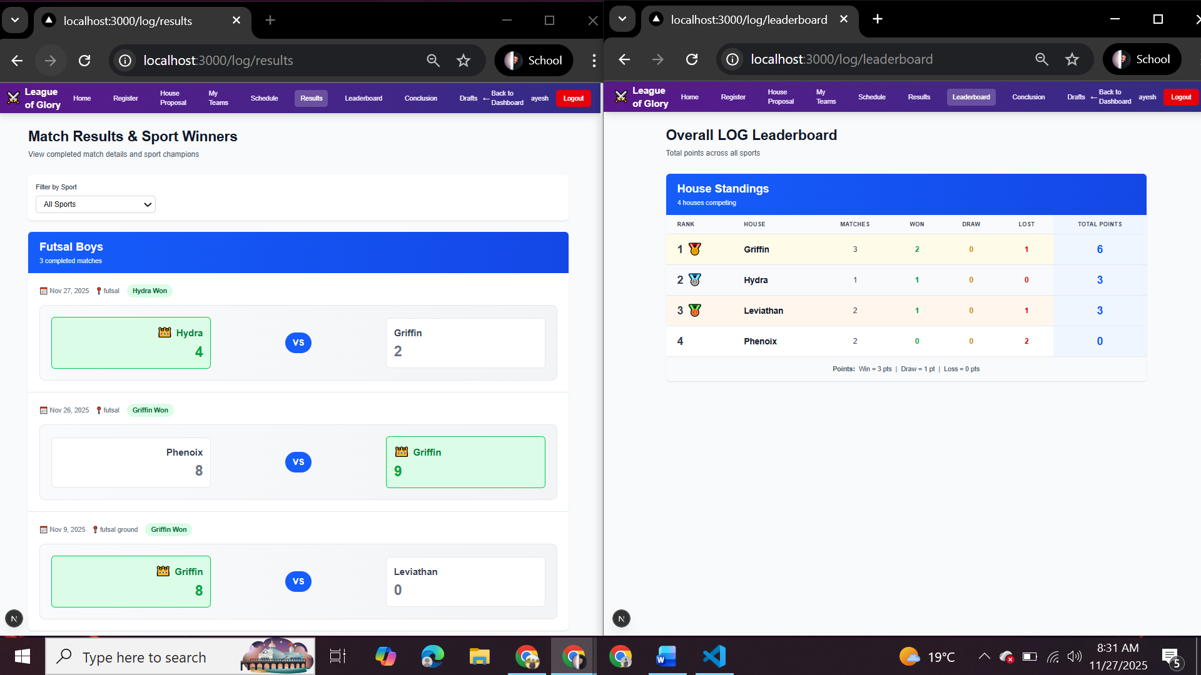

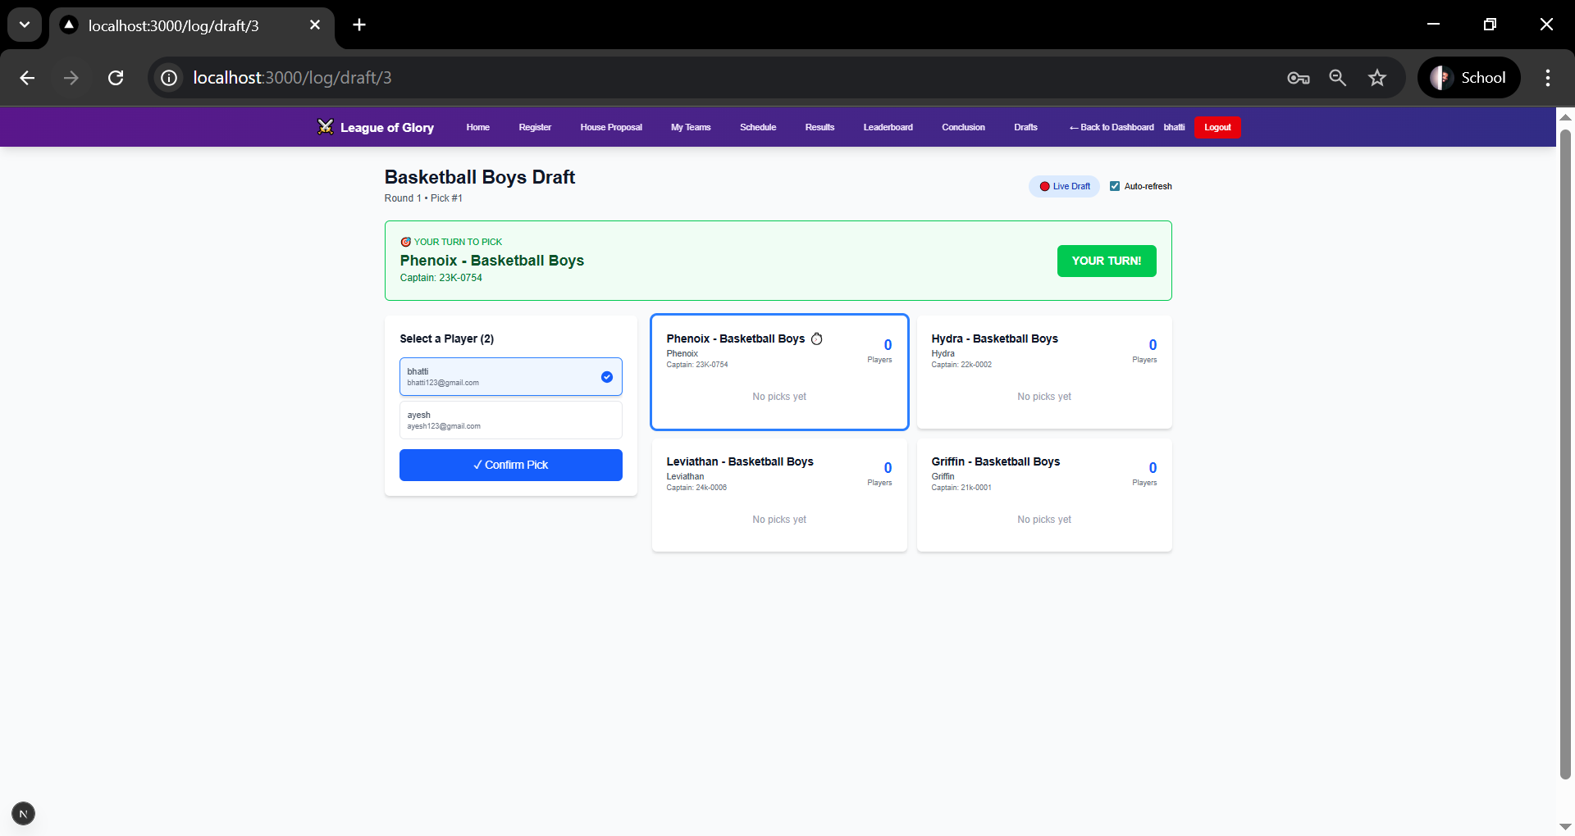

Admin can approve or reject player registration and house proposals also closes the form
It monitor draft sessions , schedule matches post their result and at last conclude the season
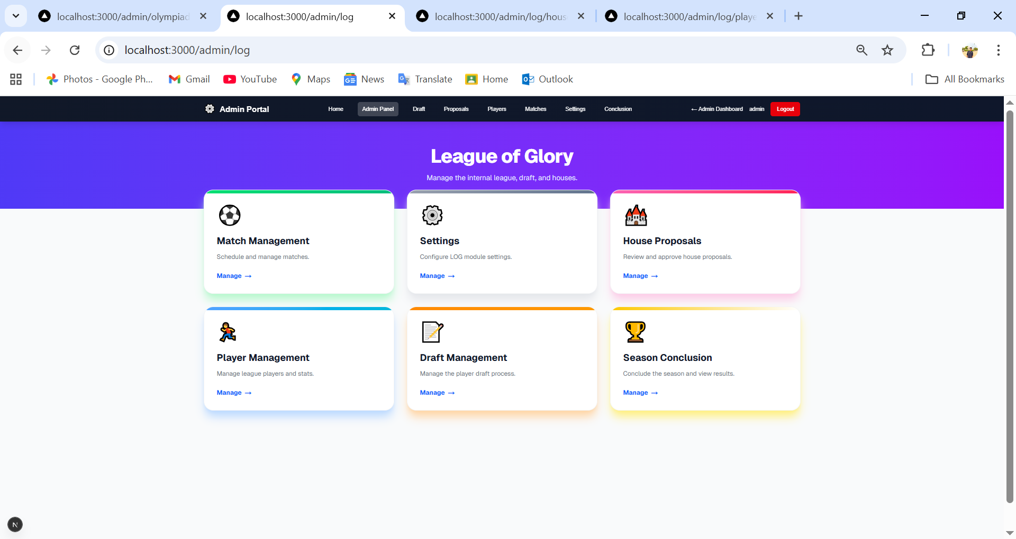

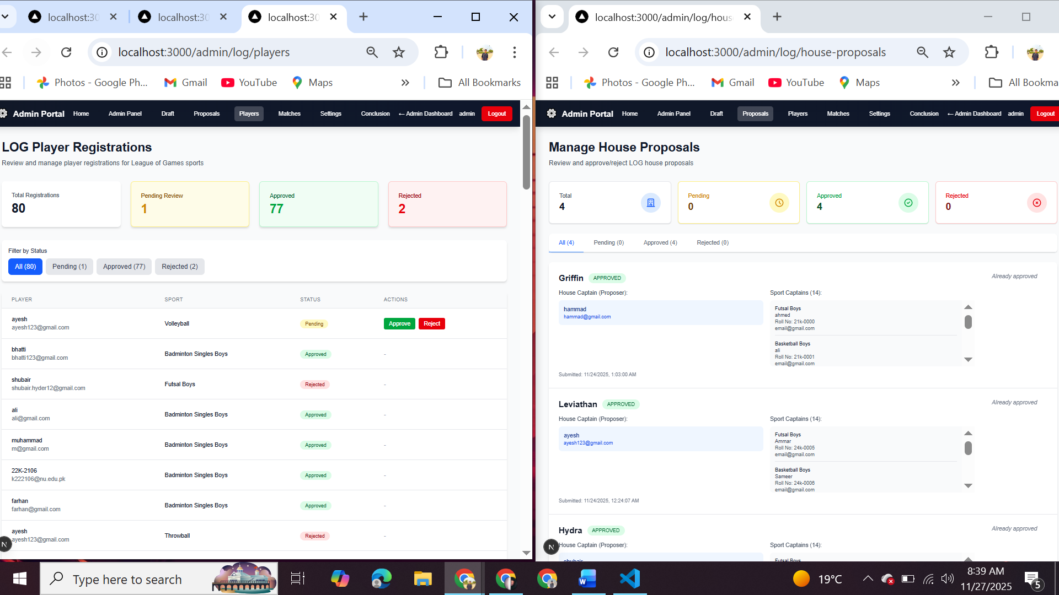

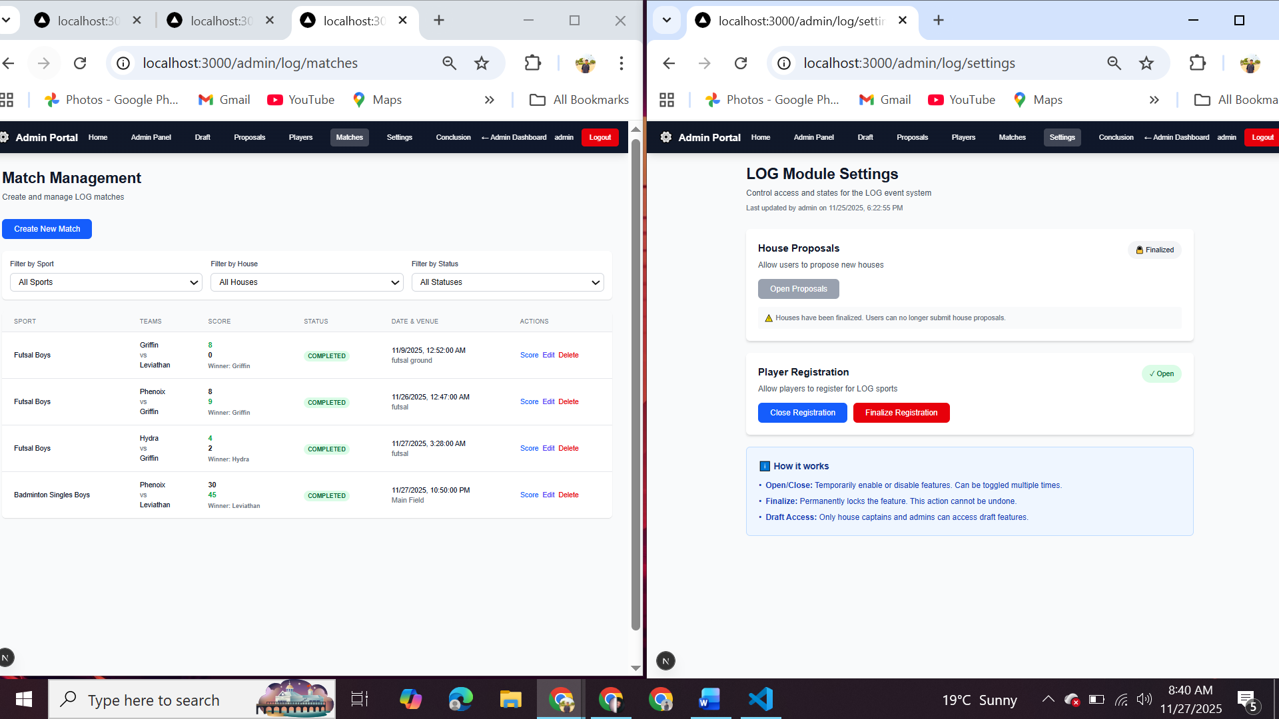

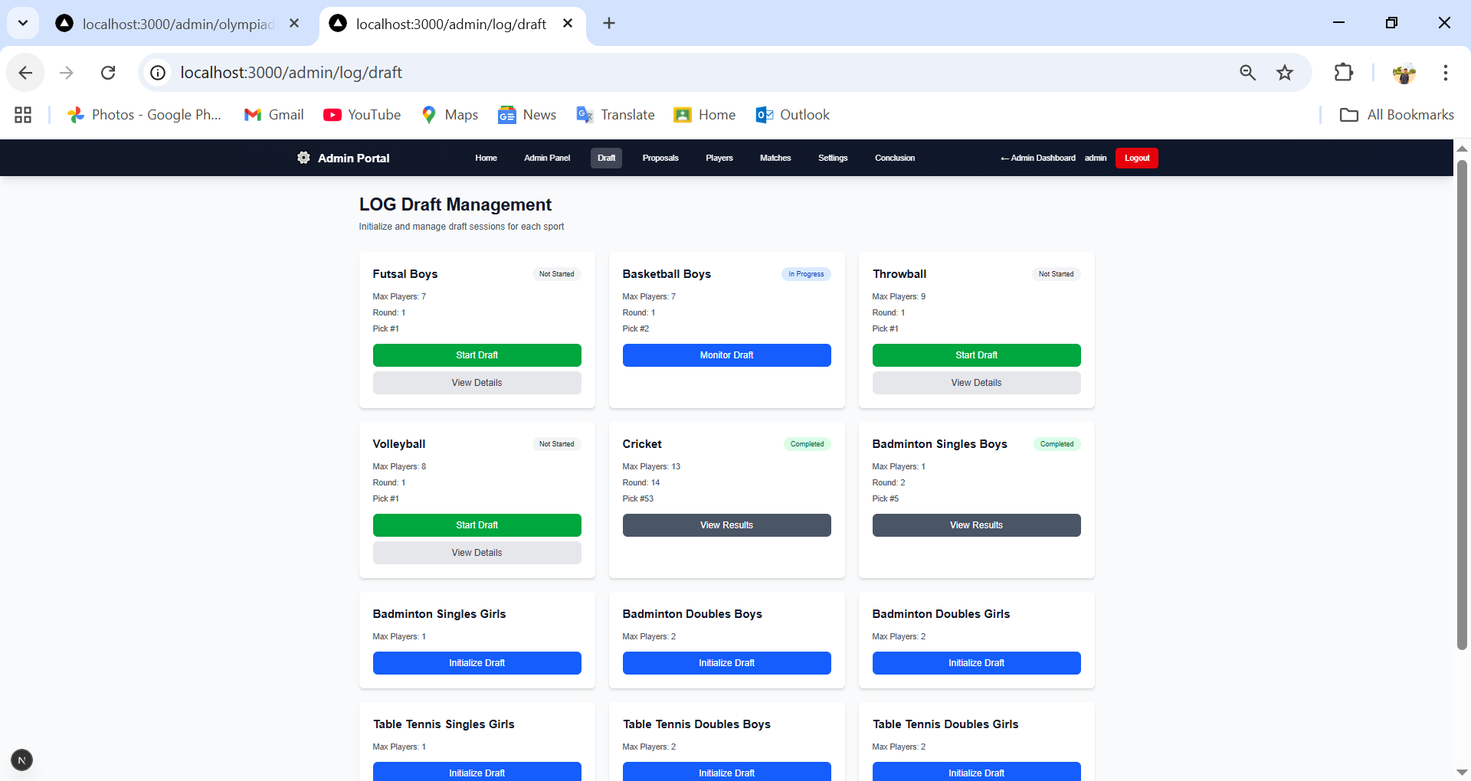

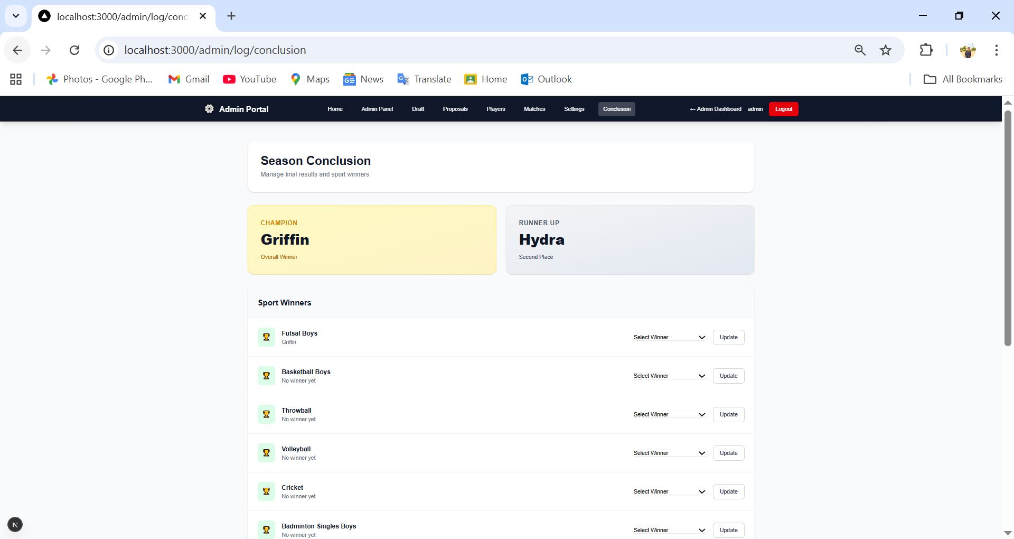

8. Results & Discussion
Achievements:
- Successfully implemented a dual-module system (LOG and Olympiad).
- Robust authentication and role management.
- Real-time updates for match results and leaderboards.
- User-friendly court booking system.
Issues:
- Initial challenges with complex draft logic for LOG.
- Handling concurrent bookings required careful transaction management.
Observations:
- The modular design allowed for easy addition of new features.
- Next.js provided a smooth client-side experience.

9. Conclusion
The SporticsEventMAnager project successfully met its primary objectives of digitizing sports event management. It provides a solid foundation for managing university sports, offering distinct workflows for different event types. The system is secure, scalable, and user-friendly, significantly reducing the administrative burden on organizers.

10. Future Enhancements
- Payment Gateway: Integration with real payment providers for registration fees.
- Mobile App: Development of a dedicated mobile application.
- Live Streaming: Integration of live match streaming links.
- Advanced Analytics: More detailed player and team statistics.
- Notifications: Email and SMS notifications for match updates and booking confirmations.

