**TUGAS BASIS DATA**

**Nama : MUHAMAD DHIKY TAUFIK HIMAWAN**

**Nim : 20180801382**

SQL CREATE TABLE

//Table Product

CREATE TABLE "PRODUCT"

( "PRODUCT_ID" VARCHAR2(5),

"PRODUCT_NAME" VARCHAR2(20),

"CATEGORY" VARCHAR2(20),

"BUY_PRICE" VARCHAR2(20),

"SELL_PRICE" VARCHAR2(20),

"PRODUCT_IMAGE" VARCHAR2(20),

"DESCRIPTION" VARCHAR2(20),

CONSTRAINT "PRODUCT_PK" PRIMARY KEY ("PRODUCT_ID") ENABLE

)

/

//Table Stock

CREATE TABLE "STOCK__"

( "PRODUCT_NAME" VARCHAR2(10) NOT NULL ENABLE,

"QUANTITY" NUMBER NOT NULL ENABLE,

"DTE" DATE NOT NULL ENABLE,

"STOCK_BY" VARCHAR2(10) NOT NULL ENABLE

)

/

ALTER TABLE "STOCK__" ADD CONSTRAINT "STOCK___FK2" FOREIGN KEY ("PRODUCT_NAME")

REFERENCES "PRODUCT" ("PRODUCT_ID") ENABLE

/

//Table Customer

CREATE TABLE "CUSTOMER_N"

( "CUSTOMER_ID" NUMBER NOT NULL ENABLE,

"FIRST_NAME" VARCHAR2(10) NOT NULL ENABLE,

"MIDDLE_NAME" VARCHAR2(10) NOT NULL ENABLE,

"LAST_NAME" VARCHAR2(10) NOT NULL ENABLE,

"SHIPPING_ADDRESS" VARCHAR2(20) NOT NULL ENABLE,

"EMAIL" VARCHAR2(20) NOT NULL ENABLE,

"CONTACT" VARCHAR2(20) NOT NULL ENABLE,

CONSTRAINT "CUSTOMER_N_PK" PRIMARY KEY ("CUSTOMER_ID") ENABLE

)

//Table Order

CREATE TABLE "ORDER__"

( "ORDER_NO" NUMBER(5,0) NOT NULL ENABLE,

"CUSTOMER_" NUMBER,

"DATE__" VARCHAR2(20),

"IS_DELIVER" VARCHAR2(20),

CONSTRAINT "ORDER___PK" PRIMARY KEY ("ORDER_NO") ENABLE

)

/

ALTER TABLE "ORDER__" ADD CONSTRAINT "ORDER___FK3" FOREIGN KEY ("CUSTOMER_")

REFERENCES "CUSTOMER_N" ("CUSTOMER_ID") ENABLE

/

//Table Order Details

CREATE TABLE "ORDER_DETAILS_"

( "ORDER_NO" NUMBER NOT NULL ENABLE,

"PRODUCT_NAME" VARCHAR2(10) NOT NULL ENABLE,

"QUANTITY" NUMBER NOT NULL ENABLE

)

/

ALTER TABLE "ORDER_DETAILS_" ADD CONSTRAINT "ORDER_DETAILS__FK" FOREIGN KEY ("ORDER_NO")

REFERENCES "ORDER__" ("ORDER_NO") ENABLE

/

ALTER TABLE "ORDER_DETAILS_" ADD CONSTRAINT "ORDER_DETAILS__FK3" FOREIGN KEY ("PRODUCT_NAME")

REFERENCES "PRODUCT" ("PRODUCT_ID") ENABLE

/

//Table Employee

CREATE TABLE "EMPLOYEE"

( "EMPLOYEE_ID" NUMBER(3,0),

"FIRST_NAME" VARCHAR2(20),

"MIDDLE_NAME" VARCHAR2(20) NOT NULL ENABLE,

"LAST_NAME" VARCHAR2(20),

"FATHER_NAME" VARCHAR2(20),

"MOTHER_NAME" VARCHAR2(20),

"EMAIL" VARCHAR2(20),

"GENDER" VARCHAR2(20),

"DATE_OF_BIRTH" DATE NOT NULL ENABLE,

"MARITAL_STATUS" VARCHAR2(20),

"ADDRESS" VARCHAR2(20),

CONSTRAINT "EMPLOYEE_PK" PRIMARY KEY ("EMPLOYEE_ID") ENABLE

)

/

SQL INSERT TABLE

//Insert Product

insert into PRODUCT_

values ('6785','PENSIL','ATK','800','1000','YAMANO','BEST SELLER')

insert into PRODUCT_

values ('6798','FLUID','ATK','4800','5000','RE-TYPE','QUALITY PRODUCT NO.1')

insert into PRODUCT_

values ('5367','MAX','ATK','7000','8000','HD10','-')

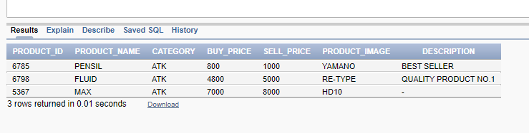

//Insert Stock

insert into STOCK_

values ('6785','50','09/08/2019','MASMUR')

insert into STOCK_

values ('6798','35','08/08/2019','AHMAD')

insert into STOCK_

values ('5367','75','10/08/2019','DENNIS')

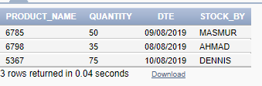

//Insert Customer

insert into CUSTOMER_N

values ('1','MIGA','DANI','WIBOWO','PURBALINGGA JATENG','MIGAWIB@gmail.com','081298978666')

insert into CUSTOMER_AWI

values ('2','SAFANDY','IMAM','SANTOSO','SEMARANG JATENG','SAFANDY12O@gmail.com','08564978666')

insert into CUSTOMER_AWI

values ('3','GALIH','NAN','PRABOWO','SURABAYA JATIM','GWO71@gmail.com','081248978656')

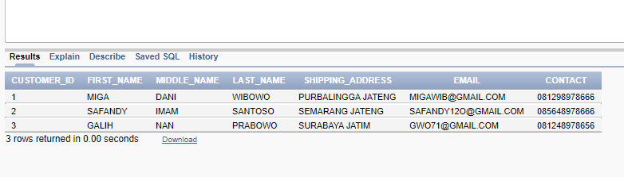

//Insert Order

insert into ORDER__

values ('5001','001','24/03/2019','D')

insert into ORDER__

values ('5002','002','02/01/2019','D')

insert into ORDER__

values ('5003','003','04/03/2019','D')

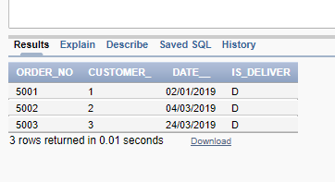

//Insert Order Details

insert into ORDER_DETAILS_

values ('5001','6785','15')

insert into ORDER_DETAILS_

values ('5002','6798','25')

insert into ORDER_DETAILS_

values ('5003','5367','38')

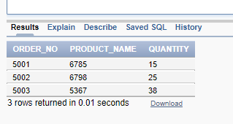

SQL SELECT TABLE

//jawaban no 6

select a.order_no, a.date__, c.first_name, b.product_name, b.quantity, d.sell_price, b.quantity*d.sell_price as total

from order__ a, order_details_ b, customer_n c, product d

where a.order_no = b.order_no and c.customer_id = a.customer_ and d.product_id = b.product_name

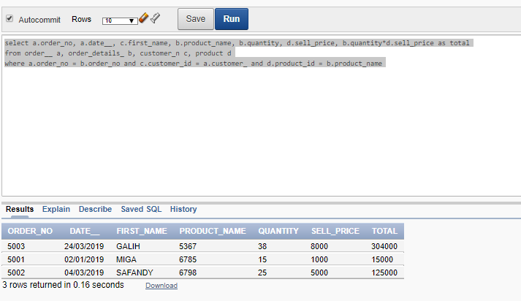

//jawaban no 7

select product_name, sum(quantity)

from order_details_

group by product_name, quantity

order by quantity desc

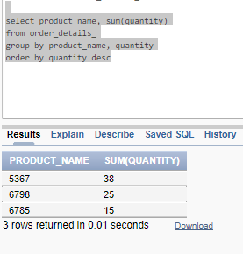

//jawaban no 8

