|  |  |
| --- | --- |
| **Logo_Baru-Rasmi_UUM_02** | STIA1123: Programming 2 Semester 181School of Computing, CAS, UUM |
| Lab 2 | |
| 18/10/2019  Submission  24/10/2019 | |

Scenario:

Consider the following scenario:

“A food delivery company (FOODNINJA) need to computerized their current delivery system. They need the system to be able to store information of their 10 delivery personnel. The information needed are staff name, id, salary and branch.

1. Identify a class in the above scenario and draw UML diagram for the identified class.
2. Write a proper Class for (a).
3. Create an object array for (b). Make sure user can enter all information.
4. Finally print back all information in the object array to the screen.

Save the following into word document

* + Java class files and main class.
  + At least 3 print screen terminal application interface screenshot that describe input-process-output.

Make sure the source code is readable and the interface screenshot is clear.

upload to:

* UUM Learning
* <http://slumberjer.com/teaching/a192/stia1123/upload/>

**Late submission will be not accepted and tolerated and will be given 0.**

|  |
| --- |
| DeliveryPersonnel |
| Staff name |
| Id |
| Salary |
| branch |

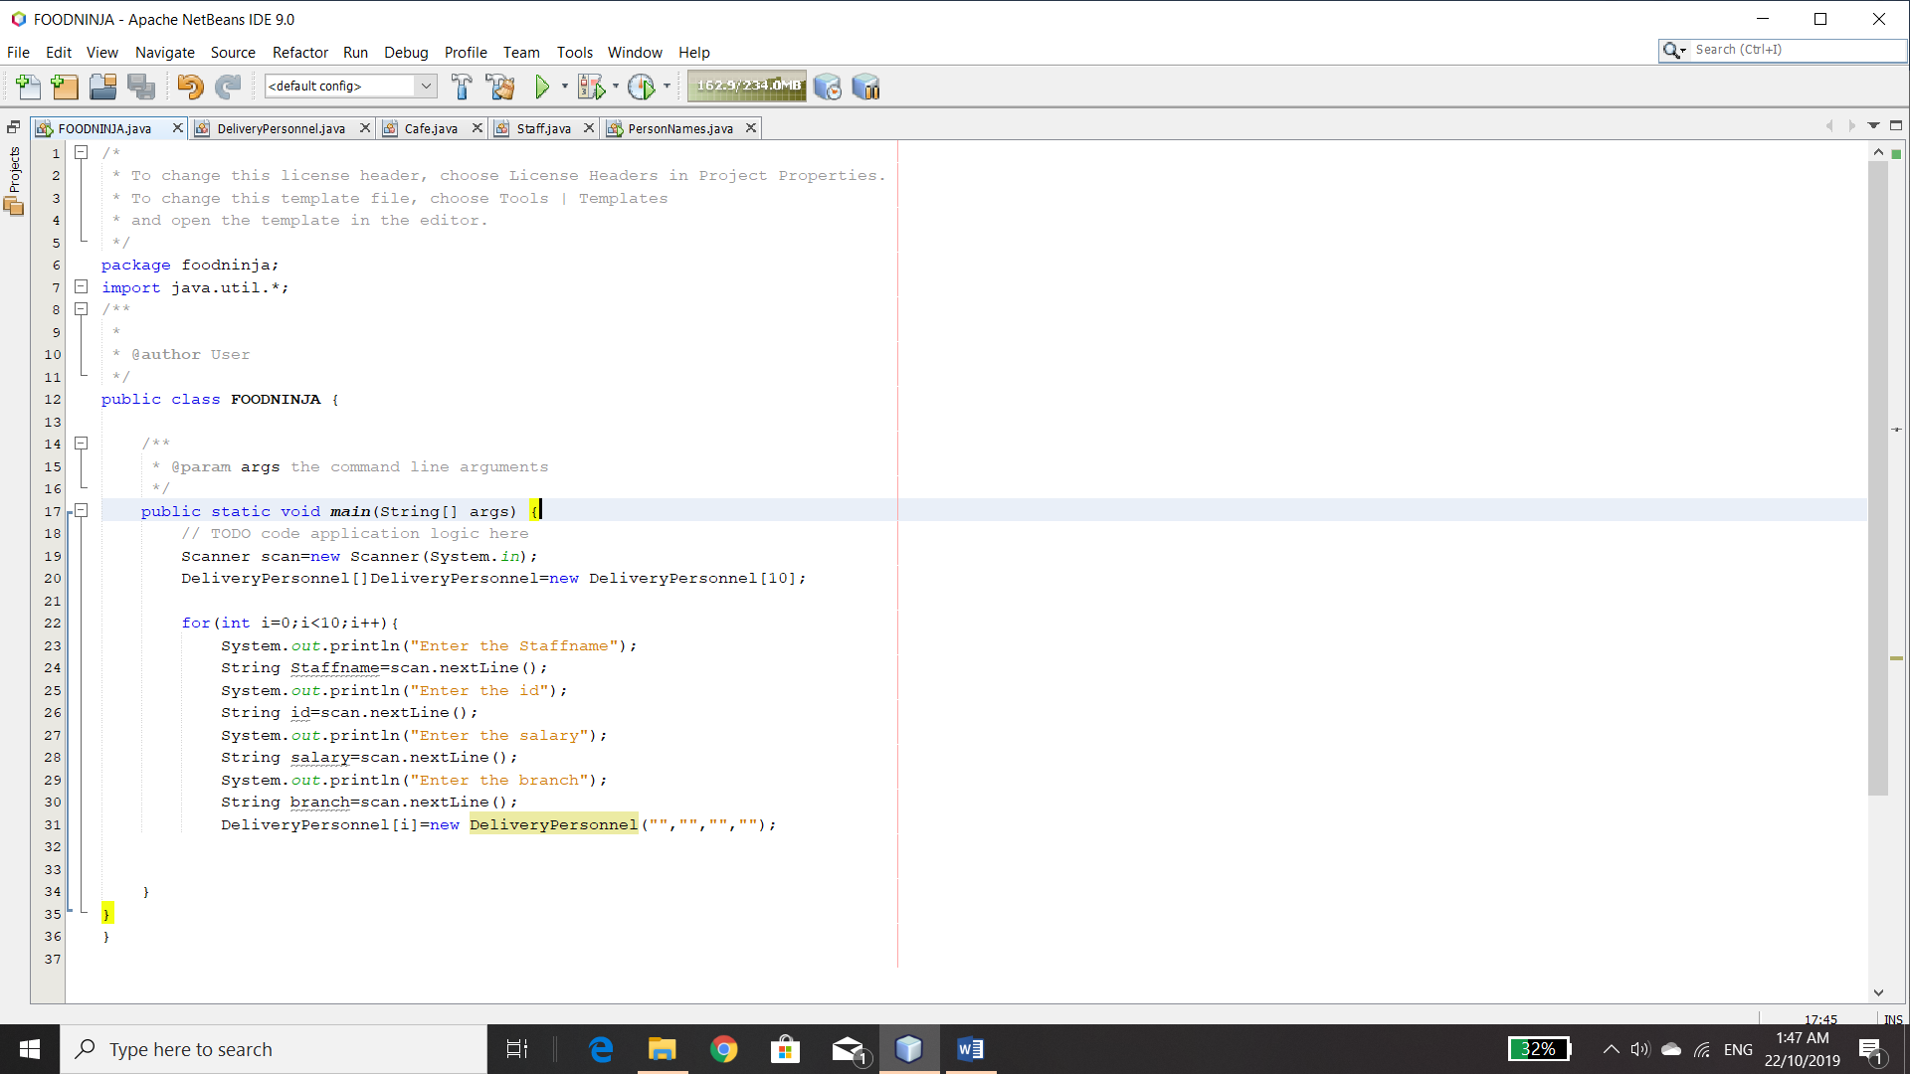

**Source code foodninja**:

package foodninja;

import java.util.\*;

public class FOODNINJA {

public static void main(String[] args) {

Scanner scan=new Scanner(System.in);

DeliveryPersonnel[]DeliveryPersonnel=new DeliveryPersonnel[10];

for(int i=0;i<10;i++){

System.out.println("Enter the Staffname");

String Staffname=scan.nextLine();

System.out.println("Enter the id");

String id=scan.nextLine();

System.out.println("Enter the salary");

String salary=scan.nextLine();

System.out.println("Enter the branch");

String branch=scan.nextLine();

DeliveryPersonnel[i]=new DeliveryPersonnel()

}

}

}

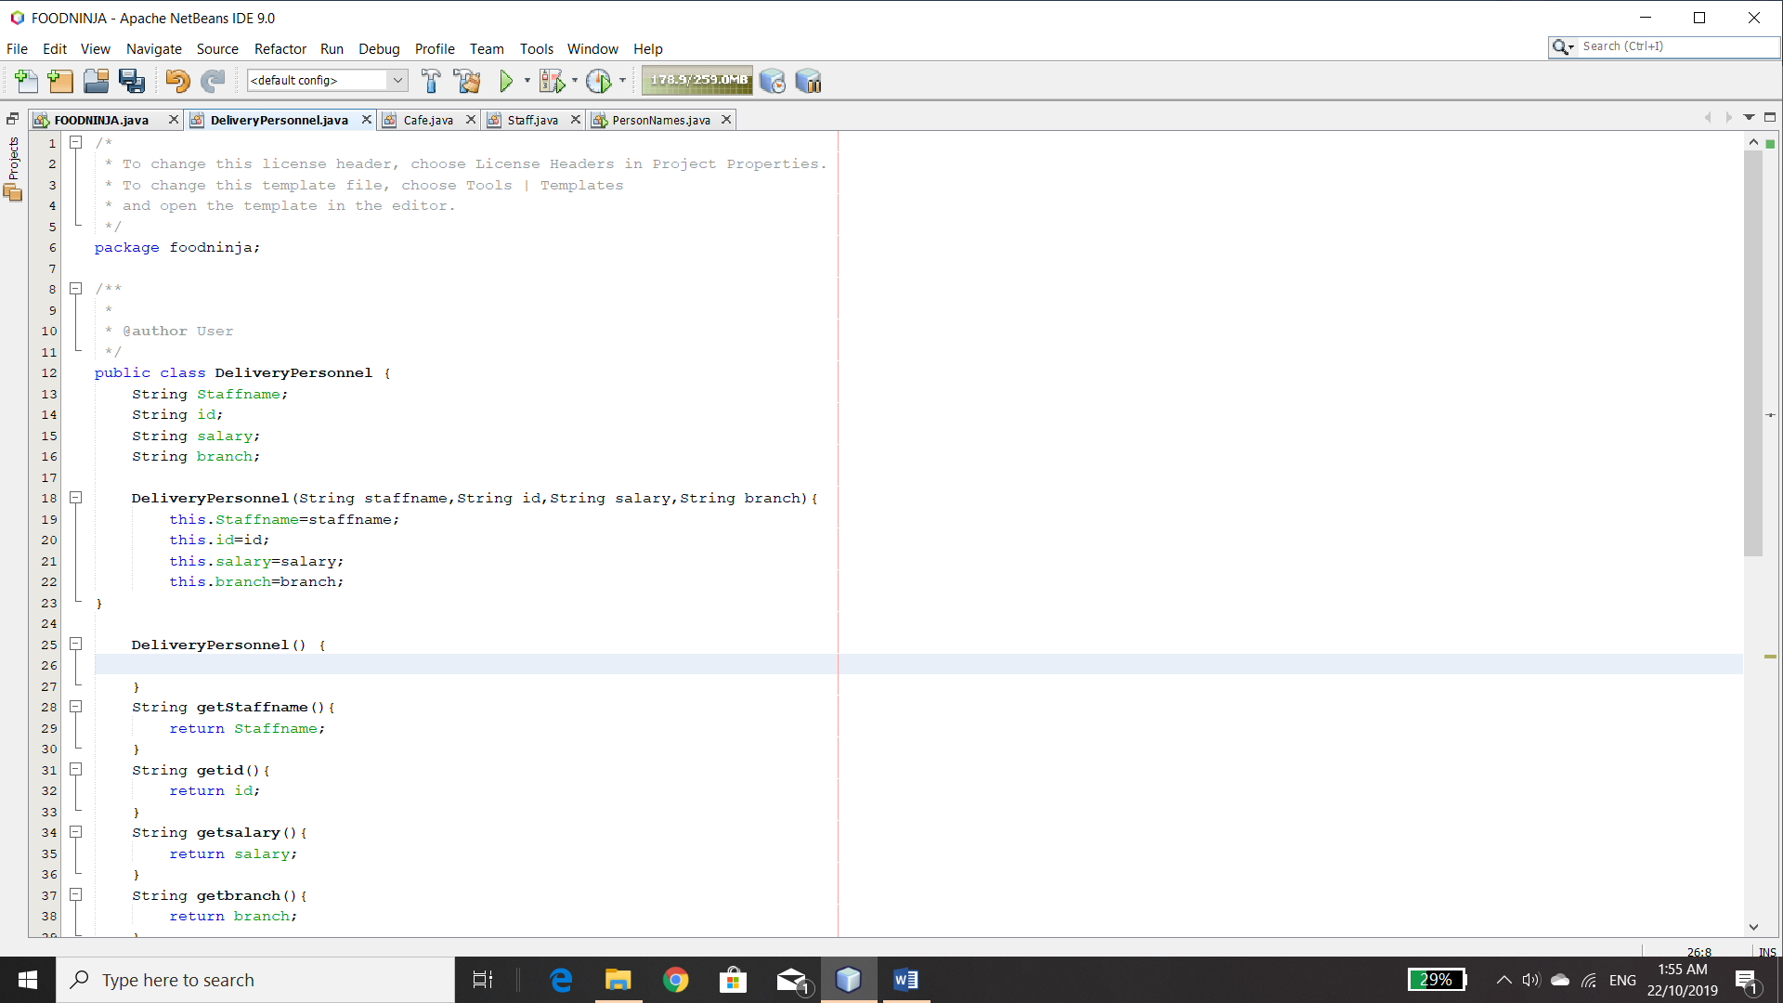

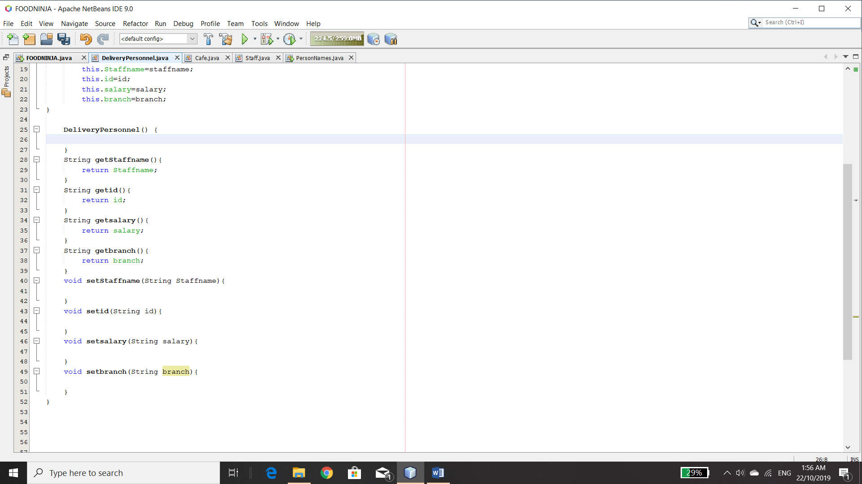

**Source code class ;**

package foodninja;

public class DeliveryPersonnel {

String Staffname;

String id;

String salary;

String branch;

DeliveryPersonnel(String staffname,String id,String salary,String branch){

this.Staffname=staffname;

this.id=id;

this.salary=salary;

this.branch=branch;

}

DeliveryPersonnel() {

}

String getStaffname(){

return Staffname;

}

String getid(){

return id;

}

String getsalary(){

return salary;

}

String getbranch(){

return branch;

}

void setStaffname(String Staffname){

}

void setid(String id){

}

void setsalary(String salary){

}

void setbranch(String branch){

}

}

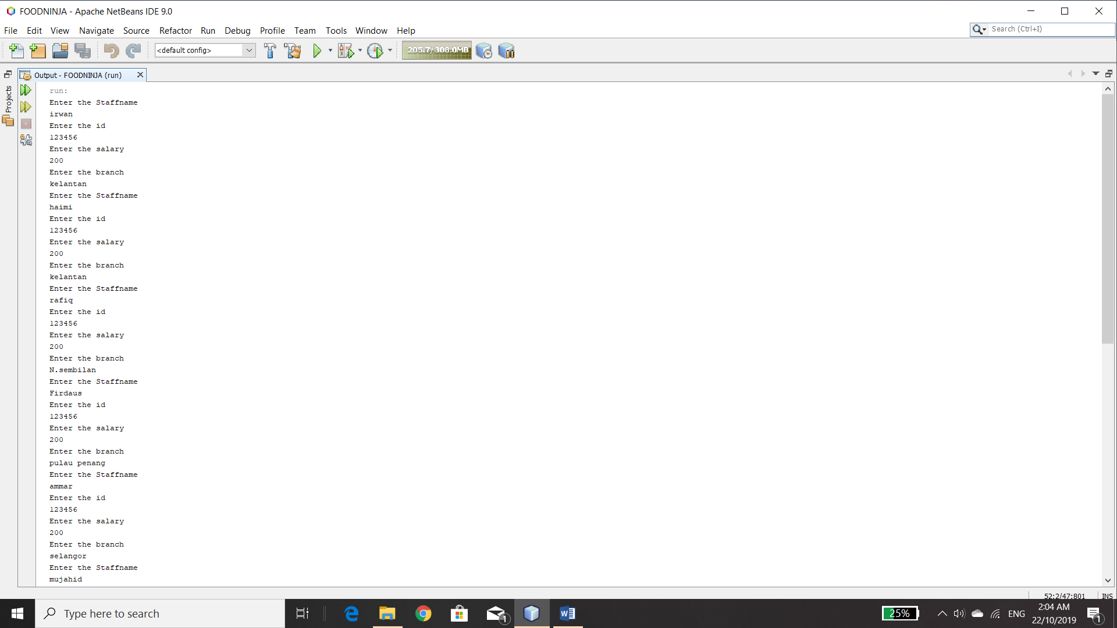

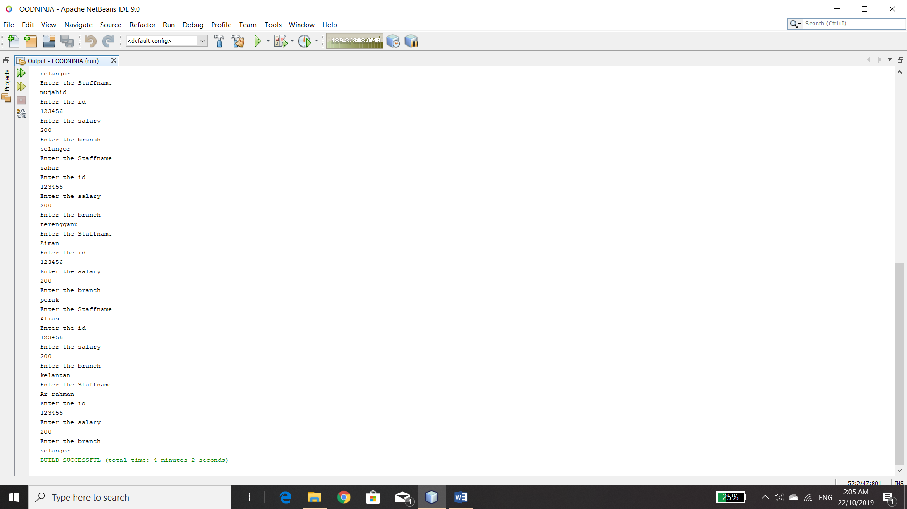

**OUTPUT;**

run:

Enter the Staffname

irwan

Enter the id

123456

Enter the salary

200

Enter the branch

kelantan

Enter the Staffname

haimi

Enter the id

123456

Enter the salary

200

Enter the branch

kelantan

Enter the Staffname

rafiq

Enter the id

123456

Enter the salary

200

Enter the branch

N.sembilan

Enter the Staffname

Firdaus

Enter the id

123456

Enter the salary

200

Enter the branch

pulau penang

Enter the Staffname

ammar

Enter the id

123456

Enter the salary

200

Enter the branch

selangor

Enter the Staffname

mujahid

Enter the id

123456

Enter the salary

200

Enter the branch

selangor

Enter the Staffname

zahar

Enter the id

123456

Enter the salary

200

Enter the branch

terengganu

Enter the Staffname

Aiman

Enter the id

123456

Enter the salary

200

Enter the branch

perak

Enter the Staffname

Alias

Enter the id

123456

Enter the salary

200

Enter the branch

kelantan

Enter the Staffname

Ar rahman

Enter the id

123456

Enter the salary

200

Enter the branch

selangor

BUILD SUCCESSFUL (total time: 4 minutes 2 seconds)