|  |  |
| --- | --- |
| **Logo_Baru-Rasmi_UUM_02** | STIA1123: Programming 2 Semester 192School of Computing, CAS, UUM |
| Lab 3 | |
| 11/11/2019  Submission  14/11/2019 | |

Scenario:

A travel agency asks you to developed an app to store their travel packages. There are 5 travel packages from (e.g. **Kuala Lumpur to Hatyai)**. The application should allow them to store all packages title together with price for single person, travel duration and description. Display back to user when all the travel packages have been successfully inserted.

The application should be able to detect if user did not enter any data and also enter incorrect data type such as price. The application can request user to enter the data again. This is a terminal based application.

Save your word document and upload to:

* UUM Learning
* <http://slumberjer.com/teaching/a191/stia1123/upload/>

**Late submission will be not accepted and tolerated and will be given 0.**

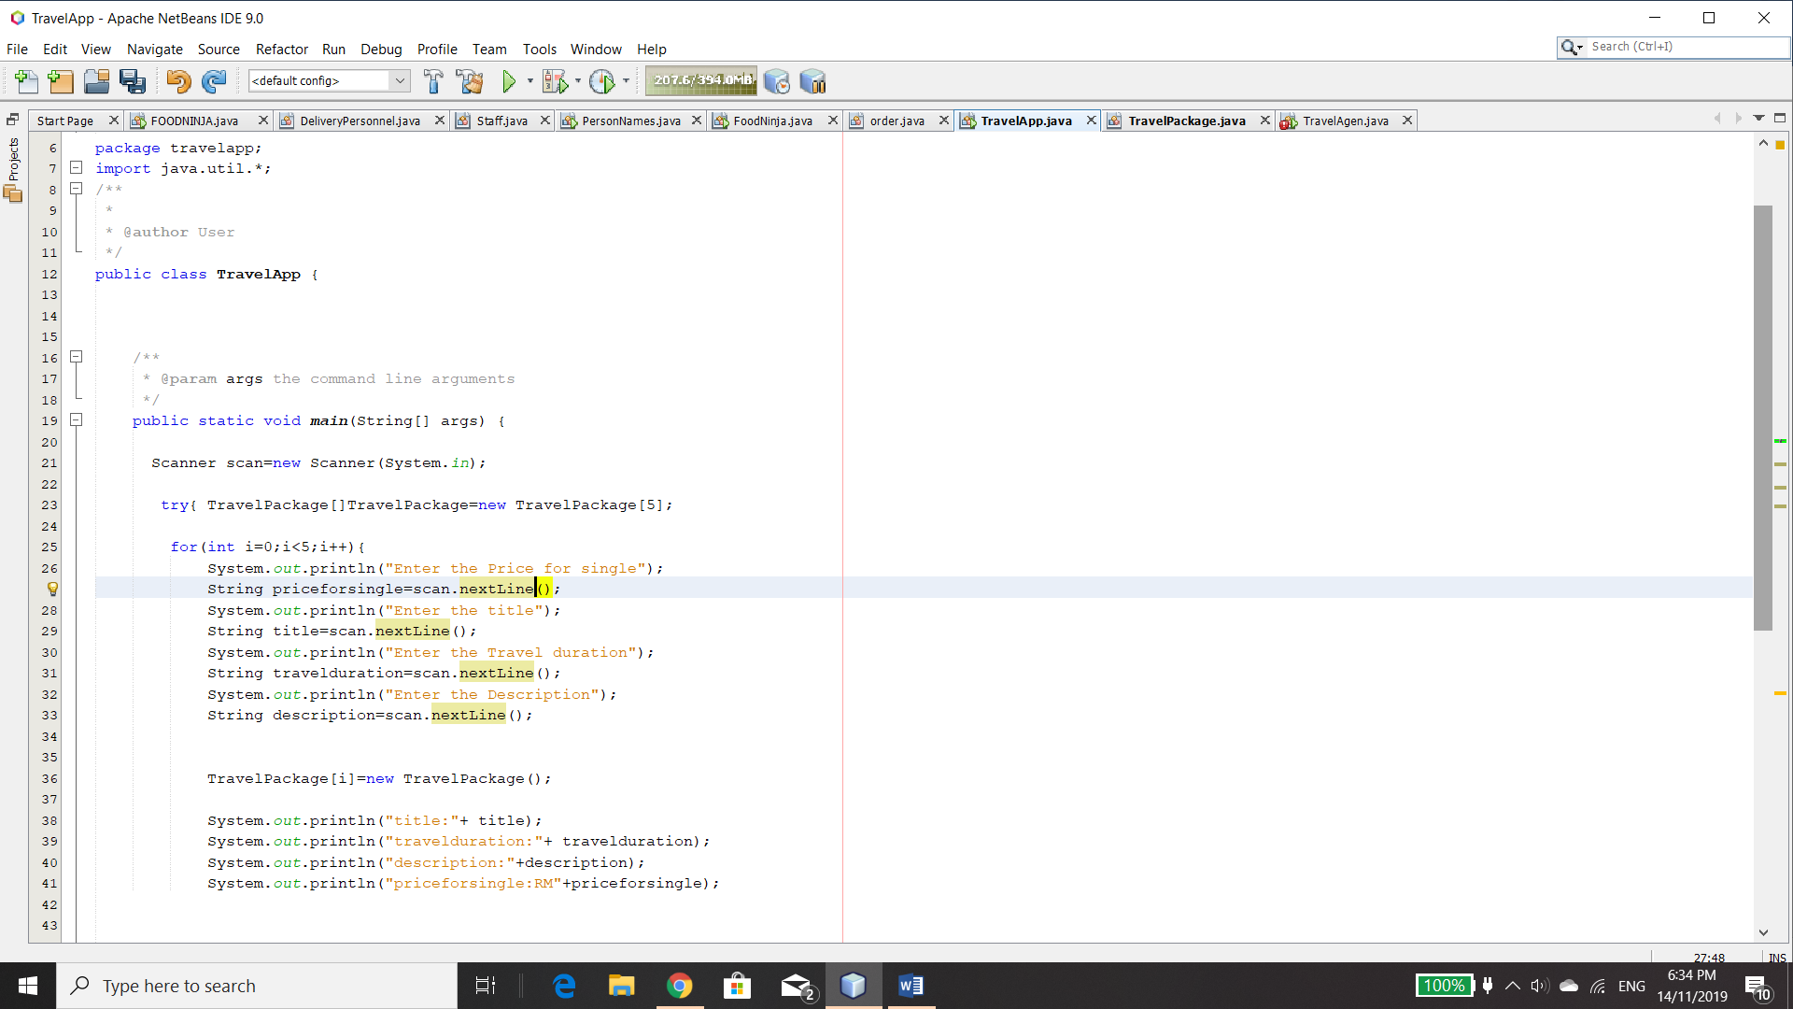

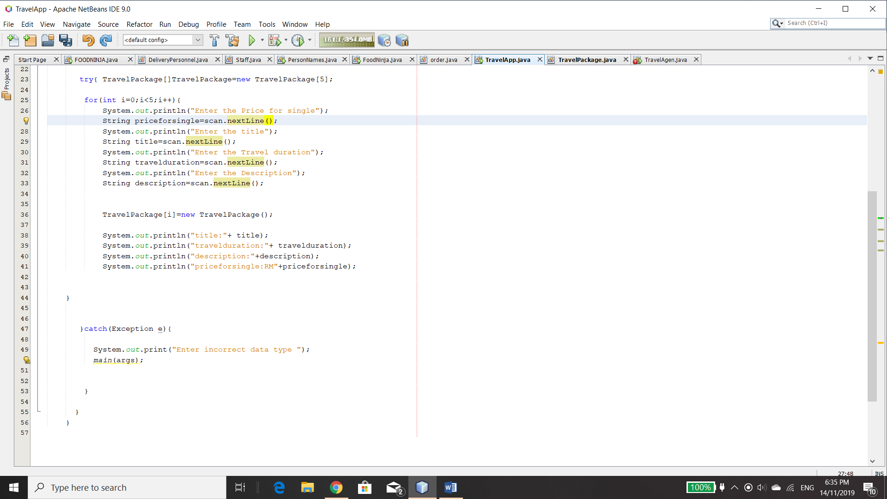

**package travelapp;**

**import java.util.\*;**

**/\*\***

**\***

**\* @author User**

**\*/**

**public class TravelApp {**

**/\*\***

**\* @param args the command line arguments**

**\*/**

**public static void main(String[] args) {**

**Scanner scan=new Scanner(System.in);**

**try{ TravelPackage[]TravelPackage=new TravelPackage[5];**

**for(int i=0;i<5;i++){**

**System.out.println("Enter the Price for single");**

**String priceforsingle=scan.nextLine();**

**System.out.println("Enter the title");**

**String title=scan.nextLine();**

**System.out.println("Enter the Travel duration");**

**String travelduration=scan.nextLine();**

**System.out.println("Enter the Description");**

**String description=scan.nextLine();**

**TravelPackage[i]=new TravelPackage();**

**System.out.println("title:"+ title);**

**System.out.println("travelduration:"+ travelduration);**

**System.out.println("description:"+description);**

**System.out.println("priceforsingle:RM"+priceforsingle);**

**}**

**}catch(Exception e){**

**System.out.print("Enter incorrect data type ");**

**main(args);**

**}**

**}**

**}**

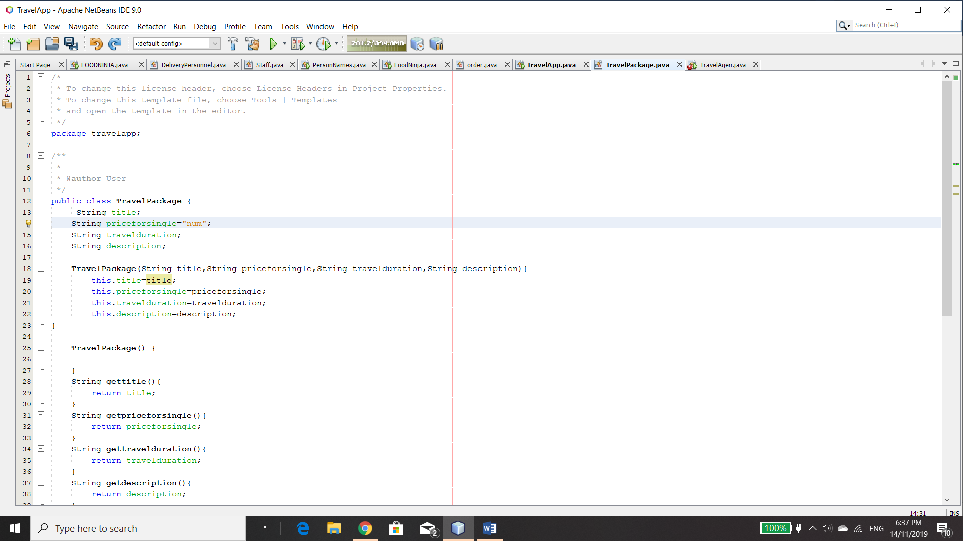

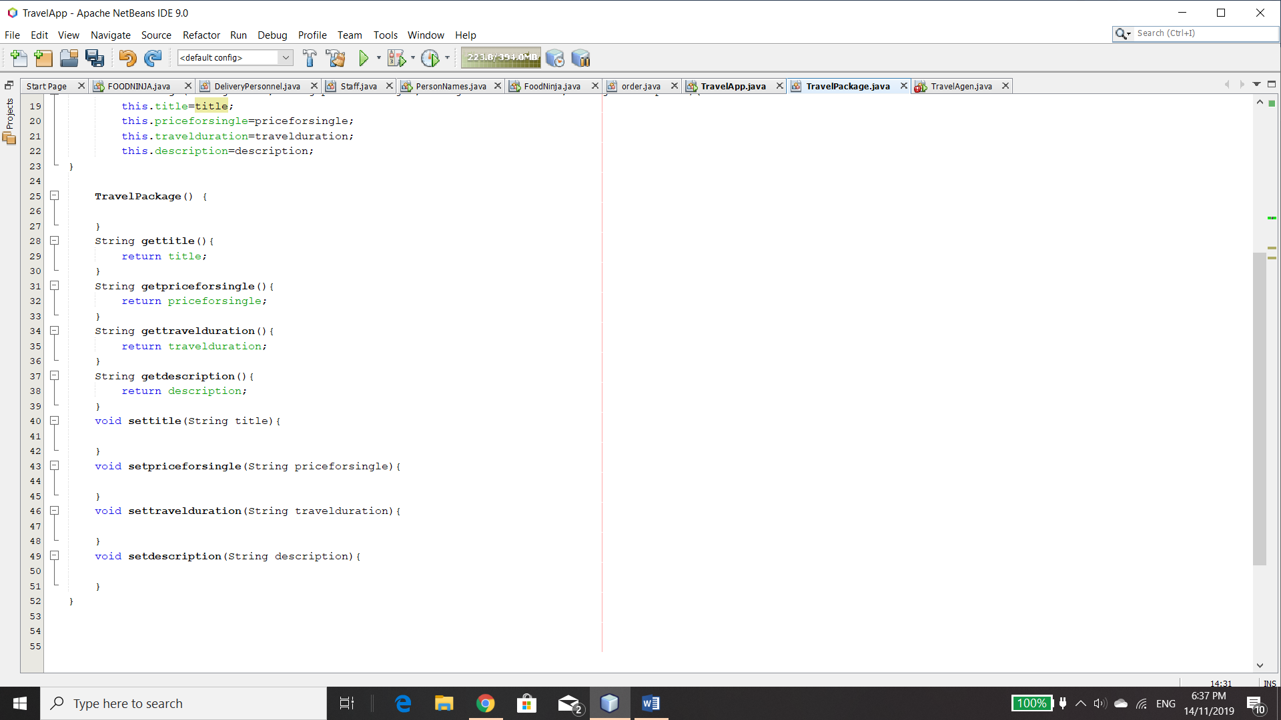

package travelapp;

/\*\*

\*

\* @author User

\*/

public class TravelPackage {

String title;

String priceforsingle="num";

String travelduration;

String description;

TravelPackage(String title,String priceforsingle,String travelduration,String description){

this.title=title;

this.priceforsingle=priceforsingle;

this.travelduration=travelduration;

this.description=description;

}

TravelPackage() {

}

String gettitle(){

return title;

}

String getpriceforsingle(){

return priceforsingle;

}

String gettravelduration(){

return travelduration;

}

String getdescription(){

return description;

}

void settitle(String title){

}

void setpriceforsingle(String priceforsingle){

}

void settravelduration(String travelduration){

}

void setdescription(String description){

}

}

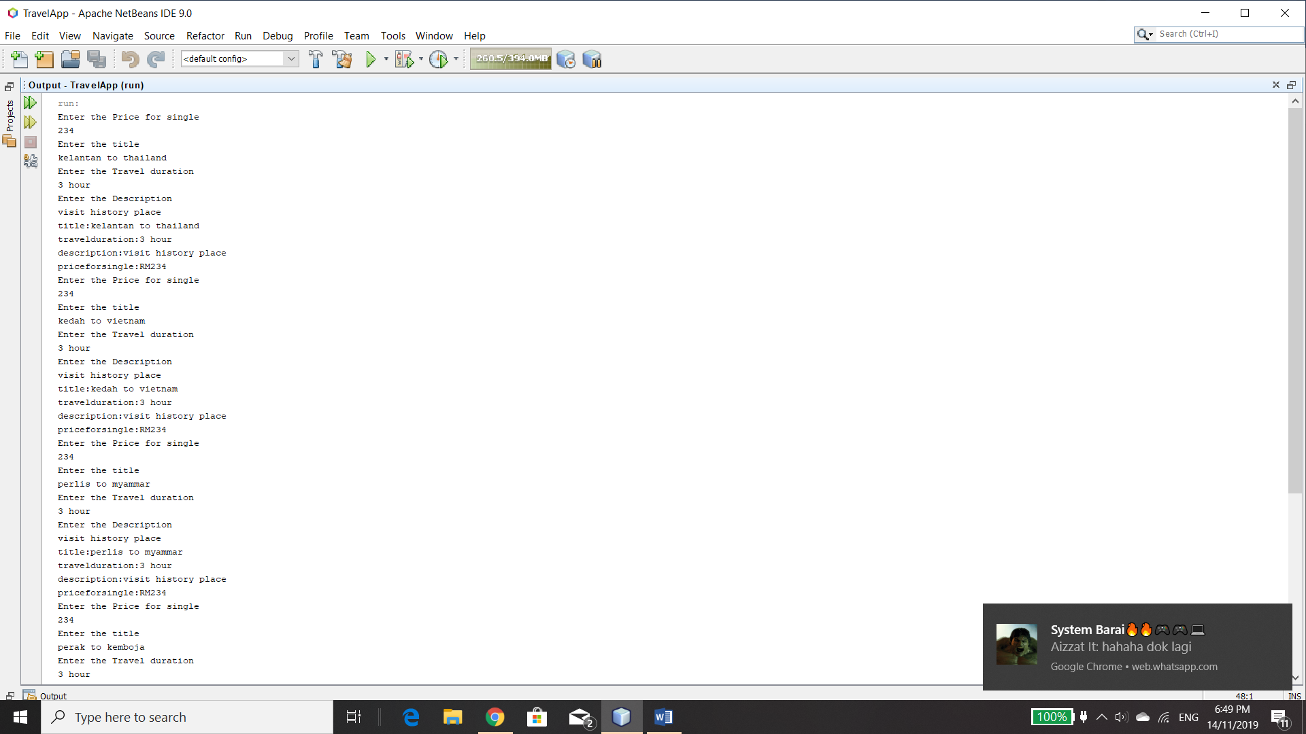

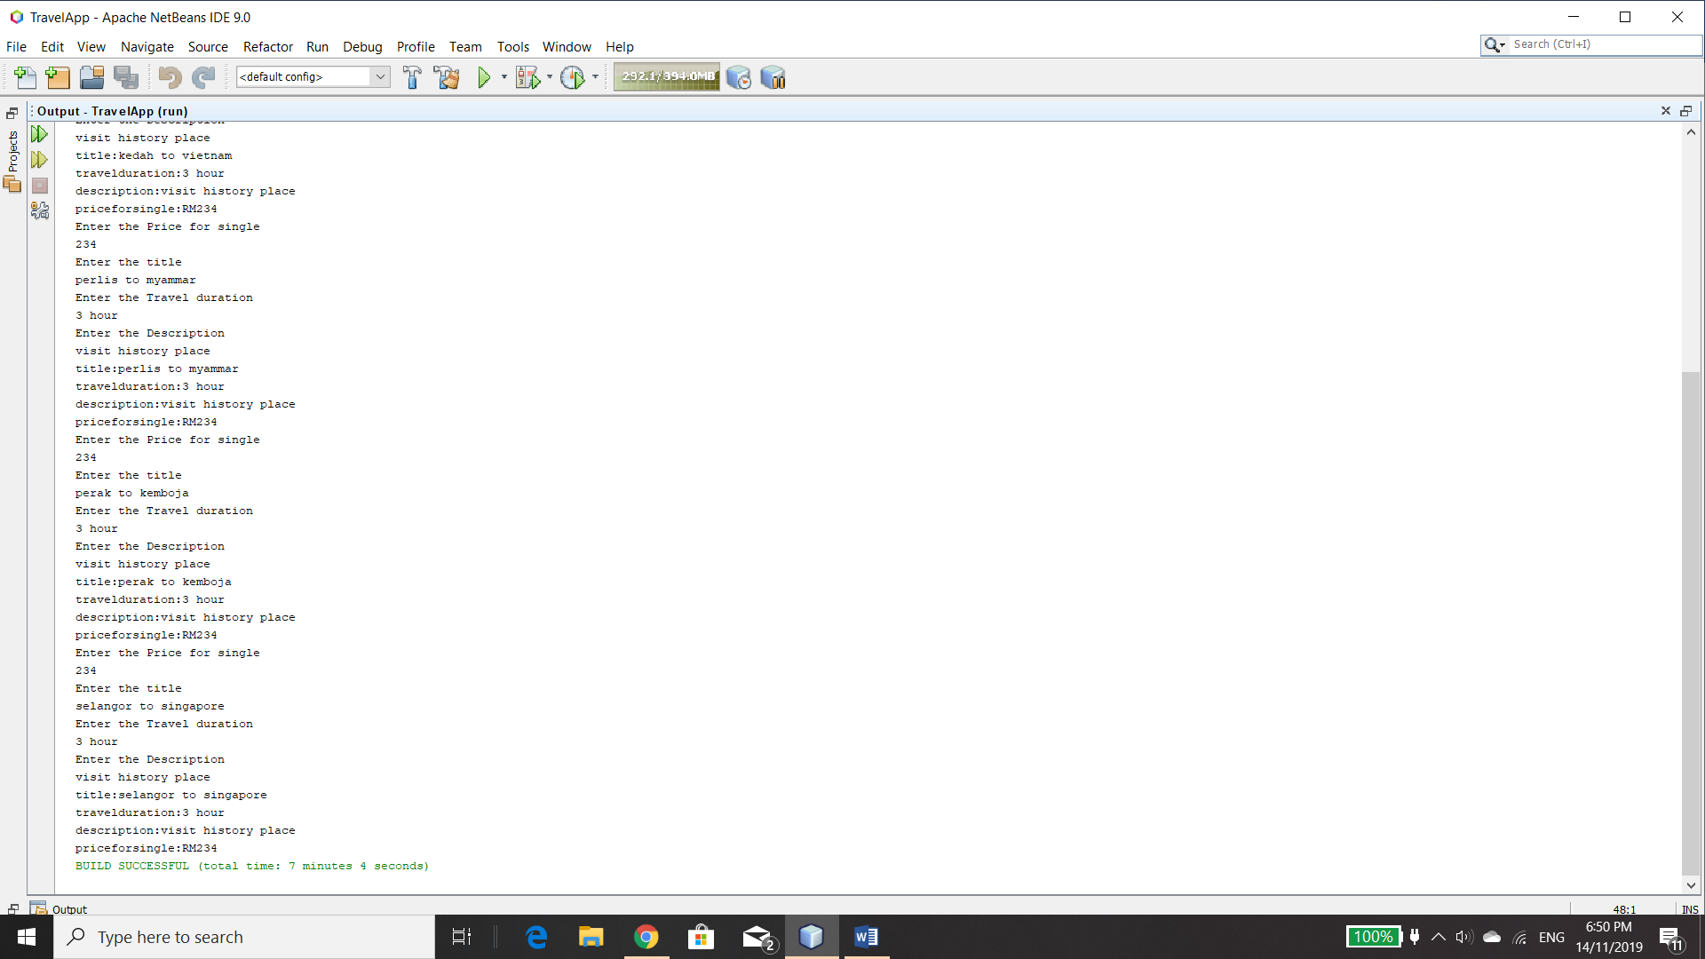

run:

Enter the Price for single

234

Enter the title

kelantan to thailand

Enter the Travel duration

3 hour

Enter the Description

visit history place

title:kelantan to thailand

travelduration:3 hour

description:visit history place

priceforsingle:RM234

Enter the Price for single

234

Enter the title

kedah to vietnam

Enter the Travel duration

3 hour

Enter the Description

visit history place

title:kedah to vietnam

travelduration:3 hour

description:visit history place

priceforsingle:RM234

Enter the Price for single

234

Enter the title

perlis to myammar

Enter the Travel duration

3 hour

Enter the Description

visit history place

title:perlis to myammar

travelduration:3 hour

description:visit history place

priceforsingle:RM234

Enter the Price for single

234

Enter the title

perak to kemboja

Enter the Travel duration

3 hour

Enter the Description

visit history place

title:perak to kemboja

travelduration:3 hour

description:visit history place

priceforsingle:RM234

Enter the Price for single

234

Enter the title

selangor to singapore

Enter the Travel duration

3 hour

Enter the Description

visit history place

title:selangor to singapore

travelduration:3 hour

description:visit history place

priceforsingle:RM234

BUILD SUCCESSFUL (total time: 7 minutes 4 seconds)