|  |  |
| --- | --- |
| **Logo_Baru-Rasmi_UUM_02** | STIJ3074: Web Programming Semester A201School of Computing, CAS, UUM |
| Lab 3 – Pset 3 | |
| Date given: 25/11/2020 9.00 AM  Submission date :**26/11/2020 9.00 AM** | |

Consider the following problems:

A restaurant owner would like to store information in a database all of his food menu. Each food contain an id (auto id), name, price, quantity, and calorie.

**Problem 1:**

Build a form that allow restaurant owner to store food information as describe in the problem above.

**Problem 2:**

Create a database in your webhosting and store the data in the above form in the database using php as backend processor.

Submission:

1. Upload both your html forms to your webhosting under **/stij3074/pset3/** folder directory in your server directory.
2. Create a word document and print screen form in problem 1 and print your htlm and php code.
3. Upload your code to your github directory.
4. Upload your document to: <http://slumberjer.com/teaching/a201/stij3074/upload/> Fill all the required information correctly.

**Late submission will be not accepted and will not be tolerated and given 0.**

Problem 1

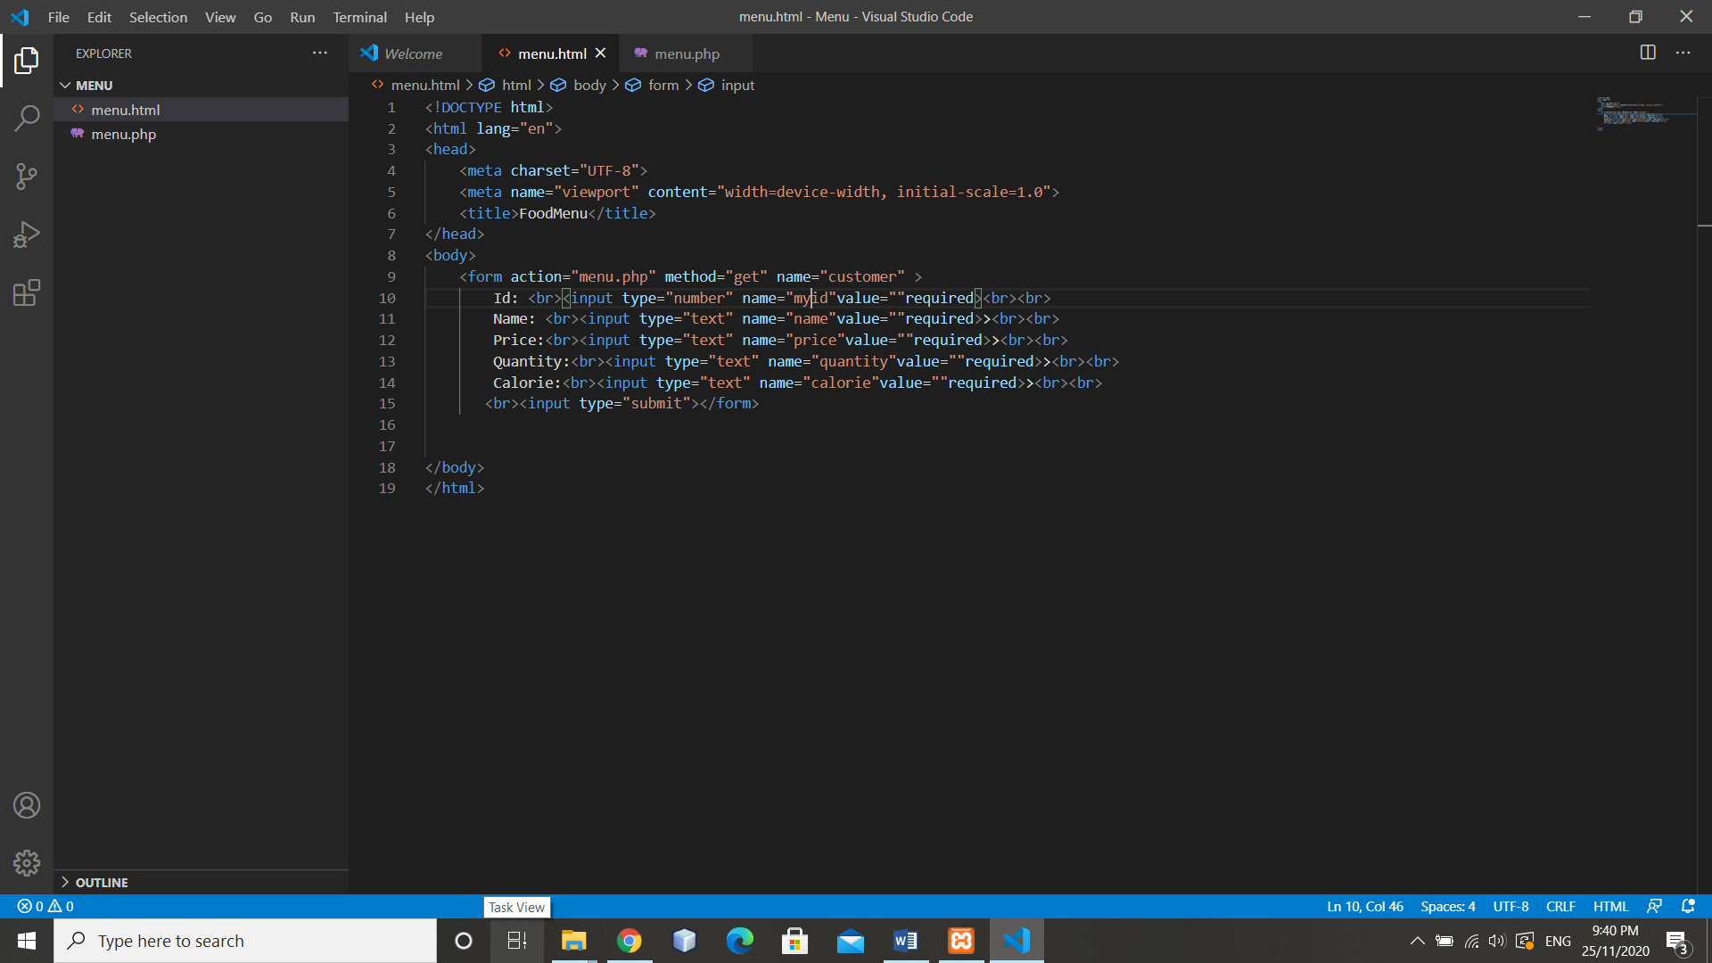

<!DOCTYPE html>

<html lang="en">

<head>

<meta charset="UTF-8">

<meta name="viewport" content="width=device-width, initial-scale=1.0">

<title>FoodMenu</title>

</head>

<body>

<form action="menu.php" method="get" name="customer" >

Id: <br><input type="text" name="myid"value=""required><br><br>

Name: <br><input type="text" name="name"value=""required>><br><br>

Price:<br><input type="text" name="price"value=""required>><br><br>

Quantity:<br><input type="text" name="quantity"value=""required>><br><br>

Calorie:<br><input type="text" name="calorie"value=""required>><br>

<br><input type="submit"></form>

</body>

</html>

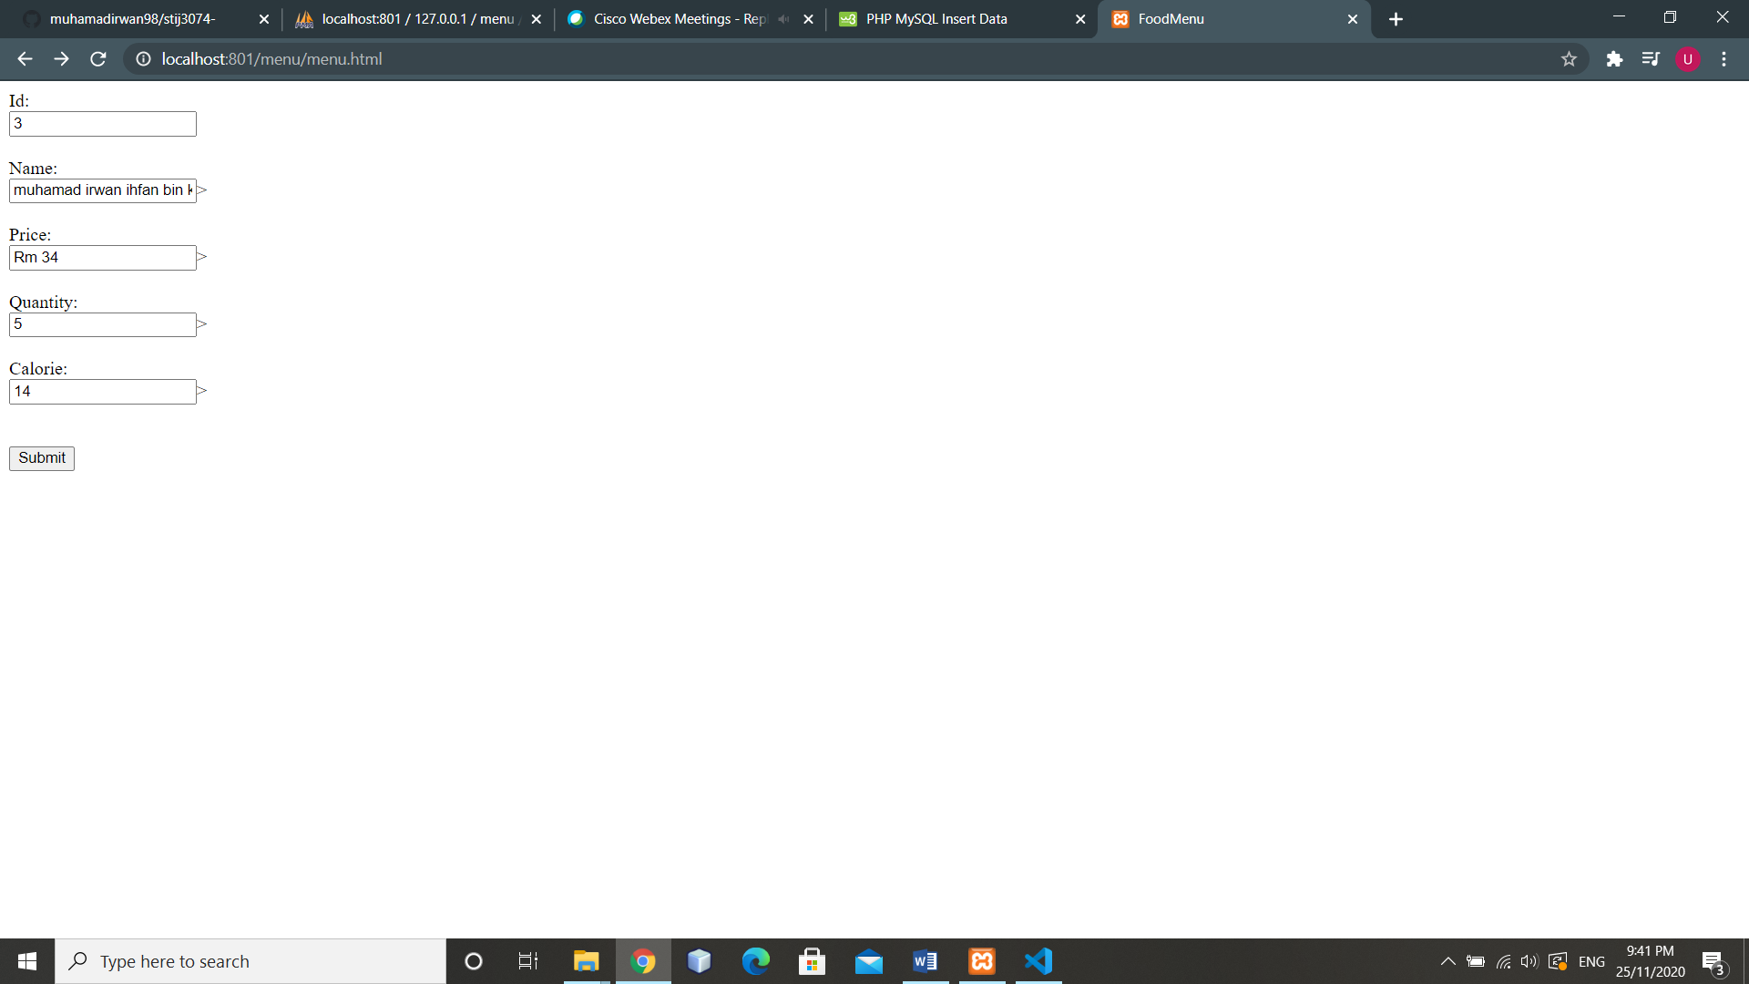

Problem 2

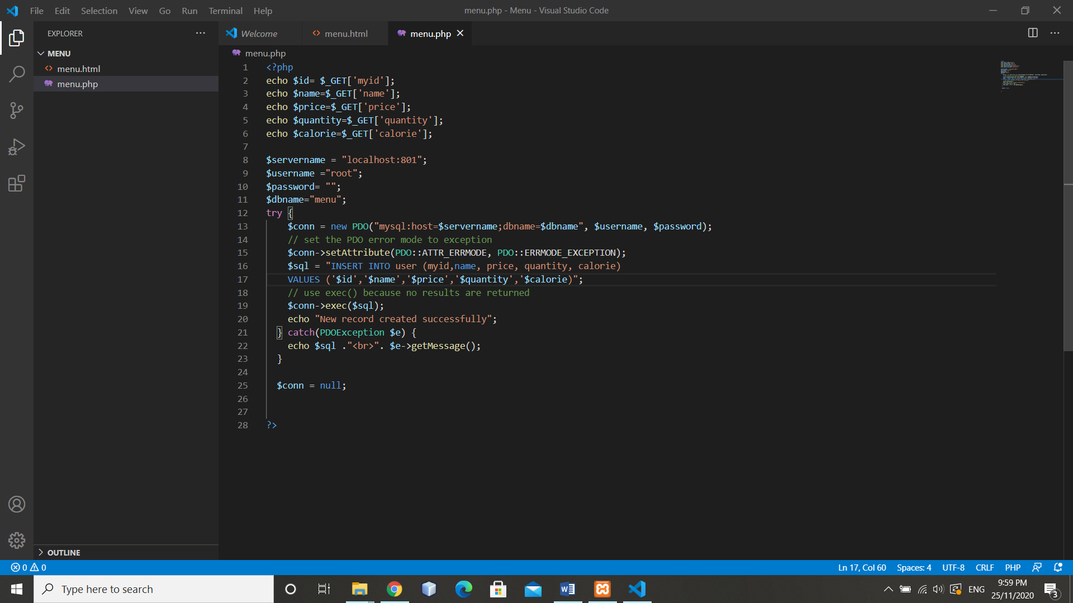

<?php

echo $id= $\_GET['myid'];

echo $name=$\_GET['name'];

echo $price=$\_GET['price'];

echo $quantity=$\_GET['quantity'];

echo $calorie=$\_GET['calorie'];

$servername = "localhost:801";

$username ="root";

$password= "";

$dbname="menu";

try {

$conn = new PDO("mysql:host=$servername;dbname=$dbname", $username, $password);

// set the PDO error mode to exception

$conn->setAttribute(PDO::ATTR\_ERRMODE, PDO::ERRMODE\_EXCEPTION);

$sql = "INSERT INTO user (myid,name, price, quantity, calorie)

VALUES ('$id','$name','$price','$quantity','$calorie)";

// use exec() because no results are returned

$conn->exec($sql);

echo "New record created successfully";

} catch(PDOException $e) {

echo $sql ."<br>". $e->getMessage();

}

$conn = null;

?>

