Muhammad Mureed
023-24-0125
Section E

1. Library Selection & README Summary
# DevFlow Homepage — React-Bootstrap Edition (Generic Student)
For this assignment, I chose **React-Bootstrap** as the official React UI component library.
It was installed into the Vite project using:
```bash
npm install react-bootstrap bootstrap
```
Using React-Bootstrap saved substantial time and manual boilerplate by providing ready-to-use accessible components like `Navbar`, `Container`, `Card`, and `Button` with built-in responsive collapsing navigation (`Navbar.Toggle`) and flexbox grid alignments (`Row`, `Col`), eliminating the need to write complex media queries and custom collapse states from scratch.
Full-Page Rendered View


Navbar & Hero Section View


Build & Development Verification
Vite Development Server ('npm run dev')
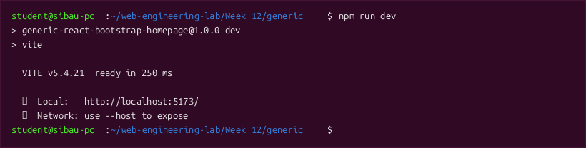

Figure 4: Production Build ('npm run build')
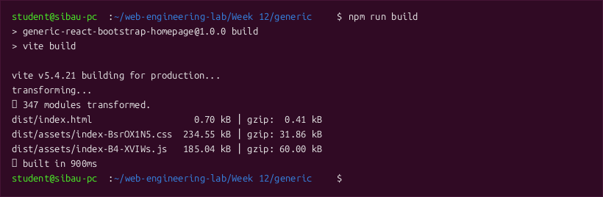
Component Architecture & Source Code
File: src/components/Navbar.jsx
import React from 'react';
import { Navbar, Nav, Container, Button } from 'react-bootstrap';
export default function AppNavbar() {
return (
<Navbar expand="lg" className="navbar-generic sticky-top" variant="dark">
<Container>
<Navbar.Brand href="#home" className="brand-generic">
<span className="logo-badge-generic">DF</span>
DevFlow
</Navbar.Brand>
<Navbar.Toggle aria-controls="generic-navbar-nav" />
<Navbar.Collapse id="generic-navbar-nav">
<Nav className="ms-auto align-items-center">
<Nav.Link href="#home" className="nav-link-generic">Home</Nav.Link>
<Nav.Link href="#features" className="nav-link-generic">Features</Nav.Link>
<Nav.Link href="#services" className="nav-link-generic">Services</Nav.Link>
<Nav.Link href="#contact" className="nav-link-generic">Contact</Nav.Link>
<Button className="btn-generic-primary ms-lg-3 mt-3 mt-lg-0">
Get Started
</Button>
</Nav>
</Navbar.Collapse>
</Container>
</Navbar>
);
}
File: src/components/Hero.jsx
import React from 'react';
import { Container, Button } from 'react-bootstrap';
export default function Hero() {
return (
<section className="hero-generic" id="home">
<Container>
<span className="hero-pill-generic">⚡ Modern Full Homepage via React-Bootstrap</span>
<h1 className="hero-heading-generic">
Building Scalable Cloud<br />Software Platforms
</h1>
<p className="hero-text-generic">
DevFlow provides developers with high-performance components, edge deployment integration, and deep observability out of the box.
</p>
<div className="d-flex justify-content-center gap-3 flex-wrap">
<Button className="btn-generic-primary">
Start Free Trial
</Button>
<Button className="btn-generic-outline">
Documentation
</Button>
</div>
</Container>
</section>
);
}
File: src/components/Features.jsx
import React from 'react';
import { Container, Row, Col, Card } from 'react-bootstrap';
export default function Features() {
const featureList = [
{
icon: '⚡',
title: 'Lightning Edge Routing',
desc: 'Sub-millisecond static and dynamic request routing powered by globally distributed serverless points of presence.'
},
{
icon: '🛡️',
title: 'Automated Hardening',
desc: 'Native DDoS mitigation, role-based access management, and automated TLS certificate rotation.'
},
{
icon: '📊',
title: 'Granular Metrics',
desc: 'Real-time telemetry, memory profiling, and query performance insights visualized in a unified dashboard.'
},
{
icon: '🧩',
title: 'Bootstrap UI Integration',
desc: 'Consistent visual design system built with responsive React-Bootstrap components and flexible 12-column layouts.'
}
];
return (
<section className="features-generic" id="features">
<Container>
<div className="text-center mb-5">
<h2 style={{ fontSize: '2.4rem', fontWeight: 700 }}>Platform Services</h2>
<p style={{ color: 'var(--text-muted)', fontSize: '1.1rem' }}>
Core foundational modules designed for rapid application engineering.
</p>
</div>
<Row className="g-4">
{featureList.map((item, index) => (
<Col key={index} md={6} lg={3}>
<Card className="feature-card-generic">
<Card.Body>
<div className="feature-icon-generic">{item.icon}</div>
<Card.Title style={{ fontSize: '1.25rem', fontWeight: 700, marginBottom: '12px' }}>
{item.title}
</Card.Title>
<Card.Text style={{ color: 'var(--text-muted)', fontSize: '0.95rem' }}>
{item.desc}
</Card.Text>
</Card.Body>
</Card>
</Col>
))}
</Row>
</Container>
</section>
);
}
File: src/components/Footer.jsx
import React from 'react';
import { Container } from 'react-bootstrap';
export default function Footer() {
return (
<footer className="footer-generic" id="contact">
<Container>
<div className="footer-links-generic mb-3">
<a href="#home">Home</a>
<a href="#features">Features</a>
<a href="#services">Services</a>
<a href="#contact">Privacy</a>
<a href="#contact">Terms</a>
</div>
<p className="mb-1" style={{ fontSize: '0.95rem' }}>
© 2026 DevFlow Platform. Built for Web Engineering Lab 12 Assignment.
</p>
<small style={{ color: 'var(--text-muted)' }}>
Sukkur IBA University — Department of Computer Science
</small>
</Container>
</footer>
);
}
File: src/App.jsx
import React from 'react';
import 'bootstrap/dist/css/bootstrap.min.css';
import './index.css';
import AppNavbar from './components/Navbar';
import Hero from './components/Hero';
import Features from './components/Features';
import Footer from './components/Footer';
export default function App() {
return (
<div className="homepage-wrapper">
<AppNavbar />
<Hero />
<Features />
<Footer />
</div>
);
}

