1. JUDUL : The Sky Is Everywhere

PENGARANG : Jandy Nelson

HARGA : Rp 165.000

DETAIL : Adrift after her sister Bailey's sudden death, Lennie finds herself torn between quiet, seductive Toby—Bailey's boyfriend who shares her grief—and Joe, the new boy in town who bursts with life and musical genius.

Tahun terbit : October 05 th 2004

1. JUDUL : Passenger

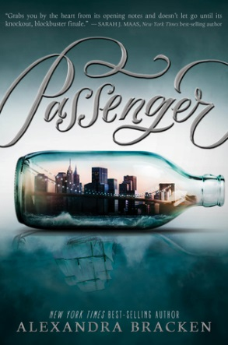PENGARANG : [Alexandra Bracken](https://www.goodreads.com/author/show/2973783.Alexandra_Bracken)

HARGA : Rp 215.000

DETAIL : In one devastating night, violin prodigy Etta Spencer loses everything she knows and loves. Thrust into an unfamiliar world by a stranger with a dangerous agenda, Etta is certain of only one thing: she has traveled not just miles but years from home.

Tahun terbit : April 21th 2008

1. JUDUL : The Truth About Forever

PENGARANG : Sarah Dessen

HARGA : 120.000

DETAIL : That's what Macy has to look forward to while her boyfriend, Jason, is away at Brain Camp. Days will be spent at a boring job in the library, evenings will be filled with vocabulary drills for the SATs, and spare time will be passed with her mother, the two of them sharing a silent grief at the traumatic loss of Macy's father.

Tahun terbit : May 11th 2004

1. JUDUL : Crooked Kingdom

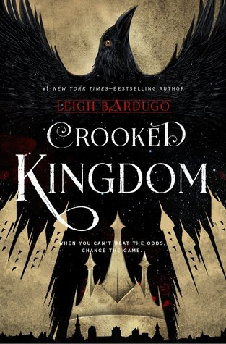PENGARANG : [Leigh Bardugo](https://www.goodreads.com/author/show/4575289.Leigh_Bardugo)

HARGA : Rp 98.000

DETAIL : Kaz Brekker and his crew of deadly outcasts have just pulled off a heist so daring even they didn't think they'd survive. But instead of divvying up a fat reward, they're right back to fighting for their lives.

Published : September 27th 2016

1. JUDUL : Two-Way Street

PENGARANG : Lauren Barnholdt

HARGA : Rp 110.000

DETAIL : This is Jordan and Courtney, totally in love. Sure, they were an unlikely high school couple. But they clicked; it worked. They're even going to the same college, and driving cross-country together for orientation.

PUBLISHED : June 26th 2007

1. JUDUL : Dreamland

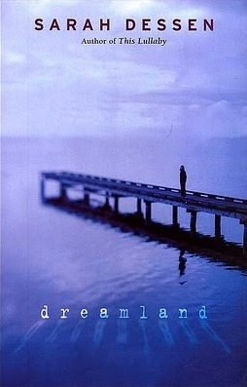PENGARANG : Sarah Dessen

HARGA : Rp 148.000

DETAIL : Ever since she started going out with Rogerson Biscoe, Caitlin seems to have fallen into a semiconscious dreamland where nothing is quite real. Rogerson is different from anyone Caitlin has ever known. He's magnetic. He's compelling. He's dangerous. Being with him makes Caitlin forget about everything

PUBLISHED : May 11th 2004