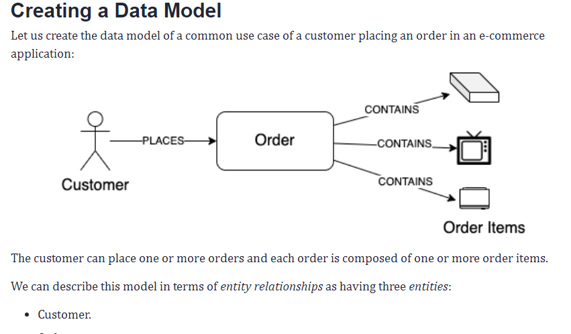

* Order.
* Order Item.

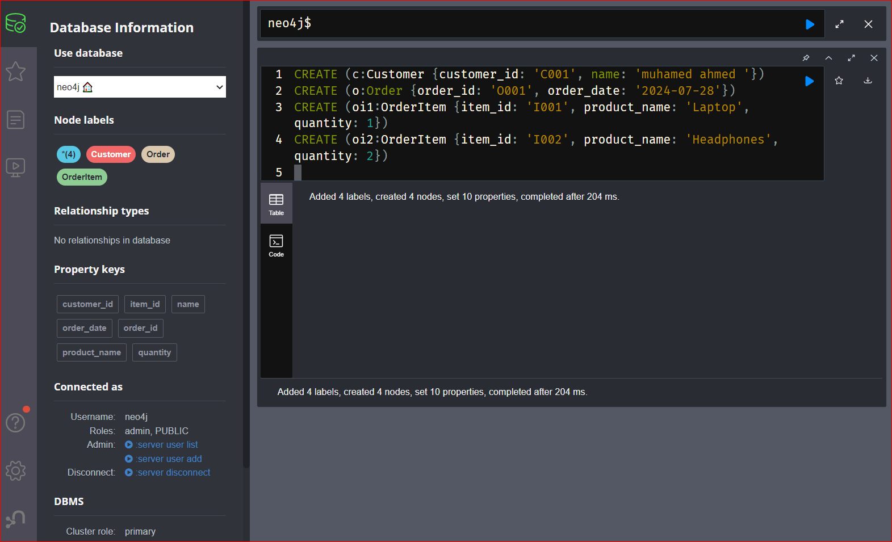

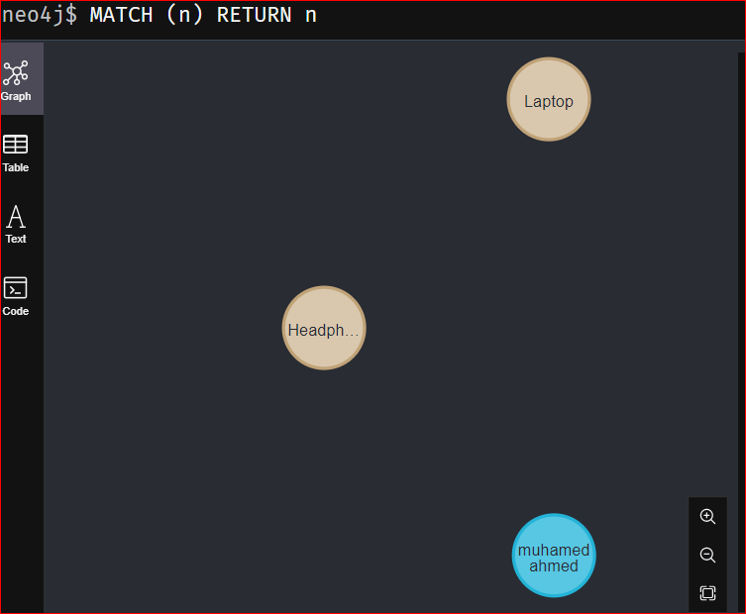

and two *associations*:

* *one-to-many* relationship between customer and order entities.
* MATCH (c:Customer {customer_id: 'C001'}), (o:Order {order_id: 'O001'})
* CREATE (c)-[:PLACES]->(o)
* *one-to-many* relationship between order and order item entities.
* MATCH (o:Order {order_id: 'O001'}), (oi1:OrderItem {item_id: 'I001'}), (oi2:OrderItem {item_id: 'I002'})
* CREATE (o)-[:CONTAINS]->(oi1)
* CREATE (o)-[:CONTAINS]->(oi2)

