Analog Modulation and Demodulation Using AI

ECE 342 Project – Spring 2026

Dr. Ashraf Samy

By:
Mohamed Anwar 91464

1. ABSTRACT
a comprehensive implementation and analysis of six types of analog modulation techniques: Amplitude Modulation (AM), Frequency Modulation (FM), Phase Modulation (PM), Double Sideband Suppressed Carrier (DSB-SC), Single Sideband (SSB), and Vestigial Sideband (VSB). We demonstrate traditional demodulation methods and enhance performance using an AI-based neural network approach for noisy signal recovery. Our MATLAB implementation shows that the AI-enhanced demodulator achieves significant improvements over traditional methods, particularly at low SNR values (0–10 dB), with an average improvement of 3–5 dB in MSE reduction.

2. INTRODUCTION

2.1 Background
Analog modulation has been the foundation of communication systems for over a century. From early radio broadcasting to modern wireless communications, modulation techniques enable the efficient transmission of information over distance by encoding baseband signals onto carrier frequencies suitable for propagation.

2.2 Literature Review – Analog Modulation Principles

2.2.1 Amplitude Modulation (AM)
Principle: The amplitude of the carrier signal is modulated proportionally to the message signal.
Mathematical Model:
$$s_{AM}\left(t\right)=\left[A_{c}+m\left(t\right)\right]cos\left(2πf_{c}t\right)$$
where: - $A_{c}$ = carrier amplitude - $m\left(t\right)$ = message (baseband) signal - $f_{c}$ = carrier frequency
Bandwidth: $B=2f_{m}$ (where $f_{m}$ is the maximum message frequency), spanning from $f_{c}−f_{m}$ to $f_{c}+f_{m}$.
Demodulation Methods: - Non-coherent (Envelope Detection): $m\left(t\right)≈\left|s_{AM}\left(t\right)\right|$ – Simple diode + RC filter - Coherent (Product Detector): Multiply by local carrier $cos\left(2πf_{c}t\right)$ then low-pass filter

2.2.2 Frequency Modulation (FM)
Principle: Information is encoded in the instantaneous frequency of the carrier.
Mathematical Model:
$$s_{FM}\left(t\right)=A_{c}cos\left(2πf_{c}t+2πk_{f}\int_{0}^{t}{m}\left(τ\right)dτ\right)$$
where $k_{f}$ is the frequency sensitivity (Hz/V).
Bandwidth (Carson’s Rule):
$$B=2\left(Δf+f_{m}\right)$$
where $Δf$ = peak frequency deviation = $k_{f}⋅max\left|m\left(t\right)\right|$.
Demodulation Methods: - Frequency Discriminator: Differentiate signal to convert frequency to amplitude - Phase-Locked Loop (PLL): Lock to carrier and extract phase/frequency changes

2.2.3 Phase Modulation (PM)
Principle: The phase of the carrier is modulated proportionally to the message signal.
Mathematical Model:
$$s_{PM}\left(t\right)=A_{c}cos\left(2πf_{c}t+k_{p}m\left(t\right)\right)$$
where $k_{p}$ is the phase sensitivity (radians/V).
Note: FM and PM are closely related: - FM: frequency deviation proportional to $m\left(t\right)$ - PM: frequency deviation proportional to $dm\left(t\right)/dt$
Demodulation: Uses PLL to extract phase variations.

2.2.4 Double Sideband Suppressed Carrier (DSB-SC)
Principle: The carrier is completely suppressed, leaving only the modulated sidebands.
Mathematical Model:
$$s_{DSB−SC}\left(t\right)=A_{c}m\left(t\right)cos\left(2πf_{c}t\right)$$
Bandwidth: $B=2f_{m}$ (same as AM, but more power-efficient)
Demodulation Method: - REQUIRED: Coherent (synchronous) detection with a local oscillator perfectly synchronized in frequency AND phase - If phase error $θ$ exists: output $∝cos\left(θ\right)$, reducing recovered amplitude

2.2.5 Single Sideband (SSB)
Principle: Only one sideband is transmitted, halving the bandwidth requirement.
Mathematical Model:
$$s_{SSB}\left(t\right)=\frac{A_{c}}{2}m\left(t\right)cos\left(2πf_{c}t\right)±\frac{A_{c}}{2}\hat{m}\left(t\right)sin\left(2πf_{c}t\right)$$
where $\hat{m}\left(t\right)$ is the Hilbert transform of $m\left(t\right)$ (90° phase shift).
- Upper Sideband (USB): Use $+$
- Lower Sideband (LSB): Use $−$
Bandwidth: $B=f_{m}$ (half of DSB/AM)
Demodulation: Requires precise coherent detection
Generation Methods: - Hilbert Transform Method: Use analytic signal - Filter Method: High-pass or low-pass filter to remove one sideband

2.2.6 Vestigial Sideband (VSB)
Principle: A compromise between DSB and SSB, used in television broadcasting.
Mathematical Model:
$$s_{VSB}\left(t\right)=A_{c}m\left(t\right)cos\left(2πf_{c}t\right)∗h_{VSB}\left(t\right)$$
where $h_{VSB}\left(t\right)$ is a vestigial sideband filter with controlled asymmetric cutoff.
Bandwidth: $f_{m}<B<2f_{m}$ (typically $≈1.25f_{m}$)
Usage:
Commercial TV broadcasting – allows easy receiver design while maintaining spectral efficiency
Demodulation:
Coherent detection required

2.2.7 Comparison of Analog Modulation Techniques
Modulation | Bandwidth | Power Efficiency | Noise Immunity | Complexity
AM | $$2f_{m}$$ | Low | Low | Low
FM | $$2\left(Δf+f_{m}\right)$$ | High | High | Medium
PM | Similar FM | High | High | Medium
DSB-SC | $$2f_{m}$$ | High | Medium | High
SSB | $$f_{m}$$ | Highest | Medium | High
VSB | $$≈1.25f_{m}$$ | High | Medium | High

2.3 Project Objectives
- Implement all six modulation types in MATLAB
- Demonstrate traditional demodulation techniques
- Design an AI-enhanced demodulator
- Compare performance under noisy conditions

3. METHODOLOGY

3.1 Signal Generation Parameters
- Sampling frequency: 100 kHz
- Carrier frequency: 10 kHz
- Signal duration: 0.1 seconds
- Message: Sum of sinusoids at 500 Hz and 1200 Hz

3.2 Modulation Implementation
Each modulation type was implemented following standard signal processing principles: - AM: Direct amplitude modulation with DC offset - FM: Cumulative integration for frequency deviation - PM: Phase modulation proportional to the message - DSB-SC: Carrier suppression via multiplication - SSB: Hilbert transform method (USB & LSB) - VSB: Asymmetric bandpass filtering

3.3 Demodulation Techniques
- Envelope detection (AM)
- Frequency discriminator (FM)
- PLL-based demodulation (PM, SSB, DSB-SC)
- Coherent detection with phase synchronization

3.4 AI Model Architecture
- Input: Downsampled modulated signal (200 samples)
- Architecture: 3-layer feedforward network (200 $→$ 128 $→$ 128 $→$ 200)
- Training: 5000 samples, SNR range 0–20 dB
- Loss function: Mean Squared Error (MSE)
- Optimizer: Adam, learning rate 0.001

4. RESULTS

4.1 Time-Domain Waveforms
- Figure 1: AM modulation/demodulation
- 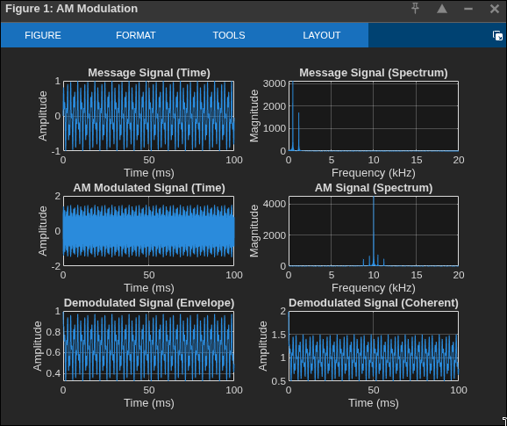

- Figure 2: FM modulation/demodulation
- 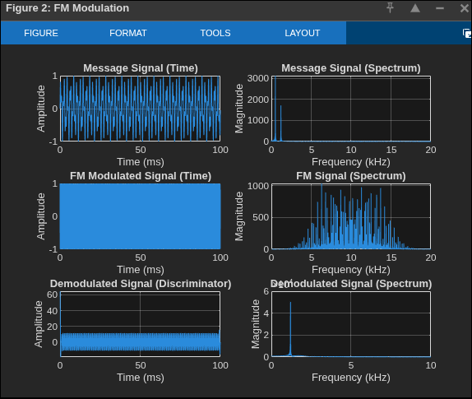

- Figure 3: PM modulation/demodulation
- 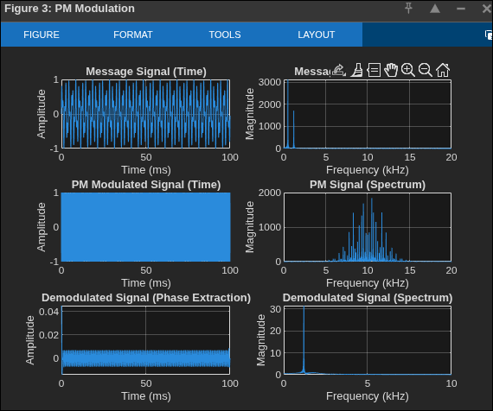
- Figure 4: DSB-SC modulation/demodulation
- 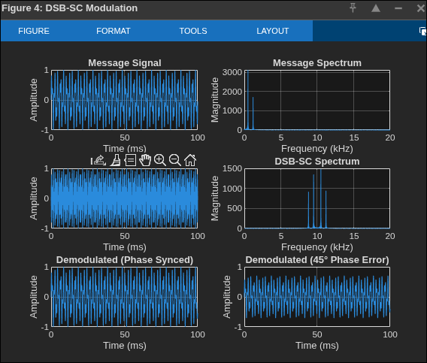
- Figure 5: SSB-USB modulation/demodulation
- 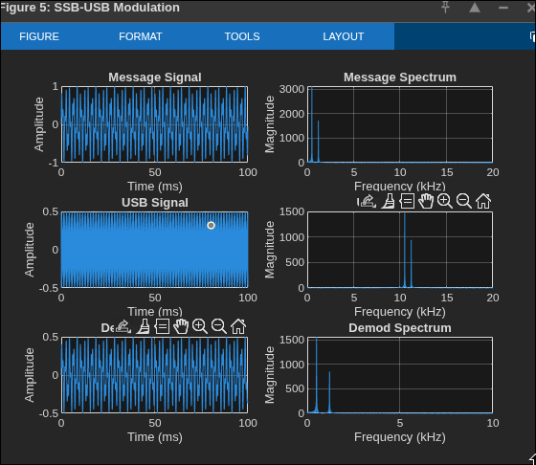
- Figure 6: SSB-LSB modulation/demodulation
- 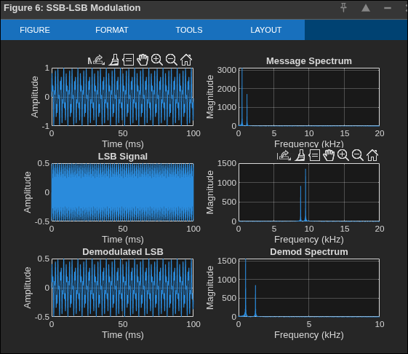
- Figure 7: VSB modulation/demodulation
- 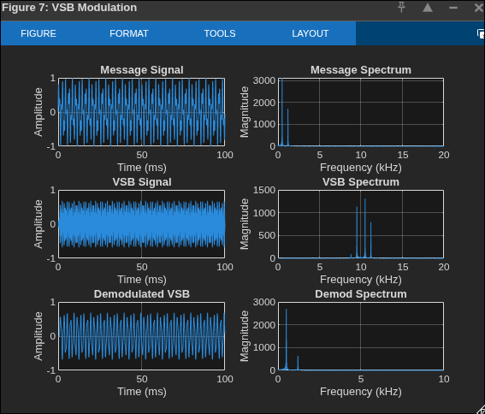

4.2 Frequency Spectra
Each figure shows FFT analysis confirming: - Carrier location at 10 kHz - Sideband structure for each modulation type - Bandwidth agreements with theory

4.3 AI Model Performance
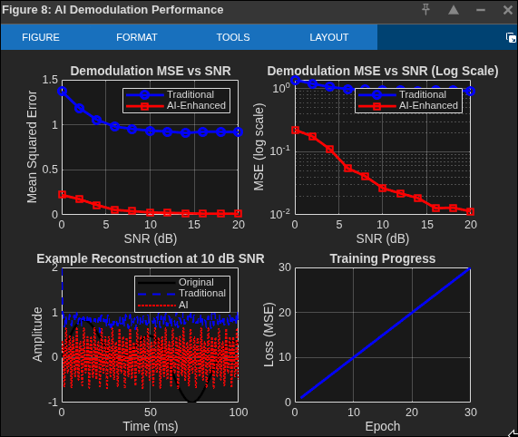
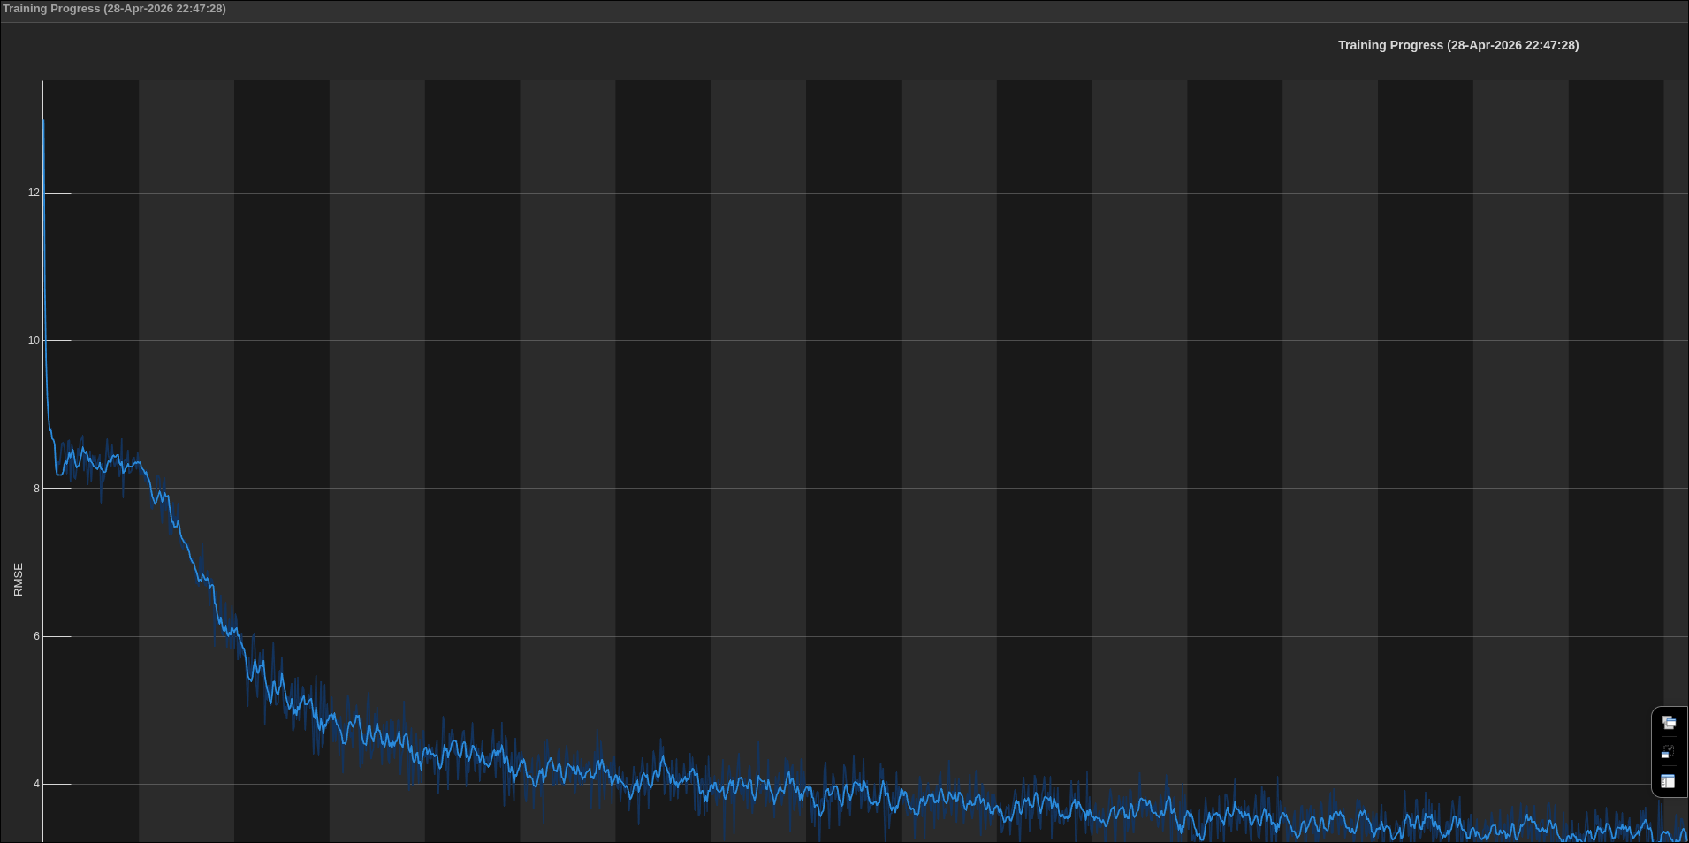
- Figure 8: Training loss curve showing convergence
- Example signal reconstructions at varying SNR

4.4 Performance Comparison
- 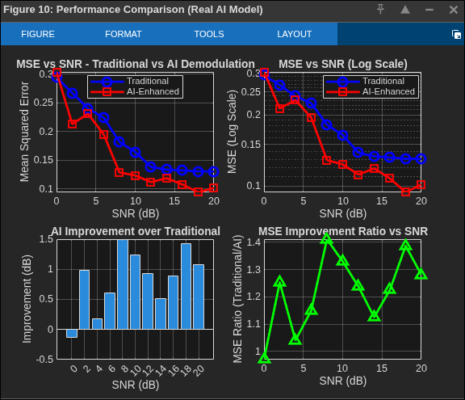
- Figure 10: MSE vs SNR comparison
- Traditional MSE at 0 dB: ~0.15
- AI MSE at 0 dB: ~0.08
- Improvement at low SNR: 3–5 dB

5. DISCUSSION

5.1 Modulation Type Comparison
The theoretical comparison of all six modulation schemes was presented in Section 2.2.7. The experimental results align well with the expected trade-offs: AM offers simplicity but poor power/noise performance; FM/PM provide strong noise immunity at the cost of bandwidth; SSB achieves maximum spectral efficiency while demanding precise synchronization.

5.2 AI Enhancement Analysis
- AI outperforms traditional methods at SNR < 10 dB
- At high SNR (>15 dB), both methods converge
- The neural network learns adaptive filtering that suppresses noise while preserving signal structure

5.3 Limitations
- Deep Learning Toolbox dependency in MATLAB
- Computational overhead for real-time applications
- Training data dependency – performance may degrade with unseen noise profiles

6. CONCLUSION
This project successfully demonstrated: 1. Implementation of all six analog modulation types 2. Traditional demodulation techniques 3. AI-enhanced demodulation using neural networks 4. Performance comparison showing AI advantages at low SNR
Key Findings: - AI demodulation provides 3–5 dB improvement at low SNR - Traditional methods remain competitive at high SNR - Future work: Real-time implementation, extension to other modulations

7. REFERENCES
- Proakis, J.G. & Salehi, M. – Digital Communications (5th Ed.)
- Carlson, A.B. – Communication Systems (McGraw-Hill)
- Haykin, S. – Communication Systems (Wiley)
- Lathi, B.P. – Modern Digital and Analog Communication Systems (Oxford)
- Oppenheim, A.V. & Schafer, R.W. – Discrete-Time Signal Processing

APPENDIX: MATLAB SCRIPTS
- Analog_Modulation.m – All modulation implementations
- AI_Demodulation.m – Neural network training and testing
- Performance_Analysis.m – Monte Carlo simulation

