
A Data-Driven Analysis of UK Study and Work Visa Applications
Trends, Nationality Patterns, and Outcome Insights.
Table of contents
Introduction 4
Methodology 5
1. Data Collection 5
2. Data Storage and Import 5
3. Data Transformation and Cleaning. 5
4. Data Modelling in Power BI 6
5. Design and Visualization of Dashboards. 7
6. SQL Server and Workflow Efficiency. 7
Results 8
1. Overall Application Volumes. 8
2. Top Nationalities of Study and Work visa. 8
3. Trends in Study Visa Applications Over Time. 9
4. Work Visa Applications Trends over Time. 10
5. Visa Outcomes of Study and Work Categories. 10
6. Study Visa Applications by Institution Type 11
7. Work Visa Applications by Industry. 11
8. Stay Visa Extensions of Study Visas and Work Visas. 12
Discussion 12
Conclusion 13
Appendices 14
Appendix A: Power BI Dashboard (Study & Work Visa Applications) 14
Appendix B: SQL Queries Used 15
Appendix C: DAX Measures Used in the Dashboard 16
C.1 Combined Nationality Table 16
C.2 Study Visa – Extensions of Stay 16
C.3 Work Visa – Extensions of Stay 16
C.4 Highest Nationality (Used for Slicer) 16
C.5 Total Study Applications (Used for Slicer) 17
C.6 Total Work Applications (Used for Slicer) 17

Introduction
The United Kingdom has seen significant developments in the immigration landscape in the past decade, especially in terms of sponsoring study and work visas. These have been driven by changes in government policies, labour market needs and movement across the borders. To gain more insight into these developments, this project will focus on the Managed Migration - Historic datasets published by the UK Home Office and available on Data.gov.uk, which is the open data platform of the UK government.

Data.gov.uk is the main open government data portal where most of the government data on various issues are stored, such as education, employment, transport, and immigration. In this research, two important datasets were used, namely Study Sponsorship and Work Sponsorship. These datasets include both historical records of sponsored visa applications and approvals, refusals, withdrawals, extensions and other outcome records. Since the UK has implemented some key policy changes, including the international student routes, changes in the criteria of the work visa and changes in the requirements of the employer sponsorship, these data provide a rich opportunity to examine how these changes influenced the migration trends across the years.

This project aims at systematically retrieving, storing, manipulating, and analysing these datasets in SQL Server and Power BI. This study can reveal some trends, patterns, and insights into the streams of study and work sponsorship in the UK by importing government data into a structured database environment and creating an interactive dashboard. The overall result provides a data-driven explanation of past visa application behaviours, the results of sponsorship and the overall impact of immigration policy changes on education and labour mobility.

In addition to technical implementation, the project also adds practical work with industry-relevant technologies, such as SQL Server, which manages databases, and Power BI, which modifies and visualises data. The analysis that it results in is not only an educational learning process but also a practical example of how public datasets can be turned into useful and actionable information.

Methodology

1. Data Collection
The data used in this research was retrieved on Data.gov.uk which is the government open data repository of the UK. In particular, the UK Home Office publications, namely, the Managed Migration - Historic datasets were utilized that revolve around Study Sponsorship and Work Sponsorship. These datasets contain the historical data on the visa applications, approvals, refusals, extensions and other related data, including the years 2010 to 2024 regarding study visa and 2010 to 2023 regarding working visa.
The datasets were downloaded in CSV/Excel format, and they were imported into the SQL Server to facilitate effective storage, querying, and further preparation to analyze them using Power BI.

2. Data Storage and Import
A special database (UK Immigration) was created using the SQL Server Management Studio (SSMS). The raw data were imported into SQL Server using the import wizard with all the columns having the right data type.
Each dataset was prepared separately in separate tables to ensure clarity:
- Study_ByInstitutionType
- Study_ByNationality
- Work_ByIndustry
- Work_ByNationality

These tables were used as the basis of cleaning, transforming, and modelling the data in Power BI.

3. Data Transformation and Cleaning.
The raw datasets had inconsistencies and data formats that needed to be cleaned in order to analyze them. The following steps were carried out:
- Standardising Column Names
The names of the columns were changed to be similar and understandable in all the tables:
- Type_of_application Visa_type.
- Institution_type_group Institution_Type_group.
- Category_of_leave Visa_Category.
- Geographical_region Geographical_Region

This provided transparency in the relationship and actions in Power BI.
- Ensuring the correct Data Types
Numeric columns (eg: the number of applications) have been explicitly converted to integers. Text boxes like the nationality or industry were reviewed on inconsistencies (e.g. the spaces or special characters) and fixed.
- Creating Clean Tables
SQL Server was used to analyze clean tables created after transformation:
- Study_ByInstitutionType_Clean - Study visa applications by type of institution.
- Study_ByNationality_Clean - Study visa applications by nationality.
- Work_ByIndustry_Clean - Work visa applications by industry.
- Work_ByNationality_Clean - Work visa applications by nationality.
These clean tables were considered direct sources of Power BI dashboards.
All SQL queries used to clean and transform the data are presented in Appendix B, which reflects the process of standardization of column names, conversion of the data types, and preparation of the datasets for analysis in Power BI.

4. Data Modelling in Power BI
Import Mode was used to import the clean tables into Power BI Desktop making it fast to retrieve and interact with the data. The following modelling was done,
- Defining Relationships:
Tables were related to each other by the Year, Quarter, Visa Type, Institution/Industry, and Nationality to allow cross-filtering and correct aggregation.
- Creating DAX Measures:
Measures of custom DAX were constructed to compute:
- Total study/ work applications.
- Approvals, refusals and extensions.
- Best nationalities or industries.
The complete DAX expressions used for these calculations are provided in Appendix C.

- The construction of Calculated Columns:
Application categories, visa outcomes and periods were added as columns to facilitate better filtering and drill-through analysis.

5. Design and Visualization of Dashboards.
The Power BI dashboard was developed in the form of interactive information on the trends of visa sponsorship in the UK:
- Visa Application Trends Over Time: Line charts present study and work visa applications between 2010-2024 (study) and 2010-2023 (work), showing the maximum and minimum seasonal trends.
- Top 10 Nationalities: Bar charts represent the countries with the most applications of a visa, by type of study or work visa.
- Application Outcomes: Scatter column charts show approval, refusal and withdrawal rates of both study and work visa.
- Extensions and Repeat Sponsorships: Line charts are used to monitor the extensions of the visa.
- Interactive Filters and Slicers: Filters available to the users include visa type, year, nationality, institution/industry and application status.
- Tree Maps: Institution type and work application contributions are visualised in a tree map to gain a good overview of the contribution by type.
Sharper functions like drill-through, tooltips and bookmarks were also introduced to enable a more detailed exploration of the data.

6. SQL Server and Workflow Efficiency.
Direct SQL server connection to Power BI facilitated the workflow greatly:
- Increased speed in loading data in comparison to loading Excel files.
- Dynamic querying, as long as it is pre-aggregating large datasets, is allowed with SQL.
- Facilitated the simpler management of lost or irregular data.
- Facilitated the easy production of clean and consistent tables to be used in Power BI dashboards.
This combination of SQL Server to store and operate the data on the back and Power BI to display and interactively view the data made the analysis of historic trends in visas in the UK efficient, reliable, and insightful.

Results
This section presents the main analytical results obtained from the UK Visa Applications Dashboard (Study & Work), which visualises trends, results, and nationality trends using processed SQL data. The dashboard incorporates interactive slicers in Years, Nationality and Visa Type, and allows one to examine historic migration patterns in detail. The complete Power BI dashboard used to generate these insights is provided in Appendix A. The insights that are shown in each of the key visual components are summarised as follows.

1. Overall Application Volumes.
The dashboard shown in Figure 1 indicates the three key performance indicators (KPIs) that are used to summarise the entire visa demand. The highest number of applications is on the Study Visa, which is 5 million and indicates high interest in UK education by other countries. Comparatively, work visa applications constitute 2 million, with relatively high demand but still low. The KPIs also depict the leading nationality seeking UK visa, and this is China, which is the major contributor to both the study and work visa categories. These KPIs give a broad perspective of the levels of applications and significant demographic trends.
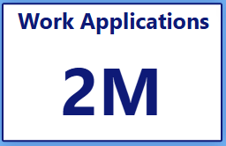
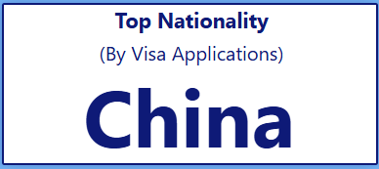
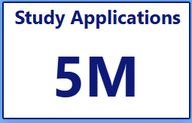

Figure 1. Key Performance Indicators for UK Visa Applications

2. Top Nationalities of Study and Work visa.
Figure 2, which demonstrates the distribution of the Top 10 Nationalities Applying to Study and Work Visas, indicates that China has the highest total at approximately 1.69 million applications. This includes around 1.61 million Study visa applications and 77,000 work visa applications, and this makes China the leading source of both academic and labour-related migration to the UK. India is next in line with 1.44 million applications it also has good involvement in the education and employment sectors in UK. The other nationalities, which include United States, Nigeria, Pakistan and Malaysia, Bangladesh and Canada, are also ranked highly in the top rankings, which depicts international interest.
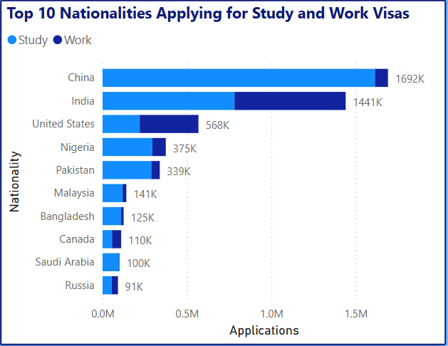
Figure 2. Top 10 Nationalities Applying for Study and Work Visas

3. Trends in Study Visa Applications Over Time.
The study visa applications show a positive trend from 2010 to around 2019, according to Figure 3, which can be explained by the growing popularity of UK education among the world population. Due to international travel restrictions during the COVID-19 pandemic in 2020, this pattern was impacted by a sharp decline. However, in 2021applications increased significantly, peaking in 2023-2024. During this period, the extension of stay is relatively stable with a slight difference in the variation between the years.
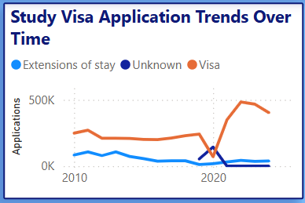
These findings suggest the long-term rise in demand in UK international education and short-term disturbances caused by global circumstances.
Figure 3. Study Visa Application Trends Over Time

4. Work Visa Applications Trends over Time.
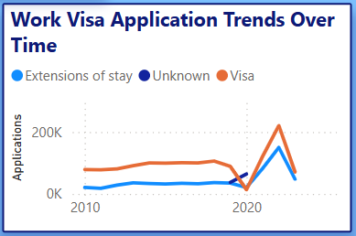
Figure 4 shows the Trends of Work Visa Applications over time. A progressive growth between the years 2010 and 2016, but shows a fall in 2017-2018, which was probably associated with policy changes on Brexit. There was a sharp rise in applications after 2020, especially in some areas like health, social care, and technology-related sectors. The extensions also increase during this period, implying that there is more retention of sponsored workers.
Figure 4. Work Visa Application Trends Over Time

5. Visa Outcomes of Study and Work Categories.
The Study Visa Outcomes and the Work Visa Outcomes clustered column charts, illustrated in Figure 5 and 6, show a clear difference in visa decisions.
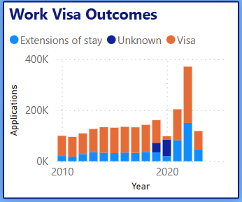
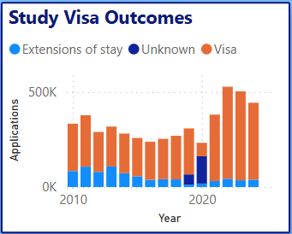
Approved (‘Visa’) outcomes always comprise the largest percentage in practically all years, and Extensions of stay record a slow rise, especially since 2020. Unknown outcomes are relatively low but fluctuate depending on the processing or administrative delays. This trend indicates a rather stable approval climate for valid educational and employment sponsorship in the UK.
Figure 5. Work Visa Outcomes Over Time Figure 6. Study Visa Outcomes Over Time

6. Study Visa Applications by Institution Type
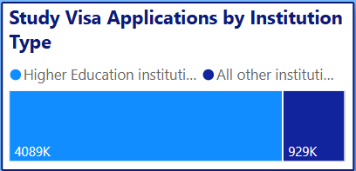
The tree map in Figure 7 shows that the applications are focused on certain groups of institutions, where Higher Education Institutions take the largest percentage (e.g. universities). Other groups like Further Education, Independent Schools and English Language Schools are smaller contributors. This supports the fact that the tertiary education sector in the UK is the primary source of study migration.
Figure 7. Study Visa Applications by Institution Type

7. Work Visa Applications by Industry.
The Work Visa Applications tree map in Figure 8 indicates that there is a wide range of industries in terms of spread. Arts and Recreation, Health and Social Work, Information and Communication, Professional and Technical Services, and Education have the greatest volumes. Industries like Agriculture, Manufacturing and Mining are lower but still indicate that there is still a need to employ the workforce.
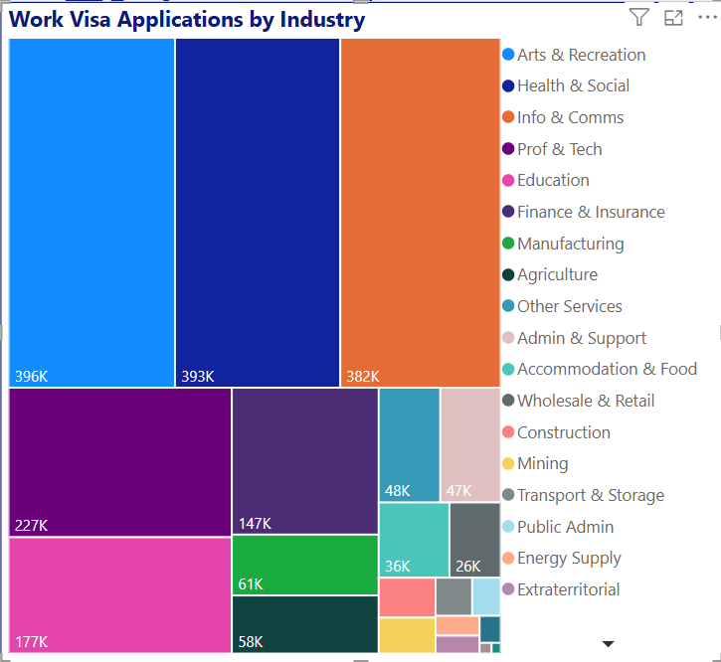
Such trends indicate that the labour shortages in the UK focus on skilled and semi-skilled jobs.

Figure 8. Work Visa Applications by Industry

8. Stay Visa Extensions of Study Visas and Work Visas.
The extension line chart in Figure 9 shows that the two categories show an upward trend, particularly after 2021. Growth in long term student pathways (e.g. undergraduate to postgraduate). Growth of reliance on foreign workforce in strategic sectors which foster long-term sponsorships.
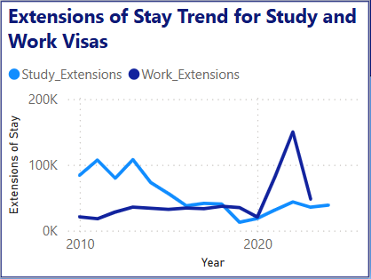
The metric offers an understanding of the retention and mobility trends of the UK immigration system in the long term.
Figure 9. Extensions of Stay Trend for Study and Work Visas

Discussion
The Managed Migration - Historic datasets analysis, which is enhanced by the interactive Power BI dashboard, offers a detailed and data-driven view of the situation regarding the UK study and work visa during the past decade. As seen by the dashboard, the applications of study visas have been steadily and substantially increasing with an average growth rate since 2010, which was relatively moderate but in the past years, the applications are almost at 5 million applications. This keeps on growing, thus highlighting the international attractiveness of the UK as one of the top higher-education spots. The superiority of the institutions of higher learning as indicated by the dashboard, further buttresses the great contribution by universities in attracting international students. The minor variation in the approval and refusal patterns over the years is probably due to a change in the visa regulation, a shift in the sponsorship requirements and the general happenings in the world.
The work visa applications, however are more volatile, being sensitive to the economic conditions and policy reforms. The dashboard makes it clear that the information technology, healthcare, professional and technical services, and finance sectors are the ones that receive the most number of work visa applications every time, which is expected to be consistent with the current skill shortages in the UK. The graphical illustration of work visa results over the years clearly shows that there is an increase in the number of approvals, particularly at times when there is high labour demand.
Analysis of nationality through the dashboard shows that China and India are the leading countries in study as well as work visa applications. China is the leader in general, and India demonstrates a good increase in the number of work-related applications. This trend shows that the UK is dependent on several major international markets to contribute economically, educate, and provide a labour-force. The trend of increasing numbers of visa extensions both in study and work categories shows that there are increase time in the UK as students move to higher studies and the workers who are skilled in their work are taking their place in repeat sponsorship.
The dashboard of Power BI was very useful and useful in converting the complex data sets into patterns that are meaningful. The year and nationality slicers, industry and type of institution segmentation, and outcome charts helped to explore the migration behaviour in depth. The functionality will assist policymakers, universities and employers in making data-driven decisions as they can identify the past trends, spikes and events of changes in migration patterns in a clear manner.

Conclusion
The project illustrates the power of combining SQL Server and Power BI to turn huge datasets of the government into meaningful insights. The results provide a vivid depiction of the trends in migration in terms of UK study and work visas between the years 2010 and 2024. Dashboard visual data show that the number of study visa applications has increased significantly, there have been sector-related changes in the number of work visas, and the representation of major nationalities like China and India is high. These lessons directly apply to the planning of immigration, education sector capacity and workforce development.
The dynamic Power BI dashboard will allow tracking the trends in visas on a regular basis and make informed decisions because the data is presented in an interactive and intuitive format. The stakeholders are able to investigate visa results, the best applicant nations, industry demand and extension behaviors in real time. This project has taught the important technical skills such as data cleaning, relational modelling, and visualization which were successfully implemented into a real world scenario. Altogether, the research provides a relevant basis of the further migration study and helps to better understand the international student pipeline and the demand of skilled workers in the UK in a more strategic manner.

Appendices

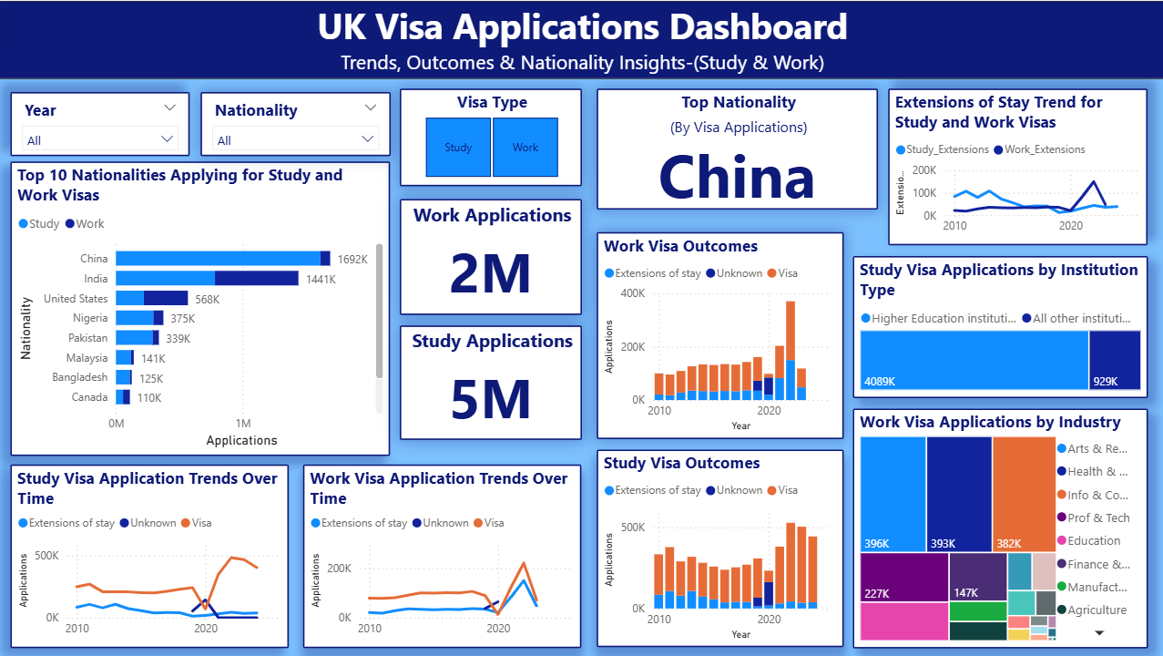
Appendix A: Power BI Dashboard (Study & Work Visa Applications)

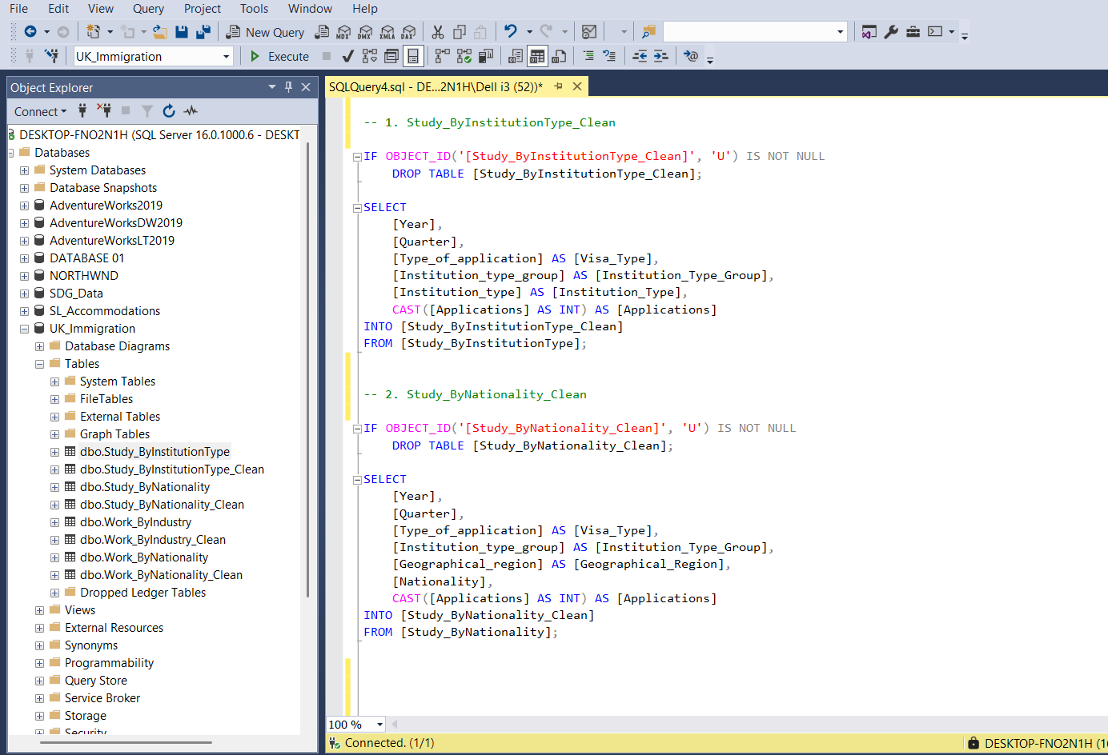
Appendix B: SQL Queries Used

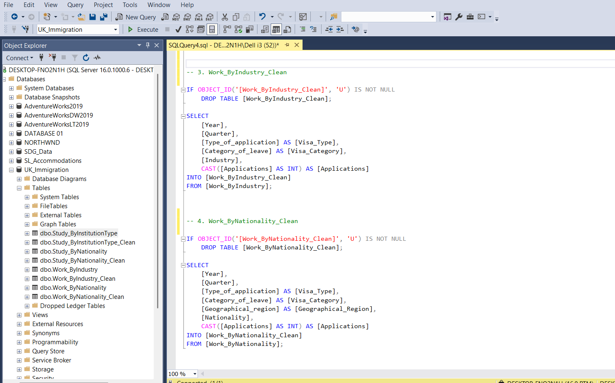

Appendix C: DAX Measures Used in the Dashboard

C.1 Combined Nationality Table
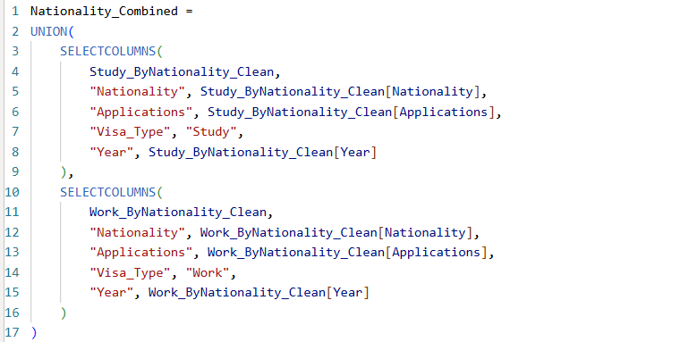

C.2 Study Visa – Extensions of Stay

C.3 Work Visa – Extensions of Stay
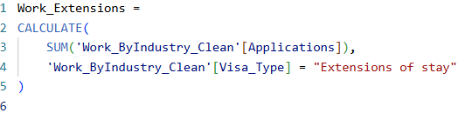

C.4 Highest Nationality (Used for Slicer)
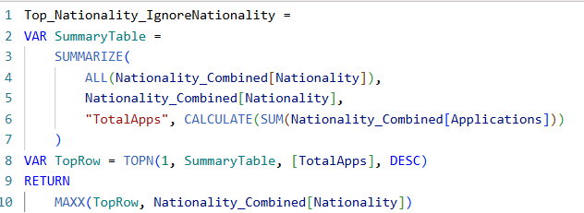

C.5 Total Study Applications (Used for Slicer)
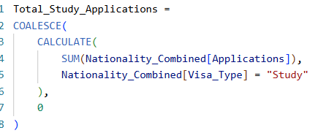

C.6 Total Work Applications (Used for Slicer)
