

**Ai / Ai Lab Project Report**

**Project Title:**

**AI Handwritten Note Reader for Visually Impaired People**

**Project Members:**

Muhammad 01-139232-047

Shahnoor Shahzad 01-139232-105

**Submitted To:**

Engr. Syed Kamran Hussain Shah

1. **Abstract**

This project aims to simulate and implement a structured inter-campus communication system for Bahria University, involving four campuses. Each campus contains seven laboratories with 14 PCs. The communication is restricted to same-lab-type communication across campuses while allowing a Rector’s Computer to access all labs. The solution utilizes routing protocols (OSPF/RIP), Access Control Lists (ACLs), and subnetting to enforce segmentation and security, **without implementing VLANs**.

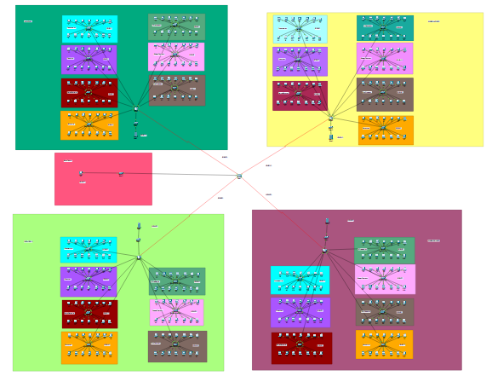

**2. Objective**

* Design a structured and secure network topology connecting Bahria University's four campuses.
* Restrict lab-level communication using ACLs and subnetting.
* Use OSPF or RIP to facilitate dynamic routing.
* Enable Rector’s Computer to have full access to all labs.
* Simulate the design using network simulation tools.
* Troubleshoot routing and access control issues.

**3. Background**

Networking across multiple campuses involves challenges such as routing, segmentation, and secure communication. Typically, VLANs are used for logical segmentation; however, in this project, segmentation is achieved via **dedicated subnets** and **ACL-based filtering** on routers. ACLs filter packet flows and restrict access between disallowed labs, while routing protocols ensure network scalability and performance.

**4. Components Description**

* **Cisco Routers and Switches (Simulated in Cisco Packet Tracer/GNS3)**
* **PCs (14 per lab × 7 labs × 4 campuses = 392 total)**
* **Subnetting Scheme (Static IP Allocation by Lab Type / Dhcp)**
* **Rector’s PC (Connected to central router with unrestricted access)**
* **Routing Protocol: OSPF or RIP (single-area)**
* **HTML Websites** (Campus-specific, hosted on local web servers)

**5. Network Diagram**

A hierarchical star topology is used:

* **Core Router** connects to 4 **Campus Routers**
* Each Campus Router connects to 7 **Lab Routers**
* Each Lab Router connects to a switch with 14 PCs
* Rector’s PC connects to the **Core Router**

Each lab of the same type in each campus is placed on the same subnet pattern, e.g.:

|  |  |  |  |  |  |
| --- | --- | --- | --- | --- | --- |
| **Lab Type** | **Islamabad (E-8)** | **Islamabad (H-11)** | **Lahore** | **Karachi** | **Color Code** |
| **Communication Lab** | 192.168.1.0 (1.1) | 192.168.8.0 (8.1) | 192.168.15.0 (15.1) | 192.168.22.0 (22.1) | Sky Box |
| **Computing Lab** | 192.168.2.0 (2.1) | 192.168.9.0 (9.1) | 192.168.16.0 (16.1) | 192.168.23.0 (23.1) | Purple Box |
| **Electrical Machines Lab** | 192.168.3.0 (3.1) | 192.168.10.0 (10.1) | 192.168.17.0 (17.1) | 192.168.24.0 (24.1) | Red Box |
| **Electronics Lab** | 192.168.4.0 (4.1) | 192.168.11.0 (11.1) | 192.168.18.0 (18.1) | 192.168.25.0 (25.1) | Yellow Box |
| **FYP Hardware Lab** | 192.168.5.0 (5.1) | 192.168.12.0 (12.1) | 192.168.19.0 (19.1) | 192.168.26.0 (26.1) | Green Box |
| **Embedded Systems Lab** | 192.168.6.0 (6.1) | 192.168.13.0 (13.1) | 192.168.20.0 (20.1) | 192.168.27.0 (27.1) | Pink Box |
| **Control Systems Lab** | 192.168.7.0 (7.1) | 192.168.14.0 (14.1) | 192.168.21.0 (21.1) | 192.168.28.0 (28.1) | Brown Box |

**Serial Links (Router-to-Router)**

|  |  |
| --- | --- |
| **Link Description** | **Subnet** |
| Serial Link 1 | 192.168.29.0 |
| Serial Link 2 | 192.168.30.0 |
| Serial Link 3 | 192.168.31.0 |
| Serial Link 4 | 192.168.32.0 |

**Server IPs (Campus Web Services / Rector’s PC)**

|  |  |
| --- | --- |
| **Campus** | **Server IP** |
| Islamabad (E-8) | 192.168.33.0 |
| Islamabad (H-11) | 192.168.34.0 |
| Lahore | 192.168.35.0 |
| Karachi | 192.168.36.0 |
| Rector Pc | 192.168.37.2 |

**6. Working**

* **Routing:**  
  OSPF/RIP is configured to allow reachability between all subnets.
* **Segmentation without VLANs:**  
  Each lab type uses a unique subnet. ACLs applied on routers restrict access so that:
  + Communication Lab PCs (from all campuses) can only talk to other Communication Lab PCs.
  + Access to/from other labs is denied.
  + Rector’s PC is given access to all subnets via exception rules in ACLs.
* **Web Hosting:**  
  Each campus runs a simple web server hosting an HTML site.  
  ACLs prevent other campuses from accessing unrelated campus sites.

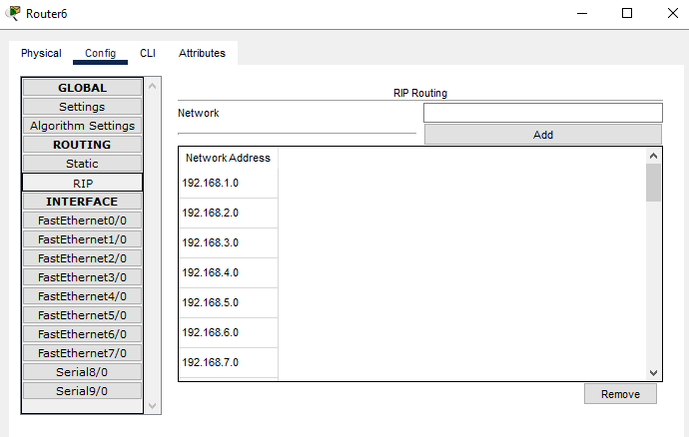

**7. Simulation Results**

Tests in Cisco Packet Tracer confirmed:

* Same-lab type PCs in different campuses can ping each other.
* Cross-lab pings (e.g., Computing to Embedded Systems) are denied.
* Rector’s PC successfully communicates with all labs.
* Websites are accessible only within campus-specific labs.
* Routing tables dynamically updated using OSPF/RIP.

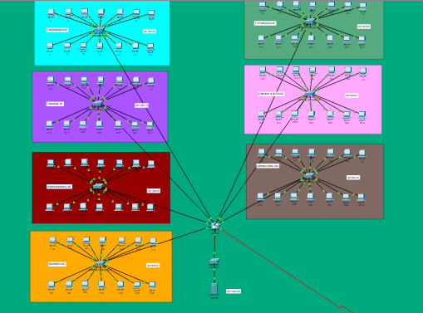

**8. Conclusion**

This project demonstrates a robust, VLAN-free method for secure inter-campus lab communication using subnetting, ACLs, and routing. The design provides efficient segmentation and policy enforcement with full administrative oversight via the Rector’s PC. The solution is scalable and effective for environments where VLAN implementation is restricted or undesirable.