

**MUHAMMAD ABBAS**

**MOBILE DEVELOPMENT**

**MODE-4201**

**MOBILE DEVICE TYPES**

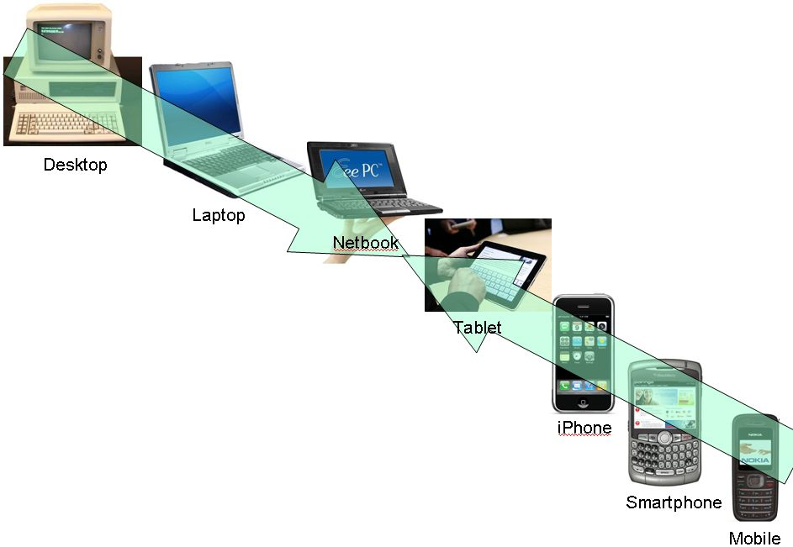

Contents

**MOBILE DEVICES** 2

**MOBILE DEVICE TYPE** 3

**Introduction** 3

**Cell Phones** 3

**Laptops** 3

**Personal Digital Assistant (PDA)** 3

**Multimedia/Gaming Devices** 4

**Navigation Devices** 4

**Radio Frequency Identification (RFID)** 4

**MOBILE MANUFACTURER** 5

**MOBILE MANUFACTURER – COMPARISON** 6

**MOBILE PLANS** 7

**MOBILE PLANS – COMPARISON** 8

**My Plan** 8

**References** 9

# **MOBILE DEVICES**

# **MOBILE DEVICE TYPE**

## **Introduction**

A mobile device is a portable computing device, whilst giving freedom of movement. Variants of mobile devices are available now a days ranging from a cellphone, smartwatches, laptops, PDA, pager etc. Each mobile device has its own utility and accordingly has its own applications for individuals. With the development the efficacy, influence and utilization are growing everyday. Salient features of mobile devices are as follows:

Portable that enables easy to carry and work with while you are on the move.

Attractive user interface.

Internet accessibility due to wireless LAN feature.

Enables voice and typical data transmission

Enables one to one contact to have conversations

Attractive user interface (History of mobile computing, 2012).

## **Cell Phones**

Cellphones primary designed for communication (calling and texting) with technological advancement has far exceeded its intended purpose. Mobile phones history goes back to 1908 when a US Patent was issued in Kentucky for a wireless telephone. Motorola, on 3 April 1973 were first company to mass produce the first handheld mobile phone. Early mobile phones are often referred to as 0G mobile phones, or Zero Generation mobile phones (History of mobile phones and the first mobile phone, 2020).

## **Laptops**

Laptops on the other hands are mobile form of Desktops intended to do computational tasks. Like other gadgets, technology has also improved it providing versatility and power to perform much complex function with a lot smaller device which earlier was not possible. Latest laptops have been incorporated with touch screen for data input.

The computer considered by most historians to be the first truly portable computer was the Osborne. It was a portable computer that weighed 24 pounds and cost $1,795. For that, users got a five-inch screen, modem port, two 5 1/4 floppy drives, a large collection of bundled software programs and a battery pack (Bellis, 2019).

## **Personal Digital Assistant (PDA)**

PDA were invented in 1980s, to act as a Digital diary where one can save numbers, addresses and also can take notes like appointments, meeting schedules etc. However, with the growing power and options mobile phones have overtaken this device.

## **Multimedia/Gaming Devices**

Audio players for music or listening to digital books have also gained popularity. In this context players and headphone have captured the multimedia market. Likewise gaming consoles have become portable and are popular amongst all age groups.

## **Navigation Devices**

With the commercial use of GPS, navigation devices have also now widely used. These are used for navigation and tracking purposes.

## **Radio Frequency Identification (RFID)**

These devices are very popular in the industrial sector and have given flexibility. RFID devices are in use for smart cards, barcodes etc.

# **MOBILE MANUFACTURER**

# **MOBILE MANUFACTURER – COMPARISON**

|  |  |  |
| --- | --- | --- |
|  | **MOBILE PHONE** | |
| MANUFACTURER | Apple | Samsung |
| Phone Model | iPhone 11 pro | NOTE 20 |
| PRICE | $1,379.00 | $1,819.99 |
| RELEASE DATE | September 20, 2019 | September 30th, 2020 |
| OPERATING SYSTEM | IOS-13 | Android |
| CHIPSET | Hexa-core A13 Bionic | Octa-core (Cortex-A-76) |
| PROCESSOR (CPU) | A-13 Bionic chip  Third-generation Neural Engine | Qualcomm Snapdragon 865+ |
| MEMORY (RAM) | 4GB | 8GB |
| MEMORY (INTERNAL) | 512GB | 512GB |
| MEMORY (EXTERNAL) | nun | 1TB |
| DISPLAY | 5.82 inch | 6.7 inch |
| CAMERA (REAR) | 12MP , 12MP, 26MP ultrawide | 12MP, 108MP AND 12MP ultrawide |
| CAMERA (FRONT) | 12MP | 10MP |
| GPS | Yes | Yes |
| BATTERY (TALK TIME) | 26 hrs | 44 hrs |
| BATTERY (STANDBY) | 18 hrs | 15.4 hrs |
| NETWORK | LTE | GSM/CDMA/LTE/5G |
| SYNCHRONIZATION W DESKTOP | Yes | Yes |
| BROWSER | Safari | Internet |
| Sensors | Face ID | Face ID |
| Multi Language Support | Yes | Yes |

# **MOBILE PLANS**

# **MOBILE PLANS – COMPARISON**

|  |  |  |
| --- | --- | --- |
|  | **SERVICE PROVIDER** | |
| **FEATRES** | **BELL** | **FIDO** |
| Plan | “Unlimited 20” | “Promotion Deal” |
| Calls | Unlimited | Unlimited |
| Data | 10GB | 9GB |
| Messaging | Unlimited | Unlimited |
| Global Texting | Unlimited | Unlimited |
| Voice Mail | Available | Available |
| Call Features | None | None |
| Service credits |  |  |
| Fees | $75.00 | $50.00 |
| Usage Policy | None | None |
| Coverage | Excellent | Good |
| Additional Feature - 1 | 20 GB Shareable data | Data Overage protection |
| Additional Feature – 2 | 5-G Ready | Extra hour of data, 5 times a month |

## **My Plan**

I am using 2+2 GB Fido prepaid plan which fulfills my requirement. Fido plan also offers extra hour of data 5 times in a billing cycle. The plan includes unlimited Canada wide calling and unlimited Canada wide and International Texting.

# **References**

Bellis, M. (2019, October 4). *The History of Laptop Computers*. Retrieved from ThoughtCo.: https://www.thoughtco.com/history-of-laptop-computers-4066247

*History of mobile computing*. (2012, October 10). Retrieved from Mobile Computing: https://mobilecomputingproject.wordpress.com/2012/10/10/history-of-mobile-computing/

*History of mobile phones and the first mobile phone*. (2020, June 4). Retrieved from Uswitch: https://www.uswitch.com/mobiles/guides/history-of-mobile-phones/