[Year]

Muhammad S Ali

[Company name]

[Date]

[Document title]

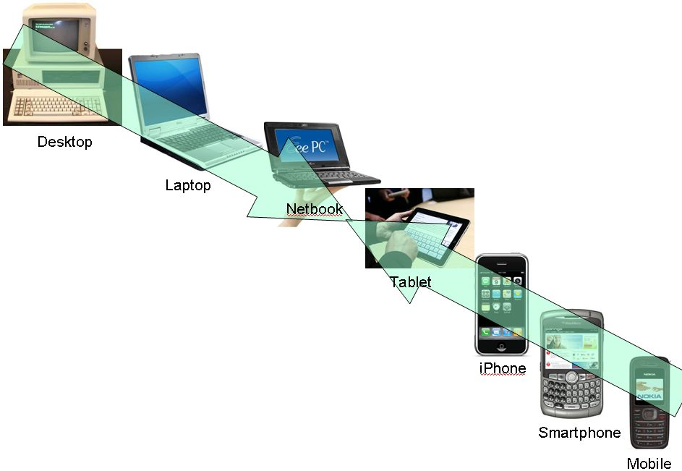

# MOBILE DEVELOPMENT

A mobile device is a portable computing device, whilst giving freedom of movement. Bluetooth, Processor, RAM, Networking, External Port, Operating System and etc. are some of the important terms for mobile devices. Laptops, Cell Phones, Tablet Computers, Smart Watches and etc. are the example of mobile devices.

The first ever computer was built in 1945 by John Mauchly and J. Presper Eckert of the University of Pennsylvania, U.S. It was called The ENIAC (Electronic Numerical Integrator and Computer) which was used for general problem solving. In 1979 software arts created VisiCalc, which was the first spreadsheet computer program and was a massive success. In 1981 The Osborne Computer Corporation releases the Osborne 1, which was the first laptop which was commercially available. The laptop didn’t have a battery and had to be constantly plugged in a power socket. 1984 Apple releases the first Macintosh which was the first computer which featured a mouse.

In 1990 a Hypertext programming language came into being which is known as “HTML”. In the same year Microsoft created Windows which came with the first Microsoft Office suite launches with Word, Excel, And PowerPoint for Windows 3.0. In 1997 Larry Page and Sergey Brin launch the Google search engine which till this day remains one of the most used and popular search engines. In 2007 Apple released a smartphone which was known as “iPhone” which featured a 3.5-inch screen and operating system made from the ground up for touchscreen. The device would popularize smartphones like no other smartphone before.

Having a mobile device can be very beneficial some of the advantages are 1) Better Communication 2) Ability to work from anywhere 3) Reduced Operational Cost and save time 4) Increased Productivity.